  - Respiration (18 Lessons)

1. The oxidation of a certain fat is represented by chemical equation shown below.
C₅₇H₁₀₄O₆ + 80 O₂ → 57CO₂+52H₂O + Energy
  - Calculate the respiratory quotient (RQ) of the fat (2marks)
  - What is the significance of RQ? ( 2marks)

2. A process that occurs in some organisms is represented by the equation below.
C₆H₁₂O₆ 2C₂H₅ oH + 2O₂ + Energy
K

a) Name the process. (1mk)
b) State the name of the compound K. (1mk)
c) State the economic importance of the above reaction in Kenyan industries. (2mks)

3. Give one structural difference and similarity between a mitochondrion and a chloroplast. (2mks) 18. What is the function of the following parts in a microscope? (2mks)
(a) Condenser.
(b) Diaphragm.
4. (a) A goat weighing 20kg requires 216KJ while a mouse weighing 54gms requires 2830KJ per day. Explain. (2 marks)
(b) What is the end products of respiration in plants when there is insufficient oxygen supply?(1 mark)
5. A food substance called tripalmitin C₁₅ H₉₈ O₆ was oxidized fully and the following equation worked out.
2C₅₁ H₉₈ O₆ + 145O₂  102CO₂ + 98H₂O
- Calculate the RQ of tripalmitin. (2 marks)
(b) From the RQ value obtained above, to what group of food substances does tripalmitin belong.
(1 mark)

6. During a strenuous exercise, the chemical process represented by the equation below takes place in human muscles.
C₆ H₁₂ O₆  2CH₃ CH (OH) COOH + 150kJ
(Substance X)
  - Name the process. (1 mark)
  - Name substance X. (1 mark)
  - State two economic importance of the above process. (2 marks)
  - Explain what happens to X after the exercise. (2 marks)
  - State two differences between aerobic respiration and photosynthesis. (2 marks)

7. State differences between Aerobic and Anaerobic respiration (2mks)

- Name the product of anaerobic respiration in; (2marks)
a) plants
b) Animals
- (a) Describe what happens in the first phase of aerobic respiration. (3marks)
- A student divided a small air tight box into two chambers with wire mesh. In one chamber he kept a number of rats and in the other a number of potted plants. What was likely to happen if the box was placed in the dark for two hours?
Explain your answer. (3marks)
10. Study the reaction below and answer the questions that follow.
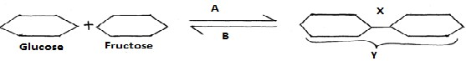
a) What biological processes are represented by A and B? |  |  |  | (2mk)
b) Identify the product Y. |  |  |  | (1mk)
c) State the bond represented by X. |  |  |  | (1mk)
11. The diagram below shows a set up that was used to demonstrate a certain physiological process.
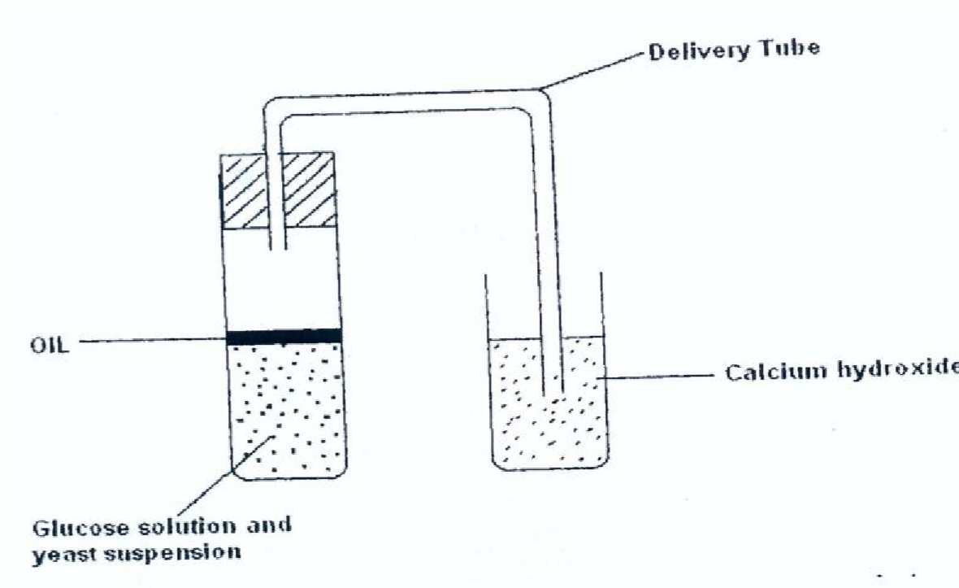
The glucose solution was boiled and oil added on top of it. The glucose solution was then allowed to cool before adding yeast suspension.
a) Identify the physiological process that was being investigated using the above set up.(1 mark)
  - Why was glucose boiled during the experiment? (1 mark)
  - What was the importance of cooling the glucose before adding the yeast suspension?(1 mark)
  - What observation would be made in test tube at the end of the experiment? (1 mark)
  - How would the observation made in (d) above be affected if oil was not added on top of the yeast suspension during the experiment? (1 mark)
  - In another investigation, a bird was found to use 10 litres of oxygen to give a respiratory quotient of 0.7 during period of flight. Name the type of food that was being respired by the bird and determine the amount of carbon (IV) oxide produced during the same flight. (3 mark)
12. Human beings are Homoiothermic.
(a) Explain the meaning of homoiothermic. (1mark)
(b) What are the effects of the following in human beings? (2marks)
(i) Decrease in body temperature below the optimum level
(ii) Increase in body temperature above the optimum level.
(iii) The pancreas of a mammal was surgically removed. A few hours later, glucose was found in urine of the mammal.
Explain the observation. (1 mark)

13. The table below shows the oxygen consumption and carbon dioxide released at rest by a number of animals under certain conditions.
Animal | Body mass(g) | Oxygen consumption in cm³ per hour | Carbon dioxide released in cm³ per hour | Respiratory Quotient
Mouse | 20 | 40 | 40
Dog | 10000 | 1960 | 2800
Sheep | 40000 | 4970 | 7100
Horse | 600000 | 700000 | 700000
- Complete the table in the last column showing respiratory quotient. (2marks)
- From the completed table suggest which animal was oxidizing. (2marks)
i) Fats
ii) Carbohydrates
- The chemical equation below represents a physiological process that takes place in living organisms. Process R
C6H12O6 + C6H12O6 → C12H22O11 +
Q

Name: (2mks)
- The process R:
- Substance Q;
15. The equation below represents a certain physiological process. Study it and answer the questions below.
C₁₈H₃₆O₂ + 26O₂ 18CO₂ + 18H₂O + ATP
(i) Name the above process. | (1mk)
(ii) Give two reasons for question (i) above. | (2mks)
(iii) Calculate the respiratory quotient of the compound that was as the substrate. | (2mks
(iv) Identify the substrate being respired in the above equation. | (1mk)
(v) State one importance of this process to living organisms.  (vi) Name the organelle where the above process takes place in animal cells. (1mk) | (1mk)
16. Explain how the following factors determine the daily energy requirement in human:
a) Age |  | (1 mark)
b) Occupation |  | (1 mark)
- Sex  17. (a) Explain why the body temperature of a healthy human being must rise upto 39ºC on humid day. (2mks)  - In an experiment a piece of brain was removed from a rat. It was found that the rat had large fluctuations of body temperature. Suggest the part of the brain that had been removed. (1mk)  18. The chemical equation below represents a reaction that occurs in cells.  2C₅₇H₉₈O₆ + 145O₂ → 102CO₂ + 98H₂O.  - Calculate the respiratory quotient (RQ). 2mks  - Identify the substrate used in respiration. 1mk  - Name the compound that stores energy released during oxidation of glucose. 1mk |  | (1 mark)

19. One molecule of lipids gives more energy than one molecule of glucose when respired aerobically but is not always used as a respiratory substrate.
  - Give two reasons for this. (2 marks)
  - Name two disaccharides which are reducing sugars. (2 marks)

20. A student set up an experiment using soaked and dry seeds as shown below.

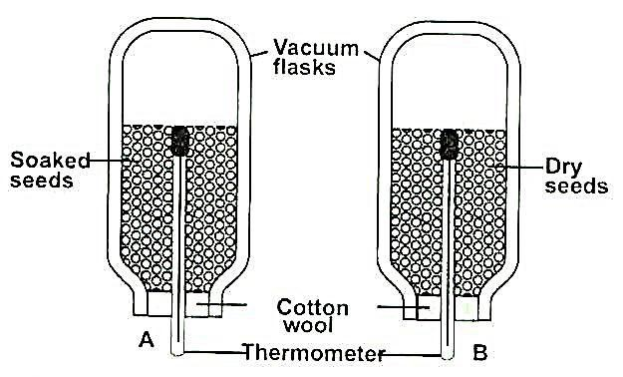

State the objective of this experiment (1mark)
 | (a) | State the observations made in each of the flask after 24 hours. | (2 marks)
 | (b) | Account for the observation made in (b) above. | (2marks)
 | (c) | Suggest why vacuum flasks were used in this experiment | (1 mark)
 | (d) | What alteration would you make in the set up to make the results more reliable? | (1 mark)
 | (e) | Why should the seeds be washed with antiseptic solution. | (1 mark)

