7.0.0 Gaseous Exchange (36 Lessons)

1. State four adaptations of respiratory surfaces. (4 marks)

- Study the diagram and use it to answer the questions that follow.

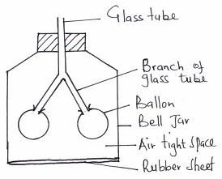
Mention the equivalent of the following in the mammalian breathing system.
  - Bell far……………………………………………………………… (1mk)
  - Balloon……………………………………………………………… (1mk)
  - Rubber sheet………………………………………………………… (1mk)

- Name the structure for gaseous exchange in
Tadpole …………………………..…………………………………. (1mk)
Grasshopper………………………………………………………….. (1mk)

- Describe the photosynthetic theory of opening and closing of the stomata. (10mks)

- (a) Which substance in the cigarettes smoke may cause lung cancer. (1 mark)
(b) The table below shows differences in air breathed in and out.
Gas | Volume of air breathed in | Volume of air breathed out
Oxygen | 21.00 | 16.00
Carbon (IV) oxide | 0.04 | 4.00
What is the reason for their differences? (2 marks)
6. The diagram below represents an organ of gaseous exchange.
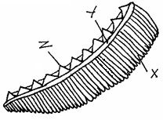

- What is the name of the organ? (1 mark)
- Name the class to which the animals that have the organ you identified in (a) above belongs. (1 mark)
- State one way in which structure X is adapted for gaseous exchange. (2 marks)

7. How does carboxyhaemoglobin lead to death? (2 marks)

8. Explain the following
(a) (i) When transplanting a seedling, it is advisable to remove some of the leaves.  (ii) There are generally fewer stomata on the upper side of a leaf than on the lower side | (1 mark)
(b) Design a simple experiment to illustrate this observation in (a) (ii) | (5marks)
9. State three adaptations of alveolus of a mammal for gaseous exchange (3mks)

10. Explain how Aerenchyma tissue are adapted to their functions (2marks)

11. Describe how gaseous exchange occurs in terrestrial plants. (13 marks)

12. The diagram below shows how gaseous exchange occurs across the gills of a fish.

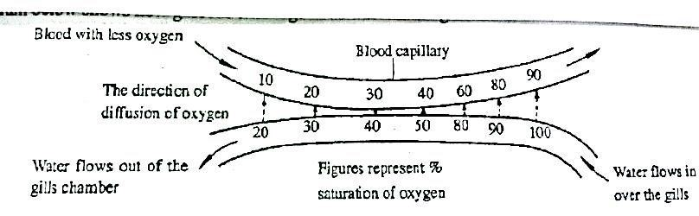
According to the diagram water and blood flows in opposite direction across the gills.
- Give the term used to describe this flow. (1mark)
- Explain the advantage of the above flow named in (a) above. (2marks)
- What differences would be observed if water and blood flow across the gills in the same direction. (2marks)

13. (a) Name the site of gaseous exchange in mammals. (1mk)
(b) State one characteristics of the site named in (a) above. (1mk)

- (a) Describe three adaptations of a respiratory surface. (6mks)
  - Describe the mechanism of gaseous exchange in a mammal. (14mks)

- a) State one function of cilia in organisms. (1 mark)
b) Name two parts of human body which have cilia. (2 marks)

- How is the alveolus of a mammal adapted for gaseous exchange? (3 marks)

17. 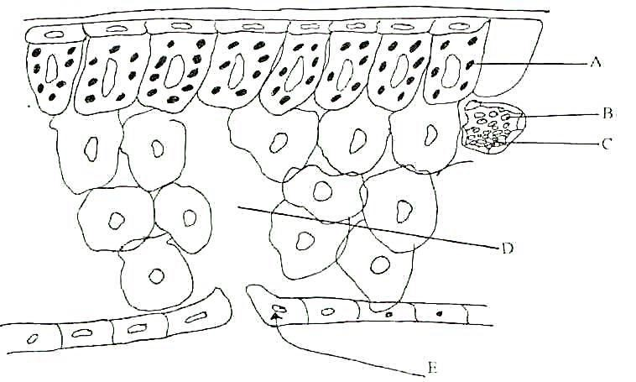

The following diagram represents the internal structure of a leaf. Study it and answer the questions that follow.
- Name the parts marked A and E (2 marks)
- State the roles of parts marked B and C in plant nutrition (2 marks)
- Briefly describe the process of gaseous exchange between part marked D and the cells during the day
(4 marks)
18. The apparatus whose diagram is given below can be used to demonstrate results of a physiological process that occurs in a mammal. To use the apparatus, the experiment places his mouth at the point marked X and breaths in and out gently.
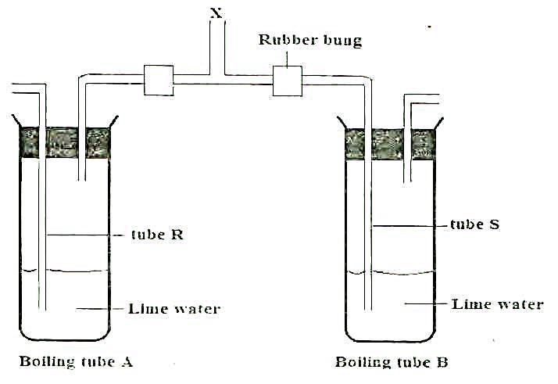

a) State the observations in the boiling tube when the experimenter
i) Breaths in:
Boiling tube, A (2 mark) Boiling tube, B (1 mark)
ii) Breaths out:
Boiling tube, A (1 mark)
Boiling tube, B (1 mark)
b) What conclusions can you draw from the results of this experiment (2 marks)
c) What is the purpose of the boiling tube A? (1 mark)

- The diagram below shows part of a mammalian respiratory system.
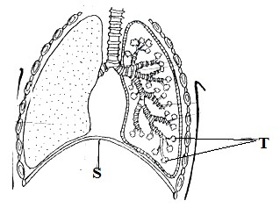
  - Explain two ways in which the part labeled T is adapted to its functions. (2mks)
  - How does the part labeled S facilitate breathing in? (2mks)

20.

The apparatus below illustrate breathing in a mammal.

plug

Rubber

plunger

baloon

syringe case

Capillary
  - Describe what happens if the rubber plug is pulled in the direction shown by the arrow. 1mk
  - Give the parts of mammal represented by:-
  - Capillarity tube. 1mk
  - Rubber plug. 1mk

