COMPETENCE BASED CURRICULUM
JUNIOR SCHOOL
FORMATIVE ASSESSMENT
TERM ONE 2024
GRADE 7

Name……………………………………………………………….………………………………………………
Centre ………………………………………………………………………………….......................................
Assessment No. ……………………………………………………………… Stream………………………
Learner’s Sign……………………………………………………..… Date: ………………..…………………..
INTEGRATED SCIENCE
FOR EXAMINERS

ASSESSMENT RUBRICS (for official use)
%SCORE RANGE | Below 40 | 40-59 | 60-79 | 80-100
PERFORMANCE LEVEL | Below expectation | Approaching expectations | Meeting expectations | Exceeding expectations
 | 1 | 2 | 3 | 4

    - Name the following instruments. (6 mks)

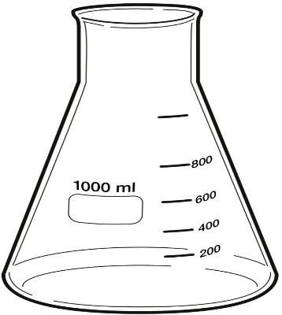 | 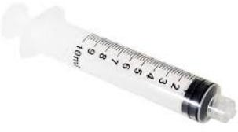 | 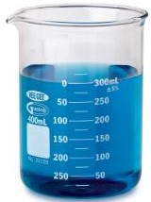
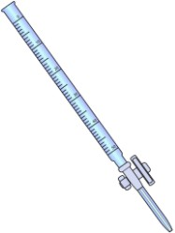 | 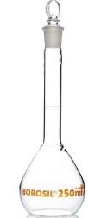 | 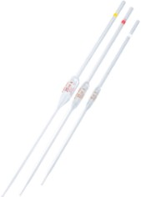

State three safe ways of Handling common laboratory apparatus and instruments (3 mks).
- ………………………………………………………………………
- ………………………………………………………………………
- ……………………………………………………………………..

- Name four common accidents in the laboratory.(4 mks)
- …………………………………………………….
- …………………………………………………….
- …………………………………………………….
- …………………………………………………….
- Name four protective wear for safety in the laboratory.(4 mks)
- ………………………………………………………………
- ……………………………………………………………...
- ………………………………………………………………
- ……………………………………………………………...
- Name three laboratory apparatus used for measuring mass of substances.(3 mks)
- ………………………………
- ……………………………….
- ………………………………..
- Name three apparatus used for measuring length.(3mks)
- ………………………………….
- …………………………………
- ………………………………….

- Name the apparatus below. (1mk)

- Name the parts R, T and P above. (3mks)
R-………………………………………………..
T-………………………………………………..
P-………………………………………………..

- Give four differences between luminous and non-luminous flame.(8 mks)
Luminous flame | Non-luminous flame

- Name the following parts of the light microscope.( 5 mks)
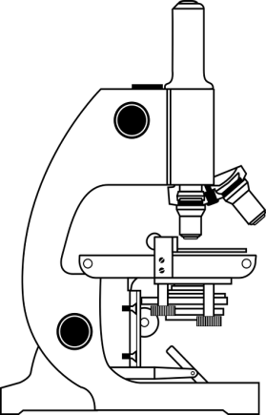

- Grade 8 students had their practical lesson in the laboratory.name two common accidents their Integrated Science teacher taught them. (2 mks)
- …………………………………….
- …………………………………….
- …………………………………….
- …………………………………….

- Name three protective wear for safety in the laboratory.( 3 mks)
- ………………………………………………
- ………………………………………………
- ……………………………………………….
- Calculate the area of the Circle whose diameter is 14cm. (2 mks)

14cm

Outline three safe ways of handling of the Bunsen burner. (3 mks)
- …………………………………………………………………………
- …………………………………………………………………………
- …………………………………………………………………………
THE END

