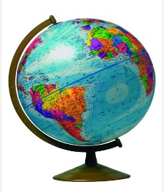**SIAYA GEOGRAPHY ASSOCIATION JOINT EXAMINATION (SIGEA) 2024**

**Kenya Certificate of Secondary Education**

**312/2 – GEOGRAPHY – Paper 2**

**MARCH - 2024**

**2 ¾ Hours**

**Name**……………………………………………….. **School**……………..…………………..

**Class**……………..….… **Index Number**…………………..…….. **Adm No**………….

**Date**……….……..

**INSTRUCTION TO CANDIDATES**

1. Write your name and Index number in the spaces provided at the top of the page.
2. Answer **all** the questions in Section A. In section B answer question **six** and any other **two** questions from this section.
3. All answers must be written in the answer booklet provided.
4. This paper consists of five printed pages.
5. Candidates should check the question paper to ascertain that all page are printed as indicated and that no question is missing.
6. Candidates should answer the questions in English

**SECTION A**

**Sub- Total**

|  |  |  |  |  |  |
| --- | --- | --- | --- | --- | --- |
| **Question Number** | **1** | **2** | **3** | **4** | **5** |
| **Marks** |  |  |  |  |  |

**SECTION B**

**Sub- Total**

|  |  |  |  |  |  |
| --- | --- | --- | --- | --- | --- |
| **Question Number** | **6** | **7** | **8** | **9** | **10** |
| **Marks** |  |  |  |  |  |

**GRAND TOTAL**

**SECTION A (25 MARKS)**

***Answer all the questions in this section***

1. a) Give **two** main Branches of Geography. (2 marks)

b) State **three** ways in which Geography is related to agriculture. (3 marks)

1. a) Identify **two** counties to the West of Rift valley where tea is grown in large scale.

(2 marks)   
b) State **three** physical factors that favour tea farming in Kenya. (3 marks)

1. a) Identify **two** traditional methods of fishing used by fishermen in Western Kenya. (2 marks)

b) State **three** factors that have favoured fishing in the South West Africa fishing

ground. (3 marks)

1. Give **five** reasons why domestic tourism is being encouraged in Kenya. (5 marks)
2. a) Apart from wood name **two** other sources of renewable energy. (2 marks)

b) Give **three** disadvantages of using wood fuel as a source of energy. (3 marks)

**SECTION B (75 MARKS)**

**Answer question six and any other two questions from this section.**

1. a) The table below shows milk production by some counties in Kenya in 000’ litres between years 2013 and 2015.

|  |  |  |  |
| --- | --- | --- | --- |
| **County** | **2013** | **2014** | **2015** |
| Kericho | 55 | 15 | 25 |
| Nandi | 35 | 20 | 25 |
| Kisii | 25 | 20 | 15 |
| Kiambu | 15 | 12 | 15 |

1. Draw a compound bar graph to represent the above information. Use vertical scale 1cm to represent 10,000 litres. (9 marks)
2. State **two** advantages of using compound bar graph to represent geographical data. (2 marks)

b) i) State **four** factors which favour beef farming in the Rift Valley (4 marks)

ii) Identify **two** traditional breeds of cattle kept by nomadic pastoralists in Kenya. (2 marks)

c) Explain **four** measures which the Kenya government has taken to assist nomadic pastoralists. (8 marks)

1. a) i) Define the term mining. (2 marks)

ii) State **three** ways in which minerals occur. (3 marks)

b) Describe open cast as a method of mining. (5 marks)

c) Explain **three** ways in which mining leads to development of industries.

(6 marks)

d) You are to carry out a field study on effects of land dereliction around your school.

i) Give **three** reasons why you would require a route map of the area of the study. (3 marks)

ii) For your study, you have prepared a working schedule. State three items you would include in the schedule. (3 marks)

1. Identify **three** benefits that your visit to the area would have to the community. (3 marks)
2. a) i) Differentiate between forestry and forest. (2 marks)

ii) Name **three** natural forest reserves found in the western region of Kenya.

(3 marks)

iii)State **three** characteristics of coniferous forests that favour their exploitation.

(3 marks)

b) Explain **three** factors that favour growth of forest in Canada. (6 marks)

(c) Explain the difference between soft wood forest in Kenya and Canada under the following sub heading

* Condition for growth rate (2 marks)
* Tree species (2 marks)
* Processing of forest products (2 marks)
* Marketing of forest products (2 marks)

(d) Identify **three** non-wood products derived from Kenyan forests. (3 marks)

1. a) Mention **three** methods which have been used to reclaim land in Kenya.

(3 marks)

b) Explain **three** physical factors that influenced the location of Perkerra Irrigation scheme. (6 marks)

c) Describe the stages involved in reclaiming land from the Sea in Netherlands.

(8 marks)

d) i) Explain **three** benefits the Dutch got from the Zuider Zee project. (6 marks)

ii) Give **two** ways that have been used to control pest in Kenya. (2 marks)

**10**.a) i) Distinguish between National Parks and games reserves. (2 marks)

ii) Give **three** reasons why most National parks and game reserves are located in arid and semi-arid areas in Kenya. (3 marks)

b) Explain **four** problems associated with wildlife in Kenya. (8 marks)

c) Use the map of East Africa to answer the question below.

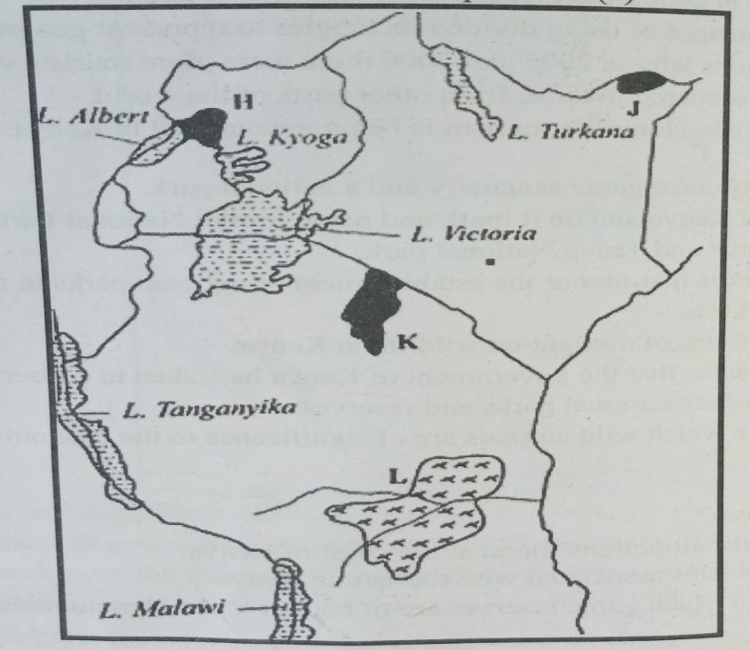

1. Name the game parks marked **H**, **J** and **K.**  (3 marks)
2. Identify the game reserve marked **L.**  (1 mark)

d) Explain **four** efforts being made by the East African countries to conserve wildlife.

(8 marks)

**THIS IS THE LAST PRINTED PAGE**