
SIAYA GEOGRAPHY ASSOCIATION JOINT EXAMINATION (SIGEA) 2024
Kenya Certificate of Secondary Education
312/1 – GEOGRAPHY – Paper 1
FEBRUARY - 2024
2 ¾ Hours
Name………………………………………..………….. School……………..…………………..

Class……………..….… Index Number…………………..…….. Adm No…………….

Date……….……..

INSTRUCTIONS TO CANDIDATES
- Write your name and Index number in the spaces provided at the top of the page.
- Answer all the questions in Section A. In section B answer question six and any other two questions from this section.
- All answers must be written in the answer booklet provided.
- This paper consists of five printed pages.
- Candidates should check the question paper to ascertain that all page are printed as indicated and that no question is missing.
- Candidates should answer the questions in English
SECTION A
Sub- Total
Question Number | 1 | 2 | 3 | 4 | 5
Marks
SECTION B
Sub- Total
Question Number | 6 | 7 | 8 | 9 | 10
Marks

GRAND TOTAL

SECTION A
Answer ALL Questions in This Section

1.(a) Define the term Geography. (2 marks)
(b) State three reasons why it is important to study Geography. (3 marks)
2. (a) Name two theories of the origin of the earth. (2 marks)
(b) State three effects of the rotation of the earth. (3 marks)
3. (a) Name two major earthquakes zones of the world. (2 marks)
(b) State three causes of earthquakes. (3 marks)
4. (a) State two characteristics of the Inter-Tropical convergence zone (I.T.C.Z).
(2 marks)
(b) The diagram below shows a hydrological cycle. What do the arrows marked K, L and M on the cycle represent? (3 marks)
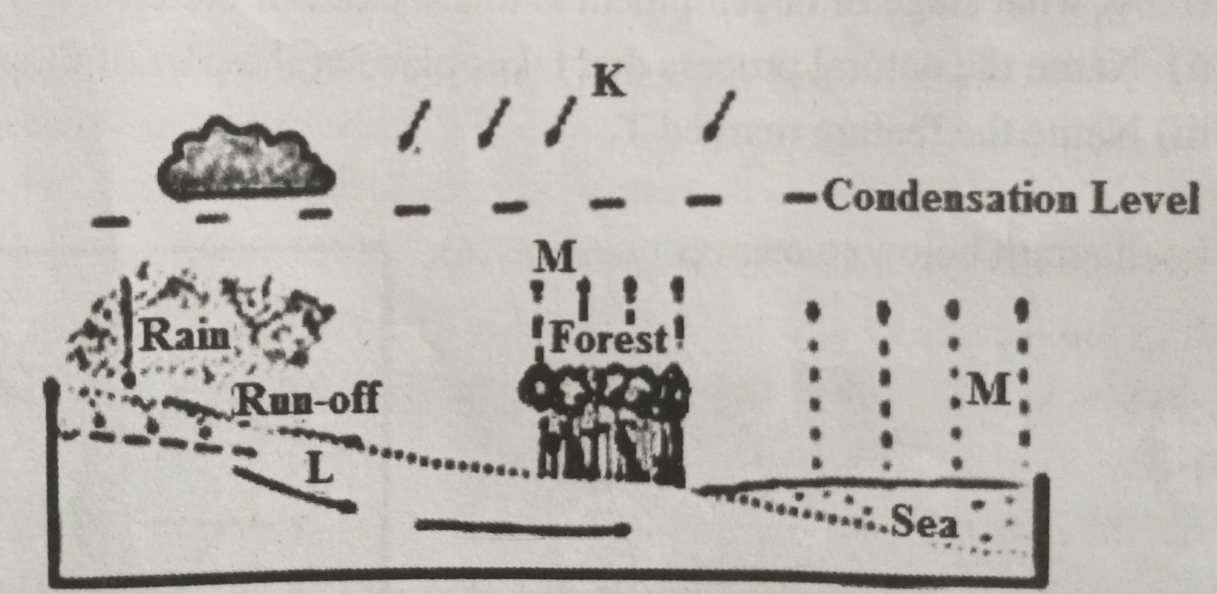

5.(a) Describe carbonation as a process of chemical weathering. (3 marks)
(b) State two reasons why there are few settlements in Karst landscape. (2 marks)

SECTION B
Answer Question 6 And Any Other Two Questions from This Section.
6. (a) Study the map of Mumias 1:50,000 (Sheet 101/2) provided and answer the following questions
i) What is the four-figure grid reference of Bumala dam. (2 marks)
(ii) Using the marginal information, give the magnetic variations of the area when the map extract was drawn. (2 marks)
(iii) What is the length in kilometers of River Lusimu from the bridge at grid square 6234 to the edge of the map, grid square 6631? (2 marks)
(b) The rectangle below represents the area in the map bound by Eastings 59 and 63 and Northings 28 and 33. Identify and name the features marked P, Q, R and S
(4 marks)
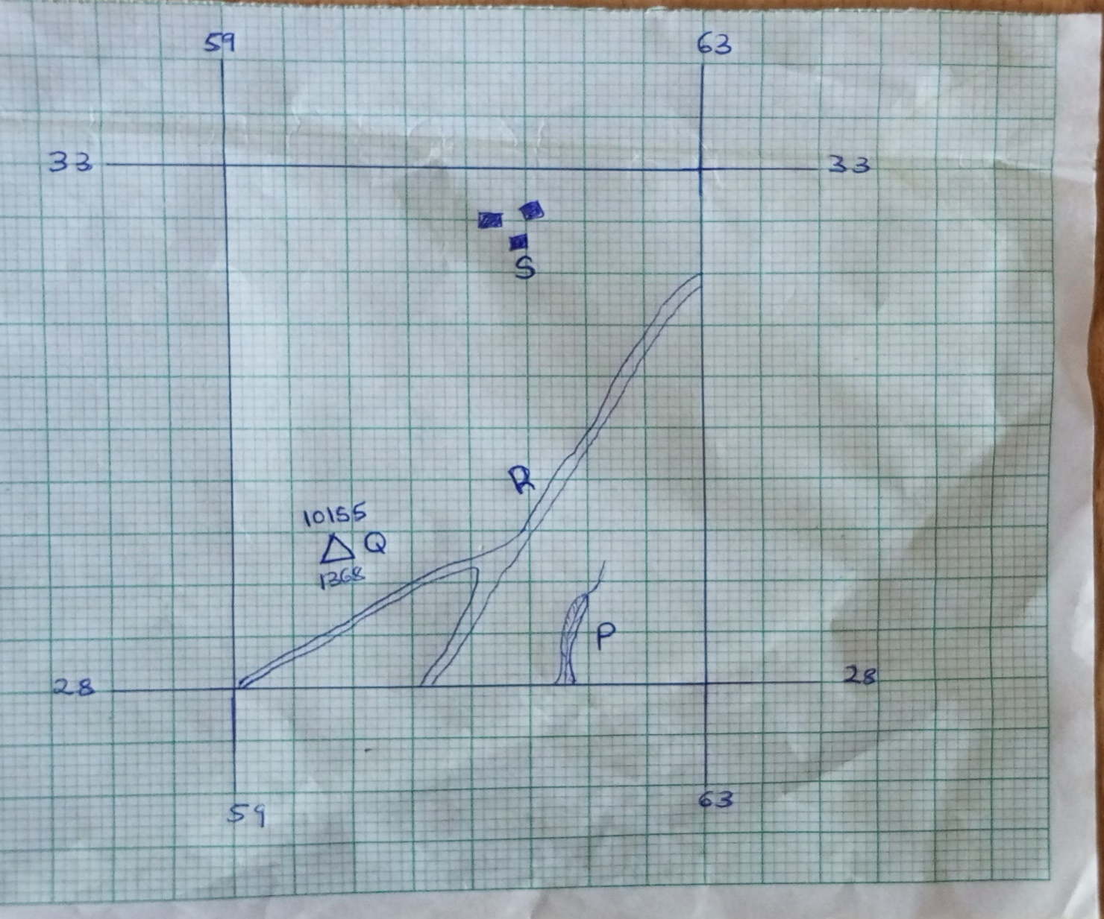
(c) i) Explain three factors which have influenced the distribution of settlement in the area covered by the map (6 marks)
(ii) Citing evidence from the map, give two economic activities carried out in the area covered by the map (4 marks)
(d) Describe the drainage of the area covered by the map. (5 marks)
7. (a) i) Give three examples of non-metallic minerals. (3 marks)
ii) Why is industrial diamond used in shaping hard stones and metals? (1 mark)
(b) i) Give two examples of hypabyssal igneous rocks. (2 marks)
ii) State two reasons why sedimentary rocks are wide spread in the coastal plain of Kenya. (2 marks)
(c) Describe the following processes of formation of metamorphic rocks:
- Thermal Metamorphism (4 marks)
- Dynamic Metamorphism (4 marks)
(d) Suppose you were to carry out a field study on rocks within the vicinity of your school.
- Name three secondary sources of information you would use for preparation of the study. (3 marks)
- State three activities you would carry out during the field study. (3 marks)
- State three problems you are likely to experience during the study (3 marks)
8. (a) Identify four theories put forward to explain the formation of fold mountains.
(4 marks)
(b) i) Apart from fold mountains, name three other features resulting from folding.
(3 marks)
(ii) With the aid of labelled diagrams, describe how fold mountains are formed.
(10 marks)
(c) Explain the significance of fold mountains to human activities. (8 marks)
9. (a) i) What is desertification? (2 marks)
ii) Name two examples of Greenhouse gases. (2 marks)
(b) Use the map below to answer questions (i) and (ii).
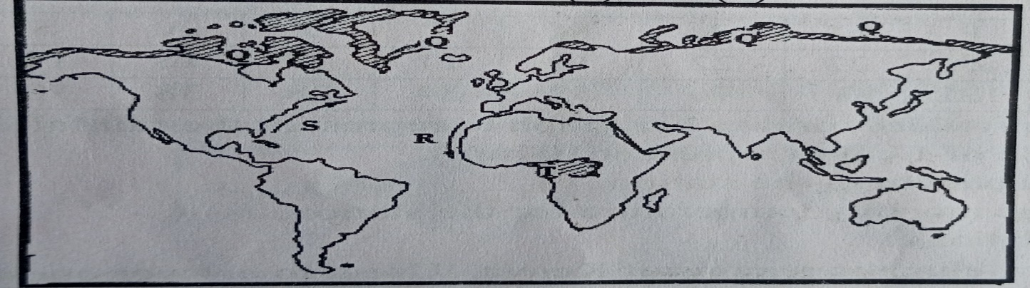

(i) Name:
- The type of climate in the shaded area marked Q (1 mark)
- The ocean currents marked R and S (2 marks)
(ii) Describe the characteristics of the type climate found in the shaded area marked T. (8 marks)
(c) Explain how the following factors influence climate:
- Altitude. (4 marks)
- Distance from the sea. (4 marks)
(d) Geography students from your school visited a weather station to study recording of weather elements.
(i) State two qualities of a Stevenson screen they would observe during the study. (2 marks)
10.(a) i) Name two sources of rivers. (2 marks)
ii)The diagram below shows the three stages of the long profile of a river
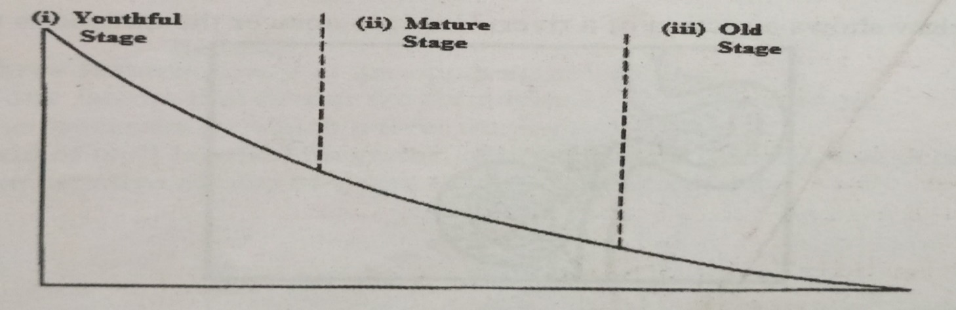
Give three features formed by the rivers in each of the three stages. (6marks)
(b) Using diagrams, describe the following drainage patterns
- Dendritic. (2 marks)
- Trellis. (2 marks)
- Centripetal. (2 marks)
(c) Describe how a river capture occurs. (6 marks)
(d) You are planning to carry out a field study on the lower course of a river
- Give three reasons why you would require a route map. (3 marks)
- What would be the advantages of dividing the class into groups? (2 marks)
THIS IS THE LAST PRINTED PAGE

