**THE HYDROLOGICAL CYCLE.**

**By Prof. Ogoti Robert Maxwell**

**Definition** –kcse 2017

- **Hydrological cycle** is the continuous movement of water from the air to the earth surface and back to the air.

**Processes of hydrological cycle.**

1. **Input process.**

* The main input process in hydrological cycle is **precipitation.**
* **Forms of precipitation are** rainfall, dew, mist, fog and snow.
* **Conditions for the formation of precipitation are;**
* Air must be saturated.
* Contain hygroscopic particles like dust, salt particles, pollen grains, gases and smoke.
* Air must cool below its dew point.

1. **Output processes.**

* The major output processes in hydrological cycle are;

1. Evaporation.

* It is the loss of water vapour from the earth surface/ open water surfaces into the atmosphere.
* The rate of evaporation depends on;
* **Availability of moisture at the surface of the earth (humidity)**. Wet surfaces result into higher rates of evaporation and vice versa.
* **Increase in temperature** leads to higher evaporation rate.
* **Wind** i.e. the higher the wind speed, the higher the evaporation rate and vice versa.
* **Sunshine duration**. Longer hours of sunshine increases the period of the process of evaporation and vice versa.
* **Characteristics of water**. Evaporation from sea/ salty water is less than evaporation from fresh water.

1. Transpiration.

* It is the loss of water vapour from vegetation/ plants to the atmosphere.
* Transpiration rate depends on;
* Time of the year. Transpiration rate is high during dry season.
* The type and the amount of vegetation cover in the region.

**NOTE: Evapotranspiration** is the loss of water vapour from both open water surfaces (sea/ ocean/ lake) and plants to the air.

1. **Internal transfer process.**

* It is the extensive movement of water which takes place in the atmosphere, land and oceans.
* It redistribute water so that the inputs and the outputs are kept in balance.
* The major internal transfer of the hydrological cycle includes;

1. **Interception.**

* It is the process by which the first rain drop of a storm will fall on trees or plants which shelter the underlying ground.
* When the rain persists, the water may reach the ground in the following ways;
* Through fall i.e. water flowing down the trunk of the vegetation before reaching the earth surface.
* Secondary interception i.e. water is temporarily stored on the vegetation by any undergrowth.

1. **Surface run-off/ overland flow.**

* This is the excess water flowing away over the earth surface which is incapable of absorbing all the rain after very heavy rainfall.
* The excess water flows over the earth surface into lakes, swamps, seas and rivers.

**Factors influencing the occurrence of surface run-off** –kcse 2017

* **The amount of rainfall.** There should be sufficient rainfall to make the soil saturated in order to allow excess water to flow on the earth surface.
* **The gradient of the land.** The gradient of the slope should be steep to allow flow of water by gravity.
* **The nature of the rock/ soil.** The rocks/ soils should be impermeable to allow for limited infiltration and percolation for the excess water to form surface run-off.
* **The water table.** The water table should be high to reduce infiltration and allow surface run-off.
* **Vegetation.** Absence of vegetation will increase the rate of run-off.
* **Human activity.** Construction of pavements or roads in built up areas prevent infiltration and arouse surface run-off.

1. **Infiltration.**

* It is the process by which rain water seeps into the ground vertically through the surface rocks like sandstones and limestones.
* It is the vertical seeping of water into the earth surface to the lower layers through pores/ joints/ cracks that are in rock.
* The speed at which water is absorbed into the soil through infiltration is called **infiltration capacity/ infiltration rate.**
* **Infiltration depends on;**
* The amount of water already in the soil.
* The porosity and the structure of the soil.
* The type of the soil.
* The amount and seasonal changes in the vegetation cover.

1. **Percolation.**

* It is the process by which water below the earth surface moves horizontally through the rocks.

1. **Storage process.**

* Once water is on the earth surface, it may be stored in many forms like;

1. **Surface water storage.**

* Rain water reaches rivers through rain falls, surface run-off, ice flow and springs.
* River water then flow towards surface storages like seas, oceans, lakes and swamps.

1. **Ground water storage.**

* This is the water that collects above an impermeable rock or fills all the pore spaces in rocks creating a zone of saturation.
* It is the zone that forms the water table.

1. **Cryosphere.**

* It refers to the water stored in the vast ice covered regions of the world.
* Water enters this storage through snow fall.

**Kcse 2014:** Give three processes in the hydrological cycle.

* Evaporation/ evapotranspiration/ moist air rising.
* Condensation/ moist air cooling.
* Infiltration/ percolation.
* Interception.
* Surface run off/ overland flow.
* Precipitation/ rainfall/ snow fall.

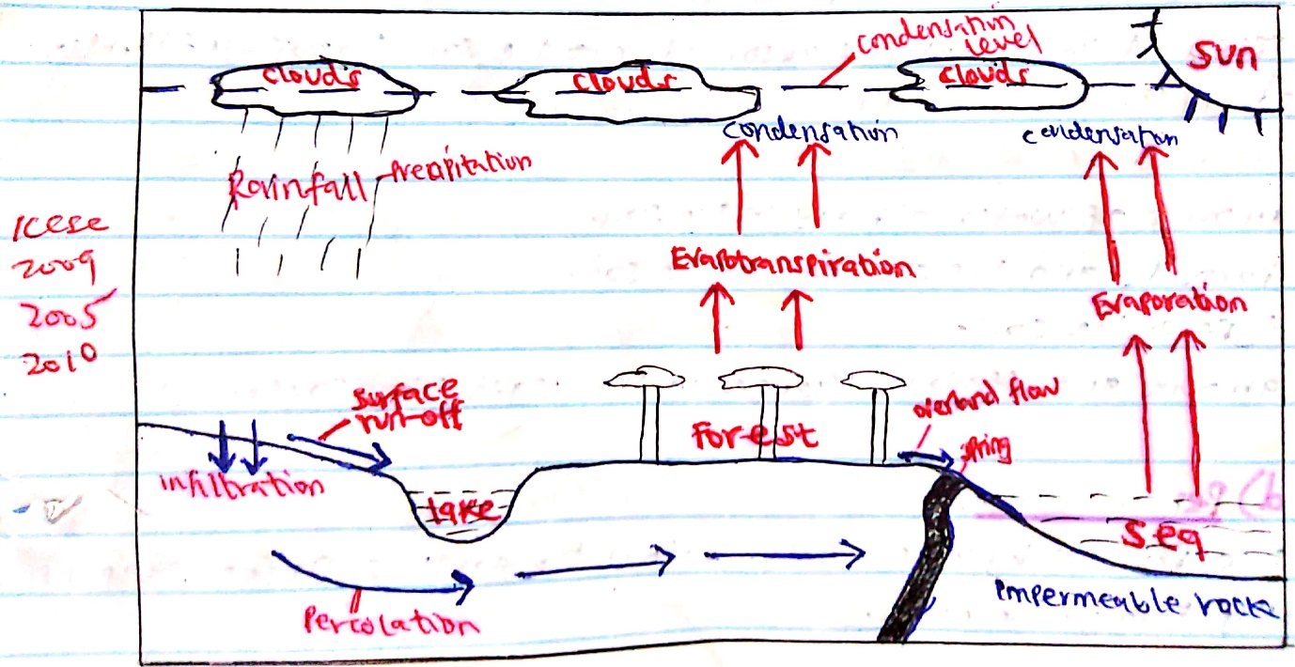

**Significance of the hydrological cycle** –kcse 2017

1. Evapotranspiration increases water in the atmosphere which forms rain that provide water for irrigation/ crop farming.
2. It helps to regulate the surface water/ underground water and water in the atmosphere.
3. It provides underground water through percolation.
4. Large rivers drain into oceans and lakes to form water bodies.
5. It controls the elements of weather such as temperatures, humidity and rainfall.
6. Water evaporates from the ground causing drying up of water bodies/ causes arid conditions.
7. Water vapour maintains heat energy in the atmosphere.
8. Moisture in the atmosphere influences solar/ terrestrial radiation.

……………………END…………………….