NAME………………………….………………………….…………STREAM ………………
ADM NO.….…………………. SIGNATURE ……………………
SCHOOL:……………………………………………………………………………………………….
232/2: PHYSICS
FORM 4 2023
PAPER 2 (THEORY)
TIME: 2 HOURS

FORM 4 PREMOCK TERM2-2023
THE SUB-ROYAL PHYSICS JOINT EXAMINATION
Kenya Certificate of Secondary Education.
INSTRUCTIONS CANDIDATES
- This paper consists of two sections A and B.
- Answer all the questions in the two sections in the spaces provided after each question
- All working must be clearly shown.
- Electronic calculators, mathematical tables may be used.
- All numerical answers should be expressed in the decimal notations.
- This paper consists of 14 printed pages and check to ensure all the pages are there.
FOR EXAMINER’S USE ONLY
SECTION | QUESTION | MAX MARKS | CANDIDATE’S SCORE
A | 1 – 11 | 25
B | 12 | 08
B | 13 | 10
B | 14 | 06
B | 15 | 07
B | 16 | 08
B | 17 | 09
B | 18 | 08
TOTAL |  | 80
This paper consists of 14 printed pages. Students should check to ensure that all pages are printed as indicated and that no questions are missing.

SECTION A (25 MARKS)
Answer ALL questions in the space provided
1.(a)Two identical metal spheres A and B each standing on an insulating base are in contact. A negatively charged rod is brought near sphere A as shown in figure below. In what way will sphere A differs from B if it is separated while the rod is near? (1mark)
Fig 1
…………………………………………………………………………………………………………………………………………………………………………………………………………………………………………………………………………………………………………………………………………………………………………………….…………………
(b) A positively charged sphere is suspended by an insulating thread. A negatively charged conductor is suspended near it. The conductor is first attracted, after touching the sphere, it is repelled. Explain this observation. (2marks)
…………………………………………………………………………………………………………………………………………………………………………………………………………………………………………………………………………………………………………………………………………………………………………………………………………………………………………………………………………………………………………………………………………
2. State two advantages of an alkaline battery over a lead acid battery. (2marks)
…………………………………………………………………………………………………………………………………………………………………………………………………………………………………………………………………………………………………………………………………………………………………………………….…………………
3. Explain why the conductivity of a metallic conductor decreases with increase in temperature while that of an intrinsic semiconductor increases with increase in temperature. (2marks)
…………………………………………………………………………………………………………………………………………………………………………………………………………………………………………………………………………………………………………………………………………………………………………………….…………………
4. State one reason why convex mirrors are used as driving mirrors. (1 mark)
……………………………………………………………………………………………………………………………………………………………………………………………………………………………………………………………………

5. How much current is taken by a bulb rated 100w, 250V. (2 marks)
…………………………………………………………………………………………………………………………………………………………………………………………………………………………………………………………………………………………………………………………………………………………………………………….…………………

6. Figure 2 shows a relationship between potential difference V and the charge Q across and stored in a capacitor.

Fig 2

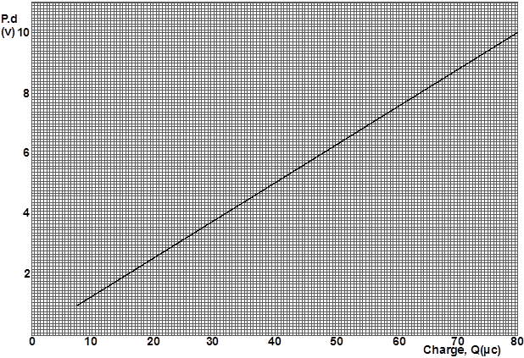

Determine the capacitance C of the capacitor. (3 marks)
…………………………………………………………………………………………………………………………………………………………………………………………………………………………………………………………………………………………………………………………………………………………………………………….…………………
…………………………………………………………………………………………………………………………………………………………………………………………………………………………………………………………………………………………………………………………………………………………………………………….…………………

7. Uranium -234 undergoes a radioactive decay represented by the equation shown below.

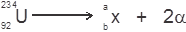

Find the value of a and b (2 marks)
…………………………………………………………………………………………………………………………………………………………………………………………………………………………………………………………………………………………………………………………………………………………………………………….…………………

8. State two modifications that can be done to a pinhole camera in order to be used to fake still photographs. (2 marks)
…………………………………………………………………………………………………………………………………………………………………………………………………………………………………………………………………………………………………………………………………………………………………………………….…………………

9. The figure below shows part of an electric circuit. The charge stored in the 9μF capacitor is 1.4 micro coulombs (μC)
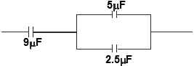

Fig. 3

Determine the p.d across the 5μF capacitor. (3marks)
…………………………………………………………………………………………………………………………………………………………………………………………………………………………………………………………………………………………………………………………………………………………………………………….…………………
……………………………………………………………………………………………………………………………………………………………………………………………………………………………………………………………………

10. A coin is placed at the bottom of a beaker filled with water to a height of 2.4cm as shown in the figure below. Given that the refractive index of water is 1.33, determine the apparent depth of the coin. (3marks)
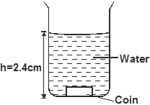
(3 marks)

Fig. 4

……………………………………………………………………………………………………………………………………………………………………………………………………………………………………………………………………………………………………………………………………………………………………………………………………………………………………………………………………………………………………………………….…………………
……………………………………………………………………………………………………………….…………………
……………………………………………………………………………………………………………………………………………………………………………………………………………………………………………………………………

11. Figure 5a and figure 5b shows a P-N junction connected to a battery. It is observed that the current in figure 5a is greater than the current in figure 5b

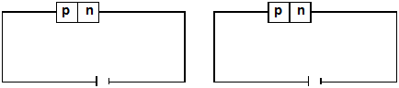

Fig 5a Fig 5b

Explain the observation. (2 marks)

…………………………………………………………………………………………………………………………………………………………………………………………………………………………………………………………………………………………………………………………………………………………………………………….…………………
…………………………………………………………………………………………………………………………………

SECTION B (55 MARKS)
Answer ALL questions in the space provided

12.(a) Figure 6 shows a loudspeaker producing sound waves in air.

Fig 6
(i)Explain how compression and rarefactions are formed. (2 marks)
……………………………………………………………………………………………………………………………………………………………………………………………………………………………............…………………………………………………………………………………………………………………………………………………………………………………………………………………………………………………………………………….……………………………………………
(ii)Show on the diagram the wavelength of the wave. (1 mark)

- In an experiment to observe interference of light waves a double slit placed close to the source as shown in figure 7 below
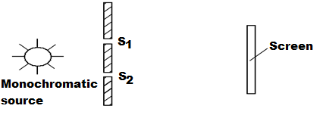
Fig 7

  - What is monochromatic source (1 mark) ……………………………………………………………………………………………………………………………………………………………………………………………………………………………………………………………………
  - State the function of the double slit. (1 mark)
………………………………………………………………………………………………………………………………………………………………………………………………………………………………………………………………………………

  - Briefly describe what is observed on the screen. (1 mark)
……………………………………………………………………………………………………………………………………………………………………………………………………………………….………………………………………………………
- Briefly explain what is observed on the screen when
- The slit separation S₁S₂ is reduced (1 mark)
……………………………………………………………………………………………………………………………………………………………………………………………………………………………………………………………………………………………………………………………………………………………………………………………………………………....
- White light source is used in place of monochromatic source. (1 mark)
………………………………………………………………………………………………………………………………………
………………………………………………………………………………………………………………………………………
…………………………………………………………………………………………………………………….…………………
13.a) Use figure 7 below to answer the question that follow;

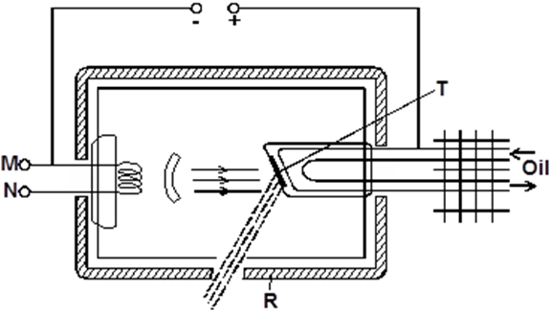
Fig 7

(i)target T is made of a material of high melting point. Give a reason for this. (1 mark)
……………………………………………………………………………………………………………………………………………………………………………………………………………………………………………………….…………………
(ii)State one reason why oil is used for cooling instead of water. (1mark)
………………………………………………………………………………………………………………………………………
………………………………………………………………………………………………………………………………………
…………………………………………………………………………………………………………………….…………………
iii) What property does the material marked R have that makes it suitable for shielding. (1 mark)
………………………………………………………………………………………………………………………………………
………………………………………………………………………………………………………………………………………
iv) How can the intensity of x-rays produced be increased. (1 mark)
………………………………………………………………………………………………………………………………………
………………………………………………………………………………………………………………………………………
b)Figure 8 below shows the main components of a cathode ray oscilloscope.

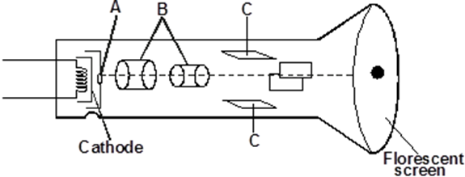

Fig 8

(i)Name the parts labelled A and B. (2 marks)
………………………………………………………………………………………………………………………………………………………………………………………………………………………………………………….…………………
ii) What is the function of parts labelled C. (1 mark)
…………………………………………………………………………………………………………………………………
……………………………………………………………………………………………………………….…………………
iii) Explain how elections are produced. (1 mark)
…………………………………………………………………………………………………………………………………
……………………………………………………………………………………………………………….…………………
iv) Give a reason why the tube is evacuated. (1 mark)
………………………………………………………………………………………………………………………………………………………………………………………………………………………………………………….…………………

14. a)i) In a consumer fuse box in domestic wiring, use of circuit breakers is preferred to fuses. State one advantage of using a circuit breaker over a fuse. (1 mark)
…………………………………………………………………………………………………………………………………………………………………………………………………………………………………………………………………………………………………………………………………………………………………………………….…………………
ii) A house is supplied with 240V from a power source which is fitted with a 13A fuse. What is the maximum number of 75w bulbs that can be fitted in the house. (2 marks)
…………………………………………………………………………………………………………………………………………………………………………………………………………………………………………………………………………………………………………………………………………………………………………………….…………………
b)Figure 9 shows two circuits close to each other.
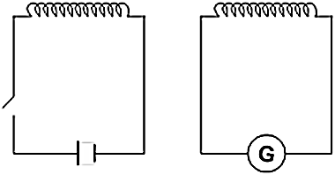
Fig 9

When the switch is closed, the galvanometer shows a reading and then returns to zero.
When the switch is then opened, the galvanometer shows a reading in the opposite
direction and then returns to zero. Explain this observation. (2 marks)
…………………………………………………………………………………………………………………………………………………………………………………………………………………………………………………………………………………………………………………………………………………………………………………….…………………
…………………………………………………………………………………………………………………………………………………………………………………………………………………………………………………………………………………………………………………………………………………………………………………….…………………
b) Explain how energy losses in a transformer are reduced by having a soft-iron core. (1 mark)
…………………………………………………………………………………………………………………………………………………………………………………………………………………………………………………………………………………………………………………………………………………………………………………….…………………

15.a) Complete the ray diagram in figure 10 below so as to form an image. (3 marks)
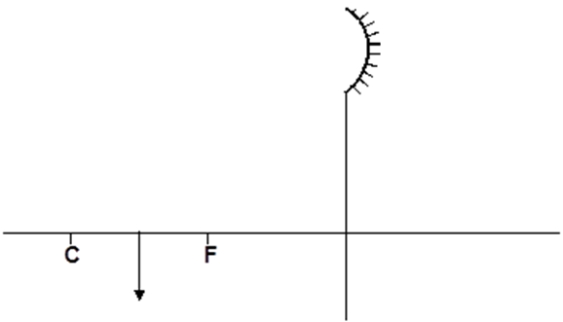

Fig 10

b)i) A ray of light is incident on a glass-water interface as shown in figure 11 below.
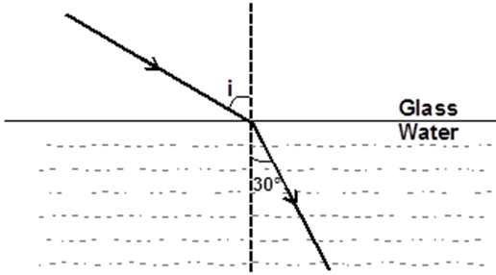

Fig 11

Calculate the angle of incidence i. (Take the refractive index of glass and water ³/₂ and ⁴/₃ respectively. (3 marks)
…………………………………………………………………………………………………………………………………………………………………………………………………………………………………………………………………………………………………………………………………………………………………………………….…………………
………………………………………………………………………………………………………………………………………………………………………………………………………………………………………………….…………………
ii) State one application of total internal reflection. (1 mark)
……………………………………………………………………………………………………………………………………………………………………………………………………………………………………………………………………

16. a)State the property of radiation that determines the number of electrons emitted when the radiation falls on a metal surface. (1 mark)
………………………………………………………………………………………………………………………………………………………………………………………………………………………………………………….…………………
b) The graph below is a variation of stopping potential, V_{s}, against frequency, f, in an experiment on photoelectric effect.
Fig. 12 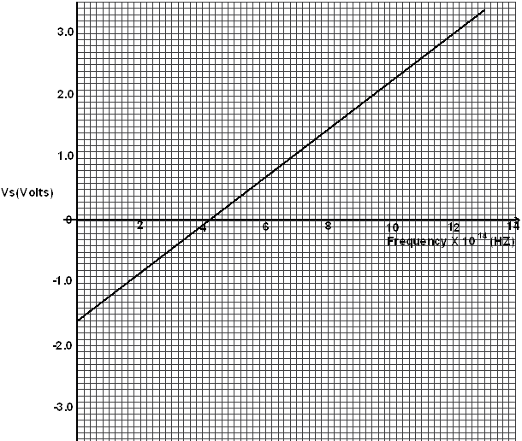
i) Explain what is meant by stopping potential. (1 mark)
………………………………………………………………………………………………………………………………………………………………………………………………………………………………………………….…………………

ii) Given that the stopping potential V_{s} is related to the frequency by the equation
V_{s} = h f - W_{o} where e is the charge of an electron. Determine the plank’s constant h. (e = 1.6 x 10⁻¹⁹C) (3 marks)
…………………………………………………………………………………………………………………………………………………………………………………………………………………………………………………………………………………………………………………………………………………………………………………….…………………
…………………………………………………………………………………………………………………………………………………………………………………………………………………………………………………………………………………………………………………………………………………………………………………….…………………
…………………………………………………………………………………………………………………………………
iii) From the graph determine the work function w_{o} for the metal in electron volts (eV) (3 marks)
…………………………………………………………………………………………………………………………………………………………………………………………………………………………………………………………………………………………………………………………………………………………………………………….…………………
…………………………………………………………………………………………………………………………………………………………………………………………………………………………………………………………………………………………………………………………………………………………………………………….…………………
17. a) Diagram below represents a metre bridge used to determine the resistance of an electrical component, X.
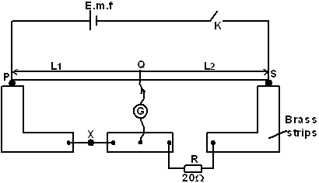

Fig. 13

From the diagram,
i) Explain why wide brass strips are used as terminals. (1 mark)
…………………………………………………………………………………………………………………………………
……………………………………………………………………………………………………………….…………………

ii) Explain why a cell of low e.m.f is preferable. (1 mark)
………………………………………………………………………………………………………………………………………………………………………………………………………………………………………………….…………………
iii) If null deflection was obtained when l₁ was 60.0cm. Calculate the resistance of component marked X. (2 marks)
…………………………………………………………………………………………………………………………………………………………………………………………………………………………………………………………………………………………………………………………………………………………………………………….…………………
…………………………………………………………………………………………………………………………………
iv) State two ways of ensuring that the error is minimized. (2 marks)
…………………………………………………………………………………………………………………………………………………………………………………………………………………………………………………………………………………………………………………………………………………………………………………….…………………
…………………………………………………………………………………………………………………………………
b)A uniform resistance wire of length 2.0m conducts a current of 0.25A when connected in series with a cell of e.m.f of 1.6V. How much current would be conducted if the wire is now cut into 2 equal lengths which are then arranged in parallel. (3 marks)
…………………………………………………………………………………………………………………………………………………………………………………………………………………………………………………………………………………………………………………………………………………………………………………….…………………
…………………………………………………………………………………………………………………………………………………………………………………………………………………………………………………………………………………………………………………………………………………………………………………….…………………
……………………………………………………………………………………………………………………………………………………………………………………………………………………………………………………………………
18. a) The diagram below is a section of a house wiring system.
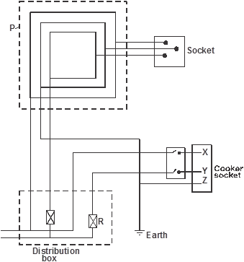

Fig. 14
Name:
i) Circuit labelled P (1 mark)
…………………………………………………………………………………………………………………………………
ii) Terminals labelled X and Y (2marks)
………………………………………………………………………………………………………………………………………
……………….………………………………………………………………………………………………………………………
iii) Why is the earthing necessary in such a circuit? (1 mark)
………………………………………………………………………………………………………………………………………
b)The cost of electricity per kilowatt hour- kWh is Ksh.8, determineshow much a household running a device rated 1500W continuously for 1.08 x 10⁵ seconds, would pay. (2 marks)
………………………………………………………………………………………………………………………………………
………………………………………………………………………………………………………………………………………
………………………………………………………………………………………………………………………………………
c) Explain reason for transmission of electrical power over along distance at very high voltage. (1 mark)
………………………………………………………………………………………………………………………………………..
…………………………………………………………………………………………………………………….…………………
d) Explain why for transmission of electrical power over long distance, alternating current (a.c) is preferred to a direct current (d.c) (1 mark)
………………………………………………………………………………………………………………………………………
………………………………………………………………………………………………………………………………………

END

