NAME………………………….………………………….…………STREAM ………………
ADM NO.….…………………. SIGNATURE ……………………
SCHOOL:……………………………………………………………………………………………….
232/1: PHYSICS
FORM 4 2023
PAPER 1
TIME: 2 HOURS

FORM 4 PREMOCK TERM2-2023
SUB-ROYAL PHYSICS JOINT EXAMINATION
Kenya Certificate of Secondary Education.
INSTRUCTIONS TO STUDENTS
- This paper consists of two sections A and B.
- Answer all the questions in the two sections in the spaces provided after each question
- All working must be clearly shown.
- Electronic calculators, mathematical tables may be used.
- All numerical answers should be expressed in the decimal notations.
- This paper consists of 14 printed pages and check to ensure all the pages are there.
FOR EXAMINER’S USE ONLY
SECTION | QUESTION | MAX MARKS | STUDENT’S SCORE
A | 1 – 14 | 25
B | 15 | 10
B | 16 | 09
B | 17 | 06
 | 18 | 09
 | 19 | 10
 | 20 | 12
TOTAL |  | 80

This paper consists of 12 printed pages. Students should check to ensure that all pages are printed as indicated and that no questions are missing.

SECTION A (25 MARKS)
Answer ALL questions in the space provided
1. The water level in a burette is 30.6cm³, 50 drops of water each of volume 0.2cm³ are added to the water in the burette. What is the final reading of the burette. (2 marks)

………………………………………………………………………………………………………………………………………………………………………………………………………………………………………………………………………………………………………………………
2. Figure 1 shows a graph showing the behaviour of a helical spring.

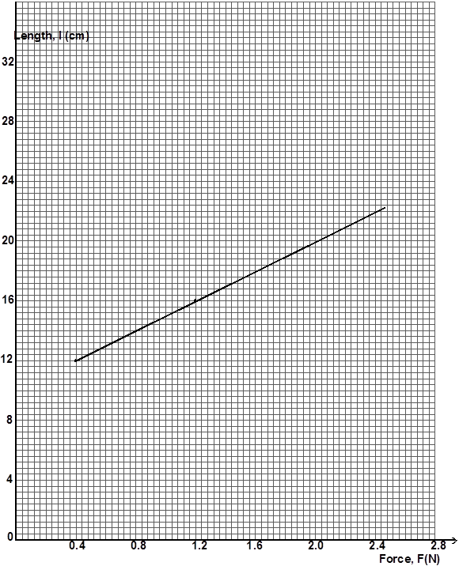
Fig 1

Determine the spring constant in SI units (3 marks)
………………………………………………………………………………………………………………………………………………………………………………………………………………………………………………………………………………………………………………………………………………………………

3. Figure 2 shows a uniform bar of weight 5N and length 1.1m pivoted at a point and in equilibrium under the action of the forces shown.
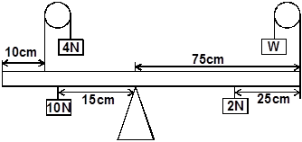
Fig 2

Determine the value of weight W. (3 marks)
…………………………………………………………………………………………………………………………
…………………………………………………………………………………………………………………………
…………………………………………………………………………………………………………………………
…………………………………………………………………………………………………………………………
…………………………………………………………………………………………………………………………
4. State the contribution physics has made to the entertainment industry. (1 mark)
…………………………………………………………………………………………………………………………
…………………………………………………………………………………………………………………………
5. State one limitation of the micrometer screw gauge. (1 mark)
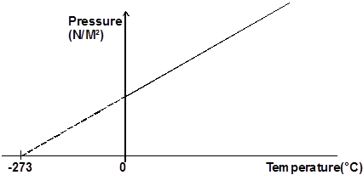

6.

Fig 3

State the law represented in figure 4. (1 mark)
…………………………………………………………………………………………………………………………
7. Alcohol was placed in a flask fitted with an air tight cork as shown in figure 4.

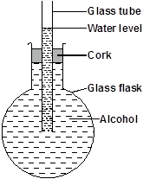

Fig 4

State and explain what would be observed if the flask was cooled. (3 marks)
…………………………………………………………………………………………………………………………
…………………………………………………………………………………………………………………………
…………………………………………………………………………………………………………………………
…………………………………………………………………………………………………………………………
…………………………………………………………………………………………………………………………
…………………………………………………………………………………………………………………………

8. Explain how the propellers on top of a helicopter help in lifting the helicopter above the ground. (2 marks)
…………………………………………………………………………………………………………………………
…………………………………………………………………………………………………………………………
…………………………………………………………………………………………………………………………

9. State the SI unit of momentum. (1 mark)
…………………………………………………………………………………………………………………………
10.(a) Define surface tension, (1mk)
…………………………………………………………………………………………………………………………
…………………………………………………………………………………………………………………………
…………………………………………………………………………………………………………………………
…………………………………………………………………………………………………………………………
(b) State ONE factor that increases surface tension of a pure liquid. (1mk)
……………………………………………..………………………………………………………………………….
11.In an experiment to demonstrate Brownian motion, smoke was placed in a smoke cell and observed using a microscope. The smoke particles were seen moving randomly in the cell. Explain this observation. (2mks)
………………………………………………………………………………………………………………………………………………………………………………………………………………………………………………………………………………………………………………………………………………………………………………
12.A pipe of radius 6mm is connected to another pipe of radius 9mm. If water flows in the wider pipe at the speed of 2ms⁻¹. What is the speed in the narrow pipe? (2mks)
…………………………………………………………………………………………………………………………………………………………………………………………………………………………………………………………………………………………………………………………………………………………………………………………………………………………………………………………………………………………………………
13.State the law of conservation of energy. (1mk)
………………………………………………………………………………………………………………………………………………………………………………………………………………………………………………………………………………………………………………………………………………………………………………
14.State ONE reason why mercury is preferred as a barometric liquid and not water (1mk)
………………………………………………………………………………………………………………………………………………………………………………………………………………………………………………………………………………………………………………………………………………………………………………

SECTION B (55 MARKS)
Answer ALL questions in the space provided

15a) Karen wants to pump up her car tyre. Her pump has a piston with an area of 7 cm².
Fig 5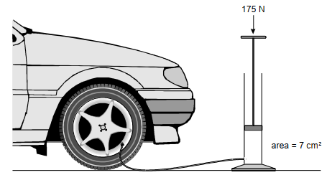

Karen pushes the handle down with a force of 175 N.
(a) What pressure does she exert on the air in the pump? (3mks)
………………………………………………………………………………………………………………………………………………………………………………………………………………………………………………………………………………………………………………………………………………………………………………
(b) What pressure would be exerted in the tyre by the pump (1mk)
...............................................................................................................................................................................................................................................................................................................................................
(c) One of the Karen’s car tyres exerts a pressure of 25 N/cm² on the road. The area of the tyre in contact with the road is 95 cm².What is the force exerted by four tyres on the road? (3mks)
..............................................................................................................................................................................................................................................................................................................................................................................................................................................................................................................................
d) State three properties of hydraulic brake fluids. (3mks)
………………………………………………………………………………………………………………………………………………………………………………………………………………………………………………………………………………………………………………………………………………………………………………
16. a)i) State Archimede's principle. (1 mark)
………………………………………………………………………………………………………………………………………………………………………………………………………………………………………………………………………………………………………………………………………………………………………………
ii) Figure 6 shows a buoy, M, of volume 120 litres and mass 60kg. It is held in position in sea water of density 1.04g/cm³ by a light cable fixed to the bottom so that ¾ of the volume of the buoy is below the surface of the sea water.
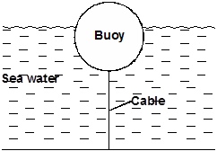

Fig 6
Determine the tension T in the cable. (4 marks)
………………………………………………………………………………………………………………………………………………………………………………………………………………………………………………………………………………………………………………………………………………………………………………
………………………………………………………………………………………………………………………………………………………………………………………………………………………………………………………………………………………………………………………………………………………………………………

b) i) During cold season boys looking after cattle lit a fire in a Kimbo tin and whirl it round vertically without its contents falling out. Explain. (1 mark)
………………………………………………………………………………………………………………………………………………………………………………………………………………………………………………………………………………………………………………………………………………………………………………
ii) A particle is moving in a circular path of radius 0.4m with velocity of 7.5m/s. Determine its angular velocity. (3 marks)
……………………………………………………………………………………………………………………………………………………………………………………………………………………………………………………………………………………………………………………………………………………………………………
………………………………………………………………………………………………………………………………………………………………………………………………………………………………………………………………………………………………………………………………………………………………………………

17.Figure 7(a) and 6(b) show the readings of a micrometer screw gauge before and after a drop of oil are placed at the jaws.
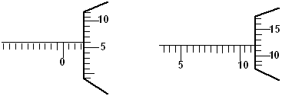

Fig. 7(a)(a) Fig. 6(b)
When the drop was made to fall on a shallow tray having water whose surface was sprinkled with lycopodium powder, it spread on the surface to form a patch of area Acm². Given that the size of one molecule of oil is 3 x 10⁻⁶cm.

a) Determine:
I. The diameter of the one drop of oil (2 marks)
………………………………………………………………………………………………………………………………………………………………………………………………………………………………………………………………………………………………………………………………………………………………………………
II.The area of the patch A (2 marks)
………………………………………………………………………………………………………………………………………………………………………………………………………………………………………………………………………………………………………………………………………………………………………………
b) State one assumption made in this experiment. (1 mark)
……………………………………………………………………………………………………………………………………………………………………………………………………………………………………………………
18.a) Define the terms ‘frequency’ as used in uniform circular motion(1 mark)
……………………………………………………………………………………………………………………………………………………………………………………………………………………………………………………
b) Figure 8 below shows a turn table, centre O with a mass of 30g at a distance of 6cm from the centre.
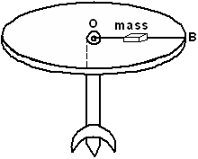

Fig. 8
- Determine the normal reaction between the 30g mass and the table. (2marks)
………………………………………………………………………………………………………………………………………………………………………………………………………………………………………………………………………………………………………………………………………………………………………

ii) The 30g mass just slides off the table when the turn table rotates at a frequency of 1 revolution per second. Determine:
- The angular velocity. (2 marks)
………………………………………………………………………………………………………………………………………………………………………………………………………………………………………………………………………………………………………………………………………………………………
II. The coefficient of friction between the 30g mass and the table. (3 marks)
………………………………………………………………………………………………………………………………………………………………………………………………………………………………………………………………………………………………………………………………………………………………………
iii) Oil is poured on the table and the table is made to rotate at the same frequency of 1 revolution per second. On the figure, mark a point P along line OB where the 30g mass will just slide off. (1 mark)
………………………………………………………………………………………………………………………………………………………………………………………………………………………………………………
19.(a) Define the term specific latent heat of vaporization of a substance. . (1mk)
……………………………………………………………………………………………………………………………………………………………………………………………………………………………………………………
(b) An electric kettle rated 2.5kW is used to raise the temperature of 3.0kg of water through 50ºC. Calculate the time required to effect this.
( specific heat capacity of water is 4200J⁻¹kg⁻¹K⁻¹ ) (3mks)
………………………………………………………………………………………………………………………………………………………………………………………………………………………………………………………………………………………………………………………………………………………………………………………………………………………………………………………………………………………………
…………………………………………………………………………………………………………………………
(c) The figure below shows features of a refrigerator.
Fig 9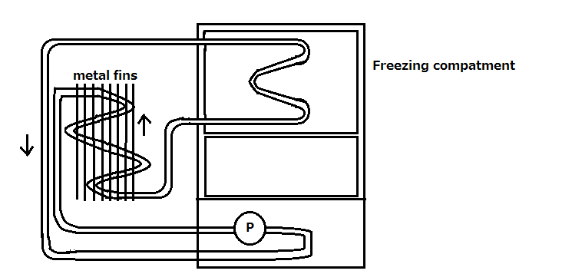
(i) Give the name of the refrigerant commonly used in refrigerators. (1mk)
…………………………………………………………………………………………………………………………
(ii) What is the function of the copper fins at the back of the refrigerators (1mk)
………………………………………………………………………………………………………………………………………………………………………………………………………………………………………………
(iii) Explain briefly how cooling takes place in the refrigerator. (2mks)
………………………………………………………………………………………………………………………………………………………………………………………………………………………………………………………………………………………………………………………………………………………………………………………………………………………………………………………………………………………………………………………………………………………………………………………………………………………………………………………………………………………………………………………………………………
(iv) Why should the fridge be placed some distance away from the wall. (1mk)
…………………………………………………………………………………………………………………………………………………………………………………………………………………………………………………..
(v) What is the purpose of the double wall? (1mk)
……………………………………………………………………………………………………………………………………………………………………………………………………………………………………………………
20.(a) A machine is a device that enables work to be done easily and conveniently. State any ONE way in which a machine makes work easier. (1mk)
..................................................................................................................................................................................................................................................................................................................................................
(b) The figure below shows a wheel and axle used to raise a load W by applying an effort E. The radius of the wheel is R and of the axle is r.
Fig 10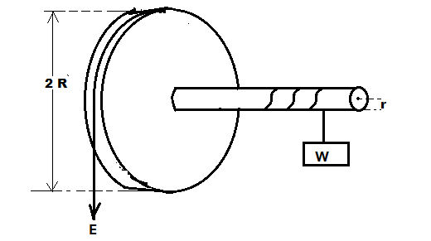

(i) Show that the velocity ratio (V.R) of the machine is given by $\frac{R}{r}$ . (3mks)
…………………………………………………………………………………………………………………………………………………………………………………………………………………………………………………………………………………………………………………………………………………………………………………………………………………………………………………………………………………………………………

(ii) Given r = 5cm, R = 50cm, determine the effort required to raise a load of 200N if the efficiency is 90%. (3mks)
……………………………………………………………………………………………………………………………………………………………………………………………………………………………………………………………………………………………………………………………………………………………………………………………………………………………………………………………………………………………………………
(iii) It is observed that the efficiency of the machine increases when it is used to lift large loads. Give a reason for this. (1mk)
……………………………………………………………………………………………………………………………………………………………………………………………………………………………………………………………………………………………………….
(iv) State TWO reasons why the efficiency of a machine is always less than 100%. . (2mks)
………………………………………………………………………………………………………………………………………………………………………………………………………………………………………………………………………………………………………………………………………………………………………………………………………………………………………………………………………………………………
(c) On the axes provided sketch a graph of mechanical advantage (M.A) against Load, L for a machine. (2mks)
Fig 11 