**[17.0.0 Support and Movement in Plants and Animals (39 Lessons)](http://www.elimu.net/Secondary/Kenya/KCSE_Student/Biology/Form4/Support/Support.htm)**

1.The diagram below represents a mammalian bone.

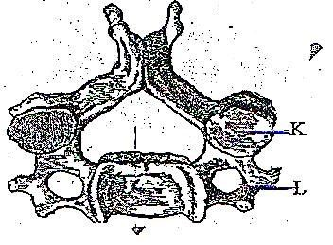

* 1. State the function of the part labeled K and L (2mark)
  2. State the region of the body in which the above bone is found. (1 mark)

2. (a) Name the hard body covering found in organisms of the phylum arthropoda. (1mk)

(b) Give **two** uses of the structure mentioned in (a) above. (2mks)

|  |  |  |  |  |
| --- | --- | --- | --- | --- |
| 3. Below is a diagram showing the forearm bones and muscles covering them? |  |  |  |  |

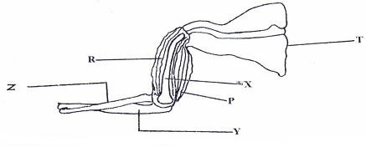

|  |  |  |  |  |  |  |  |
| --- | --- | --- | --- | --- | --- | --- | --- |
| (a) Name the bones represented by **T**, **X**, **Y** and **Z**. (b) Name the joint formed between: |  |  |  |  |  |  | (2mks) |
| (i) **T** and **X**. |  |  |  |  |  |  | (1mk) |
| (ii) **Y** and **X**. |  |  |  |  |  |  | (1mk) |
| (c) Name the muscles labelled **P** and **R**. |  |  |  |  |  |  | (1mk) |
| (d) What happens to each muscle as the arm is straightened. |  |  |  |  |  |  | (1mk) |
| (e) Name **two** strengthening tissues in woody stems. |  |  |  |  |  |  | (2mks) |

4. The diagram below represents a bone of a mammal.

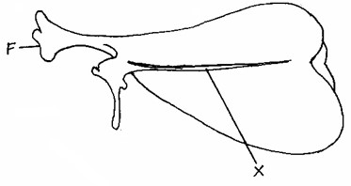

* 1. Identify the bone. (1 mark)
  2. Name the part marked **X**. (1 mark)
  3. Name the bone that articulates at the part labelled **F**. (1 mark)
  4. Explain one way in which the bone is adapted to its function. (1 mark)

5. The diagram below shows a joint in a mammal. Study it and answer the questions.

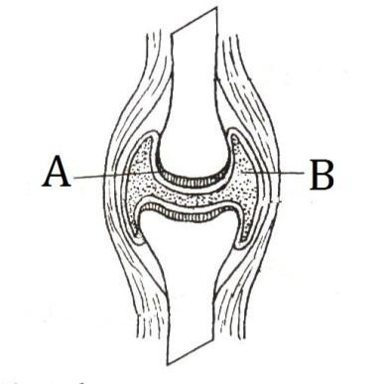

* 1. State the functions of parts A and B (2marks)
  2. Name the type of joint illustrated by the diagram (1mark)
  3. State **two** adaptations of joint named in (b) Above (2marks)

6. Name two structures in herbaceous stems that enhance their support. (2mk)

7. The diagram below represents a bone obtained from the hind limb of a goat.

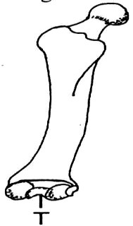

* 1. Identify the bone. (1mk)
  2. Name the type of joint formed at the part labelled T. (1mk)

|  |  |
| --- | --- |
| 8. Explain how the following tissues are adapted to provide mechanical support in plants.  (a) Collenchyma | (1mk) |
| (b) Sclerenchyma | (1mk) |

9. State the role of intervertebral discs (1 mark)

10. State **three** structural differences between biceps muscles and muscles of the gut (3marks)

11. What are the functions of the odontoid process found on the axis bone of the cervical vertebra?(2mks)

12**. Explain** the adaptations of thoracic, cervical and lumbar vertebrae to their functions (12 marks)

13. a. Name two bones that form the pectoral girdle. 2mks

b. Name the cavity formed by the scapula that form a joint with the humerous. 1mk

14. The diagram below represent a mammalian bone.

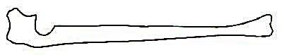

* 1. Name the bone.
  2. i) Which bone articulate with the bone shown in the diagram at the notch ? (1 mark)

ii) Name the type of joint formed when the bone in b(i) articulate. (1mark)

15. a**)** Name two supporting tissues in plants. (2 marks)

1. Study the diagram below and answer the question that follows.

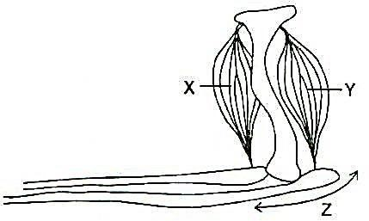

i) Identify the muscle represented by X and Y. (2 marks)

ii) Describe how muscle X and Y cause straightening of joint Z. (2 marks)

c. Name joint **Z. (**1mark)

16. The figures below illustrate specialized cells in an animal body.

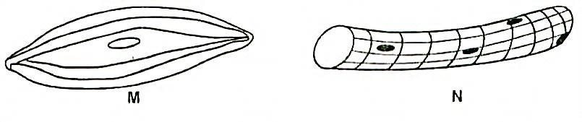

* 1. Identify the cell M and N. (2marks)
  2. State the structural differences between M and N (2marks)
  3. Which of the above specialized cells is found in the gut. (1mark)

17. The diagram below shows the bones and two of the muscles in the human arm

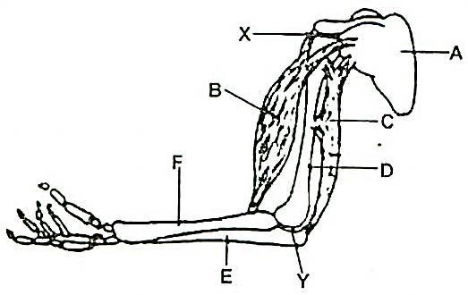

1. Name the parts A, C, E and F. (4marks)
2. i) Name the type of joint present in part X and Y (2marks)

ii) What type of movement is possible at point X. (1marks)

c) What happens when the muscle labelled C contracts. (1mark)

18. State the importance of support in plants. (3marks)

19. The diagram below represents a human arm. Study it and answer the questions that follow.

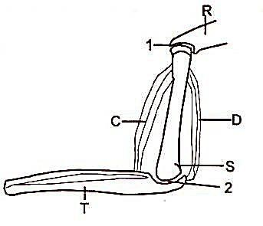

1. Name bone T and R (2marks)
2. Name muscle C and D (2marks)
3. i) Identify the fluid found at joint 2. (1mark)

i) State the function of the fluid in (i) above. (1mark)

1. i) What is the type of the joint found at part labeled 1. (1mark)

ii) Differentiate between a tendon and a ligament. (1mark)

20. a) Distinguish between a hinge joint and a ball and socket joint. 1mk

b) i) Name the cartilage found between the based of the vertebral column. 1mk

ii) State the function of the cartilage named in b (i) above 1mk