16.0.0 RECEPTION, RESPONSE AND COORDINATION IN PLANTS AND ANIMALS (43 LESSONS)
1. State the function of the following parts of the human ear.
  - Tympanic membrane (1 mark)
  - Round window (1mark)
- State the fluids that provide cushion in the following organs (4 marks)
a) Lungs …………………………………………………………
  - Heart ……………………………………………………………
  - Knee ……………………………………………………………
  - Eye ball ……………………………………………………………
- Study the diagram below showing a mammalian eye defect.

(4mks)

Retina

a) Identify the eye defect (1 mark)
b) How can the above defect be corrected (1 mark)
4. a) Describe the process of accommodation in the human eye. (10 marks)
b) Describe the mechanism of regulation of the amount of light entering the eye. (10 marks)
5.The diagram below shows a transverse section of a spinal cord.

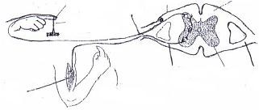
Forearm

Sense organ
(
skin) pricked

Sharp pin

Dorsal root

Gray matter

White matter

B

C

D
A

Name the parts labelled A – D.

- The diagram below shows the point of focus of light from an object.
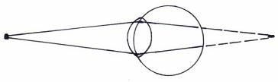

Name the eye defect shown above.
- The diagram below shows how the iris and pupil of a human eye appear under different conditions.
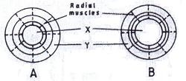

(a) Name the structures labelled X and Y. |  | (2mks)
(b) State the condition that leads to the change in appearance shown in the diagram labelled B. |  | (1mk)
(c) Describe changes that lead to the appearance of iris and pupil as shown in the diagram labelled B. |  | (4mks)

(d) What is the significance of the changes described in C above? (1mk)
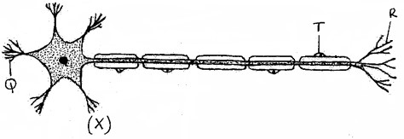
8.

The diagram below represents the structure of a nerve cell.

- Identify the nerve cell. (1 mark)
- Give a reason for your answer in (a) above. (1 mark)
- State the function of the part labelled T. (1 mark)
- Using an arrow show the direction of an impulse on the diagram. (1 mark)

9. State the functions of the following parts of a brain. (3marks)
a. Thalamus
b. Midbrain
c. Medulla oblongata
10. State three differences between Rods and Cones. (3marks)

11. The diagram below shows a mammalian eye.
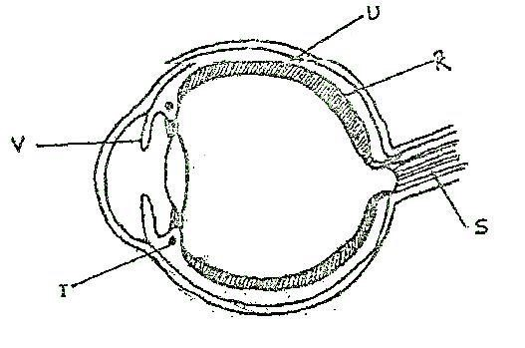

- Name the parts labeled R, S and T. (3 mks)
- Give two adaptations of part labeled U. (2 mks)
- Describe the changes that occur to part V when one moves from a bright room to a dark room. (3mks)

12. (a) What is eye accommodation? (1mk)
b) Explain how the Iris muscle controls the size of pupil when exposed to bright light. (2mks)

13. State two biological importance of tropisms in plants. | (2mks)

14. An accident victim was found to pass large volumes of dilute urine.
a) What part of brain was injured? (1mk)
b) Explain how the injury of the part of the part mentioned in 25(a) above brought about the release of large volumes
of urine. (2mks)
15. (a) Describe the mechanism of hearing in man. (16mks)
(b) State four differences between endocrine and nervous systems. (4mks)

16. State the adaptations of the following parts of the eye to its function.
  - Choroid (2 marks)
  - Retina (2 marks)

17. State the functions of the following neurons.
  - Relay neurone (1 mark)

  - Motor neurone (1 mark)

18. a) The diagram below represents a section of the human brain.
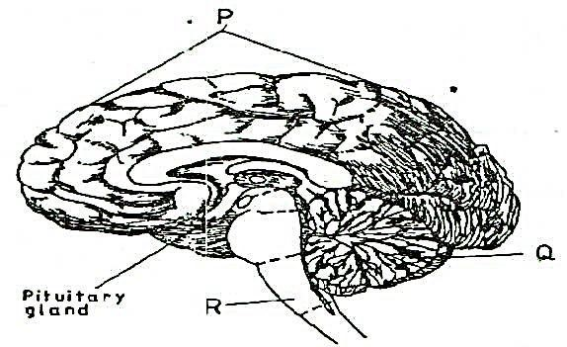

i) Name the structures labeled P and R (2 marks)
ii) State two functions of the part labeled Q. (2 marks)
b) i) Name two reproductive hormones secreted by the pituitary gland in women (2 marks) ii) State one function of each of the hormones named in (b) (i) above. (2 marks)
19. (a) In which part of the spinal cord is the cell body of the motor neurone found.
(b) Below are two features which make a neurone a specialised cell. State their roles.
- Axon.
- Dendrites.

20. A person was able to read a book clearly at arm‟s length, but not at normal distance.
  - State the eye defect the person suffered from. (1mk)
  - Why was he unable to read the book clearly at normal distance. (1mk)
  - How can the defect be corrected. (1mk)

