URANGA MATHEMATICS ASSOCIATION-2022.
FORM FOUR JUNE 2022.MARKING SCHEME

1. |  | M1  M1  A1
 |  | 03
2. | Cos (2x + 30º) = -0.5  2x + 30 = 120º, 240º, 480º, 600º  2x = 90º, 210º, 450º, 570º,  x = 450º, 105º, 225º, 285º | B1  B1  B1 | Simplification  (allow for 1st 2 values)
 |  | 03
3. | A = P(1 + r )^{n}  100  = 10000 (1 + 4 )⁶  100  = 10000(1.04)⁶  = 12653.19 (12,653) | M1  A1 | Substitution  Simplification
 |  | 02
4. | 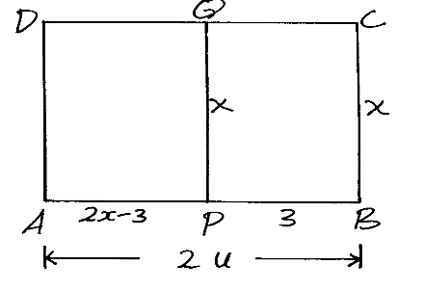  Area of APQD = x (2x - 3)  = 2x² – 3x  2x² – 3x = 135  2x² – 3x -135 = 0  (2x² – 18x) + (15x -135) = 0  2x (x – 9) + 15 (x – 9) = 0  (2x + 15) ( x – 9 ) = 0  2x + 15 = 0 or x = 9  x = 15  2  ∴BC = 9cm | M1  M1  A1
 |  | 03
5 | $$LogV=tLogK+LogA$$  $$Log K=\frac{6.771-2}{10-0}=0.4771$$  $K=3$  $$LogA=2, A=100$$ | B1  M1  A1  B1
 |  | 04
6. | Z = Kx²  y  Z = (1.2x)²K  0.64y  = 1.44Kx²  0.85y  = 1.8 Kx²  y  % increase = 80% | M1  A1  B1
 |  | 03
7.(a)  7.(b) | ( 3 + 2x)⁶ = ( 3)⁶ + 6 ( 3)⁵ 2x + 15 ( 3)⁴ (2x)² + 20 ( 3)³ (2x)³  = 27 + 108 x 3 + 270x² + 480 x³ 3  3+ 2x = 3 3  2x + 2 3  x = 3  27 + 108 3 3 + 270 3² ⁺ 480 3 ( 3)³  = 27 + 324 + 810 + 4320  = 5481 | M1  A1  M1  A1
 |  | 04
8 | OX = 2 (3i + 2j – 4k) + 1 (6i + 11j + 2k)  ~  ~  ~  ~  ~  3 3  ~  = 2i + 4j – 8k + 2i + 11 j +2k  ~  ~  ~  3 3 3  = 4i + 5j -2k  ~  ~  ~  10x1 = 16 + 25 + 4  ~  = 6.71units | M1  A1  B1
 |  | 03
9. | Det = 2 – 6  = - 4  A.S.F = 4  25.6 = 4  x  x = 6.4cm²  Area of ΔABC = 6.4cm² | M1  A1
 |  | 02
10. | 3(2 + 3 2) + 5(2-3 2)  (2 – 3 2) (2 + 3 2)  = 6 + 9 2 + 10 – 15 2  -14  = 16 – 6 2  -14  = -8 + 3 2  7 7
 |  | 03
11. | Absolute error in length = 5 x 15  100  Absolute error in width = 5 x 10  100  = 0.5  Max. area = 15.75 x 10.5  = 165.375cm²  Min. area = 14.25 x 9.5  = 135.375cm²  Absolute error in area = 165.375 – 135.375  2  = 15  % error = 15 x 100  150  = 10% | M1  M1  A1 | Either max. or min. area
 |  | 03
12. | 2x² + 2y² – 6x + 10y + 9 = 0  x² + y² – 3x + 5y + 9/2 = 0  x² + y² – 3x + 5y = -9/2  x² – 3x + 9 + y² + 5y + 25 = 8.5 – 4.5  4 4  (x – 3)² + (y + 5)² = 4  2 2  Radius = 2 units  Centre = (1.5, -2.5) | B1  B1  B1
 |  | 03
13 | $$Log\left(\frac{\left(x-2\right)\left(x+6\right)}{48}\right)=log1$$  $$\left(x-2\right)\left(x+6\right)=48$$  $x^{2}+4x-60=0$  $$\left(x-6\right)\left(x+10\right)=0$$  x=6, x=-10 | M1  M1  M1  A1
 |  | 04
14. | T₁₁ = a + 10d  T₂ = a + d  a + 10d = 4a + 4d …...........(i)  3a – 6d = 0  S7 = ⁷/₂{2a + 6d} = 175 …(ii)  2a + 6d = 50  +  3a – 6d = 0  5a = 50  a = 10  d = 5 | M1  A1  B1 | For both equations
 |  | 03
15. | T  P  O  21  60º  PT = 21 Tan 60  = 36.37cm  Area of PTOR = 2 x ½ x 21 x 36.37  = 763.77  Area of sector ROT = 120 x 22 x 21 x 21  360 7  = 462  Area of shaded part = 763.77 – 462  = 301.77 | B1  M1  M1  A1
 |  | 04
16. | Let the ratio be x: y  76x + 84y = 81(x + y)  84y – 81y = 81x – 76x  $\frac{3y}{5y}=\frac{5x}{5y}$  x : y = 3 : 5 | M1  A1 | Alt  76 84  81  3 5
 |  | 03
17 | - a,  a+2d  a+10d  - $\frac{a+2d}{a}=\frac{a+10d }{a+2d} = r$  $a+4d+a+8d=80$  $$a^{2}+4ad+d^{2}=a^{2}+10ad a=\frac{2}{3}d$$  $a+6d=40 \frac{2}{3}d+6d=40$  $d=6 , a=\frac{2}{3}×6=4$  - ii). $a+7d=46$  $$a+9d=58$$  iii).S₁₅$=\frac{15}{2} \left(2(4)+14(6)\right)$  $$=690$$ | B1  B1  M1  M1  M1  A1  B1  B1  M1  A1  10
18
 | B1  B1
  x | 0 | 15 | 30 | 45 | 60 | 75 | 90 | 105 | 120 | 135 | 150 | 165 | 180
  Cos 2x | 1 | 0.87 | 0.5 | 0 | -0.5 | -0.87 | -1 | -0.87 | -0.5 | 0 | 0.5 | 0.87 | 1.0
  Sin(x+30) | 0.5 | 0.71 | 0.87 | 0.97 | 1.0 | 0.97 | 0.87 | 0.71 | 0.5 | 0.26 | 0 | -0.26 | -0.5
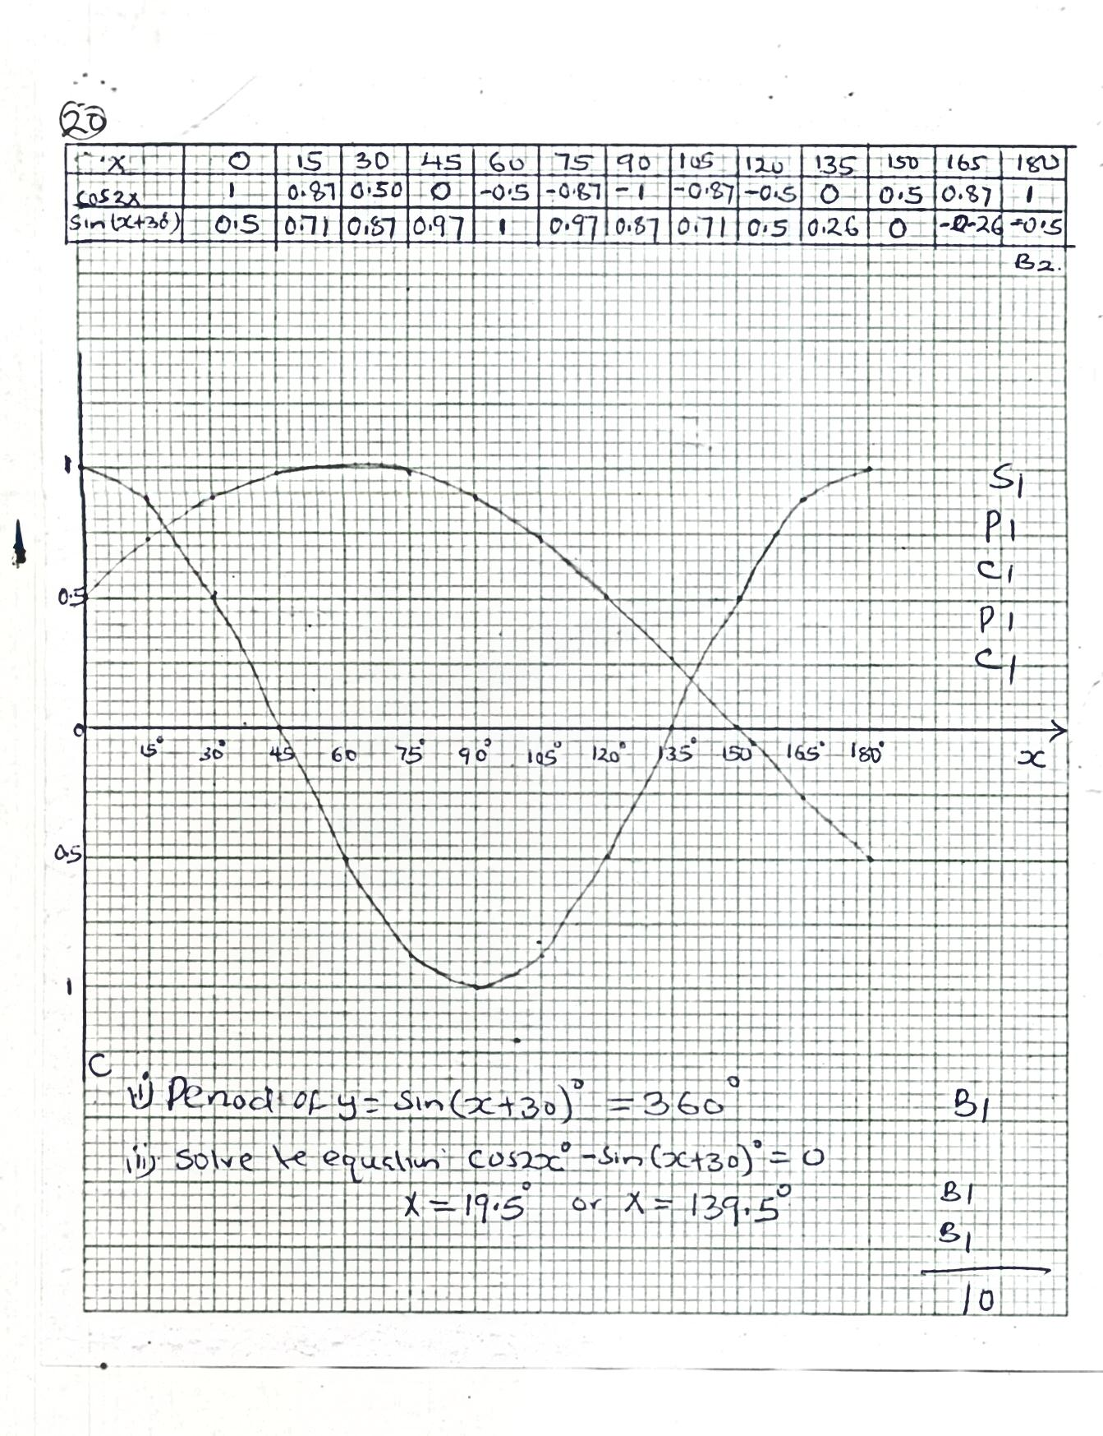  $$Y=cos2x$$  $$Y=sin(x+30)$$ | P1  C1  S1  P1  C1
19.5⁰ $≤$x $≤$139.5⁰ | B1
19.5⁰  139.5⁰ | B1  B1
 | 10
19(a)  (b)  (c) | 9000 + 350 + 800 + 1200 = 11350  9000 + 3000 = 12000  $$Total taxes = 12000 x 12$$  $$= shs. 144000p.a$$  Taxes  $4500 × 2 = shs.9000$  $$3000 × 3 = shs.9000$$  $$3000 × 4 = shs.12000$$  $$3000 × 5 = shs.15000$$  $$3000 × 6 = shs.18000$$  $$Shs. 63,000$$  $$144000 – 63000= shs.81000$$  $$7y = 81000$$  $$y = 11571$$  $$Taxable income= 4500 + 3000 × 4 + 11571$$  $= K 28071p.a$  $$Gross salary = shs. 561420p.a$$  (d)  Total allowances $= 12000 × 12$  $= 144,000$  Basic salary $= 561420$  $144000$-  $$Shs. 417,420$$  Monthly basic pay = shs. 34785 | B1  B1  B1  M1  M1  M1  A1  B1  M1  A1
 |  | 10
20 |  | B1  B1
  X | -2 | -1.5 | -1 | -0.5 | 0 | 0.5 | 1 | 1.5 | 2 | 2.5 | 3
  2x³ | -16 | -6.75 | -2 | -0.25 | 0 | 0.25 | 2 | 6.75 | 16 | 31.25 | 54
  -3x² | -12 | -6.75 | -3 | -0.75 | 0 | -0.75 | -3 | -6.75 | -12 | -18.75 | -27
  1 | 1 | 1 | 1 | 1 | 1 | 1 | 1 | 1 | 1 | 1 | 1
  y | -27 | -12.5 | -4 | 0 | 1 | 0.5 | 0 | 1 | 5 | 13.5 | 28
 | 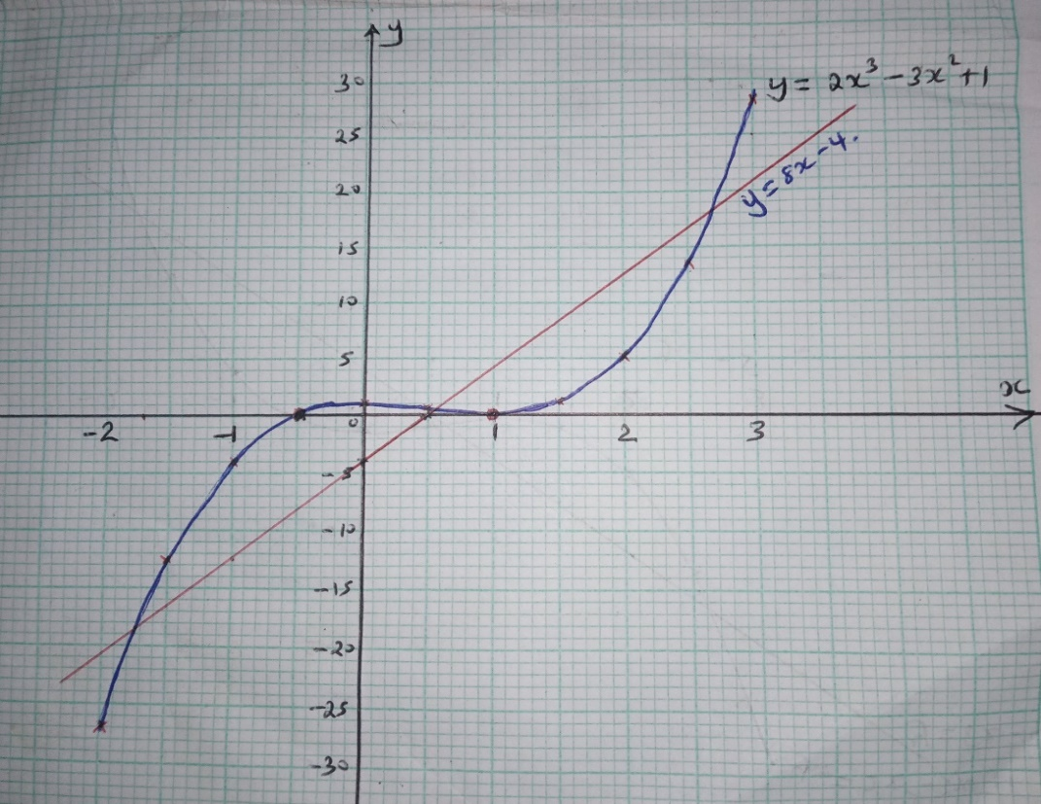 | S1  P1  C1  B1  B1 | Linear equation  Line drawn
 | $$X=-0.5$$  1 | B1  B1
 | $X=-1.8,0.6,2.6$ | B1 | All values
 |  | 10
21 | a) BD = BA + AD  = -b + ³/₅c  AE = AB + BE  = b + ½ BC = b + ½ (c – b)  = ½ b + ½ c  b) BF = t (³/₅c – b)  AF = n (½ b + ½ c) = ^{n}/₂ (b+ c)  AF = AB + BF  = b + t(³/₅c – b) = b + ³/₅tc + tb  = (1 – t) b + ³/5tc  (1 – t)b + ³/₅tc = ^{n}/₂b + ^{n}/₂c  1 – t = ^{n}/₂ ; 2 – 2t = n ………… (i)  ³/₅t = ^{n}/₂ ; 6t – 5n = 0 ………... (ii)  Sub from équation (ii)  6t – 5(2 – 2t) = 0  6t – 10 + 10t = 0  16t = 10  t = ¹⁰/₁₆ = ⁵/₈  n= ¾  c) BF = ⁵/₈ BD  F divides BD in the ratio 5 :3  AF = ¾ AE  F divides AE in the ratio 3 :1 | B1  M1  A1  B1  B1  M1  M1  A1  B1  B1 | √ equating 2 the vectors  √ solving simultaniously equation  √ for both n and t
22 | ⁵/₉  ⁴/₉  R  B  R  B  R  B  R  B  R  B  R  B  R  B  ⁴/₈  ⁴/₈  ⁵/₈  ³/₈  ²/₇  ⁵/₇  ⁴/₇  ³/₇  ³/₇  ⁴/₇  ⁴/₇  ³/₇  (a)  (b) (i) same colour = ⁵/₉ x ⁴/₈ x ³/₇ + ⁴/₉ x ³/₈x ²/₇  = ⁵/₄₂ + ¹/₇  = ¹¹/₄₂  (ii) more red balls = ⁵/₈₉ x ½ x ³/₇ + ⁵/₉ x ½ x ⁴/₇ + ⁵/₉ x ½ x ^{4/}7  = ⁵/₄₂ + ¹⁰/₆₃ = ¹⁰/₆₃  = ⁵/₄₂ + ²⁰/₆₃= 15 + 40 = 55  126 126  (iii) at least black ball was picked  = 1- ⁵/₉ x ½ x ³/₇  = 1 – ⁵/₂₁  = ¹⁶/₂₁  (iv) Atmost 1 red ball picked  = ⁵/₉ x ⁴/₂ x ³/₇ + ⁴/₉ x ⁵/₈ x ³/₇ + ⁴/₉ x ³/₈ x ²/₇  = ⁵/₄₂ + 5/₉₂ + ¹/₂₁  = 5 + 5 + 2  42  = ¹²/₄₂  = ²/₇ | B2  M1  A1  M1  A1  M1  A1  M1  A1
23. | 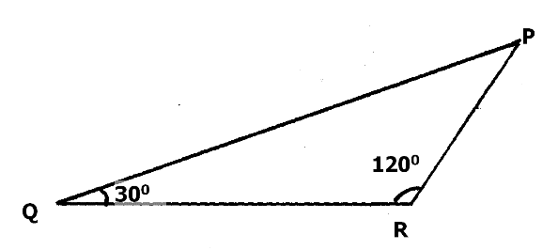  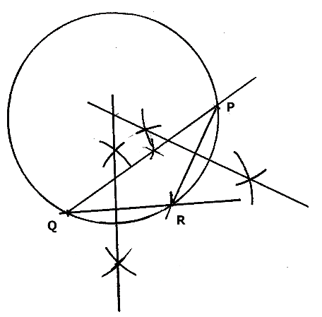 | B1  B1  B1  B1  B1  B1  B1  B1  M1  A1 | Sketch  Line QP  Line RP  Triangle completed  2 side bisectors  Centre shown  Complete circle
 |  | 10

24. | 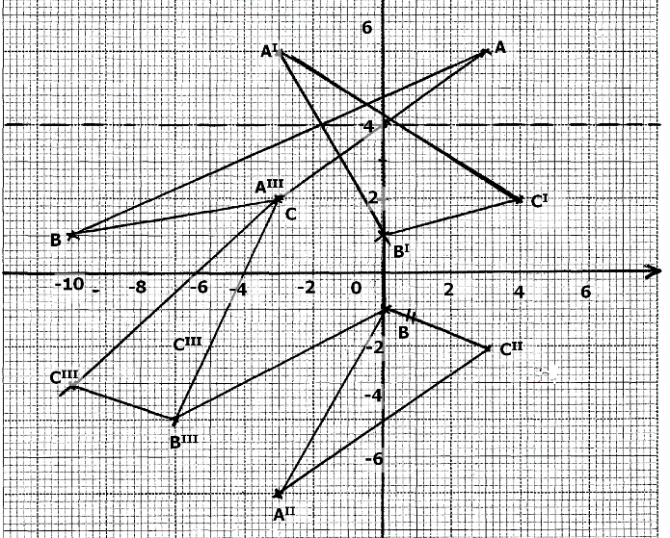  a) Shear factor = -3  ii) Enlargment scale factor - 1 centre ( -3 -2) | B1  P1  B1  P1  B1  B1  P1  B1  B2 | -6 = -3  2  All pointsly plotted  Δ ABC completed  All points ly plotted  Δ A^{II} B^{II} C^{II} completed  Transformation -  0 0  1 -1 is a reflection on X axis  All points ly plotted  Δ A^{III}B^{III}C^{III} completed  Otherwise B1 if factor or center NOT given
 |  | 10

