Name………………………………………… ADM Number:…………………….…..............
School:…...……….............................................................. Candidate’s Signature……………...
121/2
Mathematics Alt.A
FORM FOUR.
June 2022.
2 ½ Hours.

URANGA MATHEMATICS ASSOCIATION-2022.
Kenya Certificate of Secondary Education
MATHEMATICS
121/2
FORM FOUR.
TIME: 2 ½ HOURS

INSTRUCTIONS TO CANDIDATES:
- Write your name, school, admission number and sign in the spaces provided above.
- This paper contains TWO sections: Section I and Section II.
- Answer ALL the questions in Section I and FIVE questions from section II.
- All answers and working MUST be written on the question paper in the spaces provided below each question.
- Marks may be given for correct working even if the answer is wrong.
- Non-programmable silent electronic calculators and KNEC Mathematical tables may be used, except where stated otherwise.
FOR EXAMINERS USE ONLY

SECTION I
1 | 2 | 3 | 4 | 5 | 6 | 7 | 8 | 9 | 10 | 11 | 12 | 13 | 14 | 15 | 16 | Total

SECTION II
Grand Total

17 | 18 | 19 | 20 | 21 | 22 | 23 | 24 | Total

This paper consists of 15 printed pages. Candidates should check to ascertain that all pages are printed as indicated and that no questions are missing.
SECTION I:(50MARKS)
Answer All questions In The Spaces Provided
1. Make h the subject of the formula in the following equation. (3mks)

2. Solve for x in the equation 2cos(2x + 30º) = -1 for the range 0º ≤ x ≤ 360º (3mks)

3. A lady invests shs.10,000 in an account which pays 16% interest p.a. The interest is compounded
quarterly. Find the amount in the account after 1½ hrs (2mks)

4. ABCD is a rectangle in which AB = 2BC. The line PQ is parallel to BC and meets AB at P and DC at Q. If PB = 3cm, BC= x cm and area of APQD is 135cm², find BC (3mks)

5. The graph below is drawn after converting the nonlinear equation $V=AK^{t}$ ,use the graph to write a linear equation hence determine the values of the constants A and K (4mks)
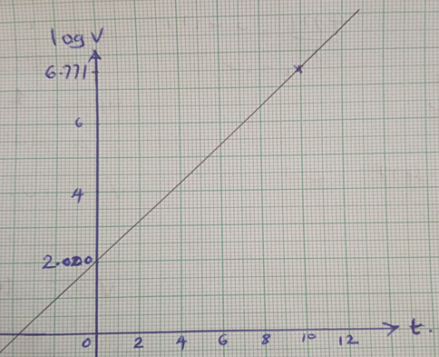

6. A quantity Z varies directly as the square of x and inversely as the square root of y. If x increases
by 20% and y decreases by 36%, find the percentage change in Z (3mks)

7. (a) Expand (3 + 2x)⁶ up to the fourth term (2mks)

(b) Use your expansion to estimate: - (3 3 )⁶ (2mks)

8. Given that O is the origin, OA = 3i + 2j – 4k and OB = 6i + 11j + 2k. If x divides AB in the ratio1:2,find the modulus of OX to 2d.p (3mks)
~
~
~
~
~
~
~
~

9. Triangle A¹B¹C¹ is the image of triangle ABC under a transformation represented by matrix
T = $\left[\begin{matrix}1 & 3 \\ 2 & 2\end{matrix}\right]$ If the area of triangle A¹B¹C¹ is 25.6cm², find the area of the object (3mks)

10. Rationalise and simplify:$\frac{3}{2-3\sqrt{2}}+\frac{5}{2+3\sqrt{2}}$ Up to the form $a + b \sqrt{c}$ where a, b, c are
constants (3mks)

11. The dimensions of a rectangle are 10cm and 15cm. If there is an error of 5% in each measurement find the percentage error in the area of the rectangle (3mks)

12. Find the radius and the Centre of a circle whose equation is 2x² + 2y² – 6x + 10y + 9 = 0.
(3mks)

13.Solve for x: $\log\left(x-2\right)+\log\left(x+6\right)-log48=0$ (4mks)

14. The eleventh term of an AP is four times the second term. If the sum of the first seven terms
of the AP is 175, find the first term and the common difference (3mks)

15. In the figure below, PR and PT are tangents. O is the centre of a circle diameter 42cm. The reflex angle ROT = 240º. Using π= $\frac{22}{7}$ find the area of the shaded region (3mks)
•
O
P
T
T
R

16. In what proportion must tea of Kshs.76 and Kshs.84 per kg each, be mixed to produce a tea costing Kshs.81 per kg? (2mks)

SECTION II (50 MARKS)
Answer FIVE questions in this section in the spaces provided.

17. An arithmetic progression (A.P) has the first term a and common difference, d.
a) Write down the first, third and eleventh terms of the A.P in terms of a and d. (2mks)

b) The A.P above is such that it is increasing and its first, third and eleventh terms form the first three terms of a G.P. The sum of the fifth and ninth terms of the A.P is 80
(i) Find the first term and the common difference of the A. P (4mks)

(ii) Write the eighth and the tenth terms of the A.P. (2mks)

(iii) Calculate the sum of the first 15 terms of the A.P. (2mks)

18. a) Complete the table below giving your values correct to 2 d.p. (2mks)

x⁰ | 0⁰ | 15⁰ | 30⁰ | 45⁰ | 60⁰ | 75⁰ | 90⁰ | 105⁰ | 120⁰ | 135⁰ | 150⁰ | 165⁰ | 180⁰
Cos2x⁰ | 1 |  |  | 0 |  |  |  |  | -0.5
Sin(x + 30) ⁰ |  |  | 0.87 |  |  |  |  | 0.71 |  |  |  |  | -0.50

b) Using the grid provided draw on the same axes, the graphs of y = Cos 2x and y = Sin (x + 30)⁰
for 0⁰ < x < 180⁰ . Take the scales 1cm for 15⁰ on the x-axis and 4cm for 1 unit on the y-axis. (5mks)


c) Using the graph in (b) above to:-
i) Determine the range of x for which $cos 2x°≤Sin (x + 30)°$ (1mk)

ii) Solve the equation Cos 2x –Sin (x + 30)⁰ = 0 (2mks)

19. Use the taxation rates in the table below to answer the questions that follow;-

Taxable income in K £ p.a | Rate % per K£
1-4500  4501-7500  7501 – 10500  10501 – 13500  13501 – 16500  0ver 16500 | 10  15  20  25  30  35

The manager of a certain company is entitled to a monthly personal relief of shs.3000 and her tax (PAYE) is kshs.9000 per month she is also deducted NHIF shs.350 per month, WCPS shs.800 per month and cooperative shares shs.1200 per month, calculate;
(a) The manager’s total deductions per month (1mk)

(b) Total tax per month (1mk)

(c) The manager’s annual gross salary in Kenya shillings (6mks)

(d) The manager’s monthly basic salary if her monthly commuter allowance and medical allowances are 10000 and 2000 shillings (2mks)

20.(a) Complete the table below for the equation of the curve given by y = 2x³ – 3x² + 1 (2mks)
X | -2 | -1.5 | -1 | -0.5 | 0 | 0.5 | 1 | 1.5 | 2 | 2.5 | 3
2x³ | -16 |  | -2 |  | 0 |  | 2 |  | 16
-3x² | -12 |  |  | -0.75 | 0 | -0.75 |  |  |  |  | -27
1 | 1 | 1 | 1 | 1 | 1 | 1 | 1 | 1 | 1 | 1 | 1
y | -27 | -12.5 |  |  | 1 |  |  |  | 5 |  | 28

(b) Use the table to draw the graph of the function y = 2x³ – 3x² + 1, taking 1cm rep 5units on y axis and 2cm rep 1unit on x axis (3mks)

(c) Use your graph to find the values of x for the equation: -
(i) The roots of 2x³ – 3x² + 1 = 0 (2mks)

(ii) 2x³ – 3x² -8x+5=0 (3mks)

21. In the figure below, E is the mid-point of BC. AD: DC=3:2 and F is the meeting point of
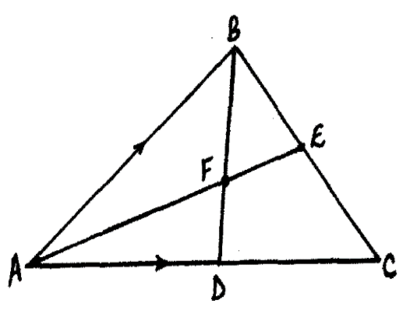
BD and AE

If AB = b and AC = c;
~
~
~
~
(a) Express BD and AE in terms of b and c (3mks)
~
~

(b) If BF =tBD and AF =nAE, find the values of t ad n (5mks)

(c) State the ratios in which F divides BD and AE (2mks)

22. A box contains five red balls and four black balls all identical. Three balls are drawn without
replacement from the box at random;
(a) Draw a tree diagram to show the situation (2mks)

(b) use the tree diagram to find the probability that;
(i) the balls picked are of the same colour (2mks)

(ii) more red balls were picked (2mks)

(iii) at least a black ball was picked (2mks)

(iv) at most 1 red ball was picked (2mks)

23. Using a ruler and a pair of compasses only
a) Construct a triangle PQR in which ∠PQR = 30°, ∠ QRP = 120° and QR = 3.5cm.(4mks)

b) Construct a circumcircle of the triangle. (3mks)

c) Measure the radius of the circle and use it to find the area of the circle drawn. (3mks)

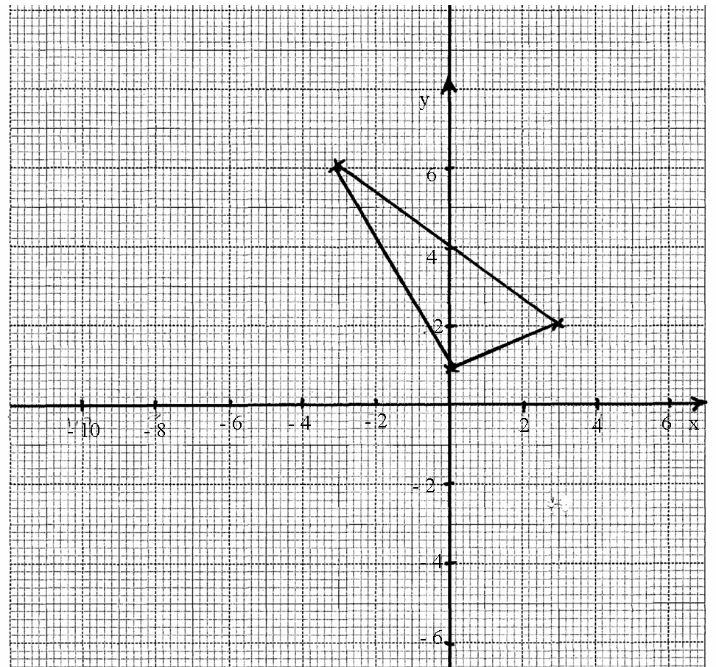
24. In the figure below, A^{I}B^{I}C^{I} with coordinates A^{I}(-3,6),B^{I}(0,1) and C^{I}(3,2) is the image of triangle ABC under a shear with line y = 4 invariant.
a) Given A (3,6) draw the object triangle ABC on the same grid (3mks)

b) Triangle A^{I}B^{I}C^{I} is mapped onto triangle A^{II}B^{II}C^{II} by a transformation represented by the matrix
(i) Draw on the same grid, triangle A^{II}B^{II}C^{II}. (2mks)

(ii) Describe fully the transformation represent by (1mk)

c) A^{III(}-3,2),B^{III}(-6, -3) and C^{III} (-9,-2) are the vertices of the image of A^{II}B^{II}C^{II} under a transformation R.
(i) Draw triangle A^{III}B^{III}C^{III}. (2mks)

(ii) Describe transformation R fully. (2mks)

