Name………………………………………… ADM Number:…………………….…............

School:…...……….............................................................. Candidate’s Signature…………….
121/1
Mathematics Alt.A
FORM FOUR.
June 2022.
2 ½ Hours.

URANGA MATHEMATICS ASSOCIATION-2022.
Kenya Certificate of Secondary Education
MATHEMATICS
121/1
FORM FOUR.
TIME: 2 ½ HOURS

INSTRUCTIONS TO CANDIDATES:
- Write your name, school, admission number and sign in the spaces provided above.
- This paper contains TWO sections: Section I and Section II.
- Answer ALL the questions in Section I and FIVE questions from section II.
- All answers and working MUST be written on the question paper in the spaces provided below each question.
- Marks may be given for correct working even if the answer is wrong.
- Non-programmable silent electronic calculators and KNEC Mathematical tables may be used, except where stated otherwise.

FOR EXAMINERS USE ONLY

SECTION I
1 | 2 | 3 | 4 | 5 | 6 | 7 | 8 | 9 | 10 | 11 | 12 | 13 | 14 | 15 | 16 | Total

SECTION II
Grand Total

17 | 18 | 19 | 20 | 21 | 22 | 23 | 24 | Total

This paper consists of 15 printed pages. Candidates should check to ascertain that all pages are printed as indicated and that no questions are missing.

SECTION I (50 MARKS)
Answer all questions in this section
- Evaluate without using a calculator or mathematical table. (3 marks) $\frac{(2\frac{2}{7}- 1\frac{5}{6})÷\frac{5}{6}}{\frac{2}{3}of 2\frac{1}{4}- 1\frac{1}{7}}$

- A perpendicular line is drawn from a point (4, 6) to the line 5y+4x = 20. Find its equation in the form ay+bx = c where a, b, c are integers. (3 marks)

- Simplify completely by factorization $\frac{20-{45x}^{2}}{{6x}^{2}-x-2}$ (3 marks)

- Solve for x in the equation $8^{(2x-1)}×{32}^{x}={16}^{x+1}$ (3 marks)

- A bank in Kenya buys and sells foreign currencies as follows.
buying (Ksh) Selling (kshs.)
1 Us dollar 85.86 86.06
1 sterling pound 142.41 142.73
A tourist from united States of America converted 43521 US dollars into Kenya shillings.
- Calculate the amount in Kenya shillings that she received (1 mark)

- While in Kenya, the tourist spent sh. 2437821 and converted the balance into sterling pounds. How much to the nearest Sterling pound did the tourist receive? (3 marks)

- Wasike bought 3 bags of DAP fertilizer and 4 bags of CAN fertilizer at sh. 21500. Had he bought 2 bags of DAP and 5 bags of CAN, he would have spent sh. 400 less. Find the cost of one bag of each type of fertilizer. (3 marks)

- Use square roots and reciprocals tables to evaluate to 4 significant figures the expression.
$(0.06458)^{\frac{1}{2}}+\frac{2}{0.4327}$ (3 marks)

- Express 128 and 200 as a product of their prime factors in power form hence evaluate $\sqrt{\frac{128}{200}}$ (3 marks)

- Given that $\sin{θ}=\frac{2}{3}$ and $θ$ is acute angle, find $\tan\left(90-θ\right).$ Give the answer to 4 significant figures. (3 marks)

- Given the column vector $P=\left(\begin{matrix}-5 \\ 3\end{matrix}\right), q=(\begin{matrix}4 \\ -8\end{matrix})$ and r = $\left(\begin{matrix}6 \\ -9\end{matrix}\right), t=2p-\frac{1}{2}q+\frac{1}{3}r$
- Express t as a column vector (2 marks)

- Calculate the magnitude of vector t in (i) above correct to 2 d.p. (1 mark)

- Four machines give out signals at intervals of 24 seconds, 27 seconds, 30 seconds and 50 seconds. At 5.00 p.m. all the four machines give out a signal simultaneously. Find the time this will happen again. (3 marks)

- A wire in form of an arc with radius 12 cm and centre angle 150⁰ is formed into a circle. Find the radius of the circle. (3 marks)

- The exterior angle of a regular polygon is equal to one – third of interior angle. Calculate the number of sides of the polygon and give its name. (3 marks)

- Sketch the net of the prism below. (3 marks)
E
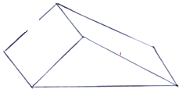
8cm
A
B
C
D
F
16cm
6cm
10cm

- Use logarithms table to evaluate $\sqrt[3]{\frac{0.006549}{81.06tan43^{0}}}$ (4 marks)

- a) Form the three inequalities that satisfy the given region R. (3 marks)
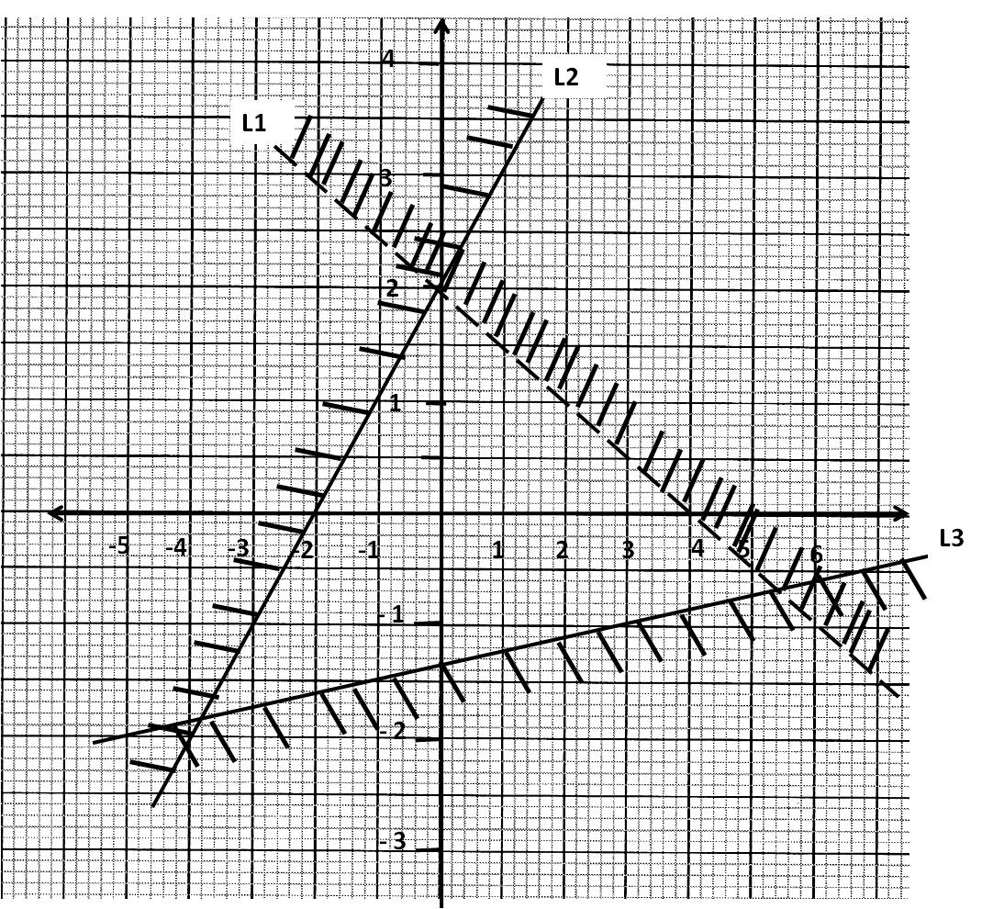

SECTION II (50 MARKS)
Answer any FIVE questions from this section in the spaces provided
17) a) Using a ruler and a pair of compasses only, construct triangle ABC in which BC = 6cm, AB
= 8.8 cm and < ABC = 22 ½ ⁰, (4 marks)

b) Measure AC and <ACB (2 marks)

c) Construct a circle that passes through A, B and C. (3 marks)

d) What is the radius of this circle (1 mark)

18) Forty students in a form 2 class were weighed and their masses recorded to the nearest
kilogram as shown below.
45 48 56 39 47 36 45
37 46 33 43 51 42 47
47 40 46 41 45 43 46
54 42 51 39 42 45 44
49 50 46 39 42 48
50 38 45 35 52 46

- Using class intervals of 5kg tabulate this data in a frequency table starting with a class of
33-37 (2 marks)

b) Find the modal frequency (1 mark)

c) Modify the table and use it to calculate the mean mass of the students (4 marks)

d) Find the median mass (3mks)

19) A bus left town A at 11.45 a.m. and travelled towards town B at an average speed of
60km/h. A matatu left town B at 1.15 p.m. and travelled towards town A along the same
road at an average speed of 90km/hr. The distance between the two towns is 540km. Determine;

a) The time of day when the two vehicles met. (4 marks)

b) How far from town A they met? (2 marks)

c) How far from town B the bus was when the matatu reached town A. (4 marks)

20) The diagram below shows a frustrum which represents a bucket with an open end
30 cm
30 cm
24 cm
diameter of 30 cm and a button diameter of 24 cm. The bucket is 30 cm deep as shown and
it is used to fill an empty cylindrical tank of diameter 1.4m and height 1.2 m.

a) Leaving $π$ in your answer, calculate
i) The capacity of the bucket in litres (6 marks)

b) The capacity of the tank in litres (2 marks)

b) Determine the number of full buckets that must be drawn in order to fill the tank. (2 marks)

21) Four matatu operators Adhiambo, Babu, Chirchir and Asai decided to buy a minibus. They
agreed to pay for the cost of the minibus in the ratio 3:4:5:6. Basing their contributions on
the marked price of the minibus, they found that chirchir would pay sh. 240000 more than
Adhiambo. The sales agent however allowed them a 10% discount on cash payment.
a) Calculate
i) The marked price of the minibus (2 marks)

ii) How much more Adhiambo and Babu paid than Asai (5 marks)

b) The four partners agreed to share monthly profits from the minibus in the ratio of their
contributions after setting a side 25% of the profit for emergencies. If the minibus realized
sh. 64000 in profits during one month, calculate Asai’s share of the profits for that month. (3 marks)

22) a) The points A(2, 6), B(1, 1) C(3, 4) and D(5, 3) are vertices of a quadrilateral ABCD. Plot
ABCD on the grid below to form quadrilateral ABCD. (2 mark)

b) ABCD undergoes a rotation of positive 90⁰, about the origin. on the same grid, draw the image A’B’C’D’ and state the coordinates of A’B’C’D’. (3 marks)

c) A’B’C’D’ undergoes a reflection in the X – axis to give A’’B’’C’’D’’. On same grid, draw A’’B’’C’’D’’ and state the coordinates of A’’B’’C’’D’’ (3 marks)

d) A’’B’’C’’D’’ is the image of ABCD under a reflection. On the grid, mark the mirror line and state its equation. (2 marks)

23) Complete the table i) and ii) below for the functions.
i) y = 7 – 3x (2 marks)
x | -2 | -1 | 0 | 1 | 2 | 3 | 4 | 5
Y | 13 |  | 7 |  |  |  |  | -8

ii) y = 2x-8 (2 marks)
x | -4 | -2 | 0 | 2 | 4 | 6 | 8 | 10
Y | -16 |  | -8 |  |  | 4
b) On the same grid, draw
y = 7 – 3x and y = 2x – 8 (4 marks)
c) Use your graphs to solve the simultaneous equations (2 marks)

24) Four points A, B, C, and D are situated on a horizontal plane such that B is 200 m on a
bearing of 065⁰ from A. C is 300m on a bearing of 120⁰ from B and D is 150m due west of C.

a) Draw a rough sketch showing the positions of the four points. (1 mark)

b) Using a suitable scale, draw an accurate scale drawing representing the positions of A, B, C, and D. (5 marks)

c) By measuring use your scale drawing to find the distance and bearing of:-
i) D from A (2 marks)

ii) B from D (2 marks)

