STIMULUS AND RESPONSE REVISION QUESTI-ONS
1. The diagrams below repents a nerve cell
- Identify the nerve cell. (1mark)
(b) (i) Give a reason for your answer in (a) above (1mark)
(ii) Show by use of an arrow the direction of flow of the nerve impulses. (1mark)
2. Below is a diagram showing parts of a synapse observe and other the questions that follow.
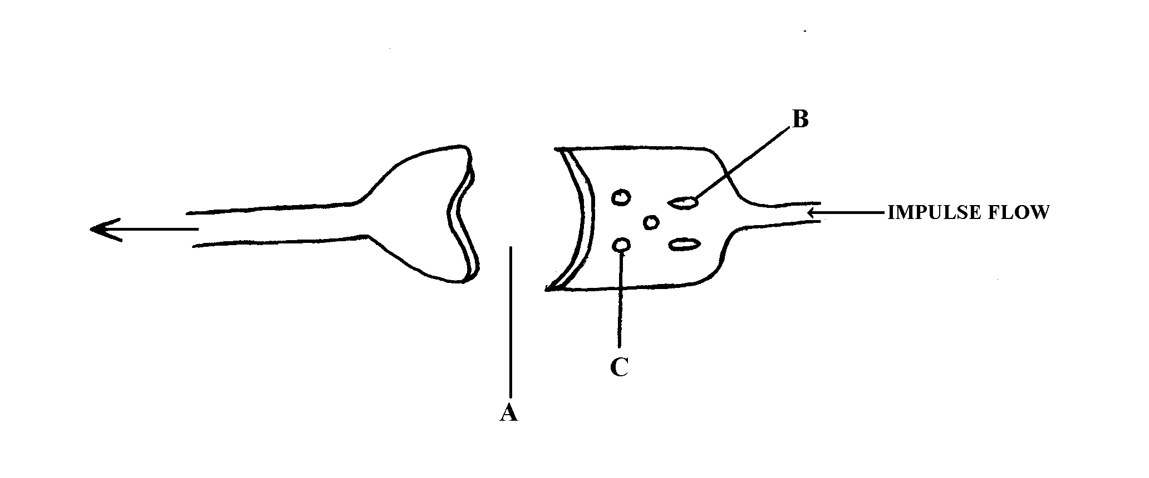
  - Name the parts labeled: A, B. (2mks)
  - What is the role of part labeled C. (1mk)
3. A student set up an experiment as shown in the diagram below.
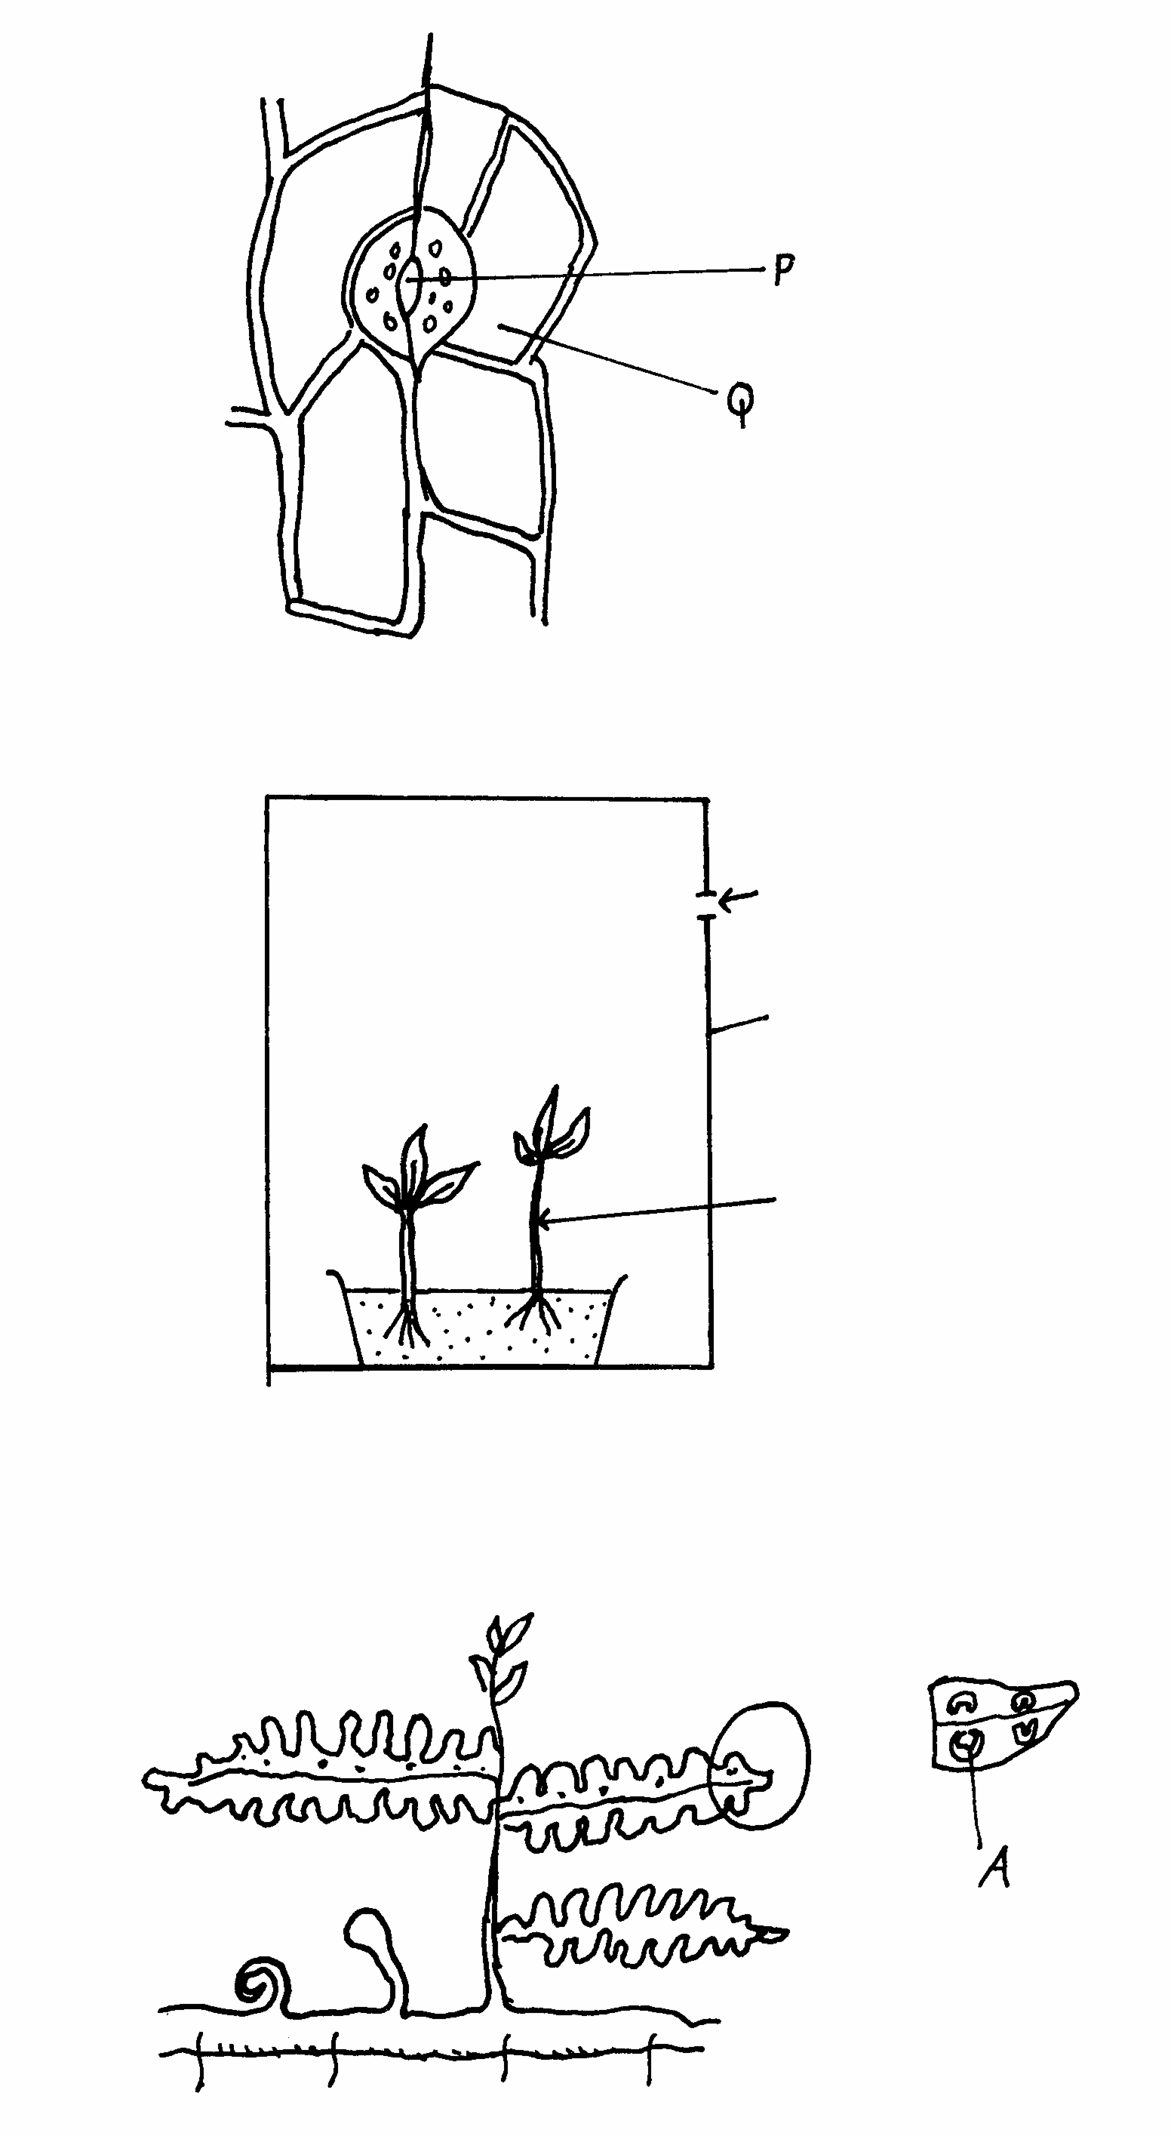
Light

Box with black paint

Seedlings
The set up was left for 4 days.
a) What was the aim of the experiment. ( 1mk)
b) i) State the expected results after 4 days. ( 1mk)
ii) Account for the results you have stated in ( b) (i) above. ( 4mks)
c) In another experiment, a student placed a seedling horizontally on moist cotton wool. Later the shoot grew upwards while the Radicle grew downwards. Explain why the radicle showed a downward curvature. ( 2mks )
4. Describe how different types of tropisms adapt plants for survival in their habitats. (20mks)
5. Diagram below shows the structure of motor neuron.
(a) Name the parts labelled. A, B (2mks)
(b) State three adaptations that enable the neurone to carry out its functions efficiently. (3mks)
(c) State two features that would distinguish sensory neurone from the above neurone. (2mks)
6. The diagram below shows the structure of its human ear.
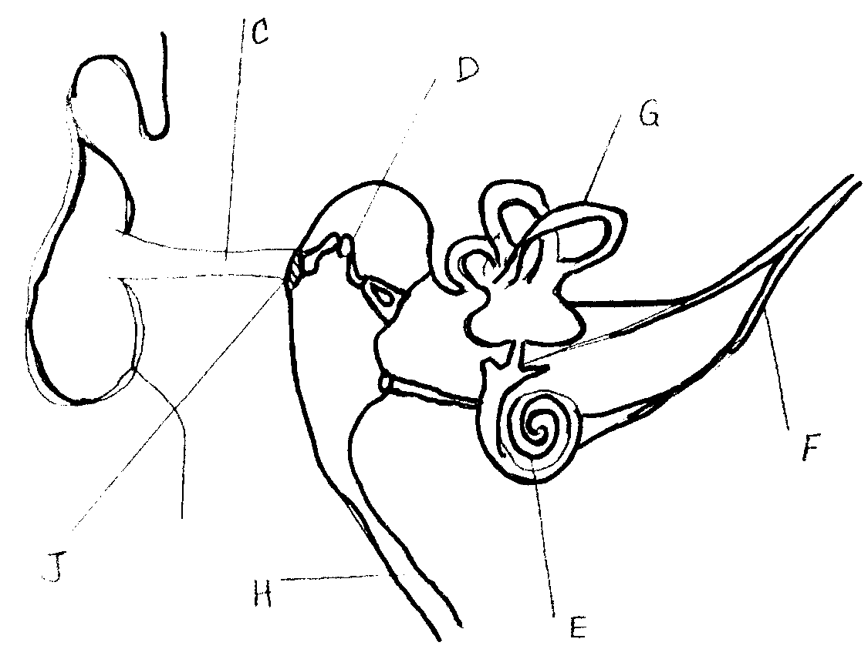
J
H
E
F
G
D
C
a) State the functions of the ear. (2mks)
b) Give the names of the structure labelled C,G and F. (3mks)
c) (i) What is the function of the structure labeled H? (1mk)
(ii) Name the structure in the ear that detects sound waves. (1mk)
d) In which structure of the ear is the velocity of the sound waves fastest? (1mk)
7. The diagram below represents a nerve cell. Study it and answer the questions that follow.
P
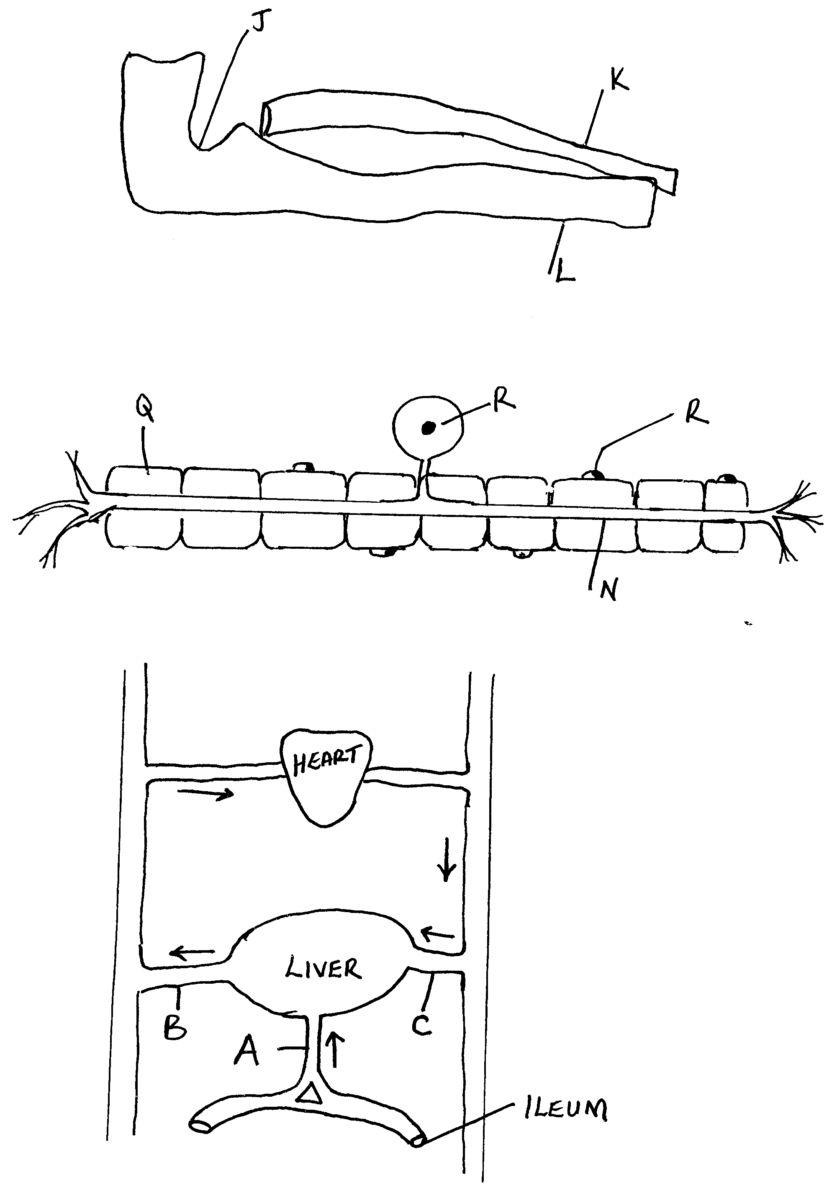
a) (i) Identify the cell (1mk)
(ii) Give a reason for your answer in a (i) above (1mk)
b) Name the parts labelled N, P, Q and R. (4mks)
c) State the functions of the parts labelled N and Q. (2mks)
8. Use the diagram below to answer the questions that follow
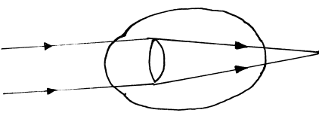
a) (i) Name the eye defect represented above (1 mk)
(ii) What is the cause of this defect (1 mk)
(iii)How can the defect you have named (a) (i) be corrected? (1 mk)
9 The diagram below shows three different types of neurones along a reflex arc
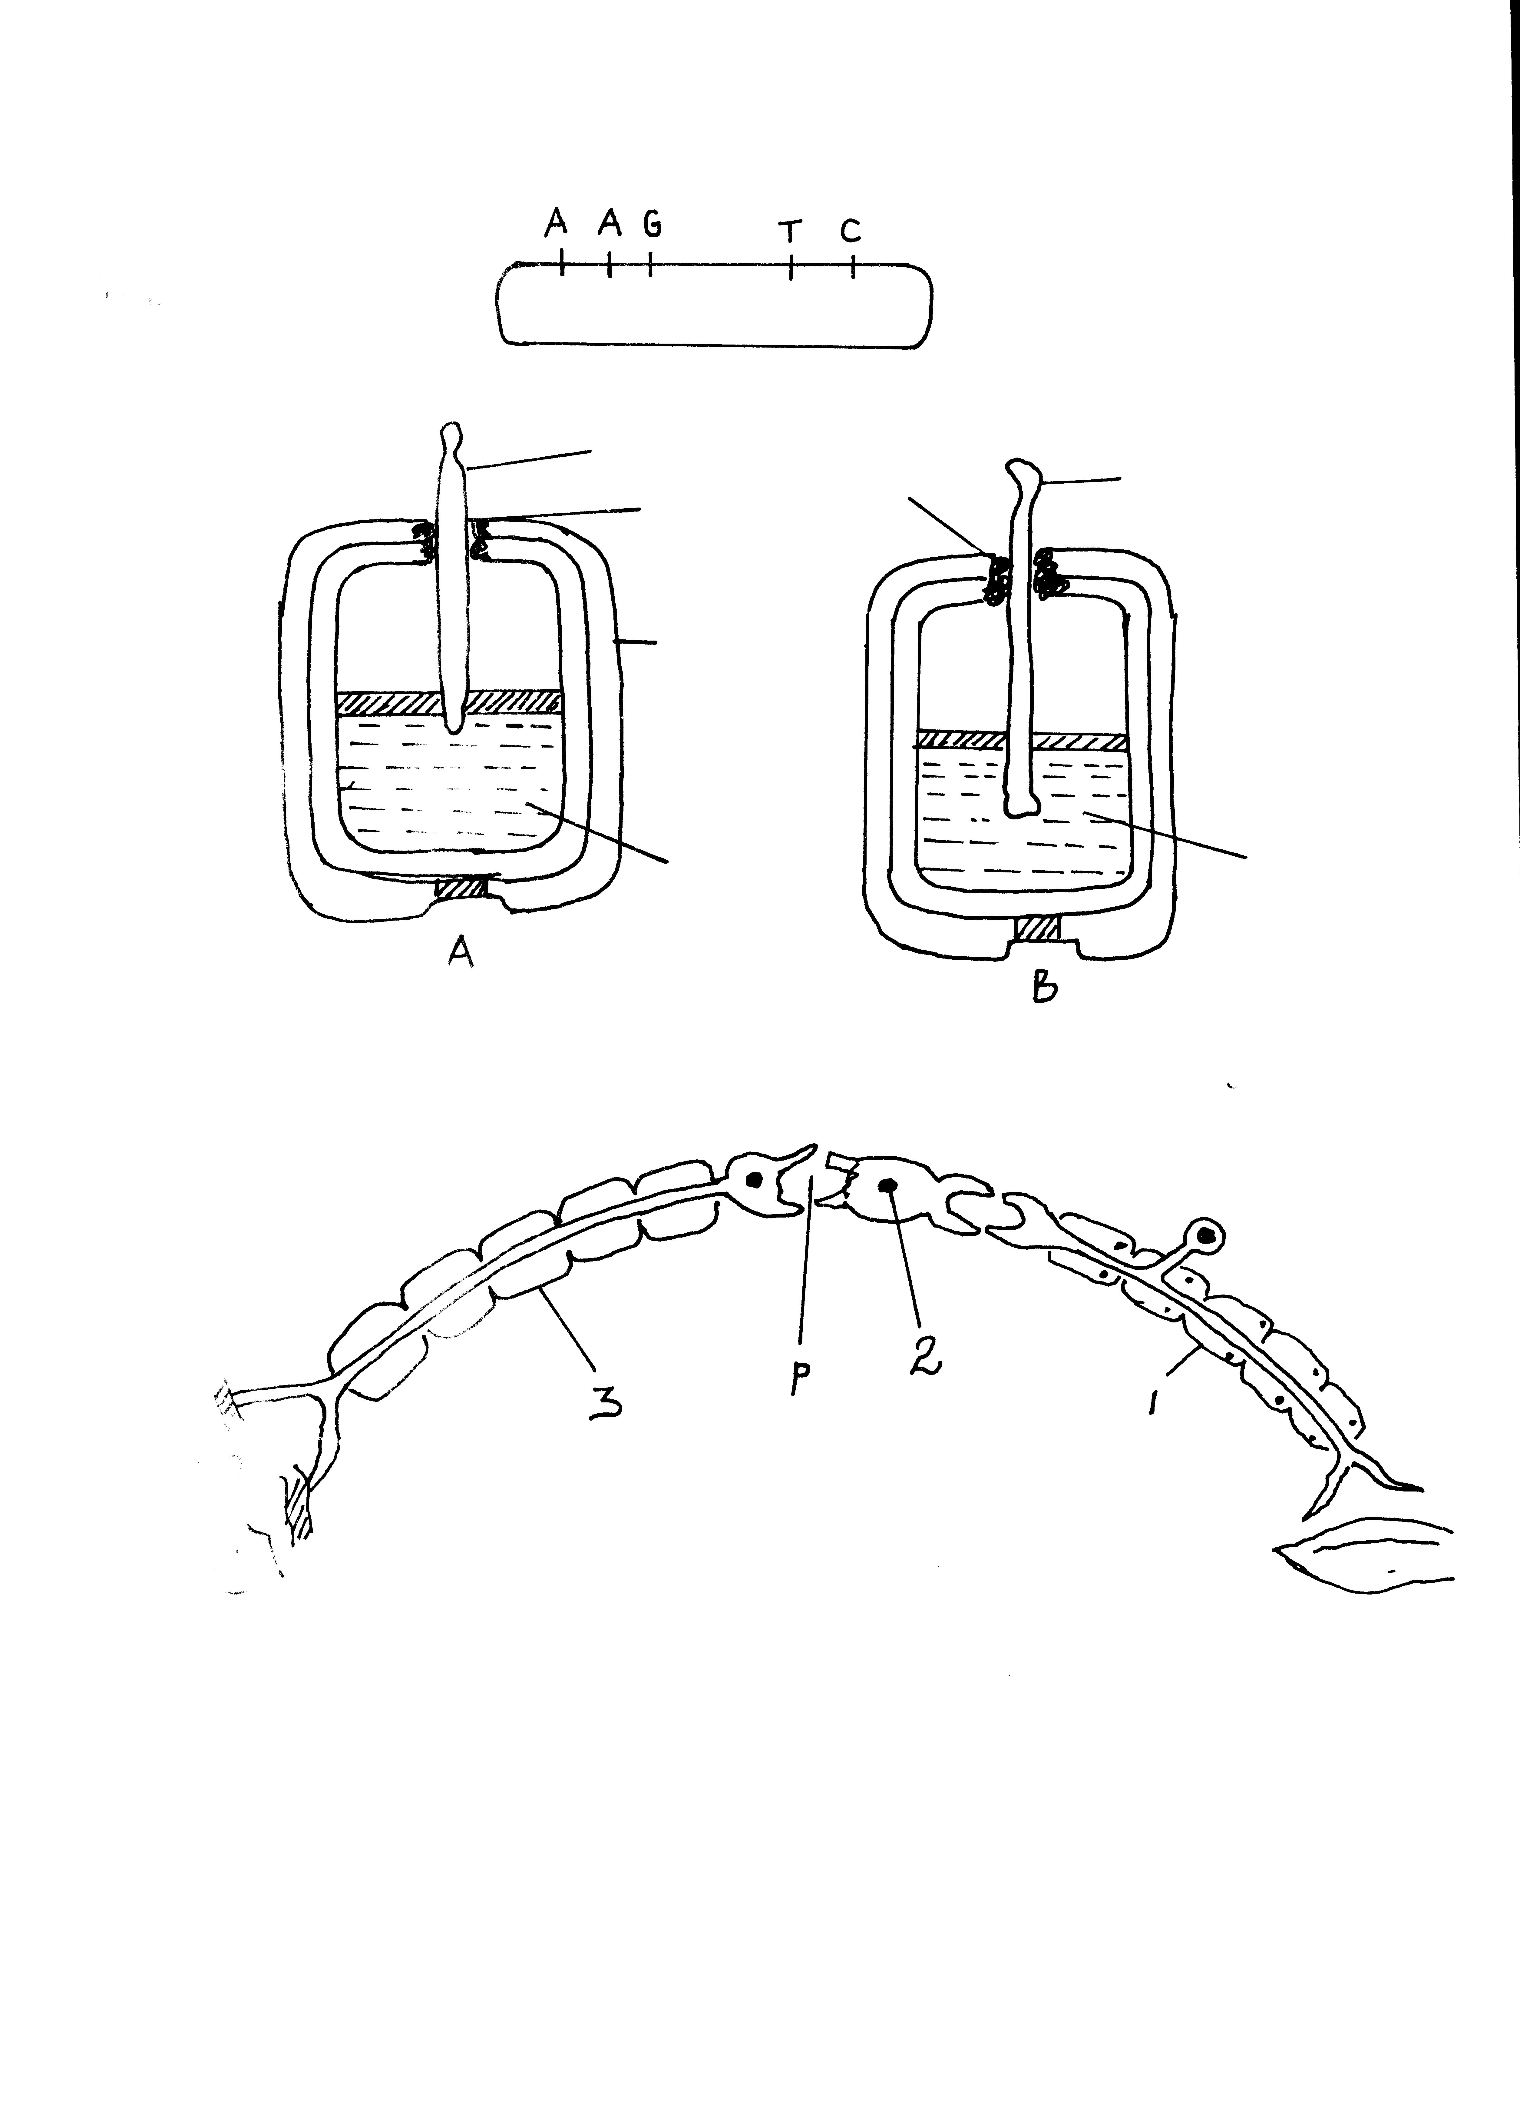

a) Identify the neuron labelled 1 ,2 and 3 (3 mks)
b) Using arrows show the direction of impulse transmission on the diagram (1 mk)
c) Name the part of the spinal cord where the cell bodies of neurone 2 and 3 are located (1mk)
d) Describe the transmission impulse across the part labelled P (3 mks)
10 A response exhibited by a certain plant tendril is illustrated below
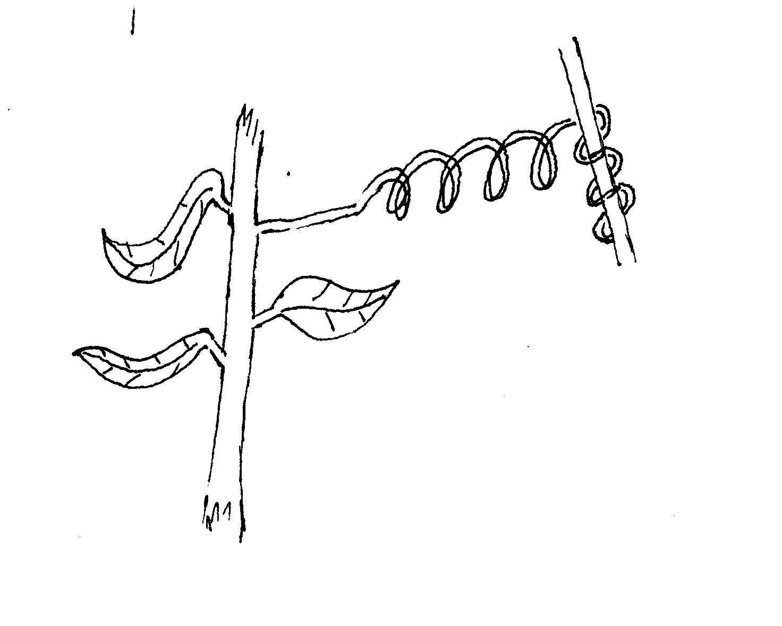
  - Name the type of response (1mk)
  - Explain how the response named in (i) above occurs. (3mks)
  - What is the importance of tactic responses to microscopic plants? (1mk)
11 Describe how the mammalian ear is adapted to perform its functions. (20mks)
12. a) Describe how the structure of the eye is adapted to its function. (16mks)
b) Identify two defects of the eye and how they can be rectified. (4mks)
13 Differentiate between nervous and endocrine communication in animals (3mks)
14. The diagram below represents a section through the mammalian ear. Study it and answer the questions that follow.
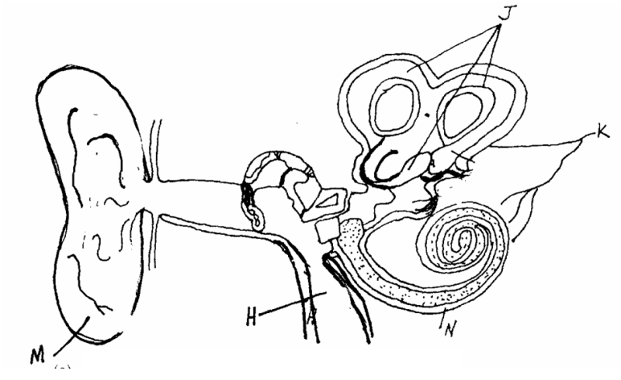
(a) Name the structures labeled H and J (2mks)
(b) State how the structures labeled H, M and N are adapted to their functions (3mks)
(c) State what would happen if the structure labeled K was completely damage (1mk)
(d) Name the fluid contained in structure N (1mk)
(e) Apart from hearing, state the other role performed by the human ear (1mk)
15 The following experiment was set up in a chamber made from two connected Petri dishes. Housefly maggots were introduced at the centre of the chamber, so the maggots could move to either Petri dish A or B as shown below.
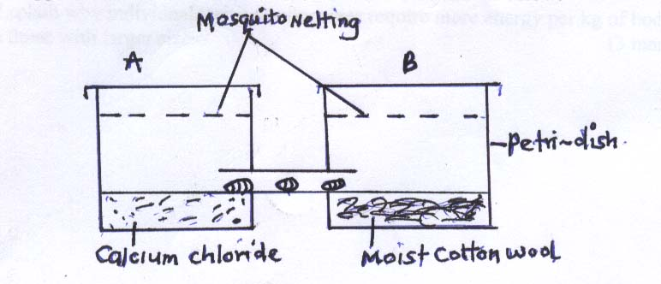
(a) Name the type of response being investigated in the set up. (1mk)
(b) State the survival value of the response named in (a) above. (1mk)
(c) Give the role of calcium chloride in the experiment above. (1mk)
16 (a) What is accommodation? (1mk)
(b) Describe the sequence of events that occur in the eye for one to be able to see clearly
(i) a distant object (4mks)
(ii) if one moved from a dim lit room to bright light. (3mks)

MARKING SCHEME STIMULUS AND RESPONSE REVISION QUESTIONS
1 (a) Motor neuron/Motor nerve cell;
(b) (i) cell body is terminally situated/located at the end of the axon;
(ii) Arrow should point away from the cell body
2. (a) A-Synaptic cleft
B- Mitochondria
- Contains the transmitter substance/ Acetylcholine.
3. a) Show the effect of unilateral light on growth of seedling / plants; (1mk)
b) (i) Curvature of the tip of the shoot toward the source light;
(ii) Auxins / IAA/ Growth harmones; produced by the apical bud; move away from light / move to the dark side; causing faster elongation; hence curvature;
- In the roots / radicle higher concentration of auxins / IAA inhibits growth; hence the upper side with less auxins grows faster than the lower side; (hence curvature downwards) (2mks)
4. Phototropisms; -enables plant shoots to grow and get light for maximum photosynthesis; Allows for leaf mosaic;
Chemotropism; -Growth curvature in response to contact/ hard surface;
-Make plants with weak stems to get support on large plants /trees; this makes then to
reach and get light for maximum photosynthesis;
Geotropism; -Growth curvature in response to gravity; enables plant roots to grow deep into the soil
to Maximum support/ anchorage;
Hydrotropism; - Growth curvature in response to moisture / water;
- Enable plant roots to grow and find water in the soil; water is then used as a raw material During photolysis stage;
Chemotropism; -Growth curvature in response to chemical concentration gradient;
- Enables pollen tubes to grow down the style and into the ovary for fertilization to occur in plants flowers;
Thermo tropism; -Growth curvature in response to temperature changes;
-Enables some plants to grow to where they can acquire optimum temperature for effective plant processes; e.g. (Sunflower orientates towards the directions of the sun.
5 (a)
  - Dendrites
  - Cell body

- Has long axon to conduct impulses from CNs to effectors / muscles / glands;
- Axon enclosed with myelin sheath with nodes of ranvies to enhance speed of impulse conduction.
- Has dendrites which receive impulses from adjacent neurones.

S.N | M.N
- Cell body has no dendrites | -Cell body has dendrites
- Cell body at a point  along nerve fibre; | -Cell body located at the top of nerve fiber;

6 a) - Hearing / detection of sound;
Body balance / posture; (2marks.)
b) (i) C- Ear canal / External auditory meetas;
(ii) G- Semi – Circular canals;
(iii) F- Auditory nerve; (3marks)
c) (i) Equalise air pressure between middle ear and outer ear / prevent damage of ear drum; (1mark)
(ii) Cochlea/ E; (1mark)
d) - Ear ossicles / D; (1mark)
7. a) i) Sensory neurons / afferent neurone
ii) Cell body located off the axon
b) N- Axon
P- Cell body
Q- Myelin Sheath
R- Schwann cell
c) N- Transmission of impulse
Q- Insulation / speed up impulse transmission.
8 a) Long sightedness / Hypermetropia ; 1 mk)
b) Short eye ball;
Weak lens (any one) ;1 mks
c) Wearing of convex lens / conveying lenses; 1 mk rj if a(i) is wrong
9 a) 1- Sensory neurone / Afferent neurone
2- Relay neurone / intermediate neurone
3- Motor neurone/ efferent neurone 3 mks
b) Check on the diagram arrows show points towards neurone 3 from 2 and 1 : 1 mk
c) Grey matter 1 mks
d) Impulse reaching the dendrites end of relay / Neurone 2 causes the synaptic vesicles, releases acetylcholine / transmitter substances; into the synaptic cleft;the acetylcholine / transmitter chemical diffuses across the cleft; and causes the depolarization of the motor neuron/ neurone

    - Name the type of response (1mk)
10 Thigmotropism/Haptotropism;
    - Explain how the response named in (i) above occurs. (3mks)
Contact with support; causes migration of auxins to the outside; causing faster growth on the side away from contact surface; (Causing dendrils to curl around the support);
NB (a) (ii) is tied to (i)
    - What is the importance of tactic responses to microscopic plants? (1mk)
Escape injurious stimuli/seek favourable habitat
Rej. Seek mate and obtain food
11. Describe how the mammalian ear is adapted to perform its functions. (20mks)
      - The pinna is flap made of skin and cartilage; for collection and concentration of sound waves;
      - Auditory canal/meatus is a tube lined with hairs which trap solid particles like dust; It has wax secreting cells; that secrete wax for trapping solids and insects entering the ear;
      - The eardrum/tympanic membrane is thin with double layer of epidermis; It vibrates translating sound waves into sound vibrations; Sound vibrations are transmitted to ear ossicles;
      - Ear ossicles are malleus, incus and stapes; they amplify and transmit vibrations to the oral window;
      - The oval window is a thin membrane which transmits sound vibrations to the fluid of the inner ear; perilymph and Endolymph;
      - Eustachian tube connects middle ear with pharynx equalizing air pressure in the ear with atmospheric pressure; to prevent distortion of the eardrum;
      - The cochlea is highly coiled tube with system of canals (and sensory cells) to occupy a small space/increase the surface area for accommodating many sensory cells to detect sounds vibrations; and generate impulses transmitted to the brain;
      - Auditory nerve transmits nerve impulses to the brain for interpretation;
      - Semicircular canals are tubular cavities containing fluid;
      - The canals are arranged at right angles to each other in the three planes of spaces; to detect changes in position of the body; the canals have ampulla: utriculus and sacculus; to detect position of body in relation to gravity;
      - Utriculus has otoliths attached to sensory cells which generate impulses which are then transmitted to the brain through the auditory nerve;
      - The perilymph and endolymph fluid in the inner ear absorb mechanical shock/transmit sound vibrations/protect delicate parts; Total 25 max 20 marks
12 a) i) Conjunctiva transparent allow light to enter eye
ii) Cornea transparent / curved allow light / refracts light entering eye;
iii) Aqueous / vitreous humour – clear / allow light pass / refract light, hydrostatic pressure –
Maintain shape of eyeball. Contains sugars / proteins / salts – provide nutrients to eye.
iv) Iris – contractile – controls light intensity / amount of light entering eye;
v) Ciliary body glandular – secretes humuor
vi) Ciliary muscle contractile – controls curvature of lens;
vii) Suspensory ligament – fibrous – holds lens in position
viii) Lens transparent / Biconvex – allow light go through to retina / refract light / focus light.
ix) Retina – rods - rhodopsin – for dim light vision;
- Iodopsin – for bright light vision
x) Fovea centralis – high concentration of cones – for accurate vision
xi) Choroid layer – blood vessels pigmented – for nutrition
- reduce light reflection / absorb stray light
xii) Sclera – fibrous – protection / give eye shape;
xiii) Optical nerves – sensory neurone – transmit impulse from retina to brain.
xiv) External eye muscle – contractile – move eyeball within socket
xv) Blind spot – cone and rods absent – no image is perceived
Correction
b) i) Short sightedness; biconcave / diverging lens
ii) Long sightedness; converging lens / convex lens
iii) Astigmatism; use of cylindrical lens
iv) Squinting; surgery (any 2 identify correction 4mks)
13. Nervous communication Endocrine communication
- Nerve impulse to evoke a response - Chemical substance/ hormone to evoke
Response
- High speed of transmission- Low speed of transmission;
- Rapid response - Response delayed
- Impulse transmitted through neurone - Hormones transmitted in blood
- Responses specific and localized to one - Responses affects several parts of the
Target organ body;
Note: Comparison should come out clearly to award.
14. a) H – Eustachian tube;
J – Semi-circular canals;
b) H – Tube open/ connection to the pharynx and to the middle ear/ opens during swallowing/ yawning and vomiting to equalize the air pressure in the middle ear with the atmospheric air pressure;
M – (pinna) curved/ funnel shaped to receive or collect and direct sound waves into the ear;
N – (cochlea) – long/highly coiled/ spiral in form to increase surface area for sound Perception;
- Has sensory hairs/ cells which convert sound vibrations to impulses/ generate impulses;
- Has endolymph to transmit vibrations;
Mark one for each structure.
Rej. If the adaptation is not tied to function.
c) Total deafness;
d) Endolymph;
e) Balance; acc body balance/ posture.
15 (a) Tactic response;
(b) Move away from a harsh environment/move to favorable environment;
(c) To absorb any moisture from Petri dish A/OWTTE
16 .(a) A reflex mechanism/ability of the eye to adjust to bring an image from near or far object into sharp focus on the retina;
(b) Circular muscles of the iris contract; while the radial muscles relax; Ciliary muscles relax; increasing tension on suspensory ligaments; lens become thinner increasing the focal length; image focused onto the retina;
(ii) Circular muscles of the iris contract; pupil constrict/become smaller; and allows enough light for (sharp) image to be focused onto the retina;

SUPPORT AND MOVEMENT IN PLANTS AND ANIMALS

- Support is the ability of organisms to bear their weight and maintain their body forms. It involves holding body parts in their position and allow for movement.
- Movement is the displacement of parts of the body of an organism e.g. growth movements in plants and limbs in animals.
- Locomotion is movement of the whole organisms.
Support and Movement in Plants
- This can be at cell level e.g. gametes in bryophytes and Pteridophytes or at organ level in tropic and nastic responses.
Importance of Movement in Plants
- Enable plants to obtain resources such as sunlight, water and nutrients due to tropic and nastic responses.
- Enhances fertilization in bryophytes and Pteridophytes
- Enhance fertilization in flowering plants by growth of pollen tube towards the embryo sac.
- Helps plants to escape harmful stimuli such as high temperature
Importance of Support in Plants
- Hold flowers in position for pollination to occur.
- Help plants to withstand forces of the environment such as gravity and air currents.
- Fruits are held in appropriate position for dispersal to occur.
- Increase the efficiency of photosynthesis as the leaves are firm and arranged in mosaic pattern for maximum absorption of light and carbon (iv) oxide.
Arrangement of Tissues in Plants
Diagrams

- Parenchyma. The cells are spherical or elongated. They are unspecialized cells forming the packing tissues. When turgid, they help in providing support in herbaceous plants.
- Collenchyma. It’s underneath the epidermis. They are similar in appearance to parenchyma and they contain living protoplasm. They have deposition of cellulose to provide mechanical support. They are mainly found in young leaves and stems.
- Sclerenchyma. They appear as long fibres in stems. Cells are dead and they have lignin. Mainly found in stems and midrib of leaves. The walls are pitted to allow exchange of substances between cells.
- Xylem vessels and Tracheids. Xylem vessels are long tube like structures with lignified walls used for transporting water and mineral salts and also give plant mechanical support. Tracheids are long cells with tapering ends whose walls are lignified to give the plant mechanical support. Both xylem vessels ant tracheids are made of dead cells manly present in woody stems.
- Tendrils and Climbing stems. Some herbaceous plants support themselves by use of tendrils e.g. pumpkins, garden peas etc. Others obtain support by twinning round other hard objects such as stem of passion fruit, morning glory etc.
- Spines and Thorns. Some plants use spines and thorns to attach to solid objects for support e.g. in rose.

Practical Activity 3

To Observe Wilting in Plants
Support and Movement in Animals
- Animals have a firm and rigid framework for support called the skeleton.
Importance of Movement in Animals
- Enable searching of food, mate and shelter.
- Move to avoid predators.
- To colonize new areas
- Move from areas with unfavourable conditions such as fire, earthquakes, flood etc.
Types and Function of Skeletons
- Hydrostatic skeleton
- It is found in soft bodied animals such as the earthworm.
- Exoskeleton
- It is made of the external covering found in arthropods.
- It’s made of waterproof cuticle which contains the protein Chitin secreted by the epidermal cells.
Functions of the Exoskeleton
- Reduces water loss
- Protection against microbial infections and mechanical injury
- Support body tissues and organs.
- Provide point for attachment of muscles allowing locomotion to take place.
- Enhance flight in insects by means of wings which are the flattened parts of the exoskeleton.
- Enhance walking in insects using jointed appendages.

NB/. 1. Exoskeleton has a disadvantage as it limits growth. To overcome this limitation it is periodically shed through moulting (ecdysis).
2. Insects that jump or hop have powerful hind limbs. The femur of the hind limb has powerful antagonistic muscles.
Diagrams

- Endoskeleton.
- It is found in all vertebrates.
- Muscles are external to the hard framework.
- It is made of living tissues either cartilage or bone which increase in size as the animal grows and therefore need not to be shed as in exoskeleton.
Functions of the Endoskeleton
- Supports the animal’s body
- Gives the body its shape
- Protects inner delicate organs such as the lungs, heart, liver etc from mechanical injury e.g. ribs.
- Provide surface for muscle attachment facilitating movement.
- Production of blood cells i.e. the long and short bones
- Acts as a reservoir of calcium and phosphate ions in the body
Locomotion in Finned Fish (Tilapia)

Diagrams
Practical Activity 5
Practical Activity 6

How a finned fish is adapted to locomotion in water
- Streamlined body/ tapered anteriorly and posteriorly; to minimize water resistance;
- Inflexible head; to maintain forward thrust;
- Overlapping scales facing posterior end; to bring about less resistance; Overlapping of scales also prevents wetting of the skin;
- Slimy/oily substance to moisten scales; hence reduce resistance between water and fish;
- Swim bladder; air filled cavity which controls/ brings buoyancy; and depth at which it swims;
- Flexible backbone /series of vertebrae with Myotomes/ muscles blocks; which contract and relax alternately bringing about thrust/force; which propels fish forwards;
- Pectoral and pelvic fins (paired fins); which bring about balancing effect; braking; and changing direction; they also control pitching i.e. control upward and downward movement;
- Dorsal fin, caudal fin and anal fin (unpaired fins); to increase vertical surface area; and therefore prevent rolling from side to side; and yawing;
- Tail fins/caudal fins that are long and flexible; for steering/ more force/ thrust;
- Lateral line has sensory cells; which enables to perceive vibrations; hence can locate objects so that it escapes / changes direction;
Support and Movement in Mammals
Diagram of a human and rabbit skeleton

The skeleton is divided into:
- Axial (skull, sternum, ribcage and vertebral column.)
- Appendicular ( consists of girdles and the limbs attached to them)
Axial Skeleton
- Skull
- Made up of many bones fused together to form the cranium.
- The bones are joined together forming immovable joins called Sutures.
- Cranium encloses and protects the brain, olfactory organs, the eyes, middle and inner ear.
- Facial skeleton has a fixed upper jaw called maxilla and a movable lower jaw known as the mandible.
- At the posterior end, there are two smooth rounded projections called occipital condyles. These articulate with the first bone of the vertebral column (atlas) forming a hinge joint.
- This joint permits nodding of the head.
- Ribcage and sternum
- Ribcage encloses the thoracic cavity protecting delicate organs such as the lungs and heart.
- Cage is made up of ribs that articulate with vertebral column at the back and sternum to the front.
- In birds, the sternum is modified to form the keel which gives a large surface area for attachment of flight muscles.
- Ribcage and sternum help during breathing because they offer the surface for attachment of the intercostals muscles.
- Vertebral column
- Consists of bones called vertebrae that are separated from each other by cartilage called inter-vertebral discs.
- The discs absorb shock and reduce friction. It also makes the vertebral column flexible.
- There are five types of vertebrae in the vertebral column;
- Cervical vertebrae
- Thoracic vertebra
- Lumbar vertebrae
- Sacral vertebrae
- Caudal vertebrae
All the vertebrae have a common basic plan.
Structure of a Vertebra
Each vertebra is made up of the following parts.
- Centrum (body). It supports the weight of the vertebra and the weight of the entire vertebral column..
- Neural arch. It encloses the neural canal.
- Neural spine. Provides surface for muscle and ligament attachment.
- Neural canal. It protects the spinal cord which passes through it.
- Transverse processes. Provides surface for muscle and ligament attachment.
- Zygapophysis (facets). These are smooth patches for articulation with the other vertebrae. (The one in front and the other one behind). The front facets are called Pre-Zygapophysis while the back pair facets are called Post-Zygapophysis
Diagram
- Cervical vertebrae
- Atlas (First cervical vertebra)
- Distinctive features.
- No Centrum
- Broad and flat transverse processes.
- Has vertebraterial canal in each transverse process for vertebral arteries to pass through.
- Front facets are large and grooved to articulate with condyles of the skull to allow nodding on the head.
- Neural spine is very small.
Diagram
- Functions
- Protect the spinal cord.
- Provide surface for muscle attachment.
- Allows head to nod.
- Axis (second)
- Distinctive features.
- Centrum prolonged to from the odontoid process.
- Has vertebraterial canal in each transverse process for vertebral arteries to pass.
- Small wing like transverse processes.
- Wide neural canal.
- Functions
- Protects the spinal cord.
- Allows the head to rotate. Odontoid process forms a peg which fits into the neural canal of the atlas.
- Provide surface for muscle attachment
Diagram
- The other cervical vertebrae.
- Distinctive features
- Short neural spine
- Transverse process divided and broad.
- Has vertebraterial canal in each transverse process for vertebral arteries to pass through.
- Wide centrum
Diagram
- Functions
- Provide surface for attachment of neck muscle.
- Protect the spinal cord.
- Supports the weight of the head.
- Thoracic vertebrae
- Distinctive features
- Long neural spine pointing backwards.
- Large centrum.
- Short transverse processes.
- Tubercular facets on each transverse for articulation with tuberculum of the rib.
- Two pairs of capitular demi-facets for articulation with capitulum of the rib.
Diagram
- Functions
- Helps to form the rib cage.
- Provides articulation for one end of each rib.
- Protects the spinal cord.
- Provides surface for muscle attachment.
- Lumbar vertebrae
- Distinctive features
- Large broad centrum to offer support.
- Broad neural spine.
- Broad and long transverse processes.
- Have extra processes like metapophysis, anapophysis and hypapophysis.
- Functions
- Protects the spinal cord.
- Provides surface for muscle attachment.
- Protect and support the heavy organs in the abdominal cavity.
- Supports the heavy weight of the upper part of the body.

Sacral vertebrae
- Distinctive features
- All sacral vertebrae fused to form sacrum
- Transverse processes of first sacral vertebra large and wing like for articulation with pelvic girdle
- Pairs of holes on the lower surface for the spinal nerves to pass through.
- Sacrum is broader on the front side and narrow towards the tail.

Functions
  - Protects alimentary canal on dorsal side.
  - Provides attachment to hip girdle
  - Protects the spinal cord
  - Provides attachment for the muscles
Diagram

- Caudal vertebrae
- Distinctive features
- Very small in size
- No neural canal

Functions
- Provides attachment for tail muscles
- Helps in the movement of the tail

Diagram

Biology Form 1-2 Work Revision
1. A student set up materials in an experiment as shown below.
Sugar solution m

Boiled
potato
Fresh potato

Water

    - State the physiological process being investigated. (1mk)

(b) If the experiment set up was left over-night, state observation in the set up A and B. (2mks)
(c) Account for the observations in each set up. (3mks)
(d) If another experiment C was set such that nothing is placed in the potato cup, state and explain the results that would have been obtained. (2mks)
2. An experiment was carried out to investigate, haemolysis of human cells. The red blood cells were placed in different concentration of sodium chloride solution. The percentage of haemolysed cells was determined. The results were shown in the table below.
Salt conc. (g/100cm3) | 0.33 | 0.36 | 0.38 | 0.39 | 0.42 | 0.44 | 0.48
Red blood cells haemolysed % | 100 | 91 | 82 | 69 | 30 | 15 | 0

(a) (i) On the grid provided plot a graph of haemolysed red blood cells against salt concentration. (6mks
(ii) At what concentration of salt solution was the proportion of haemolysed cells equal to non-haemolysed cells? (1mk)
(iii) State the percentage of red blood cells haemolysed at salt concentration of 0.45. (1mk)
(b) Account for the results obtained at:
(i)0.33% salt concentration (3mks)
(ii) 0.48% salt concentration (3mks)
(c) What would happen to the red blood cells if they were placed in 0.50% salt solution. (3mks)
(d) Explain what would happen to onion cells if they were placed in distilled water. (3mks)
3. Explain how various environmental factors affect the rate of transpiration in plants. (20mks)
4. (a) State the meaning of the following terms.
(i) Digestion (2mks)
(ii) Ingestion (2mks)
(b) Describe the process through which a piece of ugali undergoes in man from the time of ingestion up to the time of absorption. (16mks)

- The diagram below represents a unit of gaseous exchange in man. Study it carefully and answer the questions that follow.

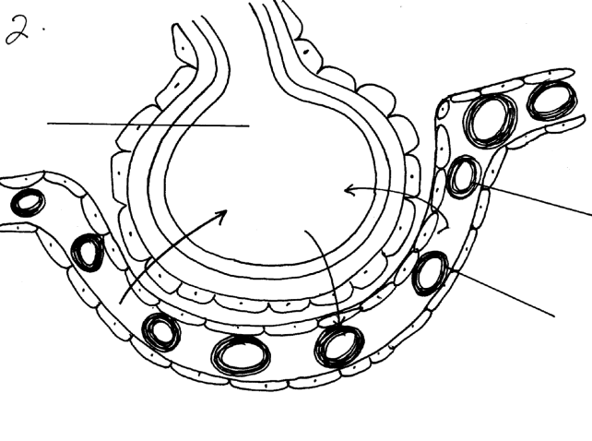
B
A
•
•

•
•
G H G
D
•
•
E
•
•
•

a) Name the blood vessel that brings blood to the lungs and the vessel which takes blood away from the lungs. (2mks)
b) Name the structure above. (1mk)
c) Label A and E. (2mks)
d) In what form is carbon (IV) oxide transported in structure labeled E. (1mk)
e) Name the gas G. (1mk)
6. Gastrin is a hormone produced by mammals.
(a) (i) Where is the hormone produced? (1mk)
(ii) What is the function of gastrin? (1mk)
(b) What stimulateds the production of gastrin. (1mk)
(c) The diagram below shows part of the human intestine.
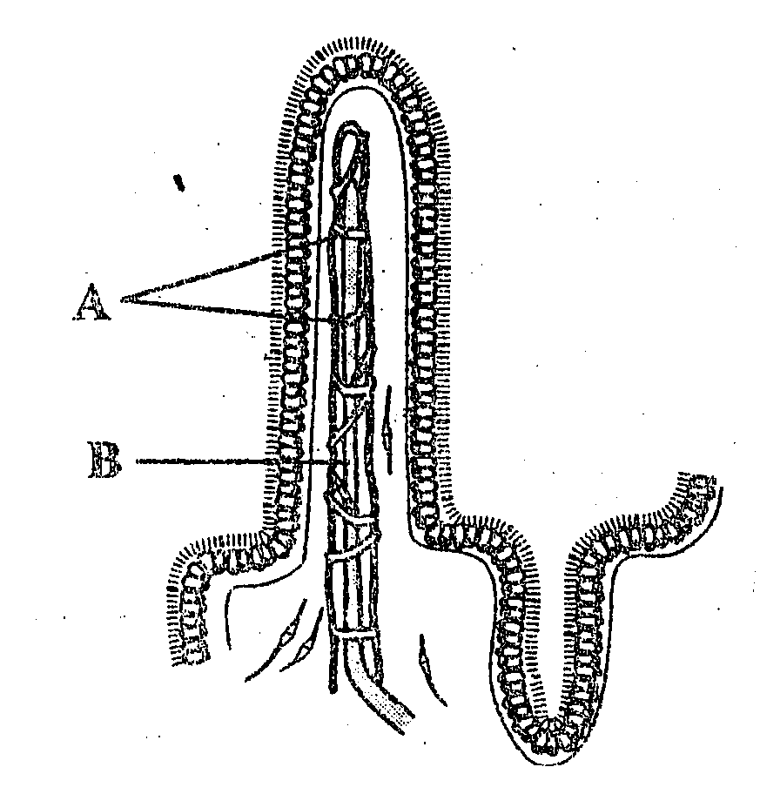

i) Identify the parts labeled A and B (1mk
(ii) To which circulatory system does the part labeled B belong. (1mk)
d) State any two adaptations of the human large intestine to its function. (2mks)
7. The diagram below represents part of a xylem tissue.
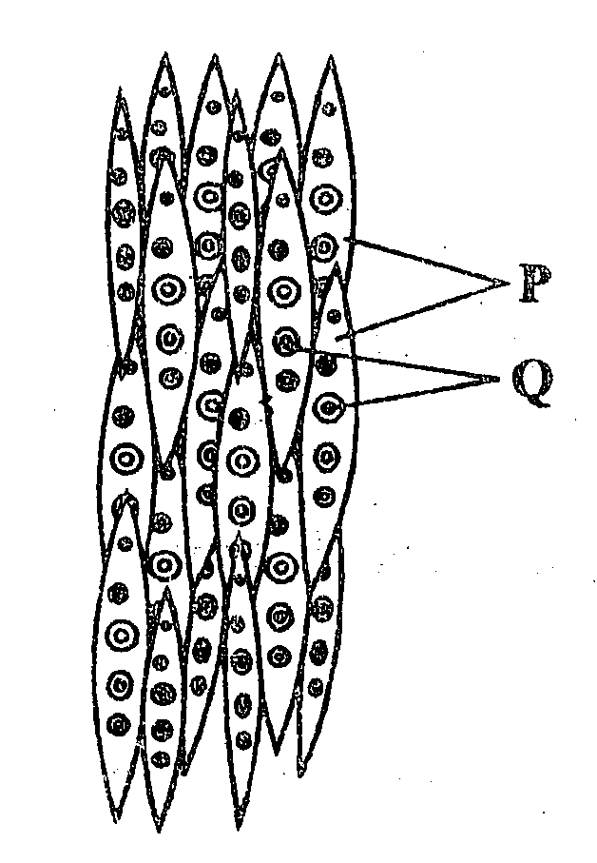

a) (i) Name the parts labeled P and Q (2mks)
(ii) Give the function of the part labeled P. (1mks)
b) State the function of the phloem tissue. (1mk)
c) (i) State how the functioning of the phloem tissue is affected if the companion cell is destroyed. (1mk)
(ii) Give a reason for your answer. (1mk
d) State any two structural differences between phloem and xylem tissues. (2mks)
8. In an experiment to determine the effect of exercise on the concentration of lactic acid in blood, the following data was obtained. Study the data and use it to answer the questions that follow.
The lactic acid concentration was measured before, during and after the exercise.
Time minutes | 0 | 10 | 20 | 25 | 30 | 40 | 50 | 60 | 70 | 80 | 90 | 100
Lactic acid conc. (arbituary units) | 0.5 | 0.5 | 5 | 13 | 12 | 8 | 6 | 4 | 3 | 2 | 1 | 0.9
a) Using a suitable scale, plot a graph of the concentration of lactic acid against time. (6mks)
b) From the graph you have drawn determine
(i) The period of exercise . Explain. (2mks)
(ii) The time when oxygen debt occurred Explain. (2mks)
(iii) The duration it took to pay back the oxygen debt.Explain (2msk)
c) On the same set of axes plot a hypothetical curve for oxygen intake during the experiment period of 90 minutes. (2mks)
d) Why does lactic acid level usually continue to rise in the blood after exercise ceases. (2mks)
e) Suggest the two importance of anaerobic respiration to animals. (2mks)
d) What is oxygen debt? (2mks)
9. What is the role of the liver in the maintance of a constant level of materials in the body. (20mks)
10.The diagram below represents a simple respiratory pathway in cells

Glucose
Ethanol + CO₂+ 210kJ
Substance B + 150kJ
Substance A
K, L, and M
Process X
Oxygen Process Y
Present
Plants
Animals

a) Name the process marked X and Y. (2mks)
b) State two differences between process X and Y. (2mks)
c) State the name of substance B and condition under which it is formed. (2mks)
d) Explain how body size affects the rate of respiration in animals. (2mks)
11. The diagram below represent the structure of a nephron. Study it and answer the questions that follow.
X
B
A
C
D
C

a) (i) State the physiological process by which solutes are selectively re-absorbed back into blood at the part labelled B. (1mk)
(ii) How is the part labeled B adapted to carry out the physiological process named in 3 (a) (i) above. (1mk)
b) In which part of the kidney is the part labelled A abundantly found. (1mk)
c) On the diagram above , indicate the direction of flow of blood using arrows at the part labelled C. (1mk)
e) State the functions carried out by the following hormones in the functioning of the nephron.
(i)Aldosterone. (1mk)
(ii)Anti diuretic hormone. (1mk)
12. The data below shows the rate of photosynthesis at different temperature in attached leaves of three East African plants. (Crotolaria, Gynandropsis and Amaranthus species) respectively which were grown outside with the same illustration while water and carbon (IV) oxide are not limiting factors in this experiment.
Rate of photosynthesis was expressed interms of carbon (IV) oxide uptake in mg/mm²/hr at various temperatures as tabulated below.
Temperature ºC | Rate of photosynthesis (mg/mm²/hr)
 | Gynandropsis sp | Crotolaris sp | Amaranthus sp
5  10  15  20  25  30  35  40  45  50 | -  22  50  60  80  85  80  73  66  2 | 20  40  49  64  48  45  42  31  15  - | -  10  27  42  55  54  50  45  40  11

a) Represent the results graphically (rate of photosynthesis against temperature)
b) Using the graph in (a) above indicate optimum temperature for the Gynandropsis and Amaranthus species. (2mks)
Gynandropsis ………………………………………………
Amaranthus ………………………………………………
c) Give a reason why Gynandaropsis and Amaranthus could not function photosynthetically at 5ºC. (1mk)
d) What are the possible ecological habitats for the following plants. (2mks)
(i) Amaranthus
(ii) Crotolaria
e) At what temperature was the amount of carbon (IV) oxide around the leaf of Gynandropsis highest? (1mk)
f) What raw material is required in the light stage of photosynthesis. (1mk)
g) Name the parts of chloroplasts in which the following stages of photosynthesis take place. (2mks)
(i) Light stage
(ii) Dark stage
h) State one structural similarity and difference between chloroplast and mitochondria. (2mks)
Similarity
Difference
i)What is the compensation point of photosynthesis? (1mk)
13 (a) Explain why plants lack elaborate excretory organs like those found in animals. (3mks)
(b) Name five methods of excretion in plants. (5mks)
(c) State any six excretory products in plants and give economic uses. (12mks)
14. During a laboratory investigation, a scientist extracted gastric juice from the mammalian stomach. He used it to carry out tests on a food sample B which was suspected to contain proteins. He divided the food sample B into three portions and treated them as below.
I. On the 1st portion of B, he added Gastric juice and mixed them thoroughly before adding sodium hydroxide followed with copper (II) sulphate drop by drop.
II. On the 2nd portion of B, he added boiled gastric juice and mixed them thoroughly before adding sodium hydroxide followed with copper (II) sulphate drop by drop.
III. On the 3rd portion of B, he added Gastric juice, sodium bi-carbonate and mixed them thoroughl before adding sodium hydroxide followed with copper (II) sulphate drop by drop.
a) State the observations he made in each set up. (3mks)
- 1st portion
- 2nd portion
- 3rd portion
b) Why was the experiment on the 1st portion included in the tests? (1mk)
c) Name the property of the chemical being investigated in these tests. (1mk)
d) Account for the observations made in 2 (a) above. (3mks)
15. The diagram below illustrates circulation in certain organs of the mammalian body.
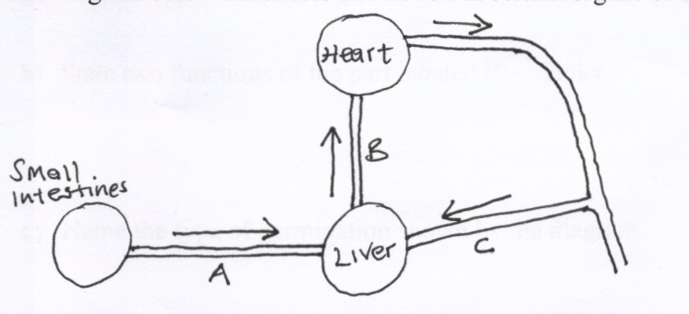
Heart
Small Intestines
B
C
Liver
A
a) Identify the blood vessels represented by A, B and C. (3mks)
b) Explain why blood from the small intestines goes to the liver before it goes to any other organ of the body. (2mks)
c) Compare the blood in vessels B and C. (1mk)
d) Outline how a glucose molecule in vessel A finally reaches the heart. (2mks)
16. The table below shows how the internal temperature two animals X and Y varied with the external temperature. The temperature was measured regularly and recorded for 12 hours in a day. Study the table and answer the questions that follow.

a) Using the same grid, draw graphs of external temperature, and internal temperature of animals X and Y
(Y-axes) against time (X-axes). (7mks)
b) Account for the variation of internal and external temperatures for the animals X and Y. (2mks)
c) Identify the classification of organisms whose internal temperature varies as X and Y (2mks)
d) Explain two ways used by organism Y to make its internal temperature vary as shown despite of changes in external temperature. (4mks)
18 a) Give the functions of the skin in organisms. (6mks)
b) How is the mammalian skin modified to enable it perform its functions? (l4mks)
19. The diagram below shows how gaseous exchange occurs across the gills in fish.

gills

(a) According to the diagram water and blood flow in opposite direction across the gills.
(i) Give the term used to describe this flow. (1 Mark)
(ii) Explain the advantage of the above flow named in a(i) above. (2 Marks)
(b) What difference would be observed if water and blood flows across the gills in the same direction? (2 Marks)
(c) In which structures in the gills does gaseous exchange take place? (1 Mark)
(d) Name two organs in man which display the flow system named in a(i). (2 Marks)
20. An experiment was carried out to investigate the effect of different concentrations of Sodium Chloride on human red blood cells. Equal volumes of blood were added to equal volumes of salt solutions of different concentrations. The results were as shown below:-
Set up | Sodium Chloride concentration | Shape of red blood cells at the end of experiment | Number of red blood cells at the end of experiment
A  B | 0.9%  0.3% | Normal  Swollen | No change in number  Fewer in number

- If the experiment was repeated with 1.4% Sodium Chloride solution, state the results you would expect with reference to:-
(i) Number of red blood cells. (1 Mark)
(ii) Appearance of red blood cells when viewed under the microscope. (1 Mark
Account for the fewer number of red blood cells in 0.3% Sodium Chloride salt solution. (3 Marks)
c) Give the biological term which can be used to describe 0.9% Sodium chloride solution.(1 Mark)
d) Define plasmolysis. (1 Mark)

Marking Scheme
1. i) Osmosis.
ii) A – solution in potato cup increases. Level of water in the beaker decrease;
B- Remain the same;
iii) A – Surrounding the cube is a region with high concentration of water molecules while in the sugar crystals, there are very few water molecules;
The sugar crystals exert on Osmosis pressure by Osmosis water molecules move across the potato tissue, which acts as a semi-permeable membrane. The level rises;
B- No change since boiling denatures the membrane structure of potato cells;
iv) C- No water moves into the potato cup/remains the same; since there is no concentration gradient;
2(a) i) Graph.
- 0.402 ± 0.01
- 11% ± 1%.
b) i) All cells have been haemolysed; cells contains one hypertonic to salt solution; water enters cells by osmosis; cells swell and eventually burst.
ii) No cells were haemolysed; cell contents were isotonic to salt solutions (aments of water entering the cell was equal to that leaving the cell); no net movement of water into cells;
c) The cells would become crenated; the cell contents would be hypotonic to salt solutions; water would leave cells by osmosis; membranes would shrink.
d) Contents of Onion epidermal cells would be hypertonic to water; water would enter cells by Osmosis; cells would become turgid;
3. - Temperature;- High temperature faster rate of transpiration; high temperature increases the capacity of atmosphere to hold water and moisture; also heat increase internal temperature of the leaf hence water evaporation; 4 accept converse
- Atmospheric pressure; Low atmospheric pressure, high rate of transpiration 2
- Humidity; Low humidity higher rate of transpiration; low humidity increases the saturation defiant; hence water moves form leaves to drier atmosphere; 4
- Wind; When it is windy the rate of transpiration is higher; wind sweeps away vapour that has accumulated at the surface of leaf; increasing saturation deficit; hence faster rate of transpiration 5
- Light intensity;High light intensity faster rate of transpiration high light intensity increase photosynthesis rate hence stomata opens; 4
- Amount of water in soil; More water in the soil increases the rate of transpiration; it wets the xylem (ensure xylem is wet throughout); 3 Max 20
4. a) Define digestion and ingestion.
i) Digestion- It is break down of complex insoluble; √ food substance into simple soluble food substance;√
ii) Ingestion- is introduction of food through the mouth into the digestive system;
b) Describe the digestion of Ugali.
- Digestion of ugali begins in the mouth; √ ugali is chewed by the teeth to increase large surface area √ for action of salivary amylase/ptyalin; √ The food mixes with saliva produced by salivary glands;√
- Saliva contains mucus and enzyme ptyalin. Mucus moistens, softens and lubricates the food;√ ptyalin speeds up the conversion of starch to maltose; √ ugali is made into bolus in the mouth;√
- The bolus moves along the oescophagus and prestalsis/by contraction and relaxation of circular and longitudinal muscles into the stomach;√
- The digestion continues until ugali become acidic since the stomach does not contain carbohydrase/carbohydrate digesting enzymes no digestion of ugali takes place here.√
- Ugali now moves into duodenum by peristalsis in form of acidic chime; √ where it mixes with the bile from the liver and pancreatic juice from the pancreases;√ bile being alkaline neutralizes the stomach acid;√ and provides a suitable alkaline medium for the enzymes to act on carbohydrates;√
- Pancreatic juice contains three enzymes out of the which enzyme amylase speeds conversion of starch to maltose;√
- When food reaches the ileum; it mixes with intestinal juice which contains several enzymes. Maltase – speeds up conversion of maltose to glucose;√
- Lactose which speeds up conversion of lactose to glucose√ and galactose; sucrase which speeds up conversion of sucrose into fructose and glucose;
- Absorption – glucose, the end product of all carbohydrates diffuses through the epithelium of villi and capillary walls and enters into blood stream and is carried to the liver via hepatic portal veins;√
- Assimilation- in the liver excess glucose is converted into glycogen and stored;
- - The rest of the glucose is carried by the blood tissues where is oxidized during tissue respiration to release energy;√ (21 max 18 mks Total 20mks)
5. (a) - Pulmonary artery
- Pulmonary vein
(b) Alveolus
(c) A- cavity of alveolus
E – Red blood cell
(d) Hydrogen carbonate ions;
Carbamino haemoglobin;
6. (a) (i) Walls of stomach;
(ii) Stimulates the secretion / production of gastric juice; √
(b) Presence of food in the stomach;
(c) A – Blood capillaries; B – Lacteal;
(d) - Produces plenty of mucus to lubricate coarse/indigestible material during peristalsis;
- Wide human accommodates /store indigestible food
- Elongate to increase surface are for absorption of water.
- has muscles to facilitate peristalsis when they contract;
7. (a) (i) P – Tracheids Q – pits
(ii) P- water conducting elements of xylem
(b) Function of phloem – translocation/ transport of organic substances from the leaves to the of the plant;
(c) (i) Translocation of food will not occur acc. Slow translocation
(ii) Reason – it contains a lot of mitochondria which provide energy for translocation;
(d)

Phloem | Xylem
- Made of living cells  - Have companion cells  - Have cytoplasmic strands  - Lack lignin deposits | - made of dead cells  - lack companion cells  - lack cytoplasmic strands  - have lignin deposits; (any 2x1=2mks)

8. (a) Photocopy – scale – 1m
Labeling axes – 1
Plotting – 2m
Curves – 2m (curves must be labeled) rej. Dotted line for curves
A GRAPH OF LACTIC ACID CONCENTRATION AGAINST TIME
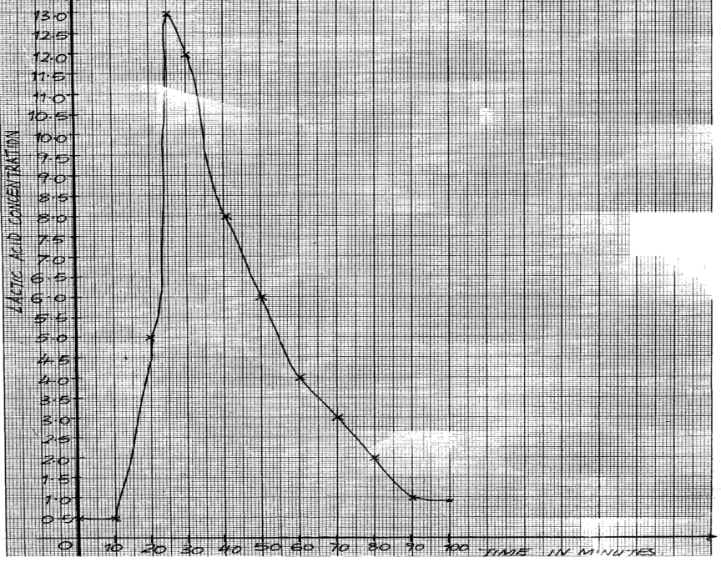

(b) (i) 10-15 minutes ; period of rapid increase in lactic acid concentration (2mks)
(ii) 10-20 seconds : period when lactic acid level starts to increase; (2mks)
(iii) 75minutes i.e. from 25th minutes to the 100minutes, this is the time lactic cid took to decrease from the highest level to normal; (2mks)
(c) It would have the same basic shape; but would peak slightly ahead of the lactic acid curve in time;
(e) Because it is still diffusing out of the muscles, where it was made a few minutes earlier;
(e) Allows for energy production even cases of oxygen deficiency; thus enables animals to survive active exercise and to inhabit even in areas with limited oxygen supply;
(f) Oxygen debt is the amount of oxygen to get rid of the lactic acid; that has accumulated due to anaerobic respiration; (2mks)
9. Regulation of blood sugar level; under the influence of insulin; and glucagons (hormones). When there is excess sugar; the hormone insulin stimulate/causes liver cell to convert it to glycogen; some converted to fats/lipids for storage;
• When the blood sugar level is below normal: the hormone glucagon causes liver cells to convert glycogen to glucose;
• Regulation of amino acids; excess amino acids; are deaminated; by the liver (cells) leading to formation of urea; which is transported by the blood to the kidney; for elimination;
• Production of heat: the liver is involved in the thermoregulation due to many metabolic, activities; taking place in the liver cells a lot of heat is generated which is distributed to the entire/whole body;
• Detoxication of toxic substances; (such as drugs and hydroxide peroxide)
• Elimination of haemoglobin; and formation of bile; breakdown worn out red blood cells; the bile salts (sodium tyrochocolate and sodium glycocholate; in the bile eEMULSIFYfats (in the duodenum)
• Storage of blood in its veins; thus regulating the volume of blood circulating in the body
• Elimination of sex hormones after they have performed their function/work; storage of vitamin AD and B₁₂ some mineral salts; thus regulating their levels in the blood TOTAL 23 MAX 20
10. (a) X - glycolysis Y – Kreb’s cycle
(b)
Process X | Process Y
- occurs in cytoplasm  - independent of oxygen  - produces less energy  - raw material is glucose  - End products are energy, CO₂, lactic acid or ethanol | - occurs in mitochondria  - Is oxygen dependent  - produces more energy  - Raw material is pyruvate  - End products are energy, CO₂ and water

(c) lactic acid; under anaerobic conditions
(d) small body size leads to alarge surface area to volume ratio; hence more loss of heat to the environment; leading to increased rate of respiration to replace the lost heat;
11. (a) (i)Active transport/diffusion
Tied (ii) Numerous Mitochondria in its wall to generate energy/microvilli/coiling increase surface area/thin epithelium for quick diffusion.
(b) Cortex
(c) on the diagram
(d) plasma proteins; Blood cells; accept specific examples e.g. albumins, red blood cells;
(e) (i) Regulate re-absorption of Sodium salts;
(ii) Regulate re-absorption of water
12. (a) Allocation of marks on graph
(b) Gynandropsis – opt To = 30ºC
Amaranthus – opt. to = 25ºC
(c)At 5ºC, the enzymes that catalyse the process of photosynthesis are inactivated.
(d) Amaranthus – Terrestrial; Crotolaria – terrestrial;
(e) 50ºC;
(f) water;
(g)(i) Granum; (ii) Stroma
(h) Similarity: Both have double membrane; 1mk – Both have fluid filled matrix;
Difference : inner membrane of mitochondrion is folded to form cristae while inner membrane of chloroplast is smooth;
- chloroplast is biconcave shaped while mitochondria is oval/sausage shaped (any 1x1=1mk)
(i) Point at which the rate of photosynthesis equals to the rate of respiration.
13. (a) – plants wastes accumulate slowly;
- plants produce less toxic wastes;
- some excretory products are recycled by plants e.g. CO₂, SO₂)
- plant tissues are tolerant to toxic wastes;
- plant wastes are stored in temporary structures which fall off e.g. leaves (any 3x1=3mks)
(b) – Diffusion;
- Transpiration;
- Exudation;
- Deposition of wastes/ leaf fall/ flower fall/ storage in bark;
- Recycling;
- Guttation ; (any 5x1=5mks)
(c)
Excretory products | Uses
- Caffeine;  - Popain;  - Tannin;  - Nicotine;  - Latex;  - Quinine;  - Atropine;  - Morphine;  - Colchine;  - Cocaine;  - Cannabis;  - Khat/ miraa; | Body stimulant;  Meat tenderizer;  Leather tanning;  Stimulant; insecticide;  Manufacture of tyre/rubber products;  Anti-malarial drugs;  Increase heart beat; dilate eye pupil;  Cancer treatment;  Used in genetics to induce polypoidy;  Anesthesia/painkiller/stimulant;  Pain killer;  Stimulant; (Any 6x2=12mks)

14. (a) 1st portion. - Blue; colour was observed
2nd portion – Purple; colour was observed
3rd portion – Purple; colour was observed
(b) A control experiment;
(c) Proteins are highly sensitive to temperature and pH changes; (award if either temp of pH is stated singly)
(d) 1st portion – Enzyme pepsin broke down proteins into peptones;
2nd portion – Enzyme pepsin works in acidic medium; (not in basic medium)
15. (a) A – Hepartic portal vein; B – Hepartic vein; C – Hepartic artery;
(b) – So that any toxic substances absorbed together with food nutrients from the ileum be detoxified;
- So that food substances e.g. glucose, amino acids can be regulated. Only the required quantity of glucose is left in circulation as excess is either stored as glycogen, fat and excess may be respired.
Excess amino acids are deaminated;
(c) B – Deoxygenated C - Oxygenated
(d) From the small intestines, it is transported to the liver through Hepartic portal vein; (It is then transported to the heart through the hepartic vein;
16. (a) graph
(b) X – Lacks internal mechanisms to regulate its internal temperature
Y – Has internal means to regulate its internal temperature. hence able to maintain it within narrow range
(c) X – Poikilotherm Y – Endotherm
(d) – Blood vessels vasodilate when temperature is higher than norm to allow for heat loss from blood through radiation, evaporation, etc; when temperature is lower, blood vessels constrict to prevent loss of heat from blood through radiation, evaporation etc;
- When temperature is higher, lies flat to allow for heat loss from the body since insulation layer of air is removed; when temperature is lower, hair strands erect to hold air which insulates the body against heat loss through radiation, evaporation etc.
17. (a) Higher temperature; increases the kinetic energy; of water molecules which makes water turn into vapour on the leaf surfaces faster and hence increase rate of transpiration
- Higher light intensity; influences maximum opening of stomata which increases the surface area; over which transpiration occurs maximumly
- Wind; carries away moisture around the plant and create a higher saturation deficit; which then increases the rate of water loss/transpiration in plants.
- Higher relative humidity; reduces saturation deficit; which causes lowering of water loss/transpiration in plants.
- Higher amount of water in the soil; makes the plant to absorb excess water which increases the need for the plant to get rid of it through transpiration faster;
- If the leaf is broader and has numerous larger open stomata; the surface area over which water loss occurs is increased; causing increase in the rate of transpiration. (award max. 12mks)
18. (a) – It protects the underlying tissues against mechanical injury, UV-light rays and entry of pathogens; (Rej. germs)
- As an excretory organs, it enables organisms to eliminate excess water, ions and traces of urea;
- As a sensory organ, it enables the organisms to be aware of deviations in pressure, touch and temperature from the external environment;
- It is a thermoregulator such that it enables the body to lose excess heat to lower its temperature back to norm or may enable the organisms to store it s heat if the temperature is lower and hence raise it back to the norm;
- It takes part in osmoregulation by enabling the body fluids to get rid of excess water or excess ions;
- It takes part in the regulation of the pH of body fluids by enabling the body to get rid of either Hydrogen ions or bi-carbonate ions;
(b) – Presence of the cornified layer; which tough and has keratin to enable it protect the underlying tissues from mechanical injury; It alsos has sebum; which is antiseptic and enables it to prtect the ody against entry of pathogesn. Presence of melanin; enables it to protect the underlying tissues against damage by t UV-light radiations.
- It has sweat glands with secretory cells; which absorb excess water, excess ions and traces fo urea from blood and secrete them into the sweat duct;
- Has the sweat pores; which open son the skin surface to allow for elimination of sweat containing excess water, excess ions and traces of urea;
- It has nerve endings; which enables it to detect any deviations in temperature, pressure and contact/touch;
- It has hair follicles; which stand erect when temperature is lower than normal to reduce heat loss from the body or lie flat to enable to body lose excess heat and lower temperature back to the norm when the internal temperature is higher;
- Has blood vessels; which vasodilate when temperature is higher than norm to enable the organisms lose than the norm to reduce heat loss from the body;
19. a) i) Counter current system;
ii) Maintain a diffusion gradient so that there is maximum uptake of oxygen; continue diffusing into blood and Carbon (iv) oxide into water;
- Parallel flow lower diffusion gradient; so that less oxygen diffuse into blood/low rate of gaseous exchange
- Gill filaments
- Placenta
Kidney
20 a) i) Remain the same
ii) Crenated
- The solution is hypotonic to red blood cells hence the cells grains water; by osmosis; swelling until they burst.
- Isotonic solution
- Plasmolysis – the process by which plant cells loss water by Osmosis shrink and become flaccid.

BIOLOGY DIAGRAMS
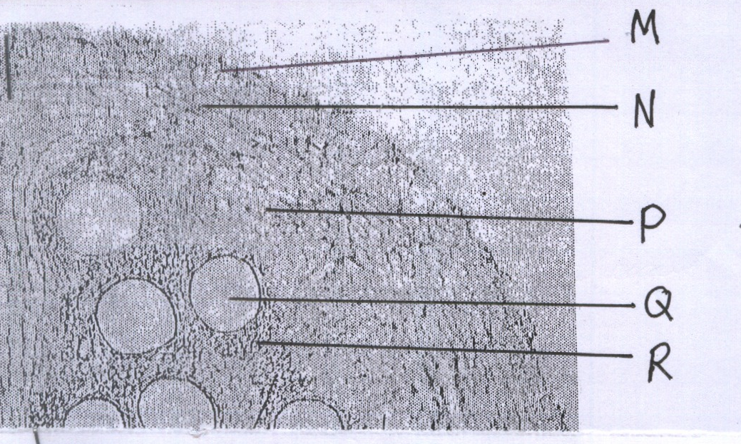
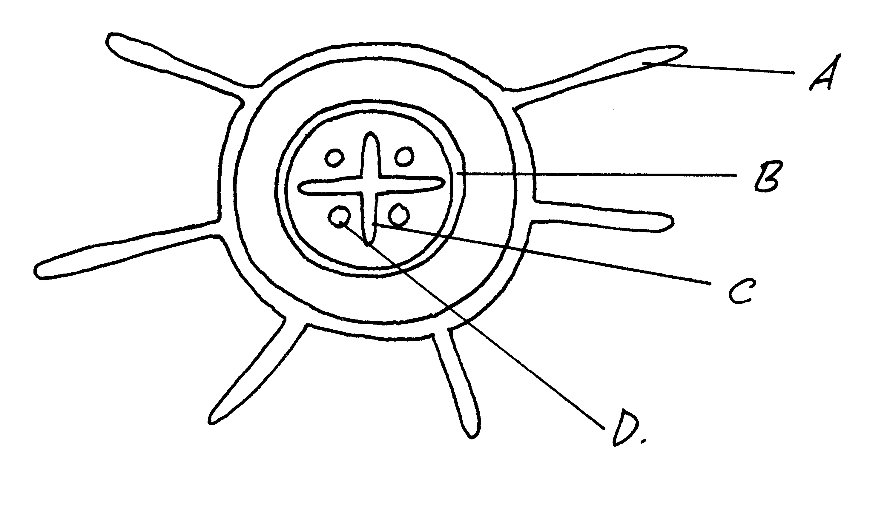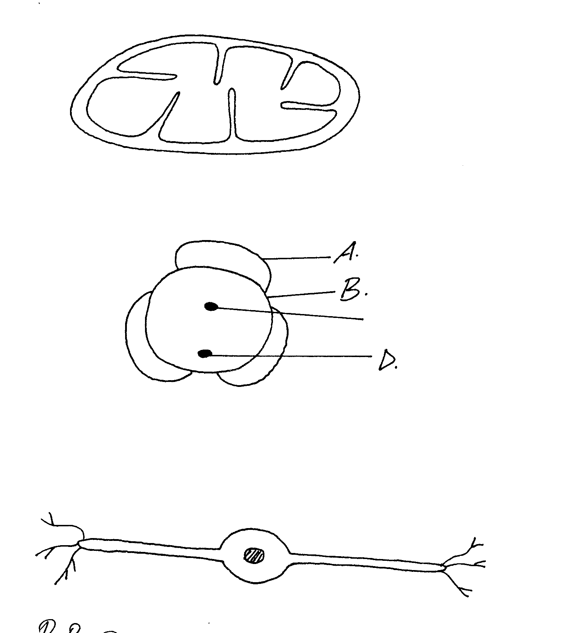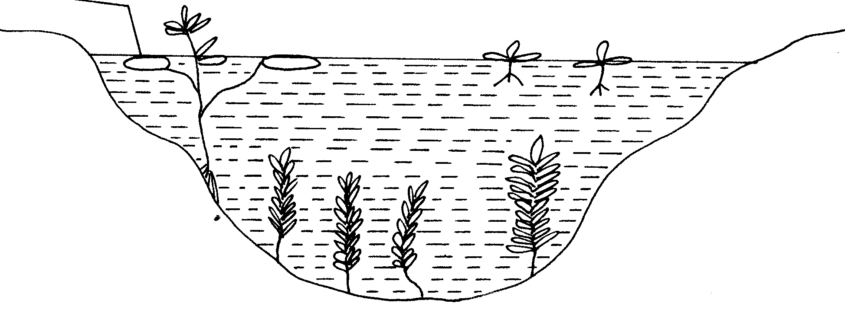
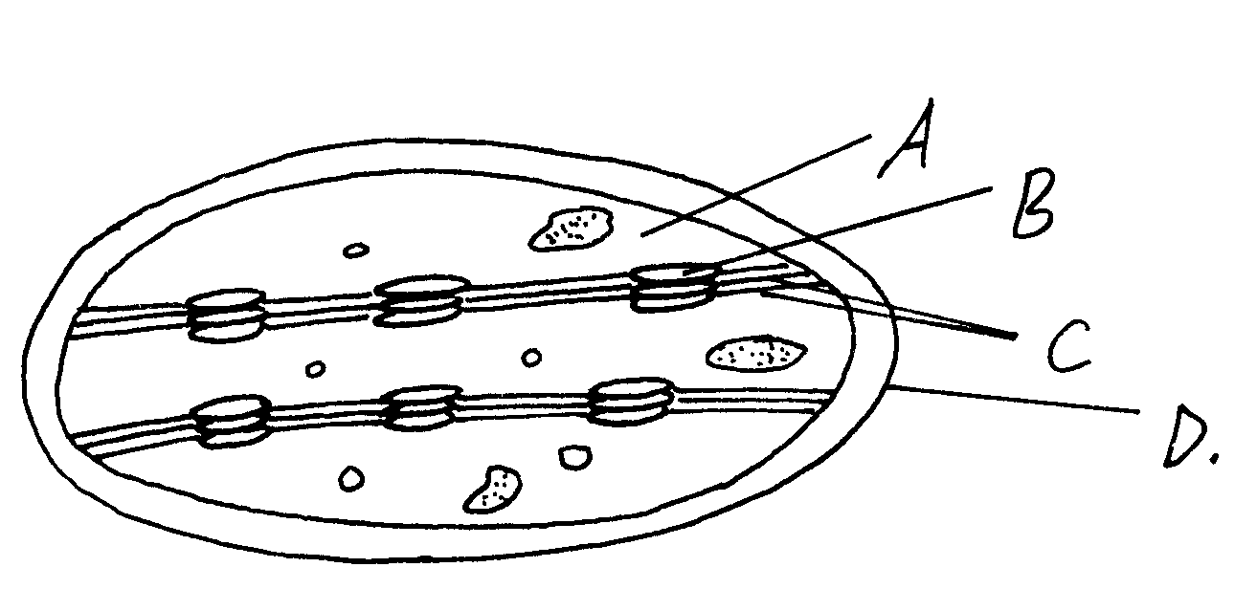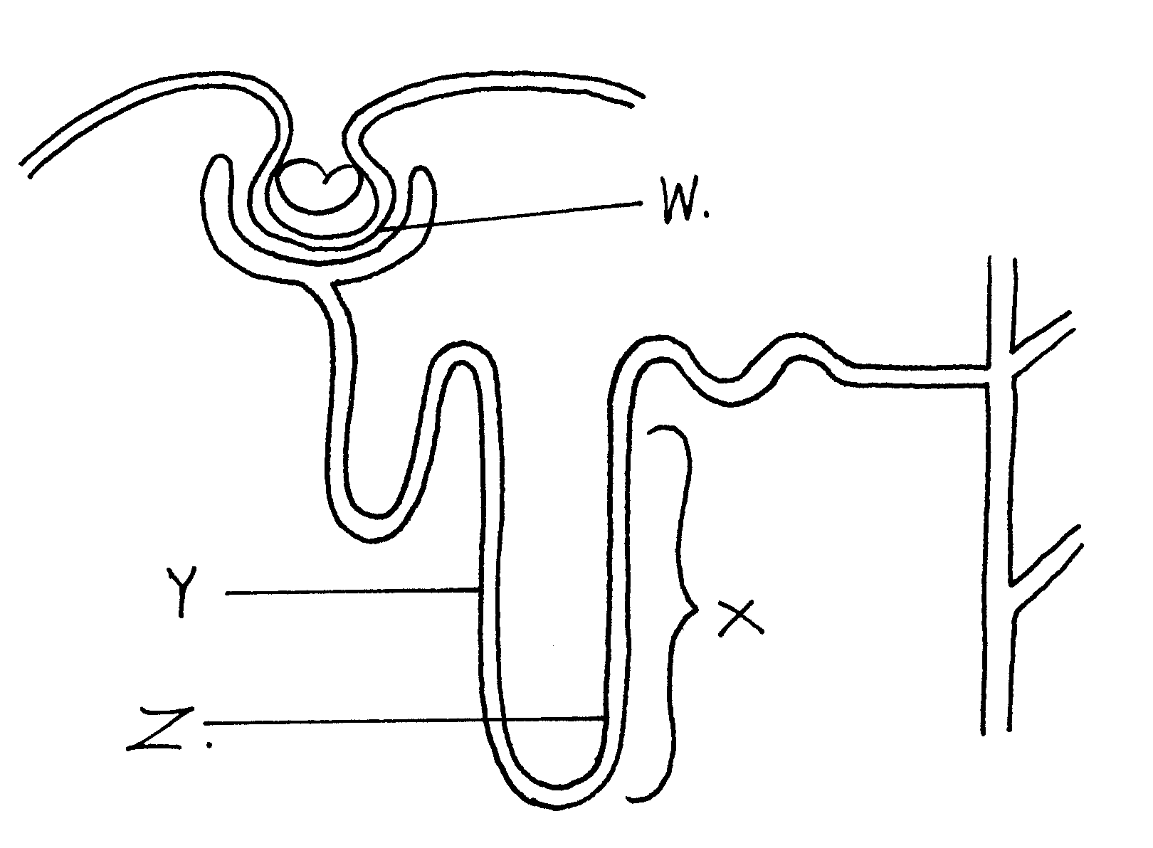

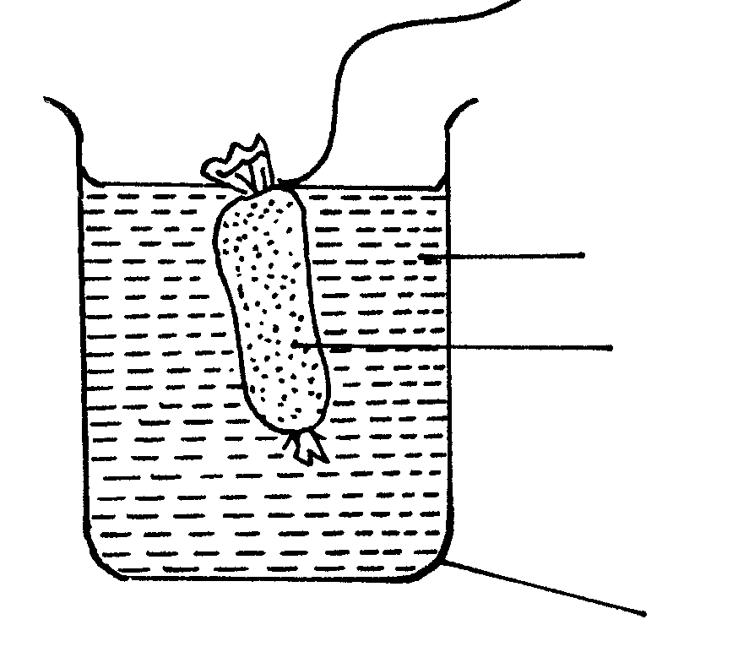
Starch and glucose solution
Boiling tube
Visking tubing
Distilled water
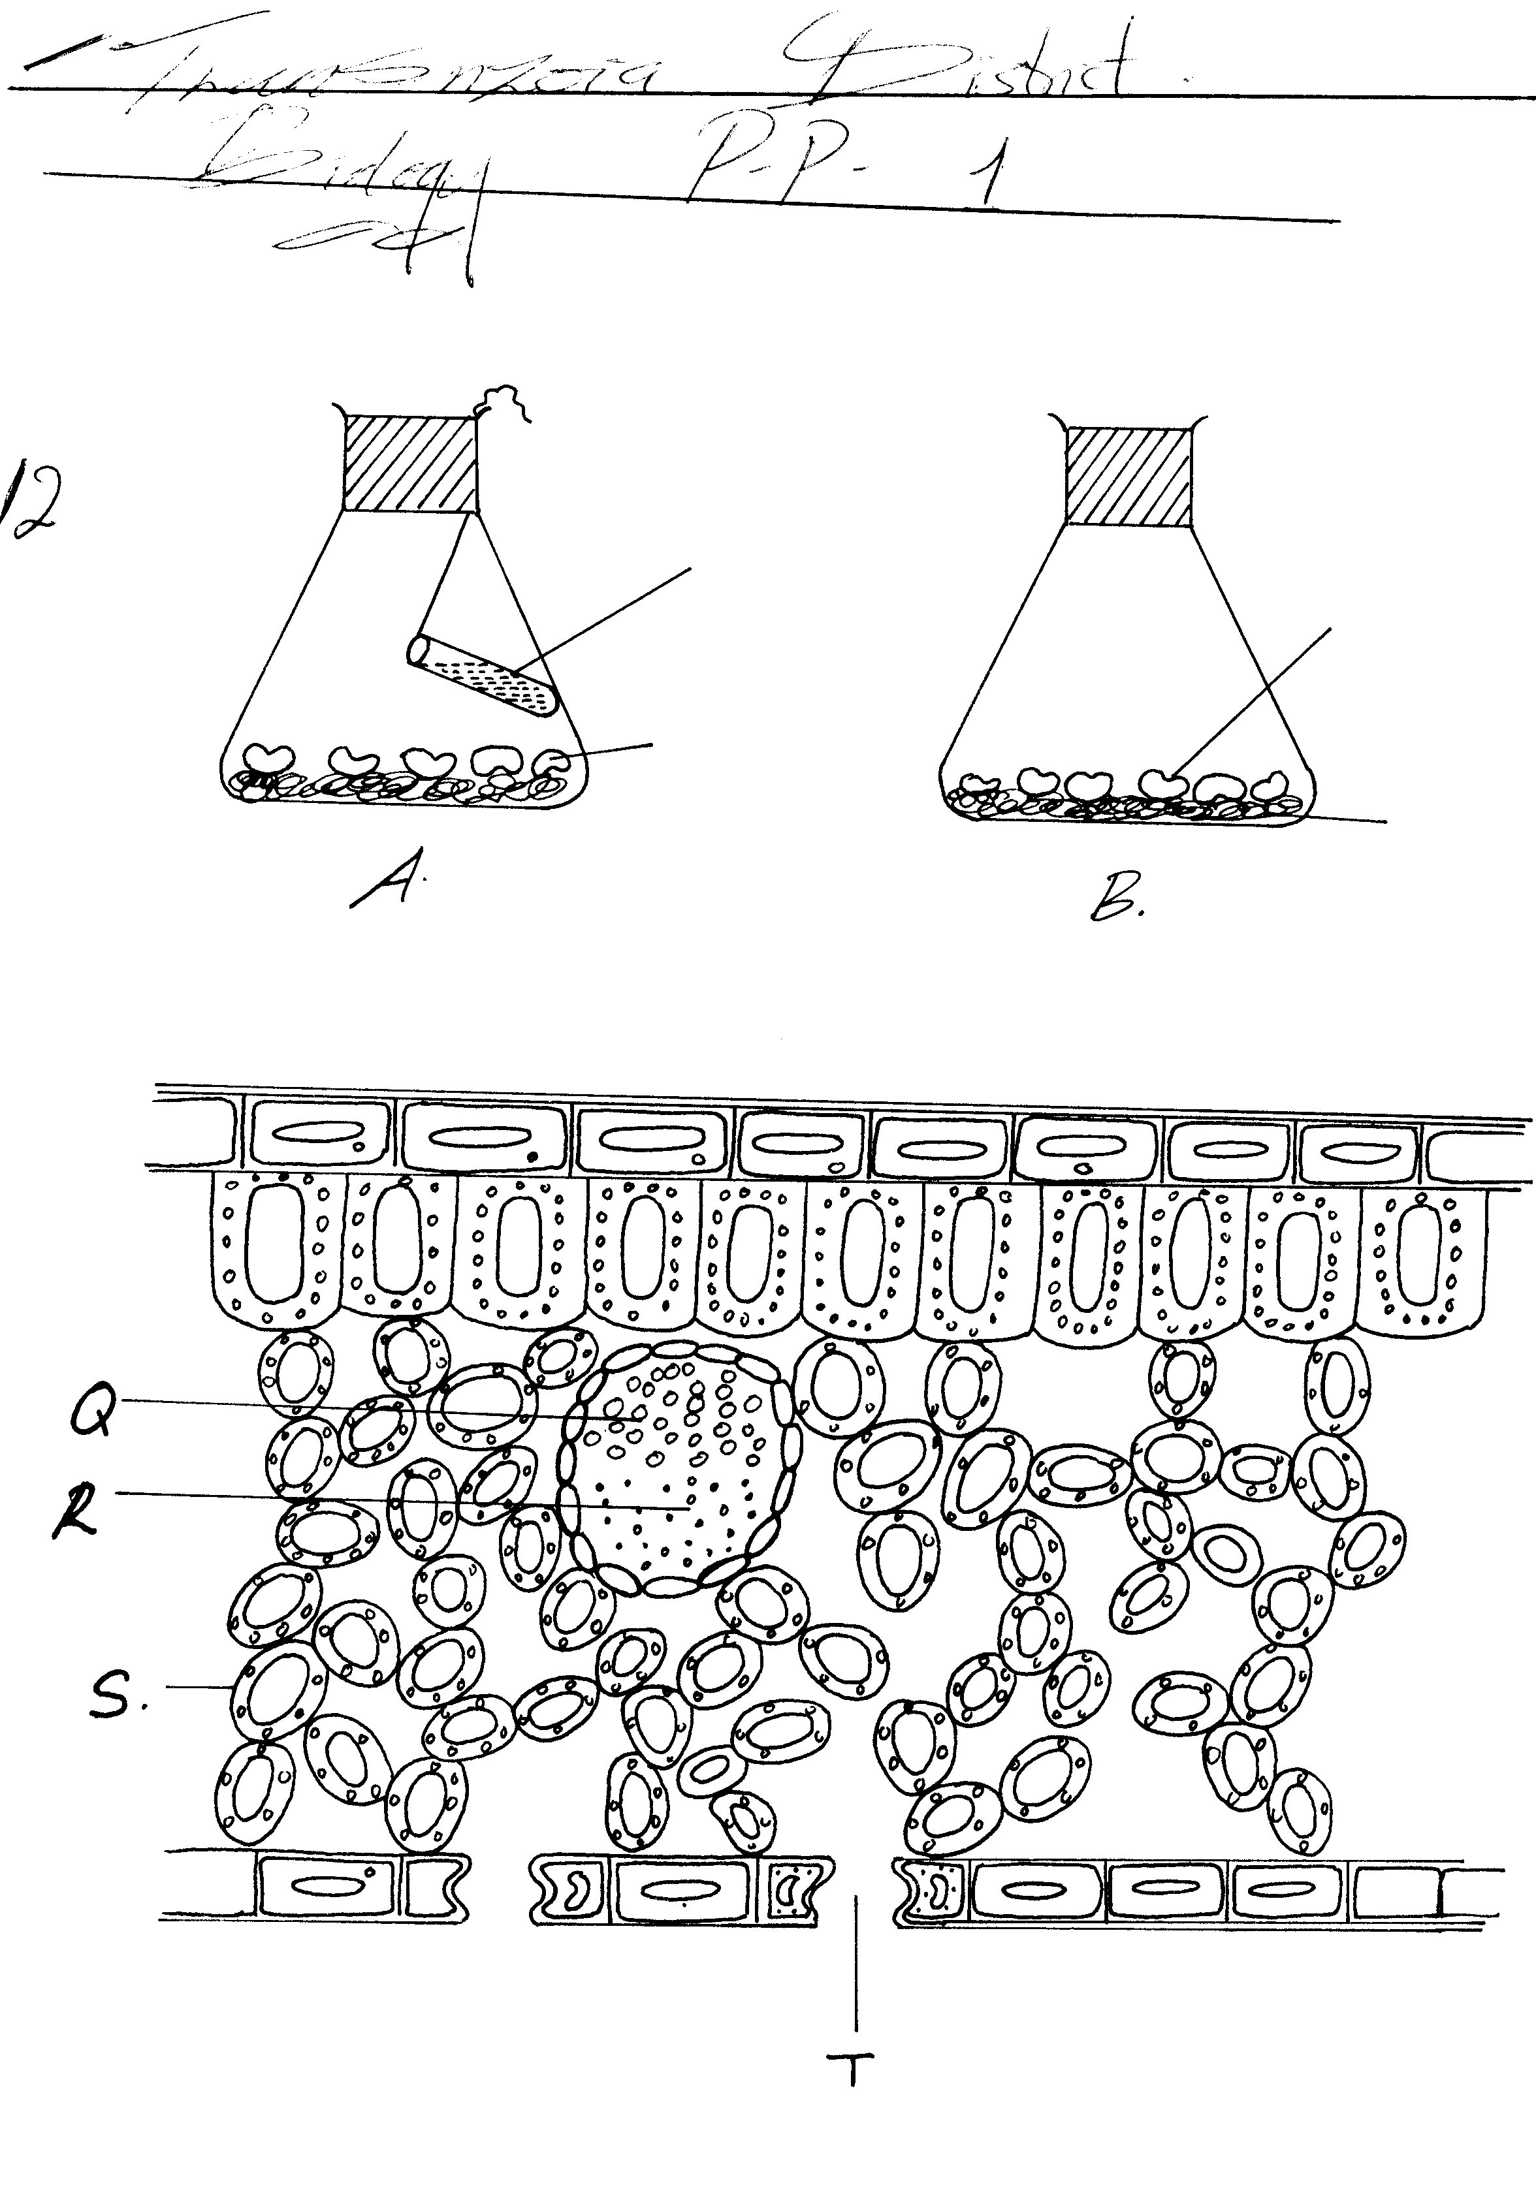
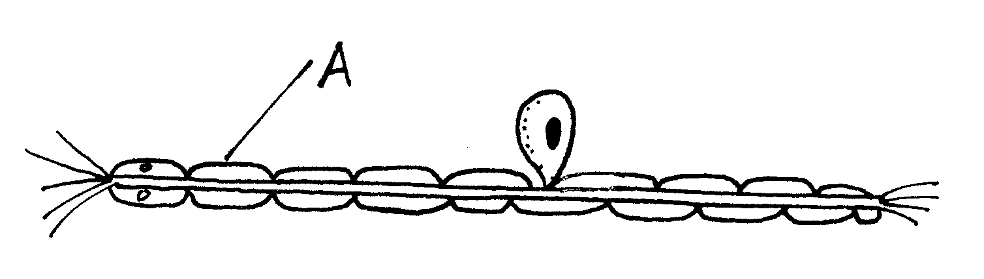
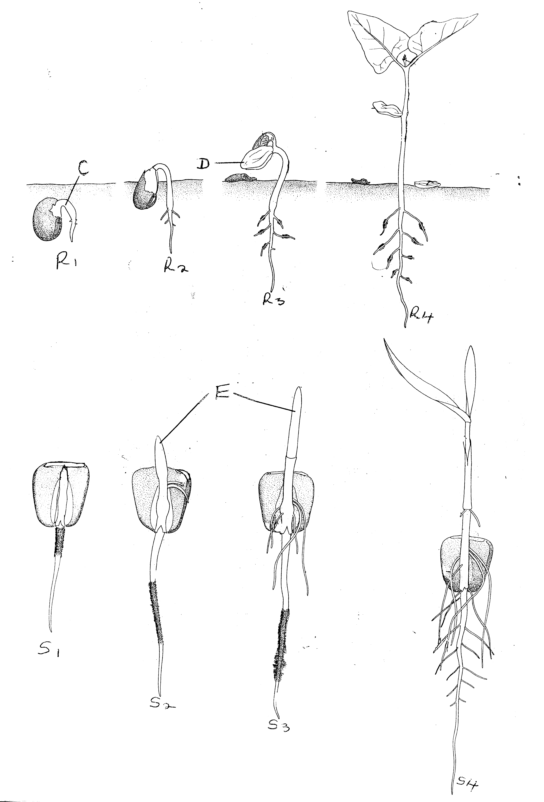
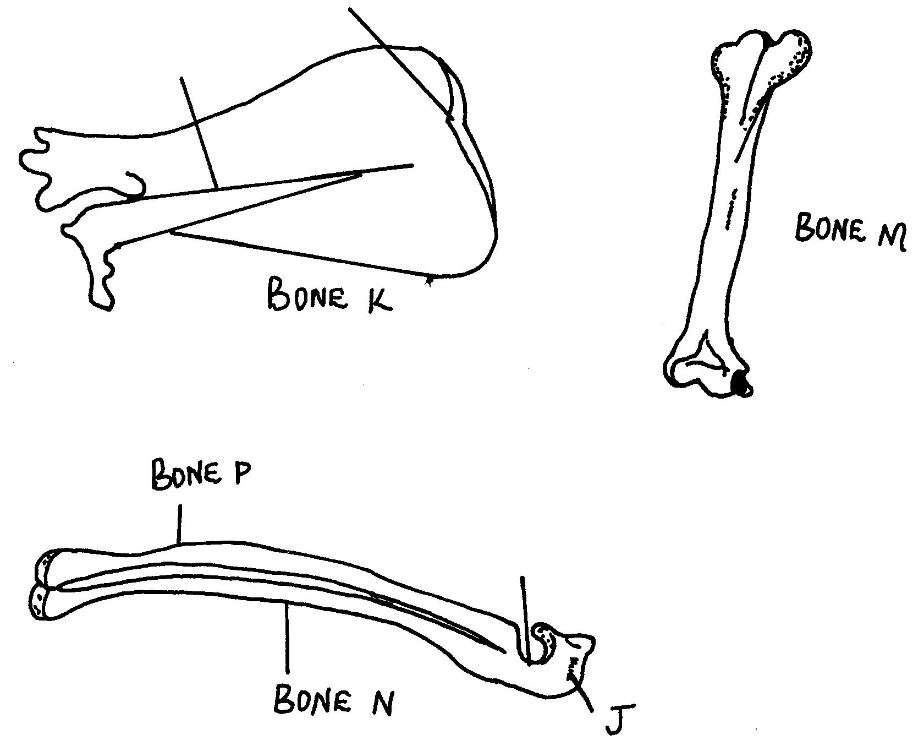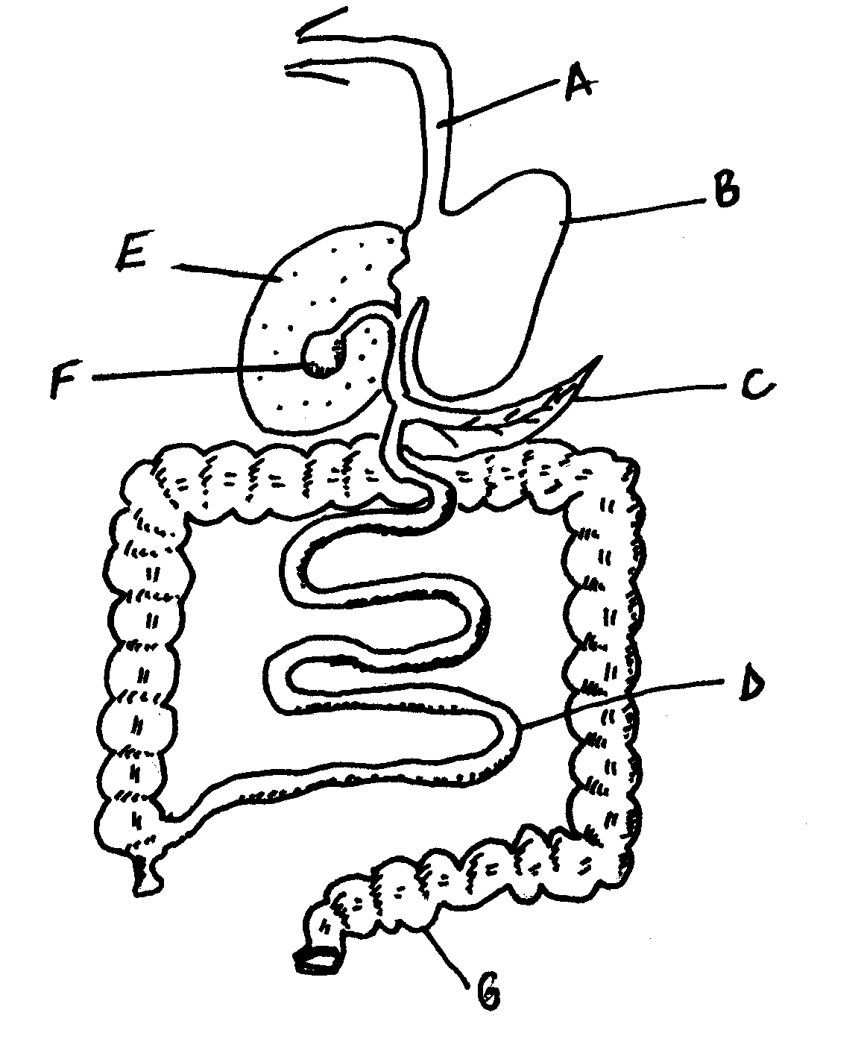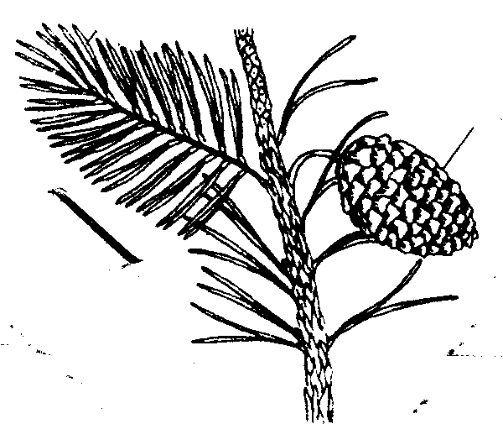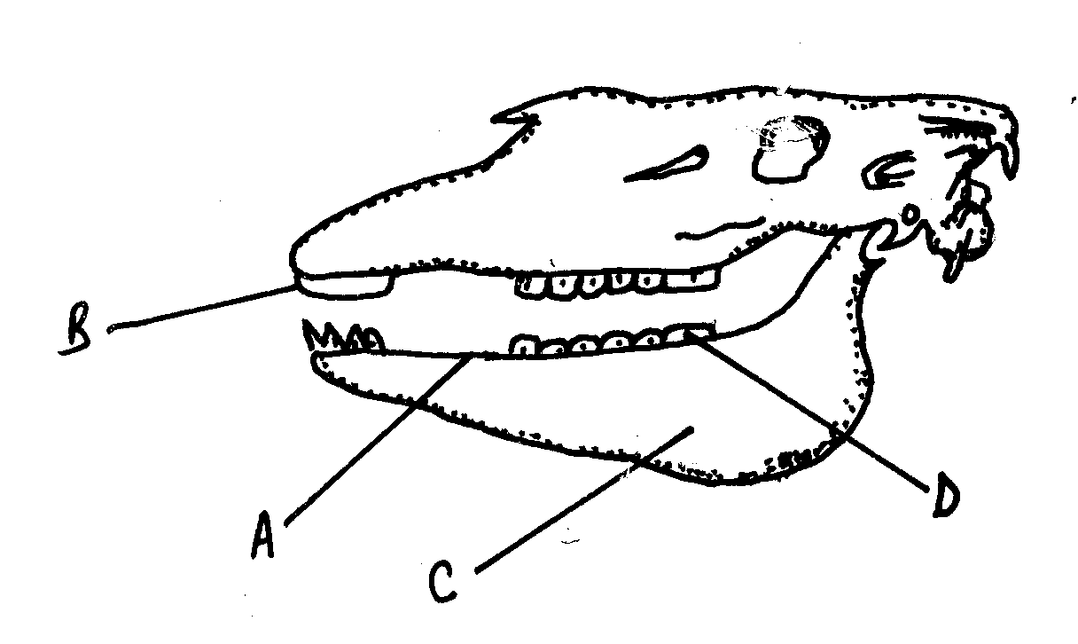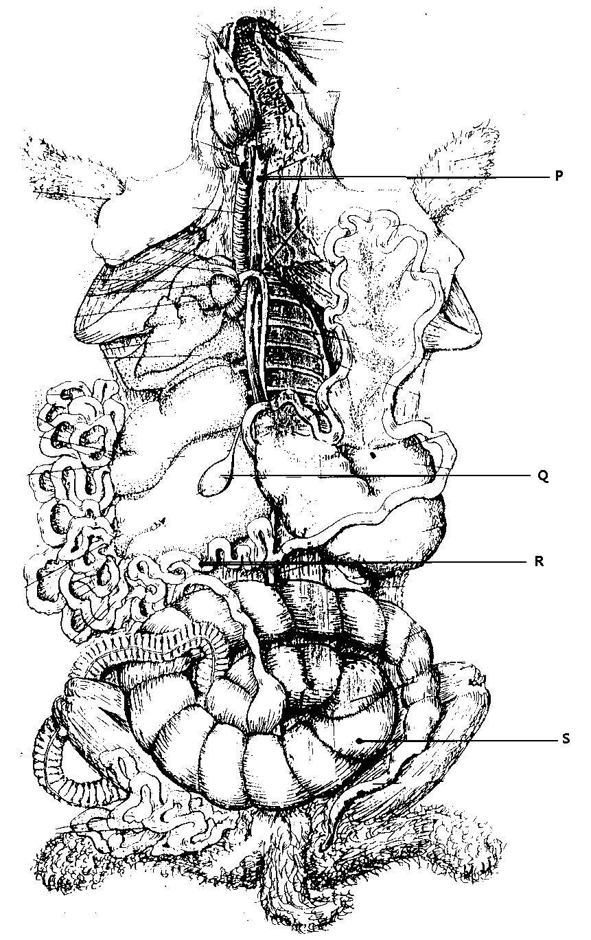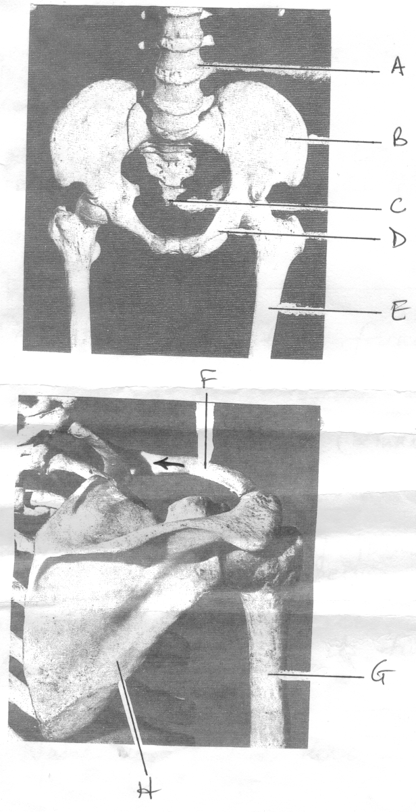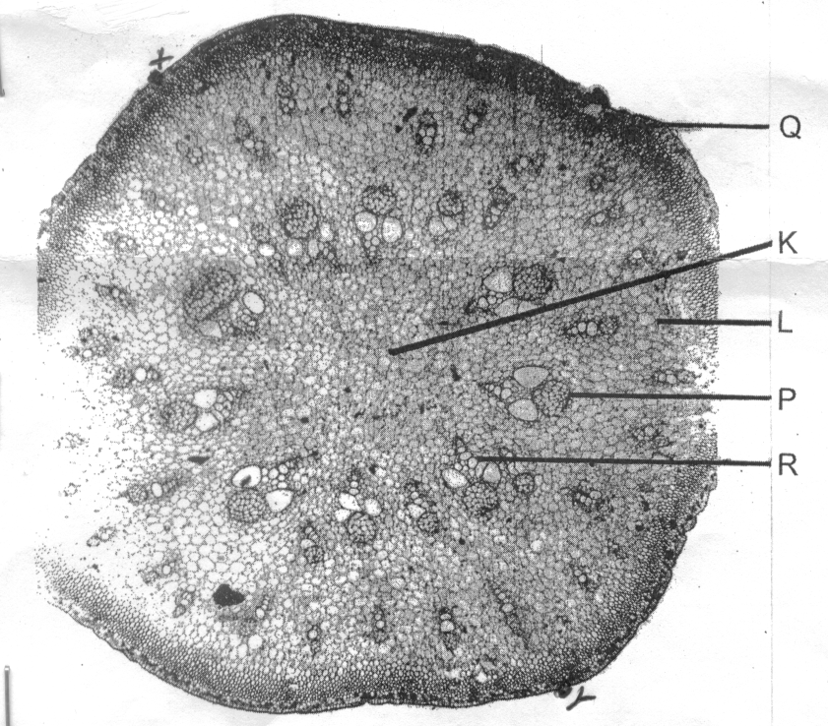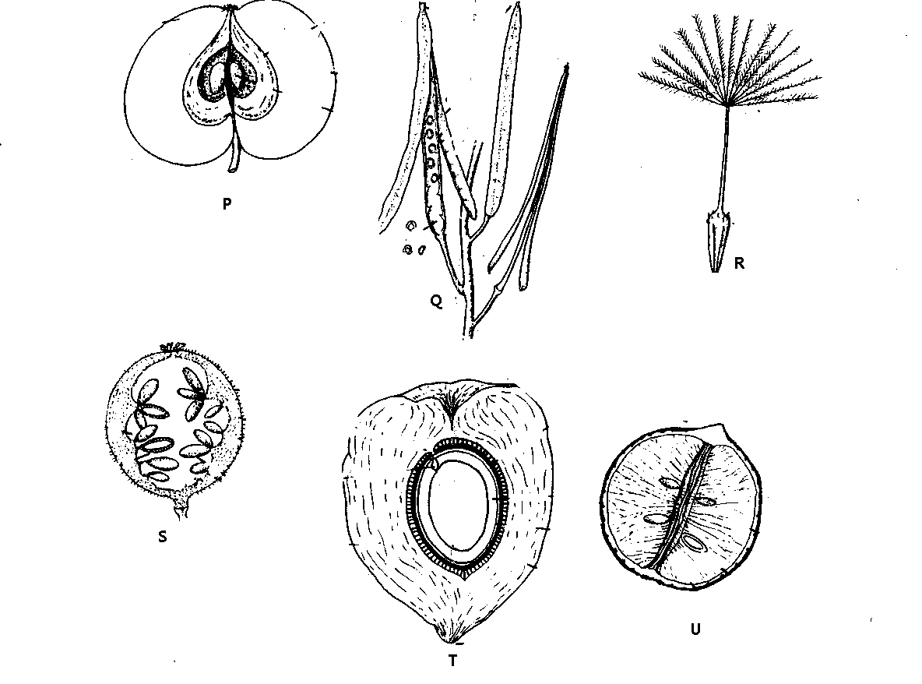
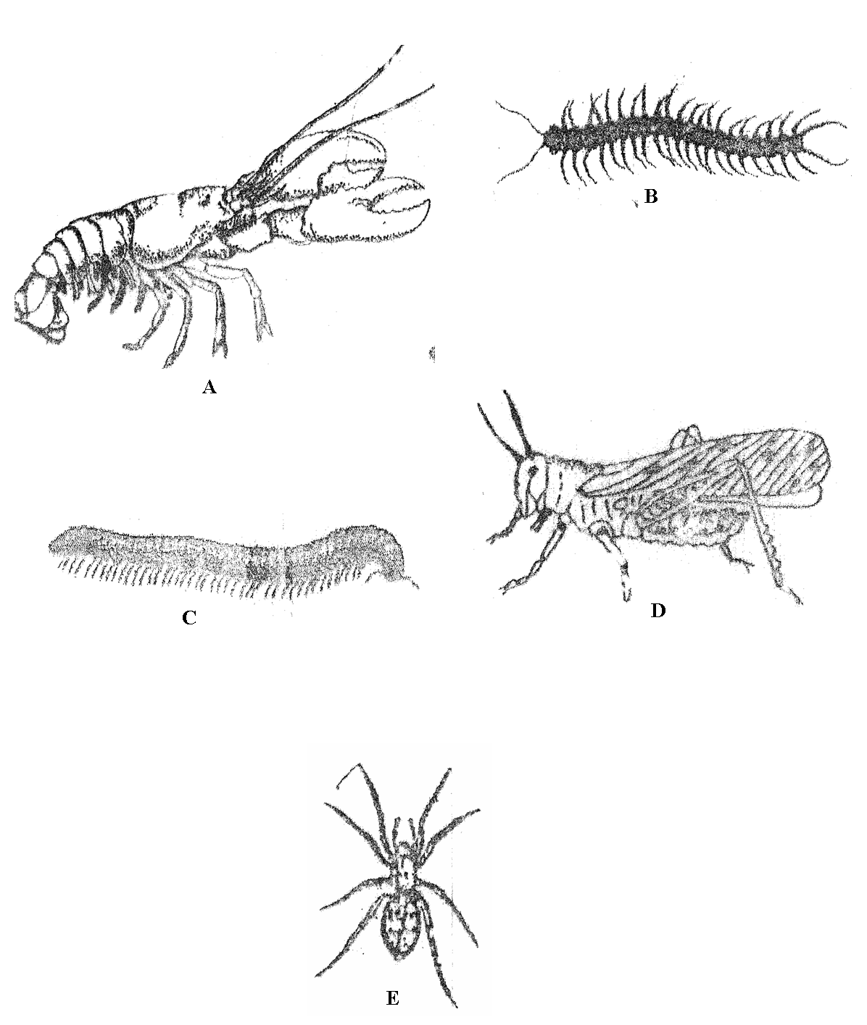
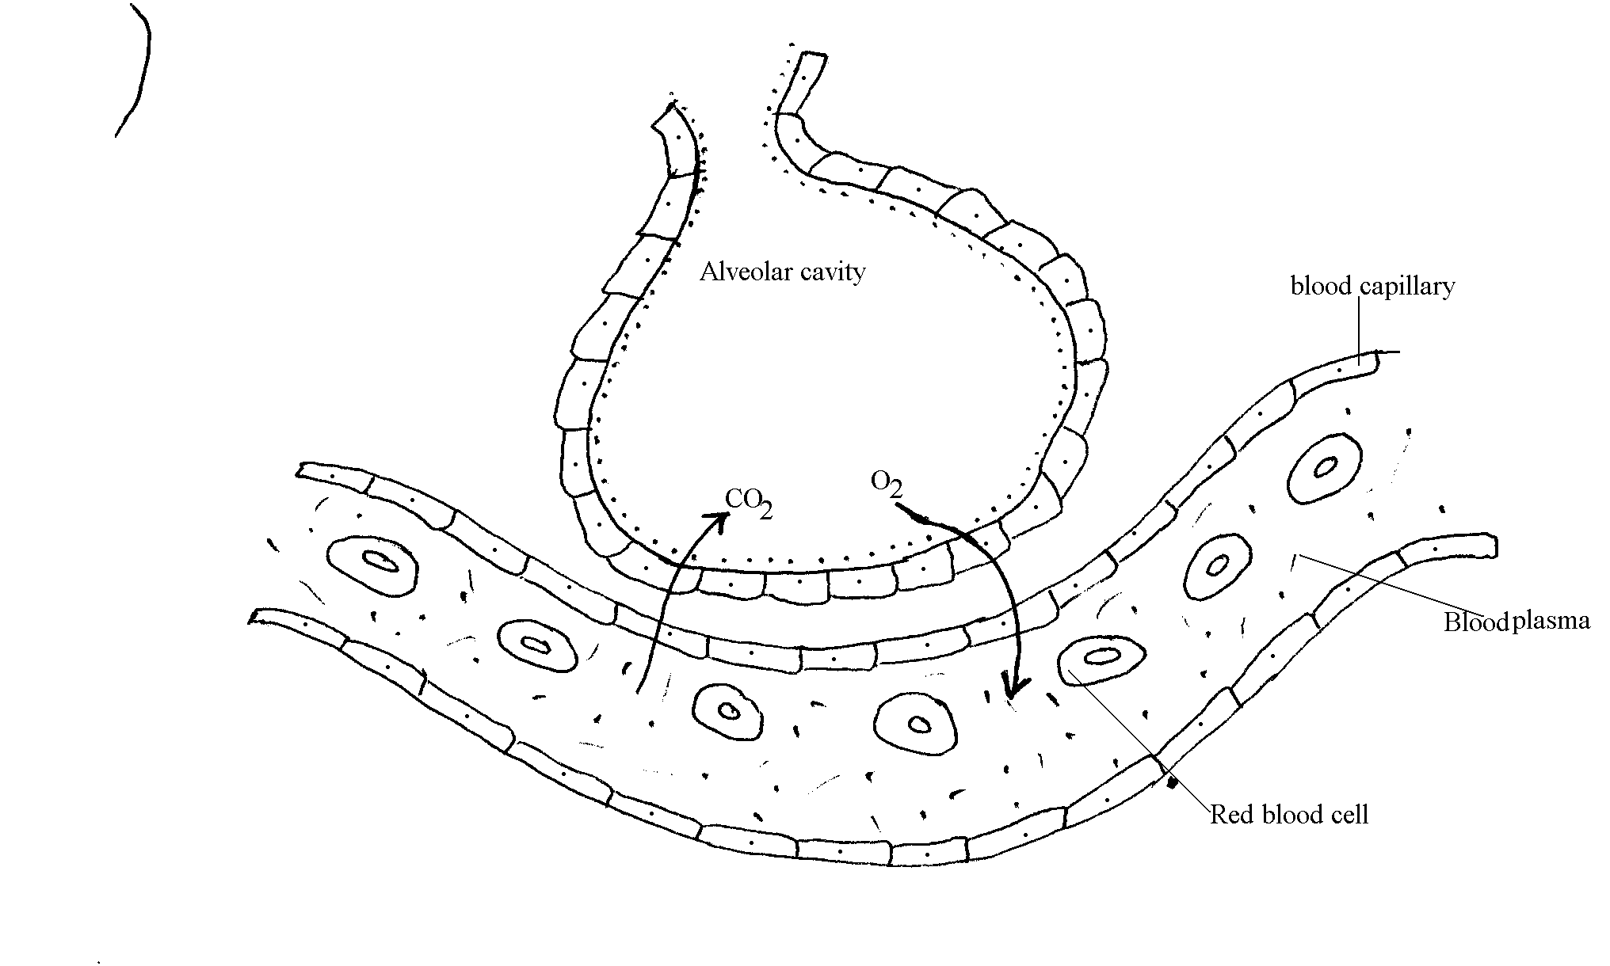
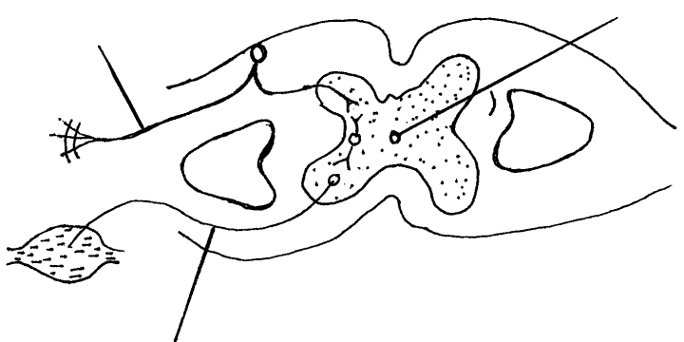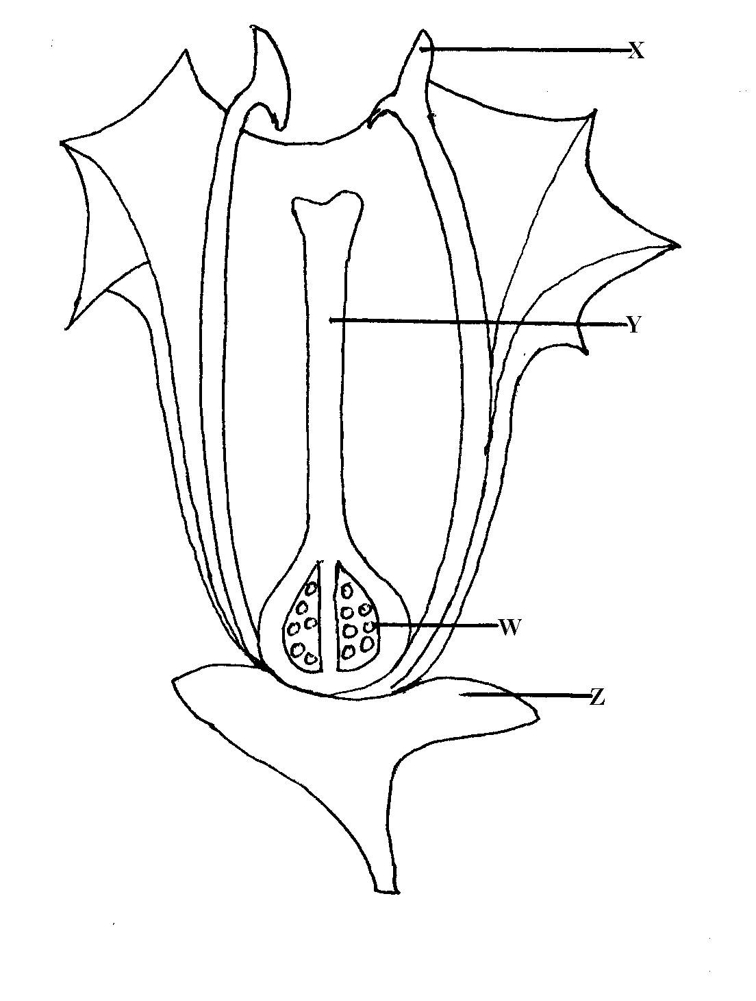

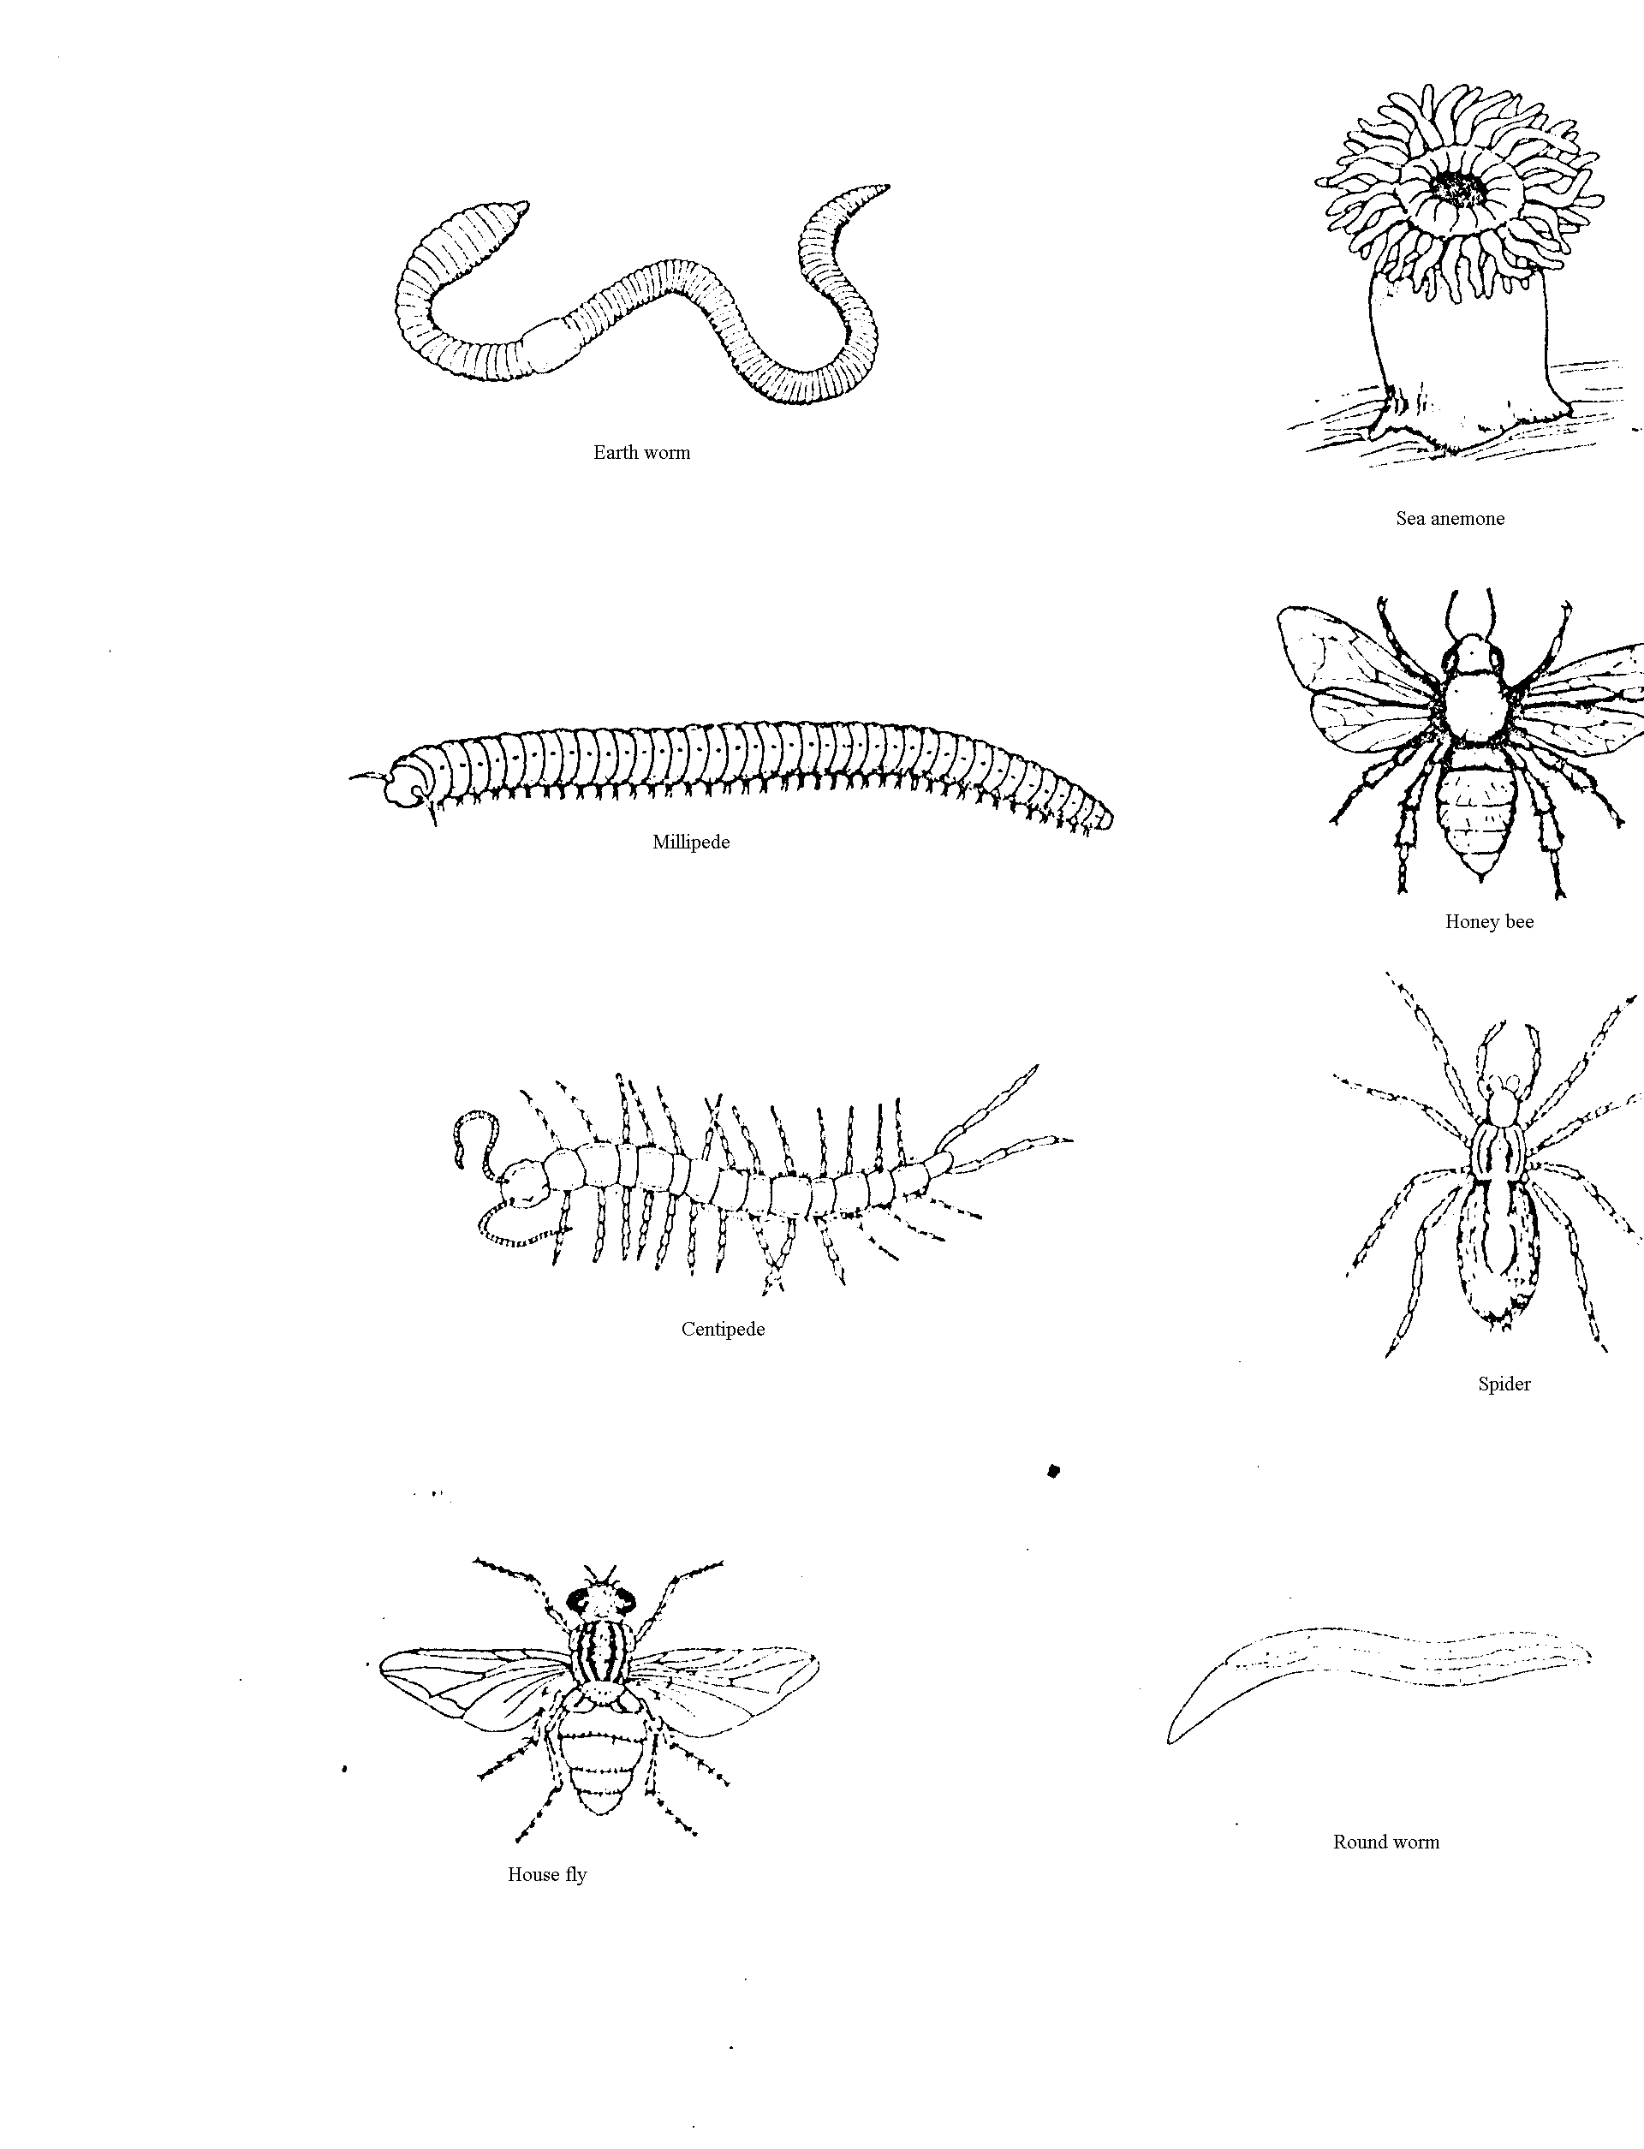
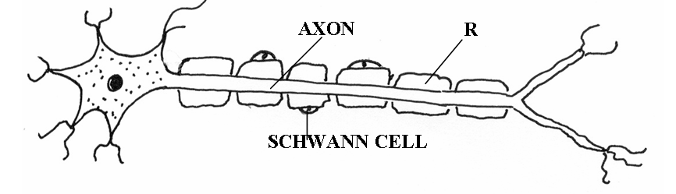
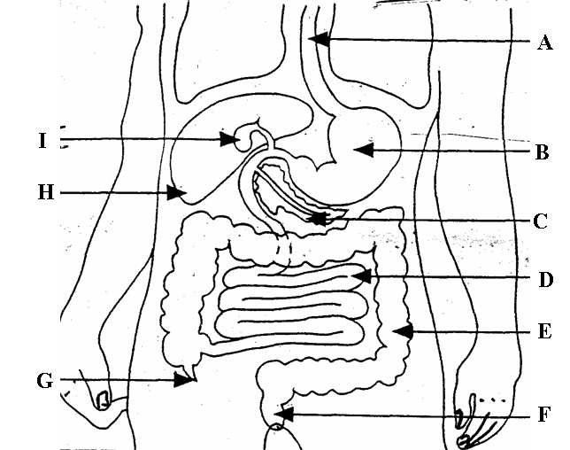
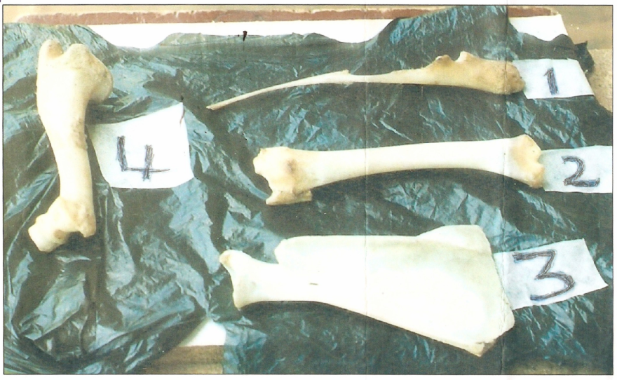

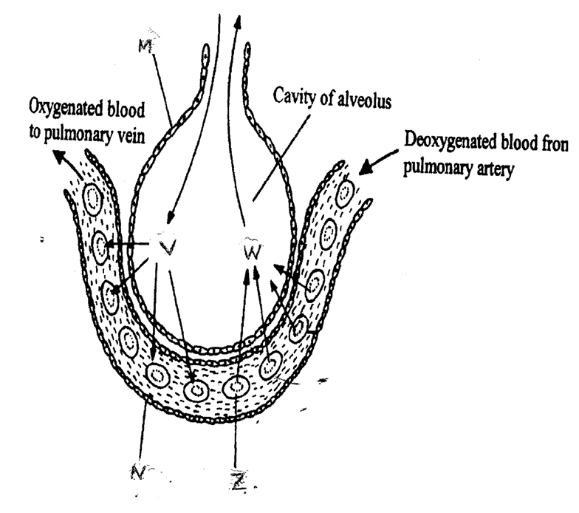
V
W
M
N
Z

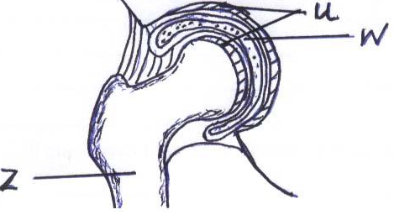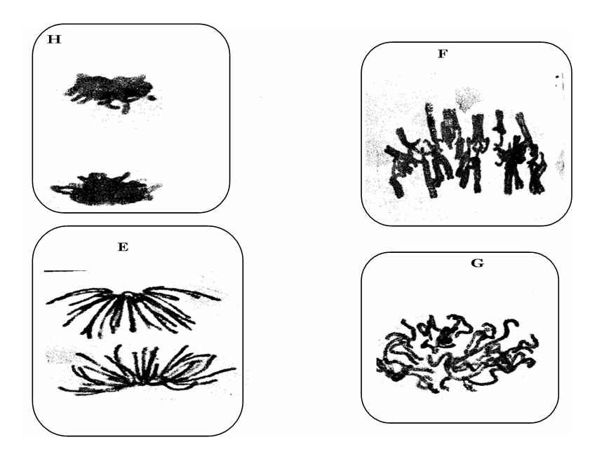
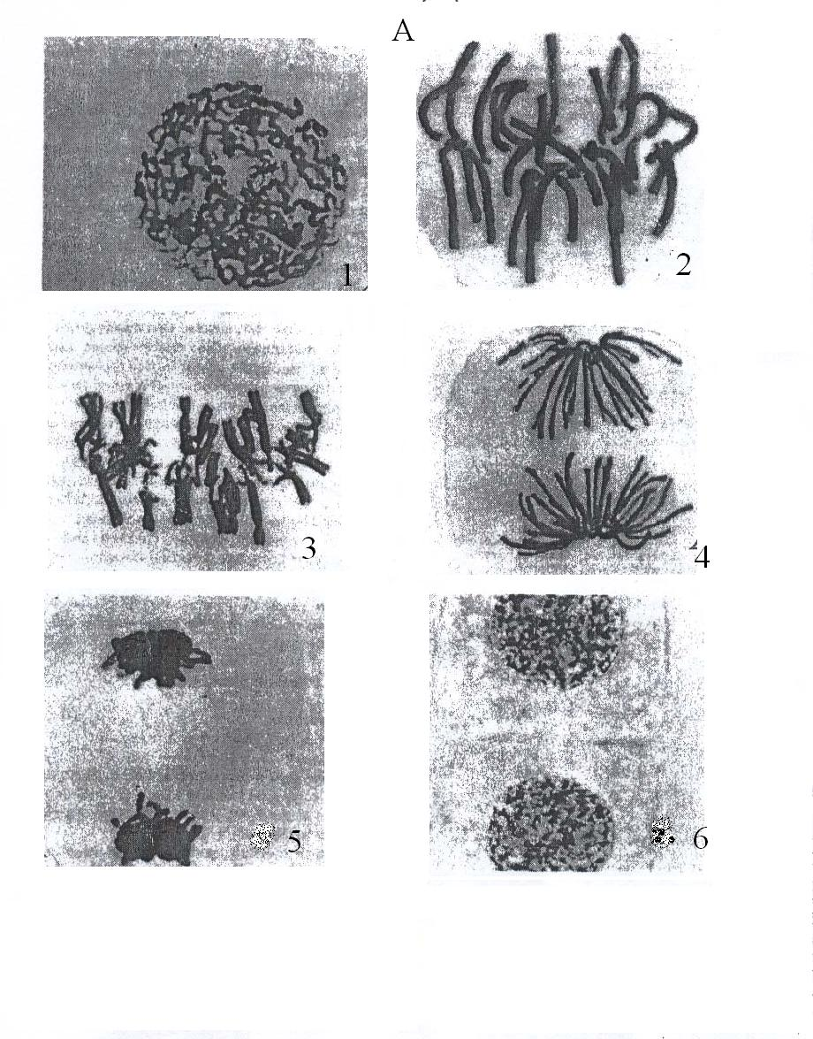
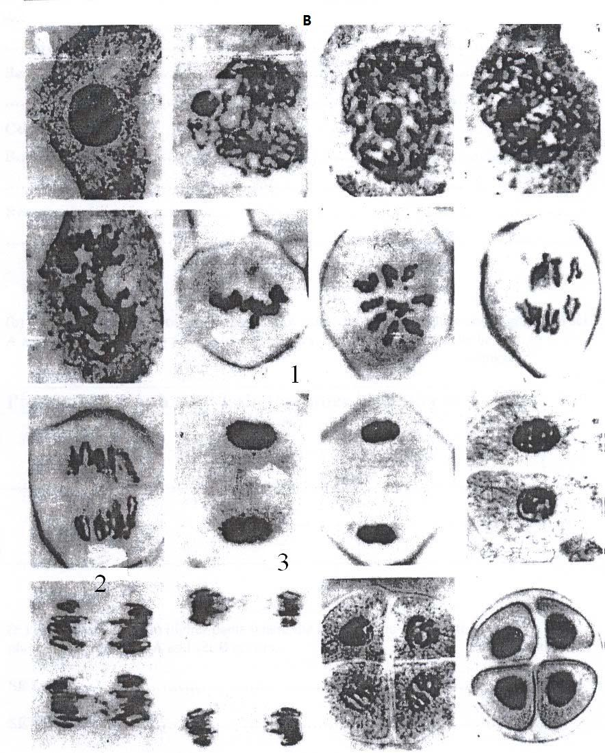
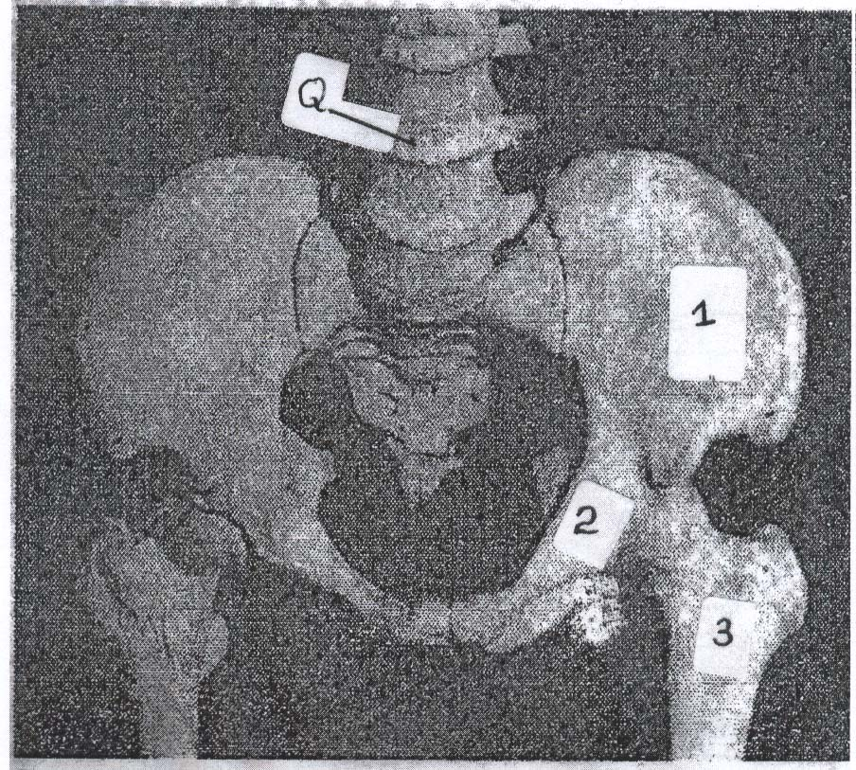

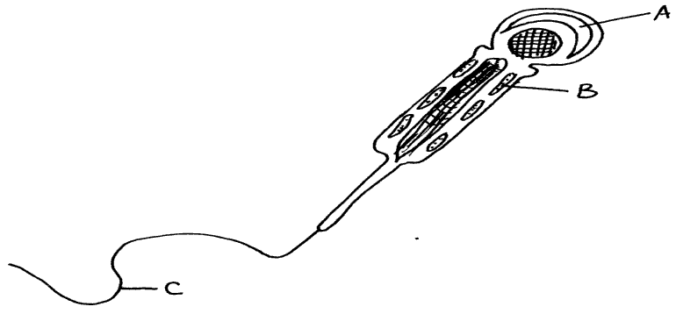
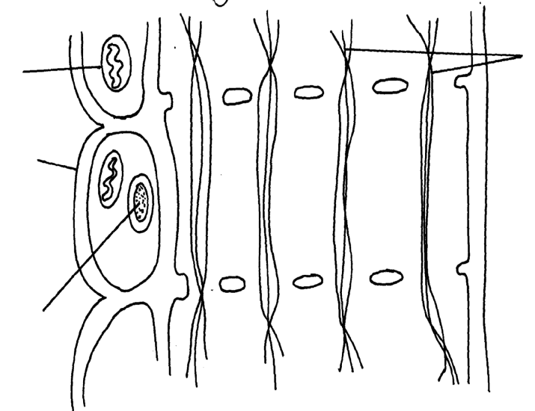
P
Q
R
Companion Cell

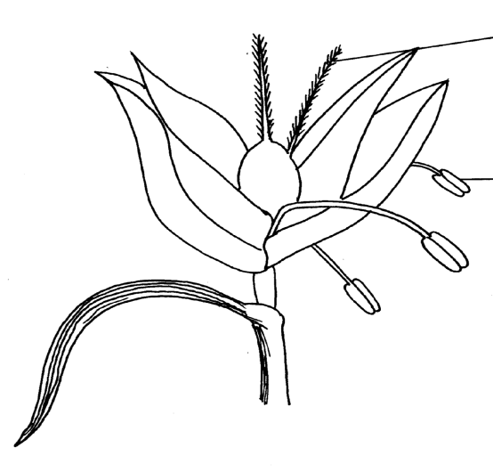
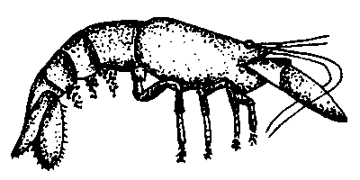
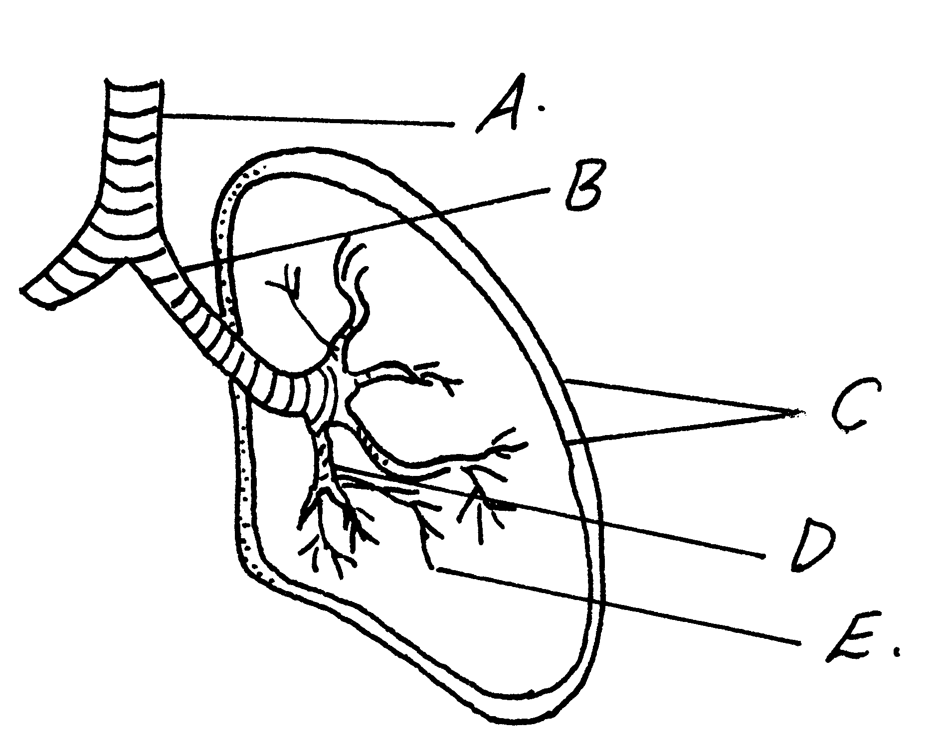
A
B

