231/2
BIOLOGY
Paper 2
(Theory)
Time 2 Hours

FORM FOUR
Kenya Certificate of Secondary Education (K.C.S.E)

INSTRUCTIONS TO CANDIDATES
- This paper consists of two sections A and B
- Answer ALL the questions in the section A in the spaces provided
- In section B answer question 6 (compulsory) and either question 7 or 8 in the spaces provided after question 8
FOR EXAMINER’S USE ONLY
SECTION | QUESTION | MAXIMUM SCORE | CANDIDATE’S SCORE
A | 1 | 8
 | 2 | 8
 | 3 | 8
 | 4 | 8
 | 5 | 20
B | 6 | 20
 | 7 | 20
 | 8
TOTAL
- The diagram below represent a set up to investigate anaerobic respiration in terminating bean seeds
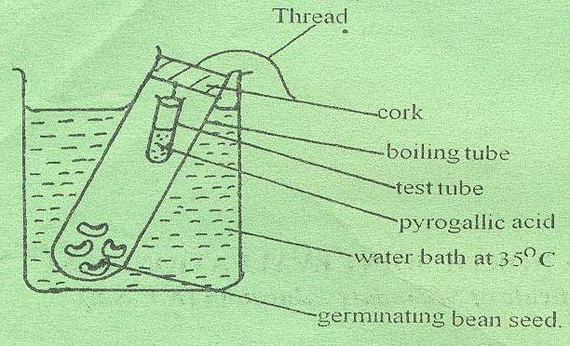

- What is the rile of pyrogallic acid in the set up (1mk)
- State the importance of the water bath (1mk)
- Write a word equation for anaerobic respiration taking place in germinating seeds
- Give a reason why plants can only respire anaerobically for a short period of time (1mk)
- What difference would be expected if the same process takes place in an animal tissue
- Distinguish between obligate and facultative anaerobes (3mks)
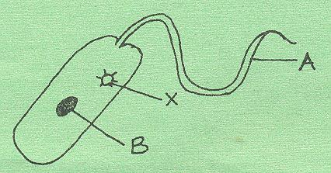
- Below is a diagram of an organism found in water. Study it and answer the following questions.

a) Giving a reason state the kingdom in which the organism belongs
Kingdom (1mk)
Reason (1mk)
b) Name the parts labeled A and B 1mk)
c) State the functions of the parts labeled A and X 2mks)
d) Explain why the organism is described as eukaryotic (1mk)
e) Name the organism (1mk)
- a) State two ways in which the leaf is adapted to gaseous exchange (4mks)
b) State the function of guard cell (1mk)
c) What are the characteristics of a guard cell that distinguish it the epidermal cell (3mks)
- Uniform coleoptiles were sued to carry out experiments in the dark, as shown in the diagram below. Coleoptiles B and C in experiments Q and R were decapitated
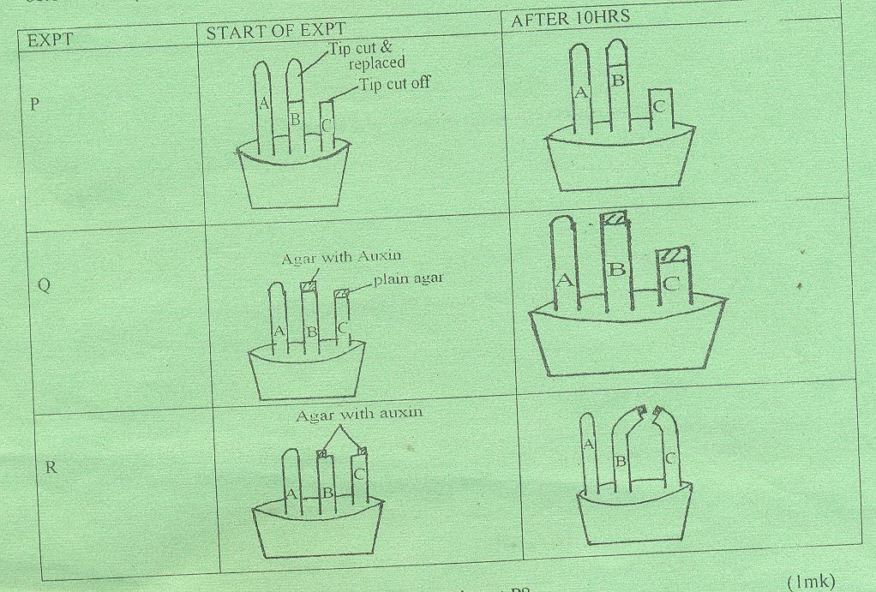

- What conclusion can be drawn from the experiment (1mk)
- Why was plain agar used a coleoptiles C in experiment Q (1mk)
- Explain the results in experiment Q (2mks)
- From the results of experiments Q and R what can you conclude about the movements of auxin in the coleoptiles (1mk)
- State two effect of auxins at the tip of a shoot (2mks)
- Give one biological importance of haptotropism in plants (1mk)
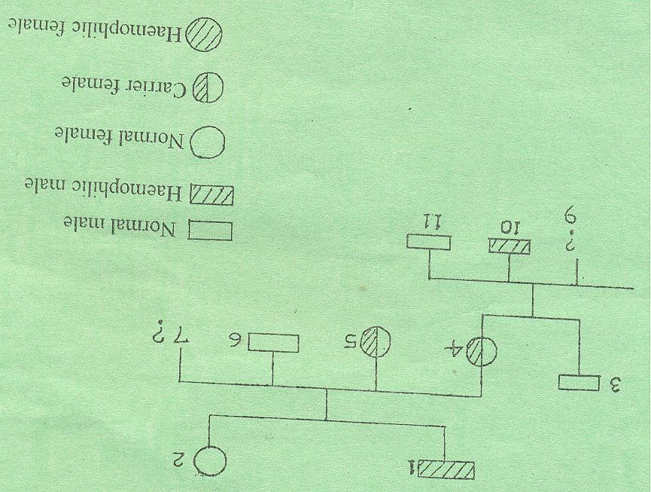
- The pedigree chart below illustrates the inheritance of haemophilia. The gene ‘h’ for the haemophilia condition is recessive to “H” for blood clotting.

- Suggest the possible genotypes of individuals (1mk)
7 and 9
- Using a checker board work out the possible genotype of offspring if individual number 4 married a haemopholic male
- Explain why there are no career male (1mk)
- What is Co-dominance (1mk)
- Name two disorders in human blood that are caused by gene mutation (2mks)

SECTION B
Answer question 6 (compulsory) and either question 7 or 8
6. Two people X and Y took 500ml of concentrated glucose solution at the same time. The amount of glucose in their blood was determined at intervals. Their results are as shown in the table below.
Time in minutes | Glucose in blood (Mg/100cm³
 | X | Y
0 | 87 | 84
15 | 112 | 123
30 | 139 | 170
45 | 116 | 188
60 | 100 | 208
90 | 95 | 202
120 | 92 | 144
150 | 88 | 123
a) Plot graphs of glucose level in blood against time (7mks)
b) What was the concentration of glucose in the blood X and Y at the 20th minute? (2mks)
c) Suggest why the glucose level in person X stopped rising after 30 minutes while it continued rising in person Y. (2mks)
d) Account for the decrease in the level of glucose in person X after 30 minutes and person Y after 60 minutes. (3mks)
e) Name the compound that stores energy released during oxidation of glucose.
(1mk)
f) Explain what happens to excess amino acids in the body. (5mks)
7. a) Distinguish between a community and population. (2mks)
b) Describe how a population of grasshoppers in a given habitat can be estimated.
(5mks)
c) Explain how halophytes are adapted to their habitat. (13mks)
8. Describe how a mammalian heart is adapted to its function. (20mks)

