NAME ………………………………………………ADM. NO ………………CLASS:……….

DATE……………..
231/3
BIOLOGY
PAPER 3
PRACTICAL
TIME: 1³/₄HRS

2020 FORM 4 TERM 1 ENTRY EXAMS
KENYA CERTIFICATE OF SECONDARY EDUCATION

Instruction to Candidates
- Write your Name, Adm. No., Class and Date in the spaces provided
- Answer all the questions
- You are required to spend the first 15 minutes of the 1³/₄Hrs allowed for this paper reading the whole paper carefully before commencing your work
- Answers must be written in the spaces provided in the question paper. Additional
Pages must not be inserted.

FOR EXAMINER’S USE ONLY
QUESTION | MAXIMUM SCORE | CANDIDATE’S SCORE
1  2  3 | 16  8  16
TOTAL SCORE | 40

- You are provided with specimen labelled F. Examine the specimen.
- With reasons state the type of fruit specimen F is. (1mk)

Reason (1mk)

- Carefully open specimen F to expose it’s contents
- State the type of placentation in the specimen. (1mk)

- Draw and label the opened specimen. (5mks)

- Work out your magnification. (2mks)

- Remove the seeds and crush them using a mortar and pestle to make a paste. Add alittle water to make about 10ml solution of the paste.
Using the reagents provided test for the food substances present in the juice. Record the food substances being tested, procedures, observation and conclusion in the table below. (6marks)
FOOD SUBSTANCE BEING TESTED | PROCEDURE | OBSERVATION | CONCLUSION

2.Identify the specimens in the photograph using the key and outline the steps followed to identify each specimen. (8mks)

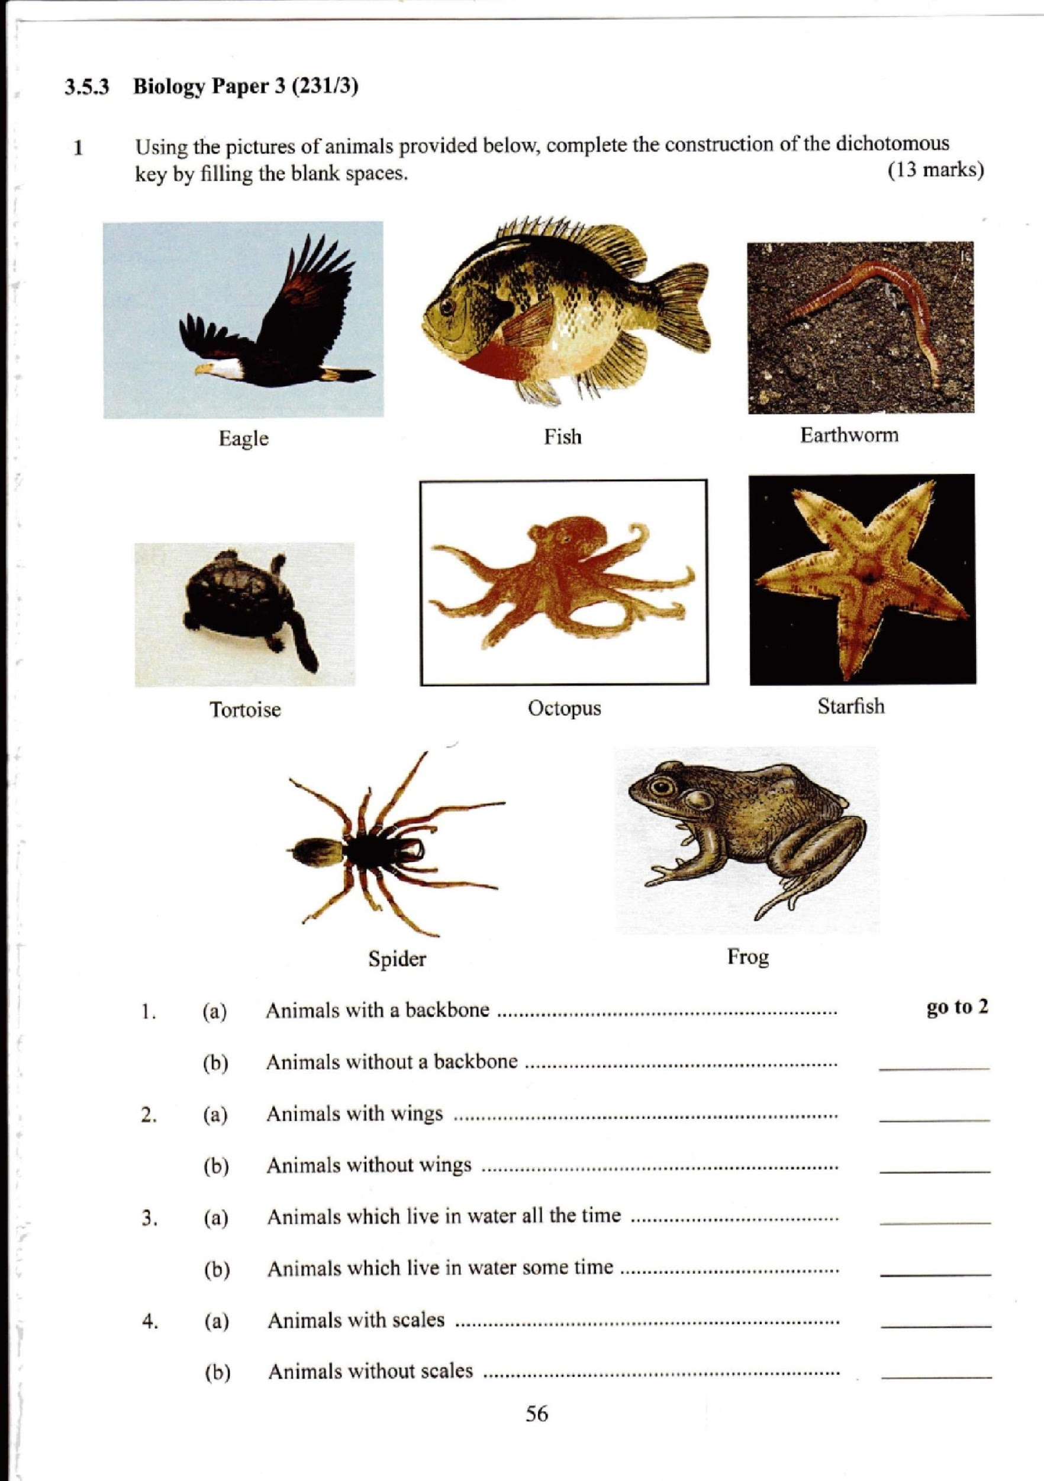
A B C
D E F
G H

- (a) Animals with a backbone ………………………………………………. Go to 2
(b) Animals without a backbone ……………………………………………. Go to 5
- (a) Animals with wings………………………………….…………….... Eagle
(b) Animals without wings …………………………………………………… go to 3
3. (a) Animals which live in water all the time………………………………… go to 4
(b) Animals which live in water some time………………………………….. Frog
4. (a) Animals with fins ……………………………………………………… Fish
(b) Animals without fins ………………………………………………….. Turtle
5. (a) Animals with legs ………………………………………………………. Go to 6
(b) Animals without legs …………………………………………………… go to 7
6. ( a) Animals with six legs ……………………………………………………... Butterfly
(b) Animals with eight legs ……………………………………………………. Spider
7. (a) Animals with a shell…………………………………………………………. Snail
(b) Animals without a shell…………………………………………………….. go to 8
8. (a) Animals with a jelly-like body ……………………………………………… go to 9
(b) Animals without a jelly-like body …………………………………………... Starfish
9. (a) Animals with a segmented body …………………………………………….. Earthworm
(b) Animals without a segmented body …………………………………………. Octopus
SPECIMEN | STEP FOLLOWED | IDENTIFY
A
B
C
D
E
F
G
H

- Below are photographs of specimens obtained from plants. Examine the photographs.
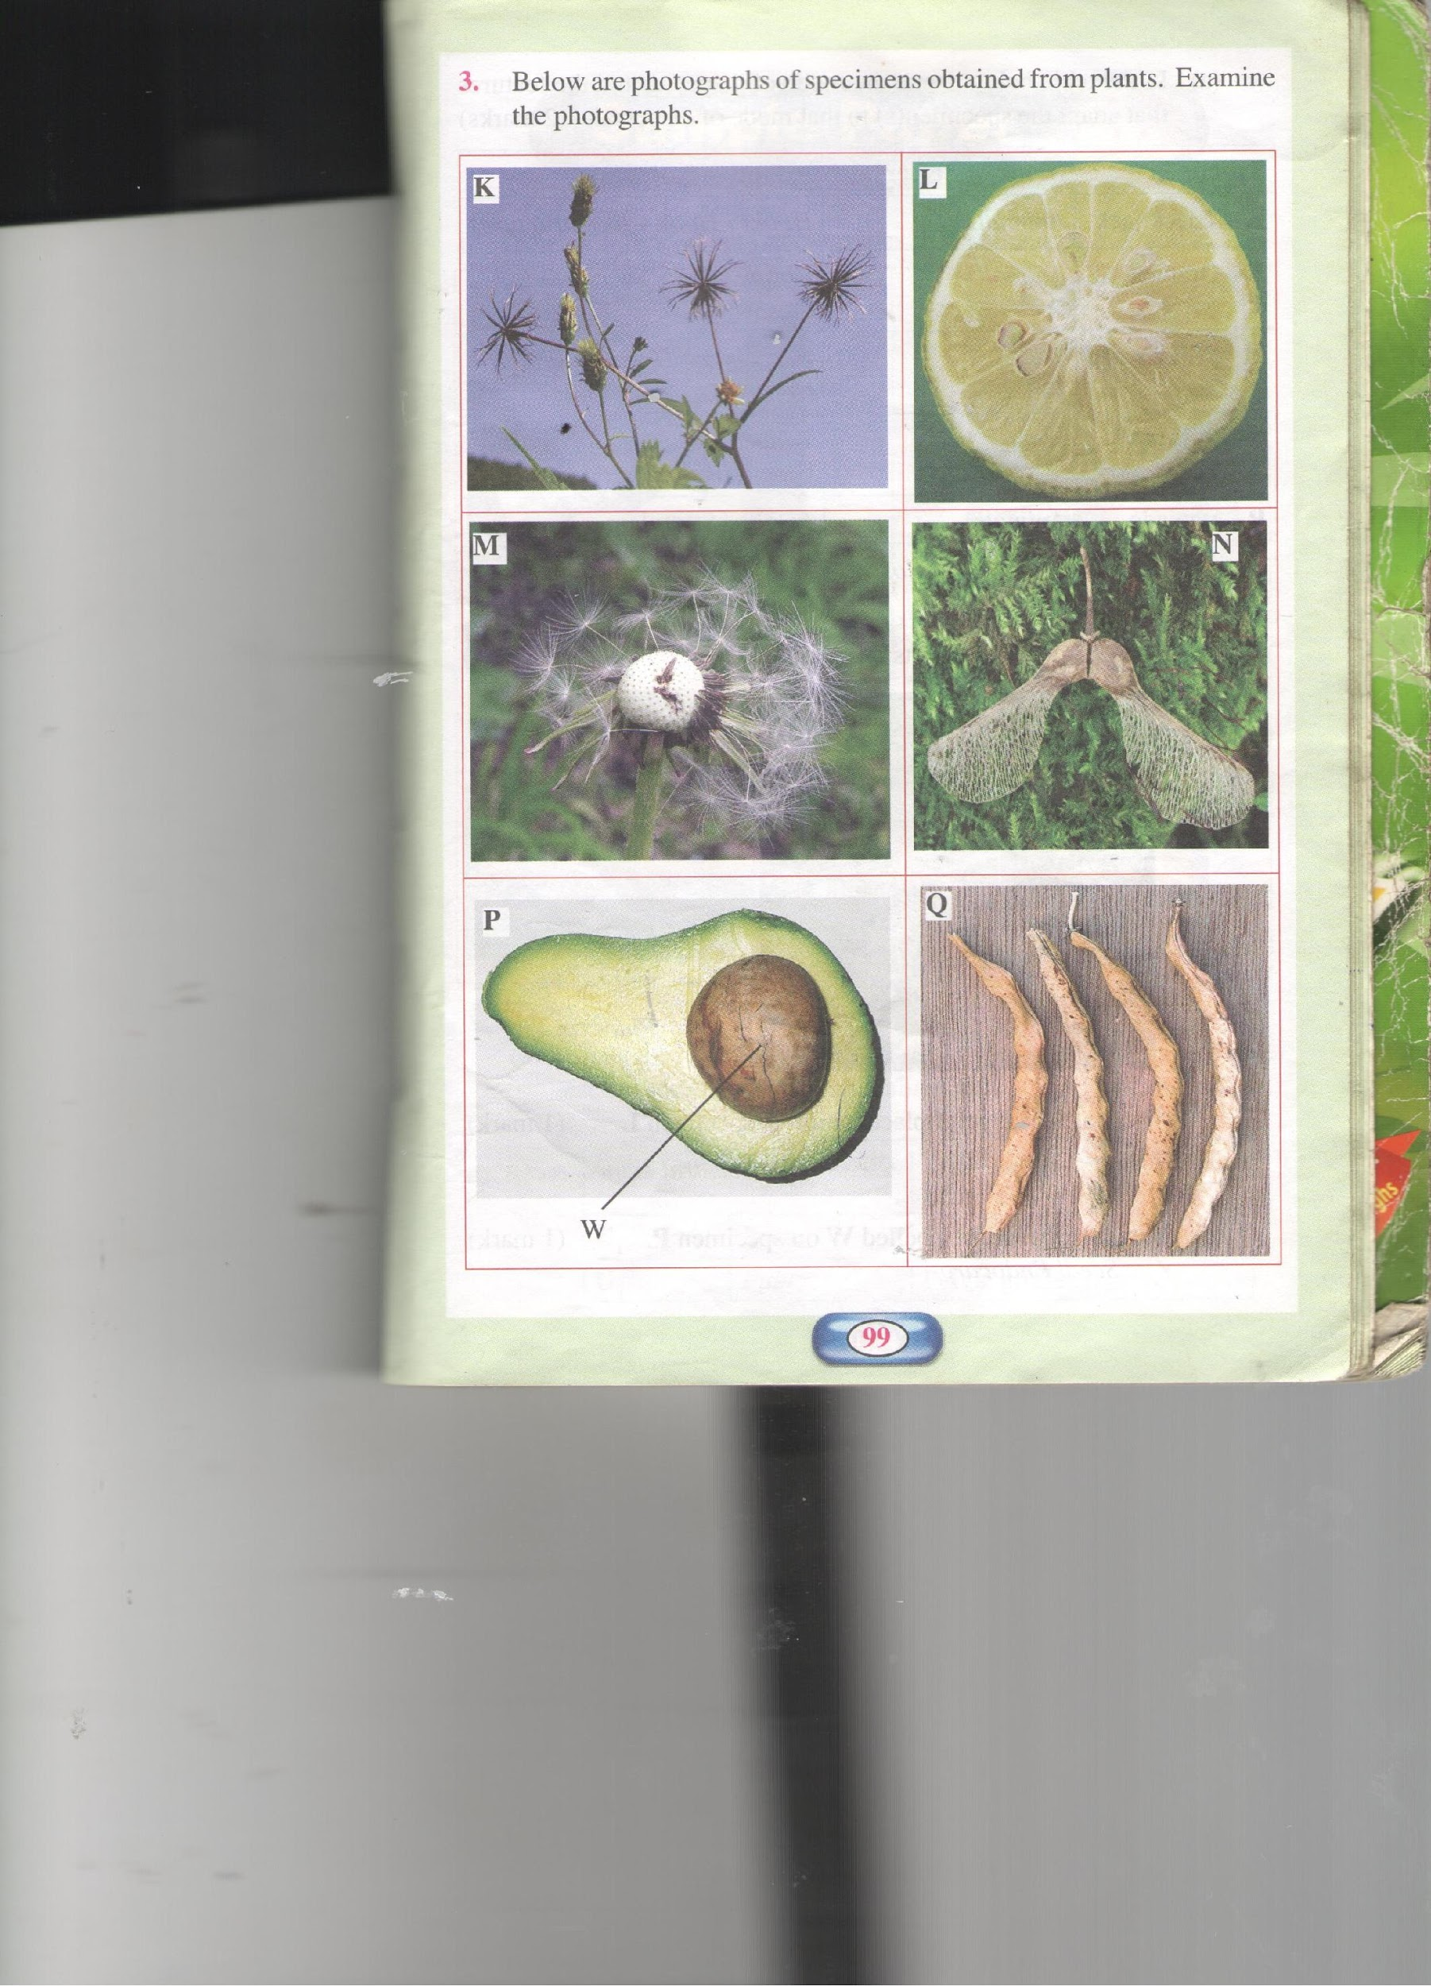

- In the table below name the mode of dispersal and the features that adapt the specimens(s) to that mode of dispersal. (12marks)
Specimen | Mode of dispersal | Adaptive feature
K
L
M
N
P
Q

- i) Label any two parts on specimen (L ( on the diagram) (2mks)
ii) State the type of placentation in specimen L. (1mk)

c. Name the structure labelled W on specimen P. (1mark)

