NAME …………………………………………………………… INDEX NO……………..……………..…

SCHOOL ………………………………………………………… CANDIDATE’S SIGNATURE………...

DATE……………………………………

231/2
BIOLOGY
PAPER 2
(THEORY)
TIME: 2 HOURS

PAVEMENT FORM 4 PRE MOCK EXAMINATION 2020
Kenya certificate of secondary education (K.C.S.E)

Kenya Certificate of Secondary Education
BIOLOGY
PAPER 2
(THEORY)
TIME: 2 HOURS

INSTRUCTIONS TO CANDIDATES
- Write your name, school and index number in the spaces provided above.
- This paper consist of TWO sections; A and B.
- Answer all the questions in the section A in the spaces provided.
- In section B answer Question 6(compulsory) and either question 7 or 8 in the space
provided after question 8.
- Check to ascertain that all pages are printed and that no questions are missing.

FOR EXAMINER’S USE ONLY
Section | Question | Maximum  Score | Candidates  Score
A | 1 | 8
A | 2 | 8
A | 3 | 8
A | 4 | 8
A | 5 | 8
B | 6 | 20
B | 7 | 20
B | 8 | 20
Total Score |  | 80

SECTION A: (40 MARKS)

Answer ALL the questions in this section in the spaces provided.

1. Examine the diagram below and use it to answer the questions that follow.

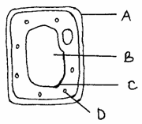

(a) Name the parts labeled. (3mks)

B __________________________________________________________________________

C __________________________________________________________________________

D __________________________________________________________________________

(b) What is substance which makes up part labeled A? (1mk)

____________________________________________________________________________

(c) Name the process by which mineral salts move into structure B. (1mk)

____________________________________________________________________________

(d) Explain what happens when a red blood cell is put in distilled water. (3mks)

____________________________________________________________________________

____________________________________________________________________________

____________________________________________________________________________

____________________________________________________________________________

2. The figure below is a pedigree showing the inheritance of colourblindness, a disease transmitted through a recessive gene located on the X-chromosome.
1
2
3
4
5
6
7
8
9
Normal male
Colourblind male
Normal female male
Colourblind male
KEY

- Using the symbol N for normal gene and n for colourblind gene, write down the genotypes
of parents 1 and 2. (2mks)

____________________________________________________________________________

____________________________________________________________________________

(b) Work out the possible genotypes of the children 3, 4 and 5. (4mks)

(c) The diagrams below illustrate some chromosome mutations.
Meiosis
χχ
χχ
X
X
A

A
B
C
D
E
F
V
U
W
X
E
F
V
U
W
X
B

C
A
C
B
D
A
B
C
D
B
C

Identify the mutations. (3mks)

A __________________________________________________________________________

B __________________________________________________________________________

C __________________________________________________________________________

3. The diagram below shows structures of the bat wing and human arm.
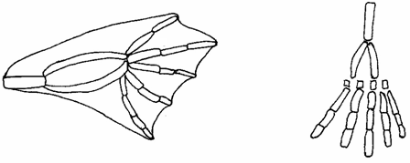
Wing membrane

- These structures are thought to have same ancestral origin. State one structural similarity
Andoneadaptational difference between the two.
(i) Structural similarity. (1mk)

______________________________________________________________________

(ii) Adaptational difference. (2mks)

______________________________________________________________________

______________________________________________________________________

______________________________________________________________________

______________________________________________________________________

(b) Give two other examples of structures in nature that show the type of evolution as in
(a) above. (2mks)

__________________________________________________________________________

____________________________________________________________________________

(c) Distinguish between the terms ‘chemical evolution’ and ‘organic evolution’. (2mks)

____________________________________________________________________________

____________________________________________________________________________

____________________________________________________________________________

____________________________________________________________________________

(d) What is the study of fossils called? (1mk)

____________________________________________________________________________

4. The diagram below represents some hormones, their sources and functions in a mammal.
Master gland
I III V
Stimulates tests Stimulates
growth of follicles Stimulates
in ovary development
of corpus luteum
II
Stimulates
spermatogenesis IV
Stimulates VI
development of Stimulates
secondary sexual development
characteristics of uterine wall

Female
Male

(a) Identify the gland described as master gland. (1mk)
__________________________________________________________________________

- Name the hormones:- (4mks)

II __________________________________________________________________________

III _________________________________________________________________________

V __________________________________________________________________________

VI _________________________________________________________________________

(c) Describe the consequences of deficiency of hormone II in man. (2mks)
____________________________________________________________________________

____________________________________________________________________________

____________________________________________________________________________

____________________________________________________________________________

(d) Other than stimulate development of uterine wall, suggest two other functions of hormone
VI. (2mks)
____________________________________________________________________________

____________________________________________________________________________

____________________________________________________________________________

____________________________________________________________________________
5. Ascarislumbricoides is an endoparasite.
(a) Name the genus to which it belongs. (1mk)

____________________________________________________________________________

(b) State the habitat of the organism. (1mk)

____________________________________________________________________________

(c) State three ways in which the organism is adapted to living in its habitat. (3mks)

____________________________________________________________________________

____________________________________________________________________________

____________________________________________________________________________

____________________________________________________________________________

(d) Mention three ways of preventing spread of the parasite. (3mks)

____________________________________________________________________________

____________________________________________________________________________

____________________________________________________________________________

____________________________________________________________________________

SECTION B: (40 MARKS)

Answer question 6 (compulsory) and EITHER question 7 or 8 in the spaces provided after
question8.

6. The table below shows how the quantities of sweat and urine vary with external temperature.

External temperature °C | Urine cm³/hr | Sweat cm³/hr
0 | 100 | 5
5 | 90 | 6
10 | 80 | 10
15 | 70 | 20
20 | 60 | 30
25 | 50 | 60
30 | 40 | 120
35 | 30 | 200

- On the same graph, plot the quantities of urine and sweat produced against the external
temperature. (7mks)

(b) At what temperature are the amounts of sweat and urine produced equal? (1mk)

__________________________________________________________________________

__________________________________________________________________________
(c) What happens to the amount of sweat produced as the temperature rises? Explain the observation. (3mks)

__________________________________________________________________________

__________________________________________________________________________

__________________________________________________________________________

__________________________________________________________________________

(d) Explain the observation made on the amount of urine produced as the temperature
increases. (3mks)

__________________________________________________________________________

__________________________________________________________________________

__________________________________________________________________________

__________________________________________________________________________

(e) How is the skin adapted for temperature regulation? (6mks)

__________________________________________________________________________

__________________________________________________________________________

__________________________________________________________________________

__________________________________________________________________________

__________________________________________________________________________

__________________________________________________________________________

__________________________________________________________________________

__________________________________________________________________________

7. Describe the structural adaptations of the mammalian heart to its function. (20mks)

8. Describe how water moves from the soil to the leaves in a tree. (20mks)

_______________________________________________________________________________________

_______________________________________________________________________________________

_______________________________________________________________________________________

_______________________________________________________________________________________

_______________________________________________________________________________________

_______________________________________________________________________________________

_______________________________________________________________________________________

_______________________________________________________________________________________

_______________________________________________________________________________________

_______________________________________________________________________________________

_______________________________________________________________________________________

_______________________________________________________________________________________

_______________________________________________________________________________________

_______________________________________________________________________________________

_______________________________________________________________________________________

_______________________________________________________________________________________

_______________________________________________________________________________________

_______________________________________________________________________________________

_______________________________________________________________________________________

_______________________________________________________________________________________

_______________________________________________________________________________________

_______________________________________________________________________________________

_______________________________________________________________________________________

_______________________________________________________________________________________

_______________________________________________________________________________________

_______________________________________________________________________________________

_______________________________________________________________________________________

_______________________________________________________________________________________

_______________________________________________________________________________________

_______________________________________________________________________________________

_______________________________________________________________________________________

_______________________________________________________________________________________

_______________________________________________________________________________________

_______________________________________________________________________________________

_______________________________________________________________________________________

_______________________________________________________________________________________

_______________________________________________________________________________________

_______________________________________________________________________________________

_______________________________________________________________________________________

_______________________________________________________________________________________

_______________________________________________________________________________________

_______________________________________________________________________________________

_______________________________________________________________________________________

_______________________________________________________________________________________

_______________________________________________________________________________________

_______________________________________________________________________________________

_______________________________________________________________________________________

_______________________________________________________________________________________

_______________________________________________________________________________________

_______________________________________________________________________________________

_______________________________________________________________________________________

_______________________________________________________________________________________

_______________________________________________________________________________________

_______________________________________________________________________________________

_______________________________________________________________________________________

_______________________________________________________________________________________

_______________________________________________________________________________________

_______________________________________________________________________________________

_______________________________________________________________________________________

_______________________________________________________________________________________

_______________________________________________________________________________________

BIOLOGY PP2(231/2) MARKING GUIDE
PAVEMENT FORM 4 PRE-MOCK EXAMINATION 2020
Kenya Certificate of Secondary Education ((K.C.S.E)

1. (a) B – Sap vacuole/cell vacuole/vacuole; (3mks)
C – Tonoplast;
D – Chloroplast;

(b) Cellulose; (1mk)

(c) Active transport. (1mk)

(d) The cell sap is hypertonic to distilled water; hence water molecules move into
the cell by osmosis; making it swell and eventually burst/get haemolysed; (3mks)
08

2. (a) I - X^{N}Y; (1mk)
2 X^{N}X^{n}; (1mk)
X^{N}Y;
X^{N}X^{n}
X^{N}
Y
X^{N}
X^{n}
X^{N}Y^{N}
X^{N}Y^{n}
X^{N}Y
X^{n}Y
;
;
;
;
Parental genotype
Gametes
Offspring’s (4mks)
X
(b)

- A – Non-disjunction;
B – Translocation; 3mks max (2mks)
C – Inversion;

3. (a) (i) Structural similarity.
- Both show the pentadactyl limb structure; (1mk)

- Adaptation difference.
  - Human arm has five digits separated into four fingers and an opposable
thump for grasping;
- The bat wing has five digits which are long and spread apart to support
a large membranous wing for flight; (2mks)

- Different shapes and sizes of beaks in birds;
Different feet structure in birds; (2mks)

- Chemical evolution explains the origin of life as having occurred when simple
chemical compounds reacted to form the simplest life forms; organic evolution
is the progressive development of complex organisms from simple pre-existing
life forms over a long period of time; (2mks)

(d) Palaeontology; (1mk)

4. (a) Pituitary gland; (1mk)

(b) II - Testosterone;
III - Follicle stimulating hormone;
V - Luteinising hormone;
VI - Progesterone; (4mks)

(c) Sterility/lack of spermatogenesis; failure of secondary sexual
characteristics; (2mks)

(d) Inhibit production of FSH/inhibit production of LH; (1mk)
08
5 (a) Ascaris; (1mk)

(b) Intestines of humans/Pig Acc. large intestine/duodenum. (1mk)

(c) Adaptations:
- Has two hosts to ensure survival;
- Lays numerous eggs to increase chances of survival;
- Has thick cuticle which protects it against digestive enzymes of the host;
- Eggs have a protective shell to survive harsh environmental conditions;
- Has tissues tolerant to low oxygen/can survive under low oxygen concentration;
- Produce anti-enzymes to counteract the effect of the host’s enzymes;
- Has a muscular pharynx through which it sucks digested food from the host’s
intestine; Any three (3mks)

- Prevention
- Proper sewage disposal/proper use of toilet facilities;
- Maintain proper personal hygiene/washing hands after visiting the toilet;
- Boiling/treating drinking water;
- Proper cleaning of vegetables and fruits; Any three (3mks)
08
6. (a) Labeling of axis;;
- Scale ; (1mk)
- Curves;; (2mks)
- Plotting points;; (2mks)
- 24ºC;

- Sweat production increases with increase in temperature; because high
temperatures increase the evaporation rate, hence more sweat is converted
towater vapour; This uses latent heat of vaporization from the body
causingcooling; (3mks)

- An increase in temperature decreases the amount of urine produced;
This is due to increased sweating which raises the osmotic pressure of blood;
A lot of water is reabsorbed into blood in the kidney tubules resulting in the production of little, concentrated urine; (3mks)
(e) Hair - When hot, the erector pili muscle relax; the hair lies that on the skin
surface; to reduce insulation and encourage heat loss;
OR - When cold, the erector pili muscles contract; causing hairs to stand;
and trap a layer of warm air which insulated the body; (3mks)

Blood verses - When cold blood vessel; constrict (vasoconstriction); Less blood
flows near skin surface; reducing heat loss by radiation and
convection;
OR - When hot, blood vessels dilate (vasodilatation); more blood flows
on the skin surface; increasing heat loss by radiation and convection
thus cooling the body; (3mks)

Sweat glands - When hot, sweat is released; it evaporates, taking latent heat of
vaporization from the body; hence cooling it;
OR - When cold, sweat glands release less sweat; there is less evaporation;
20
and hence less heat loss; Total (9mks) max (6mks)
7. - It is muscular/has cardiac muscles; which are myogenic (does not need nervous
stimulation) to pump blood;
- It is supplied by valgus and sympathetic nerves; which controls the rate of heart beat;
(depending on body’s physiological requirements)
- It has tricuspid valves and bicuspid valves;(between atrium and ventricles) which
prevent back flow of the blood into the right and left ventricles respectively.
- Present of valve tendons attached to the walls of ventricles and to the atrium
ventricular walls; to prevent atria-ventricular valves from due to changes in the
pressure in the ventricles;
- Heart is supplied by coronary artery; which supplies food and oxygen to the cardiac
muscle for their pumping action; the coronary vein; in heart removes metabolic wastes;
- The heart is enclosed by the pericardium membrane; that secretes a fluid which lubricates
it(reducing friction on the walls as it bumps);
- The heart is divided into two by the atria-ventricular septum; that prevent mixing of
oxygenated blood and deoxygenated blood;
- The left ventricles has a thick muscular wall; to pump blood at higher pressure to the
distant body issues;
- The outer part of the pericardium has a fatty layer; which act as a shock absorber;
keeps the heart in position.
- The Sino Atrial Node (S.A.N) the pacemaker region);which initiate the wave of
contraction leading into contraction and relaxation of muscles; the arterial-ventricular
node; in the heart spreads out waves of contraction throughout the heart creating the
heart beat;
8. - Water exists as a thin film in the soil between soil particles; The concentration of cell
sap is greater than that of the surrounding solution in the soil; Thus drawing water
molecules acrossthe cell wall and cell membrane into the root hair cells; by osmosis;
water drawn into the root hair cell dilutes the cell sap/makes it less concentrated than
that in the adjacent cell; water moves into the cortex cells (of the root); across the
endodermis by active transport; into the xylem vessels of the root); then conducted
up into the xylem (vessels) of the stem; into xylem of leaves; water is pushed/rises
up the stem by root pressure; (in the xylem vessels) water rises by capillarity;
cohesion; and adhesion forces; water moves as a continuous uninterrupted water
column in the xylem vessels up the tree to the leaves.
- As water vaporizes from the spongy mesophyll cells; their cell sap becomes more
concentrated than that of the adjacent cells; This increases the osmotic pressure of
the spongy mesophyll cells; As a result water flows into the cells from other
surrounding cells; which in turn takes in water from xylem vessels within the leaf
veins; This creates a pull/sunction force/transpiration pull; that pulls a stream of
water from xylem vessels in the stem and roots; The transpiration pull maintains
a continuous column of water from the roots into the leaves (transpiration stream);

NAME:.....................................................................INDEX NO.:..........................................
SCHOOL:................................................................CANDIDAES SIGNATURE:................
DATE:...................................................

231/1
BIOLOGY
PAPER 1.
THEORY

TIME: 2HRS

PAVEMENT FORM 4 PRE MOCK EXAMINATION 2020
Kenya certificate of secondary education (K.C.S.E)

231/1
BIOLOGY
PAPER 1.
THEORY

TIME: 2HRS

Instructions to candidates.
a) Write your name and index number in the spaces provided above.
b) Sign and write the examination date .
c) Answer all the questions in the spaces provided in the question paper.

This paper consists12 of printed pages
Candidates should check to ascertain that all pages are printed as indicated and that
no question is missing.

1. State ways by which synaptic transmission can be stopped. (2mks)
..................................................................................................................................................................................................................................................................................................................................................
..................................................................................................................................................................................................................................................................................................................................................
2. State two advantages which the endothermic (homoethermic) have over those that are exothermic (poikilothermic). (2mks)
..................................................................................................................................................................................................................................................................................................................................................
..................................................................................................................................................................................................................................................................................................................................................
3. a) State one function of red blood cells. (1mk)
..................................................................................................................................................................................................................................................................................................................................................
b) Give two structural difference between red blood cells and white blood cells. (2mks)
..................................................................................................................................................................................................................................................................................................................................................
4. Hairs and leaves of sundew, an insectivorous plant curl around and trap insects when they land on the plant.
a) Identify the response shown sundew plants (1mk)
..................................................................................................................................................................................................................................................................................................................................................
b) Explain the biological importance of the response in (a) above. (2mks)
..................................................................................................................................................................................................................................................................................................................................................
..................................................................................................................................................................................................................................................................................................................................................
c) Name any one type of neurons. (1mk)
..................................................................................................................................................................................................................................................................................................................................................
5. The diagram below gives an external view of the structure of the human eye observed outdoor at midday and midnight.

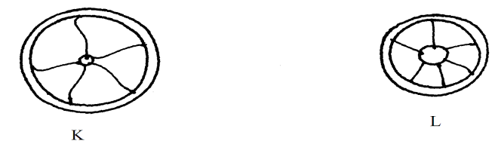

a) Which diagram represents the eye as observed during the day? (1mk)
..................................................................................................................................................................................................................................................................................................................................................
b) Give a reason for your answer in (a) above. (1mk)
..................................................................................................................................................................................................................................................................................................................................................
6. A student viewed and drew a plant cell of a diameter 4mm using a light microscope whose eye piece lens was marked x1 and objective lens marked x5. How many cells were linearly arranged along the microscope’s field of view whose diameter was 8mm .
( show your working ) (3mks)
..................................................................................................................................................................................................................................................................................................................................................
..................................................................................................................................................................................................................................................................................................................................................
..................................................................................................................................................................................................................................................................................................................................................
..................................................................................................................................................................................................................................................................................................................................................
7. Identify the nucleic and whose base sequence is shown below.
G-A-C-U-A-G-A-C-G
i) Identify the type of nucleic acid as shown below (1mk)
..................................................................................................................................................................................................................................................................................................................................................
ii) Give reason for your answer in (i) above. (1mk)
..................................................................................................................................................................................................................................................................................................................................................
iii) Write the base sequence of the DNA strand shown above (1mk)
..................................................................................................................................................................................................................................................................................................................................................
8. State the function of the following parts of a microscope (3mks)
i) Nose piece.
.........................................................................................................................................................................
ii) Condenser.
.........................................................................................................................................................................
iii) Diaphragm.
.........................................................................................................................................................................

9. Identify the mode of feeding of the animal whose dental formula is given below.
i, C, Pm, M =32.
a) Mode of feeding (1mk)
..................................................................................................................................................................................................................................................................................................................................................
b) Give a reason for your answer in (a) above. (2mks)
..................................................................................................................................................................................................................................................................................................................................................
..................................................................................................................................................................................................................................................................................................................................................
10. Study the diagram below and use it to answer the questions.
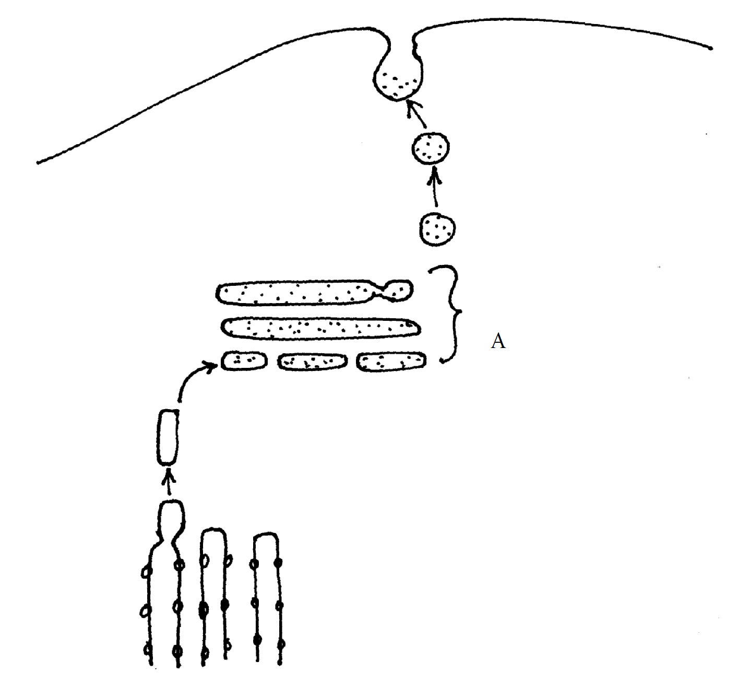
a) Identify the organelle marked A. (1mk)
..................................................................................................................................................................................................................................................................................................................................................
b) Give three functions of the organelle named in (a) above (3mks)
..................................................................................................................................................................................................................................................................................................................................................
..................................................................................................................................................................................................................................................................................................................................................
..................................................................................................................................................................................................................................................................................................................................................

11. It was found that during germination of pea seeds 9.3cm³ of carbon (iv) oxide was produced while 9.1cm³ of oxygen was used up.
a) Calculate the respiratory quotient (RQ) of the reaction taking place. (2mks)
..................................................................................................................................................................................................................................................................................................................................................
..................................................................................................................................................................................................................................................................................................................................................

b) Identify the type of food substance being metabolized. (1mk)
..................................................................................................................................................................................................................................................................................................................................................
12. Explain why Lamarck’s theory of evolution is not accepted by biologists today. (2mks)
..................................................................................................................................................................................................................................................................................................................................................
..................................................................................................................................................................................................................................................................................................................................................
13. Give three reasons why plants lack complex excretory organs like those of animals. (3mks)
..................................................................................................................................................................................................................................................................................................................................................
..................................................................................................................................................................................................................................................................................................................................................
..................................................................................................................................................................................................................................................................................................................................................
14. The diagram below shows a type of epithelial tissue.
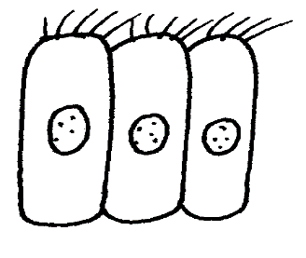
i) What is the name of the hair-like process? (1mk)
..................................................................................................................................................................................................................................................................................................................................................
ii) What is the function of the hair-like process. (1mk)
..................................................................................................................................................................................................................................................................................................................................................

b) Name one part in the human body where the hair-like process are found. (1mk)
..................................................................................................................................................................................................................................................................................................................................................
15. In an attempt to estimate the number of weaver birds in a small woodland 435 were captured , marked and released. Three days later , 620 were captured 75 of which were marked.
a) What is the name of the sampling method described above. (1mk)
..................................................................................................................................................................................................................................................................................................................................................

b) Calculate the approximate size of the weaver bird population in the woodland. (2mks)
..................................................................................................................................................................................................................................................................................................................................................
..................................................................................................................................................................................................................................................................................................................................................
c) Give one disadvantage of this method. (1mk)
..................................................................................................................................................................................................................................................................................................................................................
16. Give an example of ball and socket joint. (1mk)
..................................................................................................................................................................................................................................................................................................................................................
17. Name two types of strengthening tissues in plants. (2mks)
..................................................................................................................................................................................................................................................................................................................................................
18. Study the diagram below, and answer the questions below.
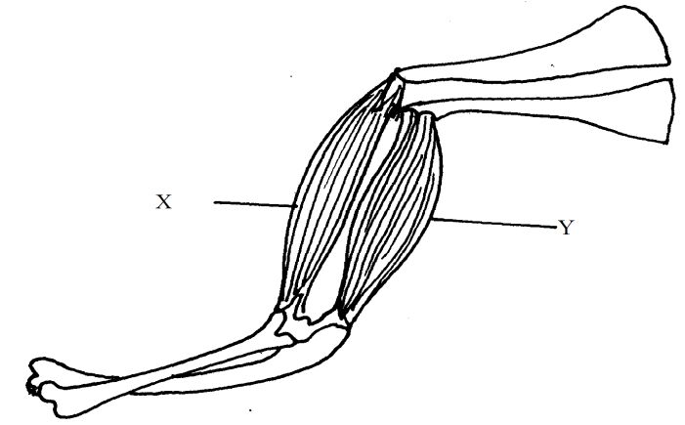

a) Name the muscles labelled X and Y. (2mks)
..................................................................................................................................................................................................................................................................................................................................................

b) What happens to each muscle as the arm is straightened? (2mks)
..................................................................................................................................................................................................................................................................................................................................................
..................................................................................................................................................................................................................................................................................................................................................
19. Nocturnal animals such as a leopard are capable of seeing fairly well at night. What two retinal adaptations have made this possible? (2mks)
..................................................................................................................................................................................................................................................................................................................................................
..................................................................................................................................................................................................................................................................................................................................................

20. The table below shows stomata distribution on leaves A and B and their surface area. Use the information to answer the questions that follow.
 | Leaf A B
Number of stomata | Upper surface 25 5  Lower surface 0 20
Surface area. | 30cm³ 19cm³

b) Identify with reasons the habitats of the plant from which the leaves were obtained (4mks)
Leaf A Habitat...................................................................................
Reasons...................................................................................
..................................................................................................................................................................................................................................................................................................................................................

Leaf B Habitat..................................................................................
Reasons..................................................................................
..................................................................................................................................................................................................................................................................................................................................................
21. A tall bean plant crossed with a dwarf one produces offspring of which about half are tall and other are dwarf .what are the genotypes of parents? Show your working (3mks)
..................................................................................................................................................................................................................................................................................................................................................
..................................................................................................................................................................................................................................................................................................................................................
..................................................................................................................................................................................................................................................................................................................................................

22. Describe what happens during the dark stage of photosynthesis. (3mks)
..................................................................................................................................................................................................................................................................................................................................................
..................................................................................................................................................................................................................................................................................................................................................
..................................................................................................................................................................................................................................................................................................................................................
23. The response exhibited by a certain plant tendril is illustrated below.

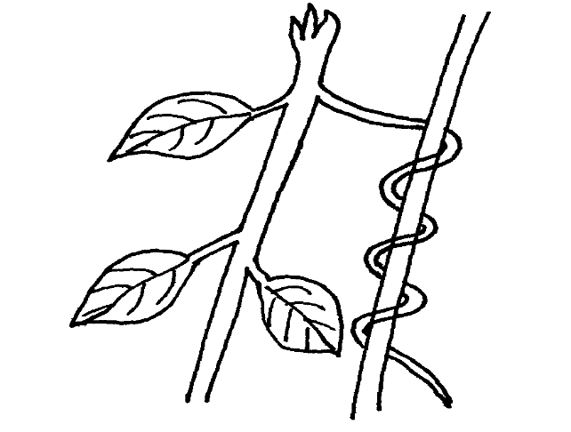
i) Name the type of response. (1mk)
..................................................................................................................................................................................................................................................................................................................................................
ii) Explain how the response named in (i) above occurs . (2mks)
..................................................................................................................................................................................................................................................................................................................................................
..................................................................................................................................................................................................................................................................................................................................................
24. State three adaptations of respiratory surfaces. (3mks)
..................................................................................................................................................................................................................................................................................................................................................
..................................................................................................................................................................................................................................................................................................................................................
..................................................................................................................................................................................................................................................................................................................................................
25. State the parts of the ear involved in:
a) Amplification of sound vibration (1mk)
..................................................................................................................................................................................................................................................................................................................................................

b) balance and posture. (1mk)
..................................................................................................................................................................................................................................................................................................................................................
26. Explain why the digestion of starch stops after food enters the stomach. (2mks)
..................................................................................................................................................................................................................................................................................................................................................
..................................................................................................................................................................................................................................................................................................................................................
27. The diagram below represents a stage during cell division.
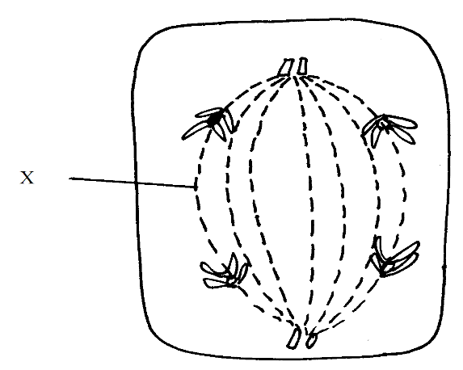
i) Identify the stage of cell division. (1mk)
..................................................................................................................................................................................................................................................................................................................................................
ii) Give two reasons for your answer (a)i) above (2mks)
..................................................................................................................................................................................................................................................................................................................................................
..................................................................................................................................................................................................................................................................................................................................................
iii) Name the structure labelled M. (1mk)
..................................................................................................................................................................................................................................................................................................................................................
28. Bivalent synapsis, crossing over are terminologies used in cell division.
a) Name the stage of meiosis in which the process takes place. (1mk)
..................................................................................................................................................................................................................................................................................................................................................
b) Distinguish between synapsis and crossing over. (2mks)
..................................................................................................................................................................................................................................................................................................................................................
..................................................................................................................................................................................................................................................................................................................................................
BIOLOGY PP1(231/1) MARKING GUIDE
PAVEMENT FORM 4 PRE-MOCK EXAMINATION 2020
Kenya Certificate of Secondary Education ((K.C.S.E)

1. Interfering with:
- Chemical mediation of synaptic junction.
- Electrical changes of ions across the synapse.
(2mks)

2. - Endothermic animals remain active at all times despite changes in environmental tempts.
They colonize/ inhabit all habitats.
(2mks)

3. a) Transport of respiratory gases i.e. O₂& CO₂.

b) RBC WBC
No nucleus Nucleated
Disc shaped Amoeboid.
(2mks)

4. a) Haptonasty (1mk)
b) Plants obtain nitrogen from plants when the insects are digested. (1mk)

c) Motor sensory, relay neurons ( any of the three) (1mk)

5. a) K (1mk)

b) The pupil is small to allow in less light (1mk)
c) Myopia / hypermetropia / astigmatism. (1mk)

6. Magnification =
=50,000 =
x=

7. i) Ribonucleic acid (1mk)
ii) Presence of uracil as one of nitrogenous bases. (1mk)
iii) C-T-G-A-T-C-T-G-C

8. i) Holds the objective lenses in place enabling change from one objective lens to the
other. (1mk)

ii) Concentrate light on the object on the stage. (1mk)
iii) Regulate amount of light passing through the condenser. (1mk)

9. a) Herbivorous rej. Herbivore (1mk)
b) Absence of incisors and canines on the upper jaw. (2mks)

10. a) Golgi apparatus/ body. (1mk)
b) i) Packaging of carbohydrates and glycoprotein.
ii) Secretion of synthesized proteins and carbohydrates.
iii) Secrete enzymes; produce lysosomes.
(3mks)

11. RQ =

=
= 1.0

b) Food is carbohydrates.
(3mks)

12. Acquired characteristics / trait cannot be inherited.
(2mks)

13. i) There is little accumulation of toxic wastes
ii) The waste products are formed slowly and get re-utilized by the plant.
iii) The waste products diffuse out through stomata e.g. CO_{2,} O₂
(3mks)

14. a) Ciliated epithelial cells (1mk)
b) Movement of trachea.
Movement of egg/ova in oviduct (1mk)

C) Trachea
Oviduct.
(1mk)

15. a) Capture recapture method. (1mk)
b)
=
=3596 weaverbirds. (2mks)

c) The released animals may not mix freely .
Some organism may move in and out of the study area. (1mk)

16. Hip joint (pelvic girdle and femur joint) shoulder joint (Pectoral girdle and homerus).
(1mk)

17. Xylem vessels tracheid’s, Sclerenchyma, Collenchyma tissues

18. a) X- biceps
Y- Triceps.
(2mks)

b) X- Biceps relaxes while Y(triceps ) contract.
(2mks)

19. Nocturnal animals.
i) Have a high concentration of rods in the retina that are sensitive to low intensity.

ii) Retinal convergence of rods enables any little stimulation of several rods to combine and generate a nerve impulse.
(2mks)

20. Leaf A Habitat Aquatic.
Reasons. -Stomata only on upper surface.
-Stomata are exposed on the upper surface to hasten rate of transpiration.
-The leaf has a large surface of 30cmcm² to provide a large surface
of transportation.

Leaf B.
Habitat. Terrestrial / normal dry land.
Reasons. Stomata are mainly on the lower surface. The upper surface is exposed to
direct light and high temperature. Hence fewer stomata to reduce water loss.

-Lower/ small surface to reduce surface exposed to transpiration.
(4mks)

21. Heterozygous tall X Homozygous dwarf.
Parental phenotypes : Heterozygous tall. x Homozygous Dwarf.
Parent genotype Tt x Tt
T
t
t
t
t
Gametes.
t
t
T

Tt Tt tt tt

Genotypes
Ratio 1Tt :1tt
(3mks)

22. Hydrogen atoms/ ions combine with carbon (iv) oxide. They form glucose using energy provided by adenosine triphosphate. (3mks)

23. i) Thigmotropism/ Haptotoprism (1mk)
ii) Contact with support causes migration of auxins to the outside

