**NAME………………………………………………………………….… ADM NO ……………**

**SCHOOL………………………………………………… INDEX NO………………………….**

**DATE: ………………….. SIGN: …………………….………**

**FORM FOUR MATHEMATICS CONTEST**

**URANGA MATHEMATICS ASSOCIATION**

**NOVEMBER, 2021**

***Kenya Certificate of Secondary Education (KCSE)***

**1 ½ HOURS**

**INSTRUCTIONS TO THE CANDIDATES**

1. *Write your* ***name*** *and* ***the other required details in*** *the spaces provided above.*
2. *Answer* ***All*** *questions*
3. ***All*** *answers and working* ***must*** *be written on the question paper in the spaces provided below each question.*
4. *Show all the steps in your calculations giving answers at each stage in the spaces provided below each question.*
5. *Marks may be given for correct working even if the answer is wrong.*
6. *Non-programmable silent electronic calculators and KNEC Mathematical tables may be used except where stated otherwise.*
7. ***This paper consists of 16printed pages. Candidates should check the question paper to ascertain that all pages are printed as indicated and that no questions are missing.***

*m) Candidates should answer questions in* ***English.***

**For examiner’s use only.**

|  |  |  |  |  |  |  |  |  |  |  |  |  |  |  |  |  |  |  |  |
| --- | --- | --- | --- | --- | --- | --- | --- | --- | --- | --- | --- | --- | --- | --- | --- | --- | --- | --- | --- |
| 1 | 2 | 3 | 4 | 5 | 6 | 7 | 8 | 9 | 10 | 11 | 12 | 13 | 14 | 15 | 16 | **17** | **18** | **19** | **20** |
|  |  |  |  |  |  |  |  |  |  |  |  |  |  |  |  |  |  |  |  |

|  |  |  |
| --- | --- | --- |
| **GRAND TOTAL** | CANDIDATES SCORE |  |
| MAXIMUM POSSIBLE SCORE | **60** |

1. A rectangular tank measures 2.6m by 4.5m by 3.2m. Calculate the percentage error in calculating the volume of the tank. (3mks)
2. Two people X and Y have goats. X has more goats than Y and if Y gives X one of his goats, X will have twice as many goats as Y. If X gives Y one of his goats, they will have an equal number of goats. How many goats do each have? (3mks)
3. At 2.30pm, Alex cycles past point P with a speed of 25km/h. One and a half hours later, Fred passes P with his motorcycle travelling in the same direction at 55km/h. if both Alex and Fred continue moving along the same road at their respective speeds, determine the time Fred catches up with Alex. (3mks)
4. A shopkeeper mixes grade A coffee worth sh. 65 per kilogram with grade B coffee worth sh. 52 per kilogram. How many kilograms of each should be used to obtain 52 kilogram of a mixture worth sh. 58 per kilogram. (3mks)
5. Solve for k in the equation

$5^{(3k+1)}+{125}^{(k+1)}=3250$ (3mks)

1. The third, sixth and seventh terms of an AP form a GP. Given that the first term of the AP is 3, find the common difference of the AP. (3mks)
2. Find the value of x given that

$\frac{1}{\log_{3}{2}}-\log{100}=\frac{1}{3}\log_{2}\left(\frac{27}{x^{3}}\right)$ (3mks)

1. Write down the expansion of ${\left(2x-\frac{y}{2}\right)}^{6}$ up to the fourth term. Hence use your expansion to estimate the value of ${\left(1.92\right)}^{6}$ (3mks)
2. The diameter of a circle, centre O, has its end points at M (3,-2) and N (1, 4). Find the equation of the circle in the form $x^{2}+y^{2}+ax+by+c=0$ where a, b, and c are constants. (3mks)
3. A point C is such that it divides AB in the ratio 5:-2. The coordinates of A and B are (2, 7) and (8, 10) respectively. Find the coordinates of point C? (3mks)
4. A triangle ABC has the vertices A (2, 0), B (-1, 0) and C (0, 1). Triangle ABC is transformed by a matrix M to AI (0, 2), BI (2,-1) and CI (-2, 1). Triangle AIBICI is then mapped onto triangle AIIBIICII by matrix T $\left(\begin{matrix}-1 & 0 \\ 0 & 2\end{matrix}\right)$. Find a single matrix that would map AIIBIICII directly onto ABC. (3mks)
5. The equation of a curve is $y=2\sin\left(2θ-15°\right)$. find the values of Ɵ for which $y=-1$ and 0°≤Ɵ°≤360° (3mks)
6. The figure below shows a histogram representing the number of hospitals in 148 towns of a certain company.

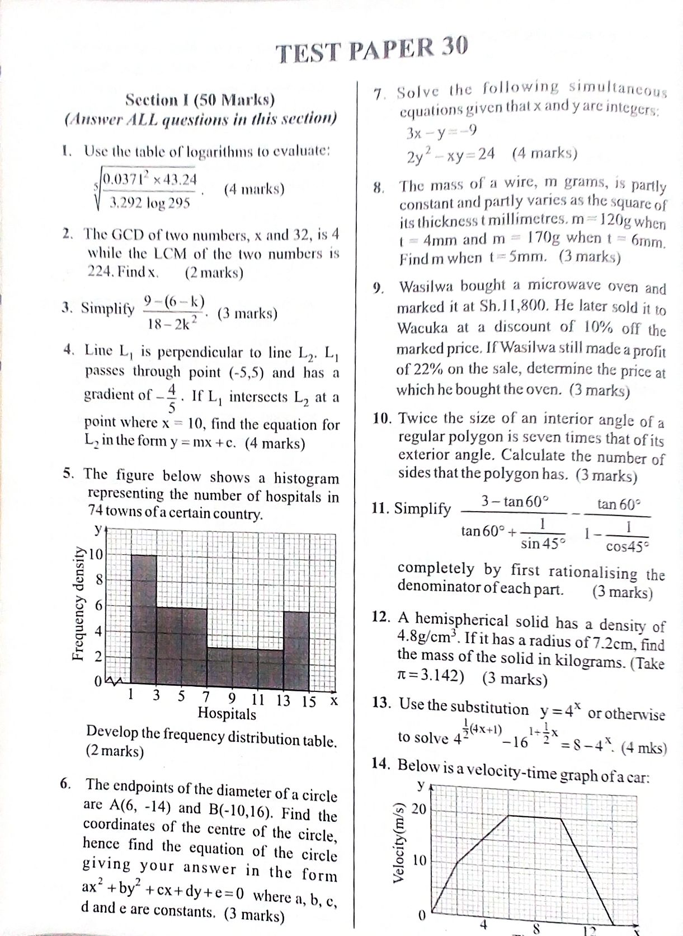

Develop a frequency distribution table. (3mks)

1. A vehicle dealer imported a car for which he paid import duty at 35% of the purchase price. He later sold it to Nanjala, making a profit of 10% in the process. This sale was carried out through an agent who charged the dealer 1% commission as payment for his services. During the sale Nanjala was given a discount of 20% of the marked price. If the discount Nanjala was given was ksh. 750,000, how much was the import duty? (3mks)
2. The vertices of a rhombus are ABCD. The diagonals of the rhombus intersect at point M. BD produced makes an angle of 26.56505118o with the y-axis. Given that BD has a negative gradient, the coordinates of point A is (-1,-2) and that line BD produced meets the y-axis at y= 4, find the coordinates of point M. (3mks)
3. In the figure below , O is the centre of the circle , BC=CD, AOD is a straight line and angle ADB=28o

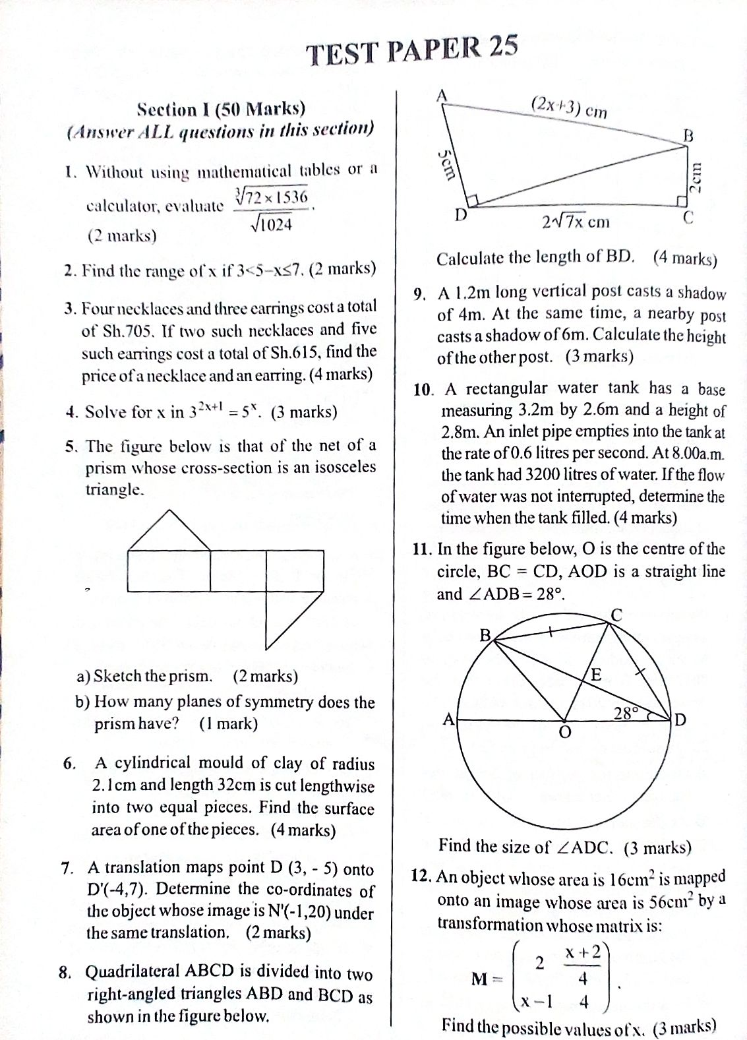

Find the size of angle ADC (3mks)

1. Using surds simplify $\frac{2}{3tan240°-4cos{45}°}+\frac{Tan135°}{6sin480°-4{\left(\sin{315°}\right)}^{-1}}$ by rationalizing the denominator, leaving your answer in the simplest form. (3mks)
2. Fatuma and Nzioka have decided to give some voluntary services to an NGO. Fatuma will be available for three hours a day for a period of 3 weeks while Nzioka will be available for four hours a day for $2\frac{1}{2}$ weeks, each week having six working days. At the end of the service the NGO will give them sh. 22800 as a token of appreciation, which they will share according to the proportion of work input. How much will each one of them get? (3mks)
3. A particle travels in a straight line such that its displacement, S, from a fixed point Q is given by $S=11+6t^{2}-t^{3}$, where *t* is the time in seconds measured from the starting point. If the particle started moving from point Q, find the distance it covers before eventually coming to rest at again. (3mks)
4. The figure below represents a cross-section of a solid. BC =10.8cm, CD = 12cm, ˂EAB = ˂CDB = 60O

12cm

10.8cm

60O

60O

C

B

D

A

E

The mass of the entire solid is 20.25kg and the area of quadrilateral ABDE is 40.5cm2. If the solid is to be divided into two parts along BD, calculate the mass of the piece whose cross-section will be BCD. (3mks)