NAME:……………………………………………….. ADM NO:………………………………...
SCHOOL:………………………………………………………… STREAM:…………………..

312/2
GEOGRAPHY
PAPER 2
AUGUST 2021

SIBUGEO JOINT EXAM
GEOGRAPHY EXAMINATION 2021
TIME 2³/₄ HRS

INSTRUCTIONS:
- This paper has two sections A and B.
- Answer all the questions in section A.
- Answer question 6 and any other two questions from section B.
- All answers must be written in the answer booklet provided.
- Candidates should check the questions paper to ascertain that all papers are printed as indicated and that no questions are missing.

For examiner’s use only
QUESTION | MAXIMUM SCORE | CANDIDATES SCORE
1 - 5
6
7
8
9
10
TOTAL

SECTION A
- a) What is human geography. (2mks)
b) State three importance of studying geography. (3mks)
- a) List two methods of underground mining. (2mks)
b) State three ways in which minerals occur. (3mks)
- a) Distinguish between fishing and fisheries. (2mks)
b) List three traditional methods of fishing. (3mks)
- a) Give two social factors influencing agriculture. (2mks)
b) State three characteristics of shifting cultivation. (3mks)
- a) What is a polder? (2mks)
b) Name three polders in Netherland. (3mks)

SECTION B
- Study the photograph below and answer questions below:

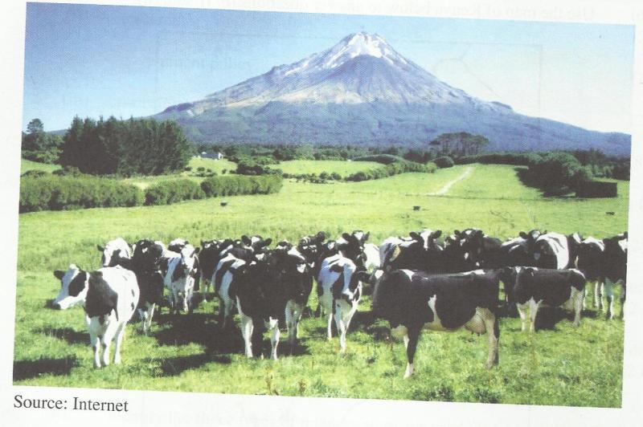

- i) Identify the type of photograph shown above. (1mk)
ii) What is the activity being carried out in the photograph. (1mk)
iii) Draw a rectangle measuring 15cm by 10cm to represent the area covered by the
photograph. (2mks)
iv) On the rectangle sketch and label four man features shown on the photograph. (3mks)
- i) Name exotic types of diary cattle reared in Kenya. (2mks)
ii) Explain three human factors that favoured dairy farming in the Kenyan highland.
(6mks)
- explain four ways in which dairy farming in Kenya is different from dairy farming in Denmark. (8mks)
- a) i) In which county is perkerra irrigation scheme. (1mk)
ii) Explain four factors that favoured the establishment of perkerra irrigation scheme.
(8mks)
b) i) Give three main crops grown in the scheme. (3mks)
ii) State four importance of the scheme. (4mks)
c) You intend to carry a field study in perkerra irrigation scheme.
i) Prepare a working scheme for such a study. (3mks)
ii) Give three follow up activities you are likely to engage in. (3mks)
iii) Identify three problems faced by the farmers in perkerra irrigation scheme. (3mks)
- a) i) Give two types of coffee grown in Kenya. (2mks)
ii) Name four counties in central Kenya where coffee is grown. (4mks)
b) State three physical conditions that favoured coffee growing in the central highlands of
Kenya. (3mks)
c) Describe the stages involved in coffee production from picking to marketing. (8mks)
d) Explain four problems facing coffee farming in Kenya. (8mks)
- a) i) Name two major fishing grounds of the world. (2mks)
ii) State five physical factors influencing fishing in Japan. (5mks)
b) Give four differences between fishing in Kenya and Japan. (8mks)
c) i) Define anadromous fishing. (2mks)
ii) Give an example of anadromous fish. (1mk)
- i) State reasons why fresh water fishing is more popular in East Africa compared to marine fishing. (6mk)
ii) What is indiscriminate fishing. (1mk)
- a) i) Define forestry. (2mks)
ii) Explain three factors that favour growth of natural forests on the slopes of mount
Kenya. (6mks)
iii) State five factors that have led to reduction of the area under forests on the slopes of
Mount Kenya. (5mks)
b) Explain four measures that the government of Kenya is taking to conserve forest in the
country. (8mks)
c) Give the differences in exploitation of softwood forests in Kenya and Canada under the
following subheadings.
- Periods of harvesting. (2mks)
- Transportation. (2mks)

