NAME:……………………………………………….. ADM NO:………………………………...
SCHOOL:………………………………………………………… STREAM:…………………..

312/1
GEOGRAPHY
PAPER 1
AUGUST 2021

SIBUGEO JOINT EXAM
GEOGRAPHY EXAMINATION 2021
TIME 2³/₄ HRS

INSTRUCTIONS:
- This paper has two sections A and B.
- Answer all the questions in section A.
- Answer question 6 and any other two questions from section B.
- All answers must be written in the answer booklet provided.
- Candidates should check the questions paper to ascertain that all papers are printed as indicated and that no questions are missing.

For examiner’s use only
QUESTION | MAXIMUM SCORE | CANDIDATES SCORE
1 - 5
6
7
8
9
10
TOTAL

SECTION A
- a) Define physical geography. (2mks)
- It is a branch of geography that is concerned with the natural physical environment such as structure and form of the land e.g seas, lakes, vegetation and atmosphere.

b) Give three areas studied in practical geography. (3mks)
- Mapwork
- Field work
- Statistics
- Photograph work

- a) What is a weather station. (2mks)
- A weather station is a place or area where all the elements of weather are observed, measured and recorded.

b) State three important features of the Stevenson’s screen. (3mks)
- The screen is painted white so as to reflect the direct rays of the sun.
- The screen is raised off the ground so as to avoid air temperature being influenced by ground temperature.
- The screen has louvred sides with slots to allow the free flow of air into and out of the free flow of air into and out of the box, so as to avoid the build-up of heat in it.
- The screen is made of wood to avoid absorption of heat.
- The screen has a double roof to prevent the sun’s heat from getting into the screen.

- a) State two factors influencing wind transportation in deserts. (2mks)
- Nature of the load
- Strength and speed of the wind
- Presence of obstacles/vegetation
- Nature of the desert surface
- State of the particles

b) Give three reasons why the action of wind is dormant in arid areas. (3mks)
- Presence of loose unconsolidated dry particles that are easily picked by wind.
- Scanty vegetation cover leaving most of the surface bared and exposed to erosion.
- Strong tropical storms are a common phenomena in the desert.

- a) Name two types of folds. (2mks)
- Simple symmetrical fold
- Assymetrical
- Overfold
- Isoclinal
- Recumbent
- Nappe/overthrust
- Anticlinorium and synclinorium

b) State three effects of fold mountains on human activities. (3mks)
- Fold mountains are important tourist attraction thus bringing in foreign exchange.
- Snow cover slopes encourage sporting activities.
- Fold mountains may act as barriers to transport and communication. They make the construction of transport and communication lines difficult and expensive.
- The windward sides of fold mountains encourage settlement and agriculture due to the warm and wet climate, while the leeward side discourage settlement and agriculture due to the cool and dry climate.
- During the formation of fold mountains valuable minerals were exposed e.g coal and petroleum.
- Fold mountains act as catchment area for rivers which provide water for agricultural, industrial and domestic purpose.

- a) Differentiate between a catchment area and a watershed. (2mks)
- A catchment area is a land or area from which a river or reservoir draws its water from while a watershed is a ridge or boundary separating drainage or river systems or basins.

b) Name three features that results from river rejuvenation. (3mks)
- River terraces
- Rejuvaned gorges
- Incised meanders
- Knick points/water points/rapids.
- Valley within a valley.

SECTION B
Study the map of KIJABE 1:50,000 (134/3) provided to answer the following questions.
- a) i) Identify the map title. (2mks)
- mapwork – EAST AFRICA 1:50,000 (KENYA)

ii) Give the longitudinal extent of the map provided. (2mks)
- The longitudinal extent.
36˚30˚E - 36˚45˚E
iii)Measure the distance of the all-weather road bound surface road C68. (2mks)
- Distance of all-weather road
14.7 km ± 0.1

b) i) Give the six-figure grid reference of the school at Mai Mahiu. (2mks)
- Six figure grid reference
314906

ii) Identify three methods used to represent relief on the map extract. (3mks)
- Contours
- Trigonometric stations
- Spot heights

c) i) Give two economic functions of KIJAMBE centre. (2mks)
- Trading centre
- Forestry
- Transport
- Manufacturing /processing
ii) Draw a rectangle measuring 10cm by 5cm to represent the area enclosed by easting
30 and 40 and Northing 95 and 00. (2mks)
On it mark and name the following features:
- Railway (1mk)
- All weather road bond surface (1mk)
- Forest (1mk)
- Murrum pit (1mk)

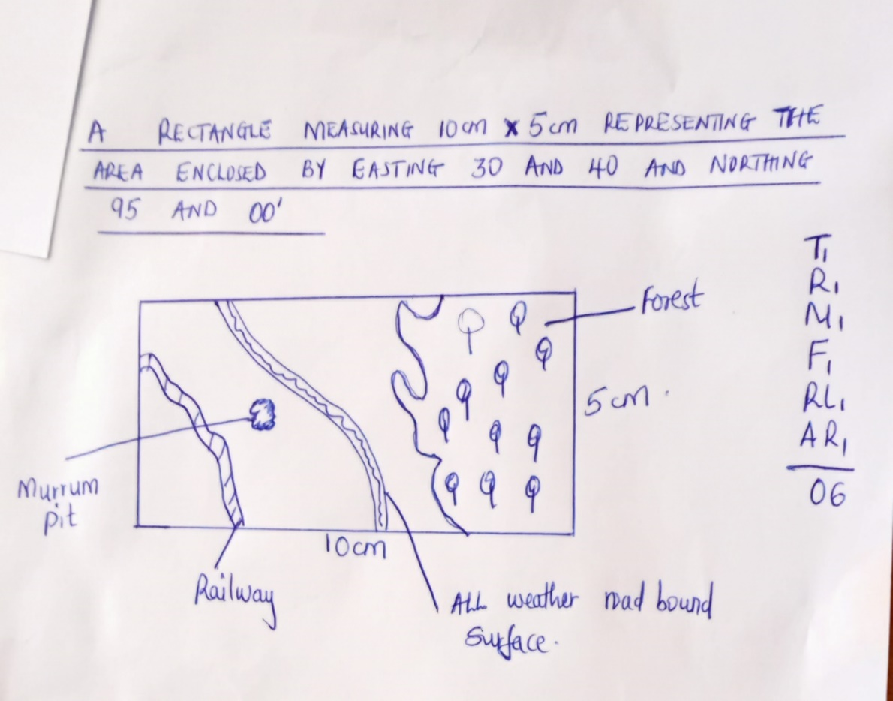
d) Explain three factors influencing the distribution of vegetation in the area covered by the map. (6mks)
- High attitude on the eastern part of the area covered has favoured the growth of forests due to the low temperatures and heavy rains.
- Human settlement on the central part of the area has discouraged the growth of vegetation thus a few woodlands.
- The cold dry descending winds (leeward side) in the Ewaso kedeng valley only supports scrub vegetation.
- The soils and unreliable rainfall encourage the growth of thickets on the lower central part of the area.

- a) i) Differentiate between volcanicity and vulcanicity. (4mks)
- vulcanicity is the process operating in the earth by which solid, liquid or gaseous materials are forced out of the interior into the earths crust or onto the surface of the earth while volcanicty is process operating within the interior of the earth involving materials that reach the surface of the earth.

ii) The diagram below shows intrusive volcanic features. Name the feature marked E, F
and G. (3mks)

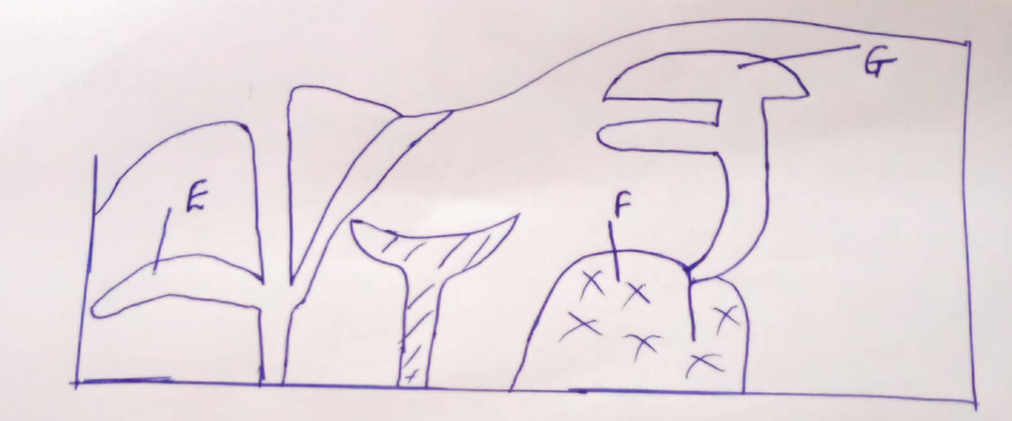

- E – A sill
- F – Batholith
- G – Loccolith

b) i) Using a well labelled diagram described the formation of a composite volcano.
(7mks)
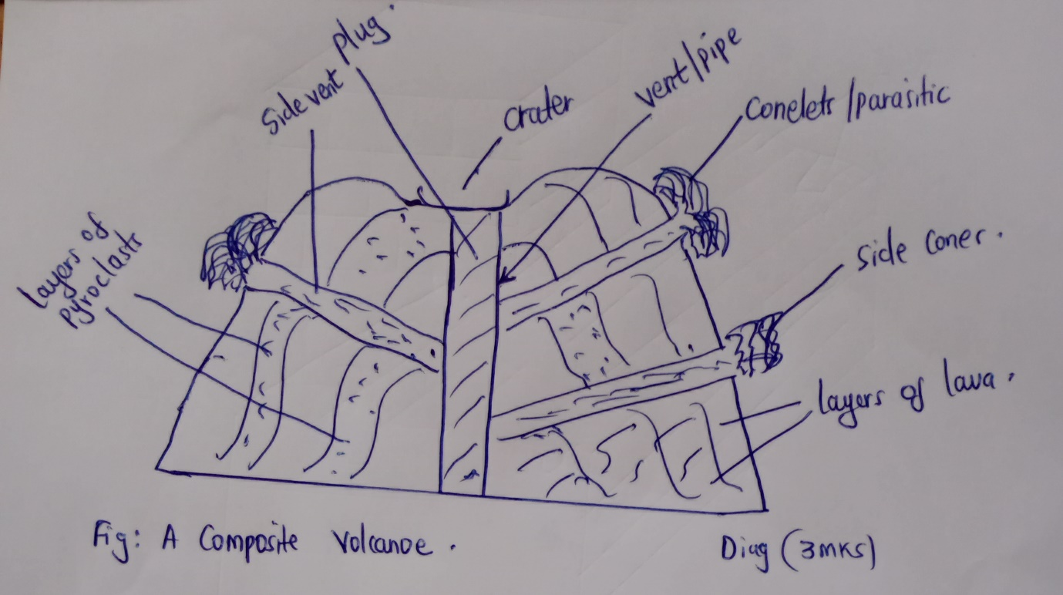
- A composite volcano is formed by successive vent eruptions.
- The first eruption thowes out solid materials (pyroclasts) followed by a mass acidic or intermediate lava, which cools and solidifies over a layer of pyroclasts.
- Magma in the vent also solidifies, followed by a period of calm.
- Pressure builds beneath and another eruption blows out the solid vent materials forming another layer of pyroclasts, followed by another flow of lava, which spreads over the pyroclasts.
- The process is repeated over years.
- This leads to the formation of stratified volcano with alternating layers of pyroclasts (ash and cinder) and lava.
- Further eruptions creates lines of weaknesses on the sides, when the magma does not overcome the resistance of the vents (plug) called side vents, which leads to accumulation of pyroclasts and lava on the side of the volcano called parasitic cones or conelets.
c) i) Name the three types of volcanoes. (3mks)
- Active volcano
- Dormant volcano
- Extinct volcano

ii) Explain the economic significance of features resulting from volcanicity. (8mks)
- Volcanicity results in formation of valuable minerals like diamonds which are mind to earn income.
- Volcanicity leads to information of volcanic mountains. Windward side of volcanic mountains receives heavy rainfall which encourages agriculture and settlement.
- Some volcanic rocks are very hard. They are used in building and construction.
- Hotsprings and geysers are harnessed to generate geothermal power.
- Features formed due to volcanicity such as volcanic mountains aid caters provide beautiful scenery. They attract tourists who provide foreign exchange.
- Some volcanic mountains are catchment areas for major rivers. Such river is harnessed for hydroelectronic power and water for domestic and industrial use.
- Fishing is carried out in some crater lakes such as Katwe in western Uganda.
- Some hot spring are used are used as spas for health purposes.

- a) i) What is masswasting? (2mks)
- Masswasting is the downward/downslope movement of weathered materials under the influence of gravity.

ii) Give two process of slow masswasting. (2mks)
- Soil creep
- Scree creep/talus creep
- Solifluction

iii) State conditions necessary for Mudflow to occur. (4mks)
- Presence of unconsolidated/loose material at the surface which become slippery when wet.
- Occurrence of steep slopes.
- An abundant but intermittent supply of water.
- Scarcity of vegetation which explains the faster moment.
b) Describe the following processes of weathering.
- Exfoliation. (3mks)
- It is the peeling off of rock surface caused by the unequal expansion and contraction due to the temperature variation.
- Hydration (3mks)
- It is the absorption of water by rocks. The rocks then expand causing internal stress which causes the rock to disintegrate.
- Action of plants (3mks)
- The penetrating and expanding power of roots on the cracks of rocks leads to disintegration.
- A close cover of vegetation may prevent rock disintegration and decay. This is because the surface of the rock is protected by the vegetation cover from weathery process. The decaying vegetation remains also release organic acids which readily assist in the decay and disintegration of rocks.

c) Explain four effects of masswasting on physical and human environment. (8mks)
- Materials derived from fertile origins end up in different destinations. These have formed rich agricultural bases.
- Some features of masswasting like rock fall and avalanches are tourist attraction which earns the government foreign exchange.
- Moulds of debris or blocks of rocks have dammed rivers courses thereby creating temporary lakes.
- Masswasting can destroy buildings, lines of communication, transport routes and cause great loss of life.
- A derelict topography cannot support vegetation and remain unattractive to human settlement since they are simple bare surface.
- Affected areas of masswasting have become centres of research and study on the dynamics of terrestrial stability.
- Areas prone to masswasting have encourage environmental conservations strategies, Agro-forestry and reforestation programmes.
- a) i) Name three types of glaciers. (3mks)
- Valley glacier
- Cirque glacier
- Piedmount glacier
- Continental glacier/ice sheet

ii) State two ways in which glacier erodes. (2mks)
- Plucking: rock particles on the floor or sides of the valley are removed or dislodged by force of the moving glacier and are carried away by ice.
- Abrasion: the moraines carried by glacier scrapes the floor and sides of the valley loose rock ends are removed and easily carried away by glacier.

b) The diagram below shows the types moraines.

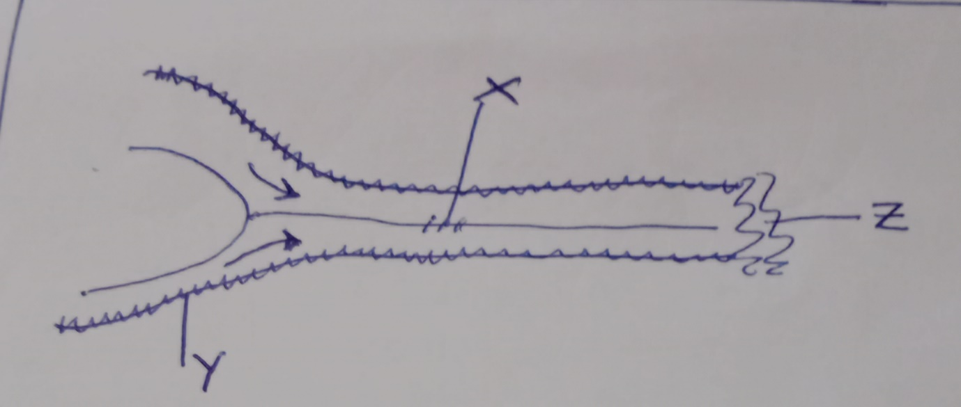

- Name the types moraines marked X, Y and Z. (3mks)
- X – medial moraine
- Y – lateral maraine
- Z – terminal moraine

- Apart from the types in the diagram above, name other two types moraines. (2mks)
- Sub – glacial/Ground moraine
- Englacial moraine.

c) Explain four conditions that may lead to glacial deposition in low lands. (8mks)
- Gradient/slopes of the land: the area has gentle slopes, which allows for slow movement of i.e. this lowers energy to transport load, thus deposition takes places.
- Rising temperature/seasonel changes high temperature leads to melting of the ice. This reduces its power to transport thus depositing some of the carried load.
- Amount of glacier: large amount of glacier exerts a lot of pressure at its base causing it to meet. This reduces the power to transport heavy materials leading to deposition.
- Friction between the moraine ice and the surface: this leads to deposition of the heavy materials beneath the ice mass.

d) Your class intends to carry out a field study in a glaciated lowland.
i) State three preparations that you will make before carrying out the study. (3mks)
- Seek permission from the school authority.
- Conduct a reconnaisance/pre – visit
- Adjust the objectives and hypotheses.
- Decide on method of data collection.
- Prepare working schedule.
- Divide yourselves into groups.

ii) Identify two glacial depositional features that you are likely to observe during the study. (2mks)
- Boulder day/till day
- Kettle lakes
- Drumlins
- Moraine damned lakes
- Crag and tail
- Kames and eskers
- Boulder train
- Erratics
- Outwash plain.

- Mention two follow up activities you will undertake after the study. (2mks)
- Comparing notes
- Reading more about the topic
- Data analysis
- Displaying labeled samples
- Drawing sketches
- Discussion
- Giving/presenting reports
- a) i) State three factors influencing the rate of water infiltration into the ground. (3mks)
- Slope: infiltration is greater o-flat and gentle slopes since weather remains at a point
longer than on steep slopes due to higher rates of surface run off.
- Vegetation cover: presence of vegetation cover increases infiltration as it breaks the
speed of the filling raindrop as well as surface runoff increasing
infiltration of bare surfaces increases surface run off reducing the rate of infiltration.
- Precipitation: Light and prolonged rainfall infiltrates more than short and heavy down
pours which encourages surface run - off.
- Melt water infiltrates at a higher rate as snowfall takes a long time to melt.
- Features of rocks: Permeable rocks, both and pervious allow infiltrates though pore
spaces and cracks, while impermeable rocks to not allow water to pass through them.
- Ground saturation level: infiltration is higher on dry ground as all pore spaces are
open, while saturated soils reduce the rate of infiltration.

ii) Identify four conditions necessary for the development of a karst scenery. (4mks)
- Surface rocks and the rock beneath should be thick limestone, dolomite or chalk.
- The rocks should be hard and well folted.
- The climate should be hot and humid for effective chemical weathery by solutions.
- The water table should be deep below to avoid the whole mass dissolving.
b) i) What is an artesian basin. (2mks)
- An artesian basin is a circular shaped depression which consists of a permeable layer of rock sandwiched between two layers of impermeable rocks.

ii) Give three factors favouring the development of an artesian well. (3mks)
- The aquifer must be sandwiched between two layers of impermeable rocks.
- The aquifer must in a region of water intake and the rock layers must form a bround syncline on basis.
- The mouth of the well must be lower than the water table to allow waterto come out by hydraulic pressure.

c) i) Apart from limestone pillars, name two underground features in limestone areas. (2mks)
- Stalactites
- Stalagmites
- Caves and caverns
- Pheatic caves
- Underground steams

ii) Using well labelled diagrams, describe the formation of grikes and clints. (5mks)
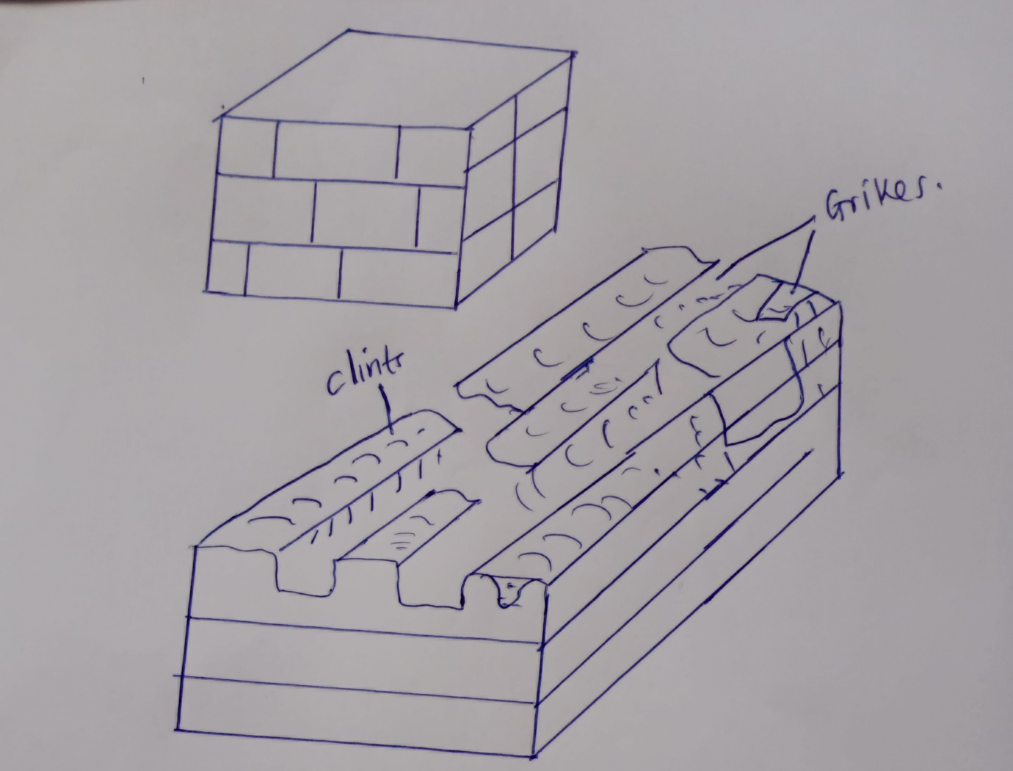
- Water action in limestone areas widers and deepens the joints in limestone rocks, which are highly soluble in rainy water, though the carbonation and solution processes resulting into development of deep irregular gullies called the grikes separating limestone blocks known as clints, hence griker and clints.

d) You intend to conduct a field study in a limestone area.
i) Give three surface erosional features you are likely to observe. (3mks)
- Dolines
- Uvalas
- Polje
- Dry valleys
- Swallow hole/sink hole
- Gorges
- Grikes and clints
ii) State three problems you are likely to experience during the study. (3mks)
- Inaccessibility due to rugged landscape hindering studying the whole region.
- High temperatures making the field study uncomfortable.
- Accidents due to unstable surface rocks with underground features, hence easily collapse.
- Attack by wild animals.

