NAME:……………………………………………….. ADM NO:………………………………...
SCHOOL:………………………………………………………… STREAM:…………………..

312/1
GEOGRAPHY
PAPER 1
AUGUST 2021

SIBUGEO JOINT EXAM
GEOGRAPHY EXAMINATION 2021
TIME 2³/₄ HRS

INSTRUCTIONS:
- This paper has two sections A and B.
- Answer all the questions in section A.
- Answer question 6 and any other two questions from section B.
- All answers must be written in the answer booklet provided.
- Candidates should check the questions paper to ascertain that all papers are printed as indicated and that no questions are missing.

For examiner’s use only
QUESTION | MAXIMUM SCORE | CANDIDATES SCORE
1 - 5
6
7
8
9
10
TOTAL

SECTION A
- a) Define physical geography. (2mks)
b) Give three areas studied in practical geography. (3mks)
- a) What is a weather station. (2mks)
b) State three important features of the Stevenson’s screen. (3mks)
- a) State two factors influencing wind transportation in deserts. (2mks)
b) Give three reasons why the action of wind is dormant in arid areas. (3mks)
- a) Name two types of folds. (2mks)
b) State three effects of fold mountains on human activities. (3mks)
- a) Differentiate between a catchment area and a watershed. (2mks)
b) Name three features that results from river rejuvenation. (3mks)

SECTION B
Study the map of KIJABE 1:50,000 (134/3) provided to answer the following questions.
- a) i) Identify the map title. (2mks)
ii) Give the longitudinal extent of the map provided. (2mks)
iii)Measure the distance of the all-weather road bound surface road C68. (2mks)
b) i) Give the six-figure grid reference of the school at Mai Mahiu. (2mks)
ii) Identify three methods used to represent relief on the map extract. (3mks)
c) i) Give two economic functions of KIJAMBE centre. (2mks)
ii) Draw a rectangle measuring 10cm by 5cm to represent the area enclosed by easting
30 and 40 and Northing 95 and 00. (2mks)
On it mark and name the following features:
- Railway (1mk)
- All weather road bond surface (1mk)
- Forest (1mk)
- Murrum pit (1mk)
d) Explain three factors influencing the distribution of vegetation in the area covered by
the map. (6mks)
- a) i) Differentiate between volcanicity and vulcanicity. (4mks)
ii) The diagram below shows intrusive volcanic features. Name the feature marked E,F
and G. (3mks)

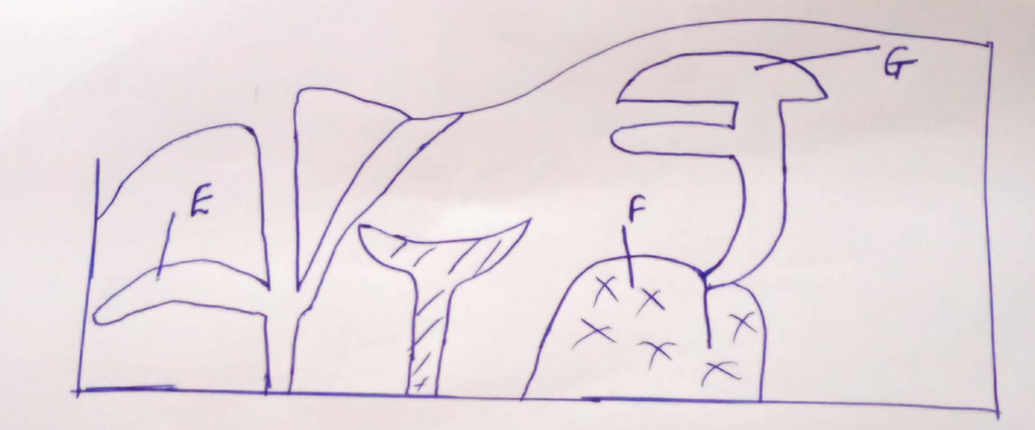

b) i) Using a well labelled diagram described the formation of a composite volcano.
(7mks)
c) i) Name the three types of volcanoes. (3mks)
ii) Explain the economic significance of features resulting from volcanicity. (8mks)
- a) i) What is masswasting? (2mks)
ii) Give two process of slow masswasting. (2mks)
iii) State conditions necessary for Mudflow to occur. (4mks)
b) Describe the following processes of weathering.
- Exfoliation. (3mks)
- Hydration (3mks)
- Action of plants (3mks)
c) Explain four effects of masswasting on physical and human environment. (8mks)
- a) i) Name three types of glaciers. (3mks)
ii) State two ways in which glacier erodes. (2mks)
b) The diagram below shows the types moraines.

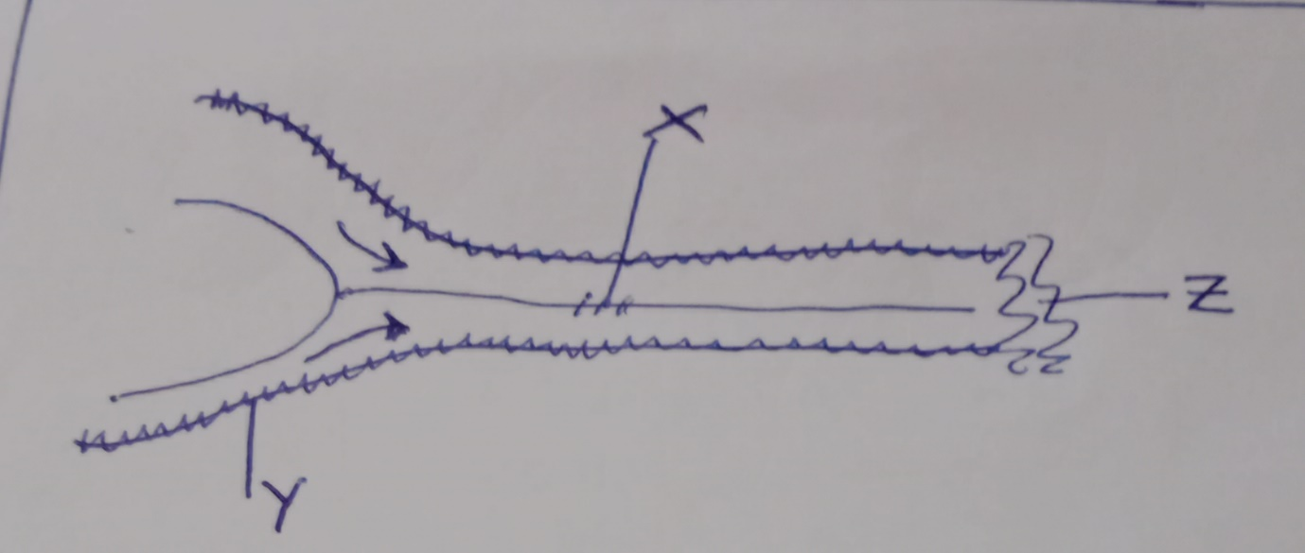

- Name the types moraines marked X, Y and Z. (3mks)
- Apart from the types in the diagram above, name other two types moraines. (2mks)
c) Explain four conditions that may lead to glacial deposition in low lands. (8mks)
d) Your class intends to carry out a field study in a glaciated lowland.
i) State three preparations that you will make before carrying out the study. (3mks)
ii) Identify two glacial depositional features that you are likely to observe during the study.
(2mks)
- Mention two follow up activities you will undertake after the study. (2mks)
- a) i) State three factors influencing the rate of water infiltration into the ground. (3mks)
ii) Identify four conditions necessary for the development of a karst scenery. (4mks)
b) i) What is an artesian basin. (2mks)
ii) Give three factors favouring the development of an artesian well. (3mks)
c) i) Apart from limestone pillars, name two underground features in limestone areas.
(2mks)
ii) Using well labelled diagrams, describe the formation of grikes and clints. (5mks)
d) You intend to conduct a field study in a limestone area.
i) Give three surface erosional features you are likely to observe. (3mks)
ii) State three problems you are likely to experience during the study. (3mks)

