


Name: ...... .......................Admission No ............... Class............

Date: .................................School Signature

KALA JOINT MOCK EXAMINATION-2024
Kenya Certificate ofSecondary education 443/1 -AGR1cuLruRE- Paper 1 2hrs
JULY/AUGUST 2024

Instructions to Candidates

(a) Write your name and index number in the spaces provided above.

- This paper consist of three sections A,B and C.

- Answer all the questions in section A and B.

- Answer any two questions in section C.

For Examiner's Use

  SECTION  - | MAXIMUM SCORE |  | -  CANDIDATES'._SCORE
A | 1-17
B | 18-20
 | 21-23 | -·--

1

�

.. ··-- ····-�- -- ..





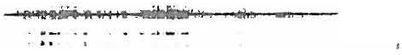

SECTION A:
Answer ALL the questions in this section in the spaces provided

- What is the meaning ofseed dressing? (lmk)

- Give four advantages of row planting. (2rnks)

- List four factors to be considered when choosing site for tomato nursery. (2rnks)

�4. State three reasons oftreating water in the farm. (1 Yi mks)

···-
. . . . . . . . . . . . . . . . . . . . . . . . . . . . . . . . . . . . . . . . . . . . . . . . . . . . . . . . . . . . . . . . . . . . . . . . . . . . . . . . . . . . . . . . . . . . . . . . . . . . . . . . . .

2

-

-·-.-.�--·
� . . .... �



Give three ways through which HIV/AIDS affect agriculture. (1 Yi mks)
5.

- State four advantages ofoverhead irrigation. (2mks)

- List three methods offarming. (3 Yi marks)

- A farmer in Premier was advised to apply 150kg C.A.N;ha while top dressing the maize crop. CAN, contains 21% N. Calculate the amount ofnitrogen applied per ha. (2mks)

. . . . . . . . . . . �. . . . . . . . . . . . . . . . . . . . . . . . . . . . . . . . . . . . . . . . . . . . . . . . . . . . . . . . . . . . . . . . . . . . . . . . . . . . . . . . . . . . . . . . . . . . . . . .

3

� �-· -

.. ..-· -·��-· ..




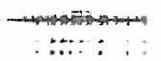
- Name four farm records that should be kept by a poultry farmer.

- Give three importance oftissue culture in crop production.

1 1. .Define the following terms as used in economics .

- National income

- Per capita income

4

--��-- --� -- -���--·
..
(2marks)

(2mks)

(!mark)

(lmark)

..

- Highlight four problems facing the marketing ofcabbages. (2mks)

- State four variable costs in maize production. (2mks)

- State four constituents ofsoil. (2mks)

- State four symptoms ofviral diseases in crops. (2marks)

· ·""· · · · · · · · · · · · · · · · · · · · · · · · · · · · · · · · · · · · · · · · · · · · · · · · · · · · · · · · · · · · · · · · · · · · · · · · · · · · · · · · · · · · · · · · · · · · · · · · · · · · · · · · ·

5


= �'-=--=

� · • ---..�- - �

,.,.

"' ---·


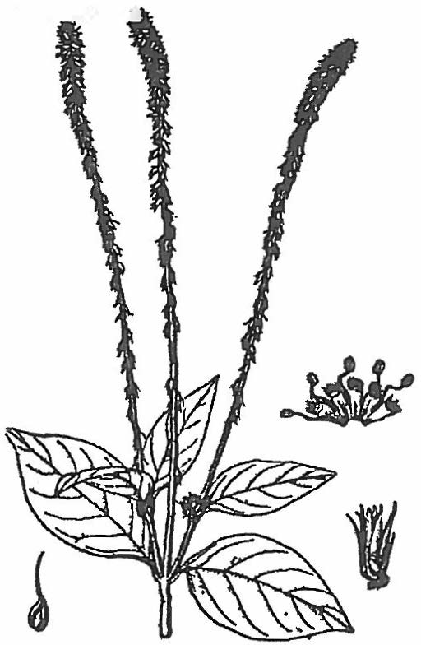
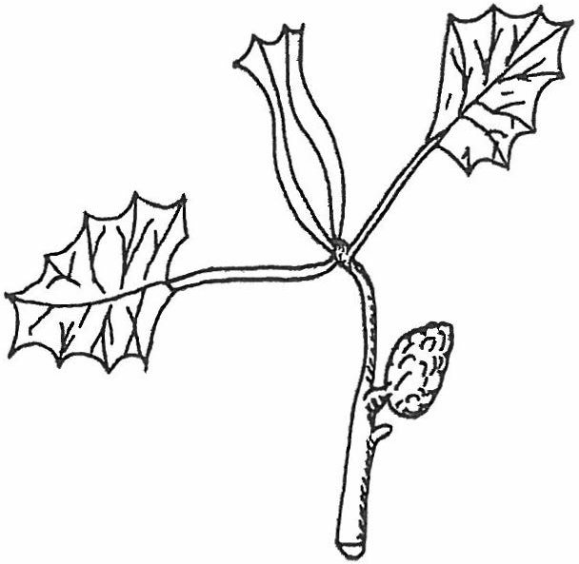




- State five factors which influence the spacing ofcrops. (2mks)

SECTION B (20 MKS)

Answer ALL Questions in this section

- Below are illustrations ofcommon weeds. Study them and answer the questions that follow

oo1 ,_i••t.>CU1

A B

  - Identify the weeds (2mks)

    - ...................................................

    - .............................................. :::..

6

��------�- ··-· .. ..

  - State the harmful effects ofthe weed B above (lmk)

  - Give four advantages ofleasehold tenure systems (2mks)

Describe the procedure which should be followed when spraying a crop ofonions using a
18.

fungicide in powder form, water and a knapsack sprayer (5mks)

- The following diagram shows a method ofcompost preparation.

PIT
1 �
PIT 2
PIT 3
PIT 4

5 =·
PIT
..


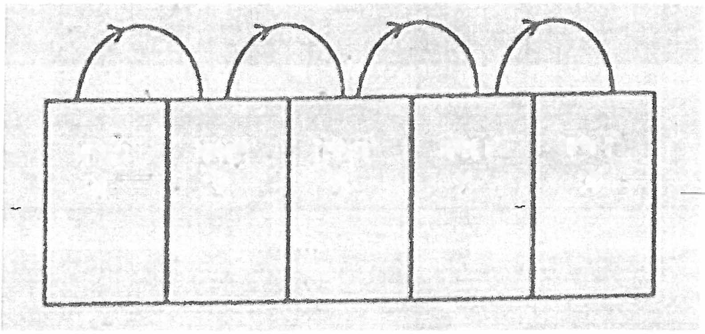


7

�-- r.:Hl';•

.. . -- �--�� ·- . .. ..

- Identify the method (1 mk)

- Give two factors considered when siting the compost pit (2 mks)

- State two factors that would determine time the manure would be ready for use in the field (2mks)

- Study the diagram below ofcrop propagation and answer the following questions

.. .

Roots develop here






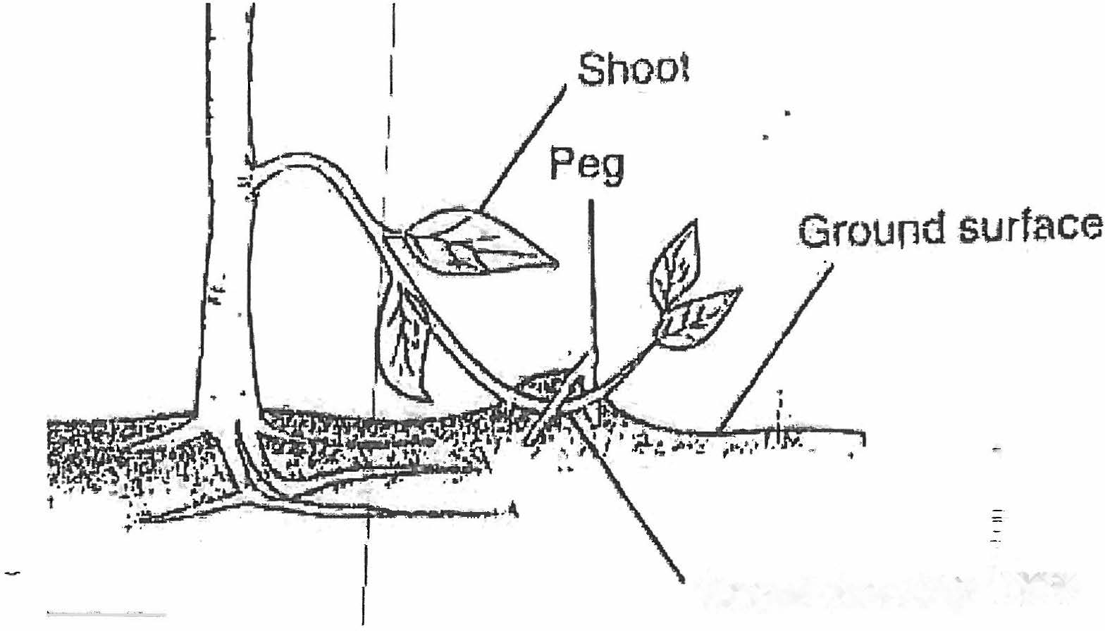

Identify the propagation method (lmark)
a)

8

-

.. ..

b) State two factors that encourage root formation in the above method of propagation (2marks)

c). Name two crops that can be propagated using the above method (2marks)

SECTION C (40MKS)
Answer any two Questions in this section
  - Describe harvesting ofpyrethrum under the following sub-headings
    - Procedure
    - Precautions
  - Describe the safety measures observed when handling farm herbicides

(4mks)
(6mks) (IOmks)

- (a)Describe the production ofcarrot (Daucus carota) under the following sub-headings
- Land preparation (4mks)



24.
- field management practices
(b) Explain six cultural methods ofsoil and water conservation
(a) Explain the benefits ofland consolidation.

- Briefly explain six factors influencing mass wasting.=
�
- Explain four ways ofimproving labour productivity

9

.,
(4mks) ( 12 marks) (6marks)
(6marks) (8marks)

.,






oi:

· · ·· · · · · · ·· · · · · · · · · ·· · · · · · · · · ·· ·"'"· · · · · · · ·· · · · · · · ·· .. · · · · · · · ·· · · · · · · · · · · · · · · · · · · · · · · · · · ·· · · · · · · · · · · ·· · ·�· · · · · · · · · · · ··

