SECTION A (40MARKS)
Answer all the questions in this section

1. The figure below represents a transverse section of a young stem.
(a) Name the parts labelledA and Bon the diagram. (2mrks)
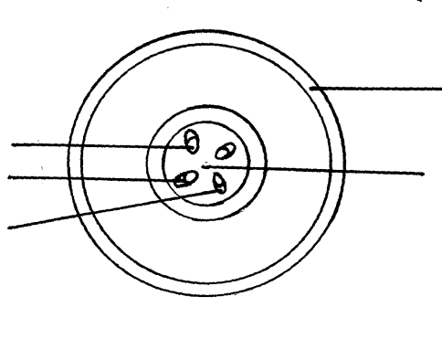

A
C
D
E
B
A.........................................................................................
B..........................................................................................
(b) State the functions of the labelledC, D and E. (3mrks)
C............................................................................................................................................
D................................................................................................................................................... E...................................................................................................................................................
(c) List three differences between the section shown above and one that would be obtained from the root of the same plant. (3mrks)
................................................................................................................................................................................................................................................................................................................................................................................................................................................................
2. A pure breeding black male mouse was mated with a pure breeding brown female mouse. all the offspring had black coat colour.
(i) Explain the appearance of black coat colour in the offspring. (1mrk)
.................................................................................................................................................................
.................................................................................................................................................................
(ii) If the black parental mouse was mated with a mouse that is heterozygous for coat colour, work out the genotype ratio of offspring. Show your working. (5mrks)

(iii) State two disorders in human being that are as a result of chromosomal mutations. (2mrks)
.................................................................................................................................................................
..................................................................................................................................................................
3. In an experiment to compare the basal metabolic rate of some animals, the amount of oxygen
consumed per unit body weight in a given period of time was determined. The table below shows results of the investigation.
Animal | Body weight(kg) | Oxygen consumed g/hr
Buffalo | 546 | 47
Man | 58 | 203
Rabbit | 3 | 318
Rat | 0.1 | 700
Mouse | 0.02 | 1510

(a) Comment on the volume of oxygen consumed by the buffalo and the mouse. (1mrk)
..................................................................................................................................................................................................................................................................................................................................
(b) Account for the above comparison for:
(i) Buffalo. (2mrks)
.................................................................................................................................................................
................................................................................................................................................................
(ii) Mouse. (2mrks)
................................................................................................................................................................
...............................................................................................................................................................
(c) What is Basal Metabolic Rate (BMR)? (1mrk)
..............................................................................................................................................................
(d) Explain how high temperature increases therate of diffusion. (2mrks)
...................................................................................................................................................................................................................................................................................................................................................................................................................................................................................................
4. In an experiment two equal volumes of solution L and M were placed into visking tubing.
The visking tubing was suspended into beakers containing equal volumes of solutions K. The set –up is as shown in the diagram A and B. The set-up was allowed to stand for 45minutes and results are as shown in the diagrams.

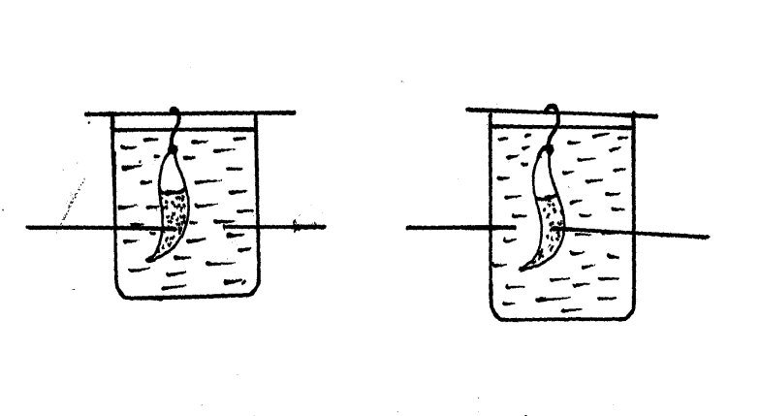
At the begining of experiment At the end of experiment
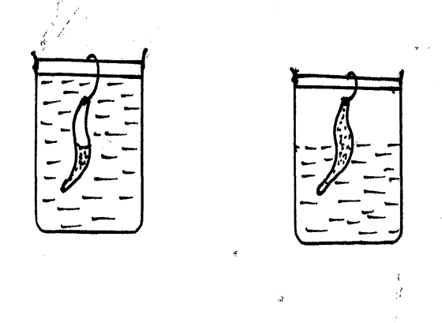
B
A
B
A

Solution L
Solution K
Solution M

(a) Name the process that was being demonstrated. (1mrk)
..........................................................................................................................................................
(b) Explain the results that were obtained at the end of the experiment in
(i) Set-up A. (2mrks)
..................................................................................................................................................
................................................................................................................................................
(ii) Set up B. (2mrks)......................................................................................................................................................
......................................................................................................................................................
(c) What is the biological importance of the process demonstrated in this experiment to plants
(2mrks)
..................................................................................................................................................................................................................................................................................................................................
(d) What happens to a marine Amoeba when it is transferred from sea water to freshwater?
(1mrk)
...............................................................................................................................................................
5. (a) Explain the term Eutrophication. (3mrks)
................................................................................................................................................................
................................................................................................................................................................
(b) How does Eutrophication lead to death of fish in a water body. (3mrks)
.................................................................................................................................................................
.................................................................................................................................................................
.................................................................................................................................................................
(c) Persistent use of a agricultural Inorganic fertilizers leads to loss of soil fertility Account for this observations. (2mrks)
.................................................................................................................................................................
................................................................................................................................................................

SECTION B(40 MARKS)
Answer question 6 (compulsory) in the spaces provided. Answer either question 7 or 8 in the
spaces provided after question 8

6. An investigation was conducted to compare loss from twigs of two species of plants X and Y. The apparatus shown below was used for this investigation. The twigs had equal leaf surface.

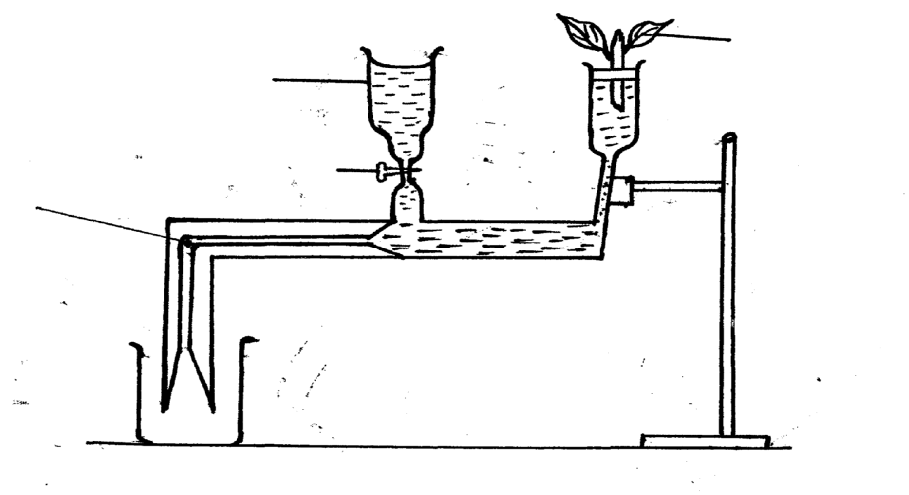
Plant twig
Tap
Air bubble
Reservoir
Plant twig
Reservoir

tap
Air bubble

The results of the investigation were recorded in the table below.

Time of the day | 6am | 8am | 10am | 12noon | 1pm | 2pm | 3pm | 4pm | 6pm | 8pm | 12midnight
Water loss  gh⁻¹ species X | 0 | 4 | 20 | 40 | 55 | 36 | 26 | 20 | 2 | 0 | 0
Water loss  gh⁻¹ species Y | 8 | 20 | 39 | 131 | 198 | 182 | 130 | 81 | 45 | 12 | 12

(a) Plot a graph of water loss gh⁻¹ against time for the plants. (7mrks)

(b) (i) Name the apparatus used in the above investigation. (1mrk)
.........................................................................................................................................................
(ii) State two precautions that were taken in setting up this experiment. (2mrks)
...........................................................................................................................................................
...........................................................................................................................................................
(c) Which of the plant species is likely to be adapted to arid conditions? Give a reason. (2mrks)
....................................................................................................................................................................................................................................................................................................................................(d) Use the graph to answer the questions that follow.
(i) At which time of the day was 60gh⁻¹ of water lost by the plant species? (1mrk)
..................................................................................................................................................................
(ii) What was the rate of water loss from species X at 11.00am? (1mrk)
................................................................................................................................................................
(e) Account for the rate of water loss between 6.00 am to 1.00pm by plant species Y. (4mrks)
............................................................................................................................................................. ......................................................................................................................................................................................................................................................................................................................................................................................................................................................................................................

(f) Suggest how the stomata of species X is structurally adapted for water loss. (2mrks)
...................................................................................................................................................................................................................................................................................................................................
7. Describe the process of fertilization in flowering plants. (20mrks)

8. (a) Sate characteristics of gaseous exchange surface. (4mrks)
(b) Describe the mechanics of gaseous exchange in mammals. (16mrks)

…………………………………………………………………………………………………..………
…………………………………………………………………………………………………..………
…………………………………………………………………………………………………..………
…………………………………………………………………………………………………..………
…………………………………………………………………………………………………..………
…………………………………………………………………………………………………..………
…………………………………………………………………………………………………..………
…………………………………………………………………………………………………..………
…………………………………………………………………………………………………..………
…………………………………………………………………………………………………..………
…………………………………………………………………………………………………..………
…………………………………………………………………………………………………..………
…………………………………………………………………………………………………..………
…………………………………………………………………………………………………..………
…………………………………………………………………………………………………..………
…………………………………………………………………………………………………..………
…………………………………………………………………………………………………..………
…………………………………………………………………………………………………..………
…………………………………………………………………………………………………..………
…………………………………………………………………………………………………..………
…………………………………………………………………………………………………..………
…………………………………………………………………………………………………..………
…………………………………………………………………………………………………..………
…………………………………………………………………………………………………..………
…………………………………………………………………………………………………..………
…………………………………………………………………………………………………..………
…………………………………………………………………………………………………..………
…………………………………………………………………………………………………..………
…………………………………………………………………………………………………..………
…………………………………………………………………………………………………..………
…………………………………………………………………………………………………………..
…………………………………………………………………………………………………..………
…………………………………………………………………………………………………..………
…………………………………………………………………………………………………..………
…………………………………………………………………………………………………..………
…………………………………………………………………………………………………..………
…………………………………………………………………………………………………..………
…………………………………………………………………………………………………..………
…………………………………………………………………………………………………..………
…………………………………………………………………………………………………..………
…………………………………………………………………………………………………..………
…………………………………………………………………………………………………..………
…………………………………………………………………………………………………..………
…………………………………………………………………………………………………..………
…………………………………………………………………………………………………..………
…………………………………………………………………………………………………..………
…………………………………………………………………………………………………..………
…………………………………………………………………………………………………..………
…………………………………………………………………………………………………..………
…………………………………………………………………………………………………..………
…………………………………………………………………………………………………..………
………………………………………………………………………………………………………….
…………………………………………………………………………………………………..………
…………………………………………………………………………………………………..………
…………………………………………………………………………………………………..………
…………………………………………………………………………………………………..………
…………………………………………………………………………………………………..………
…………………………………………………………………………………………………..………
…………………………………………………………………………………………………..………
…………………………………………………………………………………………………..………
…………………………………………………………………………………………………..………
…………………………………………………………………………………………………..………
…………………………………………………………………………………………………..………
…………………………………………………………………………………………………..………
…………………………………………………………………………………………………..………
…………………………………………………………………………………………………..………
…………………………………………………………………………………………………..………
…………………………………………………………………………………………………..………
…………………………………………………………………………………………………..………
…………………………………………………………………………………………………..………
…………………………………………………………………………………………………..………
…………………………………………………………………………………………………..………
…………………………………………………………………………………………………………..
…………………………………………………………………………………………………..………
…………………………………………………………………………………………………..………
…………………………………………………………………………………………………..………
…………………………………………………………………………………………………..………
………………………………………………………………………………………………………….
…………………………………………………………………………………………………………

