1a) Name the field of science that specializes in the study of chemical substances in an organism and the reactions in which they take part. (1mk)

……………………………………………………………………………………………………………………
b) The biological name of housefly is MUSCA domestica.
(i) State one mistake in the way the scientific name is written. (1mk)
……………………………………………………………………………………………………………………
……………………………………………………………………………………………………………………
(ii) Write the name in the correct manner following the rules of the binomial nomenclature. (1mk)
……………………………………………………………………………………………………………………
2a) What is the structural difference between the cell wall and the cell membrane? (1mk)
……………………………………………………………………………………………………………………
……………………………………………………………………………………………………………………
……………………………………………………………………………………………………………………
b) An organelle was magnified 800 times by an electron microscope. Its diameter was 2 millimetres. Calculate the actual diameter in micrometres. (2 mks)
……………………………………………………………………………………………………………………
……………………………………………………………………………………………………………………
……………………………………………………………………………………………………………………
……………………………………………………………………………………………………………………
3. Distinguish between haemolysis and plasmolysis. (2mks)
……………………………………………………………………………………………………………………
……………………………………………………………………………………………………………………
……………………………………………………………………………………………………………………
……………………………………………………………………………………………………………………
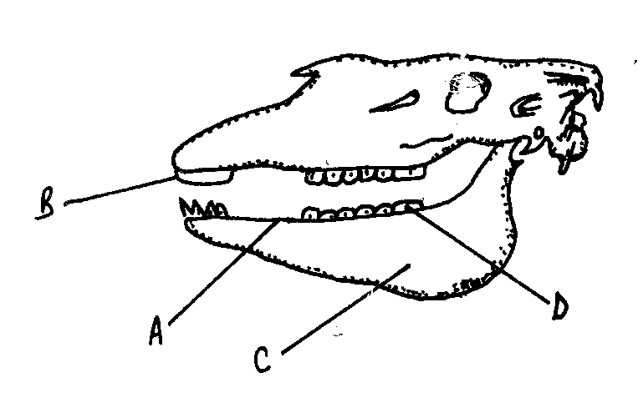
4. Study the figure below and answer the questions that follow:

D

B

A

C

- Name the parts labelled A, B, C and D (2mks)
A……………………………………
B……………………………………
C……………………………………
D……………………………………
b) State the function of part labelled A. (1 mk)
……………………………………………………………………………………………………………………
……………………………………………………………………………………………………………………
5a)Why are people with blood group O called universal donors? (1mk)
……………………………………………………………………………………………………………………
……………………………………………………………………………………………………………………
……………………………………………………………………………………………………………………
b) Most carbon (IV) oxide is transported from tissues to the lungs within the red blood cells and not in the blood
plasma.Give two advantages of this mode of transport. (2mks)
……………………………………………………………………………………………………………………
……………………………………………………………………………………………………………………
……………………………………………………………………………………………………………………
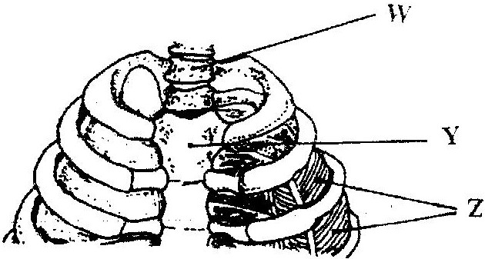
6. The diagram below represents a part of the rib cage:

a)Name the parts labelled W and Y: (2 mks)
W…………………………………………………
Y……………………………………………….…
b)How does the part labelledZ facilitates breathing out? (2 mks)
…………………………………………………….………………………………………………………………
……………………………………………….……………………………………………………………………
………………………………………………….…………………………………………………………………
7. Active yeast cells were added to dilute sugar solution in a container. The mixture was left in a warm room. After a few hours bubbles of gases were observed escaping from the mixture.
a)Write a word equation to represent the chemical reaction that took place. (1mk)
…………………………………………………………….………………………………………………………
………………………………………………………….…………………………………………………………
b)What is the importance of this type of reaction in industries? (1mk)
……………………………………………………….……………………………………………………………
……………………………………………………………………………………………………………………
8. Account for the absence of glucose and proteins in the glomerular filtrate.
(a) Glucose (1mk)
……………………………………………………….……………………………………………………………
………………………………………………………….…………………………………………………………
(b) Proteins (1mk)
………………………………………………….…………………………………………………………………
………………………………………………….…………………………………………………………………
9. Explain how hair in human beings keeps the body warm (2 mks)
…………………………………………………………………………………………………………………………
…………………………………………………………………………………………………………………………
…………………………………………………………………………………………………………………………
10. Explain how light intensity would affect the distribution of fish in a pond. (2mks)
…………………………………………………………………………………………………………………………
…………………………………………………………………………………………………………………………
…………………………………………………………………………………………………………………………
11. The diagram below shows a pollen tube as it develops down the style.
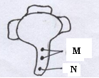
a) Name the parts labelled M and N. (2mks)
M……………………………………………
N………………………………………….…
b) State the function of the part labelled M. (1 mk)
………………………………………………………………………………………………………………………
12. Name the plant tissues responsible for growth in:
(i) Girth (1 mk)
……………………………………………………………………………………………………………………
(ii) Length (1 mk)
…………………………………………………….………………………………………………………………

13a) Name twochemical substances that form the DNA (2mks)
………………………………………………….…………………………………………………………………
…………………………………………….………………………………………………………………………
- Write the base sequence of messenger RNA (mRNA) that would be coded from the
DNA strand shown below: (1mk)
C – A – T – G – A – G – T
……………………………………………………………………………………………………………………
- What is a mutation? (1mk)
……………………………………………………………………………………………………………………
……………………………………………………………………………………………………………………
14. Define the following terms as used in Evolution:
(i)Vestigial structures (1mk)
……………………………………………………………………………………………………………………
……………………………………………………………………………………………………………………
(ii)Convergent evolution. (1mk)
……………………………………………………………………………………………………………………
……………………………………………………………………………………………………………………
(iii) Survival of the fittest (1mk)
……………………………………………………………………………………………………………………
……………………………………………………………………………………………………………………
15.In an experiment to investigate a factor affecting photosynthesis, a leaf of a potted plant which had been kept in
the dark overnight was covered with aluminium foil as shown in the diagram below.

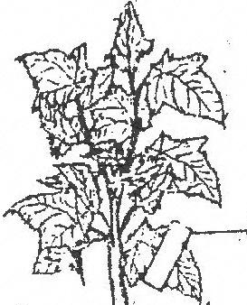

Aluminium foil

The set up was kept in sunlight for three hours after which a food test was carried out on the leaf.
i) Which factor was being investigated in the experiment? (1mk)
…………………………………………….………………………………………………………………………
ii) What food test was carried out? (1mk)
……………………………………………………….……………………………………………………………
iii) State the results of the food test. (1mk)
………………………………………………….…………………………………………………………………
………………………………………………….…………………………………………………………………
16. In an experiment to determine the population size of mosquitoes in Kisumu Museum, Kenya Research Institute researchers caught 600 mosquitoes which they marked and released. After 24hrs 300 mosquitoes were caught out of which 100 already had the marks.
a)Suggest a possible instrument of capturing the insects. (1 mk)
……………………………………………………………………………………………………………………
b)Estimate the population size of mosquitoes in Kisumu Museum. (2 mks)

17. Give two classes of the phylum Chordata whose members are all poikilothermic. (2mks)
……………………………………………………………………………….……………………………………
……………………………………………………………………………….……………………………………
18. Stateone use of each of the following excretory products in plants.
a)Colchine (1mk)
……………………………………………………….……………………………………………………………
b) Papain (1mk)
……………………………………………………………….……………………………………………………
19. After four months of pregnancy, the ovaries of a woman can be removed withoutterminating pregnancy. However, during the first four months of pregnancy, the ovaries must remain intact if pregnancy is to be maintained. Explain these observations. (3mks)
……………………………………………………………………………………………………………………
……………………………………………………………………………………………………………………
……………………………………………………………………………………………………………………
20 a) State two advantages of metamorphosis to the life of insects. (2mks)
……………………………………………………………………………………………………………………
……………………………………………………………………………………………………………………
b) Explain why several axillary buds sprout when the terminal bud in a young tree is removed. (2mks)

……………………………………………………………………………………………………………………
……………………………………………………………………………………………………………………
21. The diagram below represents some stages in mitosis:
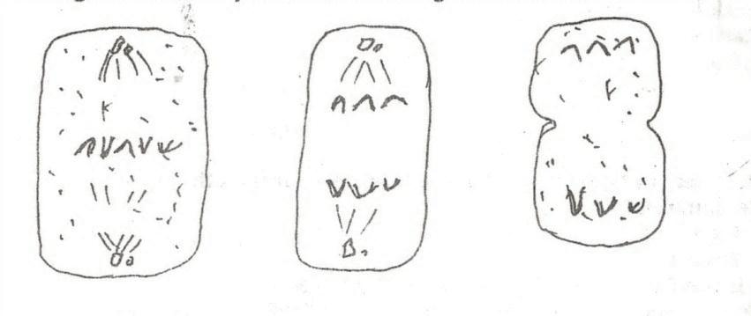

C
B
A

- Name the stages represented by the diagrams labelled A,B and C. (3mks)
A……………………………………………………
B……………………………………………………
C……………………………………………………
b) Nametwo regions in higher plants where cells actively undergo mitosis. (2mks)
……………………………………………………………………………………………………………………
……………………………………………………………………………………………………………………
……………………………………………………………………………………………………………………
22a) Name a fat soluble vitamin manufactured by the human body (1 mk)
……………………………………………………………………………………………………………………
(b) State one function of potassium in the human body (1 mk)
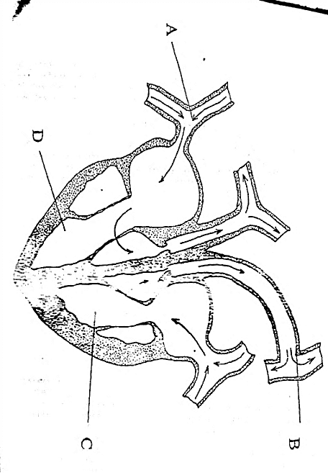
……………………………………………………………………………………………………………………
23. The diagram below represents a section through a mammalian heart.

- Label the parts marked A and B (2 mks)
A……………………………………………………
B……………………………………………………
- Explain why chamberC has thick walls than the chamber D. (1mk)
……………………………………………………………………..…………………………………………
…………………………………………………………………………………………………………………
24a) Aerenchyma tissues and pneumatophores are found in plants occupying different habitats.
Identify these habitats (2mks)
………………………………………………………………………………………………………………………
………………………………………………………………………………………………………………………
b) What is the function of pneumatophores? (1mk)
………………………………………………………………………………………………………………………
………………………………………………………………………………………………………………………
25. Name three sites where gaseous exchange takes place in plants. (3mks)
……………………………………………………………………………………………………………………
……………………………………………………………………………………………………………………
……………………………………………………………………………………………………………………
26. State the transport and synthetic roles of the rough endoplasmic reticulum. (2mks)
Transport role……………………………………………………….……………………………………….……
Synthetic role………………………………………………………..……………………………………………
27 a) Name the chemical compound formed in the mitochondria which is the source of energy.(1mk)
………………………………………………………………….…………………………………………………
b) Explain why fats are not considered as the main respiratory substrate yet they yield more energy when completely oxidized than carbohydrates. (2mks)
……………………………………………………………………………………………………………………
……………………………………………………………………………………………………………………
28. The diagram below represents the internal structure of a bean seed:

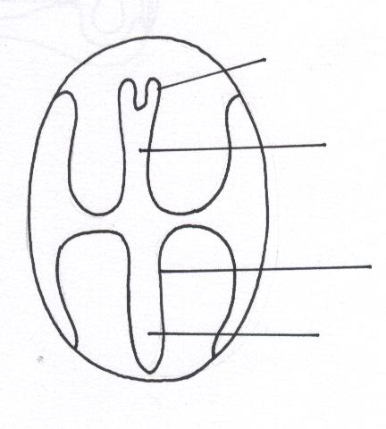
Hypocotyl
Y
X
Plumule
a) Name the parts of the seed embryo represented by letter X and Y (2mks)
X…………………………………………………………………………
Y………………………………………………………………………………
b) What type of germination would result if the hypocotyl elongated faster than the epicotyl? (1mk)
…………………………………………………………………………………………………………………… c) What is the significance of the part labelled Y emerging first during germination? (1mk)
……………………………………………………………………………………………………………………

