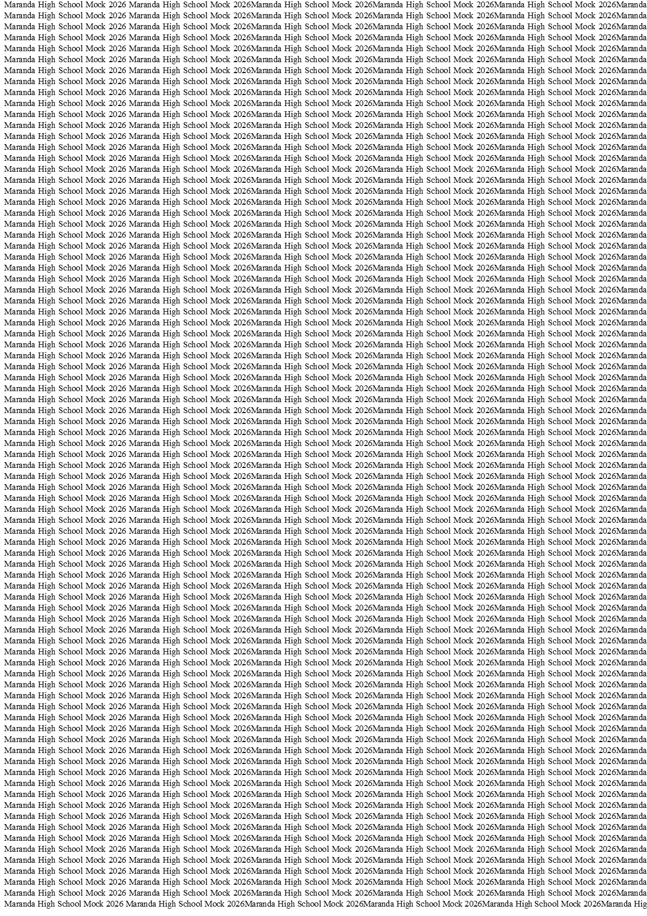



MARANDA HIGH SCHOOL
Kenya Certificate of Secondary Education
THE MOCK EXAMINATIONS, 2026
565/1 BUSINESS STUDIES PAPER 1

June 2026 Time: 2 Hours
Name: …………………………………….……. Admission No: …………
Stream: ……………. Signature: ………....... Thursday, 3rd June, 2026; 11:00am-1.00pm
Instructions
- Write your Name, Admission number and Stream in the spaces provided above.
- Sign in the spaces provided above
- Answer ALL the questions in the spaces provided below each question.
- This paper consists of 9 printed pages. Candidates should check the question paper to ascertain that all the pages are printed as indicated and that no questions are missing.
- All your answers must be written in English.
For Examiner’s Use Only
QUESTION | 1 | 2 | 3 | 4 | 5 | 6 | 7 | 8 | 9 | 10 | 11 | 12 | 13
Candidate Score
QUESTION | 14 | 15 | 16 | 17 | 18 | 19 | 20 | 21 | 22 | 23 | 24 | 25
Candidate Score

TOTAL MARKS

565/1 © 2026 The Maranda School Turn Over

- Name four commercial services that facilitate trade. (4 marks)

- ……………………………………………………………………………………………………
- ……………………………………………………………………………………………………
- ……………………………………………………………………………………………………
- ……………………………………………………………………………………………………

- Outline four ways in which the manufactures enhance customer protection. (4 marks)

- ……………………………………………………………………………………………………
- ……………………………………………………………………………………………………
- ……………………………………………………………………………………………………
- ……………………………………………………………………………………………………

- Highlight four measures that a wholesaler would take to ensure the smooth running of his warehouse. (4 marks)

- ……………………………………………………………………………………………………
- ……………………………………………………………………………………………………
- ……………………………………………………………………………………………………
- ……………………………………………………………………………………………………
- Outline four challenges that may be experienced by a new entrepreneur who is intending to start a business in Kenya. (4 marks)
- ……………………………………………………………………………………………………
- ……………………………………………………………………………………………………
- ……………………………………………………………………………………………………
- ……………………………………………………………………………………………………
- State four features of a good filing system. (4 marks)

- ……………………………………………………………………………………………………
- ……………………………………………………………………………………………………
- ……………………………………………………………………………………………………
- ……………………………………………………………………………………………………

- Give four differences between liners and tramps in water transport. (4 marks)

Liners | Tramps

- The following information relates to Ikulu enterprise
Stock (1.1.2023) 40,000
Stock (31.12.2023) 60,000
Purchases 500,000
Margin 20%
Prepare Ikulu Enterprise Trading account for the year ended 31st December, 2023. (4 marks)

- State four incentives that a government may give investors to locate their firms in rural areas. (4 marks)

- ……………………………………………………………………………………………………
- ……………………………………………………………………………………………………
- ……………………………………………………………………………………………………
- ……………………………………………………………………………………………………

- State four factors that limit the satisfaction of human wants. (4 marks)

- ……………………………………………………………………………………………………
- ……………………………………………………………………………………………………
- ……………………………………………………………………………………………………
- ……………………………………………………………………………………………………

- State four conditions that are necessary for pure competition. (4marks)

- ……………………………………………………………………………………………………
- ……………………………………………………………………………………………………
- ……………………………………………………………………………………………………
- ……………………………………………………………………………………………………

- Give four reasons why a manufacturing firm may offer after sale services to consumers. (4 marks)

- ……………………………………………………………………………………………………
- ……………………………………………………………………………………………………
- ……………………………………………………………………………………………………
- ……………………………………………………………………………………………………

- State three factors limiting the use of land to agriculture in Kenya. (3 marks)

- ……………………………………………………………………………………………………
- ……………………………………………………………………………………………………
- ……………………………………………………………………………………………………

- State four factors that could hasten the economic development of a country. (4marks)

- ……………………………………………………………………………………………………
- ……………………………………………………………………………………………………
- ……………………………………………………………………………………………………
- ……………………………………………………………………………………………………

- List four activities carried at process of distribution. (4marks)

- ……………………………………………………………………………………………………
- ……………………………………………………………………………………………………
- ……………………………………………………………………………………………………
- ……………………………………………………………………………………………………

- The government of a developing country intend to formulate an elaborate policy to address the widespread unemployment. Identify four areas of concern that the policy should look into. (4 marks)
- ……………………………………………………………………………………………………
- ……………………………………………………………………………………………………
- ……………………………………………………………………………………………………
- ……………………………………………………………………………………………………

- The following information relates to Tetema Enterprises as at 31st December, 2024
Sh.
Debtors 80,000
Creditors 30,000
Drawings 20,000
Bank overdraft 65,000
Stock 50,000
Cash 10,000
Premises 1,000,000
Required;
Calculate the Net worth of Tetema Enterprises as at 31st December, 2024. (4 marks)

- Indicate with a tick (√) in the relevant column whether each of the following business transactions will increase or decrease the capital of the business. (4 marks)
 | Transaction | Increase | Decrease
Cash donations of sh80,000 deposited into the business
bank account
 | Withdraw sh 2000 from bank personal use
 | Made a profit of sh.3000
 | The business made a loss of sh. 4000 on sale of stock

- Outline four challenges experience when using barter trade system. (4 marks)

- ……………………………………………………………………………………………………
- ……………………………………………………………………………………………………
- ……………………………………………………………………………………………………
- ……………………………………………………………………………………………………
- Highlight four items that would be included in the measurement of national income using the income approach. (4marks)
- ……………………………………………………………………………………………………
- ……………………………………………………………………………………………………
- ……………………………………………………………………………………………………
- ……………………………………………………………………………………………………

- State four factors that determine amount of revenue to be collected by Kenyan government through taxation. (4 marks)

- ……………………………………………………………………………………………………
- ……………………………………………………………………………………………………
- ……………………………………………………………………………………………………
- ……………………………………………………………………………………………………

- Outline four documents used in delivery of goods to the buyer in home trade. (4 marks)

- ……………………………………………………………………………………………………
- ……………………………………………………………………………………………………
- ……………………………………………………………………………………………………
- ……………………………………………………………………………………………………
- Identify the accounts to be debited and accounts be credited from the following transactions.
(5 marks)
 | Transactions | A/C debited | A/C credited
 | Bought stock on credit from Muya
 | Paid insurance premium by cheque
 | Bought a van by cash
 | Returned goods bought on credit to supplier
 | Took stock for family use

- The following is a subsidiary book that was drawn for the first week of the month of May 2024;
Date | Particulars | Credit note no. | Ledger folio | Amount
May 2023  1  5  14 | Mawazo Enterprises  Kanini Merchants  Jambo traders | 093  179  008 | PL  PL  PL | 43,000  7,200  10,000
 | Totals to be credited to return Outwards a/c |  |  | 60,200

- Identify the subsidiary book above. (1 mark)

……………………………………………………………………………………………………
- Give a reason for your answer above (a). (1 mark)
…………………………………………………………………………………………………………………………………………………………………………………………………………

- State the transaction that took place on the following date. (2 marks)

1st May 2023:………………………………………………………………………………………
14th May 2023:……………………………………………………………………………………..

- State three circumstances of dissolution of a company through court order. (3 marks)

- ……………………………………………………………………………………………………
- ……………………………………………………………………………………………………
- ……………………………………………………………………………………………………

- The following table shows prices of items purchased by the household in the year 2010 and 2023.
Commodity | Price in 2010 (Shs) | Weight (W) |  | Price 2023 (Shs) | Weight (W)
Sugar | 50 | 3 |  | 120 | 3
Cooking Oil | 40 | 4 |  | 100 | 4
Loaves of bread | 29 | 2 |  | 45 | 2

- Determine the weighted consumer price index. (4marks)

- Give a comment on what the answer above (i) indicates. (1mark)

…………………………………………………………………………………………………………………………………………………………………………………………………………

