
THE G8 JOINT EXAMINATION
Kenya Certificate of Secondary Education
FORM 4 TERM 2- JUNE 2026
COMPUTER STUDIES PAPER 1

MARKING SCHEME
SECTION A (40 Marks)
- State the technology used in the following computer generations (2mks)
- 1st generation
Vacuum tubes
- 2nd generation
Transistors
- 3rd generation
Integrated circuits (ICS)
- 4th generation
Very large integrated circuits (VLSI)
- State three ways in which computers have been used to fight the spread of corona virus in Kenya. (3marks)
- Computers have been used to sensitize people on safety measures that help in preventing spread of virus
- For printing posters
- For conducting medical research in KEMRI
- For carrying out statistics for people infected with corona virus in Kenya in Kenya and comparing it with other countries
- State and explain two types of booting in computer. (2 marks)
- Cold booting. This is a process of starting up a computer that was initially off by pressing power button on the system unit.
- Warm booting. This is a process restarting a computer that was initially on by pressing CTRL+ALT+DEL keys
- Explain the term “log in” as applied in internet (2marks)
- Process used to get access to an operating system or application, usually in a remote computer system or application, usually in a remote computer. Almost always a login requires that the user have:-
(1.) a user ID and (2.) a password
- (a) What is disk formatting? (1mark)
- Disk formatting is the process of preparing a data storage device such as a hard disk drive, solid-state drive, floppy disk or USB flash drive for initial use

(b) State two reasons for disk formatting (2 marks)
-To prepare a new disk so that files can be stored on it
-To create sectors & tracks for the storage of data
-To create/ prepare a new root directory and file allocation tables on the disk
-To remove/ delete any existing files or information stored on the disk, if it is no -longer needed
-To determine the effective storage capacity of the disk, i.e. formatting enables the user to know how much data the disk can hold.
- It can also check for bad sectors on the new disk.
- State a stage in system development life cycle where each of the following activities are carried out:
- identifying the technologies that may be used in a proposed system; (1 mark)
- Accept any sub stage within system analysis e.g requirement specification, problem definition, information gathering, etc
- identifying shortcomings of a system; (1 mark)
- All stages of system development
- Preparing a system for migration plan. (1 mark)
- Implementation stage
- State three reasons why an organisation may opt to develop its own software in-house rather
than buy off-the-shelf software (3marks)
- Customised to suit business needs of the organisation.
- It can be upgraded as needed by the organisation.
- The organisation can have a module that the competitors don’t have.
- The organisation develops only the modules needed/memory eptimization, or storage/space.
8. A particular computer stores numbers in a single 8-bit word. How would it represent? 0.3125₁₀ (3marks)

0.3125 × 2 = 0.625
0.625 × 2 = 1.25
0.25× 2 = 0.5
0.5 × 2 = 1.0
=0.0101 = 0.01010000₂

- (a) What is a firewall? (1mark)
- It is a program/software that filters out unwanted data and programs/criminals/hackers/malicious persons
(b) State the two reasons that may have necessitated disabling of the firewall.
- testing the communication link
- when upgrading the firewall
- when there is need to install an application and the firewall is preventing the operation
- when the firewall prevents legitimate communication
- Differentiate between absolute and relative cell references. (2 Marks)
- Absolute cell references do not change when a formula containing the absolute references is copied from one cell to another. E.g. $A$1
- Relative cell references change automatically when a formula containing the relative references is copied from one cell to another e.g. A1

- Mwanzo Micro finance organization has offices in Kericho and Nairobi connected into a network. The management is convinced that someone is illegally gaining access to the data in their computers. State three ways the company can overcome this problem. (3marks)
- Encryption
- Firewalls
- User access level/Passwords
- Limit number of log in attempts
- Audit trail
- Log files

- The following worksheet represents the number of litres of milk produced by different cows’ species at Kajiado Ranch Ltd.
s/no | A | B | C | D | E
1 | Month | Friesian | Ayrshire | Guernsey
2 | Jan | 70 | 80 | 65
3 | Feb | 120 | 62 | 75
4 | Mar | 110 | 65 | 45
5 | Apr | 70 | 45 | 60
6
The cost of each litre of milk is Kshs.30/=. This amount is typed in cell B10
- Write a function that will calculate the total number of litres of Friesian in all months (2marks)
=SUM(B2:B5)
- Write a formulae that can be typed in cell E2 and then be copied down to obtain monthly sales of milk. (1mark)
=(B2+C2+D2)*30 OR =$B$10*(B2+C2+D2)
- Identify the data type in cell C1 and cell D3 (1mark)
C1 – Label
D3 – Value @¹/₂ x2mark
- State three main types of looping control structures as used in programming. (3 marks)
- The WHILE loop
- The REPEAT …UNTIL loop
- The FOR loop
- Advantages of wireless media to the school
- The school will find it easy to add or remove nodes on the system
- In case of new building is put up, there will be no need of interfering with communication media
- Users will find it safer to move around as there are no wires around the rooms
- Students will be able to roam as they access the network
- State the functions of the following keys on the computer keyboard:
(a) Backspace (1 mark)
- This key deletes typed characters or words from right to left on the same line at the cursor position
(b) Tab key (1 mark)
- Tab key is used to move the cursor at set horizontal interval on the same line such as 0.5 inch, 10 inch etc

SECTION B (60MARKS)
Answer question 16 and any other THREE questions from this section in the spaces provided
- (a) What is meant by each of the following terms (3marks)
- Pseudocode
Pseudocode describes module design in words using syntax like programming language. It aims at proving programmer with clear and unambiguous process specification
- Flowchart
Diagrammatic or pictorial representation that illustrates the sequence of operations to be performed to get the solution of a problem
- Dry run
The process of manually tracing through a program using a pen and a paper to identify any errors
- Outline two disadvantages of low level programming languages (2marks)
- Difficult and cumbersome to use and learn
- They require highly trained experts to develop and maintain programs
- Removing errors (debugging) is difficult
- Are machine dependent i.e. are not transferrable from one hardware of software platform to another

C) Differentiate between compilers and interpreters as used in programming. (2marks)
- An interpreter translates the source program one statement at a time while a compiler translates the entire source code at once before execution.
- Interpreted programs are slower than compiled program
- Interpreted programs takes less memory compared to compiled program

b) A trader bought a car from a manufacturer and later sold the car to another person. Design a pseudocode that will accept the buying price and the selling price of the car, determine whether the trader made a profit /or loss, calculate the profit/loss and display it. (5mks)
START
ENTER “Buying Price( Bp), Selling price (sp)”
IF Bp<Sp THEN
Profit= Sp-Bp
PRINT Profit
Else
Loss=Bp-Sp
PRINT Loss
Endif
STOP

Design a flowchart for the above case.
START
STOP
ENTER Buying Price ,(BP) and Selling Price ,(SP)
Is SP >BP ?
Profit= SP-BP
Loss= BP-SP
PRINT profit
PRINT Loss

NO

YES

- (a) STATE three limitations of traditional filing methods
- Unnecessary duplication of data
- Boredom and time wastage when searching records
- Misleading reports due to poor data entry
- Poor update of records

(b) Below are two table structures of files in a database.
TABLE A TABLE B
FIELD | DATA TYPE
Employee name | Text
Employee number | Auto number
DOB | Date/time
Address | Text

FIELD | DATA TYPE
Employee no. | Number
Date employed | Date/time
Department | Text
Salary | Currency

- Which of the two tables is likely to be the parent table (1mark)
- Table A because it has employee information
- It is advisable to ‘enforce referential integrity’ when creating a relationships. What do you understand by the term referential integrity? (2marks)
- To ensure all records entered in the related table exist in the primary table
- The field ‘Employee no’ in TABLE B is likely to be the foreign key. What is a foreign key? (2marks)
- A unique field that identifies each record in the secondary table in a relationship
- Which field in both tables is most appropriate for creating relationship? (1mark)
- Employee number
- What would make the relationship between the tables fail to work? (2marks)
- The data type for the same field in two tables is not similar
- In databases the field properties specify finer details related to the fields and the table entries expected. State four field properties. (4marks)
- Input mark
- Validation rule
- Required
- Indexed
- Field size
- Format
- Decimal
- Caption
- Default value
- Validation text

- (a) Characteristics of octal number system.
- each symbol is represented by 3 bits.
- The number is made of 8 symbols 0, 1, 2, ...............7;
- Maximum value of a single digit is 7 (one less than the value of the base);
- This number system uses base 8.
(Any 2 x 1)
b) i) 111.101₂ to decimal (3marks)
solution

111 = 1 x 2²+1 x 2²+ 1 x 2⁰
= 4 + 2 + 1 = 710
1012 = 1 x 2⁻¹ + 0 x 2⁻²+ 1 x2⁻³
= 1 x ¹/₂ + 0 x ¹/₄ + 1 x ¹/₈
= 0.5 + 0 + 0.125 = 0.62510
111.1012 = 7.625
ii) 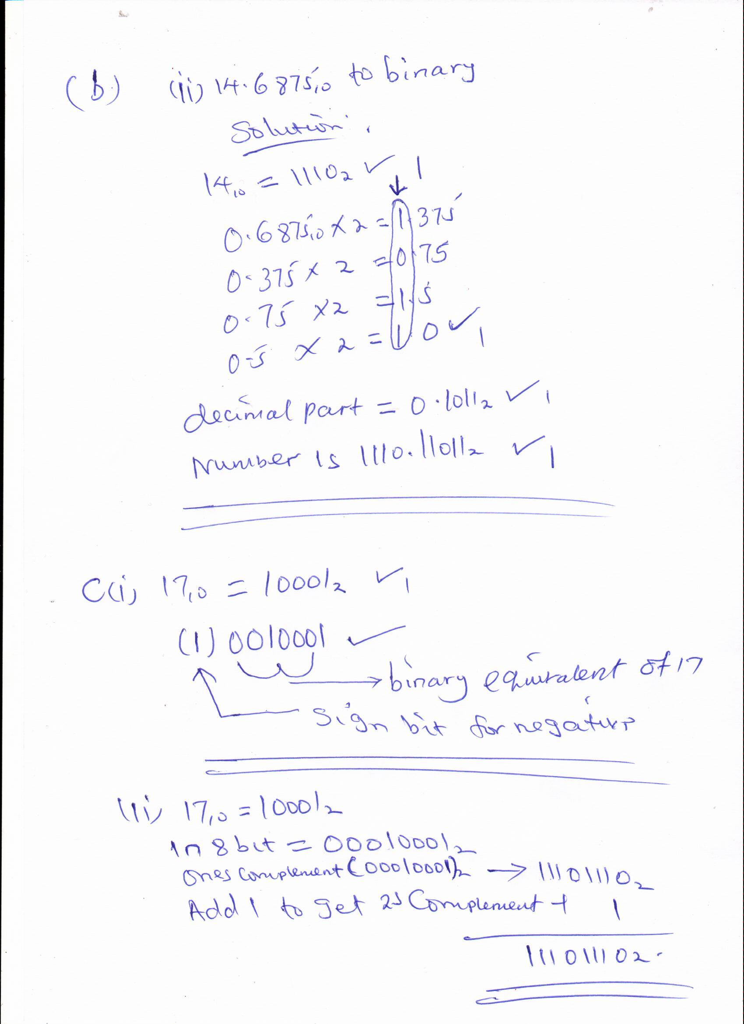

- (c) State any three reasons why people may resist the introduction of computers at their place of work (3marks)
- Insecurity of replacement
- Hostility towards machines
- Computer illiteracy
- Fear of training

20 a) State the role of each of the following data communication devices:
(i) Repeater
A device used to re-construct data signal during data transmission to its original strength/amplify/boost/regenerate.
(ii) Router
- It is a device used to facilitate movement of data or packets between twoor more LANS of different configuration (expansion of networks).
- Delivers a packet/data directly to destination computers.
- Interconnects different networks/provides network services.

(b) (i) The component P is the terminator. 1
(ii) Terminator in a backbone is used to prevent data signal from bouncing back/absorb signals.

(c) Use of internet in environmental conservation club
- Source of knowledge on environmental matters;
- Collaboration with peers from other schools or organizations;
- Dissemination of information on what the club is doing;
- Seeking for funding from sponsors. First 3 x 1) 3 marks
(d) (i) Benefits of linking branch B and C
- Speed of communication between B and C is increased since the traffic
between the two branches can be re-routed through the link BC;
- If either AC or AB is down, the three branches can still communicate;
- If the HQ systems fail, the two branches B and C can communicate using this link.
(First2x2) 4marks

