
THE G8 EXAMINATION
Kenya Certificate of Secondary Education
FORM 4 TERM 2- JUNE 2026

451/1
COMPUTER STUDIES
PAPER 1 (THEORY)
TIME: 2 ½ HOURS

Admission No. …………………Adm .No.………........…………………………………...

School……………….………………………………Date………..….…Signature…………

Instructions to Candidates
- Write your name and admission number in the spaces provided above.
- This Paper consists of two sections A and B.
- Answer ALL the questions in section A.
- Answer question 16 (compulsory) and any other THREE questions from section B.
- All answers should be written in the spaces provided.
- This paper consists of 14 printed pages. Candidates should check to ensure that all pages are printed as indicated and no questions are missing
FOR EXAMINER’S USE ONLY
Section | Questions | Candidate’s score
A | - 15
B | 16
B | 17
B | 18
B | 19
B | 20
B | TOTAL SCORE

This paper consists of 14 printed pages. Candidates should check to ensure that all pages are printed as indicated and no question is missing.
SECTION A (40 Marks)
Answer all questions in this section
- For each of the following computer generations, state the technology used to control the internal operations. (2marks)
- 1st generation:
……………………………………………………………………………………………………………………………………………………………………………………………………………………………………………………………………………………………………………………….
- 2nd generation:
…………………………………………………………………………………………………………………………………………………………………………………………………………………………………………………………………………………………………………………………
- 3rd generation:
…………………………………………………………………………………………………………………………………………………………………………………………………………………………………………………………………………………………………………………………
iv) 4th generation: ……………………………………………………………………………………………………………………………………………………………………………………………………………………………………………………………………………………………………………………………..
- State three ways in which computers have been used to fight the spread of corona virus in Kenya. (3marks)
.................................................................................................................................................................................................................................................................................................................................................................................................................................................................................................................................................................................................................................................................................................................................................................................................

- Define two types of booting in computer. (2 marks)
............................................................................................................................................................................................................................................................................................................................................................................................................................................................................................................................................................................................................................................................................................................................................................................................................
- Explain the term “log in” as applied in internet (2marks)
..................................................................................................................................................................................................................................................................................................................
- a) What is disk formatting? (1mark)

……………………………………………………………………………………………………………………………………………………………………………………………………
b) State two reasons for disk formatting (2 marks)
…………………………………………………………………………………………………………………………………………………………………………………………………..
…………………………………………………………………………………………………
- State a stage in system development life cycle where each of the following activities are carried out:
- identifying the technologies that may be used in a proposed system; (1 mark)
..........................................................................................................................................
- identifying shortcomings of a system; (1 mark)
.......................................................................................................................................
- Preparing a system for migration plan. (1 mark)
.......................................................................................................................................

- State three reasons why an organisation may opt to develop its own software in-house rather
than buy off-the-shelf software. (3 marks)
....................................................................................................................................................................................................................................................................................................................................................................................................................................................................................................................................................................................................................................................................................................................................................................
- A particular computer stores numbers in a single 8-bit word. How would it represent? 0.3125₁₀ (3marks)
........................................................................................................................................................................................................................................................................................................................................................................................................................................................................................................................................................................................................................................
- A computer technician found it necessary to disable a firewall when working on a computer system.
(a) What is a firewall? (1mark)
........................................................................................................................................................................................................................................................................................................................
(b) State two reasons that may have necessitated disabling of the firewall. (2marks)
....................................................................................................................................................................................................................................................................................................................................................................................................................................................................................
- Differentiate between absolute cell references and relative cell references as applied to spreadsheets. (2 Marks)
.......................................................................................................................................................................................................................................................................................................................................................................................................................................................................................
- Mwanzo Micro finance organization has offices in Kericho and Nairobi connected into a network. The management is convinced that someone is illegally gaining access to the data in their computers. State three ways the company can overcome this problem. (3marks)
...........................................................................................................................................................................................................................................................................................................................................................................................................................................................................................................................................................................................................................................................................................................................................................................................................................
- The following worksheet represents the number of litres of milk produced by different cows’ species at Kajiado Ranch Ltd.
s/no | A | B | C | D | E
1 | Month | Friesian | Ayrshire | Guernsey
2 | Jan | 70 | 80 | 65
3 | Feb | 120 | 62 | 75
4 | Mar | 110 | 65 | 45
5 | Apr | 70 | 45 | 60
6

The cost of each litre of milk is Kshs.30/=. This amount is typed in cell B10
- Write a function that will calculate the total number of liters of Friesian in all the months. (1mark)
....................................................................................................................................................................................................................................................................................................................
- Write a formula that can be typed in cell E2 and then be copied down to obtain monthly sales of milk. (1mark)
....................................................................................................................................................................................................................................................................................................................

- Identify the data type in cell C1 and cell D3 (1mark)
...................................................................................................................................................................................................................................................................................................................
- . State three main types of looping control structures as used in programming. (3 marks)
……………………………………………………………………………………………………………………………………………………………………………………………………………………………………………………………………………………………………………………………………………………………………………………………………………………
- A school intends to install wireless media in their communication system.
a) State any two types of wireless communication media. (1mark)

..............................................................................................................................................................................................................................................................................................................................................................................................................................................................................

- Give two advantages of this mode of communication media. (2marks)
.......................................................................................................................................................................................................................................................................................................................................................................................................................................................................................................................................................................................................................................
- State the functions of the following keys on the computer keyboard:
(a) Backspace (1 mark)
..............................................................................................................................................................................................................................................................................................................
(b) Tab key (1 mark)
........................................................................................................................................................................................................................................................................................................
SECTION B (60 MARKS)
Answer question 16 and any other THREE questions from this section in the spaces provided
- (a) What is meant by each of the following terms as used in programming. (3marks)
- Pseudocode
..............................................................................................................................................................................................................................................................................................................................................................................................................................................................................
- Flowchart
..............................................................................................................................................................................................................................................................................................................................................................................................................................................................................
- Dry run
..............................................................................................................................................................................................................................................................................................................................................................................................................................................................................

- Outline two disadvantages of low level programming languages. (2marks)
..............................................................................................................................................................................................................................................................................................................................................................................................................................................................................
- Differentiate between compilers and interpreters as used in programming. (2marks)
..............................................................................................................................................................................................................................................................................................................................................................................................................................................................................

- A trader bought a car from a manufacturer and later sold it to another person. Write a pseudocode for a program that will accept the buying price and the selling price of the car, determine whether the trader made a profit /or loss, calculate the profit/loss and display it. (4marks)

- Draw a flowchart for the above pseudocode (4marks)

- (a) State three limitations of traditional filing methods (3marks)
....................................................................................................................................................................................................................................................................................................................................................................................................................................................................................................................................................................................................................................
(b) Below are two table structures of files in a database.
FIELD | DATA TYPE
Employee no. | Number
Date employed | Date/time
Department | Text
Salary | Currency
TABLE A TABLE B
FIELD | DATA TYPE
Employee name | Text
Employee number | Auto number
DOB | Date/time
Address | Text

- Which of the two tables is likely to be the parent table (1mark)
………………………………………………………………………………………………………
- It is advisable to ‘enforce referential integrity’ when creating a relationships. What do you understand by the term referential integrity? (2marks)
..............................................................................................................................................................................................................................................................................................................................................................................................................................................................................
- The field ‘Employee no’ in TABLE B is likely to be the foreign key. What is a foreign key? (2marks)
..............................................................................................................................................................................................................................................................................................................................................................................................................................................................................
- Which fields in both tables is most appropriate for creating relationship? (1mark)
..............................................................................................................................................................................................................................................................................................................................................................................................................................................................................

- What would make the relationship between the tables fail to work? (2marks)
..............................................................................................................................................................................................................................................................................................................................................................................................................................................................................
- In databases the field properties specify finer details related to the fields and the table entries expected. State four field properties in database. (4marks)
........................................................................................................................................................................................................................................................................................................................................................................................................................................................................................................................................................................................................................................
- (a) Describe any two characteristics octal number system. (2marks)
..........................................................................................................................................................................................................................................................................................................................................................................................................................................................................
(b) Convert each of the following to the number system indicated:
- 111.101₂ to decimal (3marks)
...................................................................................................................................................................................................................................................................................................................................................................................................................................................................................................................................................................................................................................................................................................................................................................
- 14.6875₁₀ to binary (4marks)
................................................................................................................................................................................................................................................................................................................................................................................................................................................................................................................................................................................................................................................................................................................................................................................................................................................................................................................................................................................................................................................................................................................................................................................................................................

- Convert the number -17₁₀ into 8-bit:
- signed magnitude representation (2marks)
....................................................................................................................................................................................................................................................................................................................................................................................................................................................................................................................................................................................

- two’s complement (2marks)
.................................................................................................................................................................................................................................................................................................................................................................................................................................................................................................................................................................................................................................................................................................................................

d) Perform the arithmetic operation.
110.11₂ +11.011₂ (2marks)
........................................................................................................................................................................................................................................................................................................................................................................................................................................................................... .........................................................................................................................................................
- a) distinguish between Computer Aided Instructions (CAI) and Computer Aided Learning(CAL) (4marks)
............................................................................................................................................................................................................................................................................................................................................................................................................................................................................................................................................................................................................................................................................................................................................................................................................................................................................................................................................................

(b) i) State four activities that may be carried out when disposing off an old system in an organization. (4 marks)
.......................................................................................................................................................................................................................................................................................................................................................................................................................................................................................................................................................................................................................................................................................................................................................................................................................................................................................................................
ii) State four ways of getting user specifications during system design. (4 marks)
............................................................................................................................................................................................................................................................................................................................................................................................................................................................ ............................................................................................................................................................................................................................................................................................................................................................................................................................................................
(c) State any three reasons why people may resist the introduction of computers at their place of work (3 marks)
................................................................................................................................................................................................................................................................................................................................................................................................................................................................................................................................................................................................................

- a) State the role of each of the following data communication devices:
- repeater; (1mark)
……………………………………………………………………………………………………………………………………………………………………………………………………
- router. (1mark)
……………………………………………………………………………………………………………………………………………………………………………………………………
- Figure 3 shows a network based on the bus topology

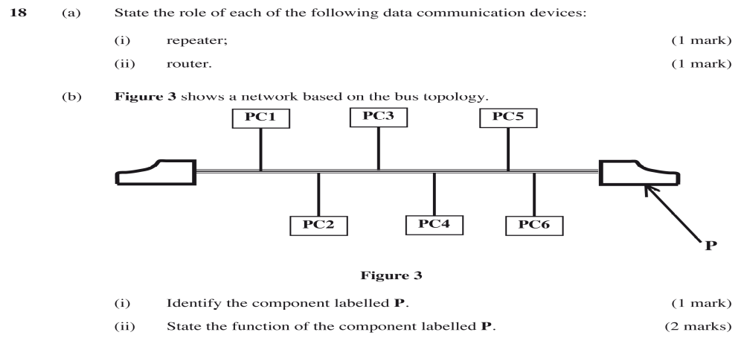
- Identify the component labelled p (1mark)
……………………………………………………………………………………………………………………………………………………………………………………
- State the function of component labelled p (2marks)
………………………………………………………………………………………………………………………………………………………………………………………………………………………………………………………………………………
- Students of Neema secondary school formed an environmental club with a goal of taking part in environmental conservation activities. Outline three ways in which they can use the internet to achieve this goal. (3marks)
…………………………………………………………………………………………………………………………………………………………………………………………………………………………………………………………………………………………………………………………………………………………………………

- i) A company has three branches A, B and C where A is the headquarter. The local area network (LAN) is directly connected to LAN at B and directly to the LAN at C. Explain two benefits of having the LAN at B also directly connected to the LAN at C. (4marks)
……………………………………………………………………………………………………………………………………………………………………………………………………………………………………………………………………………………………………………………………………………………………………………………………………………………………………………………………………
………………………………………………………………………………………………………………………………………………………………………………………………………………………………………………………………………………
…………………………………………………………………………………………
- List three ways by which parents can protect their children from accessing inappropriate content from the internet. (3 marks)

………………………………………………………………………………………………………………………………………………………………………………………………………………………………………………………………………………
………………………………………………………………………………………………………………………………………………………………………………………………………………………………………………………………………………

This is the last printed page.

