ELITE EXAMINATIONS
MOCK EXAMINATIONS 2026
451/1
Computer
Paper 1
July, 2026
MARKING SCHEME
- You are provided with two types of DTP tools (2mks)

(R) (Q)

a) Identify tool.
- R — crop tool
- Q — Text tool
b) State two methods of transforming an object in DTP (1mk)
- Rotate

- What precaution would you take in the computer room in case the user complain of backaches. (2mks)

- Differentiate between COM ports and LPT ports (2mks)

- COM ports are used for serial cables while LPT are used for parallel cables connection

- Threats to the safety of computer systems take many forms such as; White collar crime, natural disasters and carelessness. Give one way as to how each of these forms of threats can be controlled. (3mks)
- White collar. | By carrying out audit trial  Having special program files called log files that records all events carried out in a computer system
- Natural disaster. | Protection against natural disaster should be considered when the location for the computer room is chosen e.g. avoid areas prone to tremors, floods etc.
- Carelessness. | By setting up a comprehensive error recovery strategy in the  Organization  Use of backups sp that incase of any accidents loss the backup can be  used to recover the data.
- Give three reasons why primary storage devices are not used for secondary storage. (3mks)
- They provide temporary storage.
- They are volatile i.e. their contents disappears incise of power failure or on switching off the computer.
- Primary storage devices are fixed i.e. cannot be shared by many computers unlike secondary storage.
- Compared with the primary storage, the secondary storage holds large volume of data

- Explain briefly how Electronic Funds Transfer (EFT) and Electronic Point of Sale
(EPOS) is Used to facilitate business in Nakumatt supermarkets in Kenya (2mks)
- EFT allows customers to do purchases using their ATM and credit cards without
involving direct EPOS the prices of the items bought are tagged so that by swapping them on the scanner Sends the prices to the computer.

- Describe two situations in which speech recognition devices may be useful as a method of data entry (2mks)

    - Where hands or eyes are busy handing documents.
    - Where people are moving around, since wireless microphone can be used
    - Where people have special disability e. g. A person without hands, blind etc
- Some of the storage disks available are; Zip disks, 3 and 1/2 inch floppy disks, DVDs, 5 and 1/4 inch floppy disks. Arrange these devices in an ascending order of storage capacity
(2mks)
      - 5 and 1/4 inch floppy disks.
      - 3 and 1/2 inch floppy disks.
      - Zip disks.
      - DVDs.

- List the two categories of system software. (1 mark)
- Firm ware
- Os
- Network software

- Describe three disadvantages of using monolithic program. (3mks
- It’s difficult to debug.
- It’s not easy to learn.
- It’s not flexible.
- It’s not easy to modify.

- Differentiate between Value parameter and actual parameter in relation to number system. (2 mks)
- Value parameters are those data input specifications as entered by the user as required BUT Actual parameters are the exact stored results from the given logics Differentiate between hardware and software portability

- a) What is utility software? (1mk)

- Utility software is a special program that performs commonly used services that make certain aspects of computing to go on smoothly
b) Give two examples of utility software. (1mk)
- Text editors
- Loader
- System level utility
- Copy utility

- A firm operates an order system that coordinates orders ,raw materials and inventory across its three factories .Currently the orders are processed manually at each factory and communicated to the others over phone . The management intends to computerise their operations. State the first two computer professionals who will be required and their roles. (2mrks)

14. An operating system organizes files in directories as shown in the chart below.
Study it and answer the questions that follow.

  - What is the name of this file structure? (2mrk)

- Hierarchical/tree structure.

  - One of the files in miscellaneous has a file name similar to one in CHEMISTRY in form 1. Describe what happens if all the contents of chemistry are copied to miscellaneous. (2mks)

I) The file with the file name file 01 will be replaced with the one already existing in miscellaneous folder
15. Perform the decimal subtraction 14₁₀ - 6₁₀ using (3mks)
- Regular binary
- Regular binary (3mks)
14₁₀ ⇒ 1110₂
6₁₀ ⇒ 0110₂
14₁₀ - 6₁₀
⇒ 1110
-0110
1000₂ ⇒ 1000₂

SECTION B (60 MARKS)
Answer questions 16 (Compulsory) and any other three questions from this section
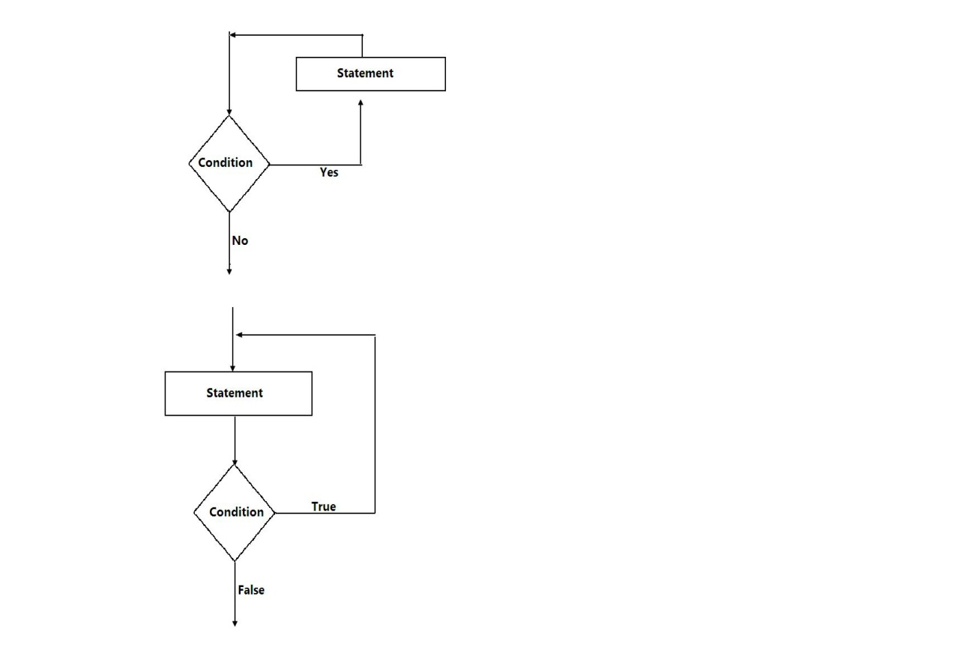
16.a) Consider the module flow charts extracts below

b) State the looping structure demonstrated in above diagram (2mks)
    - While –do -structure
    - Repeat -until
c)Define the following terms
(i) Structured programming (1mk)
(ii) Constants (1mk)
(iii) Variable (lmk)

e) Study the flowchart below and answer the question that follows

Start

Year =1,
A = 5,
Profit = 2

Write A
A = A * Profit

Is
Year <= 7
Year = Year +2
Yes

No

P = A * Year

Output P

Stop

f) List the various outputs from the flowchart above. Show your working. (4 marks)
(i) A = 5 * 2 = 10 (ii) A = 10 * 2 = 20
YEAR = 1 + 2 = 3 YEAR = 3 + 2 = 5
A = 10 1 A = 20 1

(iii) A = 20 * 2 = 40 (iv) A = 40 * 2 = 80
YEAR = 5 + 2 = 7 YEAR = 7 + 2 = 9
A = 40 1 A = 80
P = 80 * 9 = 7201

g) Write a pseudocode for the flowchart. (6 marks)
START
Initialize year = 1, profit = 2, A = 5
REPEAT
A = A * Profit
Year = year + 2
Output A
UNTIL
Year <= 7
P = A * year
OUTPUT P
STOP

17. (a) i) List two devices used in wireless communication. (2 marks)
- Access points (AP)
- Wireless antennae
- PCMCIA cards.

ii) Explain any three communication devices. (6 marks)
Network interface cards
- Modems and codec
- Hubs
- Bridges
- Repeaters
- Router
- Gateways
- Switches
(c) i) Describe the term data integrity (2 mks)
- Data integrity refers to the accuracy and completeness of data entered in a computer or received from the information system
ii) State four benefits in which data may lose integrity (2mks)
  - If the data is not accurate
  - If it’s not relevant.
  - If the data information is not available when needed.
  - If it’s not verifiable.

(d) i) What is meant by computer aided manufacture? (1 mark)
- Refers to the integration of the computer and graphics to and in design and drafting of products.

ii) Give two examples of computer aided design software. (2marks)

- Softpan
- Autocad
- Archicad

18.a) What is information superhighway? (2mks)
This is availability and use of advanced information services by means of a variety of high capacity data transport facility especially computers and computer network

b) Answer the following questions.
Define the following web related terms (3mks)
    - Web browser.
It’s an application software that enables a person to access information from the internet
    - Hyper link.
This is a text or picture on an electronic document, especially web page, that causes other web pages to open when the link is clicked.

    - Hypertext document.
It’s a collection that contains cross references called hyperlinks which allow the user tojump easily from one document to another.

c) i) Name two methods of paper orientation. (2mks)
    - Portrait
    - Landscape

ii) Give two reasons why it’s important to preview a document before printing. (2mks)

iii) What is done during page setup in Microsoft Word (3mks)
      - To confirm that no details are outside the printable area
      - To ensure that the document layout is okay
.
e) Explain the following terms as used in spreadsheet charts
Data series,
It refers to a group of related data, such as the numbers in a row or column of the selected area of the worksheet
Axis
Refers to the boundary line of the chart. There bottom boundary line of the chart is the x – axis while the left boundary line of the chart is the y – axis.
Legend

      - t’s a key that explains what each color or patterns of the data representations in the chart means.

19. a) State three data representation codes used in computers. (3mks)
Binary Coded Decimal (BCD) | This is a 4-bit code used to represent numeric data only. i.e. number 0 to 9. e.g. number like 4 can be represented as 0100₂.
Extended Binary Coded Decimal Interchange Code (EBCDIC) | This is an 8-bit character coding scheme. A total of 256 (2*) characters can be coded using this scheme. i.e. a number like 5 is represented as 11110101_{2.}
American Standard Code For Information Interchange (ASCII) | This is a 7-bit code. Only 128 characters (2⁷) can be represented. i.e. a number like 5 is represented as 0110101_{2.}
b) Write 1 in two’s complement notation in byte form. (3mks)

Digit 1 in binary
⇒ 0001₂

Digit 1 in one’s complement
⇒ 1110₂

Digit 1 in two’s complement
1 1 1 0₂
+ 1
1 1 1 1
⇒ 1111₂
c) Describe two ways in which a computer can represent a positive and negative number. (2mks)
Using one’s complement. In this method the 1’s complement of a binary number if found by changing all 1’s to 0’s and all 0’s to 1’s e.g. 4₁₀ → 0100₂, 4₁₀ → 1011₂n (by complementing each binary digit)
Using two’s complement. In 2’s complement a number is obtained by getting the 1’s complement then adding a 1. e.g. 45₁₀ → 00101101₂
One’s complement → 11010010₂
Two’s complement → + 1
11010011₂
d) A particular computer stores numbers in a single 8-bits word. How would it represent 0.3125₁₀? (2mk)
Whole number part Fraction part
0 0 2 Rem 0.3125×2=0.625
0 0 0.625 ×2 =1.25
0.25 ×2=0.5 copy
⇒0 0.5 ×2=0.1
⇒0.0101
⇒0000.0101₂

e) What is a Radix of a number system? (2mks)
- Radix refers to the base value of a number.

f) Using a well labeled diagram Explain how data is represented in a CD-ROM (3mks)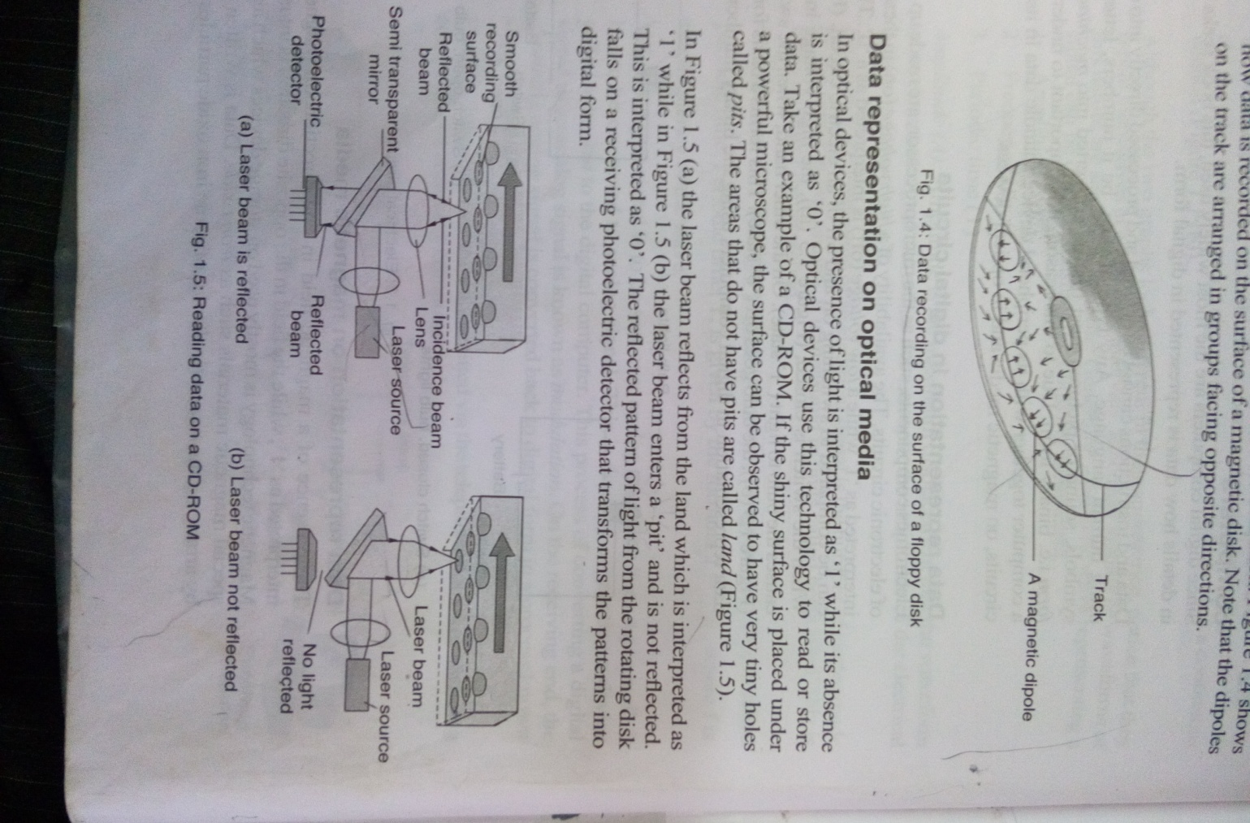
In a CO-ROM, the presence of light is interpreted as ‘1’ while its absence is interpreted as ‘0’.

20. Study the diagram below and answer the question that follows.
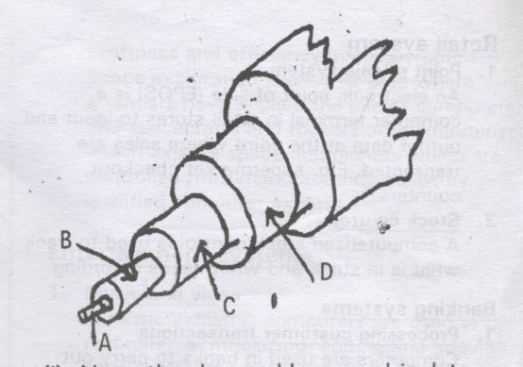

  - Name the above cable as used in data communication media. (1mk)
- Coaxial cable.
  - Name the part labeled A, B, C and D. (3 mks)
    - copper wire
    - core insulation
    - aluminum foil
    - braided shielding

  - What is the importance of part labeled D? (2mks)
- It protects the media from Radio frequency interference and electromagnetic interference Highlight three advantages of the above cable. (3mks)
- They are very stable even under high loads.
- Have a large bandwidth.
- They are more resistant to radio and electromagnetic interference than twisted pair cables.
- They can carry voice, data and video signal simultaneously.

e. Why is fiber optic becoming the number one choice for local area networks? (3mks)
- Fibre optic have a much greater bandwidth i.e. can carry more data.
- They are less susceptible to interference.
- They are much thinner and lighter, hence occupy less space.
- They have high speed of data transmission
i) What is an expert system? (3mks)
- An expert system is a software that store the knowledge of human experts and is then used as consultant in a particular field. E.g. to help doctors diagnose patients.

