Name…………………………….……………. Index Number…………...……….………….
Adm. No………….……. Class: ………….… Candidate’s Signature: ……………………….
School ………………………………………………………. Date: ……………………………….
451/1
COMPUTER
Theory
Paper 1
July, 2026
Time: 2 ½ Hours
ELITE EXAMINATIONS
MOCK EXAMINATIONS 2026
451/1
Computer
Paper 1
July, 2026

INSTRUCTIONS TO CANDIDATES:

- Write your name and Index number in the spaces provided above.
- This paper consists of TWO sections A and B.
- Answer ALL the questions in section A.
- Answer question 16 and any other THREE questions from section B.
- All answer should be written in the spaces provided
- This paper consists of 13 printed pages.
- Students should check the question paper to ascertain that all the pages are printed as indicated and no question is missing.
- The candidates should confirm all the papers are printed and non is missing
- Candidates should answer the questions in English.
SECTION | QUESTIONS | CANDIDATE’S SCORE
A | 1-15
B | 16
B | 17
B | 18
B | 19
B | 20
 | TOTAL SCORE

- You are provided with two types of DTP tools (2mks)

(R) (Q)

a) Identify tool.
i) R…………………….……………………………………………..…………………………………
ii) Q………………………………………………………………………………………………………
b) State two methods of transforming an object in DTP (1mk)
………………………………………………………………………………………………………………………………………………………………………………………………………………………………………………………………………………………………………………………………………………………
- What precaution would you take in the computer room in case the user complains of backaches. (2mks)
…………………………………………………………………………………………………………………………………………………………………………………………………………………………………………………………………………………………………………………………………………………………………………………………………………………………………………………………………………

- Differentiate between COM ports and LPT ports (2mks)
…………………………………………………………………………………………………………………………………………………………………………………………………………………………………………………………………………………………………………………………………………………………………………………………………………………………………………………………………………

- Threats to the safety of computer systems take many forms such as; White collar crime, natural disasters and carelessness. Give one way as to how each of these forms of threats can be controlled. (3mks)
White collar.
Natural disaster.
Carelessness.

- Give three reasons why primary storage devices are not used for secondary storage. (3mks)
……………………………………………………………………………………………………………………………………………………………………………………………………………………………………………………………………………………………………………………………………………………………………………………………………………………………………………………………………………………………………………………………………………………………………………………………
- Explain briefly how Electronic Funds Transfer (EFT) and Electronic Point of Sale (EPOS) is Used to facilitate business in supermarkets in Kenya (2mks)
…………………………………………………………………………………………………………………………………………………………………………………………………………………………………………………………………………………………………………………………………………………………………………………………………………………………………………………………………………
- Describe two situations in which speech recognition devices may be useful as a method of data entry (2mks)
…………………………………………………………………………………………………………………………………………………………………………………………………………………………………………………………………………………………………………………………………………………………………………………………………………………………………………………………………………

- Some of the storage disks available are; Zip disks, 3¹/₂ inch floppy disks, DVDs, 5¹/₄ inch floppy disks. Arrange these devices in an ascending order of storage capacity
(2mks)
………………………………………………………………………………………………………………………………………………………………………………………………………………………………………………………………………………………………………………………………………………………………………………………………………………………………………………………….………………
- List the two categories of system software. (1 mark)
………………………………………………………………………………………………………………………………………………………………………………………………………………………………………………………………………………………………………………………………………………………

- Describe three disadvantages of using monolithic program. (3mks)
…………………………………………………………………………………………………………………………………………………………………………………………………………………………………………………………………………………………………………………………………………………………………………………………………………………………………………………………………………
- Differentiate between Value parameter and actual parameter in relation to number system. (2mks)
…………………………………………………………………………………………………………………………………………………………………………………………………………………………………………………………………………………………………………………………………………………………………………………………………………………………………………………………………………
- a) What is utility software? (1mk)

………………………………………………………………………………………………………………………………………………………………………………………………………………………………………………………………………………………………………………………………………………………
b) Give two examples of utility software. (1mk)
…………………………………………………………………………………………………………………………………………………………………………………………………………………………………………………………………………………………………………………………………………………………………………………………………………………………………………………………………………
- A firm operates an order system that coordinates orders, raw materials and inventory across its three factories. Currently the orders are processed manually at each factory and communicated to the others over phone. The management intends to computerize their operations. State the first two computer professionals who will be required and their roles. (2mrks)
…………………………………………………………………………………………………………………………………………………………………………………………………………………………………………………………………………………………………………………………………………………………………………………………………………………………………………………………………………
14. An operating system organizes files in directories as shown in the chart below.
Study it and answer the questions that follow.

  - What is the name of this file structure? (2mrk)
……………………………………………………………………………………………………………………………………………………………………………………………………………………………………………………………………………………………………………………………………………………………………………………………………………………………………………………….………………..
  - One of the files in miscellaneous has a file name similar to one in CHEMISTRY in form 1. Describe what happens if all the contents of chemistry are copied to miscellaneous.
(2mks)
…………………………………………………………………………………………………………………………………………………………………………………………………………………………………………………………………………………………………………………………………………………………………………………………………………………………………………………………………………
15. Perform the decimal subtraction 14₁₀ - 6₁₀ using Regular binary (3mks)
………………………………………………………………………………………………………………………………………………………………………………………………………………………………………………………………………………………………………………………………………………………………………………………………………………………………………………………….………………

SECTION B (60 MARKS)
Answer questions 16 (Compulsory) and any other three questions from this section
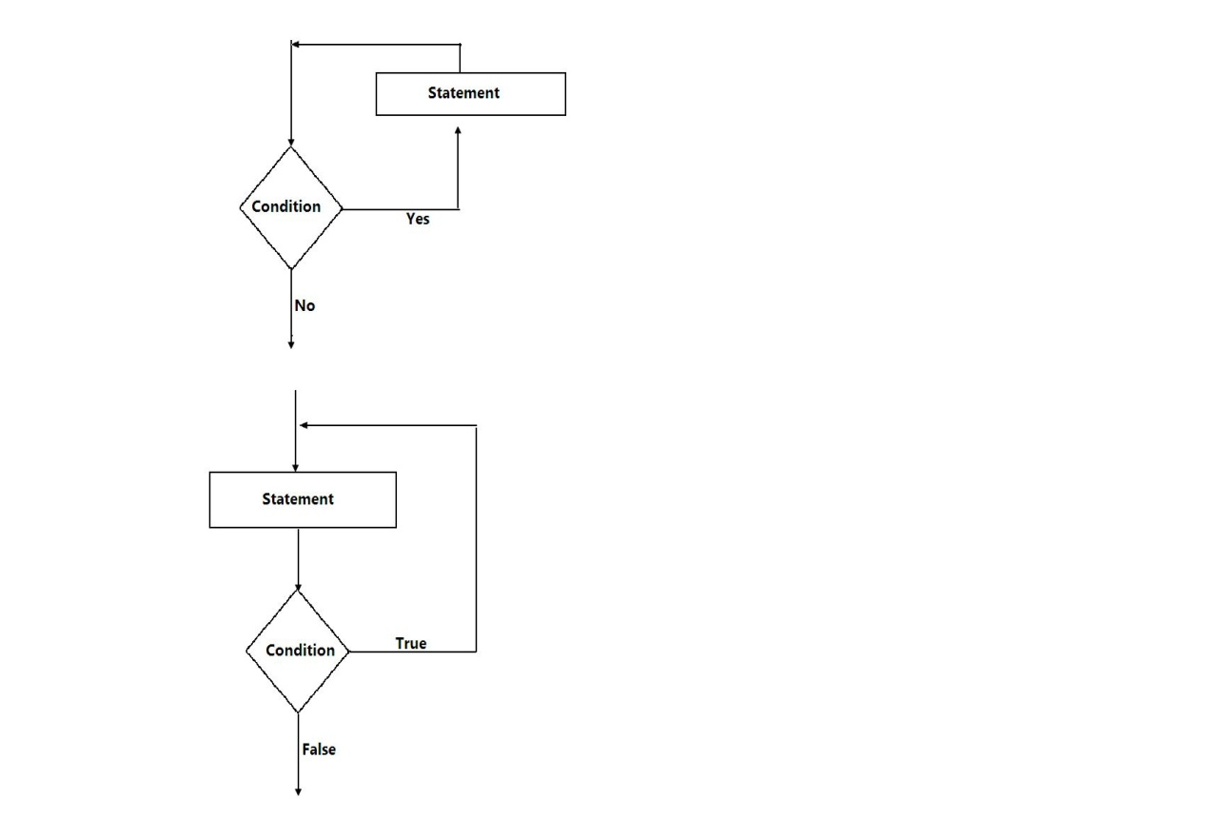
16.a) Consider the module flow charts extracts below

b) State the looping structure demonstrated in above diagram (2mks)
…………………………………………………………………………………………………………………………………………………………………………………………………………………………………………………………………………………………………………………………………………………………………………………………………………………………………………………………………………
c) Define the following terms as used in computer programming.
(i) Structured programming (1mk)
……………………………………………………………………………………………………………………………………………………………………………………………………………………………………
(ii) Constants (1mk)
……………………………………………………………………………………………………………………………………………………………………………………………………………………………………
(iii) Variable (1mk)
……………………………………………………………………………………………………………………………………………………………………………………………………………………………………
e) Study the flowchart below and answer the question that follows
Start

Year =1,
A = 5,
Profit = 2

Write A
A = A * Profit

Is
Year <= 7
Year = Year +2
Yes

No

P = A * Year

Output P

Stop

f) List the various outputs from the flowchart above. Show your working. (4 marks)

g) Write a pseudocode for the flowchart. (6 marks)

17. (a) i) List two devices used in wireless communication. (2 marks)
…………………………………………………………………………………………………………………………………………………………………………………………………………………………………………………………………………………………………………………………………………………………………………………………………………………………………………………………………………………………………………………………………………………………………………………………….
ii) Explain any three communication devices. (6 marks)
…………………………………………………………………………………………………………………………………………………………………………………………………………………………………………………………………………………………………………………………………………………………………………………………………………………………………………………………………………………………………………………………………………………………………………………………….

(c) i) Describe the term data integrity (2 marks)
……………………………………………………………………………………………………………………………………………………………………………………………………………………………………………………………………………………………………………………………………………………………………………………………………………………………………………………………………………………………………………………………………………………………………………………………
ii) State four benefits in which data may lose integrity (2mks)
………………………………………………………………………………………………………………………………………………………………………………………………………………………………………………………………………………………………………………………………………………………………………………………………………………………………………………………………………………………………………………………………………………………………………………
(d) i) What is meant by computer aided manufacturing? (1 mark)
……………………………………………………………………………………………………………………………………………………………………………………………………………………………………
ii) Give two examples of computer aided design software. (2marks)

………………………………………………………………………………………………………………………………………………………………………………………………………………………………………………………………………………………………………………………………………………………
18. a) What is information superhighway? (2mks)
………………………………………………………………………………………………………………………………………………………………………………………………………………………………………………………………………………………………………………………………………………………
b) Answer the following questions.
Define the following web related terms (3mks)
    - Web browser.
……………………………………………………………………………………………………………………………………………………………………………………………………………………………………
    - Hyper link.
……………………………………………………………………………………………………………………………………………………………………………………………………………………………………
    - Hyper text document.
………………………………………………………………………………………………………………………………………………………………………………………………………………………………………………………………………………………………………………………………………………………

c) i) Name two methods of paper orientation. (2mks)
…………………………………………………………………………………………………………………………………………………………………………………………………………………………………………………………………………………………………………………………………………………………………………………………………………………………………………………………………………
ii) Give two reasons why it’s important to preview a document before printing. (2mks)
…………………………………………………………………………………………………………………………………………………………………………………………………………………………………………………………………………………………………………………………………………………………………………………………………………………………………………………………………………
iii) What is done during page setup in Microsoft Word (3mks)
………………………………………………………………………………………………………………………………………………………………………………………………………………………………………………………………………………………………………………………………………………………
e) Explain the following terms as used in spreadsheet charts
Data series,
……………………………………………………………………………………………………………………………………………………………………………………………………………………………………
Axis
………………………………………………………………………………………………………………………………………………………………………………………………………………………………………………………………………………………………………………………………………………………
Legend.
………………………………………………………………………………………………………………………………………………………………………………………………………………………………………………………………………………………………………………………………………………………

19. a) State three data representation codes used in computers. (3mks)
………………………………………………………………………………………………………………………………………………………………………………………………………………………………………………………………………………………………………………………………………………………
b) Write 1 in two’s complement notation in byte form. (3mks)

………………………………………………………………………………………………………………………………………………………………………………………………………………………………………………………………………………………………………………………………………………………
c) Describe two ways in which a computer can represent a positive and negative number. (2mks)
………………………………………………………………………………………………………………………………………………………………………………………………………………………………………………………………………………………………………………………………………………………
d) A particular computer stores numbers in a single 8-bits word. How would it represent 0.3125₁₀? (2mk)
………………………………………………………………………………………………………………………………………………………………………………………………………………………………………………………………………………………………………………………………………………………
e) What is a Radix of a number system? (2mks)
………………………………………………………………………………………………………………………………………………………………………………………………………………………………………………………………………………………………………………………………………………………
f) Using a well labeled diagram Explain how data is represented in a CD-ROM (3mks)

…………………………………………………………………………………………………………………………………………………………………………………………………………………………………………………………………………………………………………………………………………………………………………………………………………………………………………………………………………

20. Study the diagram below and answer the question that follows.
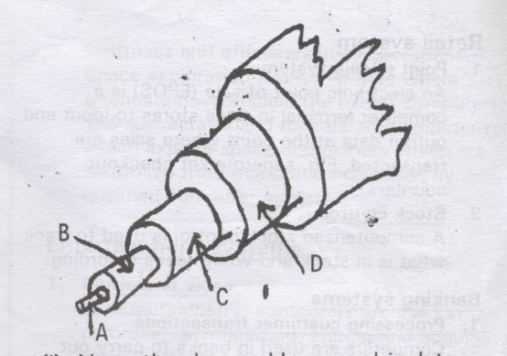

  - Name the above cable as used in data communication media. (1mk)
………………………………………………………………………………………………………………………………………………………………………………………………………………………………
  - Name the part labeled A, B, C and D. (3 mks)
………………………………………………………………………………………………………………………………………………………………………………………………………………………………………………………………………………………………………………………………………………

  - What is the importance of part labeled D? (2mks)
………………………………………………………………………………………………………………………………………………………………………………………………………………………………………………………………………………………………………………………………………………
  - Highlight three advantages of the above cable. (3mks)
………………………………………………………………………………………………………………………………………………………………………………………………………………………………………………………………………………………………………………………………………………………………………………………………………………………………………………………………
e. Why is fiber optic becoming the number one choice for local area networks? (3mks)

………………………………………………………………………………………………………………………………………………………………………………………………………………………………………………………………………………………………………………………………………………………
i) What is an expert system? (3mks)
…………………………………………………………………………………………………………………………………………………………………………………………………………………………………………………………………………………………………………………………………………………………………………………………………………………………………………………………………………
.

