Name: ……………………………………………………….….Index.No. ……………………………….
Adm No…………….Class…………..
School………………………………………………………...Candidate’s Signature: …………………...

R.C.E.A GROUP OF SCHOOLS JOINT EXAMINATIONS
Kenya Certificate of Secondary Education
Physics Paper 232/2
2 Hours

INSTRUCTIONS TO CANDIDATES:

- Write your name, school, admission number and index number is the spaces provided above.
- Sign and write the date of examination in the spaces above.
- Answer ALL the questions in section A and B in the spaces provided.
- All working MUST be clearly shown.
- Non-programmable silent electronic calculators and KNEC mathematical tables may be used.
- This paper consists of 15 pages.
- Candidates should check the question paper to ascertain that ALL the pages are printed and that no questions are missing.

FOR EXAMINER’S USE ONLY.

SECTION | QUESTIONS | MAX. SCORE | CANDIDATE’S SCORE
A | 1 -10 | 25
B | 11 | 11
B | 12 | 11
B | 13 | 12
B | 14 | 10
 | 15 | 11
 | TOTAL | 80
SECTION A (25MKS): Answer ALL the questions in the spaces provided
- In the figure below the lamps in the two circuits, A and B are identical and the cells have the same electromotive force.
(A)
(B)
Lamp

Explain why the lamps in B may glow brighter than those in A when the circuits are closed at the same time. (2mks)

..................................................................................................................................................................................................................................................................................................................................................................................................................................................................
......................................................................................................................................................
- The figure below shows two rays drawn from an object on to the mirror.

Mirror
Object

Complete the ray diagram to show the position of the image. (2mks)

- Your house is supplied with 240 v from a power source which is fitted with a 13 A safe fuse. What is the maximum number of 60w bulbs that can be fitted in the house? (2mks)

................................................................................................................................................................................................................................................................................................................................................................................................................................................................................................................................................................................................
- (a) A steel is to be magnetized by electrical method as shown below. Identify the pole P and Q of the resulting magnet. (1mk)
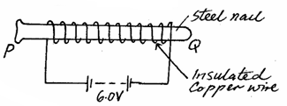

P: ………………………………………………

Q: ………………………………………………..

(b) State the difference between a soft magnetic material and a hard magnetic material. (1mk)
..................................................................................................................................................................................................................................................................................................................................................................................................................................................................................
- (a) Define diffraction with respect to waves. (2mks)
................................................................................................................................................................................................................................................................................................
(b) In the diagram below the size of the aperture at the barrier is 10cm while the distance between two consecutive wave fronts is 3cm. If the waves are moving towards the barrier, draw the wave fronts as they appear after passing through the aperture. (2mks)
Wave front
Barrier

- A girl standing at a distance claps her hands and hears an echo from a tall building 2 seconds later. If the speed of sound in air is 340m/s, determine how far the building is. (3mks)
................................................................................................................................................................................................................................................................................................................................................................................................................................................................................................................................................................................................................................................
- The figure below (drawn to scale) shows the image I, formed by a convex mirror. F is the virtual principal focus of the mirror.

I
F

Using ray diagrams locate the position of the object and draw the object. (3mks)

- The table below shows part of the electromagnetic spectrum in order of decreasing wavelength
A | B | INFRA RED  RADIATION | VISIBLE  LIGHT | C | D

(a) How are waves C produced? (1mk)
…………………………………………………………………………………………………...........................................................................................................................................
(b) State one use of the wave D (1mk)
………………………………………………………………………………………………………………………………………………………………………………………………………………

- An alternating voltage of peak value 15v and frequency 25Hz is applied to the terminals of a Cathode ray oscilloscope. The Y-gain is set at 5 v/cm and the time base at 10 ms/cm. Draw the trace observed on the screen. (2mks)
1cm
1cm

- Four 10Ω resistors are connected to a 10V dc supply as shown in the diagram below.
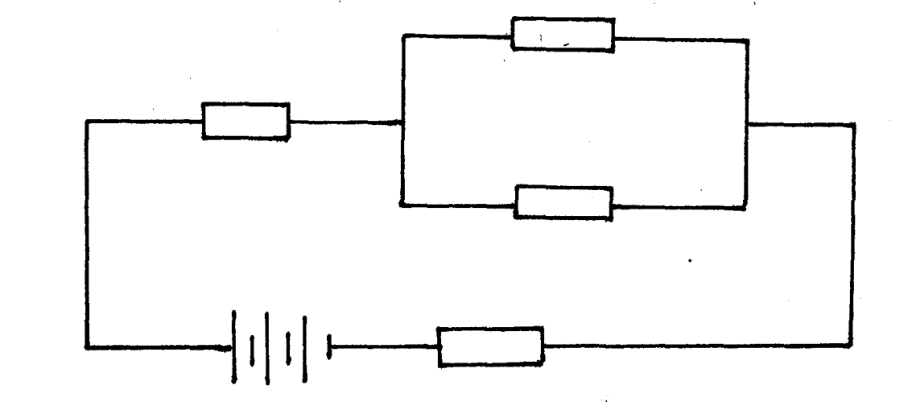
10Ω
10Ω
10Ω
10Ω
10V

Calculate the total current flowing in the circuit. (3mks)
………………………………………………………………………………………………………………………………………………………………………………………………………………………………………………………………………………………………………………………………………………………………………………………………………………………………
SECTION B (55MKS): Answer ALL the questions in the spaces provided
- (a) Define the following terms as used in photoelectric effect (1mk)
- Work function
...........................................................................................................................................................................................................................................................................................................................................................................................................
- Threshold frequency. (1mk)
...............................................................................................................................................................................................................................................................................................................................................................................................................................................................................................................................................(b) The figure below shows Ultra-violet light striking a polished Zinc plate placed on a positively charged gold-leaf electroscope.

UV light

Zinc plate

- Explain the observations that the leaf did not fall. (1mk)
..............................................................................................................................................................................................................................................................................................................................................................................................................................

(ii) In an experiment using a photocell, U.V light of varying frequency but constant intensity was made to strike a metal surface. The maximum kinetic energy (KE_{Max}) of photoelectrons for each frequency, f, was measured. The graph shows how KE_{Max} varies with f.
2
F x 10¹⁵ Hz
8
6
4
Max. K.E.x10⁻¹⁹ J

0
2
1
4
3
5

Use the graph to determine the:
- Threshold frequency (2mks)
................................................................................................................................................................................................................................................................................................
II) Planck’s constant (3mks)
................................................................................................................................................................................................................................................................................................................................................................................................................................................................................................................................................................................................
- Work function (3mks)
……………………………………………………………………………………………………………………………………………………………………………………………………………
- (a) A radioactive element A of half-life 31 days decays to element B. A sample of A of mass 32g is kept in a container. Assuming B is stable, calculate the mass of B that will be in the container after 124 days. (3mks)
............................................................................................................................................................................................................................................................................................................................................................................................................................................................................................................................................................................................................................................................................................................................................................................................................
- The figure below shows the features of an x-ray tube.

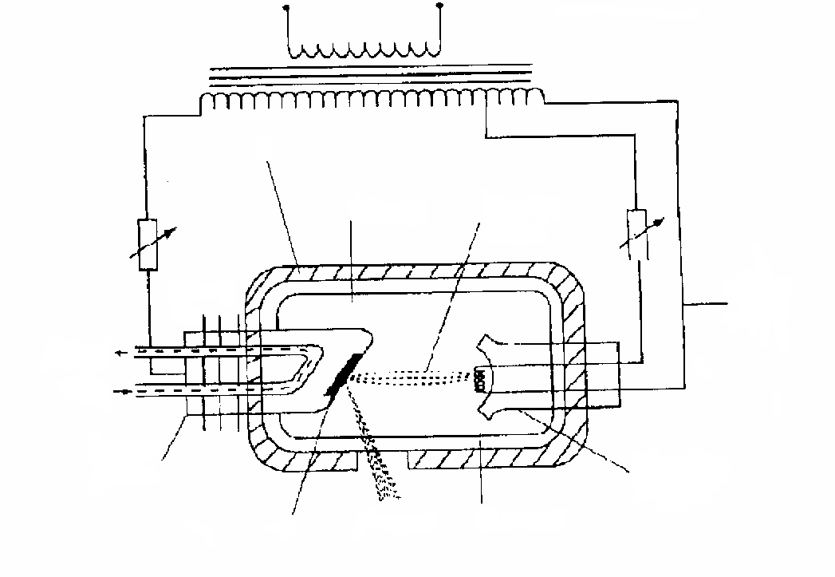

Y
Electron beam
Heater circuit
Vacuum
Focusing Cathode
Filament
X-rays
X
Copper anode
Oil in
Oil out
Cooling tins

i) Name the parts X and Y (2mks)
X…………………………………………………………..…………………………
Y……………………………………………………………………………………….
ii) State the reason why the inner part of an X- Ray tube is evacuated. (1mk) …………………………………………………………………………………………………………..……………………………………………………………………………..……………………………………………………………………………………………………………………………iii) Explain how the X-rays are produced in the X-ray tube. (3mks)
...........................................................................................................................................................................................................................................................................................................................................................................................................................................................................................................................................................................................................................................................................................................................................................................................................
- X-ray tube operates at 1000KV between the cathode and the anode. Calculate the maximum energy of the X-ray photons produced.
(charge of an electron, $e=1.6x{10}^{-19} C$ ). (2mks)

..............................................................................................................................................................................................................................................................................................................................................................................................................................
- (a) A transformer with 2000 turns in the primary circuit and 150 turns in the secondary circuit has its primary circuit connected to a 800Va.c. source. It is found that when a heater is connected to the secondary circuit it produces heat at the rate of 1000W. Assuming 100% efficiency, determine the:
(i) Voltage in the secondary circuit. (2mks)
………………………………………………………………………………………………………………………………………………………………………………………………………………………………………………………………………………………………………………………

- Current in the primary circuit. (2mks)

………………………………………………………………………………………………………………………………………………………………………………………………………………………………………………………………………………………………………………………
(iii) Current in the secondary circuit. (1mk)

………………………………………………………………………………………………………………………………………………………………………………………………………………………………………………………………………………………………………………………
- State the type of transformer represented above. (1mk)

………………………………………………………………………………………………

(b) (i) State the reason why long distance power transmission is done at a very high voltage and using thick cables. (1mk)
………………………………………………………………………………………………………………………………………………………………………………………………………………

(ii). Calculate the cost of using the following appliances in one month (30 days) of the company rate is Ksh.9.50 per unit. (3mks)
I A 2000W water heater for 2 hours per day.
II A 75W bulb for 10 hours per day.
III An 1500W electric iron for 1 hour per day.

……………………………………………………………………………………………………………………………………………………………………………………………………………………………………………………………………………………………………………………………………………………………………………………………………………………………..

- Find the total monthly bill for the above household if in addition to the energy consumed, the power company charges each consumer. (2mks)
I A standing charge of Ksh.200.
II Fuel cost levy at 70 cents per unit.
………………………………………………………………………………………………………………………………………………………………………………………………………………………………………………………………………………………………………………………
- (a) Define doping as used in electronics (1mk)
............................................................................................................................................................................................................................................................................................................................................................................................................
- With the help of a diagram, describe how a p-type semiconductor is made. (3mks)
........................................................................................................................................................................................................................................................................................................................................................................................................................................................................................................................................................................................................................................................................................................................................................................................................................................................................................................................................................................

- Explain what happens to the depletion layer when a diode is forward biased. (2mks)
...........................................................................................................................................................................................................................................................................................................................................................................................................................................................................................................................................................................................................................................................................................................................................................................................................
- Show the charge distribution on the hollow conductor shown below if it is positively charged. (1mk)

Insulator

(e) The diagram below shows a circuit containing three capacitors.
C₂
C₁
X Y
C₃
If c₁=6µF, c₂=4.5µF and c₃=5 µF, calculate the charge stored when point XY is connected in series with a battery of 6V (3mks)
……………………………………………………………………………………………………………………………………………………………………………………………………………………………………………………………………………………………………………………………………………………………………………………………………………………………..

- (a) The following graph shows the variation of image distance, v, with magnification, m, for a converging lens.
Image distance,V(cm)
10
Magnification, M
4
2
3
1
40
30
20

Using the graph and the equation $\frac{V}{f}=M+1$ to determine: (3mks)
- The object position when the image position is 45cm.
..............................................................................................................................................................................................................................................................................................................................................................................................................................
..........................................................................................................................................

- The focal length of the lens. (3mks)
........................................................................................................................................................................................................................................................................................................................................................................................................................................................................................................................................................................

- The power of the lens. (2mks)
..............................................................................................................................................................................................................................................................................................................................................................................................................................
..........................................................................................................................................
(c) The following figure shows an eye defect

Name the defect and illustrate on the same diagram how the defect could be corrected. (3mks)
..............................................................................................................................................

THE END

