Marking scheme

Name: …………………………………………………… Index no ……..…...................................

School: ……………………………………………....…. Candidate’s sign ……………………....

Date: ……………………………………………

231/3
BIOLOGY
PAPER 3
JULY- 2026
TIME:1 ¾ HOURS

R.C.E.A JOINT EXAMS
Kenya Certificate of Secondary Education (K.C.S.E.)
BIOLOGY
PRACTICAL

INSTRUCTIONS TO CANDIDATES:
- Write your name and index number in the spaces provided.
- Sign and write date of examination in the spaces provided above
- Answer all the questions in the spaces provided.

For Examiner’s Use Only:

QUESTIONS | MAXIMUM SCORE | CANDIDATES SCORE
1 | 13
2 | 15
3 | 12
TOTAL | 40

1. You are provided with 8cm³ solution Q. Iodine solution, Benedict’s solution, dil HCL, sodium hydrogen carbonate, means of heating test tube rack, 3 dry test tube and a water bath.
Use the provided reageants and apparatus to establish food substances present in solution Q. Fill the observation and conclusion in the table provided.
(a) Take sample of solution Q and test them for the food substances present using the reagents provided. Record in a table, the food substance tested, the procedure of the test, the observations and conclusions. (9mks)
Food Substance | Procedure | Observations | Conclusions
Starch | - Put 2ml of solution Q in a test tube  - Add iodine solution dropwise | Colour changes from brown to blue-black. | Starch present
Reducing sugars | - Place 2ml of solution Q in a test tube  - Add equal amount of Benedicts solutions  - Boil the mixture in a water bath | Blue colour persists | Reducing sugars absent.
Non-reducing sugars | - Place 2ml of solution Q in a test tube  - Add 3 drops of HCL  - Heat the mixture  - Cool the mixture and add NaJVO3 dropwise untill fizzing stops  - Add 2ml of benedicts solution  - Boil the mixture in a water bath | Colour changes from blue to orange | Non- reducing sugar present

(b) How would you test for the presence of vitamins in solution Q (2mks)
- Place 2ml of DCPIP in a test tube
- Add solution Q dropwise
(c) State two food substance in Q and enzymes in human beings that would digest them. (2mks)

Food substance | Enzyme
Starch | Amylase/ptyalin(enzyme)
Sucrose/disaccharaides | Sucrase

2. Use the photographs provided to answer the questions that follow.

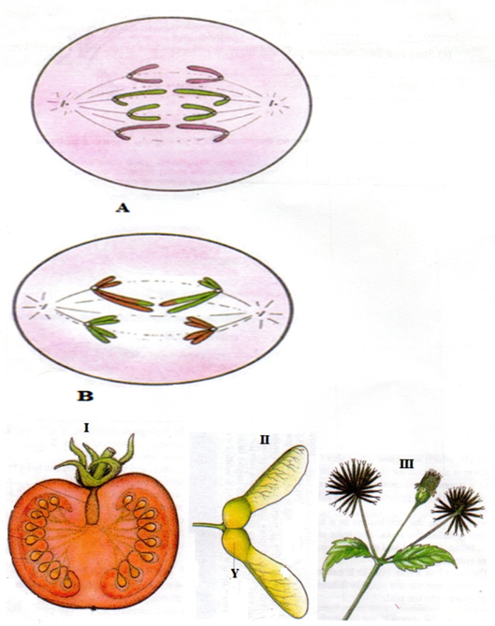

(a) (i) Identify the type of cell division represented inthe photographs A and B (2mks)
A- mitosis
B –meiosis
(ii) With a reason, name the stage of cell division represented in each case (4mks)
A anaphase
Reason
Sister chromatids have separated (and are migrating to opposite poles of spindle fibre)
B anaphase I
Reason
Homologous chromosomes have separated; and are migrating to the opposite poles of spindle.
(iii) Name the parts of human body where the process B represented above occur. (2mks)
- Testicles/testis
- Ovary
(b) (i) What type of fruits is represented by photograph I? Give two resons.
Type Berry;
Reason – presence of many seeds
Fleshy mesocarp/endocarp
(ii) Name the agent of dispersal for fruits II and III (2mks)
I wind
II animal
(iii) How are the fruits adapted for the mode of dispersal stated in (b) (ii) above? (2mks)
II has wing- like extension that increases surface area to be carried by air currents
III has hooks that make it stick onto animals fur/hair or even clothes of huma beings
(iv) Identify the type of placentation shown by photograph I (1mk)
Free central
3. The photography below shows four specimens labelled P,Q R and S which were obtained from the same animal. Examine them.
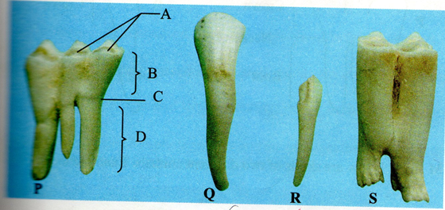

(a) With reasons identify P and Q (5mks)
P Molar tooth
Two reasons
- Biting surface is wide and has c-biting surface is wide and has cusps/ridges
- presence of three roots
Q incisor
Reasons
Biting surface in chisel shaped/wedge shaped
(b) Based on their structure, suggest the functions of specimens P and Q. (2mks)
P Grinding and crushing of food
Q gripping and cutting food
(c) In specimen P name the part labelled A (1mk)
A cusps/ridges
(d) Explain how specimen s is adapted for its functions. (2mks)
It has cusps/ridges on its biting surface; that enable crushing and grinding of food
(e) Using observable features only, state
(i) One similarity between specimens Q and R (1mk)
Both have one root
(ii) One difference between specimens Q and R . (1mk)
Q is chisel-shape/wedge-shaped biting surface while R has a pointed surface

