NAME…………………………………………………..…….INDEX NO…….……..………
SCHOOL……………………………………….….CANDIDATE’S SIGN…………………
DATE…………………………….……..

443/1
AGRICULTURE PAPER 1
TIME: 2 HOURS
SUKELLEMO JOINT PREMOCK 1
Kenya Certificate of Secondary Education (K.C.S.E)
443/1
AGRICULTURE
PAPER 1

INSTRUCTIONS TO CANDIDATES
- Write your name and index no. In the spaces provided above.
- Sign and write the date of examination in the spaces provided above.
- This paper contains three sections A,B and C
- Answer ALL the questions in section A and B
- Answer any TWO questions from section C.
- Candidates should answer the questions in English.

FOR EXAMINERS USE ONLY
SECTION | QUESTION | MAXIMUM SCORE | CANDIDATE SCORE
A | 1-17 | 30
B | 18-21 | 20
C |  | 40
 | Total score | 90

This paper consists of 10 printed pages. Candidates should check the paper to ensure that all the pages are printed as indicated and no questions are missing.

SECTION A (30MKS)
Answer all questions in this section.
- Outline four human factors that influence agriculture. (2 marks)
............................................................................................................................................................................................................................................................................................................................................................................................................................................................................................................................................................................................................................................................................................................................
- State two harmful effects of wind on crop production. (1 mark)
.......................................................................................................................................................................................................................................................................................................................................................................................................................................
- Mention four economic importance of crop diseases to a maize farmer. (2 marks)
...................................................................................................................................................................................................................................................................................................................................................................................................................................................................................................................................................................................................................................................................................…..........................................
- Give four reasons for early land preparation. (2 marks)
...........................................................................................................................................................................................................................................................................................................................................................................................................................................................................................................................................................................................................................................................................................................................…
- What are the functions of the following chemicals used in treatment of water? (1 mark)
Chlorine
............................................................................................................................................
Aluminium sulphate (Alum)
............................................................................................................................................
- State four factors that influence spacing of annual crops. (2 marks)
..........................................................................................................................................................................................................................................................................................................................................................................................................................................................................................................................................................................................................................................................................................................................…..
- State four benefits of processing certificate of land ownership. (2 marks)
.........................................................................................................................................................................................................................................................................................................................................................................................................................................................................................................................................................................................................................................................................................................................…...
- List any two financial documents. (1 mark)
.................................................................................................................................................................................................................................................................................................................................................................................................................................…..s
- State four benefits of agroforestry to a maize crop. (2 marks)
................................................................................................................................................................................................................................................................................................................................................................................................................................................................................................................................................................................................................................................................…............................................................
- State four advantages of tillage as a method of weed control. (2 marks)
............................................................................................................................................................................................................................................................................................................................................................................................................................................................................................................................................................................................................................................................................................................................
- (a) State two advantages of raising seedlings using polythene sleeves. (1 mark)
...................................................................................................................................................................................................................................................................................…...…………………………………………………………………………………………….
- What is the importance of root pruning in agroforestry? (1 mark)
..........................................................................................................................................................................................................................................................................................
- Name the plant part used for vegetative propagation for each of the following plants: (2 marks)
Sisal
............................................................................................................................................
Pyrethrum
............................................................................................................................................
- Differentiate between the terms settlement and resettlement as used in land tenure and reforms. (2 marks)
..................................................................................................................................................................................................................................................................................................................................................................................................................................................................................................................................................….........................….…………………………………………………………………………………………….
- Define the term economic injury level. (1 mark)
.....................................................................................................................................................................................................................................................................................................................................................................................................................…..............
- State the advantages of the following nursery practices. (2 marks)
- Hardening off
.................................................................................................................................................................................................................................................….....................................
- Watering before transplanting.
...........................................................................................................................................................................................................................................................................…...........
- Name the type of farm record from which each of the following information can be obtained. (2 marks)
- Common livestock disease occurring in a given farm.
............................................................................................................................................
- The best fertilizer to use for topdressing.
............................................................................................................................................
- The number of slashers a farm owns.
............................................................................................................................................
- A sire used to obtain calves on the farm
............................................................................................................................................
- (a) Name two examples of liabilities in a balance sheet. (1 mark)
....................................................................................................................................................................................................................................................................................…..…………………………………………………………………………………………….
- Define the following terms
- Opportunity cost (¹/₂ mark)
........................................................................................................................................................................................................................................................................................
- Agricultural Economics (¹/₂ mark)
........................................................................................................................................................................................................................................................................................

SECTION B (20 marks)
Answer all the questions in this section.
- Below is an illustration of common weeds in arable land. Study them and answer questions that follow.
A B C
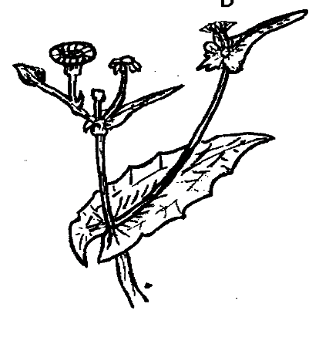
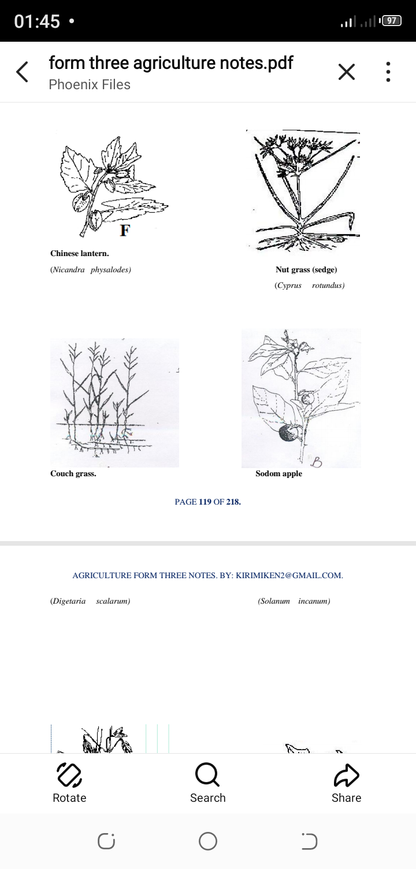
- Identify each of the weeds labelled A and C. (1 mark)
A ……………………………………………………………………
C ……………………………………………………………………
- State one reason why it's difficult to control the weed labeled A. (1 mark)
........................................................................................................................................................................................................................................................................................
- Give three harmful effects of the weed labelled B. (3 marks)
....................................................................................................................................................................................................................................................................................................................................................................................................................................
- After a soil analysis, it was found that the following should be applied, 60kgN, 30kgP₂O₅ and 40kg K₂O per ha. Calculate the amount of S.A, SSP and KCl required per ha if the fertilizer available are sulphate of ammonia (S.A) 20%N, SSP 20% P₂O₅ and muriate of potash 50% K₂O. (5 marks)

- Mr. Mkulima delayed to spray his crop of tomatoes against late Blight Disease. He realized that his plants had been attacked by the Disease and rushed to purchase a chemical which he sprayed but the disease kept spreading.
- Name two symptoms Mr. Mkulima may have noticed to conclude that the disease was Late Blight. (2 marks)
......................................................................................................................................................................................................................................................................................................................................................................................................................…..........
- State the cultural methods of controlling the disease. (1 mark)
.....................................................................................................................................................................................................................................................................................................................................................................................................................…..........
- What precautions should Mr. Mkulima observe when handling the chemical? (2 marks)
................................................................................................................................................................................................................................................................................................................................................................................................................................................................................................................................................................................
- The diagram below shows a method of crop propagation.

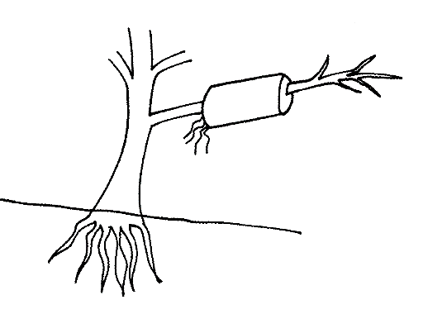

Soil level

- Identify the propagation method illustrated above. (1 mark)
..........................................................................................................................................………………………………………………………………………………………….

- State four ways of initiating faster root development in propagation method illustrated. (4 marks)
..........................................................................................................................................................................................................................................................................................................................................................................................................................................................................................................................................................................................................................................................................................................................
SECTION C (40 MARKS)
Answer only two questions in this section
- (a) Describe the field production of tomato grown for fresh vegetable market under the following sub headings:
- Pest Control (2 marks)
- Weed Control (2 marks)
- Harvesting (3 marks)
- List seven benefits of using organic matter for mulching. (7 marks)
- List six methods of harvesting water in the farm. (6 marks)
- (a) Describe the establishment and management of grass Pasture under the following sub headings
- Planting (3 marks)
- Field Management Practices (5 marks)
- On 1st July 2022 Jashi Farm purchased on credit the following items from Mamboleo Agro-Vet.
10 bags of sow and weaner meal 100kg each at ksh 1300 per bag
15 bags of finisher meal 70kg each at ksh 700 per bag
12 bags DAP fertilizer 50kg each at ksh 1050 per bag
4 milking Churns 50 litres each at ksh 2500 per churn.
4 pruning knives at ksh 400 per knife
Prepare a purchase order that Jashi Farm made to Mamboleo Agro-vet. (7 marks)
- State five reasons for crop rotation. (5 marks)

- (a) Explain ten cultural methods of controlling pests. (10 marks)
- Discuss the importance of drainage in land reclamation. (6 marks)
- Describe harvesting of sugarcane. (4 marks)
.......................................................................................................................................................................................................................................................................................................................................................................................................................................................................................................................................................................................................................................................................................................................................................................................................................................................................................................................................................................................................................................................................................................................................................................................................................................................................................................................................................................................................................................................................................................................................................................................................................................................................................................................................................................................................................................................................................................................................................................................................................................................................................................................................................................................................................................................................................................................................................................................................................................................................................................................................................................................................................................................................................................................................................................................................................................................................................................................................................................................................................................................................................................................................................................................................................................................................................................................................................................................................................................................................................................................................................................................................................................................................................................................................................................................................................................................................................................................................................................................................................................................................................................................................................................................................................................................................................................................................................................................................................................................................................................................................................................................................................................................................................................................................................................................................................................................................................................................................................................................................................................................................................................................................................................................................................................................................................................................................................................................................................................................................................................................................................................................................................................................................................................................................................................................................................................................................................................................................................................................................................................................................................................................................................................................................................................................................................................................................................... ....................................................................................................................................................................................................................................................................................................................................................................................................................................................................................................................................................................................................................................................................................................................................................................................................................................................................................................................................................................................................................................................................................................................................................................................................................................................................................................................................................................................................................................................................................................s.................................................................................................................................................................................................................................................................................................................................................................................................................................................................................................................................................................................................................................................................................................................................................................................................................................................................................................................................................................................................................................................................................................................................................................................................................................................................................................................................................................................................................................................................................................................................................................................................................................................................................................................................................................................................................................................................................................................................................................................................................................................................................................................................................................................................................................................................................................................................................................................................................................................................................................................................................................................................................................................................................................................................................................................................................................................................................................................................................................................................................................................................................................................................................................................................................................................................................................................................................................... ..........................................................................................................................................................................................................................................................................................................................................................................................................................................................................................................................................................................................................................................................................................................................................................................................................................................................................................................................................................................................................................................................................................................................................................................................................................................................................................................................................................................................................................................................................................................................................................................................................................................................................................................................................................................................................................................................................................................................................................................................................................................................................................................................................................................................................................................................................................................................................................................................................................................................................................................................................................................................................................................................................................................................................................................................................................................................................................................................................................................................................................................................................................................................................................................................................................................................................................................................................................................................................................................................................................................................................................................................................................................................................................................................................................................................................................................................................................................................................................................................................................................................................................................................................................................

