
THE SUCCESS PATH EXAMINATION COUNCL

Paving the Way to Success
233/ 1 Paper 1
Serial No. 4992104/06
Chemistry - (Theory)
Trial 4 – 2 hours

Name …………………………………………….……… Adm Number…………………………
Candidate’s Signature ………………….…...……….. Date …………………………………
Trial 4

Instructions To Candidates
  - Write your name and index number in the spaces provided
  - Sign and write the date of examination in the spaces provided
  - Answer ALL questions in the spaces provided
  - Mathematical table and electronic calculators may be used.
  - ALL working MUST be shown clearly where necessary
  - Candidates should check the question paper to ensure that all pages are printed as indicated and no questions are missing
For Examiner’s Use Only
QUESTION | MAXIMUM SCORE | CANDIDATE’S SCORES
1 – 31 | 80

1. a) Name and provide the function of the following pieces of apparatus. Name: ( ½ Mark)
Function ½ mark

b) Name: ( ½ Mark)
Function ½ mark

2. A mixture consists of sulphur and iron filings.
a) Describe how to obtain sulphur from the mixture using methylbenzene. (2 marks)

b) Is the mixture homogenous or heterogeneous? Explain. (1 mark)

3. Proteins are obtained from amino acid monomers. Complete the equation below to show how the polymer is formed. (1 mark)
H₂N CH₂ COOH + H₂N CH₂CH₂COOH

b) Name the type of polymerization shown above. (1 mark)

4. The energy level diagram below is for the reversible reaction.
X₂(g) + 3 Y_{2(g)} 2 XY₃ _{(g}

Energy (kJ)

X_{2 (g)} + 3Y_{2 (g)}
0

2 XY_{3 (g)}

Reaction path

a)Explain how the decrease in temperature will affect the above reaction (2 marks)

b) Sketch on the same axes the energy level diagram for a catalyzed reaction assuming that the above energy level diagram is for uncatalysed reaction. (1 mark)
5. The set-up below shows how nitrogen gas is prepared in the laboratory.

Nitrogen
Mixture of gas
ammonium chloride
and sodium nitrite
Water

Heat Substance L

- Describe how nitrogen gas is formed in the flask. (2 marks)

b) Nitrogen gas is inert. State one use of the gas based on this property. (1 mark)

6. Unstable nuclide had the equation below occurring. Study the equation and answer the question that follows:
${}_{O}^{1 }n$ ${}_{1}^{1}P+Y$
a) Name particle Y (1 mark)

b) What is the effect of particles towards a magnetic field? (1 mark)

c) Precisely classify the radioactive process above. (1 mark)

7. Starting with copper turnings describe how a sample of copper (II) carbonate can be prepared.
(3 marks)

8. When dilute hydrochloric acid was added to iron (II) sulphide, a colourless gas W with a characteristic smell of rotten eggs was produced.
a) Name gas W. ( ½ mark)

b) Explain how the above gas can be collected. (1 ½ mark)

c) Give the test for gas W. (1 mark)

9. a) Name the chief ore from which lead is extracted and give its chemical formula. (1 mark)

b) Describe the froth floatation process in the extraction of lead metal. (2 marks)

10. a) Determine the oxidation number of sulphur in S₂O₈²⁻ hence write the electron arrangement of sulphur. (2 marks)

b) The standard electrode potentials of a metal G and iron are given below.
Fe²⁺(aq) + 2e⁻⁻ Fe_{(s)} - 0.44V
G²⁺_{aq} + 2e⁻ G_{(s)} - 0.91V
A piece of iron is coated with metal G. If the coating is scratched, would the iron be protected from rusting. Explain. (2 marks)

11. Study the equation below
Process Q
Al₂ Cl₆ _{(g)} 2AlCl₃ (s)
Process P
A B
a) Name process Q. (1 mark)

b) Of what application is this equation? (1 mark)

c) List two other substances which show this process. (1 mark)

12. R – OO⁻ Na⁺ and R – CH₂ OSO₃⁻ Na ⁺ represent two types of cleansing agents. (1 mark)
a) Name the class of cleansing agent to which each belongs.
R – COO⁻ – Na⁺ ( ½ mark)
R – CH₂ OSO₃⁻ Na⁺ ( ½ mark)

b) Which of the above cleansing agent is likely to pollute the environment? Explain. (2 marks)

13. Ammonia gas in solution dissociates according to the equation below.
NH_{3(g)} + H₂ O₍₁₎ NH₄⁺ + OH⁻
a) Identify the acidic species in the forward reaction. Explain. (1 mark)

b) Write the formula of the complex formed when ammonia is added to copper (II) sulphate solution until in excess. (1 mark)

c) What observation is made in (b) above. (1 mark)

14. The graph below represents the solubility curve of a gas in water.
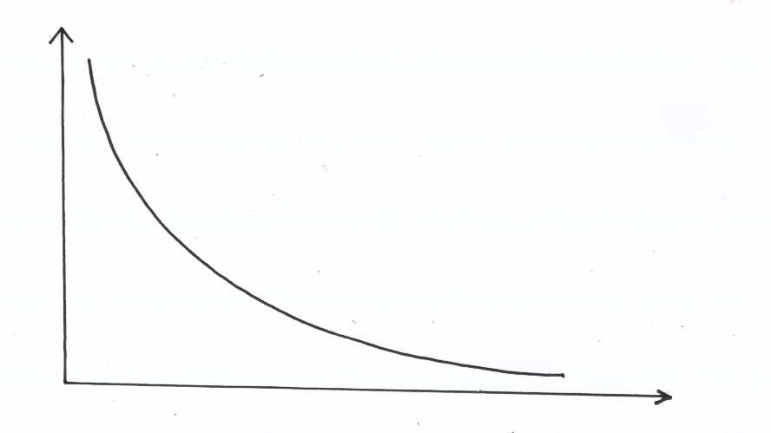

Solubility(g/100g
water

Temperature (ºC)

- State and explain the conclusion that can be drawn from this curve about the solubility of the gas. (1mark)

b) Study the information in the table below on solubility and answer the questions that follow.

Salt | Solubility (g 1 100 g H₂ O
 | At 60⁰ C | At 40 ºC
Cu SO4 | 40 | 28
Pb (N0₃)₂ | 99 | 79

Calculate the mass of copper (II) sulphate that will crystalize if 40g of a saturated solution is cooled from 60 ºC to 40 ºC. ( 2 marks )

15. Carbon is known to occur in different forms is solid form. Study the diagram below and answer the question that follow.
$${}_{6}^{14}c$$
Q
P
Diamond

Carbon

$${}_{6}^{12}C$$
Graphite

a) Name the natural phenomena exhibition by the path.
i) P (1 mark)

ii) Q (1 mark)

b) Give one use of ${}_{6}^{14}c$ ( 1 mark)

c) Provide an explanation why graphite is used in the HB pencil. (1 mark)

16. a) The diagram below represent the Frasch process.
A

C

B

Name the substances that pass through A and C.
A…………………………………………………………………………………………..(1 mark)
C………………………………………………………………………………………….. (1 mark)

b)Study the flow chart below and answer the questions that follow.
Heat
HCl _{(aq)}
Iron
Compound T
Gas X
Sulphur

a) Name gas X. (1 mark)

b) State the observation made when gas X is bubbled through a tube containing Iron (III) chloride
(1 mark)

17. Study the flow chart below and answer the questions that follow.
Water
Carbon Acid A
Burning magnesium ribbon
(IV)oxide

White solid B+ Black specs

+ water
Alkaline solution C

Write the formula of substances A, B and C ( 3 marks)
A………………………………………………………………………………………………………….
B………………………………………………………………………………………………………….
C………………………………………………………………………………………………………….

19. Below is a sketch required to investigate the reaction between chlorine and heated iron. Use it to answer the question that follow.
Drying agent
Chlorine

B
A
Iron

Heat
a) Name a suitable drying agent shown above. (1 mark)

b) The iron powder is heated before chlorine is passed over it. What would be observed when chlorine comes in contact with hot iron. (1 mark)

c) Write an equation for the reaction in A. (1 mark)

19. In Turkana, gnawing chalk was used to fight excess stomach acid. A patient suffering from intestinal ulcer released 30 cm³ of 1M hydrochloric acid in his stomach. He chewed 5g of impure chalk to neutralize the acid released. (Ca = 40, C = 12, O = 16)
a) Write a balanced equation for the reaction that took place. (1 mark)

b) Calculate the number of moles of calcium carbonate used up. (1 mark)

c) Calculate the percentage impurity of calcium carbonate (chalk) used. (1 mark)

20. The table below show elements represented by letters P, Q, R, S, T, U and V and their atomic numbers.
Elements | P | Q | R | S | T | U | V
Atomic number | 11 | 12 | 13 | 14 | 15 | 16 | 17

a) In which period of the periodic table do these elements belong? (1 mark)

b) How does the atomics radius of P compared with that of U? (2 marks)

c) Which of these ions P⁺ and Q⁺ is more stable? Explain. (1 ½ marks)

21. The diagram below represents the industrial manufacture of hydrochloric acid, study it and answer the questions that follow.

Water

Glass beads

Hydrochloric
acid
Point Z
Hydrogen
Chlorine

a) Name one source of hydrogen and chlorine in this process.
Hydrogen (1 mark)

Chlorine (1 mark)

b) The reaction between chlorine and hydrogen can be explosive. How can this be avoided.
(1 mark)

c) What is the role of glass beads in the absorption chamber? (1 mark)

d) Explain why copper reacts with concentrated nitric (v) acid but doesn’t react with concentration hydrochloric acid. (1 mark)

22. Draw a well labelled diagram of an electrolytic cell that can be used to purify impure copper metal.
(2 marks)

23. A mixture of phenolphthalein and methyl orange was separated as shown in the diagram.

a) Name the method used in the separation of the mixture. (1 mark)

b) State the colour of methyl orange in this experiment. (1 mark)

c) Phenolphthalein is usually colourless. Explain why it is pink in this experiment? (1 mark)

24. Calcium reacts with cold water. Explain two observations during the above reaction. (2 marks)

25. a) M grams of a radioactive isotope decayed to 5 grams in 100 days. The half life of the isotope is 25 day.
a) Define the term half life. (1 mark)

b) Calculate the initial mass of M of the radioactive isotope. (2 marks)

26 a) A student set up experiments as illustrated by the diagrams below. Before introducing each metal into the solution it was cleaned.
A B C

Heavy metal
Zinc metal
Zinc metal

Dilute sulphuric (VI) acid
Dilute sulphuric (VI) acid
Copper (II) sulphate

i)Why is it necessary to clean the metal pieces before introducing them into their respective beakers
( 1 mark)

ii) What observation were made immediately the metal pieces were introduced into the beakers A, B and C? (3 marks)

THIS IS THE LAST PRINTED PAGE

