

URANGA MATHEMATICS ASSOCIATION
Kenya Certificate of Secondary Education
TERM ONE JOINT EVALUATION, 2026

121/2 MATHEMATICS PP2 Alt A
MARCH, 2026 TIME: 2½ Hrs
FORM FOUR

Name: …………………………………….…….…… Admission No: …………

School: ………………...................... Signature: ……….Wednesday, 11th Mar, 2026.
INSTRUCTIONS TO CANDIDATES:
- Write your name, school, admission number and sign in the spaces provided above.
- This paper contains TWO sections: Section I and Section II.
- Answer ALL the questions in Section I and FIVE questions from section II.
- All answers and working MUST be written on the question paper in the spaces provided below each question.
- Marks may be given for correct working even if the answer is wrong.
- Non-programmable silent electronic calculators and KNEC Mathematical tables may be used, except where stated otherwise.
- This paper consists of 16 printed pages. Check to confirm that all pages are printed.

For Examiner’s Use Only
SECTION I
1 | 2 | 3 | 4 | 5 | 6 | 7 | 8 | 9 | 10 | 11 | 12 | 13 | 14 | 15 | 16 | Total

SECTION II
17 | 18 | 19 | 20 | 21 | 22 | 23 | 24 | Total

TOTAL

SECTION I (50 MARKS)
Answer ALL questions in this section

1. The masses in kg of eight boys are 56,62,58,65,50,49,57,59. Find the quartile deviation of the
data. (3 marks)

2. Solve for Ɵ in the equation 6 sin² Ɵ - cos Ɵ = 5 For 0⁰≤ Ɵ ≤ 360⁰ (3 marks)

3. Two circles of radii 3cm and 8cm have their centres 13cm apart. Calculate the length of their
direct common tangent. (3marks
4. Ken deposited Kshs 30,000 in a financial institution that paid simple interest at the rate of 12%
per annum. Wekesa deposited the same amount of money as Ken in another financial
institution that paid compound interest. After 5years, they had equal amounts of money in the
financial institutions. Determine the compound interest rate, to 1 decimal place for Wekesa’s
deposit. (3 marks)

5. Make P the subject of the formula in $\text{X= (}\frac{\text{1}}{{MP}^{3}}\text{-}{\text{A}}^{\text{2}}\text{)B}$ (3 marks)

6. The position vector of points A and B are 2i-j+4k and 4i+3j respectively. If point R is the
mid-point of AB, find the magnitude of AR. (4marks)
7. Determine the amplitude, period and phase angle of the wave represented by the equation
$\text{y}\text{=}\frac{3}{2}\text{sin}\text{(}\frac{\text{2}}{\text{5}}\text{x}\text{+4}{\text{0}}^{\text{0}}\text{)}$ (3 marks)

- Without using a calculator, simplify $\frac{\sqrt{252} + \sqrt{72} }{\sqrt{32} + \sqrt{28 }}$, leaving the answer in the form
a$\sqrt{b}$ + c where a, b and c are integers.
(3 marks)

9. A triangle whose area is 6.5cm² is mapped onto a triangle whose area is 13cm² by the
matrix.
$\left(\begin{matrix}x+4 & 6 \\ 5 & x\end{matrix}\right).$Find the values of x. (3marks)
10. In the figure below, ABC is a tangent at B and CDE is a straight line.$\text{.}\text{∠}\text{BED=5}{\text{0}}^{\text{∘}}\text{,<DEF=3}{\text{5}}^{\text{0}}\text{and} \text{<ECB=2}{\text{5}}^{\text{0}}$.Calculatc the valuc of x and z. (2 marks)
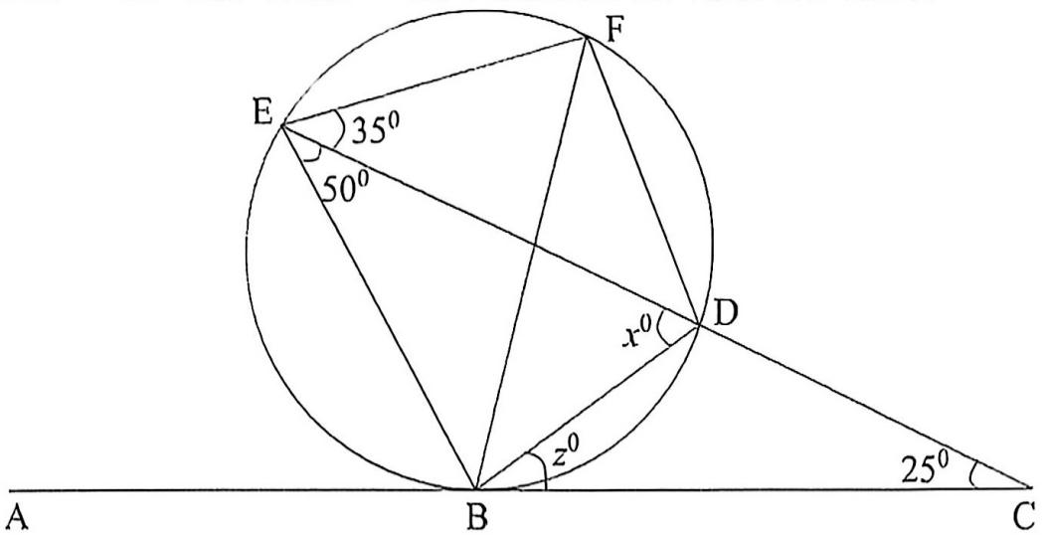

11. Two variables P and L are such that P varies partly as L and partly as the square root of
L. Determine the relationship between P and L given that when L = 16, P = 500 and when
L = 25, P = 800. (3 marks)

12. Two grades of tea costing shs.100 and shs.150 per kg respectively are mixed in the ratio
3: 5 by weight. The mixture is then sold at shs.160 per kg. Find the percentage profit on
the cost price. (3 marks)

13. The points (2, 2) and (-4, -4) are the end points of the diameter of a circle. Find the
equation of the circle giving your answer in the form ax² + by² + cx + dy = e where a, b, c
and e are integers (4 marks)

14. Without using logarithm tables or calculator, solve for $x$ (3 marks)
$$\log{5-2+\log\left(2x+10\right)=\log{(x-4)}}$$

15. By using completing square method, solve for $x$ in: (3 marks)
$${3x}^{2}+4x-4=0$$

16. The table below represents a relationship between two variable P and T connected by the
equation P = aT + b where a and b are constants
T | 0.1 | 0.2 | 0.3 | 0.4 | 0.5 | 0.6
P | 62 | 56 | 48 | 40 | 34 | 27
- Ona grid, draw the line of best fit for the data (3 marks)



- Use your graph to find the value of P when T = 0 (1 mark)

SECTION II (50 MARKS)
Answer ONLY five questions from this section.
17. The table below shows masses of 100 form 4 students;

Mass | 30-34 | 35-39 | 40-44 | 45-49 | 50-54 | 55-59 | 60-64 | 65-69
No. Of students | 4 | 6 | 10 | 14 | 22 | 24 | 14 | 6

(a) Taking 52 as the working mean. Find the actual mean mass (4 marks)

(b) Determine the variance (5 marks).

(c) Find the standard deviation (1 mark)
18.Use a ruler and a pair of compass only for all construction in this question.

(a) Draw a line AB = 4cm.On the upper side of AB, Construct the locus of P such that is equidistant from A and B. Locate a point D on the locus of P such that $\text{<A}\text{BD} \text{=} \text{6}{\text{0}}^{\text{∘}} \text{(3 marks)}$
(b) Construct the locus of Q such th$\text{at }\text{<}\text{AQB}\text{=3}{\text{0}}^{\text{∘}}$ (2 marks)
(c) Mark a point;
(i) X where the locus of P and Q intersect. (1 mark)
(ii) Y on the locus of Q such that the area of triangle ABD is equal to the area of
triangle AYB. (2 marks)
(d) The points A,B,X and Y are the vertices of a Pentagon with the locus of P as a
line of symmetry. Complete the pentagon. (2marks)
19. A bag contains 7 red, 4 white, and 6 blue balls. Two balls are drawn at random from the bag
one at a time without replacement.
(a) Represent the information above on a a tree diagram (2 marks)

(b) Use the tree diagram to find the probability that;

- The second ball drawn is red (2 marks)

- The two balls are of the same colour (2 marks)

- No white ball is drawn (2 marks)

- At least one ball is blue (2 marks)

20. a)The first term of an Arithmetic Progression (AP) is 2. The sum of the first 8 terms of the AP
is 156
i) Find the common difference of the AP. (2 marks)

ii) Given that the sum of the first n terms of the AP is 416, find n. (3 marks)

b) The 3rd, 5th and 8th terms of another AP form the first three terms of a Geometric
Progression (GP) If the common difference of the AP is 3, find:
i) The first term of the GP; (3 marks)

ii) The sum of the first 9 terms of the GP, to 4 significant figures. (2 marks)
21. Rectangle ABCD in which A(1,3), B(8,3), C(8,5) and D(1,5) undergoes a shear with x = 4 as
the invariant line.
a) Plot the rectangle ABCD (1 mark)



b) If the point C is mapped on the point C¹(8,9) under this transformation, determine the
coordinates of A^{l}, B^{l} and D^{l}. (3 marks)

c) Plot the figure A^{l},B^{l},C^{l},D^{l} (1 mark)
d) Find the matrix representing this transformation (2 marks)

e) Using the determinant of the matrix in (d) above, find the area of the figure A^{l}, B^{l}, C^{l}, D^{l}
^{(3marks)}
22.The following table shows the rate at which income tax was charged during the year 2024.
Monthly taxable income in Ksh. | Tax rate %
0-9860 | 10
9861-19720 | 15
19721-29580 | 20
29581-39440 | 25
39441-49300 | 30
49301-59160 | 35
Over 59160 | 40

Mr. Kennedy earns a basic salary of Ksh 68,000, a monthly house allowance of Kshs. 16000 and commuter allowance of Ksh 8000. He contributes 7.5% of his basic salary to pension scheme and 5% of his basic salary towards SHA. These two contributions are exempted from taxation.
Calculate:
(a) His monthly Taxable income. (2 marks)

(b) Calculate his net monthly tax if he is entitled to a person relief of sh. 2400 per month.
(6 marks)

(c) In addition, the following deductions were made from his salary: Bank Service charge
ksh.200,Bank loan repayment ksh.5,000,Cooperative shares of ksh.6000. Calculate his
net salary per month. (2marks

23. In the figure below OAB is a triangle in which M divides OA in the ratio 2:3 and N divides
OB in the ratio 4:1. AN and BM intersects at X.

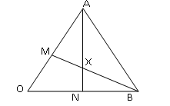
(a) Given that vectors OA = a and OB = b, express the following vectors in terms of a and b (i) AN (1 mark)

(ii) BM (1 mark)

(iii) AB (1 mark)

(b) If AX = sAN and BX = tBM, where s and t are constants. Find the values of s and t
~
~
~
~
(6 marks)

(c) Find the ratio in which X divides AN (1 mar

24. Complete the table below for the functions y = 3sin 3 θ and y = 2 Cos (θ + 40⁰) (2 marks)

θ⁰ | 0⁰ | 10⁰ | 20⁰ | 30⁰ | 40⁰ | 50⁰ | 60⁰ | 70⁰ | 80⁰ | 90⁰
3 Sin 3θ | 0 | 1.50 |  | 3.00 |  |  | 0.00 |  |  | -3.0
2 Cos (θ + 40⁰) | 1.53 | 1.29 |  |  | 0.35 |  |  | -0.69 |  | -1.29

- On the grid provided, draw the graphs of y= 3 Sin 3 θ and y = 2 Cos (θ + 40⁰) on the same axis. Take 1 cm to represent 10⁰ on the x-axis and 4 cm to represent 2 unit on the y – axis.
(5 marks)
(b) From the graph find the roots of the equation.
(i) $\frac{3}{4}$ Sin 3θ = $\frac{1}{2}$ Cos (θ + 40⁰) (2 marks)

(ii) 2 Cos (0 + 40⁰) = 0 in the range 0 ≤θ≤ 90⁰ (1 mark)

