

URANGA MATHEMATICS ASSOCIATION
Kenya Certificate of Secondary Education
TERM ONE JOINT EVALUATION, 2026

121/1 MATHEMATICS PP1 Alt A
MARCH, 2026 TIME: 2½ Hrs
FORM FOUR

Name: …………………………………….…….…… Admission No: …………

School: ………………...................... Signature: ……….Tuesday, 10th Mar, 2026.
INSTRUCTIONS TO CANDIDATES:
- Write your name, school, admission number and sign in the spaces provided above.
- This paper contains TWO sections: Section I and Section II.
- Answer ALL the questions in Section I and FIVE questions from section II.
- All answers and working MUST be written on the question paper in the spaces provided below each question.
- Marks may be given for correct working even if the answer is wrong.
- Non-programmable silent electronic calculators and KNEC Mathematical tables may be used, except where stated otherwise.
- This paper consists of 16 printed pages. Check to confirm that all pages are printed.

For Examiner’s Use Only
SECTION I
1 | 2 | 3 | 4 | 5 | 6 | 7 | 8 | 9 | 10 | 11 | 12 | 13 | 14 | 15 | 16 | Total

SECTION II
17 | 18 | 19 | 20 | 21 | 22 | 23 | 24 | Total

TOTAL

SECTION I (50 MARKS)
Answer ALL questions in this section
- Without using mathematical tables or calculators, evaluate:
³/₈÷ (½-¹/₃) of ¾ - ¹/₁₀ (3 marks)

- Simplify completely.
$\frac{2ax +3bx – 2ay – 3by }{y-x}$ (3 marks)

- In a class of 43 students there are 5 girls more than boys. Every boy pays Ksh. 2,400 for
uniform and every girl pays Sh.3,000. How much is paid for uniform by the class?. (3 marks)

4. The radius of a sphere is increased by 5%. Calculate the percentage increase in its volume.
(3 marks)

5. Find all the integral values of $x$ which satisfy the inequality; (3 marks)
$3\left(1+x\right)<5x-11<x+45$

6. Use a ruler and a pair of compasses only to construct a trapezium ABCD such that AB is
parallel to DC, AB = 8.5 cm, BC = 5cm, <BAD = 90º and < ABC =120º. Measure the
shortest distance from C to line AB. (3marks)

7. Given tan θº = 3³/_{7,} find cos (90 - θ)º as a decimal to four significant figures. (3 marks)

- John, a tourist arriving in Kenya from Britain had 9600 UK sterling pounds. He converted the pounds to Kenyan shillings at a commission of 5%. While in Kenya, he spent three-quarters of this money. He exchanged the balance to US dollars after his stay. If he was not charged any commission for this last transaction, calculate, to the nearest US dollars, the amount he received. (4 marks)
 | BUYING | SELLING
1 US Dollar | 63.00 | 63.20
1 UK pound | 125.30 | 125.95

9. Use tables of squares, square roots and reciprocal to find the value of x if it is given that
x= $\frac{2}{\sqrt{0.4278}}$ +$\frac{1}{{6.04}^{2}}$ (4 marks)

10. Find the value of m in the equation below. (3 marks)
${\left(\frac{1}{27}\right)}^{M}$ x (81)⁻¹ = 243

11. Given that the area of the trapezium ABCD is 30.8cm², find the length of AD. (3 marks)
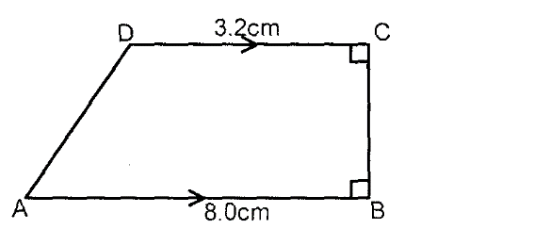

12. Solve for x in the equation; (3 marks)

13. Complete the shape below using the centre O to show a rotational symmetry of order 3.
(3 marks)

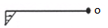

14. The points P, Q and R lie on a straight line. The position vectors of P = 2i + 2j+13k and that
of R = 2i +5j + 4k. Q divides PR internally in the ratio 2: 1

Find;
i) The position vector of Q in terms of i, j and k. (2 marks)

ii) The magnitude of Q above. (1 mark)

15. A chord of length 13cm subtends an angle of 67º at the circumference of a circle centre O.
Find the radius of the circle. (3marks)

16. The figure below shows a regular polygon A B C D E F with the interior angles indicated.
Find the value of the smallest angle in the polygon. (3 marks)

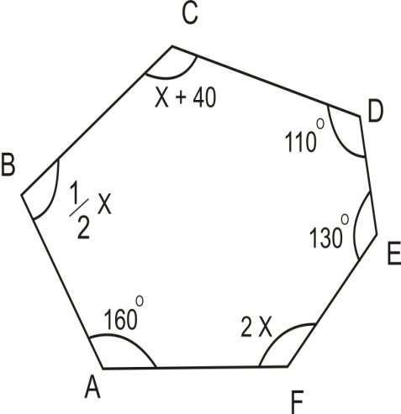

SECTION II (50 MARKS)
Answer any five questions in this section.
17. The distance between two towns A and B is 460 km. a minibus left town A at 8.45 am and travelled towards Bat an average speed of 65km/hr. A matatu left B at 10.55 am on the same day and travelled towards A at an average speed of 80km/hr.
- How far from town B did they meet? (4 marks)

- At what time did the two vehicles meet? (2 marks)

- A motorist started from his home at 9.15am on the same day and travelled to B at an average speed of 120km/hr. he arrived at the same time as the minibus. Calculate the distance from B to his home. (4 marks)

- A line $L_{1 }$passes through the points $(-2, 3)$ and $(-1, 6)$ and is perpendicular to $L_{2}$at $(-1, 6)$.
- Find the equation of $L_{1}$. (2 marks)

- Find the equation of $L_{2}$ in the form $ax+by-c=0$ where a, b and c are constants. (2 marks)

- Given that another line $L_{3}$ is parallel to $L_{1}$ and passes through point $\left(1,2\right)$ , find the $x$ and $y$ intercepts of $L_{3}$ . (3 marks)

- Find the point of intersection of $L_{2}$and $L_{3}$. (3 marks)

19. In the year 2022 the price of a sofa set in a shop was Ksh. 120,000
(a) Calculate the amount received from the sales of 240 sofa sets that year. (2 marks)

(b) In the year 2023 the price of each sofa set increased by 25% while the number of sets sold decreased by 10%.
(i) Calculate the percentage increase in the amount received from the sales . (3 marks)

(ii) If at the end of the year 2023, the price of each sofa set changed in the ratio 16:15. Calculate the price of each sofa set in the year 2024. (2 marks)

- The number of sofa sets sold in the year 2024 was p% less than the number sold in the year 2023. Calculate the value of p given that the amount received from the sales in the years were equal. (3 marks)

20. The figure below show a solid frustum ABCDEFGH with a rectangular base measuring 18cm by 24cm and the top measuring 6 cm by 8cm. The slant edges AF=BG=CH=DE= 26cm long.

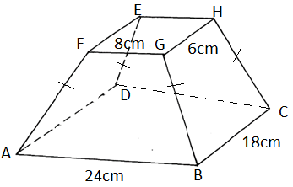

Determine:
a) Height of the original pyramid. (4marks)

b) Volume of the frustrum. (3marks)

c) Density in g/cm³ if the solid has a mass of 7.488kg. (3marks)

21. The frequency distribution table below shows marks obtained by pupils in a certain school.

Marks | 200 $≤$ x $≤$220 | 220 $≤$ x $≤$240 | 240 $≤$ x $≤$280 | 280 $≤$ x $≤$ 320 | 320 $≤$ x $≤$340
No. of pupils | 6 | 14 | 12 | 8 | 5

a) Calculate the mean. (4 marks)

b) (i) On the grid provided, draw a histogram to represent the information above. (4 marks)


ii) Use your histogram to estimate the median. (3 marks)

22.a) Given that the matrix , find A⁻¹, the inverse of A. (2 marks)

b) Kariuki bought 400 goats and 600 sheep for a total of Kshs 1,700,000. Maina bought 180 goats and 240 sheep for a total of Kshs 720,000. If the price of a goat is sh. X and that of a sheep is shs y.
- Form two equations to represent the above information. (2 marks)

- Use the matrix A⁻¹ to find the price of one goat and one sheep. (3 marks)

c) John bought 450 goats and 720 sheep. He was given a total discount of shs 66,600.
If the discount on the price of a goat was 2%, calculate the percentage discount on the price of a goat. (3 marks)

23. A village Q is 7 km from village P on a bearing of 045⁰. Village R is 5 km from village Q on
a bearing of 120⁰ and village S is 4 km from village R on a bearing of 270⁰.
- Taking a scale of 1 cm to represent 1 km, locate the three villages. (3 marks)

- Use the scale drawing to find the:
- Distance and bearing of the village R from village P. (2 marks)

- Distance and bearing of village P from village S. (2 marks)

- Calculate the area enclosed by the three villages in square km. (3 marks)

24. A¹(-1,0) B¹(-1,2) and C¹(-4,0) is the image of A(2,1), B(4,1) and C(2,4) respectively under a rotation
- Plot the two triangles on the grid provided (2 marks)


- By construction find the center and angle of rotation (3 marks)

- $A^{''}B^{'' }C^{''}$ is the image of A¹B¹C¹ under enlargement, center (-2,-1) and scale factor -2. Plot $A^{''}B^{'' }C^{''}$and state its coordinates $(3 marks)$

- $A$¹¹¹B¹¹¹C¹¹¹ is the image of $A^{''}B^{'' }C^{''}$ under reflection in the line $y+2=0$. Plot $A$¹¹¹B¹¹¹C¹¹¹ on the same grid and state its coordinates $\left(2 marks\right)$

