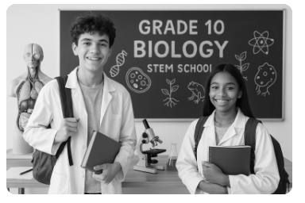

GRADE 10
COMPETENCE BASED CURRICULUM
SENIOR SCHOOL



GRADE GUIDE NOTES



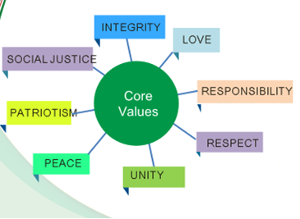

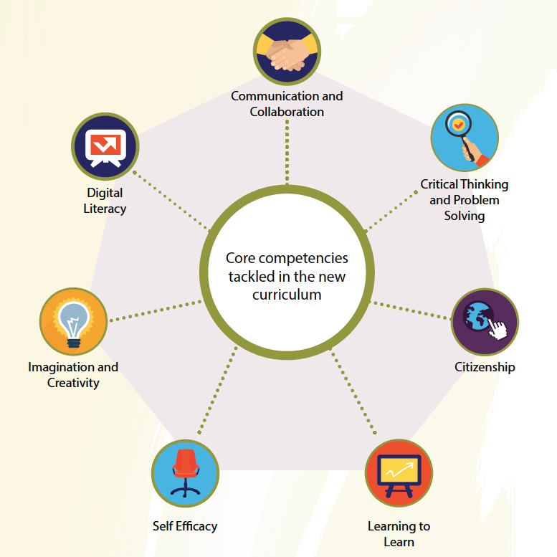

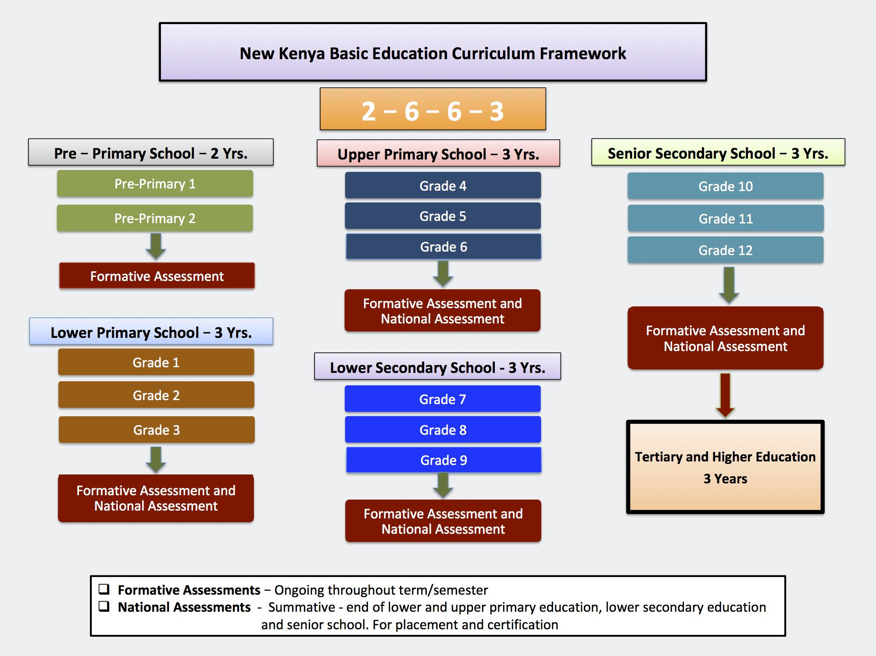
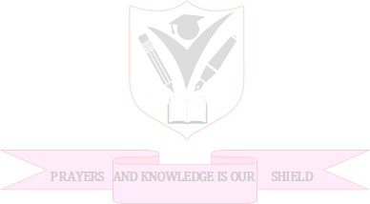
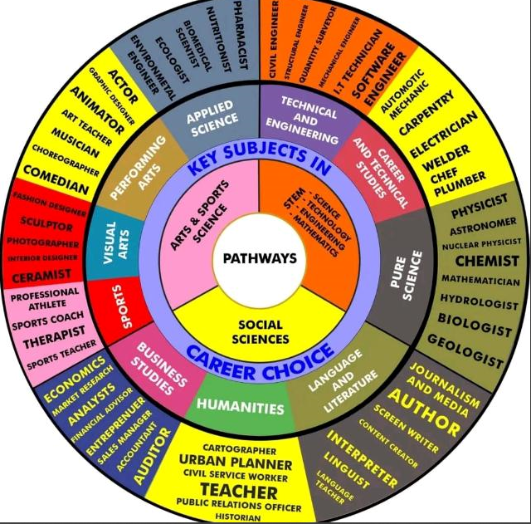

NATIONAL GOALS OF EDUCATION
Education in Kenya should:
1. Foster nationalism and patriotism and promote national unity
Kenya’s people belong to different communities, races and religions, but these differences need not divide them. They must be able to live and interact as Kenyans. It is a paramount duty of education to help young people acquire this sense of nationhood by removing conflicts and promoting positive attitudes of mutual respect which enable them to live together in harmony and foster patriotism in order to make a positive contribution to the life of the nation.
2. Promote the social, economic, technological and industrial needs for national development
Education should prepare the youth of the country to play an effective and productive role in the life of the nation.
a) Social Needs
Education in Kenya must prepare children for changes in attitudes and relationships which are necessary for the smooth progress of a rapidly developing modern economy. There is bound to be a silent social revolution following in the wake of rapid modernization. Education should assist our youth to adapt to this change.
b) Economic Needs
Education in Kenya should produce citizens with the skills, knowledge, expertise and personal qualities that are required to support a growing economy. Kenya is building up a modern and independent economy which is in need of an adequate and relevant domestic workforce.
c) Technological and Industrial Needs
Education in Kenya should provide learners with the necessary skills and attitudes for industrial development. Kenya recognizes the rapid industrial and technological changes taking place, especially in the developed world. We can only be part of this development if our education system is deliberately focused on the knowledge, skills and attitudes that will prepare our young people for these changing global trends.

3. Promote individual development and self-fulfilment
Education should provide opportunities for the fullest development of individual talents and personality. It should help children to develop their potential interests and abilities. A vital aspect of individual development is the building of character.
4. Promote sound moral and religious values
Education should provide for the development of knowledge, skills and attitudes that will enhance the acquisition of sound moral values and help children to grow up into self-disciplined, self-reliant and integrated citizens.
5. Promote social equity and responsibility
Education should promote social equality and foster a sense of social responsibility within an education system which provides equal educational opportunities for all. It should give all children varied and challenging opportunities for collective activities and corporate social service irrespective of gender, ability or geographical environment.
6. Promote respect for and development of Kenya’s rich and varied cultures
Education should instill in the youth of Kenya an understanding of past and present cultures and their valid place in contemporary society. Children should be able to blend the best of traditional values with the changing requirements that must follow rapid development in order to build a stable and modern society.
7. Promote international consciousness and foster positive attitudes towards other nations
Kenya is part of the international community. It is part of the complicated and interdependent network of peoples and nations. Education should therefore lead the youth of the country to accept membership of this international community with all the obligations and responsibilities, rights and benefits that this membership entails.
8. Promote positive attitudes towards good health and environmental protection
Education should inculcate in young people the value of good health in order for them to avoid indulging in activities that will lead to physical or mental ill health. It should foster positive attitudes towards environmental development and conservation. It should lead the youth of Kenya to appreciate the need for a healthy environment.
LEARNING OUTCOMES FOR SENIOR SCHOOL
By the end of senior school, the learner should be able to:
1. Communicate effectively and utilize information and communication technology across varied contexts,
2. Apply mathematical, logical and critical thinking skills for problem solving,
3. Apply basic research and scientific skills to manipulate the environment and solve problems,
4. Exploit individual talents for leisure, self-fulfillment, career growth, further education and training,
5. Uphold national, moral and religious values and apply them in day-to-day life,
6. Apply and promote health care strategies in day-to-day life,
7. Protect, preserve and improve the environment for sustainability,
8. Demonstrate active local and global citizenship for harmonious co-existence,
9. Demonstrate appreciation of diversity in people and cultures,
10. Manage pertinent and contemporary issues responsibly.

THE SENIOR SCHOOL IN THE COMPETENCY BASED CURRICULUM (CBC)
Senior School is the forth level of Basic Education in the Competency Based Curriculum (CBC) that learners shall come to after the Pre-Primary, Primary and Junior School (JS). The essence of Senior School is to offer learners a Pre- University/ Pre- career experience where the learners have an opportunity to choose pathways where they have demonstrated interest and/or potential at the earlier levels. Senior school comprises three years of education for learners in the age bracket of 15 to 18 years and lays the foundation for further education and training at the tertiary level and the world of work. In the CBC vision, learners exiting this level are expected to be engaged, empowered and ethical citizens ready to participate in the socio-economic development of the nation.
At this level, learners shall take SEVEN (07) learning areas (LAs) as recommended by the Presidential Working Party on Educational Reforms (PWPER). These shall comprise Four Compulsory learning areas, and Three learning areas opted for by the learner according to their choses Pathway. While English and Kiswahili are indicated as Compulsory, the learners who opt for these learning areas as their subjects of specialization shall go through a differentiated curriculum in terms of scope, experiences and assessment. Such learners shall; therefore, take Advanced English or Kiswahili Kipevu with additional two lessons. It is recommended that AT LEAST TWO learning areas should be from chosen Pathway. In exceptional cases, some learners may opt for ONE learning area from the chosen Pathway and a maximum of TWO learning areas from any of the three pathways; depending.

LIST OF LEARNING AREAS AT SENIOR SCHOOL
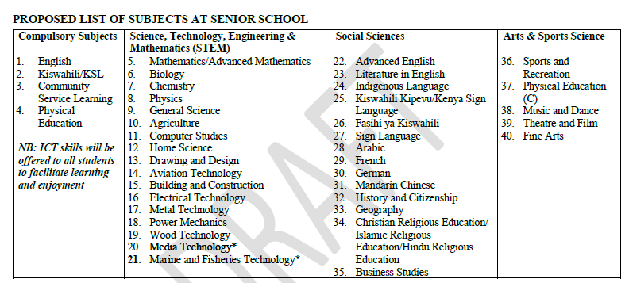

LESSON DISTRIBUTION AT SENIOR SCHOOL
The number of lessons in each of the compulsory learning areas shall be 4; while the optional areas shall be 6 lessons each. A lesson shall be 40 minutes. The "free" lessons shall be used for development of ICT skills, Pastoral Instruction Programme (PPI), projects, collaborative study and further reading.

ESSENCE STATEMENT
Biology is a branch of Science that deals with the study of life as manifested in life forms such as viruses, bacteria, fungi and complex organisms such as plants and animals. The interrelationships within, among them and with their environments ensure continuity of life. This depends on the working of this broad spectrum of organisms in relation to that of the humans.
The achievement of Vision 2030 greatly depends on Science, Technology and Innovation. For a breakthrough towards industrialisation, achievement of the desired economic growth targets, social and human capital development through education and training should be prioritised (Sessional Paper No.1 of 2005). This can be achieved by promoting the teaching of science and technology. Sessional paper No. 1 of 2019 also underscores the need for sustainable basic and higher education with emphasis on Science, Technology and Innovation (ST&I). This makes it necessary for Biology as a subject to be taught in Senior School as its content is needed for developing technologies that support humans and other life forms.
The Biology content presents basic knowledge for the learner to understand how the human body and other life systems work. The content provided empowers the learners to make informed decisions in promoting positive attitude towards their individual health, community and the environment for sustainable development.
Biology is a foundational subject for careers in Medicine, Agriculture, Marine Science, Anthropology, Environmental Studies and other related fields. The subject also enables learners to build relevant knowledge, skills and attitudes necessary for further education and training in the related careers.

Suggested pedagogical approaches include Inquiry Based Learning, Project Based Learning and Problem Based Learning as advocated by constructivist theory. The theory emphasizes that the learner is given an opportunity to learn through hands-on activities which develop practical life skills.

BIOLOGY GENERAL LEARNING OUTCOMES
By the end of the course the learner should be able to:
1. Develop relevant knowledge, skills and attitudes for further education and for training in biology related scientific fields;
2. Demonstrate an understanding of interrelationships among humans, other organisms and their environment and apply the knowledge to conserve nature;
3. Describe features of various groups of living organisms and identify unknown organisms using simple biological keys;
4. Apply the knowledge gained on human body systems and functions to improve the quality of life for self and the community while enhancing healthy living;
5. Design and carry out practical activities and projects that will enable them to understand biological concepts;
6. Demonstrate relevant technical skills and scientific knowledge necessary for socio-economic development;
7. Demonstrate resourcefulness in designing projects necessary for community service learning;
8. Communicate biological information in a precise, clear and logical manner;
9. Apply knowledge on plant and animal structure and functions to industrialization, innovation and sustainability of life;
10. Use knowledge gained to make informed decisions about scientifically-based personal and societal issues to solve emerging issues in health and environment.

SUMMARY OF STRANDS AND SUB STRANDS
1.0 CELL BIOLOGY AND BIODIVERSITY
1.1 Introduction to Biology
1.2 Scientific investigations in Biology
1.3 Cell structure and Specialization
1.4 Chemicals of life
2.0 ANATOMY AND PHYSIOLOGY OF PLANTS
2.1 Nutrition
2.2 Transport
2.3 Gaseous exchange and Respiration
3.0 ANATOMY AND PHYSIOLOGY OF ANIMALS
3.1 Nutrition
3.2 Transport
3.3 Gaseous exchange and Respiration

STRAND 1: CELL BIOLOGY AND BIODIVERSITY

Sub-strand 1.1: Introduction to Biology

Definition of Biology - What is Biology?
Biology is a branch of science that deals with the study of living things.
- There are diverse forms of life on earth ranging from the invisible microscopic living things to the gigantic life forms. It aims at explaining the living world in terms of scientific principles.
- It is important to note, however, that living things interact with the non living things in the environment as well.
- Biology, therefore also entails the study of non living things as well. The role of human beings in shaping the environment is also investigated in biology.
- In summary, biology deals with the study of origins, types, nature, growth, development, interactions and maintenance of all life forms on earth.

Importance of biology
The study of biology is very important. The knowledge acquired from this study can benefit an individual in myriad ways. The study of biology is important in that:
- The knowledge acquired from the study of biology can be very helpful in solving environmental problems such as food shortage, poor health services, pollution and environmental degradation.
- The study of biology can grant one an entry into various careers such as medicine, veterinary medicine, animal husbandry, horticulture and dentistry.
- The study of biology leads to development of scientific skills which are very useful in life. These include skills of observing, identifying, recording, classifying, measuring, analyzing and evaluating. These skills can enable one learn how to make right choices and lead an improved life.
- Through the study of biology man learns the causes of human, plant and human diseases and how best these diseases can be prevented and cured.
- Biological knowledge acquired in the study of biology is very useful in enhancing international cooperation. Some biology related international conventions include:
  - Joint development of HIV/AIDS vaccine by Kenyan and British scientists.
  - The coordinated fight against Severe Acute Respiratory Syndrome involving scientist all over the world.
  - The fight to save the ozone layer from depletion through various international agreements such as the Kyoto protocol.
  - Management of resources through international treaties such as the CITES (Convention against International Trade on Endangered Species).

Application of Biology in Everyday Life
Biology plays a role in:
Area | Example of Application
Medicine & Health | Disease diagnosis, drug development
Agriculture | Improving crop yield, livestock breeding
Environment | Conservation, waste management
Food Industry | Fermentation, food preservation
Forensics | DNA fingerprinting, crime solving
Research & Tech | Biotechnology, cloning, genetic engineering

Learner Activity:
- Learners work in groups to list how biology impacts their daily lives.
- Each group presents findings.

Fields of Study in Biology (15–20 min)

Branches of Biology
Biology is such a broad field of knowledge. It is divided into two broad branches.
- Zoology - This is a branch of biology that deals with the study of animal life.
- Botany- This is a branch of biology that deals with the study of plant life.
Within the two branches, there exist even smaller branches because the branches (botany and
zoology) are very wide and complex.

Key Fields:
Field of Biology | Description
Botany | Study of plants
Zoology | Study of animals
Taxonomy | Classification of living things
Anatomy | Structure of living organisms
Physiology | Functions of body systems
Ecology | Relationships in ecosystems
Biochemistry | Chemical processes in organisms
Biotechnology | Application of biological systems
Genetics | Study of heredity and variation
Parasitology | Study of parasites
Microbiology | Study of microorganisms
Entomology | Study of insects

Learner Activity:
- Use textbooks or internet to research one field of biology.
- Share with the class: field name, what it involves, and at least one related career.

Careers Related to Fields of Biology (15 min)
Field | Related Career(s)
Botany | Botanist, Agricultural Officer
Zoology | Zoologist, Park Ranger
Genetics | Geneticist, Lab Technician
Biotechnology | Genetic Engineer, Biomedical Scientist
Ecology | Environmentalist, Ecologist
Anatomy | Surgeon, Physiotherapist
Microbiology | Microbiologist, Pathologist
Entomology | Entomologist, Pest Control Expert

Learner Activity:
- Role-play or create a skit showcasing a professional in a biology-based career.

Influences on Career Choices (10 min)

Positive Factors:
- Personal interest
- Abilities and talents
- Passion and motivation
- Career demand and job availability

Negative Factors (should NOT influence):
- Gender roles/stereotypes
- Cultural beliefs
- Disabilities
- Peer pressure
- Environmental background

Discussion Questions:
- “Why is it important to choose a career based on interest and ability?”
- “Can girls be surgeons or boys be florists? Why or why not?”

Assessment Questions
- Define Biology.
- Mention four careers that come from studying Biology.
- Explain two ways Biology is useful in health and agriculture.

- Motor vehicles move, use energy and produce carbon dioxide and water. Similar characteristics occur in living organisms yet motor vehicles are not classified as living. List the other characteristics of living things that do NOT occur in motor vehicles.

- Give the name to the study of:

The cell

Micro—organisms

The study of differences between parents and their offspring

The study of relationships between organisms and their environment

C. Research/Project Work
- In pairs, research and create a poster showing one field of biology and three careers related to it.
- Present the poster to the class.

Sub-strand 1.12 scientific investigation in Biology
Collection of Specimen
We have defined biology as the study of living things. For effective study, a biologist may have to collect some living things or some parts of living things for observation and analysis. The living things or parts of living things that are used for biological study are called specimens. Biological studies always take place in laboratories. A laboratory is a building or a room that is designed and equipped for scientific studies. Collections of living things especially animals may not be very easy. Some of the animals are not easy to catch while some are quite dangerous. Knowledge on proper specimen collection and handling of is very important. We will discuss some of the apparatus used in specimen collection.

1. Apparatus for Specimen Collection and Preservation
Apparatus/Material | Use
Pooter/Aspirator | Sucking small insects safely
Pitfall trap | Trapping crawling insects or animals
Soapy water | Used in traps for drowning insects
Forceps | Picking small specimens without damage
Sweep net / Aerial net | Catching flying insects
Light trap | Attracting and trapping nocturnal insects
Tullgren funnel | Extracting small animals from soil/litter
Envelopes | Holding butterflies or moths
Labels & Permanent Ink | Marking collected specimens
Hand lens | Magnifying small features
Tracing paper | Drawing and recording features
Gloves and Digger | Safe and effective soil specimen collection
Knife or Secateurs | Cutting plant parts
Collecting bags | Transporting specimens

- Sweep net
This is used for catching flying insects.
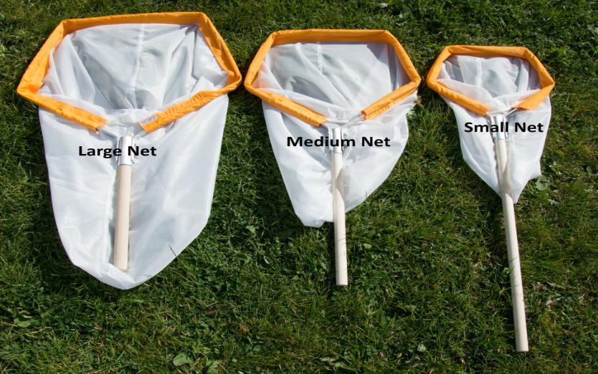

- Fish net
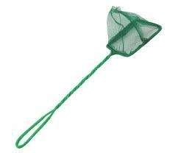
This is used for trapping small fish and other small water animals.

- Pooter

This is used for sucking small animals from rock surfaces or barks of trees.

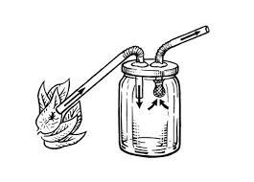
- Bait trap

This is used for attracting and trapping small animals including rats.
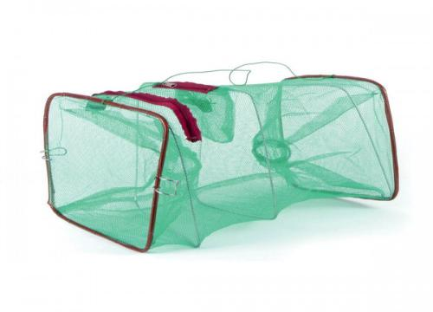

- Pit fall trap

This is used for catching crawling animals.
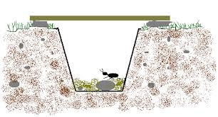

- Pair of forceps

This is an apparatus used for picking up small crawling animals e.g. stinging insects.

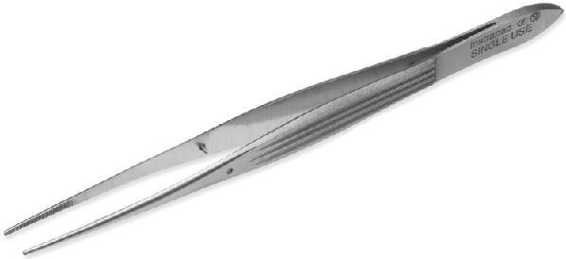

- Specimen bottles

These are bottles used for keeping collected specimen. They are of different sizes depending on the size of the specimen being studied.
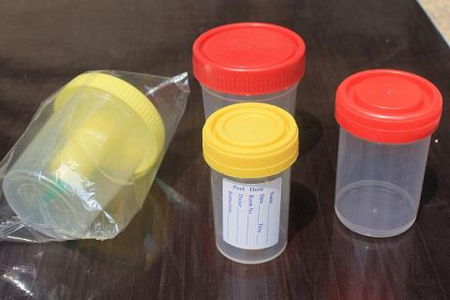

- Magnifying lens

This is used to enlarge small objects. A hand lens is a common magnifying lens used in the laboratory. The magnifying power of the hand lenses is always indicated on the lens e.g. X10, X5, X8. The magnifying power of a lens shows how many times the image will be enlarged compared to the object.
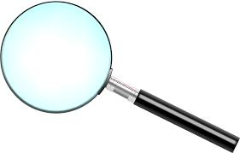

How to use a magnifying lens

-To use a magnifying lens, place the object to be enlarged on the bench. Hold the magnifying lens on one

hand and while closing one eye, move the lens towards the object until the image comes into clear focus.

-If a magnifying lens is used to make a drawing of a specimen, the magnification of the drawing will have no

relation with the size of the drawing.

The magnification of the drawing can be calculated using the formula shown below.

Drawing magnification= ^{length of drawing}/_{length of actual object}
The multiplication sign must come before the magnification value e.g. X10, X5, X15 etc.
Precautions During Collection and Observation of Specimen

While collecting specimen for observation, a biologist should play close attention to the following:

Collect only the number of specimen you need; do not collect more than you need.

Do not harm the specimen during the capture/collection exercise.

Do not destroy the natural habitat of the specimens.

Handle dangerous/injurious specimens with care. Such injurious specimens can be stinging plants or insects.

Forceps and hand gloves should be used in such cases.

Techniques in Collection, Processing, and Preservation

A. Plant Specimens
- Collection: Use secateurs/knife to cut leaves, flowers, or small branches.
- Processing: Press using blotting paper and weight.
- Preservation: Dry, mount on paper, and label (common name, scientific name, locality).
- Storage: Keep in dry, insect-free environments.

B. Animal Specimens
- Collection: Use pooters, nets, pitfall traps depending on size/type.
- Processing:
  - Sort by type.
  - Mount on soft boards (for insects).
- Preservation:
  - Use ethanol or formalin (wet preservation).
  - Label properly (name, date, locality).

Project-Based Learning (PBL) – Specimen Collection Project

Requirements:
- Plan the project (set objectives, timeline, and resources).
- Budget (include transport, containers, materials).
- Collect both plant and animal specimens.
- Record and document each step (photos, labels, notes).
- Reflect and present to class or school science fair.

Financial Literacy Integration:
- Budgeting: Estimate costs for materials.
- Planning: Schedule collection days and assign roles.
- Saving: Encourage low-cost or improvised tools.
- Recording: Keep receipts or a cost breakdown.

Learning Activities:
Activity Type | Description
Group Research | Find tools used in specimen collection from books/online
Practical Session | Collect, press, mount, and label plant specimens
Demonstration | Show use of pooter, pitfall trap, and improvised traps
Improvisation Workshop | Learners create specimen traps using local materials
Class Discussion | Debate on ethics, safety, and importance of preservation
Project Portfolio | Document progress, include photos, and present findings

Assessment:Formative:
- Q&A during class.
- Group work observation.
- Demonstration of apparatus.

Summative:
- Project evaluation.
- Written reflection or short test.
- Peer and self-assessment using rubrics.

Sample Questions:
- Name three apparatus used to collect small crawling insects.
2. State two reasons why specimens should be preserved properly.
3. List any four materials used in making a herbarium.
4. Describe how to process and preserve a plant specimen.
5. Match the following tools with their correct function: (Pooter, Tullgren funnel, Secateurs).

Collection and Observation of Organisms
Biology as a practical subject is learnt through humane handling of organisms.

Materials needed for collection of organisms:-
- Knives to cut portions of plant stem/root or uproot.
- Polythene bags to put the collected plant or specimens.
- Insect collecting jars.
- Insect killing jars.
- Hand gloves.
- Sweep nets
- Pooters
- Traps

Observation of Organisms
- Observe the plant/animal in its natural habitat before collecting.
- Identify the exact place -on surface, under rock, on tree trunk, on branches.
- What does it feed on?
- How does it interact with other animals and the environment?
- How many of that kind of plant or animal are in a particular place?
- Plant specimens placed on the bench and sorted out into;- seeds/stems/roots/leaves/fruits.
- Animal specimens may be left inside polythene bags if transparent.
- Others (killed ones) are put in petri dishes.
- Use hand lens to observe the external features of small animals.

Presenting the Results of Observations
- Organisms are observed and important features noted down: colour, texture hard or soft; if hairy or not. Size is measured or estimated.
- Biological Drawings - It is necessary to draw some of the organisms.
- In making a biological drawing, magnification (enlargement) is noted.
- Indicate the magnification of your drawing.
- i.e how many times the drawing is larger/smaller than the actual specimen MG=length of drawing/length specimen

How to Draw
- Several drawings of one organism may be necessary to represent all features observed, e.g.
- Anterior view of grasshopper shows all mouth parts properly, but not all limbs.
- Lateral (side) view shows all the legs.

Collection, Observation and Recording of Organisms

Collection
- Plants and animals collected from the environment, near school or within school compound using nets, bottles and gloves.
- Animals collected include:-arthropods, earthworms and small vertebrates like lizards/chameleons/ rodents.
- Place in polythene bags and take to the laboratory.
- Stinging/poisonous insects killed using ether.
- Other animals are observed live and returned to their natural habitat.
- Plant specimen collected include:- leaves, flowers and whole plants.
- Observations are made to show the following:-
- Plants have roots, stems, leaves and flowers.
- Animals have legs, hair, hard outer covering, feathers, eyes, mouth, limbs and other appendages,

Sub-strand 1.3 cell structure and specialization

Preparation and Observation of Temporary Slides of Plant Cells
- A piece of epidermis is made from the fleshy leaf of an onion bulb. It is placed on a microscope slide and a drop of water added.
- A drop of iodine is added and a cover slip placed on top.
- Observations are made, under low and medium power objective.
- The cell wall and nucleus stain darker than other parts.
- A labelled drawing is made.
- The following are noted: Nucleus, cell wall, cytoplasm and cell membrane.

Observation of permanent slides of animal cells
- Permanent slides of animal cells are obtained e.g, of cheek cells, nerve cells and muscle cells.
- The slide is mounted on the microscope and observations made under low power and medium power objectives.
- Labelled drawings of the cells are made.
- A comparison between plant and animal cell is made.

Observation and Estimation of Cell Size and Calculation of Magnification of Plant Cells.
- Using the low power objective, a transparent ruler is placed on the stage of the microscope.
- An estimation of the diameter of the field of view is made in millimeters.
- This is converted into micrometres (1mm=1000u)
- A prepared slide of onion epidermal cells is mounted.
- The cells across the centre of the field of view are counted from left and right and top to bottom.
- The diameter of field of view is divided by the number of cells lying lengthwise to give an estimate of the length and width of each cell.

Estimation of cell size during microscopy
Magnification of a cell refers to how many times larger an image of the cell appears under a microscope compared to its actual size.
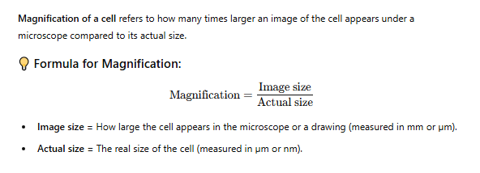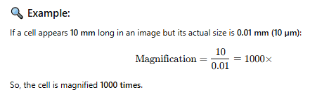

⚠️ Important:
- Always make sure units are the same before dividing.
- Use a scale bar in diagrams when provided.
- Common microscope magnifications are 40x, 100x, 400x, and 1000x.

Differences between a light microscope and an electron microscope:
Feature | Light Microscope | Electron Microscope
Source of illumination | Light (visible light) | Beam of electrons
Magnification power | Up to about 1,500× | Up to about 2,000,000×
Resolution (clarity) | Lower resolution (~200 nm) | Higher resolution (~0.2 nm)
Image produced | In color (can be seen directly) | Black and white (often colored artificially)
Specimen state | Can view living or dead specimens | Only dead specimens (because of vacuum requirement)
Preparation of specimen | Simple and quick | Complex and time-consuming
Cost | Relatively cheap | Very expensive
Size and portability | Small and portable | Large and bulky

- Light microscopes are great for basic biology and school labs — they're affordable and can view live cells.
- Electron microscopes are used in advanced science for detailed views of viruses, cell structures, and nanomaterials.

Cell Structures as Seen under the Light and Electron Microscope
Cell Structure under Light Microscope
The structures within the cell are referred to as organelles. Some of the cell organelles that can be observed under the light microscope include the cell wall, cell membrane, cytoplasm, nucleus, vacuole and chloroplasts.
These cell organelles perform specific functions within the cell.
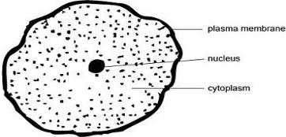

Animal Cell as shown above

Plant cell as shown above
The Cell as Seen under the Electron Microscope
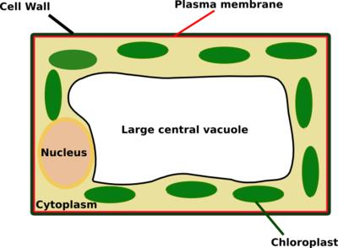

The electron microscope is more powerful than the light microscope. It uses a beam of electrons to illuminate the specimen instead of light as in the case of light microscope.
Electron microscope can magnify an object up to 500,000 times.

It also has a very high resolving power. Resolving power is the ability to distinguish between separate things which are close to each other.
The high resolving power makes the electron microscope a very important research tool in microbiology.

Through the electron microscope, very fine details of the cell can be observed.
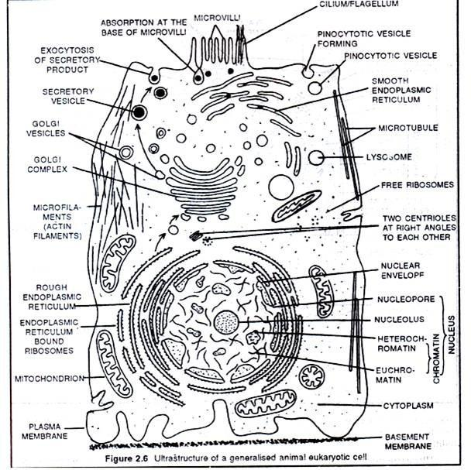

Fig. Animal Cell

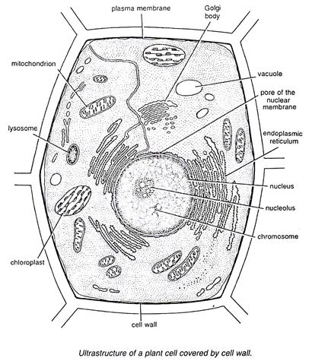

Fig. Plant Cell
Structure and Functions of the Cell Organelles
- Cell membrane

The cell membrane, also known as plasma membrane or plasmalemma consists of three layers when viewed under the electron microscope. The three layers are composed of one layer of phospholipid sandwiched between two protein layers.
It is flexible and has pores. The cell membrane is important in that:

It encloses the cell contents.

It allows for selective movement of materials in and out of the cells. The pores allow materials particularly of small molecular size to move in and out of the cells.

- Cytoplasm

Cytoplasm consists of a fluid medium in which chemical reactions take place. It contains organelles and other inclusions such as starch, glycogen, fat droplets and many other dissolved substances.
Cytoplasm is not static; it undergoes a movement known as cytoplasmic streaming.

It provides a suitable medium for cellular reactions to take place.
- Mitochondrion

Mitochondrion is a sausage shaped organelle that provides sites for respiratory reactions that yield energy for the cell. Mitochondria is thus, referred to as the powerhouse of the cell.
It is bound by two membranes. The inner membrane is greatly folded into cristae to increase surface area for respiration.
The arrangement and number of mitochondria in a cell depends on the cell energy requirements. Cells that require large amounts of energy contain high amount of mitochondria.
Such cells include muscle cell, sperm cell, apical meristem cells, and kidney cell.

Mitochondria are self replicative that is they can divide to form new ones.
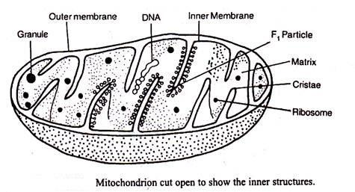

- Endoplasmic Reticulum

Endoplasmic reticulum appears as a series of interconnected channels, running throughout the cytoplasm.
Their membranes are continuous with the outer membrane of the nuclear membrane.

Some endoplasmic reticula have granules called ribosomes on their surfaces and are referred to as rough or granular endoplasmic reticula. Endoplasmic reticula that are not associated with ribosomes are called smooth endoplasmic reticula.
The rough endoplasmic reticulum transports proteins while the smooth endoplasmic reticulum transports lipids.
Generally, endoplasmic reticula also act as storage areas for synthesized molecules such as enzymes.

They also contribute to mechanical support.

- Ribosomes

These are spherical in shape. While some are bound to the endoplasmic reticula, some ribosomes are scattered within the cytoplasm (free ribosomes). Their largest dimension is 25 nanometres.
They are synthesised in the nucleolus.

They form sites for protein synthesis.

- Lysosomes

These are spherical sac-like organelles bound by a single membrane. They contain lytic enzymes which break down large molecules, destroy worn out organelles or even the entire cells.
Lysosomes also play crucial role in digestion in unicellular organisms.

The lysosomes are also vital in breakdown of bacteria and other harmful microbes that might have been ingested in food. This explains their high relative abundance in injured or infected cells.
The membrane of the lysosomes are intact. This is important because if the enzymes leak out, they may destroy the whole cell.

- Golgi bodies/Golgi apparatus

These are stacks of membrane bound tube like sacs. They are found close to the cell membrane.

Golgi bodies perform the following functions:

They package and transport glycoproteins.

They are involved in secretion of synthesized proteins and carbohydrates.

They manufacture lysosomes.

Note: Golgi bodies are abundant in cells that are active in secretion. For instance pancreatic cells which secrete enzymes and the nerve cells which secrete neurotransmitter substances.
- Centrioles

These are rod shaped structures located just outside the nuclear membrane.

They take part in cell division and also in the formation of cilia and flagella in lower organisms.

Plant cells lack centrioles.

- Chloroplasts

Chloroplasts are egg-shaped structures surrounded by two membranes and contain a gel like stroma through which runs a system of membranes that are stacked together to form grana.
The granum contains chlorophyll which traps light energy that is used during photosynthesis.

It is in the chloroplasts that photosynthesis takes place.

- Vacuoles

These are sacs that are filled with fluid called cell sap. Vacuoles vary in size.

Animal cells contain small vacuoles which may be numerous in the cells while plant cells contain one large centrally placed vacuole.
Sap vacuoles store sugars and salts thereby contributing to the osmotic properties of the cell. This influences how materials move in and out of the cell.
In some unicellular organisms, food vacuole stores and digests food substances while the contractile vacuole excretes unwanted materials from the cell.

- Cell wall

This is the rigid outer cover of plant cells and some lower organisms.

In plants it is composed of cellulose fibres.

Cell wall is important in that:

It gives plant cells their definite shape

It provides mechanical support and protection against mechanical injury.

The cell wall allows gases, water and other substances to pass through it.

- Nucleus

Nucleus is a double membrane bound structure made up of a viscous fluid known as nucleoplasm in which nucleolus and chromatin materials are suspended. The nuclear membrane has minute pores, nuclear pores which allow materials to move in and out of the nucleus.
Nucleus controls all the activities of the cell.

Nucleolus is responsible for manufacture of ribosomes while chromatin contains hereditary materials.

Nucleus generally takes a sperical or oval shape.

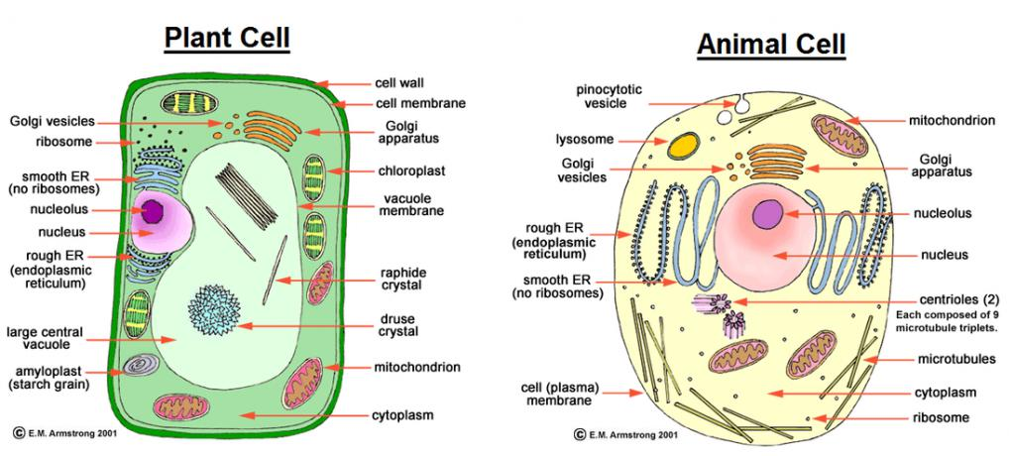
Comparison between Plant Cells and Animal Cells

While there exist many similarities between plant and animal cells, there are a number of differences.

Plant cell

Usually large

Regular in shape

Has a cell wall

Usually has a large central vacuole
Cytoplasm and nucleus are usually located towards the periphery of the cell

Some have chloroplasts

Usually more store oils, starch and proteins.

Has no centriole.
Animal cell
Smaller in size
Irregular in shape
Has no cell wall

Usually has no vacuoles but when present, they are often temporary and small structures within the cytoplasm

Cytoplasm occupies most space in the cell with the nucleus usually centrally placed

Has no chloroplasts
Store glycogen and fats
Has centrioles

Cell Specialization/Cell Differentiation

This refers to the process by which a cell becomes structurally modified to perform specific functions While cells have a basic outline, they become differentiated to perform specific functions.
In particular, the root hair cell has extended surface for absorption while the sperm cell has a tail-like extension for swimming towards the ovum.
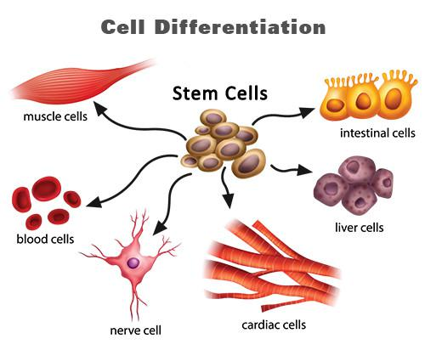

Tissues

A tissue is a group of cells of a particular type that are grouped together to perform the same function.

- Tissue types in animals

  - Epithelial tissue- This is a thin continuous layer of cells for lining and protection of internal and external surfaces.
  - Skeletal muscle - This is a bundle or sheets of elongated cells with fibres that can contract. Its contraction and relaxation brings about movement.

  - Blood tissue - This is a fluid containing red blood cells, white blood cells and platelets. The main functions of blood tissue are transportation of nutrients and gases as well as protection of the body against infections.

  - Connective tissue - This tissue consists of strong fibres that connects other tissues and organs thereby holding them in position.
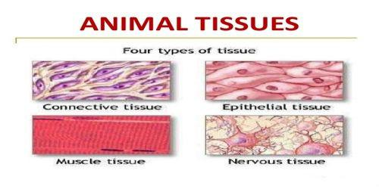

- Tissue types in plants

  - Epidermal tissue- This is a single thin layer of cells covering the outer surfaces. It protects inner tissues of plants from mechanical damage and infection.
- Palisade tissue- This is a group of cells rich in chloroplasts containing chlorophyll. It has a site for the absorption of light energy and manufacture of food by photosynthesis.
- Parenchyma tissue- This tissue consists of special thin walled irregularly shaped cells. They form packaging and storage cells.

- Conducting tissue/Vascular bundle- This tissue consists of xylem and phloem. Xylem conducts water and dissolved mineral salts in a plant while phloem conducts food substances in solution.
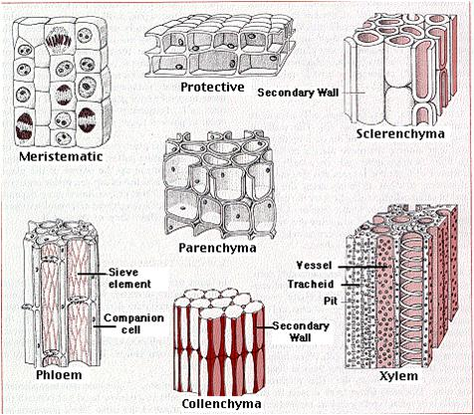

Organs

An organ is a group of specialized tissues that are grouped together to perform a common function.

Organs in animals include:

- Heart- composed of connective, muscle, epithelial and blood tissues.

- Kidney - Composed of connective, epithelial and muscle tissues

- Brain- Composed of epithelial, connective tissues

- Lungs- Composed of epithelial, connective tissues.

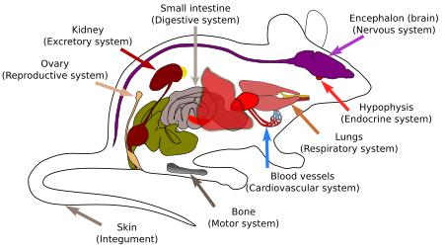

Organs in plants include:

- Roots- composed of epidermal, conducting and parenchyma tissues.

- Flowers- This is composed of epidermal, conducting tissues.

- Stem- Composed of conducting, parenchyma, and epidermal tissues and palisade tissues in some cases

- Leaves- Composed of palisade, conducting and epidermal tissues.

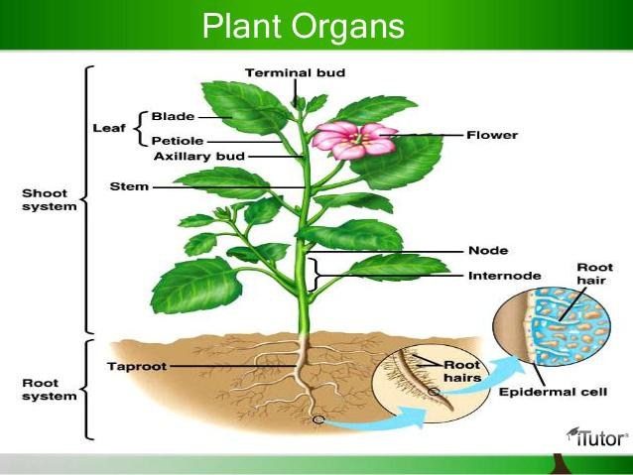

Organ System

This is a group of organs whose functions are coordinated and synchronized to perform the same function.

Organ systems are more pronounced in animals than in plants Organ systems in animals include

- Digestive system composed of organs such as oesophagus, stomach, intestines and their associated glands.

- Circulatory system composed of the heart, blood vessels (arteries, veins, capillaries).

- Excretory this is composed of kidney, liver, and blood vessels.

- Respiratory system composed of trachea, bronchus, and lungs.

- Reproductive system composed of the reproductive organs and associated glands.

- Nervous systems composed of the brain, spinal cord, eye, ear organs.

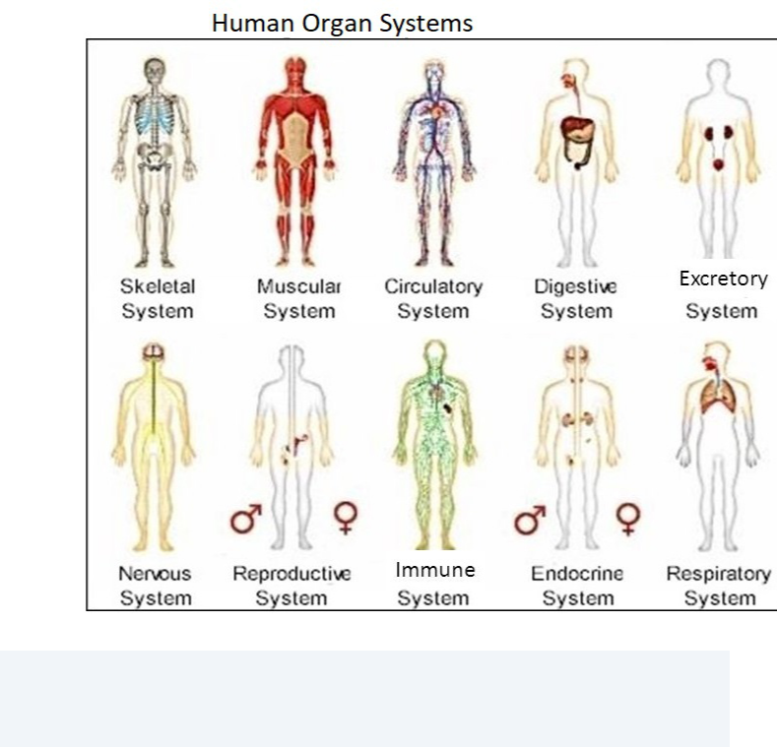

Strand 1.4 chemicals of life

✅ Introduction
- Living organisms are made up of various chemical substances that are essential for life.
- These substances are called the chemicals of life.
- They include:
➤ Carbohydrates
➤ Proteins
➤ Lipids (fats and oils)
➤ Vitamins
➤ Enzymes
➤ Water
➤ Mineral salts

1️⃣ CARBOHYDRATES

✳️ Composition:
- Made up of Carbon (C), Hydrogen (H), and Oxygen (O).

✳️ Types:
- Monosaccharides (simple sugars): e.g. glucose, fructose
- Disaccharides: e.g. sucrose (table sugar)
- Polysaccharides: e.g. starch (plants), glycogen (animals), cellulose (fiber)

✳️ Properties:
- Soluble in water (monosaccharides & disaccharides)
- Sweet tasting (especially simple sugars)
- Polysaccharides are often insoluble

✳️ Functions:
- Provide energy
- Stored as starch (plants) or glycogen (animals)
- Cellulose forms plant cell walls
- Fiber aids in digestion

2️⃣ LIPIDS (FATS AND OILS)

✳️ Composition:
- Made up of Carbon (C), Hydrogen (H), and Oxygen (O)
- Formed from glycerol and fatty acids

✳️ Properties:
- Insoluble in water
- Fats are solid at room temp, oils are liquid
- Store more energy than carbohydrates

✳️ Functions:
- Energy storage
- Insulation (keep body warm)
- Protect internal organs
- Make up cell membranes

3️⃣ PROTEINS

✳️ Composition:
- Made up of Carbon (C), Hydrogen (H), Oxygen (O), Nitrogen (N) (sometimes Sulfur - S)
- Built from amino acids

✳️ Properties:
- May be soluble or insoluble
- Sensitive to heat and pH (can denature)

✳️ Functions:
- Build and repair body tissues
- Form enzymes and hormones
- Used in muscles and skin
- Provide immunity (antibodies)

4️⃣ VITAMINS

✳️ Composition:
- Organic compounds needed in small amounts
- Not all vitamins have the same chemical composition (varies per type)

✳️ Examples and Functions:
Vitamin | Function | Deficiency Disease
C | Wound healing, immunity | Scurvy
A | Good vision, healthy skin | Night blindness
D | Strong bones and teeth | Rickets (in children)
K | Blood clotting | Excessive bleeding

5️⃣ ENZYMES

✳️ Meaning:
- Biological catalysts that speed up chemical reactions in living cells
- Made of proteins

✳️ Properties:
- Speed up reactions without being used up
- Specific to the reactions they catalyze
- Affected by temperature and pH

✳️ Factors affecting enzyme activity:
Factor | Effect
Temperature | Too high = denatures enzymes; too low = slows down reactions
pH | Extreme pH can denature enzymes
Substrate concentration | More substrate = faster reaction (up to a point)
Enzyme concentration | More enzyme = faster reaction (if enough substrate is present)

✳️ Example:
- Catalase is an enzyme found in liver and potato that breaks down hydrogen peroxide (H₂O₂) into water and oxygen

6️⃣ WATER

✳️ Properties:
- Universal solvent
- Neutral pH (7)
- Makes up a large part of the body

✳️ Functions:
- Medium for chemical reactions
- Regulates body temperature
- Helps in transport of nutrients and waste
- Keeps cells hydrated and active

7️⃣ MINERAL SALTS

✳️ Functions of common minerals:
Mineral | Function | Source
Calcium | Strong bones and teeth | Milk, fish, green veg
Iron | Forms haemoglobin in blood | Liver, beans, spinach
Iodine | Helps thyroid function | Iodized salt, seafood
Potassium | Muscle and nerve function | Bananas, potatoes
Sodium | Controls water balance and nerve signals | Salt, processed foods

🧪 EXPERIMENTS TO TEST FOR FOOD SUBSTANCES
Food Component | Test Used | Positive Result
Starch | Iodine solution | Turns blue-black
Reducing sugars | Benedict’s solution + heat | Turns brick-red
Proteins | Biuret solution | Turns purple or violet
Lipids | Grease spot test / Ethanol test | Grease mark / cloudy white layer
Vitamin C | DCPIP test | DCPIP decolorizes (from blue to clear)

🧪 INVESTIGATING ENZYMES (CATALASE)
- Cut a fresh potato or liver
- Add hydrogen peroxide
- Observe bubbling (oxygen gas released)
→ shows presence of catalase enzyme

🔍 DETERMINING FACTORS AFFECTING ENZYME ACTIVITY
Set up experiments changing:
- Temperature (e.g., fridge, room temp, warm water)
- pH (using acidic or basic solutions)
- Amount of enzyme or substrate
Measure how fast bubbles form (for catalase) or color change (for starch breakdown by amylase).

🧃 FOOD LABEL EXAMINATION
- Look at labels of packaged foods.
- Check:
  - Ingredients
  - Nutrient content (carbs, fats, proteins, vitamins)
  - Expiry dates
  - Additives (preservatives, colors)

🤔 KEY QUESTIONS TO THINK ABOUT:
- How are chemicals important in cells?
→ They provide energy, build structures, help in growth, protection, and life processes.
- How is the presence of chemicals of life determined?
→ Through food tests, observations, and enzymatic reactions in experiments.

Summary on
Chemicals of Life
These are chemical compounds that constitute the living organisms.

Biochemistry is the branch of biology that deals with the study of the chemicals of life and their reactions.

Chemicals of life include carbohydrates, proteins and lipids.

Carbohydrates

Are compounds of carbon, hydrogen and oxygen in the ratio of 1:2:1.

They have a general formula (CH₂O)n where n represents the number of carbon atoms.
Carbohydrates are grouped into three categories:

Monosaccharides

These are the simplest carbohydrates.

They include glucose, fructose, galactose.

Their general formula is C₆H₁₂O₆.

Properties of Monosaccharides

They are sweet tasting

They readily dissolve in water

They are crystallisable

They are reducing sugars; monosaccharides reduce blue copper (II) sulphate in Benedict’s solution to red brown copper (I) oxide when heated.

Note:

Most fruits are sweet tasting because they contain a lot of monosaccharides.

Monosaccharide units can be combined to form complex carbohydrate molecules through a process known as condensation. Water molecules are produced in the process.

Functions

They are the chief respiratory substrate. They are broken down to release energy in the body.

They are condensed to form complex important carbohydrates.

Disaccharides

These are complex sugars formed by linking two monosaccharide units through condensation.

They have a general formula C₁₂H₂₂O₁₁. The bond that holds two monosaccharide units is called glycosidic bond.

Examples of disaccharides include:

Maltose-common in germinating seeds

Sucrose-fruits and sugar cane. Sucrose is the form in which carbohydrates are transported in plants Lactose- found in milk

Properties of Disaccharides
They are sweet tasting

They are crystallizable

They are water soluble

While they are non reducing sugars, some such as maltose is sugar reducing and is known as a complex reducing sugar.

They can be broken down into their constituent monosaccharide units through hydrolysis.

Hydrolysis is the process through which complex molecules are broken down in the presence of water molecules.

In living systems, hydrolysis is carried out by enzymes. However, in the laboratory, hydrolysis can be carried out by boiling the disaccharide in dilute acid such as hydrochloric acid.

Functions

They are hydrolyzed into monosaccharides and respired on to yield energy

They are the form in which carbohydrates are transported in plants due to their soluble and inert nature.

Polysaccharides

These are formed through linking of numerous monosacchride units through condensation.

Their general formula is (C₆H₁₀O₅)n where n is a very large number.

Properties of Polysaccharides

They are non sweet

They do not dissolve in water

They are non crystalline

They are non-reducing sugars

Examples of Polysaccharides

Starch- Made by linking numerous glucose molecules. It is a form in which carbohydrates are stored in plants.

Glycogen- Is a storage carbohydrate in liver and muscles of animals. It is broken down to glucose in animals when blood glucose falls.
Cellulose- This is a structural polysaccharide in plants. It is a component of the cell wall Chitin- A structural carbohydrate found in cell wall of fungi and arthropod exoskeletons

Functions of polysaccharides

They are storage carbohydrates; their insolubility and inertness makes them ideal for storing carbohydrates.

They are structural carbohydrates e.g. cellulose forms the plant cell walls

They can be hydrolyzed into monosacharides and be broken down to release energy

Lipids

These are compounds of carbon, hydrogen and oxygen. However, they contain lesser oxygen but higher hydrogen compared to carbohydrates.
Building units for lipids are fatty acids and glycerol. To synthesize a molecule of lipid, three fatty acids and a glycerol molecule are linked through a condensation reaction.
There is one type of glycerol but numerous fatty acids

There are different types of fatty acids. The property of a lipid therefore depends on the type of fatty acids that link up with the glycerol.
There are complex lipids such as phospholipids, steroids, waxes and cholesterol. These also form through condensation.

Properties of Lipids

Fats easily change to oil when heated while oils easily solidify when cooled.

They are insoluble in water but readily dissolve in organic solvents such as chloroform to form emulsions They are inert hence can be stored in tissues of organisms.

Functions

They are a source of energy when oxidized. They yield more energy compared to carbohydrates when oxidized per unit weight. However, they are less preferred as source of energy because they require a lot of oxygen to oxidize. In addition, they are insoluble hence not easy to transport to respiratory sites.
They are a source of metabolic water. When oxidized, they yield a lot of metabolic water. This explains why some desert animals such as camels store large quantities of fat in their bodies.
Lipids offer protection to internal organs as they are deposited around them to act as shock absorbers.

Lipids provide heat insulation when stored underneath the skin as they are poor conductors of heat hence do not conduct heat away from the body. Organisms in cold areas tend to be short and plump as they have fatter fat adipose.
Lipids form structural compounds for instance phospholipids in cell membrane.

Complex lipids such as waxes in leaves help minimize water loss through transpiration.

Some lipids mediate communication between cells

Proteins

These are compounds of carbon, hydrogen and oxygen. In addition, they also contain nitrogen and sometimes phosphorous or sulphur or both.
Some proteins molecules contain other elements. In particular, haemoglobin contains iron.

Proteins are made up of amino acids. There are about twenty known amino acids. Amino acids are of two kinds:

- Essential - These are those amino acids that cannot be synthesized by the body systems hence have to be supplied in the diet.
- Non essential - These are amino acids that can be synthesized by the body mechanisms hence do not need to be supplied in the diet.

An amino acid has an amino group, carboxyl group, hydrogen atom and an alkyl, R group. Amino acids differ from each other by the alkyl group.
Proteins are of two kinds:

- First class proteins - Contain all essential amino acids

- Second class proteins - Proteins lack one or more essential amino acids

Protein synthesis

Two amino acids combine through a condensation process to form a dipeptide molecule. Several amino acids link up to form a polypeptide chain. Proteins are made up of long chain polypeptides.
Properties of a protein depend on the type of amino acids present in its chain and the sequence in which the amino acids link up in the polypeptide chain.

Properties of Proteins

They dissolve in water to form colloidal suspensions in which the particles remain suspended in water.

They are denatured at temperatures beyond 40°C. Strong acids, bases, detergents and organic solvents also denature proteins.
They are amphoteric- possess both acidic and basic properties. This property enables them to combine with other non protein substances to form conjugated proteins such as:
Mucus- Protein plus carbohydrate

Haemoglobin- Protein plus iron

Functions of Proteins

- They are structural compounds of the body. Cell membrane is protein in nature. Hair, nails and hooves are made up of protein keratin.
- Proteins are broken down to release energy during starvation when all carbohydrate and lipid reserves are depleted.

- Functional proteins play vital roles in metabolic regulation. Hormones are chemical messengers while enzymes regulate the speed of metabolic reactions.

- Proteins such as antibodies provide protection to the body against infections

- Some protein molecules are transport molecules. Haemoglobin molecule plays a crucial role in transportation of respiratory gases.

- Proteins play a vital role in blood clotting e.g. fibrinogen.

- Contractile proteins such as actin and myosin bring about movement.

Enzymes

What are enzymes?

Are organic catalysts that are protein in nature and regulate the rate of metabolic reactions.

They speed up or slow down the rate of metabolic reactions but to not get used up in the process.

Types of Enzymes

- Extracellular: Are produced within the cells but used outside the cells e.g. digestive enzymes.

- Intracellular: Are enzymes produced and used within the cells e.g. respiratory enzymes.

Importance of Enzymes

They speed up the rate of chemical reactions that would otherwise be too slow to support life.

Some enzymes take part in synthesis/building of useful complex substances such as DNA.

Digestive enzymes breakdown complex food substances into simple foods that can be utilized by the cells. Some metabolic enzymes such as catalase play a vital role in detoxification (making poisonous substances less harmful.

Enzyme Nomenclature

- Two systems of naming enzymes have been adopted.

1. Trivial naming

This is where an enzyme is named by the scientist who discovered it.

In trivial naming all enzyme names end in prefix –in.

Examples

  - Pepsin (Theodor Schwann, German physiologist -1836).

  - Ptyalin (Anselme Payen, a French chemist- 1833).

  - Trypsin.

- Use of suffix –ase

Enzymes are assigned names by adding suffix –ase to the food substrate acted by the enzyme or by adding the suffix to the reaction being catalyzed by the enzyme.

Substrates

Amylose (starch)…………..amylase.

Lipids……………………....lipase.

Protein……………………. .protease.

Carbohydrate……………….carbohydrase.

Lactose……………………...lactase

Processes/Reactions

Hydrolysis………………….hydrolase

Reduction…………………..reductase

Oxidation…………………...oxidase

Mechanism of Action of Enzymes

- Enzymes are not used up during metabolic reactions. They do have “active sites” through which the substrate molecules bind to the enzymes. The reaction is then catalyzed and the end products released. The enzyme is free to bind with another substrate molecule. The enzymes can be used again and again.
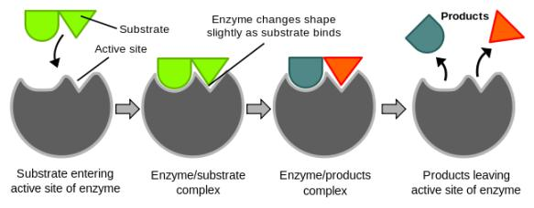

Properties of Enzymes

They are protein in nature; hence affected by temperature and pH.

They are substrate specific e.g. maltase cannot digest sucrose.

They are efficient in small amounts since they are re-used in the reactions.

They mostly take part in reversible reactions.

They regulate the rate of metabolic activities but are not used up.

Factors Affecting Enzyme Activity

Temperature.

pH.

Substrate Concentration.

Enzyme Concentration.

Enzyme co-factors and co-enzymes; Fe, Mg, Zn, Cu ions.

Specificity.

- Enzyme inhibitors.
- Temperature

At low temperatures, kinetic energy of enzymes and molecules are low. There are few collisions leading to low enzyme activity.
As temperature increases, the kinetic energy of the enzyme and substrate molecules increases leading to increased collisions hence increase in enzyme activity.
Enzyme activity is optimum at (35 -40)°C.

Beyond 40 °C the rate of enzyme activity decreases and eventually stops. This is because enzymes get denatured and their active sites get destroyed.

pH

Enzymes work best under different pH conditions.

Some enzymes work best under alkaline conditions e.g amylase. Some also work better under acidic conditions e.g. pepsin. However, most intracellular enzymes work better under neutral conditions. Altering the pH conditions would affect enzyme activity.

Enzyme Specificity

A particular enzyme will only act on a particular substrate or will only catalyze a particular reaction.

For instance, sucrase enzymes can only breakdown sucrose.

Substrate Concentration

Assuming all other factors are constant, with low substrate concentration, the rate of enzyme activity is low.

Increase in substrate concentration increases the rate of enzyme activity since more active sites of the enzymes will be occupied and there will also be an increase in enzymesubstrate collisions leading to increased reaction.
The reaction increases up to a point at which it becomes constant. At this point, all active sites are utilized. The enzymes become the limiting factor of reaction. Increasing enzyme concentration would increase the rate of enzyme activity.

Enzyme Concentration

An increase in enzyme concentration increases the rate of enzyme reaction up to a level beyond which the rate of reaction becomes constant.
At low enzyme concentration, rate of enzyme activity is low because there are fewer sites and also fewer enzyme-substrate collisions that would lead to reactions.
Increasing enzyme concentration increases rate of enzyme activity since there will be an increase in number of active sites and enzyme-substrate collisions.
At optimum enzyme concentration, substrate concentration is the limiting factor. Increasing substrate concentration increases the rate of reaction.

Enzyme Co-factors

These are inorganic substances which activate enzymes.

Without them, most enzymes would not function properly.

Co- factors include mineral ions like iron, magnesium, copper, manganese, zinc as well as vitamins.

They are used again and again since like enzymes, they do not get used up during the reactions.

Co-enzymes

These are organic molecules that are required by some enzymes for their efficient functioning. Some enzymes will not function without them.
Most co-enzymes are derivatives of vitamins.

Examples

NAD- Nicotine Adenine Dinucleotide.

FAD- Flavine Adenine Dinucleotide.

NADP- Nicotine Adenine Dinucleotide Phosphate.

Enzyme Inhibitors

These are chemical substances which slow down or eventually stops enzyme activity.

They are of two types:

- Competitive

- Non- competitive

  - Competitive inhibitors

These are chemical substances which are structural analogs of the substrates i.e. they take up the shape of the substrates and compete for the active sites of the enzymes.
They bind with the enzymes and do not disentangle easily (they stay in the enzyme active site for a long time) thereby slowing down the rate of enzyme activity.
The reaction can be increased by increasing the substrate concentration.

2. Non competitive inhibitors

These are inhibitors that do not resemble the substrate molecules but they combine with the enzyme at any site other the active site and alter the structure of the active site of the enzyme. The normal substrate, therefore, fails to bind to the active site leading to decreased rate of reaction.
Note that these substances do not compete for the active sites of the enzymes.

The enzymes are destroyed permanently hence the effect cannot be reversed.

Examples of non competitive inhibitors : Heavy metals (such as lead, mercury, silver), Cyanide, organophosphates such as malathion.

STRAND 2: ANATOMY AND PHYSIOLOGY IN PLANTS
Heterotrophism

This is a mode of nutrition in which organisms take in already manufactured complex food substances such as carbohydrates, proteins and lipids.
Heterotrophs are organisms that feed on already manufactured food substances.

These substances are broken down in the bodies of the Heterotrophs into simple soluble food substances that can be absorbed and be utilized by the cells.

Modes of Heterotrophism

There are four main heterotrophic modes on nutrition:

- Holozoic - Where organisms ingest, digest and assimilate solid complex food substances.

- Saprophytism – Where organisms feed on dead decaying matter causing decomposition.

- Parasitism - a feeding association in which one organism (parasite) feeds on or obtain nutrients on another organism, the host.

- Symbiosis/Mutualism - An association where two organisms live together and mutually benefit from each other.

Parasitism

There are two main types of parasites:

Endo parasites - Live inside the host Ecto-parasites - Found on the external surface of the host.

The parasite benefits but the host does not. Some of the parasites cause diseases to the hosts and damage their tissues thereby weakening them.

Symbiosis

In symbiotic relationships, both organisms benefit:

Symbiotic r/ships include

Rhizobium and leguminous plants: rhizobium fixes nitrogen for the legume while the bacteria obtains manufactured food from the legumes.
Lichen: association of fungi (absorbing water and nutrients) and algae (manufacturing food for the association.
Catalase digesting bacteria and ruminants.

Modes of Nutrition

There are two main nutrition modes:

- Autotrophism: mode of nutrition through which living organisms manufacture their own food from simple inorganic substances in the environment such as carbon (IV) oxide, water and mineral ions. Organisms that make their own food through this mode are autotrophs.

- Heterotrophism: mode of nutrition in which living organisms depend on already manufactured food materials from other living organisms. Heterotrophs are the organisms that feed on already manufactured food materials.

Autotrophism

In this mode of nutrition, organisms manufacture their own food from readily available materials in the environment. These organisms use energy to combine carbon (IV) oxide, water and mineral salts in complex reactions to manufacture food substances. Depending on the source of energy used to manufacture the food There are two types of autotrophism:

- Chemosynthesis

  - This is the process whereby some organisms utilize energy derived from chemical reactions in their bodies to manufacture food from simple substances in the environment.

  - This nutrition mode is common in non green plants and some bacteria which lack the sun trapping chlorophyll molecule.

- Photosynthesis

  - This is the process by which organisms make their own food from simple substances in the environment such as carbon (IV) oxide and water using sunlight energy.

  - Such organisms often have chlorophyll which traps the required sunlight energy.

  - This mode of nutrition is common in members of the kingdom Plantae. Some protoctists and bacteria are also photosynthetic.

Importance of Photosytnthesis

- Photosynthesis helps in regulation of carbon (IV) oxide and oxygen gases in the environment.

- Photosynthesis enables autotrophs make their own food, thus, meet their nutritional requirements.

- Photosynthesis converts sunlight energy into a form (chemical energy) that can be utilized by other organisms that are unable to manufacture their own food.

Photosynthesis largely occurs in the leaf.

To understand the process of photosynthesis, it is important to understand the leaf structure.

External Leaf Structure

Externally, the leaf has a petiole through which it attaches to the leaf branch or stem, lamina- the broad flat surface, margin- the outline and the leaf apex.
The leaf margin can be smooth, dentate, serrated or entire.

The size of a leaf depends on its environment. Plants in arid areas have small sized leaves with some leaves reduced to needle like shape. This helps reduce the rate of water loss in such plants. However, the plants in areas of water abundance have broad leaves to enable them lose the excess water.

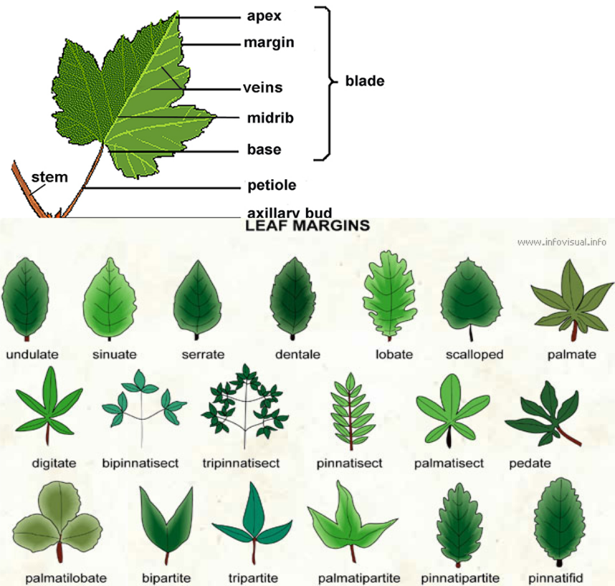
The image below shows types of leaves margins.

Internal Leaf Structure

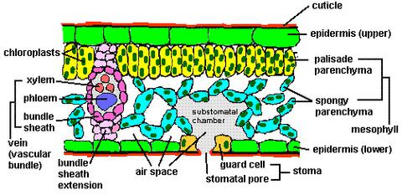

- Cuticle

This is the outermost layer of the leaf.

It is a thin non-cellular, waxy, transparent and waterproof layers that coats the upper and lower leaf surfaces.

Functions of the cuticle

- Being waterproof, it minimizes water loss from the leaf cells to the environment through transpiration and evaporation.
- It protects the inner leaf tissues from mechanical damage.

- It prevents entry of pathogenic microorganisms into the leaf.

2. Epidermis

This is the outermost one cell thick layer covering upper and lower leaf surfaces. Its cells are flattened and lack chloroplasts.

Functions of the epidermis:

It protects the leaf from mechanical damage.

It also protects the leaf from entry of disease-causing microorganisms.

It secretes the cuticle.

There are many small pores on the epidermis known as stomata (singular-stoma) through which exchange of materials occur. The opening and closing of the stomata is controlled by the guard cells. Each stoma is controlled by two guard cells.
The guard cells have chloroplasts and are bean shaped. They have thicker inner cell wall and thinner outer cell wall.

Adaptations of the guard cells

They have differentially thicker walls to enable them bulge as they draw water through osmosis from the neighboring cells making them to open the stomata.
They contain chloroplasts that manufacture sugars which increase osmotic pressure of the guard cells.

As they draw water through osmosis, they bulge making the stomata to open.

3. Palisade mesophyll

This is the chief photosynthetic tissue in plants. Its cells are regular in shape.

Its cells contain numerous chloroplasts for photosynthesis.

Their close packing and location just below the epidermis enables them to trap maximum sunlight for photosynthesis.
Location of palisade layer on the upper surface explains why upper leaf surfaces are greener than the lower surfaces.
4. Spongy mesophyll layer

This layer contains loosely arranged irregular cells. This leaves large airspaces between the cells which permits free circulation of gases carbon (IV) oxide and oxygen into the photosynthetic cells. Spongy mesophyll cells contain fewer chloroplasts compared to palisade cells.
5. Vascular bundle/tissue

This is found in the midrib and leaf veins. Vascular bundle is made of phloem and xylem tissues. Xylem tissues conduct water and some dissolved mineral salts from the roots to other plant parts while phloem translocates manufactured food materials from photosynthetic areas to other plant parts.
6. Chloroplast

This is the organelle in which photosynthesis takes place. It is an oval shaped double membrane bound organelle.
Internally, it is made up of membranes called lamellae suspended in a fluid filled matrix called stroma.

Lamellae forms stacks at intervals called grana (singular-granum). Chlorophyll molecules are contained in the grana.
Within the stroma, fat droplets, lipid droplets and starch grains are found.

The stroma contains enzymes and forms the site where light independent reactions take place.

Adaptations of the Leaf to Photosynthesis

The leaf has a flat and broad lamina to increase surface area for trapping sunlight energy and for gaseous exchange.
The leaf has numerous stomata through which photosynthetic gases diffuse.

The leaf is thin to reduce the distance through which carbon (IV) oxide has to diffuse to the photosynthetic cells.
The palisade mesophyll cells contain numerous chloroplasts which contain chlorophyll molecules which trap sunlight energy for photosynthesis.
The photosynthetic mesophyll is located towards the upper surface for maximum absorption of sunlight energy.
The leaf has an extensive network of veins composed of xylem which conducts water to the photosynthetic cells and phloem to translocate manufactured food materials to other plant parts.
The epidermis and cuticle are transparent to allow light to penetrate to the photosynthetic cells.

Raw Materials for Photosynthesis

Water

Carbon (IV) oxide

Conditions for Photosynthesis

Light energy

Chlorophyll

Photosynthesis Process

Photosynthesis is a complex process that involves a series of reactions. It can be summarized into two main reactions.

- Light reaction/Light stage

This is the first stage of photosynthesis. It occurs in the presence of light. Without light it cannot take place.
Light stage occurs in the grana of the chloroplasts.

During light stage, two fundamental processes occur:

i. Photolysis of water

This refers to the splitting of water molecules using sunlight energy to give hydrogen ions and oxygen gas.
This is aided by the fact that the grana contain chlorophyll molecules that trap sunlight energy for photolysis.
The oxygen gas produced can either be released into the atmosphere or be utilized by the plant for respiration.
Water → Hydrogen atoms + Oxygen gas

ii. Formation of adenosine triphosphate (ATP)

Some of the sun light energy is used to combine Adenosine Diphospate molecule in the plant tissues with a phosphate molecule to form Adenosine Triphosphate (ATP). ATP is an energy rich molecule that stores energy for use in the dark stage when sunlight energy could be unavailable.
ADP+P→ATP

The hydrogen ions and ATP formed during light stage are later used in dark stage.

Dark reaction/Dark stage

These reactions are light independent. The energy that propels these reactions are derived from the ATP formed during light stage.
Also known as carbon (IV) oxide fixation, dark stage involves combination of carbon (IV) oxide molecule with hydrogen ions to form a simple carbohydrate and a water molecule.
Dark reactions take place in the stroma.

CO₂ + 4H⁺ → (CH₂O)n + H2O
Other food materials are then synthesized from the simple sugars through complex synthesis reactions.
The simple sugar formed in dark stage is quickly converted to starch which is osmotically inactive. When a lot of simple sugars accumulate in the chloroplasts, osmotic pressure of the guard cells would increase causing the guard cells to draw a lot of water through osmosis. This makes the guard cells to bulge and open the stomata. This can result into excessive water loss. To prevent, this, the simple sugars are quickly converted to starch. To test whether photosynthesis has taken place in a leaf, therefore, a test for presence of starch and not simple sugars is carried out.

Testing for Starch in a Leaf

Requirements

Iodine solution

Methylated spirit/alcohol

Boiling tube

Droppers

Water

White tile

Fresh leaf

Means of heating

Timer
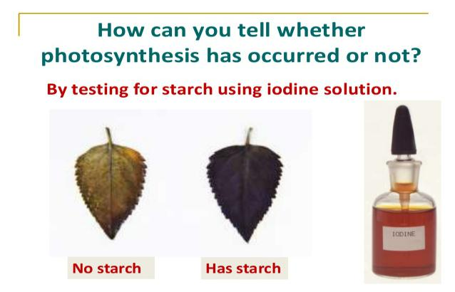

Procedure

Detach a leaf that has been exposed to light for about six hours. This duration ensures that the leaf has photosynthesized.
Put the leaf in boiling water for 10 minutes. This kills the protoplasm, denatures the enzymes and stops any chemical reactions in the leaf.
Remove the leaf and put it in a boiling tube containing methylated spirit or alcohol and boil in a water bath. Methylated spirit is highly flammable hence should be boiled indirectly. Boiling with methylated spirit or alcohol decolourises the leaf (removes the chlorophyll). This ensures that the leaf becomes white so that colour changes can be observed easily when iodine is added.
Remove the leaf and wash off in hot water to remove methylated spirit and to soften the leaf.

Spread the leaf on a white tile and add drops of iodine solution onto the leaf and observe.

Observations

If there is formation of blue black patches on the leaf then starch is present

If the yellow/brown colour of iodine persists on the leaf then starch is absent in the leaf.

Factors Affecting the Rate of Photosynthesis

- Carbon (IV) oxide concentration

While the concentration of carbon (IV) oxide in the atmosphere is fairly constant at 0.03%, an increase in carbon (IV) oxide concentration translates into an increase in the rate of photosynthesis upto a certain point when the rate of photosynthesis becomes constant.
At this point, other factors such as light intensity, water and temperature become limiting factors. 2. Light intensity

The rate at of photosynthesis increases with an increase in light intensity up to a certain level. Beyond the optimum light intensity the rate of photosynthesis becomes constant. To this effect, plants photosynthesize faster on bright and sunny days than on dull cloudy days.

Light quality/wavelength also affects the rate of photosynthesis. Most plants require red and blue wavelengths of light for photosynthesis.
Light duration also affects photosynthesis rate.

3. Temperature

Photosynthesis is an enzyme controlled process.

At very low temperatures the rate of photosynthesis is slow because the enzymes are inactive.

As temperature increases, the rate of photosynthesis increases because the enzymes become more active. Rate of photosynthesis is optimum at (35-40) °C.
Beyond 40°C the rate of photosynthesis decreases and eventually stops since the enzymes become denatured.
4. Water

Water is a raw material for photosynthesis. At extreme level of water shortage, rate of photosynthesis will be severely affected.

Experiment to Investigate the Gas Produced During Photosynthesis

Requirements

Water plant e.g. elodea, spirogyra, Nymphea (water lily), glass funnels, beakers, small wooden blocks, test tubes, wooden splints and sodium hydrogen carbonate.

Procedure

1. Set up the apparatus as shown in the figure below
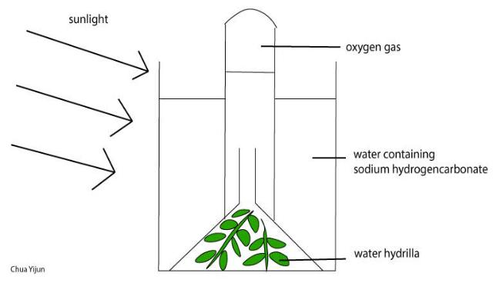

- Place the set up in the sunlight to allow photosynthesis to take place.

- Leave the set up in the sun until sufficient gas has collected in the test tube.

- Test the gas collected with a glowing splint.

- Record your observations.

Note:

In this experiment, sodium hydrogen carbonate is added to the water to boost the amount of carbon (IV) oxide in the water since water has a low concentration of carbon (IV) oxide.
A water plant is also selected because water plants are adapted to photosynthesis under the low light intensity in water where terrestrial plants cannot easily photosynthesize.
This experiment can also be used to investigate the factors affecting the rate of photosynthesis:

Carbon (IV) oxide concentration

Carry out the experiment using different amounts of dissolved sodium hydrogen carbonate e.g 5g, 10g, 15g, 20g and examine the rate at which the gas collects.
Light intensity:

An artificial light source can be used. Illuminate the plant and vary the distance between the set up and the light source while recording the time it takes for the gas jar to fill or counting the number of bubbles per unit time.
Temperature:

carry out the experiment at varying temperatures and record the rate at which the gas collects.

Experiments on Factors Necessary for Photosynthesis

Light

Requirements

Methylated spirit, iodine solution, water, white tile, droppers, beaker, source of heat, boiling tube, light proof material e.g. aluminium foil, potted plant and clips.

Procedure

Cover two or more leaves of a potted plant with a light proof material.

Place the plant in a dark place for 48 hours (keeping the plant in the dark for 48 hours is to ensure that all the starch in it is used up. This makes the leaves ideal for investigating whether starch would form in the experimental period. This is called destarching).
Transfer the potted plant to light for 5 hours.

Detach and uncover the leaves and immediately test for starch in one of the covered leaves and one that was not covered.

Carbon (IV) oxide

Requirement

Sodium hydroxide pellets, flask, jelly

Procedure

Destarch the plant for 48 hours

Place a few pellets of sodium hydroxide in the flask

Bore a hole in the cork of the same size as the petiole of the leaf being used

Cut the cork lengthwise.

Chlorophyll

For this experiment, a variegated leaf is required. This is a leaf in which some patches lack chlorophyll.

These patches could be yellow. They lack chlorophyll hence photosynthesis does not take place in them.

Procedure

Detarch or remove variegated leaf that has been exposed to light for at least three hours.

Draw a large diagram of the leaf to show the distribution of the chlorophyll Test the leaf for starch and record observations.

TRANSPORT IN PLANTS
Introduction

Transport is the movement of substances within an organism.

All living cells require oxygen and food for various metabolic processes.

These substances must be transported to the cells.

Metabolic processes in the cells produce excretory products which should be eliminated before they accumulate.
The excretory products should be transported to sites of excretion.

Organisms like amoeba are unicellular.

They have a large surface area to volume ratio.

The body is in contact with the environment.

Diffusion is adequate to transport substances across the cell membrane and within the organism.

Large multi-cellular organisms have complex structure where cells are far from each other hence diffusion alone cannot meet the demand for supply and removal of substances.
Therefore an elaborate transport system is necessary.

Transport in Plants

Simple plants such as mosses and liverworts lack specialized transport system.

Higher plants have specialized transport systems known as the vascular bundle.

Xylem transports water and mineral salts.

Phloem transports dissolved food substances like sugars.

Internal Structure of Roots and Root Hairs
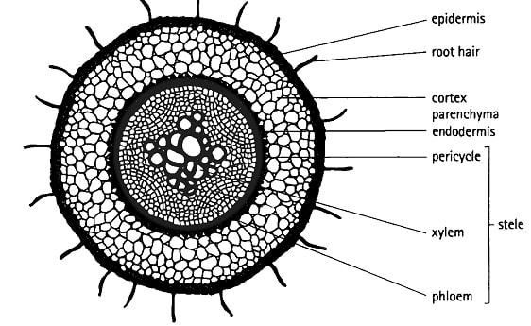

The main functions of roots are ;

Anchorage

absorption.

storage

gaseous exchange.

The outermost layer in a root is the piliferous layer.

This is a special epidermis of young roots whose cells give rise to root hairs.

Root hairs are microscopic outgrowths of epidermal cells.

They are found just behind the root tip,

They are one cell thick for efficient absorption of substances.

They are numerous and elongated providing a large surface area for absorption of water and mineral salts.

Root hairs penetrate the soil and make close contact with it.

Below the piliferous layer is the cortex.

This is made up of loosely packed, thin walled parenchyma cells.

Water molecules pass through this tissue to reach the vascuiar bundles.

In some young plant stems, cortex cells contain chloroplasts.

The endodermis (starch sheath) is a single layer of cells with starch grains.

The endodermis has a casparian strip which has an impervious deposit controlling the entry of water and mineral salts into xylem vessels.
Pericyc1e forms a layer next to the endodermis.

Next to the pericycle is the vascular tissue.

In the Dicotyledonous root, xylem forms a star shape in the centre, with phloem in between the arms.

It has no pith. In monocotyledonous root, xylem alternates with phloem and there is a pith in the centre.

Internal Structure of a Root Hair Cell

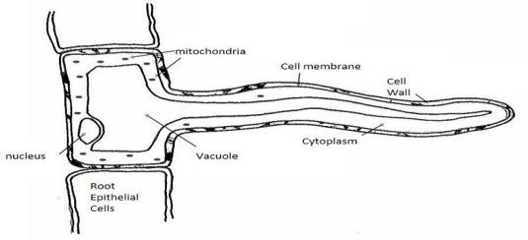

The Stem
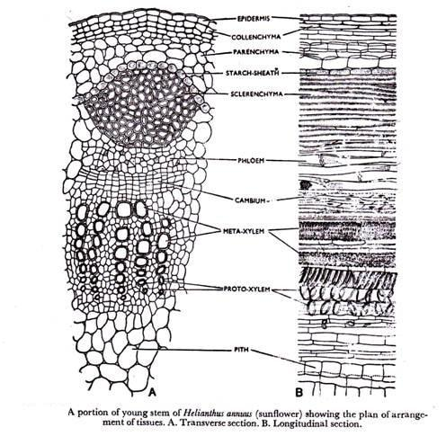

The main functions of the stem are;

support and exposure of leaves and flowers to the environment,

conducting water and mineral salts

conducting manufactured food from leaves to other parts of the plant.

In monocotyledonous stems, vascular bundles are scattered all over the stem, while in dicotyledonous stems vascular bundles are arranged in a ring.
Vascular bundles are continuous from root to stems and leaves.

The epidermis forms a single layer of cells enclosing other tissues.

The outer walls of the cells have waxy cuticle to prevent excessive loss of water.

The cortex is a layer next to the epidermis.

It has collenchyma, parenchyma and schlerenchyma cells.

Collenchyma

Is next to the epidermis and has thickened walls at the corners which strengthen the stem.

Parenchyma

Cells are irregular in shape, thin walled and loosely arranged hence creating intercellular spaces filled with air.
They are packing tissues and food storage areas.

Sclerenchyma

Cells are closely connected to vascular bundles.

These cells are thickened by deposition of lignin and they provide support to plants.

Pith

Is the central region having parenchyma cells.

Absorption of Water and Mineral Salts

Absorption of Water

Root hair cell has solutes in the vacuole and hence a higher osmotic pressure than the surrounding soil water solution.
Water moves into the root hair cells by osmosis along a concentration gradient.

This makes the sap in the root hair cell to have a lower osmotic pressure than the surrounding cells.

Therefore water moves from root hair cells into the surrounding cortex cells by osmosis.

The process continues until the water gets into the xylem vessels.

Uptake of Mineral Salts

If the concentration of mineral salts in solution is greater than its concentration in root hair cell, the mineral salts enter the root hair cell by diffusion.
If the concentration of mineral salts in the root hair cells is greater than in the soil water, the mineral salts enter the root hairs by active transport.
Most minerals are absorbed in this way.

Mineral salts move from cell to cell by active transport until they reach the xylem vessel.

Once inside the xylem vessels, mineral salts are transported in solution as the water moves up due to root pressure, capillary attraction and cohesion and adhesion forces.

Transpiration

Transpiration is the process by which plants lose water in the form of water vapour into the atmosphere.

Water is lost through stomata, cuticle and lenticels.

Stomatal Transpiration:
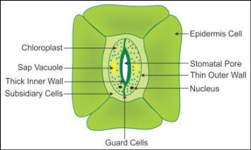

This accounts for 80-90% of the total transpiration in plants.

Stomata are found on the leaves.

Cuticular Transpiration:

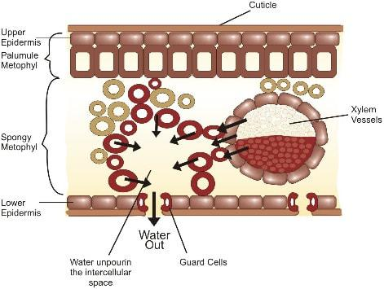

The cuticle is found on the leaves, and a little water is lost through it.

Plants with thick cuticles do not lose water through the cuticle.

Lenticular Transpiration
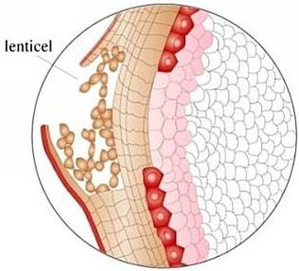

Is loss' of water through lenticels.

These are found on stems of woody plants.

Water lost through the stomata and cuticle by evaporation leads to evaporation of water from surfaces of mesophyll cells .
The mesophyll cells draw water from the xylem vessels by osmosis.

The xylem in the leaf is continuous with xylem in the stem and root.

Structure and Function of Xylem

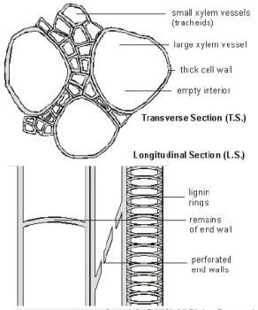

Movement of water is through the xylem.

Xylem tissue is made up of vessels and tracheids.

Xylem Vessels

Xylem vessels are formed from cells that are elongated along the vertical axis and arranged end to end.

During development, the cross walls and organelles disappear and a continuous tube is formed.

The cells are dead and their walls are strengthened by deposition of lignin.

The lignin has been deposited in various ways.

This results in different types of thickening

Annular.

Simple spiral.

Double spiral.

Reticulate.
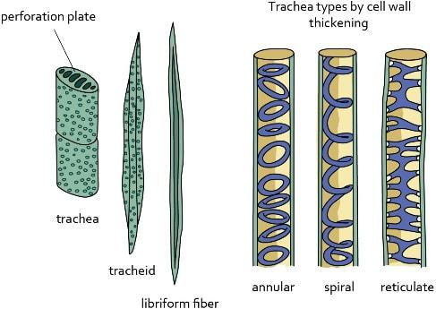

The bordered pits are areas without lignin on xylem vessels and allow passage of water in and out of the lumen to neighbouring cells.

Tracheids

Tracheids have cross-walls that are perforated.

Their walls are deposited with lignin.

Unlike the xylem vessels, their end walls are tapering or chisel-shaped.

Their lumen is narrower.

Besides transport of water, xylem has another function of strengthening the plant which is provided by xylem fibres and xylem parenchyma.

Xylem Fibres ;

Are cells that are strengthened with lignin.

They form wood.

Xylem Parenchyma:

These are cells found between vessels.

They form the packing tissue.

Forces Involved in Transportation of Water and Mineral Salts

Transpiration Pull

As water vaporises from spongy mesophyll cells into sub-stomatal air spaces, the cell sap of mesophyll cells develop a higher osmotic pressure than adjacent cells.
Water is then drawn into mesophyll cells by osmosis from adjacent cells and finally from xylem vessels.

A force is created in the leaves which pulls water from xylem vessels in the stem and root.

This force is called transpiration pull.

Cohesion and Adhesion:

The attraction between water molecules is called cohesion.

The attraction between water molecules and the walls of xylem vessels is called adhesion.

The forces of cohesion and adhesion maintain a continuous flow of water in the xylem from the root to the leaves.

Capillarity:

Is the ability of water to rise in fine capillary tubes due to surface tension.

Xylem vessels are narrow, so water moves through them by capillarity.

Root Pressure:

If the stem of a plant is cut above the ground level, it is observed that cell sap continues to come out of the cut surface.
This shows that there is a force in the roots that pushes water up to the stem.

This force is known as root pressure.

Importance of Transpiration

Transpiration leads to excessive loss of water if unchecked.

Some beneficial effects are:

Replacement of water lost during the process.

Movement of water up the plant is by continuous absorption of water from the soil.

Mineral salts are transported up the plant.

Transpiration ensures cooling of the plant in hot weather.

Excessive loss of water leads to wilting' and eventually death if water is not available in the soil.

Factors Affecting Transpiration

The factors that affect transpiration are grouped into two. i.e. environmental and structural.

Environmental Factors

Temperature

High temperature increases the internal temperature of the leaf which in turn increases kinetic energy of water molecules which increases evaporation.
High temperatures dry the air around the leaf surface maintaining a high concentration gradient.

More water vapour is therefore lost from the leaf to the air.

Humidity

The higher the humidity of the air around the leaf, the lower the rate of transpiration.

The humidity difference between the inside of the leaf and the outside is called the saturation deficit.

In dry atmosphere, the saturation deficit is high.

At such times, transpiration rate is high.

Wind

Wind carries away water vapour as fast as it diffuses out of the leaves.

This prevents the air around the leaves from becoming saturated with vapour.

On a windy day, the rate of transpiration is high.

Light Intensity

When light intensity is high; more stomata open hence high rate of transpiration.

Atmospheric Pressure

The lower the atmospheric pressure the higher the kinetic energy of water molecules hence more evaporation.
Most of the plants at higher altitudes where atmospheric pressure is very low have adaptations to prevent excessive water-loss.

Availability of Water

The more water there is in the soil, the more is absorbed by the plant and hence a lot of water is lost by transpiration.

Structural Factors

Cuticle

Plants growing in arid or semi-arid areas have leaves covered with a thick waxy cuticle.

Stomata

The more the stomata, the higher the rate of transpiration.

Xerophytes have few stomata which reduce water-loss.

Some have sunken stomata which reduces the rate of transpiration as the water vapour accumulates in the pits.
Others have stomata on the lower leaf surface hence reducing the rate of water-loss.

Some plants have reversed stomatal rhythm whereby stomata close during the day and open at night.

This helps to reduce water-loss.

Leaf Size and Shape

Plants in wet areas have large surface area for transpiration.

Xerophytes have small narrow leaves to reduce water-loss.

The photometer can be used to determine transpiration in different environmental conditions.

Translocation of Organic Compounds

Translocation of soluble organic products of photosynthesis within a plant is called translocation.

It occurs in phloem in sieve tubes.

Substances translocated include glucose, amino acids, vitamins.

These are translocated to the growing regions like stem, root apex, storage organs e.g. corms, bulbs and secretory organs such as nectar glands.

Phloem

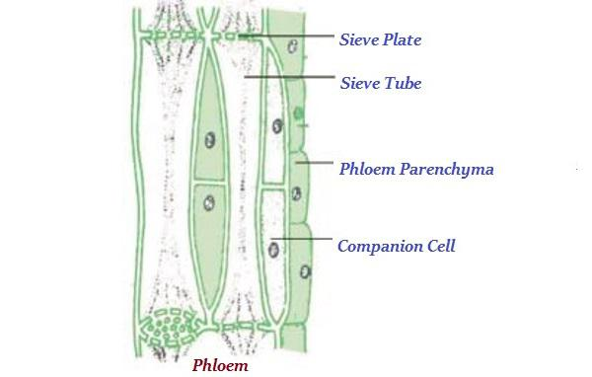

phloem is made up of;

sieve tubes,

companion cells

parenchyma, a packing tissue

schlerenchyma, a strengthening tissue

Sieve Tubes

These are elongated cells arranged end to end along the vertical axis.

The cross walls are perforated by many pores to make a sieve plate.

Most organelles disappear and those that remain are pushed to the sides of the sieve tube.

Cytoplasmic strands pass through the pores in the plate into adjacent cells.

Food substances are translocated through cytoplasmic strands.

Companion Cells

Companion cells are small cells with large nuclei and many mitochondria.

They are found alongside each sieve element.

The companion cell is connected to the tube through plasmodesmata.

The mitochondria generate energy required for translocation.

Phloem Parenchyma

These are parenchyma cells between sieve elements.

They act as packing tissue.
Necessity for Gaseous Exchange in Living Organisms

Living organisms require energy to perform cellular activities.

The energy comes from breakdown of food in respiration.

Carbon (IV) oxide is a by product of respiration and its accumulation in cells is harmful which has to be removed.
Most organisms use oxygen for respiration which is obtained from the environment.

Photosynthetic cells of green plants use carbon (Iv) oxide as a raw material for photosynthesis and produce oxygen as a byproduct.
The movement of these gases between the cells of organisms and the environment comprises gaseous exchange.
The process of moving oxygen into the body and carbon (Iv) oxide out of the body is called breathing or ventilation.
Gaseous exchange involves the passage of oxygen and carbon (IV) oxide through a respiratory surface.

Diffusion is the main process involved in gaseous exchange.

Gaseous Exchange in Plants

Oxygen is required by plants for the production of energy for cellular activities.

Carbon (IV) oxide is required as a raw material for the synthesis of complex organic substances.

Oxygen and carbon (IV) oxide are obtained from the atmosphere in the case of terrestrial plants and from the surrounding water in the case of aquatic plants.
Gaseous exchange takes place mainly through the stomata.

Structure of Guard Cells

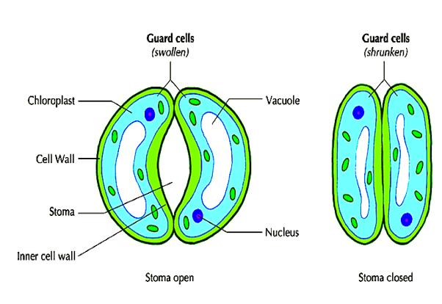

The stoma (stomata - plural) is surrounded by a pair of guard cells.

The structure of the guard cells is such that changes in turgor inside the cell cause changes in their shape.

They are joined at the ends and the cell walls facing the pore (inner walls) are thicker and less elastic than the cell walls farther from the pore (outer wall).
Guard cells control the opening and closing of stomata

Proposed Causes of Turgor Changes in Guard Cells.

Accumulation of sugar

Guard cells have chloroplasts while other epidermal cells do not.

Photosynthesis takes place during daytime and sugar produced raises the solute concentration of guard cells.

Water is drawn into guard cells by osmosis from surrounding cells. Guard cells become turgid and stoma opens.
At night no photosynthesis occurs hence no sugar is produced The solute concentration of guard cells falls and water moves out of the guard cells by osmosis.
Guard cells lose turgidity and the stoma closes

Alkaline pH favours conversion of starch to sugar.

Solute concentration increases inside guard cells, water is drawn into the cells by osmosis. Guard cells become turgid and the stoma opens.
At night when no photosynthesis, Respiration produces carbon (IV) oxide which raises acidity

This favours conversion of sugar to starch. low sugar concentration lead to loss of turgidity in guard cells and stoma closes.

Explanation is based on accumulation of potassium ions

In day time (light) adenosine triphosphate (ATP) is produced which causes potassium ions to move into guard cells by active transport.
These ions cause an increase in solute concentration in guard cells that has been shown to cause movement of water into guard cells by osmosis.
Guard cells become turgid and the stoma opens.

At night potassium and chloride ions move out of the guard cells by diffusion and level of organic acid also decreases.
This causes a drop in solute concentration that leads to movement of water out of guard cells by osmosis.

Guard cells lose turgor and the stoma closes.

Mechanism of Opening and Closing of Stomata

In general stomata open during daytime (in light) and close during the night (darkness).

Stomata open when osmotic pressure in guard cells becomes higher than that in surrounding cells due to increase in solute concentration inside guard cells.
Water is then drawn into guard cells by osmosis.

Guard cells become turgid and extend The thinner outer walls extend more than the thicker walls This causes a bulge and stoma opens.
Stomata close when the solute concentration inside guard cells become lower than that of surrounding epidermal cells.
The water moves out by osmosis, and the guard cells shrink i.e. lose their turgidity and stoma closes.

Process of Gaseous Exchange in Root, Stem and Leaves of Aquatic and Terrestrial Plants

Gaseous Exchange in leaves of Terrestrial Plants
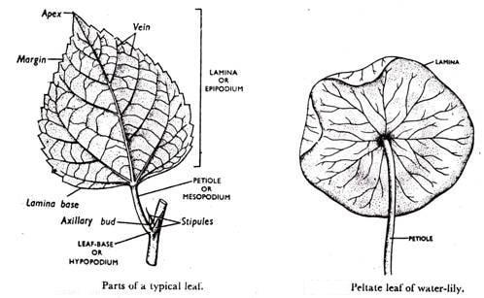

Gaseous exchange takes place by diffusion.

The structure of the leaf is adapted for gaseous exchange by having intercellular spaces that are filled.

These are many and large in the spongy mesophyll.

When stomata are open,carbon(IV)oxide from the atmosphere diffuses into the substomatal air chambers.

From here, it moves into the intercellular space in the spongy mesophyll layer.

The CO₂ goes into solution when it comes into contact with the cell surface and diffuses into the cytoplasm.
A concentration gradient is maintained between the cytoplasm of the cells and the intercellular spaces.
CO₂ therefore continues to diffuse into the cells.

The oxygen produced during photosynthesis moves out of the cells and into the intercellular spaces

From here it moves to the substomatal air chambers and eventually diffuses out of the leaf through the stomata.
At night oxygen enters the cells while CO₂ moves out.

Gaseous exchange in the leaves of aquatic(floating)plants

Aquatic plants such as water lily have stomata only on the upper leaf surface.

The intercellular spaces in the leaf mesophyll are large.

Gaseous exchange occurs by diffusion just as in terrestrial plants.

Observation of internal structure of leaves of aquatic plants

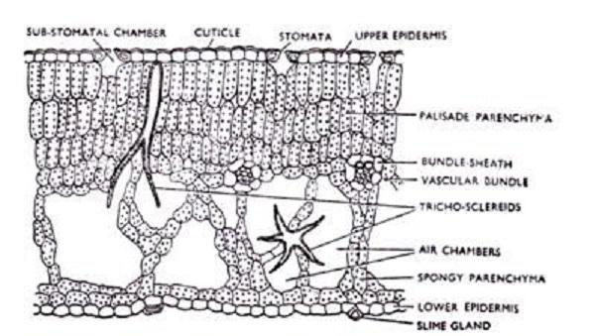

Transverse section of leaves of an aquatic plant such as Nymphaea differs from that of terrestrial plant.

The following are some of the features that can be observed in the leaf of an aquatic plant;

Absence of cuticle

Palisade mesophyll cells are very close to each other ie.compact.

Air spaces (aerenchyma) in spongy mesophyll are very large

Sclereids (stone cells) are scattered in leaf surface and project into air spaces.

They strengthen the leaf making it firm and assist it to float.

Gaseous Exchange Through Stems

Terrestrial Plants

Stems of woody plants have narrow openings or slits at intervals called lenticels.

They are surrounded by loosely arranged cells where the bark is broken.

They have many large air intercellular spaces through which gaseous exchange occurs.

Oxygen enters the cells by diffusion while carbon (IV) oxide leaves. Unlike the rest of the bark, lenticels are permeable to gases and water

Aquatic Plant Stems

The water lily, Salvia and Wolfia whose stems remain in water are permeable to air and water.

Oxygen dissolved in the water diffuses through the stem into the cells and carbon(IV) oxide diffuses out into the water.

Gaseous Exchange in Roots

Terrestrial Plants

Gaseous exchange occurs in the root hair of young terrestrial plants.

Oxygen in the air spaces in the soil dissolves in the film of moisture surrounding soil particles and diffuses into the root hair along a concentration gradient.
It diffuses from root hair cells into the cortex where it is used for respiration.

Carbon (IV) oxide diffuses in the opposite direction.

In older roots of woody plants, gaseous exchange takes place through lenticels.

Aquatic Plants

Roots of aquatic plants e.g. water lily are permeable to water and gases.

Oxygen from the water diffuses into roots along a concentration gradient.

Carbon (IV) oxide diffuses out of the roots and into the water.

The roots have many small lateral branches to increase the surface area for gaseous exchange.

They have air spaces that help the plants to float.

Mangroove plants grow in permanently waterlogged soils, muddy beaches and at estuaries.

They have roots that project above the ground level.

These are known as breathing roots or pneumatophores.

These have pores through which gaseous exchange takes place e.g. in Avicenia the tips of the roots have pores.
Others have respiratory roots with large air spaces.

STRAND 3: ANATOMY & PHYSIOLOGY OF ANIMALS

🦟 A. MOUTHPARTS OF INSECTS
Insects have different mouthparts adapted to their modes of feeding:
Insect | Type of Mouthpart | Feeding Mode | Adaptation (Structure)
Locust/Grasshopper | Biting and chewing | Feeds on leaves | Strong jaws (mandibles) for cutting and grinding food
Cockroach | Biting and chewing | Omnivorous | Similar to locusts
Mosquito | Piercing and sucking | Sucks blood | Sharp, needle-like proboscis
Butterfly/Moth | Siphoning | Feeds on nectar | Long, coiled proboscis for sucking nectar
Tsetse Fly | Cutting and sucking | Feeds on blood | Sharp mouthparts to pierce skin and suck blood
Housefly | Sponging | Feeds on liquids | Sponge-like mouthpart for soaking liquids

🔍 How to Study:
- Collect and observe real specimens like grasshoppers.
- Watch animations/videos to understand how each mouthpart works.
- Draw diagrams of different insect mouthparts and label them.

🐦 B. BEAKS OF BIRDS
Birds have different beak shapes adapted to their feeding habits:
Bird Type | Feeding Mode | Beak Adaptation | BEAK STRUCTURE
Seed/Grain eaters | Crack hard seeds | Short, thick, conical beak (e.g., finch)
Nectar feeders | Suck nectar | Long, slender, curved beak (e.g., sunbird)
Fish eaters | Catch fish | Long, pointed beak (e.g., kingfisher)
Flesh eaters | Tear meat | Strong, hooked beak (e.g., eagle, hawk)
Filter feeders | Filter small organisms | Flat, broad beak (e.g., duck, flamingo)
Insect eaters | Pick small insects | Sharp, thin beak (e.g., swallow)
Fruit eaters | Eat soft fruits | Wide, curved beak (e.g., toucan)
Wood chippers | Bore into wood | Chisel-like beak (e.g., woodpecker)
Multipurpose feeders | Omnivorous diet | Medium beak (e.g., crow, chicken)

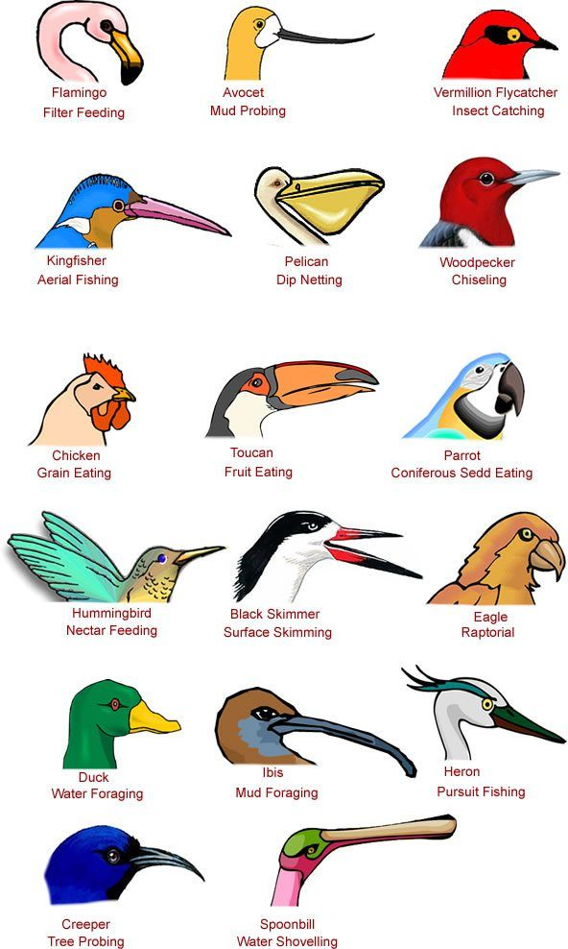

🐤 Observation Activity:
- Go for a nature walk and observe bird feeding.
- Note the type of beak and what the bird is eating.
- Write a short report: name of bird, type of beak, feeding behavior.

✏️ PRACTICAL ACTIVITIES:
- 🔬 Observe mouthparts of real insects (locust, cockroach, mosquito).
- 🎥 Watch educational videos or animations showing insect feeding.
- 🖍️ Draw and label diagrams of insect mouthparts and bird beaks.
- 👣 Go on a bird-watching walk and record observations.
Transport in Animals
The Circulatory System

Large and complex animals have circulatory systems that consist of tubes, a transport fluid and a means of pumping the fluid.
Blood is the transport fluid which contains dissolved substances and cells.

The tubes are blood vessels through which dissolved substances are circulated around the body.

The heart is the pumping organ which keeps the blood in circulation.

The types of circulatory system exist in animals: open and closed.

In an open circulatory system;

The heart pumps blood into vessels which open into body spaces known as haemocoel.

Blood comes into contact with tissues.

A closed circulatory system;

Found in vertebrates and annelids where the blood is confined within blood vessels and does not come into direct contact with tissues.

Transport in Insects
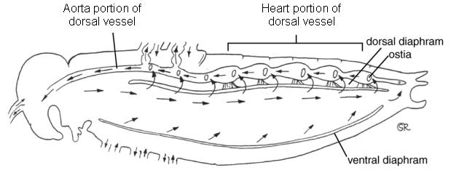

In an insect, there is a tubular heart just above the alimentary canal.

This heart is suspended in a pericardial cavity by ligaments.

The heart has five chambers and extends along the thorax and abdomen.

Blood is pumped forwards into the aorta by waves of contractions in the heart.

It enters the haemocoel and flows towards the posterior.

The blood flows back into the heart through openings in each chamber called ostia.

The ostia have valves which prevent the backflow of blood.

Blood is not used as a medium for transport of oxygen in insects.

This is because oxygen is supplied directly to the tissues by the tracheal system.

The main functions of blood in an insect are to transport nutrients, excretory products and hormones.

Mammalian Circulatory System

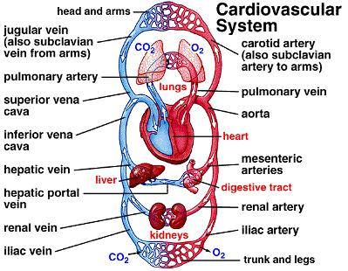

Mammals have a closed circulatory system where a powerful heart pumps blood into arteries.

The arteries divide into smaller vessels called arterioles.

Each arteriole divides to form a network of capillaries inside the tissues.

The capillaries eventually re-unite to form venules, which form larger vessels called veins.

The veins take the blood back to the heart.

Blood from the heart goes through the pulmonary artery to the lungs and then back to the heart through pulmonary vein.
This circulation is called pulmonary circulation.

Oxygenated blood leaves the heart through the aorta and goes to all the tissues of the body.

From the tissues, deoxygenated blood flows back to the heart through the vena cava.

This circulation is called systemic circulation.

In each complete circulation, the blood flows into the heart twice.

This is called double circulation.

Some other animals like fish have a single circulation.

Blood flows only once through the heart for every complete circuit.

Structure and Function of the Heart

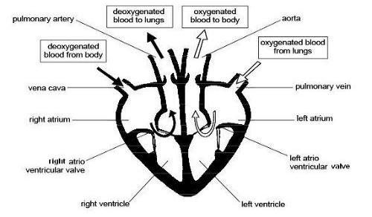

The heart has four chambers:

Two artria (auricles) and two ventricles.

The left and right side of the heart are separated by a muscle wall (septum) so that oxygenated and deoxygenated blood does not mix.
Deoxygenated blood from the rest of the body enters the heart through the vena cava.

Blood enters the right atrium, then through tricuspid valve into right ventricle.

Then via semi-lunar valve to the pulmonary artery to the lungs.

Oxygenated blood from the lungs enters the heart through pulmonary vein.

It enters the left atrium of the heart, then through bicuspid valve into left ventricle.

Then via semi-lunar valves to aorta which takes oxygenated blood round the body.

A branch of the aorta called coronary artery supplies blood to the heart muscle.

The coronary vein carries blood from the heart muscle to the pulmonary artery which then takes it to the lungs for oxygenation.

Pumping Mechanism of the Heart

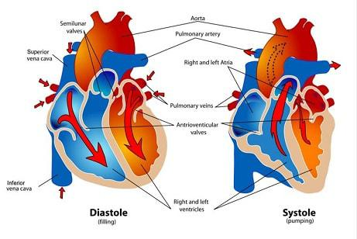
The heart undergoes contraction (systole) and relaxation (diastole).

Systole

When the ventricular muscles contract, the cuspid valves (tricuspid and bicuspid) close preventing backflow of blood into auricles.
The volume of the ventricles decreases while pressure increases.

This forces blood out of the heart to the lungs through semi-lunar valves and pulmonary artery, and to the body tissues via semi-lunar valve and aorta respectively.
At the same time the atria are filled with blood.

The left ventricle has thicker muscles than the right ventricle, and pumps blood for a longer distance to the tissues.

Diastole

When ventricular muscles relax, the volume of each ventricle increases while pressure decreases.

Contractions of atria force the bicuspid and tricuspid valves to open allowing deoxygenated blood from right atrium into right ventricle which oxygenated blood flows from left atrium into the left ventricle.
Semi-lunar valves close preventing the backflow of blood into ventricles.

The slight contractions of atria force the , blood flow into ventricles.

The Heartbeat

The heart is capable of contracting and relaxing rhythmically without fatigue due to its special muscles called cardiac muscles.
The rhythmic contraction of the heart arise from within the heart muscles without nervous stimulation.

The contraction is said to be myogenic.

The heartbeat is initiated by the pacemaker or sino-artrio-node (SAN) which is located in the right atrium.

The wave of excitation spreads over the walls of atria.

It is picked by the artrio-ventricular node which is located at the junction of the atria and ventricles, from where the purkinje tissue spreads the wave to the walls of the ventricles.
The heart contracts and relaxes rhythmically at an average rate of 72 times per minute.

The rate of the heartbeat is increased by the sympathetic nerve, while it is slowed down by the vagus nerve.

Heartbeat is also affected by hormones e.g. adrenaline raises the heartbeat.

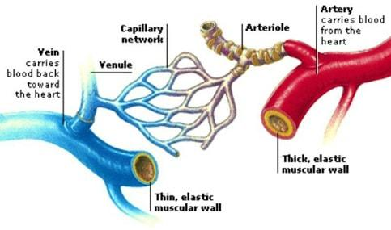
Structure and Function of Arteries, Capillaries and Veins

Arteries

Arteries carry blood away from the heart.

They carry oxygenated blood except pulmonary artery which carries deoxygenated blood to the lungs.

Arteries have a thick, muscular wall, which has elastic and collagen fibres that resist the pressure of the blood flowing in them.
The high pressure is due to the pumping action of the heart.

The pressure in the arteries originate from the pumping action of the heart.

The pulse or number of times the heart beats per minute can be detected by applying pressure on an artery next to the bone. e.g. by placing the finger/thumb on the wrist.
The innermost layer of the artery is called endothelium which is smooth.

It offers least possible resistance to blood flow.

Have a narrow lumen.

The aorta forms branches which supply blood to all parts of the body.

These arteries divide into arterioles which further divide to form capillaries.

Capillaries

Capillaries are small vessels whose walls are made of endothelium which is one cell thick.

This provides a short distance for exchange of substances.

Capillaries penetrate tissues,

The lumen is narrow therefore blood flowing in capillaries is under high pressure.

Pressure forces water and dissolved substances out of the blood to form tissue fluid.

Exchange of substances occurs between cells and tissue fluid.

Part of the tissue fluid pass back into capillaries at the venule end.

Excess fluid drains into small channels called lymph capillaries which empty their contents into lymphatic vessels.
Capillaries join to form larger vessels called venules which in turn join to form veins which transport blood back to the heart.

Veins

Veins carry deoxygenated blood from the tissues to the heart (except pulmonary vein which carries oxygenated blood from the lungs to the heart).
Veins have a wider lumen than arteries.

Their walls are thinner than those of arteries.

Blood pressure in the veins is low.

Forward flow of blood in veins is assisted by contraction of skeletal muscles, hence the need for exercise.

Veins have valves along their length to prevent backflow of blood.

This ensures that blood flows towards the heart.

The way the valves work can be demonstrated on the arm.

By pressing on one vein with two fingers, leaving one and pushing blood toward the heart then releasing the latter finger, it can be observed that the part in between is left with the vein not visible.

This is because blood does not flow back towards the first finger.

Diseases and Defects of Circulatory System

Thrombosis
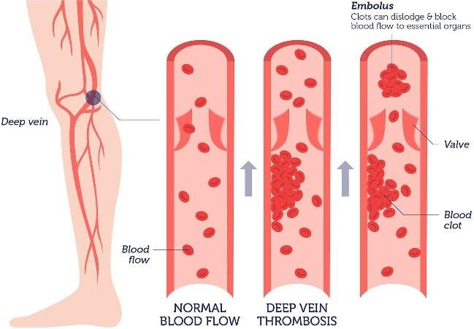

Formation of a clot in the blood vessels is called thrombosis.

Coronary thrombosis is the most common.

It is caused by blockage of coronary artery which supplies blood to the heart.

Blockage may be due to artery becoming fibrous or accumulation of fatty material on the artery walls.

Narrow coronary artery results in less blood reaching the heart muscles.

A serious blockage can result in heart attack which can be fatal.

Heavy intake of fat, alcohol, being overweight and emotional stress can cause coronary thrombosis.

A blockage in the brain can lead to a stroke causing paralysis of part of the body, coma or even death.

A healthy lifestyle, avoiding a lot of fat in meals and avoiding alcohol can control the disease.

Arteriosclerosis
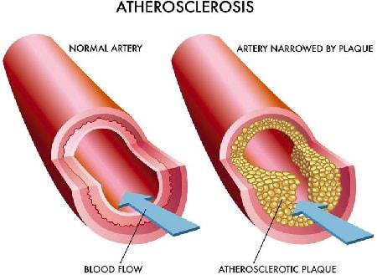

This condition results from the inner walls having materials being deposited there or growth of fibrous connective tissue.
This leads to thickening of the wall of the artery and loss of elasticity.

Normal blood flow is hindered.

Arteriosclerosis can lead to thrombosis or hypertension.

A person with hypertension which is also called high blood pressure has his/her blood being pumped more forcefully through the narrow vessels.
This puts stress on the walls of the heart and arteries.

Regular exercise, healthy diet and avoiding smoking can help maintain normal blood pressure.

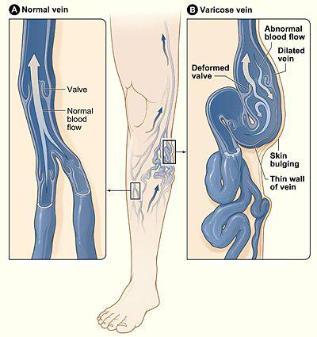
Varicose Veins

Superficial veins especially at the back of the legs become swollen and flabby due to some valves failing to function properly.
This results to retention of tissue fluid.

Regular physical exercise will prevent this condition.

Repair of valves through surgery can also be done.

Wearing surgical stockings may ease a mild occurence.

Structure and Function of Blood

Composition of Blood

The mammalian blood is made up of a fluid medium called plasma with substances dissolved in it.

Cellular components suspended in plasma include;

erythrocytes (red blood cells),

leucocytes (white blood cells)

thrombocytes (platelets)

blood proteins.

Plasma

This is a pale yellow fluid consisting of 90% water.

There are dissolved substances which include;

glucose, amino acids, lipids, salts,

hormones, urea, fibrinogen, albumen,

antibodies, some enzymes suspended cells.

Serum is blood from which fibrinogen and cells have been removed.

The functions of plasma include:

Transport of red blood cells which carry oxygen.

Transport dissolved food substances round the body.

Transport metabolic wastes like nitrogenous wastes and carbon (IV) oxide in solution about 85% of the carbon (IV) oxide is carried in form of hydrogen carbonates.
Transport hormones from sites of production to target organs.

Regulation of pH of body fluids.

Distributes heat round the body hence regulate body temperature.

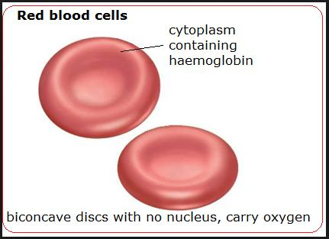
Erythrocytes (Red Blood Cells)

In humans these cells are circular biconcave discs without nuclei.

Absence of nucleus leaves room for more haemoglobin to be packed in the cell to enable it to carry more oxygen.
Haemoglobin contained in red blood cells is responsible for the transport of oxygen.

Haemoglobin + Oxygen =oxyhaemoglobin

(Hb) + (4O₂) __ (HbO_{g})
Oxygen is carried in form of oxyhaemoglobin.

Haemoglobin readily picks up oxygen in the lungs where concentration of oxygen is high.

In the tissues, the oxyhaemoglobin breaks down (dissociates) easily into haemoglobin and oxygen.

Oxygen diffuses out of the red blood cells into the tissues.

Haemoglobin is then free to pick up more oxygen molecules.

The biconcave shape increases their surface area over which gaseous exchange takes place.

Due to their ability, they are able to change their shape to enable themselves squeeze inside the narrow capillaries.
CO₂+ H₂O carbonic anhydrase

There are about five million red blood cells per cubic millimetre of blood.

They are made in the bone marrow of the short bones like sternum, ribs and vertebrae.

In the embryo they are made in the liver and spleen.

Erythrocytes have a life span of about three to four months after which they are destroyed in the liver and spleen.
Also in the red blood cells is carbonic anhydrase which assists in the transport of carbon (IV) oxide.

Leucocytes (White Blood Cells)

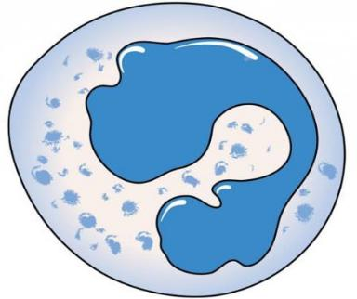

These white blood cells have a nucleus.

They are divided into two:

Granulocytes (also phagocytes or polymorphs)

Agranulocytes

White blood cells defend the body against disease.

Neutrophils form 70% of the granulocytes.

Others are eosinophils and basophils.

About 24% agronulocytes are called lymphocytes, while 4% agranulocytes are monocytes.

The leucocytes are capable of amoebic movement.

They squeeze between the cells of the capillary wall to enter the intercellular spaces.

They engulf and digest disease causing organisms (pathogens) by phagocytosis.

Some white blood cells may die in the process of phagocytosis.

The dead phagocytes, dead organisms and damaged tissues form pus.

Lymphocytes produce antibodies which inactivate antigens.

Antibodies include:

Antitoxins which neutralise toxins.

Agglutinins cause bacteria to clump together and they die.

Lysins digest cell membranes of microorganisms.

Opsonins adhere to outer walls of microorganisms making it easier for phagocytes to ingest them.

Lymphocytes' are made in the thymus gland and lymph nodes.

There are about 7,000 leucocytes per cubic millimetre of blood.

Platelets (Thrombocytes)
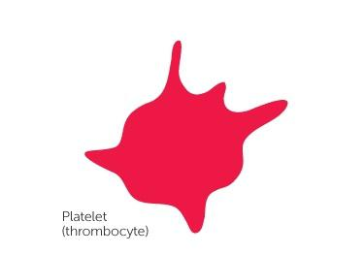

Platelets are small irregularly shaped cells formed from large bone marrow cells called megakaryocytes.

There are about 250,000 platelets per cubic millimetre of blood.

They initiate the process of blood clotting.

The process of clotting involves a series of complex reactions whereby fibrinogen is converted into a fibrin clot.
When blood vessels are injured platelets are exposed to air and they release thromboplastin (thrombokinase) which initiates the blood clotting process.
Thromboplastin neutralises heparin the anti-clotting factor in blood and activates prothrombin to thrombin.

The process requires calcium ions and vitamin K.

Thrombin activates the conversion of fibrinogen to fibrin which forms a meshwork of fibres on the cut surface to trap red blood cells to form a clot.
The clot forms a scab that stops bleeding and protects the damaged tissues from entry of micro-organisms.

Blood clotting reduces loss of blood when blood vessels are injured.

Excessive loss of blood leads to anaemia and dehydration.

Mineral salts lost in blood leads to osmotic imbalance in the body.

This can be corrected through blood transfusion and intravenous fluid.

ABO Blood Groups

There are four types of blood groups in human beings: A, B, AB and O.

These are based on types of proteins on the cell membrane of red blood cells.

There are two types of proteins denoted by the letters A and B which are antigens.

In the plasma are antibodies specific to these antigens denoted as a and b.

A person of blood group A has A antigens on the red blood cells and b antibodies in plasma.

A person of blood group B has B antigens on red blood cells and a antibodies in plasma.

A person of blood group AB has A and B antigens on red blood cells and no antibodies in plasma .

A person of blood group a has no antigens on red blood cells and a and b antibodies in plasma.

Blood groups


Blood
_{Groups} Antigen Antibodies

A |  | A |  | b
B |  | B |  | a
AB |  | A and B |  | None
O |  | None |  | a and b

Blood Transfusion

Blood transfusion is the transfer of blood from a donor to the circulatory system of the recipient.

A recipient will receive blood from a donor if the recipient has no corresponding antibodies to the donor's antigens.

If the donor's blood and the recipient's blood are not compatible, agglutination occurs whereby red blood cells clump together.

Blood Typing

A person of blood group 0 can donate blood to a person of any other blood group.

A person of blood group 0 is called a universal donor.

A person of blood group AB can receive blood from any other group.

A person with blood group AB is called a universal recipient.

A person of blood group A can only donate blood to another person with blood group A or a person with blood group AB.
A person of blood group B can only donate blood to somebody with blood group B or a person with blood group AB.
A person with blood group AB can only donate blood to a person with blood group AB.

Blood screening has become a very important step in controlling HIV/AIDS.

It is therefore important to properly screen blood before any transfusion is done.

Rhesus Factor

The Rhesus factor is present in individuals with the Rhesus antigen in their red blood cells.

Such individuals are said to be Rhesus positive (Rh+), while those without the antigen are Rhesus negative (Rh-).
If blood from an Rh+ individual is introduced into a person who is Rh- , the latter develops antibodies against the Rhesus factor.
There may not be any reaction after this transfusion.

However a subsequent transfusion with Rh+ blood causes a severe reaction, and agglutination occurs i.e.

clumping of red blood cells.

The clump can block the flow of blood, and cause death.

Erythroblastosis foetalis (haemolytic disease of the newborn) results when an Rh- mother carries an Rh+ foetus.
This arises when the father is Rh+.

During the latter stage of pregnancy, fragments of Rhesus positive red blood cells of the foetus may enter mother's circulation.
These cause the mother to produce Rhesus antibodies which can pass across the placenta to the foetus and destroy foetal red blood cells.
During the first pregnancy, enough antibodies are not formed to affect the foetus.

Subsequent pregnancies result in rapid production of Rhesus antibodies by the mother.

These destroy the red blood cells of the foetus, the condition called haemolytic disease of the newborn.

The baby is born anaemic and with yellow eyes (jaundiced).

The condition can be corrected by a complete replacement of baby's blood with safe healthy blood.

Lymphatic System

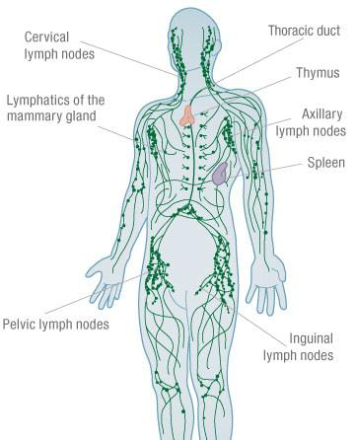

The lymphatic system consists of lymph vessels.

Lymph vessels have valves to ensure unidirectional movement of lymph.

Lymph is excess tissue fluid i.e. blood minus blood cells and plasma proteins.

Flow of lymph is assisted by breathing and muscular contractions.

Swellings called lymph glands occur at certain points along the lymph vessels.

Lymph glands are oval bodies consisting of connective tissues and lymph spaces.

The lymph spaces contain lymphocytes which are phagocytic.

Lymph has the same composition as blood except that it does not contain red blood cells and plasma proteins.
Lymph is excess tissue fluid.

Excess tissue fluid is drained into lymph vessels by hydrostatic pressure.

The lymph vessels unite to form major lymphatic system.

The main lymph vessels empty the contents into sub-clavian veins which take it to the heart.

Immune Responses

Immune response is the production of antibodies in response to antigens.

An antigen is any foreign material or organism that is introduced into the body and causes the production of antibodies.
Antigens are protein in nature.

An antibody is a protein whose structure is complementary to the antigen.

This means that a specific antibody deals with a specific antigen to make it harmless.

When harmful organisms or proteins invade the body, lymphocytes produce complementary antibodies, while bone marrow and thymus gland produce more phagocytes and lymphocytes respectively.

Types of Immunity

There are two types of immunity; natural and artificial.

Natural Immunity is also called innate immunity. It is inherited from parent to offspring.

Artificial Immunity can be natural or induced.

- attacked by diseases like chicken pox, measles and mumps, those who recover from these diseases develop resistance to any subsequent infections of the same diseases. This is natural acquired immunity.

Artificial Acquired Immunity:

When attenuated (weakened) or dead microorganisms are introduced into a healthy person.

The lymphocytes synthesis the antibodies which are released into the lymph and eventually reach the blood.

The antibodies destroy the invading organisms.

The body retains 'memory' of the structure of antigen.

Rapid response is ensured in subsequent infections.

Vaccines generally contain attenuated disease causing organisms.

Artificial Passive Acquired Immunity:

Serum containing antibodies is obtained from another organism, and confers immunity for a short duration.

Such immunity is said to be passive because the body is not activated to produce the antibodies.

Importance of Vaccination

A vaccine is made of attenuated, dead or nonvirulent micro-organism that stimulate cells in the immune system to recognise and attack disease causing agent through production of antibodies.
Vaccination protects individuals from infections of many diseases like smallpox, tuberculosis and poliomyelitis.
Diseases like smallpox, tuberculosis and tetanus were killer diseases but this is no longer the case.

Diphtheria Pertussis Tetanus (DPT) vaccine protects children against diphtheria, whooping cough and tetanus.
Bacille Calmette Guerin (BCG) vaccine is injected at birth to children to protect them against tuberculosis.

Measles used to be a killer disease but today, a vaccine injected into children at the age of nine months prevents it.
At birth children are given an inoculation through the mouth of the poliomyelitis vaccine.

Allergic Reactions

An allergy is a hypersensitive reaction to an antigen by the body.

The antibody reacts with the antigen violently.

People with allergies are oversensitive to foreign materials like dust, pollen grains, some foods, some drugs and some air pollutants.
Allergic reactions lead to production of histamine by the body.

Histamine causes swelling and pain.

Allergic reactions can be controlled by avoiding the allergen and administration of anti-histamine drugs.
Gaseous Exchange in Animals

All animals take in oxygen for oxidation of organic compounds to provide energy for cellular activities.

The carbon (IV) oxide produced as a by-product is harmful to cells and has to be constantly removed from the body.
Most animals have structures that are adapted for taking in oxygen and for removal of carbon (IV) oxide from the body.
These are called "respiratory organs".

The process of taking in oxygen into the body and carbon (IV) oxide out of the body is called breathing or ventilation.
Gaseous exchange involves passage of oxygen and carbon (IV) oxide through a respiratory surface by diffusion.

Types and Characteristics of Respiratory Surfaces

Different animals have different respiratory surfaces.

The type depends mainly on the habitat of the animal, size, shape and whether body form is complex or simple.

Cell Membrane

In unicellular organisms the cell membrane serves as a respiratory surface.

Gills

Some aquatic animals have gills which may be external as in the tadpole or internal as in bony fish e.g.

tilapia.

They are adapted for gaseous exchange in water.

Skin

Animals such as earthworm and tapeworm use the skin or body surface for gaseous exchange.

The skin of the frog is adapted for gaseous exchange both in water and on land.

The frog also uses epithelium lining of the mouth or buccal cavity for gaseous exchange.

Lungs

Mammals, birds and reptiles have lungs which are adapted for gaseous exchange.

Characteristics of Respiratory Surfaces

They are permeable to allow entry of gases.

They have a large surface area in order to increase diffusion.

They are usually thin in order to reduce the distance of diffusion.

They are moist to allow gases to dissolve.

They are well-supplied with blood to transport gases and maintain a concentration gradient.

Gaseous Exchange in Amoeba
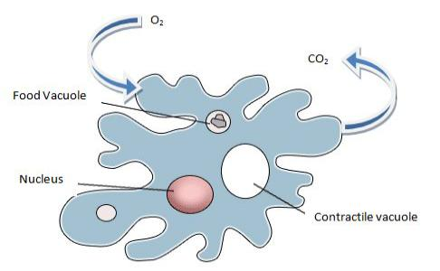

Gaseous exchange occurs across the cell membrane by diffusion.

Oxygen diffuses in and carbon (IV) oxide diffuses out.

Oxygen is used in the cell for respiration making its concentration lower than that in the surrounding water.

Hence oxygen continually enters the cell along a concentration gradient.

Carbon (IV) oxide concentration inside the cell is higher than that in the surrounding water thus it continually diffuses out of the cell along a concentration gradient.

Gaseous Exchange in Insects

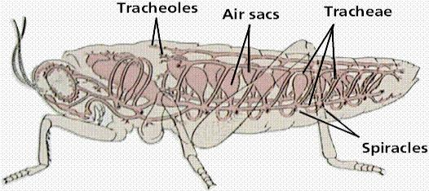

Gaseous exchange in insects e.g., grasshopper takes place across a system of tubes penetrating into the body known as the tracheal system.
The main trachea communicate with atmosphere through tiny pores called spiracles.

Spiracles are located at the sides of body segments;

Two pairs on the thoracic segments and eight pairs on the sides of abdominal segments.

Each spiracle lies in a cavity from which the trachea arises.

Spiracles are guarded with valves that close and thus prevent excessive loss of water vapour.

A filtering apparatus i.e. hairs also traps dust and parasites which would clog the trachea if they gained entry.
The valves are operated by action of paired muscles

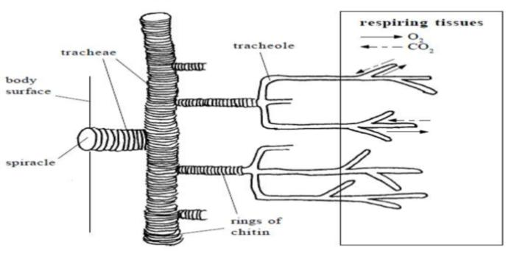
Mechanism of Gaseous Exchange in Insects

The main tracheae in the locust are located laterally along the length of the body on each side and they are interconnected across.
Each main trachea divides to form smaller tracheae, each of which branches into tiny tubes called tracheoles.

Each tracheole branches further to form a network that penetrates the tissues. Some tracheoles penetrate into cells in active tissue such as flight muscles.
These are referred to as intracellular tracheoles.

Tracheoles in between the cells are known as intercellular tracheoles The main tracheae are strengthened with rings of cuticle.
This helps them to remain open during expiration when air pressure is low.

Adaptation of Insect Tracheoles for Gaseous Exchange

The fine tracheoles are very thin about one micron in diameter in order to permeate tissue.

They are made up of a single epithelial layer and have no spiral thickening to allow diffusion of gases.

Terminal ends of the fine tracheoles are filled with a fluid in which gases dissolve to allow diffusion of oxygen into the cells.
Amount of fluid at the ends of fine tracheoles varies according to activity i.e. oxygen demand of the insect.

During flight, some of the fluid is withdrawn from the tracheoles such that oxygen reaches muscle cells faster and the rate of respiration is increased.
In some insects, tracheoles widen at certain places to form air sacs.

These are inflated or deflated to facilitate gaseous exchange as need arises.

Atmospheric air that dissolves in the fluid at the end of tracheoles has more oxygen than the surrounding cells of tracheole epithelium'.
Oxygen diffuses into these cells along a concentration gradient. '

Carbon (IV) oxide concentration inside the cells is higher than in the atmospheric .

Air and diffuses out of the cells along a concentration gradient.

It is then removed with expired air.

Ventilation in Insects

Ventilation in insects is brought about by the contraction and relaxation of the abdominal muscles.

Air enters and leaves the tracheae as abdominal muscles contract and relax.

The muscles contract laterally so the abdomen becomes wider and when they relax it becomes narrow.

Relaxation of muscles results in low pressure hence inspiration occurs while contraction of muscles results in higher air pressure and expiration occurs.
In locusts, air enters through spiracles in the thorax during inspiration and leaves through the abdominal spiracles during expiration.
This results in efficient ventilation.

Maximum extraction of oxygen from the air occurs sometimes when all spiracles close and hence contraction of abdominal muscles results in air circulating within the tracheoles.
The valves in the spiracles regulate the opening and closing of spiracles.

Observation of Spiracle in Locust

Some fresh grass is placed in a gas jar.

A locust is introduced into the jar.

A wire mesh is placed on top or muslin cloth tied around the mouth of the beaker with rubber band.

The insect is left to settle.

Students can approach and observe in silence the spiracles and the abdominal movements during breathing.

Alternatively the locust is held by the legs and observation of spiracles is made by the aid of hand lens. In locusts, air is drawn into the body through the thoracic spiracles and expelled through the abdominal spiracles.

Gaseous Exchange in Bony Fish (e.g, Tilapia)

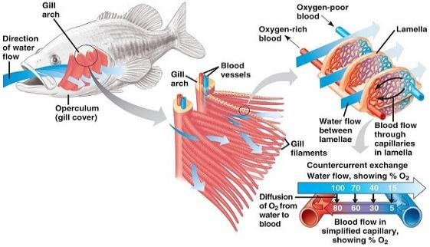

Gaseous exchange in fish takes place between the gills and the surrounding water.

The gills are located in an opercular cavity covered by a flap of skin called theoperculum.

Each gill consists of a number of thin leaf-like lamellae projecting from a skeletal base branchial arch (gill bar) situated in the wall of the pharynx.
There are four gills within the opercular cavity on each side of the head.

Each gill is made up of a bony gill arch which has a concave surface facing the mouth cavity (anterior) and a convex posterior surface.
Gill rakers are bony projections on the concave side that trap food and other solid particles which are swallowed instead of going over and damaging the gill ftlaments.
Two rows of gill filaments subtend from the convex surface.

Adaptation of Gills for Gaseous Exchange

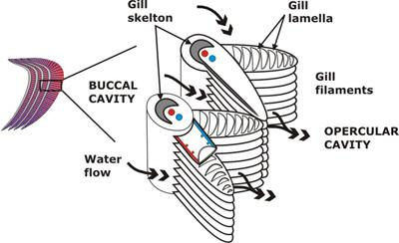

Gill filaments are thin walled.

Gill filaments are very many (about seventy pairs on each gill), to increase surface area.

Each gill filament has very many gill lamellae that further increase surface area.

The gill filaments are served by a dense network of blood vessels that ensure efficient transport of gases.

It also ensures that a favourable diffusion gradient is maintained.

The direction of flow of blood in the gill lamellae is in the opposite direction to that of the water (counter current flow) to ensure maximum diffusion of gases.

Ventilation

As the fish opens the mouth, the floor of the mouth is lowered.

This increases the volume of the buccal cavity.

Pressure inside the mouth is lowered causing water to be drawn into the buccal cavity.

Meanwhile, the operculum is closed, preventing water from entering or leaving through the opening.

As the mouth closes and the floor of the mouth is raised, the volume of buccal cavity decreases while pressure in the opercular cavity increases due to contraction of opercular muscles.
The operculum is forced to open and water escapes.

As water passes over the gills, oxygen is absorbed and carbon dioxide from the gills dissolves in the water.

As the water flows over the gill filaments oxygen in the water is at a higher concentration than that in the blood flowing, in the gill.
Oxygen diffuses through the thin walls of gill filaments/lamellae into the blood.

Carbon (IV) oxide is at a higher concentration in the blood than in the water.

It diffuses out of blood through walls of gill filaments into the water.

Counter Current Flow

In the bony fish direction of flow of water over the gills is opposite that of blood flow through the gill filaments .
This adaptation ensures that maximum amount of oxygen diffuses from the water into the blood in the gill filament.
This ensures efficient uptake of oxygen from the water.

Where the flow is along the same direction (parallel flow) less oxygen is extracted from the water.

Observation of Gills of a Bony Fish (Tilapia)

Gills of a fresh fish are removed and placed in a petri-dish with enough water to cover them.

A hand lens is used to view the gills.

Gill bar, gill rakers and two rows of gill filaments are observed.

Gaseous Exchange in Amphibians - Frog

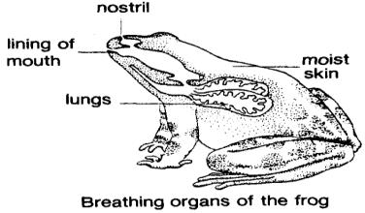

An adult frog lives on land but goes back into the water during the breeding season.

A frog uses three different respiratory surfaces.

These are the skin, buccal cavity and lungs.

Skin

The skin is used both in water and on land.

It is quite efficient and accounts for 60% of the oxygen taken in while on land.

Adaptations of a Frog's Skin for Gaseous Exchange

The skin is a thin epithelium to allow fast diffusion.

The skin between the digits in the limbs (i.e. webbed feet) increase the surface area for gaseous exchange.

It is richly supplied with blood vessels for transport of respiratory gases.

The skin is kept moist by secretions from mucus glands.

This allows for respiratory gases to dissolve.

Oxygen dissolved in the film of moisture diffuses across the thin epithelium and into the blood which has a lower concentration of oxygen.
Carbon (IV) oxide diffuses from the blood across the skin to the atmosphere along the concentration gradient.

Buccal (Mouth) Cavity

Gaseous exchange takes place all the time across thin epithelium lining the mouth cavity.

Adaptations of Buccal Cavity for Gaseous Exchange

It has a thin epithelium lining the walls of the mouth cavity allowing fast diffusion of gases.

It is kept moist by secretions from the epithelium for dissolving respiratory gases.

It has a rich supply of blood vessels for efficient transport of respiratory gases.

The concentration of oxygen in the air within the mouth cavity is higher than that of the blood inside the blood vessels.
Oxygen, therefore dissolves in the moisture lining the mouth cavity and then diffuses into the blood through the thin epithelium.
On the other hand, carbon (IV) oxide diffuses in the opposite direction along a concentration gradient.

Lungs

There is a pair of small lungs used for gaseous exchange.

Adaptation of Lungs

The lungs are thin walled for fast diffusion of gases.

Have internal foldings to increase surface area for gaseous exchange.

A rich supply of blood capillaries for efficient transport of gases.

Moisture lining for gases to dissolve.

Ventilation

Inspiration

During inspiration, the floor of the mouth is lowered and air is drawn in through the nostrils.

When the nostrils are closed and the floor of the mouth is raised, air is forced into the lungs.

Gaseous exchange occurs in the lungs, oxygen dissolves in the moisture lining of the lung and diffuses into the blood through the thin walls.
Carbon (IV) oxide diffuses from blood into the lung lumen.

Expiration

When the nostrils are closed and the floor of mouth is lowered by contraction of its muscles, volume of mouth cavity increases.
Abdominal organs press against the lungs and force air out of the lungs into buccal cavity.

Nostrils open and floor of the mouth is raised as its muscles relax.

Air is forced out through the nostrils.

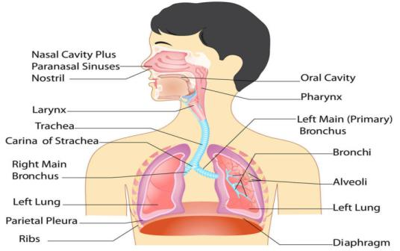
Gaseous Exchange in a Mammal -Human

The breathing system of a mammal consists of a pair of lungs which are thin-walled elastic sacs lying in the thoracic cavity.
The thoracic cavity consists of vertebrae, sternum, ribs and intercostal muscles

The thoracic cavity is separated from the abdominal cavity by the diaphragm.

The lungs lie within the thoracic cavity.

They are enclosed and protected by the ribs which are attached to the sternum and the thoracic vertebrae.

There are twelve pairs of ribs, the last two pairs are called 'floating ribs' because they are only attached to the vertebral column.
The ribs are attached to and covered by internal and external intercostals muscles.

The diaphragm at the floor of thoracic cavity consists of a muscLe sheet at the periphery and a central circular fibrous tissue.
The muscles of the diaphragm are attached to the thorax wall.

The lungs communicate with the outside atmosphere through the bronchi, trachea, mouth and nasal cavities.

The trachea opens into the mouth cavity through the larynx.

A flap of muscles, the epiglottis, covers the opening into the trachea during swallowing.

This prevents entry of food into the trachea.

Nasal cavities are connected to the atmosphere through the external nares(or nostrils)which are lined with hairs and mucus that trap dust particles and bacteria, preventing them from entering into the lungs.
Nasal cavities are lined with cilia.

The mucus traps dust particles,

The cilia move the mucus up and out of the nasal cavities.

The mucus moistens air as it enters the nostrils.

Nasal cavities are winding and have many blood capillaries to increase surface area to ensure that the air is warmed as it passes along.
Each lung is surrounded by a space called the pleural cavity.

It allows for the changes in lung volume during breathing.

An internal pleural membrane covers the outside of each lung while an external pleural membrane lines the thoracic wall.
The pleural membranes secrete pleural fluid into the pleural cavity.

This fluid prevents friction between the lungs and the thoracic wall during breathing.

The trachea divides into two bronchi, each of which enters into each lung.

Trachea and bronchi are lined with rings of cartilage that prevent them from collapsing when air pressure is low.
Each bronchus divides into smaller tubes, the bronchioles.

Each bronchiole subdivides repeatedly into smaller tubes ending with fine bronchioles.

The fine bronchioles end in alveolar sacs, each of which gives rise to many alveoli.

Epithelium lining the inside of the trachea, bronchi and bronchioles has cilia and secretes mucus.

Adaptations of Alveolus to Gaseous Exchange

Each alveolus is surrounded by very many blood capillaries for efficient transport of respiratory gases.

There are very many alveoli that greatly increases the surface area for gaseous exchange.

The alveolus is thin walled for faster diffusion of respiratory gases.

The epithelium is moist for gases to dissolve.

Gaseous Exchange Between the Alveoli and the Capillaries

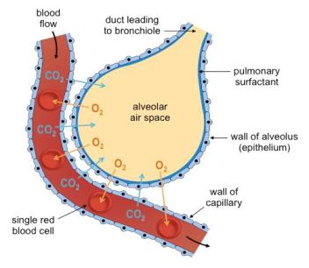

The walls of the alveoli and the capillaries are very thin and very close to each other.

Blood from the tissues has a high concentration of carbon (IV) oxide and very little oxygen compared to alveolar air.
The concentration gradient favours diffusion of carbon (IV) oxide into the alveolus and oxygen into the capillaries .
No gaseous exchange takes place in the trachea and bronchi.

These are referred to as dead space.

Ventilation

Exchange of air between the lungs and the outside is made possible by changes in the volumes of the thoracic cavity.
This volume is altered by the movement of the intercostal muscles and the diaphragm.

Inspiration

The ribs are raised upwards and outwards by the contraction of the external intercostal muscles, accompanied by the relaxation of internal intercostal muscles.
The diaphragm muscles contract and diaphragm moves downwards.

The volume of thoracic cavity increases, thus reducing the pressure.

Air rushes into the lungs from outside through the nostrils.

Expiration

The internal intercostal muscles contract while external ones relax and the ribs move downwards and inwards.
The diaphragm muscles relaxes and it is pushed upwards by the abdominal organs. It thus assumes a dome shape.
The volume of the thoracic cavity decreases, thus increasing the pressure.

Air is forced out of the lungs.

As a result of gaseous exchange in the alveolus, expired air has different volumes of atmospheric gases as compared to inspired air.

Comparison of Inspired and Expired Air (% by volume)


Component |  | Insipired % |  | Expired %
Oxygen |  | 21 |  | 16
Carbon dioxide |  | 0.03 |  | 4
Nitrogen |  | 79 |  | 79

Moisture

Variable
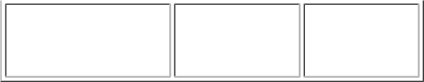
Saturated

Lung Capacity

The amount of air that human lungs can hold is known as lung capacity.
The lungs of an adult human are capable of holding 5,000 cm³ of air when fully inflated.
However, during normal breathing only about 500 cm³ of air is exchanged.

This is known as the tidal volume.

A small amount of air always remains in the lungs even after a forced expiration.

This is known as the residual volume.

The volume of air inspired or expired during forced breathing is called vital capacity.

Control of Rate of Breathing

The rate of breathing is controlled by the respiratory centre in the medulla of the brain.

This centre sends impulses to the diaphragm through the phrenic nerve.

Impulses are also sent to the intercostal muscles.

The respiratory centre responds to the amount of carbon (IV) oxide in the blood.

If the amount of carbon (IV) oxide rises, the respiratory centre sends impulses to the diaphragm and the intercostal muscles which respond by contracting in order to increase the ventilation rate.
Carbon (IV) oxide is therefore removed at a faster rate.

Factors Affecting Rate of Breathing in Humans

Factors that cause a decrease or increase in energy demand directly affect rate of breathing.

Exercise, any muscular activity like digging.

Sickness

Emotions like anger, flight

Sleep.

Effects of Exercise on Rate of Breathing

Students to work in pairs

One student stands still while the other counts (his/her) the number of breaths per minute.

The student whose breath has been taken runs on the sport vigorously for 10 minutes.

At the end of 10 minutes the number of breaths per minute is immediately counted and recorded.

It is noticed that the rate of breathing is much higher after exercise than at rest.

Dissection of a Small Mammal (Rabbit) to Show Respiratory Organs

The rabbit is placed in a bucket containing cotton wool which has been soaked in chloroform.

The bucket is covered tightly with a lid.

The dead rabbit is placed on the dissecting board ventral side upwards.

Pin the rabbit to the dissecting board by the legs.

Dissect the rabbit to expose the respiratory organs.

Ensure that you note the following features.

Ribs, intercostal muscles, diaphragm, lungs, bronchi, trachea, pleural membranes, thoracic cavity.

Diseases of the Respiratory System

Asthma

Asthma is a chronic disease characterised by narrowing of air passages.

Causes

Allergy

Due to pollen, dust, fur, animal hair, spores among others.

If these substances are inhaled, they trigger release of chemical substances and they may cause swelling of the bronchioles and bring about an asthma attack.

Heredity

Asthma is usually associated with certain disorders which tend to occur in more than one member of a given family, thus suggesting' a hereditary tendency.

Emotional or mental stress

Strains the body immune system hence predisposes to asthma attack.

Symptoms

Asthma is characterized by wheezing and difficulty in breathing accompanied by feeling of tightness in the chest as a result of contraction of the smooth muscles lining the air passages.

Treatment and Control

There is no definite cure for asthma.

The best way where applicable is to avoid whatever triggers an attack (allergen).

Treatment is usually by administering drugs called bronchodilators.

The drugs are inhaled, taken orally or injected intravenously depending on severity of attack to relief bronchial spasms.

Bronchitis

This is an inflammation of bronchial tubes.

Causes

This is due to an infection of bronchi and bronchioles by bacteria and viruses.

Symptoms

Difficulty in breathing.

Cough that produces mucus.

TreatmentAntibiotics are administered

Pulmonary Tuberculosis

Tuberculosis is a contagious disease that results in destruction of the lung tissue.

Causes

Tuberculosis is caused by the bacterium Mycobacterium tuberculosis.

Human tuberculosis is spread through droplet infection i.e., in saliva and sputum.

Tuberculosis can also spread from cattle to man through contaminated milk.

From a mother suffering from the disease to a baby through breast feeding.

The disease is currently on the rise due to the lowered immunity in persons with HIV and AIDS (Human Immuno Deficiency Syndrome).
Tuberculosis is common in areas where there is dirt, overcrowding and malnourishment.

Symptoms

It is characterised by a dry cough, lack of breath and body wasting.

Prevention

Proper nutrition with a diet rich in proteins and vitamins to boost immunity.

Isolation of sick persons reduces its spread.

Utensils used by the sick should be sterilised by boiling.

Avoidance of crowded places and living in well ventilated houses.

Immunisation with B.C.G. vaccine gives protection against tuberculosis.

This is done a few days after birth with subsequent boosters.

Treatment

Treatment is by use of antibiotics.

Pneumonia

Pneumonia is infection resulting in inflammation of lungs.

The alveoli get filled with fluid and bacterial cells decreasing surface are for gaseous exchange.

Pneumonia is caused by bacteria and virus.

More infections occur during cold weather.

The old and the weak in health are most vulnerable.

Symptoms

Pain in the chest accompanied by a fever, high body temperatures (39-40°C) and general body weakness.

Prevention

Maintain good health through proper feeding.

Avoid extreme cold.

Treatment

If the condition is caused by pneumococcus bacteria, antibiotics are administered.

If breathing is difficult, oxygen may be given using an oxygen mask.

Whooping Cough

Whooping cough is an acute infection of respiratory tract.

The disease is more common in children under the age of five but adults may also be affected

Causes

It is caused by Bordetella pertusis bacteria and is usually spread by droplets produced when a sick person coughs.

Symptoms

Severe coughing and frequent vomiting

Thick sticky mucus is produced

Severe broncho-pneumonia

Convulsions in some cases.

Prevention

Children may be immunised against whooping cough by means of a vaccine which is usually combined with those against diphtheria and tetanus.
It is called "Triple Vaccine" or Diptheria, Pertusis and Tetanus ( DPT).

Treatment
Antibiotics are administered

- To reduce the coughing, the patient should be given drugs

🦠 COVID-19 (corona virus disease 2019)

1️⃣ WHAT IS COVID-19?
- COVID-19 is an infectious disease caused by a virus called SARS-CoV-2.
- It started spreading globally in late 2019 and was declared a pandemic by the World Health Organization (WHO) in 2020.

2️⃣ CAUSES OF COVID-19
- Cause: A virus from the coronavirus family called SARS-CoV-2.
- Transmission: Mainly spreads from person to person through:
  - Inhaling droplets when an infected person coughs, sneezes, or talks
  - Touching contaminated surfaces and then touching your face (especially mouth, nose, or eyes)

3️⃣ SYMPTOMS OF COVID-19
- Common symptoms:
  - Fever
  - Dry cough
  - Tiredness
- Other symptoms may include:
  - Sore throat
  - Difficulty in breathing
  - Loss of taste or smell
  - Headache, muscle pain, diarrhea (in some cases)

4️⃣ PREVENTION OF COVID-19
To stay safe, you should: ✅ Wash hands regularly with soap and water
✅ Use hand sanitizers (alcohol-based)
✅ Wear a face mask in public
✅ Keep social distance (at least 1 metre)
✅ Avoid crowded places and touching your face
✅ Stay at home if feeling unwell
✅ Get vaccinated if eligible

5️⃣ TREATMENT OF COVID-19
- No specific cure, but most people recover at home with rest and fluids.
- Mild cases: Treated with rest, fluids, and fever reducers like paracetamol.
- Severe cases: May need hospital care, oxygen support, or even a ventilator.
- Vaccines help prevent severe illness and are widely used globally.

6️⃣ KEY SAFETY MEASURES
💉 Vaccination: Protects against severe COVID-19
😷 Masks: Protect you and others from virus spread
🧼 Hygiene: Handwashing is powerful
🏠 Isolation: If infected, stay isolated to protect others

Meaning and Significance of Respiration
- Respiration is the process by which energy is liberated from organic compounds such as glucose.
- It is one of the most important characteristics of living organisms.
- Energy is expended (used) whenever an organism exhibits characteristics of life, such as feeding, excretion and movement.
- Respiration occurs all the time and if it stops, cellular activities are disrupted due to lack of energy.
- This may result in death e.g., if cells in brain lack oxygen that is needed for respiration for a short time, death may occur.
- This is because living cells need energy in order to perform the numerous activities necessary to maintain life.
- The energy is used in the cells and much of it is also lost as heat.
- In humans it is used to maintain a constant body temperature.

Tissue Respiration
- Respiration takes place inside cells in all tissues.
- Every living cell requires energy to stay alive.
- Most organisms require oxygen of the air for respiration and this takes place in the mitochondria.

Mitochondrion Structure and Function

Structure
- Mitochondria are rod-shaped organelles found in the cytoplasm of cells.
- A mitochondrion has a smooth outer membrane and a folded inner membrane.
- The folding of the inner membrane is called cristae and the inner compartment is called the matrix.

Adaptations of Mitochondrion to its Function
- The matrix contains DNA ribosomes for making proteins and has enzymes for the breakdown of pyruvate to carbon (IV) oxide, hydrogen ions and electrons.
- Cristae increase surface area of mitochondrial inner membranes where attachment of enzymes needed for the transport of hydrogen ions and electrons are found.
- There are two types of respiration:
- Aerobic Respiration
- Anaerobic. Respiration
Aerobic Respiration
- This involves breakdown of organic substances in tissue cells in the presence of oxygen .
- All multicellular organisms and most unicellular organisms e.g. some bactena respire aerobically.
- In the process, glucose is fully broken down to carbon (IV) oxide and hydrogen which forms water when it combines with the oxygen.
- Energy produced is used to make an energy rich compound known as adenosine triphosphate (ATP).
- It consists of adenine, an organic base, five carbon ribose-sugar and three phosphate groups.
- ATP is synthesised from adenosine diphosphate (ADP) and inorganic phosphate.
- The last bond connecting the phosphate group is a high-energy bond.
- Cellular activities depend directly on ATP as an energy source.
- When an ATP molecule is broken down, it yields energy.

Process of Respiration
- The breakdown of glucose takes place in many steps.
- Each step is catalysed by a specific enzyme.
- Energy is released in some of these steps and as a result molecules of ATP are synthesised.
- All the steps can be grouped into three main stages:

Glycolysis.
- The initial steps in the breakdown of glucose are referred to as glycolysis and they take place in the cytoplasm.
- Glycolysis consists of reactions in which glucose is gradually broken down into molecules of a carbon compound called pyruvic acid or pyruvate.
- Before glucose can be broken, it is first activated through addition of energy from ATP and phosphate groups.
- This is referred to as phosphorylation.
- The phosphorylated sugar is broken down into two molecules of a 3-carbon sugar (triose sugar) each of which is then converted into pyruvic acid.
- If oxygen is present, pyruvic acid is converted into a 2-carbon compound called acetyl coenzyme A (acetyl Co A).
- Glycolysis results in the net production of two molecules of ATP.
- The next series of reactions involve decarboxylation i.e. removal of carbon as carbon (IV) oxide and dehydrogenation, removal of hydrogen as hydrogen ions and electrons.
- These reactions occur in the mitochondria and constitute the Tri-carboxylic Acid Cycle (T.C.A.) or Kreb's citric acid cycle.
- The acetyl Co A combines with 4-carbon compound with oxalo-acetic acid to form citric acid - a 6 carbon compound.
- The citric acid is incorporated into a cyclical series of reactions that result in removal of carbon (IV) oxide molecules, four pairs of hydrogen, ions and electrons.
- Hydrogen ions and electrons are taken to the inner mitochondria membrane where enzymes and electron carriers effect release of a lot of energy.
- Hydrogen finally combines with oxygen to form water, and 36 molecules of ATP are synthesised.

Anaerobic Respiration
- Anaerobic respiration involves breakdown of organic substances in the absence of oxygen.
- It takes place in some bacteria and some fungi.
- Organisms which obtain energy by anaerobic respiration are referred to as anaerobes.
- Obligate anaerobes are those organisms which do not require oxygen at all and may even die if oxygen is present.
- Facultative anaerobes are those organisms which survive either in the absence or in the presence of oxygen.
- Such organisms tend to thrive better when oxygen is present e.g. yeast.

Products of Anaerobic Respiration
- The products of anaerobic respiration differ according to whether the process is occurring in plants or animals.

Anaerobic Respiration in Plants
- Glucose is broken down to an alcohol, (ethanol) and carbon (IV) oxide.
- The breakdown is incomplete.
- Ethanol is an organic compound, which can be broken down further in the presence of oxygen to provide energy, carbon (IV) oxide and water.
C₆H_{I2}0₆ _ 2C₂H₅0H + 2C0₂ + Energy
(Glucose) (Ethanol) (Carbon (IV) oxide)

Fermentation-
- Is the term used to describe formation of ethanol and carbon (IV) oxide from grains.
- Yeast cells have enzymes that bring about anaerobic respiration.

Lactate Fermentation
- Is the term given to anaerobic respiration in certain bacteria that results in formation of lactic acid.

Anaerobic Respiration in Animals
- Anaerobic respiration in animals produces lactic acid and energy.
C₆H₁P6 _ 2CH₃CHOH.COOH + energy
(Glucose) (Lactic acid) + energy
- When human muscles are involved in very vigorous activity, oxygen cannot be delivered as rapidly as it is required.
- The muscle respire anaerobically and lactic acid accumulates.
- A high level of lactic acid is toxic.
- During the period of exercise, the body builds up an oxygen debt.
- After vigorous activity, one has to breathe faster and deeper to take in more oxygen.
- Rapid breathing occurs in order to break down lactic acid into carbon (IV) oxide and water and release more energy.
- Oxygen debt therefore refers to the extra oxygen the body takes in after vigorous exercise.

Practical Activities

To Show the Gas Produced When the Food is burned
- A little food substance e.g., maize flour or meat is placed inside a boiling tube.
- The boiling tube is stoppered using a rubber bung connected to a delivery tube inserted into a test-tube with limewater.
- The food is heated strongly to bum.
- Observations are made on the changes in lime water (calcium hydroxide) as gas is produced.
- The clear lime water turns white due to formation of calcium carbonate precipitate proving that carbon (Iv) oxide is produced.

Experiment to Show the Gas Produced During Fermentation

- Glucose solution is boiled and cooled. Boiling expels all air.
- A mixture of glucose and yeast is placed in a boiling tube, and covered with a layer of oil to prevent entry of air.
- A delivery tube is connected and directed into a test-tube containing lime water.
- The observations are made immediately and after three days the contents are tested for the presence of ethanol.
- A control experiment is set in the same way except that yeast which has been boiled and cooled is used.
- Boiling kills yeast cells.
- The limewater becomes cloudy within 20 minutes.
- This proves that carbon (IV) oxide gas is produced.
- The fermentation process is confirmed after three days when alcohol smell is detected in the mixture.

Experiment to Show Germinating Seeds Produce Heat
- Soaked bean seeds are placed in a vacuum flask on wet cotton wool.
- A thermometer is inserted and held in place with cotton wool .
- The initial temperature is taken and recorded.
- A control experiment is set in the same way using boiled and cooled bean seeds which have been washed in formalin to kill microorganisms.
- Observation is made within three days.
- Observations show that temperature in the flask with germinating seeds has risen.
- The one in the control has not risen.

Comparison Between Aerobic and Anaerobic Respiration

 | Aerobic Respiration | Anaerobic Respiration
 |  | -
1. Site | In the mitochondria. | In the cytoplasm.
2. Products | Carbon dioxide and water. | Ethanol in plants and lactic acid in animals-
3. Energy yield | 38 molecules of A TP (2880 KJ) from | 2 molecules of ATP 210KJ from each
3. Energy yield | each molecule of glucose. | molecule of glucose.
4. Further reaction | No further reactions on carbon | Ethanol and lactic acid can be broken down
4. Further reaction | dioxide and water. | further in the presence of oxygen.

Comparison Between Energy Output in Aerobic and Anaerobic Respiration
- Aerobic respiration results in the formation of simple inorganic molecules, water and carbon (Iv) oxide as the byproducts.
- These cannot be broken down further. A lot of energy is produced.
- When a molecule of glucose is broken down in the presence of oxygen, 2880 KJ of energy are produced (38 molecules of ATP).
- In anaerobic respiration the by products are organic compounds.
- These can be broken down further in the presence of oxygen to give more energy.
- Far less energy is thus produced.
- The process is not economical as far as energy production is concerned.
- When a molecule of glucose is broken down in the absence of oxygen in plants, 210 KJ are produced (2 molecule ATP).
- In animals, anaerobic respiration yields 150 kJ of energy.

Substrates for Respiration
- Carbohydrate, mainly glucose is the main substrate inside cells.
- Lipids i.e. fatty acids and glycerol are also used.
- Fatty acids are used when the carbohydrates are exhausted.
- A molecule of lipid yields much more energy than a molecule of glucose.
- Proteins are not normally used for respiration.
- However during starvation they are hydrolysed to amino acids, dearnination follows and the products enter Kreb's cycle as urea is formed.
- Use of body protein in respiration result to body wasting, as observed during prolonged sickness or starvation.
- The ratio of the amount of carbon (IV) oxide produced to the amount of oxygen used for each substrate is referred to as Respiratory Quotient (RQ) and is calculated as follows:

R.Q. = Amount of carbon (IV) oxide produced

Amount of oxygen used
- Carbohydrates have a respiratory quotient of 1.0 lipids 0.7 and proteins 0.8.
- Respiratory quotient value can thus give an indication of types of substrate used.
- Besides values higher than one indicate that some anaerobic respiration is taking place.

Application of Anaerobic Respiration in Industry and at Home

Industry
- Making of beer and wines.
- Ethanol in beer comes from fermentation of sugar(maltose) in germinating barley seeds.
- Sugar in fruits is broken down anaerobically to produce ethanol in wines.
- In the dairy industry, bacterial fermentation occurs in the production of several dairy products such as cheese, butter and yoghurt.
- In production of organic acids e.g., acetic acid, that are used in industry e.g., in preservation of foods.

Home

- Fermentation of grains is used to produce all kinds of beverages e.g., traditional beer and sour porridge.
- Fermentation of milk.

This CLASS notes have been prepared by following the curriculum design Developed by KICD

All rights reserved

