NAME: …………………………………………. INDEX NO: ……………………………….

DATE : …………………………………..CANDIDATE’S SIGNATURE:…………………

MANGU HIGH SCHOOL TRIAL 4 MOCK 2025


232/1
PHYSICS PAPER 1
TIME: 2HRS

PHYSICS FORM 4

INSTRUCTIONS TO CANDIDATES
- Write your name and Adm No in the spaces provided above
- Answer all questions in section A and B in the spaces below each question.
- For numerical questions, show all your working
- Maths table and calculators may be used for calculation

Section | Questions | Max score | Candidate score
A | 1 - 13 | 25
B | 14  15  16  17  18 | 14  11  11  11  8
 | TOTAL | 80

- A salt solution of volume 30cm³ and density 1.1 g/cm³ is mixed with 25cm³ of pure water of density 1g/cm³. determine
  - Total mass of the mixture (1mk)

  - Density of the mixture (2 mks)

- The figure below shows a section of a vernier callipers to measure the thickness of a wooden block.

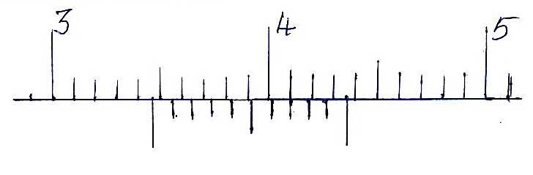
If the vernier calliper has zero error of. What is the actual reading of the vernier callipers (2mks)

- State the type of equilibrium for a rubber ball placed on a horizontal table as shown below (1mks)
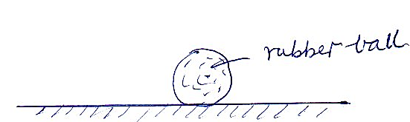
- A ball is thrown vertically upwards and return to its starting point after 6 seconds. Calculate the maximum height reached (g=10m/s²) (3 mks)

- A piece of paper is held in front of the mouth and air is blown horizontally over the paper.it is observed that the paper get lifted up. Explain this observation (2mks)

- The figure below shows a uniform metre rule balancing when a mass of 200g is hung at one end. Determine the tension, T in the string. (3mks)
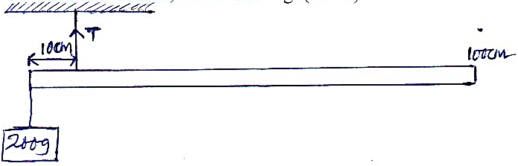

- A diver is 12m below the surface of water in a dam. If the density of the sea water is 1000kg/m3 determine the pressure due to the water on the diver. (g =10N/kg (2mks)

- A crystal of potassium permanganate was carefully introduced at the bottom of water column held in a gas jar. After sometime the whole volume of water was coloured. Explain this observation (1mks)

- Define absolute zero temperature for an ideal gas (1mk)

- A substance of mass 2kg and specific heat capacity 400jkg⁻¹k⁻¹ initially at 80°c is immersed in water at 19°c. If the final temp is 20°c. Calculate the mass of water specific heat capacity of water = 4200jkg-1k-1. (3mks)

- The cover of a ball point has a small hole on the stem as shown below
Explain its function (1mk)
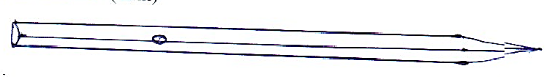

- Give a reason why hot water put in a sufuria covered with a blackened aluminium foil cools faster than one covered with a shiny foil . (1mks)

- A mass of 7.5kg has a weight of 30N on a certain planet .calculate the acceleration due to gravity on this planet (2mks)

SECTION B (55MARKS)
- (a) Define angular velocity and state its SI unit (2mk)

(b) A stone of mass 500g is whirled in a vertical circle at 5 revolutions per
Second. If the length of the string used is 1.5m, determine
    - The angular velocity (3mks)

    - The maximum tension of the string (3mks)

(c) State three factors that will make the stone to remain in a state of vertical
motion (3mks)

(d) A glass block of mass 300g is placed on a frictionless rotating table while
fixed 10cm from the centre of the table by a light thread. The string can withstand a maximum tension of 6.6N. Determine the maximum velocity that the table can attain before the string cuts. (3mks)

- (a) State hooke’s law (1mk)

(b) A form 4 student did an experiment on hooke’s law and from his data drew the following graph.
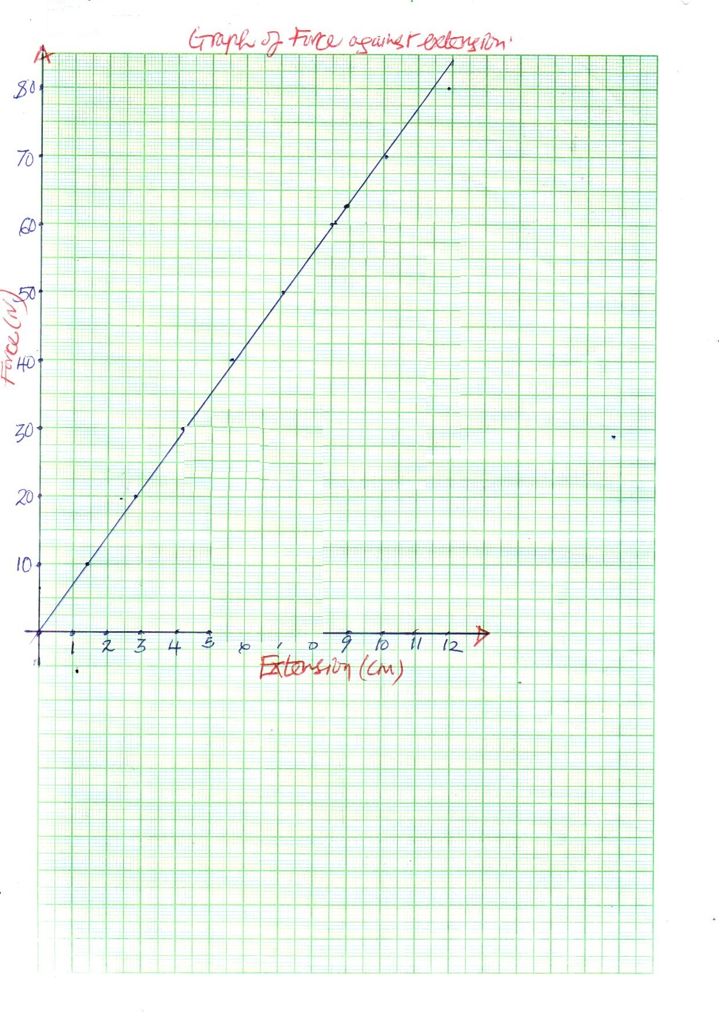

From the graph,
i) Determine the spring constant (2mks)

(ii) Work done in producing an extension, e of 8cm. (2mks)

c) State the factors which affect the spring constant calculated in b (i) above (2mks)

- A column of air 26cm is trapped by mercury thread 5cm long as shown in the diagram below.

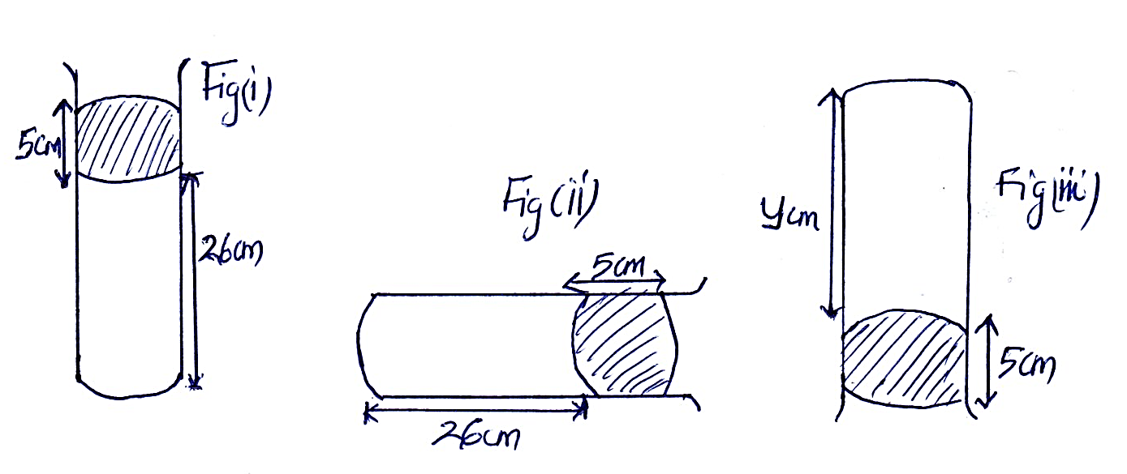
- When the tube is laid horizontally as in figure (ii) the air column is now x cm long. When inverted as shown in figure (iii), the length of the column is y cm.
Find
- The values of x (2mks)

- The values of y (2mks)
(Take atmospheric pressure to be 70cmHg)
- (a) State newtons third law of motion. (1mk)

(b) A car of mass 900kg is initially moving at 20m/s, calculate
i) Acceleration of the car (2mks)

(ii) The force required to bring the car to rest over a distance of 15M. (2mks)

(c) Two trolleys of masses 2.0 kg and 1.5kg travelling towards each other at 0.20m/s and 0.35m/s respectively combine head on. The trolleys combine on collision. Calculate the velocity of the combined trolleys. (3mks)

(d.)A stone is projected vertically upwards with a velocity of 30m/s from the ground. Determine the maximum height reached (3mks)

- (a) State the law of floatation (1mk)

(b)The diagram below shows a wooden block of dimensions 50cm by 40cm by 20cm held in a position by a string attached to the bottom of a swimming pool.( density of block is 600kg/m³, density of water = 1000kg/m³)

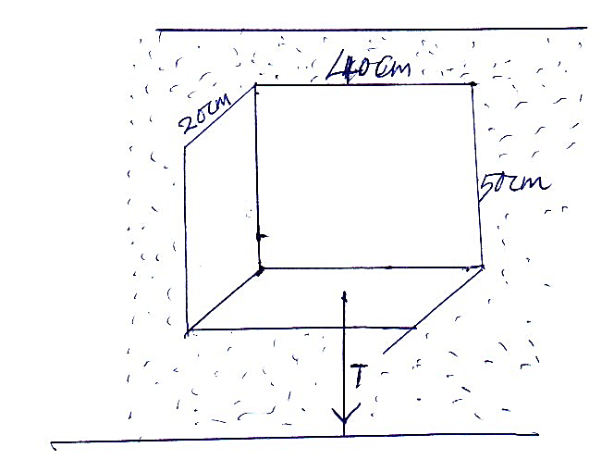

The three forces acting on the block are tension (T) in the string, the weight (W) of the block and the up thrust (U) due to water.
    - Write an equation relating T, W and U when the block is at stationery position. (1mk)

    - What is the weight of the block (3mks)

    - What is the weight of the water displaced by the block (2mks)

    - Determine the tension (T) on the string. (2 mks)

(c) Some ether is put in a combustion tube and two glass tubes inserted into the tube through a cork as shown in the figure below. The combustion tube is then put into a smaller beaker containing some water and a thermometer dipped in the water.

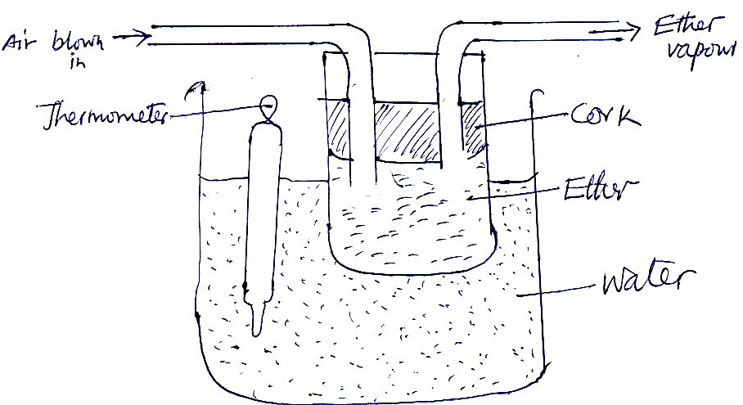

When air is blown into the ether, the reading in the thermometer lowers. Explain this observation (2mks)

- (a) Complete the diagram below to show how the pulleys can be used to raise a load, L by applying an effort ,E (2mks)
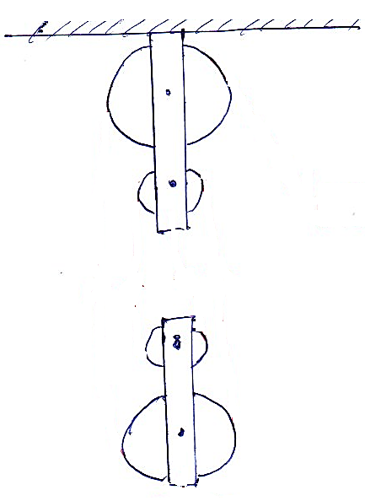
(b) The pulley system above has a mechanical advantage of 3. Determine
    - The velocity ratio of the system (2mks)

    - The efficiency of the system (2mks)

    - The effort when a load of 60N is raised (2mks)

