
THE NAMBA EVALUATION TEST
The Kenya Certificate of Secondary School
JULY 2025
233/2 Chemistry Paper 2 Time: 2 Hours

Name: ……………………………………… Index No: ………...……
233/2 – Chemistry
Wednesday, 16th July, 2025
Mid morning
11.00am-1.00pm

Stream: ……………….. Signature: ………............ School: ………….
Instructions
- Write your name, admission number, date, stream and signature in the spaces provided above.

- All answers must be written in the spaces provided in the booklet.
- This paper consists of 15 printed pages with 7 questions. Candidates should check the question paper to ascertain that all the pages are printed as indicated and that no questions are missing
- Candidate should answer the questions in English
FOR EXAMINERS USE ONLY
Questions | Maximum Score | Candidate’s Score
1 | 13
2 | 10
3 | 10
4 | 13
5 | 10
6 | 12
7 | 12
TOTAL | 80

1. The table below shows properties of some elements. The letters do not represent the actual symbols
of the elements. Study the information in the table and answer the questions that follow.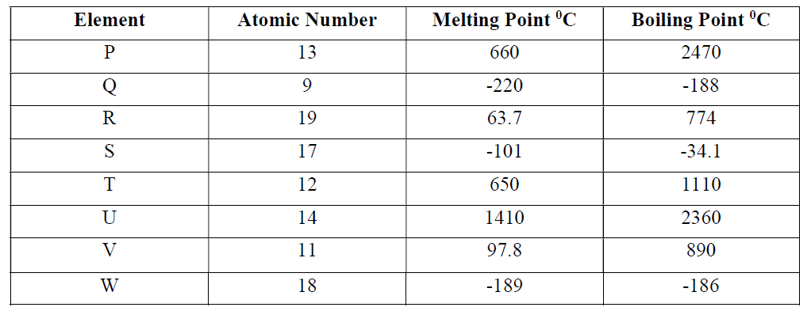
(a) Select the element with the highest ionization energy. (1 mark)
………………………………………………………………………………………………………………..
(b) How do the atomic radii of the following elements compare. Explain your answer.
(i) S and T. (2 marks)
………………………………………………………………………………………………………………..
………………………………………………………………………………………………………………..
(ii) R and V. (2 marks)
………………………………………………………………………………………………………………..
………………………………………………………………………………………………………………..
(c) How do the reactivity of Q and S with V compare. Explain your answer. (2 marks)
………………………………………………………………………………………………………………..
………………………………………………………………………………………………………………..
………………………………………………………………………………………………………………..
(d) (i) Write the formula of the compound formed between P and S. (1 mark)
………………………………………………………………………………………………………………..

(ii) Write an equation for the reaction between V and S. (1mark)
………………………………………………………………………………………………………………..
………………………………………………………………………………………………………………..
(iii) State and explain how the boiling points of the compounds formed in d (i) and (ii) above
compare. (2 marks)
………………………………………………………………………………………………………………..
………………………………………………………………………………………………………………..
(e) What would be the effect of aqueous solution of compounds formed in d (i) and (ii) above on blue
litmus paper. Explain. (2 marks)
………………………………………………………………………………………………………………..
………………………………………………………………………………………………………………..
………………………………………………………………………………………………………………..
2. I. Study the flow chart below and answer the questions that follow
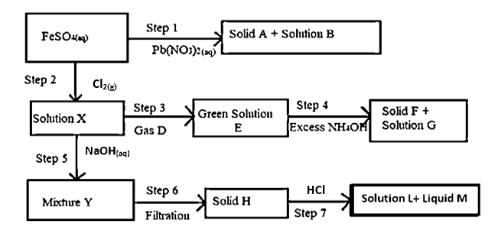
(a)Identify the following substances. (2marks)
i. Solution E
………………………………………………………………………………………………………………..

ii. Solid H
………………………………………………………………………………………………………………..
iii. Solution L
………………………………………………………………………………………………………………..
iv. Gas D
………………………………………………………………………………………………………………..
b. State and explain observation made in Step 2. (1mark)
………………………………………………………………………………………………………………..
………………………………………………………………………………………………………………..
………………………………………………………………………………………………………………..
c. Write an ionic equation for step 5. (1mark)
………………………………………………………………………………………………………………..
………………………………………………………………………………………………………………..
d. A student determined the solubility of potassium nitrate at 60⁰C. The results obtained as follows:
Mass of evaporating dish = 14.32g
Mass of evaporate dish + solution = 35.7g
Mass of evaporating dish + solid salt = 18.6g
Determine the solubility of potassium nitrate from sample results. (2marks)
………………………………………………………………………………………………………………..
………………………………………………………………………………………………………………..
………………………………………………………………………………………………………………..
………………………………………………………………………………………………………………………………………………………………………………………………………………………………..
II. A solution of hydrogen chloride in methyl benzene does not react with carbonates. However, on adding water and then shaking the resultant mixture, there is vigorous effervescence. Explain these observations. (2marks)
………………………………………………………………………………………………………………..
………………………………………………………………………………………………………………..
………………………………………………………………………………………………………………..
………………………………………………………………………………………………………………………………………………………………………………………………………………………………………………………………………………………………………………………………………………..
II. The setup below was used to remove hardness in water
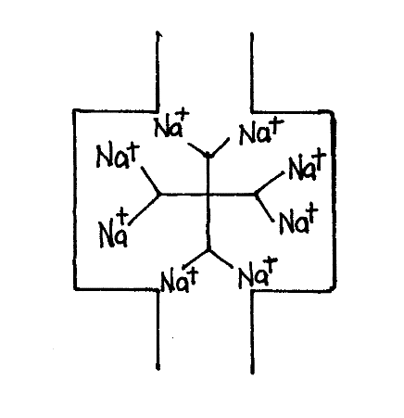
i. Identify the above method of removing water hardness. (1mark)
………………………………………………………………………………………………………………..
ii. The above system eventually lacks ability to soften hard water. Explain how it can be reactivated.
(1mark)
………………………………………………………………………………………………………………..
………………………………………………………………………………………………………………..
………………………………………………………………………………………………………………..

3. In an experiment to study the rate of reaction a 10cm length of magnesium ribbon was reacted with 50cm³ of 1M hydrochloric acid. The table below gives the data that was collected.
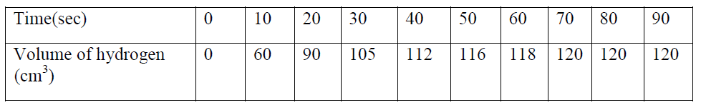
(a) (i) Plot a graph of volume of hydrogen against time. (3 marks)

(ii) From the graph find:
I. The volume of hydrogen that had been produced when time was 35 seconds. (1 mark)
………………………………………………………………………………………………………………..
II. The rate of reaction when time is 45 seconds. (1 mark)
………………………………………………………………………………………………………………..
………………………………………………………………………………………………………………..
III. Sketch on the diagram the curve you would obtain if the reaction is repeated using 0.5M HCl. Label this curve as C. (1 mark)
………………………………………………………………………………………………………………..
………………………………………………………………………………………………………………..
(b) (i) State what is meant by the term “dynamic equilibrium”. (1 mark)
………………………………………………………………………………………………………………..
………………………………………………………………………………………………………………..
(ii) One of the reactions in the manufacture of Nitric (V) acid involves catalytic oxidation of ammonia as

The reaction is carried out at a pressure of 10 atmospheres and a temperature of 900⁰C.State the effect on the position of equilibrium if the reaction is carried out;
I. at 10 atmospheres pressure and 450⁰C. (1 mark)
………………………………………………………………………………………………………………..
………………………………………………………………………………………………………………..
………………………………………………………………………………………………………………
II. at 900⁰C and 20 atmospheres pressure. (1 mark)
………………………………………………………………………………………………………………..
………………………………………………………………………………………………………………..
III. In the absence of a catalyst. (1 mark)
………………………………………………………………………………………………………………..
………………………………………………………………………………………………………………..

4. a) Study the flow chart below and answer the questions that follow
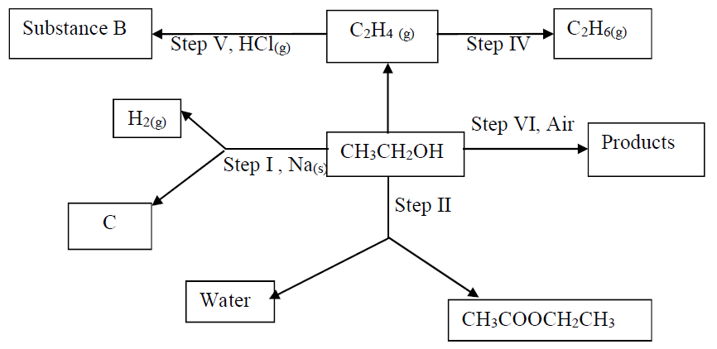
(i) Describe how the reaction in step II is carried out in the lab. (2 marks)
………………………………………………………………………………………………………………..
………………………………………………………………………………………………………………..………………………………………………………………………………………………………………..
(ii) Name substance B. (1 mark)
………………………………………………………………………………………………………………..
(iii) Name and draw the structural formula of substance C. (2 marks)
………………………………………………………………………………………………………………..
………………………………………………………………………………………………………………..
………………………………………………………………………………………………………………..
………………………………………………………………………………………………………………..
(iv) Give the reagent and condition in step IV. (1 mark)
Reagent ……………………………………………………………………………………………………...
Condition …………………………………………………………………………………………………….

(b) The repeating unit of a polymer P is shown below
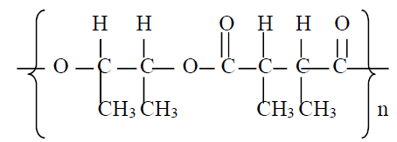
Draw the structures of two compounds which react together to form polymer P. (2 marks)
………………………………………………………………………………………………………………..
………………………………………………………………………………………………………………..
………………………………………………………………………………………………………………..
………………………………………………………………………………………………………………..
(c) The scheme below represents the manufacture of a cleansing agent.
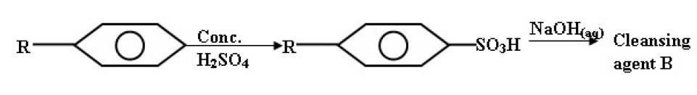
i) Draw the structure of B and state the type of cleansing agent for which it belongs.
Structure. (1 mark)
………………………………………………………………………………………………………………..
………………………………………………………………………………………………………………..
………………………………………………………………………………………………………………..
Type (1 mark)
………………………………………………………………………………………………………………..
………………………………………………………………………………………………………………..
ii) State one disadvantage of using B as a cleansing agent. (1 mark)
………………………………………………………………………………………………………………..

iii) Describe how a cleansing agent removes grease dirt from linen. (2 marks)
………………………………………………………………………………………………………………..
………………………………………………………………………………………………………………..
………………………………………………………………………………………………………………..
………………………………………………………………………………………………………………..
5. (a) The diagram below shows the set-up used to test a property of carbon in the laboratory. Study it and use it to answer the questions that follow.
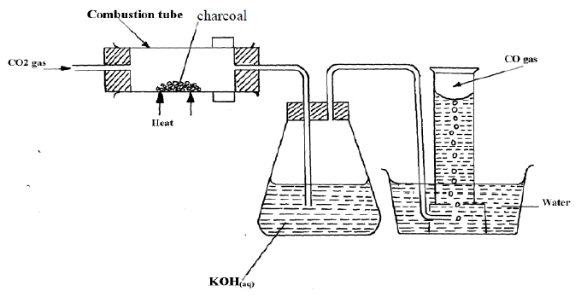
i. State the role of potassium hydroxide solution. (1 mark)
………………………………………………………………………………………………………………..
ii. Write an equation for the reaction in the combustion tube. (1 mark)
………………………………………………………………………………………………………………..
iii. State the property of carbon being investigated. (1 mark)
………………………………………………………………………………………………………………..
………………………………………………………………………………………………………………..

(b) Sodium carbonate is prepared industrially using Solvay process. The flow diagram below shows some of the reactions in the process. Study it and use it to answer the questions that follow
i. Identify; (2 marks)
Solid Y ………………………………………………………………………………………………………
Solid P ……………………………………………………………………………………………………….
ii. Write an equation for the reaction taking place in chamber M. (1 mark)
………………………………………………………………………………………………………………..
iii. Name the process taking place in chamber N. (1 mark)
………………………………………………………………………………………………………………..
(c) The set-up below was used to prepare carbon (IV) oxide gas in the laboratory. Study it and answer the questions that follow.
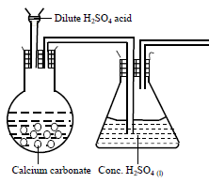
i. Identify one mistake in the set-up and suggest a possible correction. (2 marks)
………………………………………………………………………………………………………………..
………………………………………………………………………………………………………………..
ii. Complete the diagram showing how the gas can be collected. (1 mark)
6. The diagram below represent a set-up that can be used for the electrolysis of dilute sulphuric(VI) acid
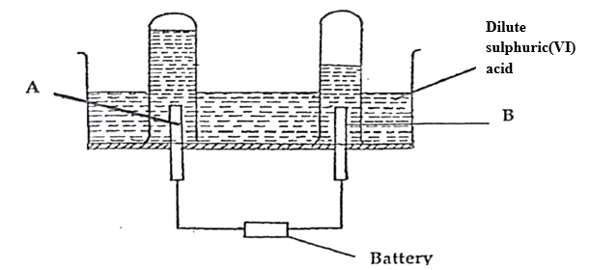
(i) Name electrode A and B (1 mark)
………………………………………………………………………………………………………………..
………………………………………………………………………………………………………………..
(ii) Write an equation for the reaction taking place at electrode B. (1 mark)
………………………………………………………………………………………………………………..
(iii) What happens to the concentration of dilute sulphuric (VI) acid as the reaction continues. Explain
(2 marks)
………………………………………………………………………………………………………………..
………………………………………………………………………………………………………………..
………………………………………………………………………………………………………………..
(b) When nitrate solution of a certain metal X waselectrolysed,1.174g of metal X was deposited by a current of 4.0 amperes for 16 minutes.
Determine the formula of the metal nitrate.
(1F=96,500C, R.A.M of X=59). (3 marks)
………………………………………………………………………………………………………………..
………………………………………………………………………………………………………………..
(c)The diagram below shows a Le’clanchecell (Dry cell)
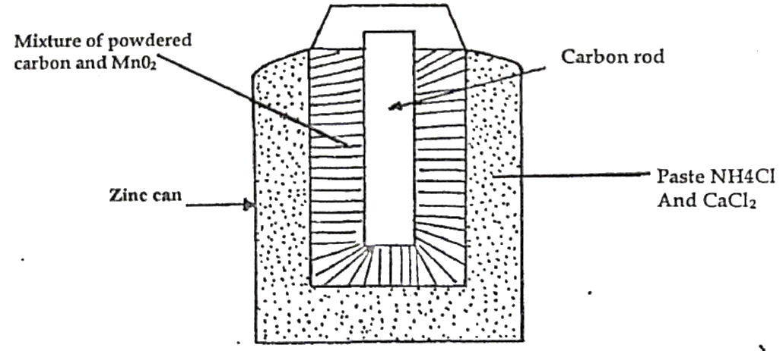

(i) What is the function of the following of the following substances in the above cell.
I. MnO₂ (1 mark)
………………………………………………………………………………………………………………..
II.CaCl₂ (1 mark)
………………………………………………………………………………………………………………..
(ii) Write an equation that occurs at the negative terminal (1 mark)
………………………………………………………………………………………………………………..
(iii) A paste rather than dry form of ammonium chloride is used. Explain. (1 mark)
………………………………………………………………………………………………………………..
(iv) What is the main disadvantage of this type of cell (1 mark)
………………………………………………………………………………………………………………..
………………………………………………………………………………………………………………..
7. (a) In an experiment to determine the molar heat of reaction when magnesium displaces copper, excess
magnesium powder was added to 25.0cm³ of 2.0M copper (II) chloride solution at 23ºC. The temperature rose to 38⁰C.
(i) Apart from increase in temperature, state and explain the other two observations which were made during the reaction. (2 marks)
………………………………………………………………………………………………………………..
………………………………………………………………………………………………………………..
………………………………………………………………………………………………………………………………………………………………………………………………………………………………
………………………………………………………………………………………………………………..
………………………………………………………………………………………………………………..
(ii) Calculate the heat change during the reaction. (1 mark)
(Specific heat capacity of the solution =4.2 J g⁻¹ K⁻¹, density of the solution =1g/cm³).
………………………………………………………………………………………………………………..
………………………………………………………………………………………………………………..
………………………………………………………………………………………………………………..
………………………………………………………………………………………………………………..
(iii) Write the ionic equation for the reaction. (1 mark)
………………………………………………………………………………………………………………..
………………………………………………………………………………………………………………..
(iv) Determine the molar heat of displacement of copper by magnesium. (2marks)
………………………………………………………………………………………………………………..
………………………………………………………………………………………………………………..
………………………………………………………………………………………………………………..
………………………………………………………………………………………………………………..

(b) Use the thermo chemical equations below to answer the questions that follow.
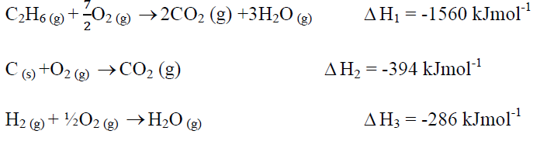
(i) Name two types of heat changes represented by $Δ$ H₃. (2 marks)
………………………………………………………………………………………………………………..
………………………………………………………………………………………………………………..
………………………………………………………………………………………………………………..
(ii) Draw an energy level diagram for the reaction represented by equation for $Δ$ H₁ (2 marks)
………………………………………………………………………………………………………………..
………………………………………………………………………………………………………………..
………………………………………………………………………………………………………………..
………………………………………………………………………………………………………………..
………………………………………………………………………………………………………………
………………………………………………………………………………………………………………..
………………………………………………………………………………………………………………..
(iii) Calculate the standard enthalpy of formation of ethane. (2 marks)
………………………………………………………………………………………………………………..
……………………………………………………………………………………………………………….
THIS IS THE LAST PRINTED PAGE

