

THE NAMBA EVALUATION TEST
The Kenya Certificate of Secondary School
JULY/AUGUST 2025
231/2 BIOLOGY (Theory) Paper 2
Time: 2½ Hours
Name: ……………………………………………….Index No: ………...…… Stream: ……………….. Signature: ………............
231/2 – Biology
School:……………………………………………………
Instructions to candidates:
- Write your name and Index Number in the spaces provided above
- This paper consists of two sections: A and B. Answer ALL questions in section A in the spaces provided. In section B, answer question 6 (compulsory) and either question 7 or 8 in the spaces provided after question 8.
- Candidates should answer the questions in English

For examiners use only

Section | Questions | Maximum Score | Candidate’s  Score
A | 1 | 8
A | 2 | 8
A | 3 | 8
A | 4 | 8
A | 5 | 8
B | 6 | 20
B | 7 | 20
B | 8 | 20
Total Score |  | 80

Answer all the questions in this section in the spaces provided
- Jack and Jill set up an experiment to investigate certain physiological process, the set up as shown in the diagram below

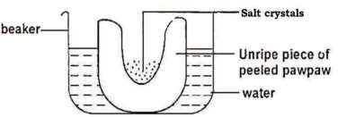
- What physiological process was been investigated (1 marks)
…………………………………………………………………………………………………………
…………………………………………………………………………………………………………
- Account for the observation. (4 marks)

…………………………………………………………………………………………………………
…………………………………………………………………………………………………………………………………………………………………………………………………………………………………………………………………………………………………………………………………………………………………………………………………………………………………………
- (i) Suggest the result that would be obtained if they repeated the experiment using a piece of boiled pawpaws. (1 mark)
……………………………………………………………………………………………………………………………………………………………………………………………………………………
…………………………………………………………………………………………………………

(ii) Give a reason for your answer in (i) above. (2 marks)
………………………………………………………………………………………………………………………………………………………………………………………………………………………………………………………………………………………………………………………………
- The diagram below represents a structure in a mammalian kidney
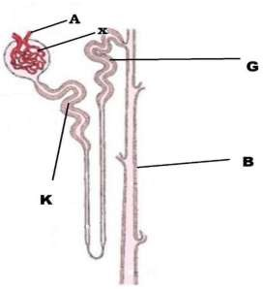

  - Name the structures labelled A and B (2 marks) A……………………………………………………………………………………………B……………………………………………………………………………………………
  - Explain the processes that take place in the regions labelled: (2 marks)
X.............................................................................................................................………………………………………………………………………………………………………………………………………………………………………………………………………………………………………………………………………………………………………… K…………………………………………………………………………………………………………………………………………(2 marks)

………………………………………………………………………………………………………………………………………………………………………………………………………………………………………………………………………………………………
  - How the structure is labelled G adapted to its function. (2 marks)
………………………………………………………………………………………………………………………………………………………………………………………………………………………………………………………………………………………………………………

- a) What is meant by the following terms.

- Protandry. (1 mark)
…………………………………………………………………………………………………………………………………………………………………………………………………… (ii)Parthenocarpy. (1marks)
……………………………………………………………………………………………………………………………………………………………………………………………………

- The diagram below shows a stage during fertilization in a plants

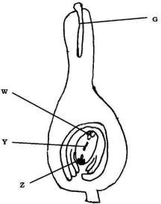

  - Name the parts labelled. (3 marks) W………………………………………………… Y………………………………………………… Z……………………………………………………
  - State two functions of parts labelled G (2 marks)
…………………………………………………………………………………………………………………………
…………………………………………………………………………………………………………………………
…………………………………………………………………………………………………………………………
…………………………………………………………………………………………………………………………

- Immediately after fertilization a fruit develops immediately, identify the hormone responsible.(8 marks)
……………………………………………………………………………………………………………………
……………………………………………………………………………………………………………………

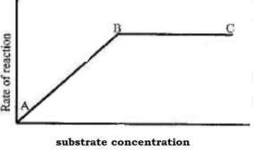
- The graph below shows the effect of a substrate concentration on the rate of enzyme reaction
- Account for the shape of the graph between.
  - A and B (3 marks)
………………………………………………………………………………………………………………………
………………………………………………………………………………………………………………………
………………………………………………………………………………………………………………………
………………………………………………………………………………………………………………………

  - Band C (2 marks)
………………………………………………………………………………………………………………………
………………………………………………………………………………………………………………………
………………………………………………………………………………………………………………………
………………………………………………………………………………………………………………………

- How can the rate of reaction be increased after point B. (1 marks)
………………………………………………………………………………………………………………………
………………………………………………………………………………………………………………………
……………………………………………………………………………………………………………………….

- State two other factors that affect the rate of enzyme reaction. (2 marks)
………………………………………………………………………………………………………………………
………………………………………………………………………………………………………………………
……………………………………………………………………………………………………………………….

- OJwang Hatari was a top student in biology, but opted for law at the university, he found himself quite often using his knowledge in genetics to solve cases of disputed paternity. A case he solved, the mother has type A blood, the child has type O blood and the alleged father has type B
- What would be the probable genotype of the parents (2 marks)
…………………………………………………………………………………………………………………
…………………………………………………………………………………………………………………
…………………………………………………………………………………………………………………

- What would be the probability of the alleged parents producing a child of blood group B. Show your working using a genetics cross (5 marks)
…………………………………………………………………………………………………………………
…………………………………………………………………………………………………………………
…………………………………………………………………………………………………………………
…………………………………………………………………………………………………………………
…………………………………………………………………………………………………………………
…………………………………………………………………………………………………………………

- Give an example of characteristic showing discontinuous variation. (1 marks)
…………………………………………………………………………………………………………………
…………………………………………………………………………………………………………………
…………………………………………………………………………………………………………………

Answer questions 6(compulsory) and either question 7or 8 in the space provided after question 8
- Two persons X and Y drank concentrated solution of glucose. The amount of glucose in their blood was determined at intervals
The results are as shown in the table below Glucose level in blood (mg/1000cm3)
 | Glucose level in blood (mg/1000cm³)
Time(minutes) | X | Y
0 | 87 | 84
15 | 112 | 123
30 | 139 | 170
45 | 116 | 188
60 | 100 | 208
90 | 95 | 202
120 | 92 | 144
150 | 88 | 123
- On the grid provided, plot graphs of glucose level in blood against time on same axes. (7 marks)

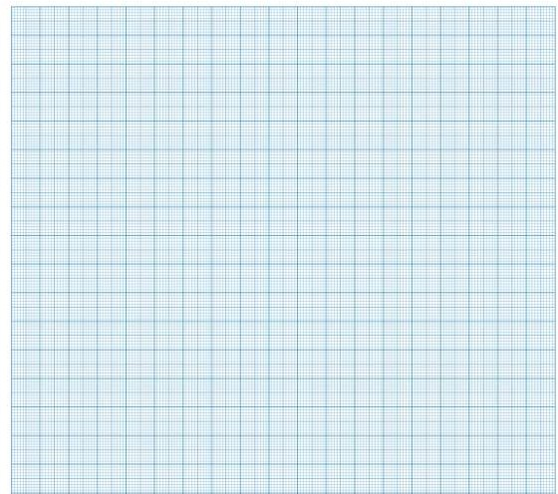
- What was the concentration of glucose in the blood of X and Y at 40th minutes. (2 marks)
……………………………………………………………………………………………………………………
……………………………………………………………………………………………………………………
……………………………………………………………………………………………………………………

- Suggest why the glucose level in person X stopped rising after 30 minutes while it continued rising in person Y.(2 marks)
……………………………………………………………………………………………………………………
……………………………………………………………………………………………………………………
……………………………………………………………………………………………………………………

- Account for the decrease in glucose level in person X after 30 minutes and person Y after 60 minutes. (3 marks)
………………………………………………………………………………………………………………………………………………………………………………………………………………………………………………………………………………………………………………………………………………………………

- Name the compound that stores energy released during oxidation of glucose .(1 marks)
………………………………………………………………………………………………………………………………………………………………………………………………………………………………………………………………………………………………………………………
F) Suggest why the skin temperature rises shortly after drinking iced water? (5 marks)
…………………………………………………………………………………………………………………………………………………………………………………………………………………………………………………………………………………………………………………………………………………………………………………………………………………………………………………………………………………………………………………………………………………………………………………………………………………………………………………………………………………………………………………………………………………………………………………………………………………………………………………………………………………………………………………………………………………………………………………………………………………………………………………………………………………………………………………………………………………………………………………………………………………

- a) Describe the process of blood clotting in human being. (10 marks)
b) Using relevant examples, describe how an allergic reaction occurs in a human being. (10 marks)
- How the human eye is structurally adapted to its function? (20 marks)

………………………………………………………………………………………………………………………………………………………………………………………………………………………………………………………………………………………………………………………………………………………………………………………………………………………………………………………………………………………………………………………………………………………………………………………………………………………………………………………………………………………………………………………………………………………………………………………………………………………………………………………………………………………………………………………………………………………………………………………………………………………………………………………………………………………………………………………………………………………………………………………………………………………………………………………………………………………………………………………………………………………………………………………………………………………………………………………………………………………………………………………………………………………………………………………………………………………………………………………………………………………………………………………………………………………………………………………………………………………………………………………………………………………………………………………………………………………………………………………………………………………………………………………………………………………………………………………………………………………………………………………………………………………………………………………………………………………………………………………………………………………………………………………………………………………………………………………………………………………………………………………………………………………………………………………………………………………………………………………………………………………………………………………………………………………………………………………………………………………………………………………………………………………………………………………………………………………………………………………………………………………………………………………………………………………………………………………………………………………………………………………………………………………………………………………………………………………………………………………………………………………………………………………………………………………………………………………………………………………………………………………………………………………………………………………………………………………………………………………………………………………………………………………………………………………………………………………………………………………………………………………………………………………………………………………………………………………………………………………………………………………………………………………………………………………………………………………………………………………………………………………………………………………………………………………………………………………………………………………………………………………………………………………………………………………………………………………………………………………………………………………………………………………………………………………………………………………………………………………………………………………………………………………………………………………………………………………………………………………………………………………………………………………………………………………………………………………………………………………………………………………………………………………………………………………………………………………………………………………………………………………………………………………………………………………………………………………………………………………………………………………………………………………………………………………………………………………………………………………………………………………………………………………………………………………………………………………………………………………………………………………………………………………………………………………………………………………………………………………………………………………………………………………………………………………………………………………………………………………………………………………………………………………………………………………………………………………………………………………………………………………………………………………………………………………………………………………………………………………………………………………………………………………………………………………………………………………………………………………………………………………………………………………………………………………………………………………………………………………………………………………………………………………………………………………………………………………………………………………………………………………………………………………………………………………………………………………………………………………………………………………………………………………………………………………………………………………………………………………………………………………………………………………………………………………………………………………………………………………………………………………………………………………………………………………………………………………………………………………………………………………………………………………………………………………………………………………………………………………………………………………………………………………………………………………………………………………………………………………………………………………………………………………………………………………………………………………………………………………………………………………………………………………………………………………………………………………………………………………………………………………………………………………………………………………………………………………………………………………………………

