
THE NAMBA EVALUATION TEST
The Kenya Certificate of Secondary School
JULY 2025
231/1 Biology Paper 1 Time: 2 Hours

Name: ……………………………………………….…… Index No: …………….....……
231/1 – Biology
Friday, 18th July, 2025
Morning
8.00 – 10.00 am

Stream: ……………….. Signature: ………............
School: ……………………………………………………
Instructions to candidates:

- Write your name, admission number, date, stream and signature in the spaces provided above.

- All answers must be written in the spaces provided in the booklet.
- This paper consists of 14 printed pages with 28 questions. Candidates should check the question paper to ascertain that all the pages are printed as indicated and that no questions are missing
- Candidate should answer the questions in English

FOR EXAMINERS USE ONLY
Questions | Maximum Score | Candidate’s Score
1-28 | 80
Answer all the questions in this paper.
1. State the importance of the following biological phenomenon in living things
(a) Irritability (1 mark)
………………………………………………………………………………………………….
(b) Seed dormancy (1 mark)
………………………………………………………………………………………………….
2. State the function of the mitochondrial cristae. (1 mark)
……………………………………………………………………………………………………
……………………………………………………………………………………………………
3. Name the disease condition caused by deficiency of:
(a) Iodine (1 mark)
……………………………………………………………………………………………………
(b) Vitamin B₁ (1 mark)
……………………………………………………………………………………………………
4. A goat and a sheep are both herbivores. Explain why the two can comfortably exist in the same ecosystem. (2marks)
…………………………………………………………………………………………………
……………………………………………………………………………………………………
……………………………………………………………………………………………………
5. State the importance of the following process that take place in the nephrons of a human kidney.
(a) Ultra-filtration. (1 mark)
……………………………………………………………………………………………………
……………………………………………………………………………………………………
(b) Selective reabsorption. (1 mark)
……………………………………………………………………………………………………
……………………………………………………………………………………………………
6. Name the respiratory structure in:
(a) The amoeba (1 mark)
……………………………………………………………………………………………………
(b) Give a reason for your answer in (a). (1 mark)
……………………………………………………………………………………………………
……………………………………………………………………………………………………
7. (a) What is cell specialization? (1 mark)
……………………………………………………………………………………………………
(b) State two adaptations of a neuron to its function. (2 marks)
……………………………………………………………………………………………………
……………………………………………………………………………………………………
……………………………………………………………………………………………………

8. The diagram below shows a bean seedling pinned in a horizontal position inside a Clinostat.
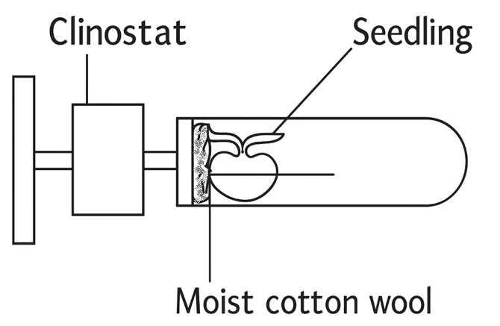
a) State the role of a Clinostat in tropism. (1 mark)
……………………………………………………………………………………………………
b) What observation would be made if the Clinostat was rotating. (1 mark)
…………………………………………………………………………………………………………………………………………………………………………………………………………
9. A lion is an exclusive carnivore. State two dental adaptations it has to its mode of feeding.
(2 marks)
……………………………………………………………………………………………………
……………………………………………………………………………………………………
……………………………………………………………………………………………………
10 a) Differentiate between primary growth and secondary growth in woody plants.
(2 marks)
……………………………………………………………………………………………………
……………………………………………………………………………………………………
b) Name two tissues responsible for secondary growth in flowering plants. (2 marks)
……………………………………………………………………………………………………
……………………………………………………………………………………………………
11. During a microscopy class a student was unable to see the field of view. State two possible adjustment she needed to make to ensure that the field of view becomes visible. (2 marks)
……………………………………………………………………………………………………
……………………………………………………………………………………………………
……………………………………………………………………………………………………
12. The diagram below represents a simplified nitrogen cycle.
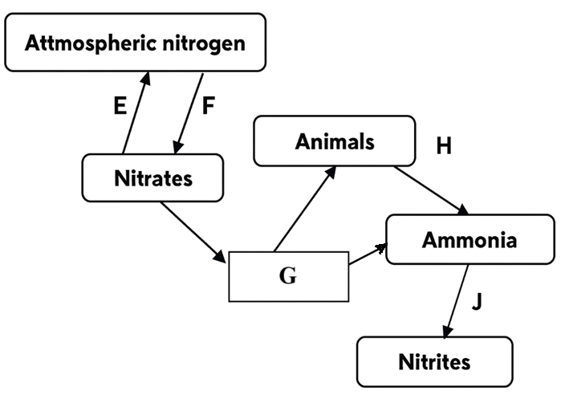
a) Name the organisms that causes process E and J. (2 marks)
(i) E ………………………………………………………………………………………
(ii) J ………………………………………………………………………………………
b) Name the process represented by F and H. (2 marks)
(i) F ………………………………………………………………………………………
(ii) H ………………………………………………………………………………………
c) Name the group of organisms represented by G. (1 mark)
……………………………………………………………………………………………………
13. Mosquitoes, grasshoppers and weevils have their mouth parts adapted to sucking, biting and piercing respectively. Name:
a) The type of evolution exhibited by the mouth parts. (1 mark)
……………………………………………………………………………………………………
b) The type of evolutionary structure. (1 mark)
……………………………………………………………………………………………………
14. Study the graph below and answer the questions that follow
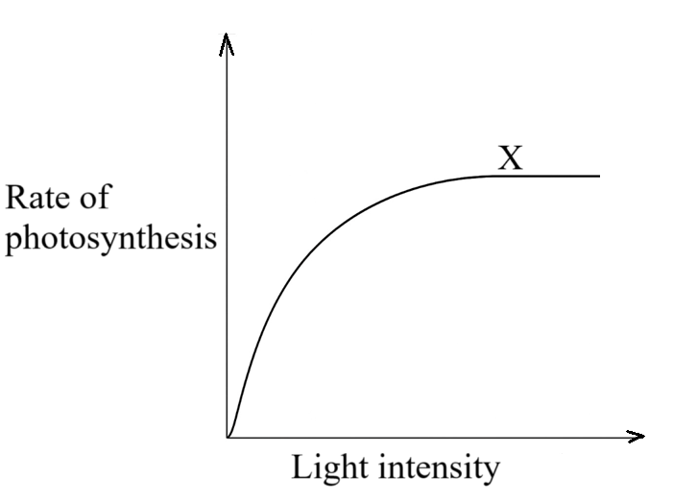
- Why does the rate of photosynthesis become constant at the point labeled X?
(2 marks)
……………………………………………………………………………………………………
……………………………………………………………………………………………………
(b) State two other factors that affect the rate of photosynthesis. (2 marks)
……………………………………………………………………………………………………
……………………………………………………………………………………………………
15. State one function of each of the following tissues.
(a) Skeletal muscle (1 mark)
……………………………………………………………………………………………………
……………………………………………………………………………………………………
(b) Sclerenchyma tissues (1 mark)
……………………………………………………………………………………………………
……………………………………………………………………………………………………
16. Explain why X-linked recessive traits tend to affect the male child commonly as compared to female child. (2 marks)
……………………………………………………………………………………………………
……………………………………………………………………………………………………
……………………………………………………………………………………………………

17. Illustrated below is the movement of material in a certain physiological process
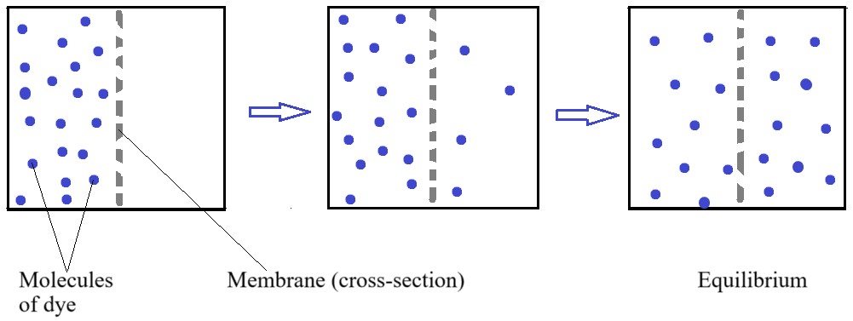

- (i) Name the physiological process illustrated above (1 mark)
……………………………………………………………………………………………………
(ii) Give two examples of applicability of the process named in (a)(i) above in plants.
(2 marks)
……………………………………………………………………………………………………
……………………………………………………………………………………………………
b) State two ways by which the movement of the dye molecules would be slowed down. (2 marks)
……………………………………………………………………………………………………
……………………………………………………………………………………………………
……………………………………………………………………………………………………
18. The scientific name of the European wild cat, a nocturnal mammal that inhabit forest of western, southern, central and Eastern Europe is Felis silvestris.Write down:

a) The scientific name of the European wild cat. (1mark)
……………………………………………………………………………………………………
b) The species name of the European wildcat. (1mark)
……………………………………………………………………………………………………
19. The diagram below illustrates a set of biological process in a green plant
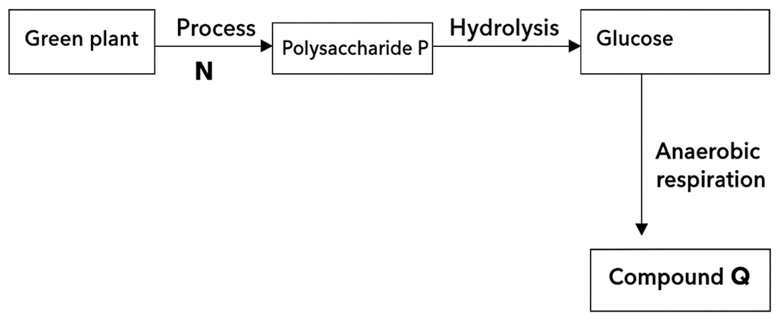
a) Name:
(i) Process N (1mark)
……………………………………………………………………………………………………
(ii) Polysaccharide P (1mark)
……………………………………………………………………………………………………
- State two conditions necessary for the formation of compound Q. (2marks)
…………………………………………………………………………………………………………………………………………………………………………………………………………

- State two environmental conditions necessary for the process N to take place.
(2 marks)
……………………………………………………………………………………………………
……………………………………………………………………………………………………
20. In an attempt to estimate the numbers of weaver birds in small woodland, 435 were captured, marked and released. Three days later, 620 were captured 75 of which were marked. Calculate the approximate size of weaver bird population in the woodland. (2 marks)
……………………………………………………………………………………………………
……………………………………………………………………………………………………
……………………………………………………………………………………………………
……………………………………………………………………………………………………
21. The diagram below represents a model used to determine breathing in mammals.
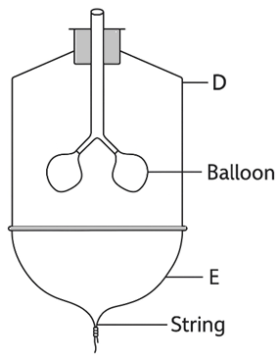
a) Name the mammalian structure represented by the part labeled D and E
(i) D (1 mark)
……………………………………………………………………………………………………
(ii) E (1 mark)
……………………………………………………………………………………………………..
b) State the observation made when the string is pulled downwards. (1mark)
……………………………………………………………………………………………………
c) Explain the observation in (b) above. (2marks)
……………………………………………………………………………………………………
……………………………………………………………………………………………………
……………………………………………………………………………………………………
22 a) What feature is absent in relay neuron that make it to be so unique from the sensory neuron? (1 mark)
…………………………………………………………………………………………………
b) Explain the significance of the feature in (a) above. (2 marks)
……………………………………………………………………………………………………
……………………………………………………………………………………………………
……………………………………………………………………………………………………
23. The following is an illustration of a flower
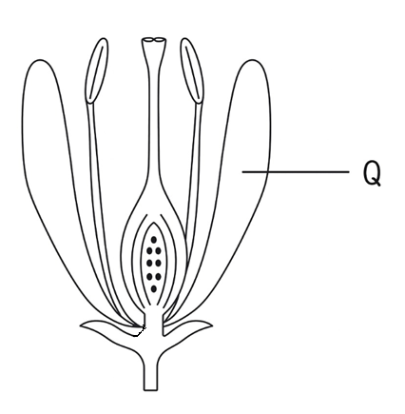
- State two ways part Q helps encourage pollination by insects. (2 marks)
……………………………………………………………………………………………………
……………………………………………………………………………………………………
……………………………………………………………………………………………………
- Give two features which promote self-pollination in the flower shown above.
(2 marks)
……………………………………………………………………………………………………
……………………………………………………………………………………………………
24. Identical twins were separated after birth and were then raised in different environments. One in Kenya and the other in U.S.A. They rejoined after 18years and they looked slightly different.
a) Name the type of variations the twins exhibited. (1 mark)
……………………………………………………………………………………………………
……………………………………………………………………………………………………
b) Give two observable differences likely to be noted between the twins. (2 marks)
……………………………………………………………………………………………………
……………………………………………………………………………………………………
25. Name the three types of skeletons found in multicellular organisms. (3 marks)
……………………………………………………………………………………………………
……………………………………………………………………………………………………
……………………………………………………………………………………………………

26. Change in soil pH can affect the rate at which plant absorbs mineral salts. Explain.
(3 marks)
……………………………………………………………………………………………………
……………………………………………………………………………………………………
……………………………………………………………………………………………………
……………………………………………………………………………………………………
27. The diagram below represents regions of a root tip
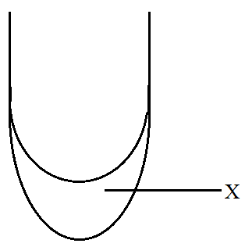

(a) Name the two regions above X in ascending order. (2 marks)
……………………………………………………………………………………………………
……………………………………………………………………………………………………
……………………………………………………………………………………………………
(b) State the function of the party labeled X. (1 mark)
……………………………………………………………………………………………………
……………………………………………………………………………………………………

28. Name the apparatus used to measure the following abiotic factors.
a) Penetration of light in water (1 mark)
……………………………………………………………………………………………………
……………………………………………………………………………………………………
b) Light intensity (1 mark)
……………………………………………………………………………………………………

