
THE NAMBA EVALUATION TEST
The Kenya Certificate of Secondary School
JULY 2025
450/1 AVIATION PAPER TIME: 2½ Hrs
Name: …………………………………….…….…… Admission No: …………
Stream: ……………….. Signature: ………............
Instructions
- Write your name, class, admission number, date and sign in the spaces provided.
- Candidate should have the following for this examination.
  - Drawing instruments.
  - Drawing paper.
- The paper consists of two Sections A and B.
- Answer all questions in Section A and any Four in Section B in the spaces provided.
- Question 11 should be answered on the drawing paper provided. All dimensions are in millimeters unless otherwise stated.
- Candidates should check the question paper to ensure that all the pages are printed as indicated and no question is missing.
- Candidates should answer the questions in English.
For Examiner’s Use Only
SECTION | QUESTION | MAXIMUM  SCORE | CANDIDATE’S  SCORE
A | 1-10 | 44
B | 11 | 14
B | 12 | 14
B | 13 | 14
B | 14 | 14
B | 15 | 14
TOTAL |  | 100

SECTION A (44 MARKS)
Answer all questions in this section.
- State two major functions of the Kenya Civil Aviation Authority (KCAA). (2 marks)
…………………………………………………………………………………………………………………………………………………………………………………………………………………………………………………………………………………………………………………………………………………………………………..
- Give two reasons for aircraft pressurization. (2 marks)
…………………………………………………………………………………………………………………………………………………………………………………………………………………………………………………………………………………………………………………………………………………………………………..
- Outline two roles of an Air Traffic Controller (ATC). (2 marks)
…………………………………………………………………………………………………………………………………………………………………………………………………………………………………………………………………………………………………………………………………………………………………………
- State two methods used to reduce drag on aircraft surfaces. (2 marks)
………………………………………………………………………………………………………………………………………………………………………………………………………………………………………………………………………………………………………………………………………………………………………….

- Differentiate between aspect ratio and wing loading. (4 marks)
………………………………………………………………………………………………………………………………………………………………………………………………………………………………………………………………………………………………………………………………………………………………………….
…………………………………………………………………………………………………………………………………………………………………………………….
- Name four common causes of metal fatigue in aircraft structures. (4 marks)
……………………………………………………………………………………………………………………………………………………………………………………………………………………………………………………………………………………………………………………………………………………………………………………………………………………………………………………………………
- List four emergency equipment found onboard a commercial aircraft. (4 marks)
………………………………………………………………………………………………………………………………………………………………………………………………………………………………………………………………………………………………………………………………………………………………………….
- With the aid of a diagram describe the wing nomenclature (6marks)
………………………………………………………………………………………………………………………………………………………………………………………………………………………………………………………………………………………………………………………………………………………………………………………………………………………………………………………………………………………………………………………………………………………………………………………………………………………………………………………………………………………………………………………………………………………………………………………………………………………………………………………………………………………………………………………………………………………………………………………………………………………………………………………………………………………………
- State two functions of a transponder in aircraft. (2 marks)
…………………………………………………………………………………………………………………………………………………………………………………………………………………………………………………………………………………………………………………………………………………………………………..
- Describe two safety precautions taken when handling aviation fuels. (4 marks)
…………………………………………………………………………………………………………………………………………………………………………………………………………………………………………………………………………………………………………………………………………………………………………
- Name four instruments found in the basic 'six pack' of a flight panel. (4 marks)
……………………………………………………………………………………………………………………………………………………………………………………………………………………………………………………………………………………………………………………………………………………………………………………………………………………………………………………………………

- Explain how the Center of Gravity (CG) position affects aircraft stability. (4 marks)
………………………………………………………………………………………………………………………………………………………………………………………………………………………………………………………………………………………………………………………………………………………………………………………………………………………………………………………………………………………………………………………………………………………………………………………………………………………………………………………………………………………………………………………………………………………………………………………………………………………………………………………………………………………………………………………………………………………………………………………………………………………………………………………………………………………………………………………………

SECTION B (56 MARKS)
Answer any FOUR questions from this section.
- Figure 2 shows a truncated hexagonal pyramid made of sheet metal and have sides measuring 60 mm. draw, HALF FULL size, the following:
- The front elevation as shown
- The plan in direction of arrow X
- The development with joint at A-A. (14 marks)
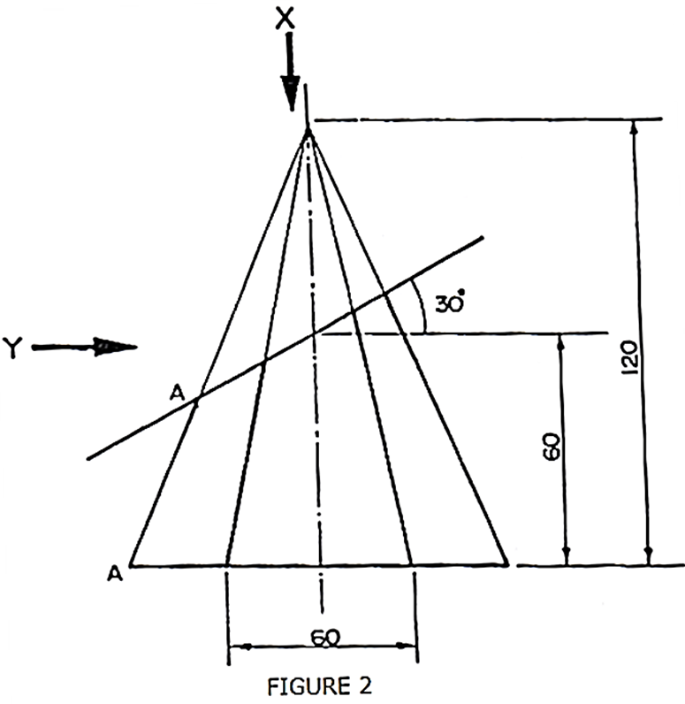

  - Explain four advantages of composite materials in aircraft manufacturing. (8 marks)
…………………………………………………………………………………………………………………………………………………………………………………………………………………………………………………………………………………………………………………………………………………………………………………………………………………………………………………………………………………………………………………………………………………………………………………………………………………………………………………………………………………………………………………………………………………………………………………………………………………………………………………………………………………………………………………………………………………………………………………………………………………………
b) Describe with sketches, three types of aircraft wing designs based on planform. (6 marks)
…………………………………………………………………………………………………………………………………………………………………………………………………………………………………………………………………………………………………………………………………………………………………………………………………………………………………………………………………………………………………………………………………………………………………………………………………………………………………………………………………………………………………………………………………………………………………………………………………………………………………………………………………………………………………………………………………………………………………………………………………………………………………………………………………………………………………………………………………………………………………………………………………………………………………………………………………………………………………………………………………………………………………………………………………………………………………………………………………………………………………………………………………………………………………………………………………………………………………………………………………………………………………………………………………………………………………………………………………………………………………………………………………………………………………………………………………………………………………………………………………………………………………………………………………………………………………………………………………………………………………………………………………………………………………………………………………………………………………………………………………………………………………………………………………………………………………………………………………………………………………………………………………………………………………
  - Define the following terms as used in aircraft engines:
i. Detonation (2marks)
………………………………………………………………………………………………………………………………………………………………………………………………………………………………………………………………………………………………………………………………………………………………………………………………

.ii. Pre-ignition (2marks)
……………………………………………………………………………………………………………………………………………………………………………………………………………………………………………………………………………………………………………………………………………………………………………………………………………………………………………………………………………………………………………
iii. Volumetric efficiency. (2marks)
……………………………………………………………………………………………………………………………………………………………………………………………………………………………………………………………………………………………………………………………………………………………………………………………………………………………………………………………………………………………………………
b) With the aid of a labeled diagram, explain the working of a four-stroke cycle piston engine. (8 marks)
…………………………………………………………………………………………………………………………………………………………………………………………………………………………………………………………………………………………………………………………………………………………………………………………………………………………………………………………………………………………………………………………………………………………………………………………………………………………………………………………………………………………………………………………………………………………………………………………………………………………………………………………………………………………………………………………………………………………………………………………………………………………………………………………………………………………………………………………………………………………………………………………………………………………………………………………………………………………………………………………………………………………………………………………………………………………………………………………………………………………………………………………………………………………………………………………………………………………………………………………………………………………………………………………………………………………………………………………………………………………………………………………………………………………………………………………………………………………………………………………………………………………………………………………………………………………………………………………………………………
16.a) Explain four factors that affect take-off performance of an aircraft. (8 marks)
……………………………………………………………………………………………………………………………………………………………………………………………………………………………………………………………………………………………………………………………………………………………………………………………………………………………………………………………………………………………………………………………………………………………………………………………………………………………………………………………………………………………………………………………………………………………………………………………………………………………………………………………………………………………………………………………………………………………………………………………………………………………………………………………………………………………………………………………………………………………………………………………………………………………………………………………………………………………………………………………………………………………………………………………………………………………………………………………………………………………………………………………………………………………………………………………………………………………………………………………………………………………………………………………………………………………………………………………………………………………………………………………………………………………………………………………………………………………………………………………………………………………………………………………………………………………………………………………………………………………………………………………………………………………………………………………………………………………………………………………………………………………
b) An aircraft with a wing area of 25 m², a lift coefficient of 0.5, and a flight speed of 180 knots is flying at sea level. Calculate the lift generated. (Use air density = 1.225 kg/m³).
(6 marks)
………………………………………………………………………………………………………………………………………………………………………………………………………………………………………………………………………………………………………………………………………………………………………………………………………………………………………………………………………………………………………………………………………………………………………………………………………………………………………………………………………………………………………………………………………………………………………………………………………………………………………………………………………………………………………………………………………………………………………………………………………………………………………………………………………………………………………………………………………………………………………………………………………………………………………………………………………………………………………………………………….
17.a) Define the following terms as used in navigation: (6 marks)
i. Magnetic variation
ii. Compass deviation,
iii. True course.
b) An aircraft is flying with a heading of 065° and TAS of 140 knots. The wind is from 320° at 25 knots. Use the wind triangle method to calculate track and groundspeed. (8 marks)

