MATHEMATICS FORM FOUR PAPER 2
MARKING SCHEME
No | Working | Marks
1 | $$\log{5^{2}-\log{{16}^{\frac{1}{2}}+\log{{40}^{2}}}}$$  $$\log\left(\frac{25×1600}{4}\right)$$  $$\log{10^{4}=4}$$ | M1  M1  A1
2 | - ${{\left(2+x\right)}^{5}=1(2)}^{5}{(x)}^{0}+{5(2)}^{4}{(x)}^{1}+{10(2)}^{3}{(x)}^{2}+…$  $$=32+80x+{80x}^{2}+…$$  - $1.{97}^{5}={(2-0.03)}^{5}$  $$x=-0.03$$  $${\left(2-0.03\right)}^{5}=32+80\left(-0.03\right)+80{\left(-0.03\right)}^{2}$$  $$=32-2.4+0.072=29.67$$ | B$1$  M1  M1  A1
3 | $$A=200 000{\left(1.07\right)}^{4}$$  $=262 159.20$  Interest = $262 159.20-200 000$  $=Sh. 62 159.20$ | M1  M1  A1
4 | 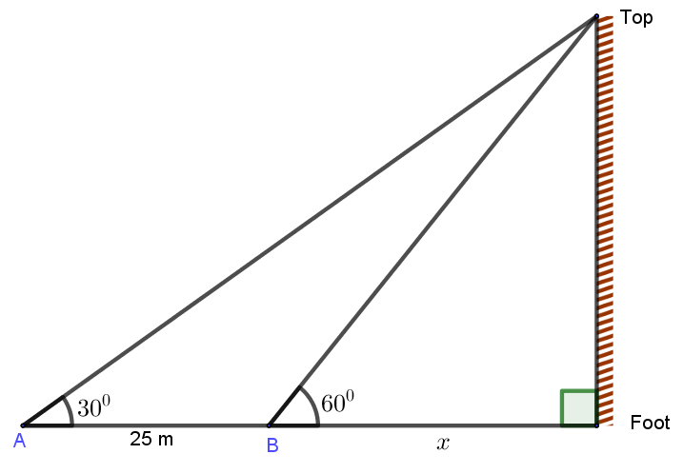  $$\tan{60=\frac{h}{x}}$$  $h=x tan 60$ ....... (i)  $$\tan{30=\frac{h}{x+25}}$$  $h=\left(x+25\right)\tan{30}$ ...... (ii)  $$equating \left(i\right)and (ii)$$  $$1.732x=0.5774x+14.43$$  $$x=14.43÷1.1546=12.50 m$$  $$h=12.50×1.732=21.65 m$$ | M1  M1  A1
5 | $$\frac{\sqrt{5}}{\sqrt{7}-\sqrt{2}}×\frac{\sqrt{7}+\sqrt{2}}{\sqrt{7}+\sqrt{2}}$$  $$\frac{\sqrt{35}+\sqrt{10}}{7-2}=\frac{\sqrt{35}+\sqrt{10}}{5}$$ | M1  A1
6 | - $4x-9≤x+6$  $$4x-x≤6+9$$  $x≤5$  $$4+x≥8-3x$$  $$x+3x≥8-4$$  $$x≥1$$  $$1≤x≤5$$  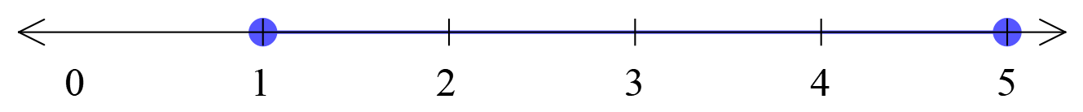 | M1  M1  A1  B1
7 | $$2s=2ut+at^{2}$$  $$⟹at^{2}+2ut-2s=0$$  $$solving quadratically,$$  $$t=\frac{-2u±\sqrt{4u^{2}+8as}}{2a}$$ | M1  M1  A1
8 | Cost per Kg = $\frac{\left(350×84\right)+\left(140×105\right)}{350+140}=Sh. 90$  Selling price = $\frac{125}{100}×90=Sh. 112.50$ | M1 M1  A1
9 | - $m_{x=1.5}=3$  - $m_{x=-0.8}=-1.6$  NB. Right angled triangle must be shown for both cases | M1 A1  M1 A1
10 | - Period = $\frac{360}{1}=360°$  - Phase angle = $30°$ | B1  B1
11 | $$10,12,13,14,15,17$$  $$Q_{1}=12$$  $$Q_{3}=15$$  Interquartile range = $15-12=3$ | M1  A1
12 | $$UW=\sqrt{{4.5}^{2}+8^{2}}=9.18 cm$$  $$\tan{α=\frac{RW}{UW}=\frac{6}{9.18}}$$  Angle RUW = $\tan^{-1}\left(\frac{6}{9.18}\right)=33.2°$ | M1  M1  A1
13 | $$\overset{⃑}{OP}=\left(i+2j-k\right)-3\left(4i-j+2k\right)+\left(2i+3k\right)$$  $$=\left(i-12i+2i\right)+\left(2j+3j\right)+\left(-k-6k+3k\right)$$  $$=-9i+5j-4k$$  $$\vec{OP}=\left(\begin{matrix}-9 \\ 5 \\ -4\end{matrix}\right)$$  Co ordiantes of P are $(-9, 5, -4)$ | M1  M1  A1
14 | P(r) = $\frac{x}{14}$  $$P\left(r\right)⟹\frac{x-4}{10}=\frac{2}{5}$$  $$5\left(x-4\right)=20$$  $$x=8$$ | M1  M1  A1
15 | Area of sector ABC = $\frac{75}{360}×\frac{22}{7}×{14}^{2}=128.33 cm^{2}$  Area of triangle ABD = $0.5×14×22×\sin{75=148.75 cm^{2}}$  Area of unshaded = $148.75-128.33=20.42 cm^{2}$ | M1  M1  A1
16 | Actual value = $\frac{2.3+8.7}{2.2}=5$  Maximum value = $\frac{2.35+8.75}{2.15}=5.163$  Minimum value = $\frac{2.25+8.65}{2.25}=4.844$  Absolute error = $\frac{5.163-4.844}{2}=0.1595$  Percentage error = $\frac{0.1595}{5}×100\%=3.19\%$ | M1  M1  M1  A1
17 | - $m=kr^{2}h$  $$r_{1}=3r and h_{1}=0.5h$$  $$m_{1}=k{r_{1}}^{2}h_{1}=k{\left(3r\right)}^{2}\left(0.5h\right)=4.5kr^{2}h$$  $$m_{1}=4.5m$$  Percentage change = $\left(\frac{4.5m-m}{m}\right)×100\%$  $=350\%$  - (i) $m=kr^{2}h$  $k=\frac{m}{r^{2}h}=\frac{990}{3^{2}×7}=\frac{110}{7}$  $$m=\frac{110}{7}r^{2}h$$  (ii) $m=\frac{110}{7}×{3.5}^{2}×5=962.5 g$  - Volume = $πr^{2}h=\frac{22}{7}×{3.5}^{2}×5=192.5 cm^{3}$  Density = $\frac{mass}{volume}$  $$=\frac{962.5 g}{192.5 cm^{3}}$$  $$=5 g/cm^{3}$$ | M1  M1  A1  M1  M1 A1  M1 A1  M1  A1
18 | 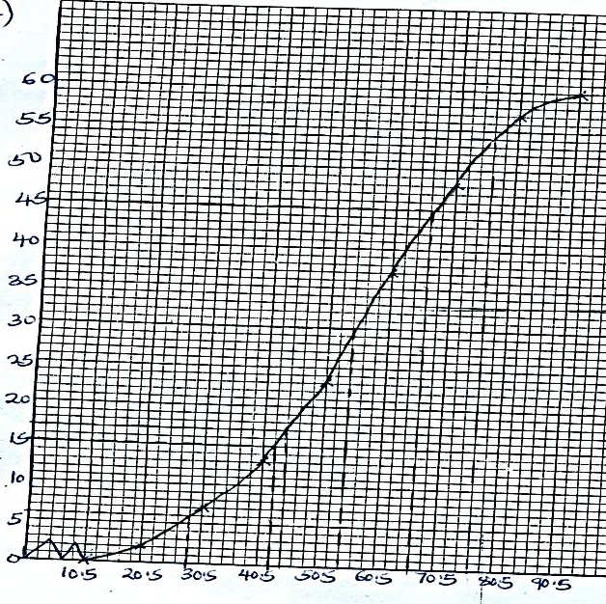  - (i) Median mark = 54.5  (ii) $Q_{1} = 42.5$  $Q_{3} = 66.5$  Quartile deviation $=\frac{Q_{3}-Q_{1}}{2}$  $$=\frac{66.5-42.5}{2}=12$$  (iii) $76.5-28.5=48$  - $\frac{\left(60-17\right)}{60}×100\%=72 \%$ | M1  M1 A1  M1 A1  M1 A1
  Marks | $$f$$ | Cumulative frequency | LCL
   |  | 0 | 10.5
  $$11 – 20$$ | 2 | 2 | 20.5
  $$21 – 30$$ | 5 | 7 | 30.5
  $$31 – 40$$ | 6 | 13 | 40.5
  $$41 – 50$$ | 10 | 23 | 50.5
  $$51 – 60$$ | 14 | 37 | 60.5
  $$61 – 70$$ | 11 | 48 | 70.5
  $$71 – 80$$ | 9 | 57 | 80.5
  $$81 – 90$$ | 3 | 60 | 90.5
19 | - $23=a+5d$ .... (i)  $50=a+14d$ ...... (ii)  $$50=\left(23-5d\right)+14d$$  $$27=9d$$  $$d=3$$  $$a=23-15=8$$  - $n=8+10\left(3\right)$  $=38 seats$  - $S_{n}=\frac{n}{2}\left(2a+\left(n-1\right)d\right)$  $$S_{20}=\frac{20}{2}\left\{16+\left(20-1\right)3\right\}$$  $$=10\left(16+57\right)$$  $$=730 seats$$
20 | - Area of hemisphere = $2×3.142×35^{2}=7 697.9 cm^{2}$  - Let the slant height of the smaller cone cut be $x$  $\frac{x}{x+60}=\frac{15}{35}$  $$35x=15x+900$$  $$x=45 cm$$  Slant height of bigger cone = 45 + 60 =105 cm  - S.A = $π\left(RL-rl\right)$  $$=3.142\left(\left(35×105\right)-\left(15×45\right)\right)$$  $=9 426 cm^{2}$  - Area of circular base = $3.142×{15}^{2}=706.95 cm^{2}$  - T.S.A = $7 697.9+9 426+\left(3.142×{15}^{2}\right)=17 830.85 cm^{2}$ | M1 A1  M1  A1  M1  A1  M1 A1  M1 A1
21 | - Taxable income $35 500+15 600=Sh. 48 100$  - PAYE  1st band = $13 450×0.1=Sh. 1 345$  2nd band = $12 900×0.15=Sh. 1 935$  3rd band = $12 900×0.20=Sh. 2 580$  4th band = $8 850×0.25=Sh. 2 212.50$  Gross tax = $1 345+1 935+2 580+2 212.50=sh. 8 072.50$  PAYE = $8 072.50-1 845=Sh. 6 227.50$  - Net salary = Gross pay – All deductions  Gross pay $= 48 100 + 5 872 = Sh. 53 972$  Net pay = $53 972-\left(6 227.50+1 000+455+200\right)$  $$=Sh. 46 089.50$$ | M1 A1  M1  M1  M1  M1 A1  M1  M1  A1
22 | 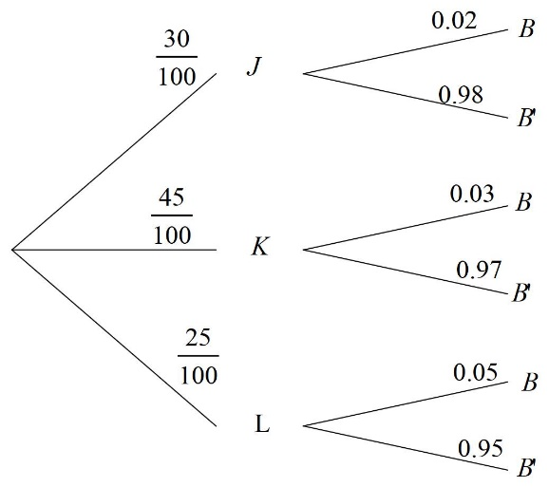  - (i) P$\left(JB^{'}\right)=\frac{30}{100}×\frac{98}{100}$  $$=\frac{147}{500}$$  $(ii)$ $P\left(B\right)=P\left(KB\right)+P\left(JB\right)+P\left(LB\right)$  $=\left(\frac{45}{100}×\frac{3}{100}\right)+\left(\frac{30}{100}×\frac{2}{100}\right)+\left(\frac{25}{100}×\frac{5}{100}\right)$  $=\frac{27}{2000}+\frac{3}{500}+\frac{1}{80}$  $=\frac{4}{125}$  (iii) $P\left(JB\right) or P\left(LB\right)=\left(\frac{30}{100}×\frac{2}{100}\right)+\left(\frac{25}{100}×\frac{5}{100}\right)$  $=\frac{3}{500}+\frac{1}{80}$  $=\frac{37}{2000}$ | B1  B1  M1 M1  A1  M  M1  A1  M1  A1
23 | - $∠AEC=90°$  Angle subtended by the diameter on the circumference  - $∠CAB=50°$  Angle subtended in alternate segment by same chord are equal  - $∠ADB=60°$  Angle subtended by a chord on the circumference is half of the angle subtended by the same chord at the centre of the circle.  - $∠BCD=180°-50°=130°$  Opposite angles in a cyclic quadrilateral are supplementary  - Reflex $∠AOB=360°-120°=240°$  Angles at a point add up to $360°$ | B1  B1  B1  B1  B1  B1  B1  B1  B1  B1
24 | - Angle PAQ $=2×42=84°$  Angle PBQ $=2×30=60°$  - Area of sector APQ $=\frac{84}{360}×\frac{22}{7}×36=26.4 cm^{2}$  Area of sector PBQ $=\frac{60}{360}×\frac{22}{7}×64=33.52 cm^{2}$  - Area of triangle APQ $=\frac{1}{2}×36×\sin{84=17.90 cm^{2}}$  Area of triangle APQ $=\frac{1}{2}×64×\sin{60=27.71 cm^{2}}$  - Area of shaded region $=\left(26.4-17.90\right)+\left(33.52-27.71\right)$  $=8.5+5.81$  $=14.31 cm^{2}$ | M$1$  M1  M1  M1  M1  M1  M1 M1  M1  A1

