Metals
1. a) chlorine gas would react with steel anode
²⁴
¹¹

Na

Na
b) Hood and steel gauze prevent chlorine sodium, from anode and cathode from mixing
and reacting.
- Sodium metal is less dense, floats on motten brine where it is siphoned out.
c) -To Whom It May Concern: melt the ore, rock salt
- For electrolysis of the molten ore
2. a) SO_{2(g)} is produced as a by- product, this mixes with rain water producing acid rain which
may corrode buildings and affect plants √ ½
SO_{2(g)} is poisonous when inhaled √ ½
b) - H₂SO₄ manufacture – to make use of SO_{2 (g)}
- Manufacture of dry cells – make use of zinc
- Production of iron sheets which are galvanized using zinc (Any one with an explanation)
c) Low density, does not corrode easily, duchle, malleable (Any 2 each ½ mark)
3. Aluminium is lighter/low density. (any)
 1
It is a good conductor of electricity
4. Stage 1 – oxidation; Coke is oxidized to CO
 ½
 ½
Stage 2 – Reduction: zinc is reduced to Zinc metal
 ½
 ½
Stage 3;- Recycling stage; CO₂ is reduced to regenerate CO

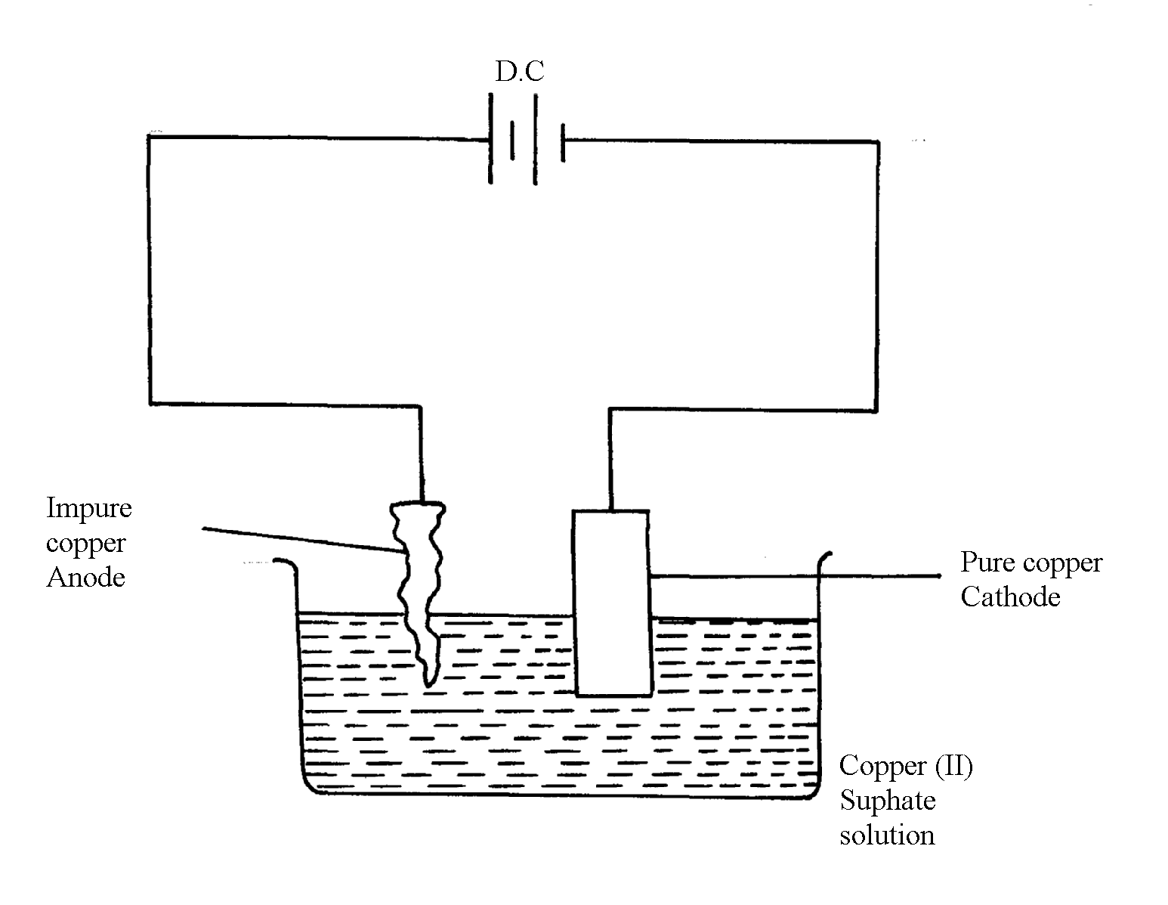
5. a) Q is sulphur (IV) oxide SO₂(g). ^{√1}

b)

- Impure copper is the while pure copper is cathode. During electrolysis impure copper is purified and pure copper deposited on the cathode as shown in the half electrode reaction below;
CATHODE EQUATION:
Cu²⁺ + 2e Cu(s) ^{√½}
- The cathode is therefore removed and replaced after an interval.

6. (i) I-I-I-tetrachloromethane /Tetrachloromethane
(ii) Chloric (I) acid
 1

7. Oxide of W has simple molecular structure while that of Z has giant ionic structure

8. (a) Froth floatation. √1 (1 mk)
(b) PbCO_{3(s)} PbO_{(s)} + CO_{2(g)} (1 mk)
(c) Making of pipes/lead acid accumulators. √1 (any one) 3

9. a) bauxite√
b) Copper pyrites √

10. i)
ii) I It’s uneconomic// Expensive// a lot of energy is required to produce this
high temperature
II Addition of cryolite √ ½ mark

iii) The melting point is below 800 C √ ½ mark
11. (a) (i) Bauxite
(ii) Iron (III) Oxide
 1
Silica (any one)
(b)(i) On the diagram
 1
(ii) It is expensive /a lot of energy will be used
 1
(iii) The ore is dissolved in cryolite (NaAlF₆)
12. (i) Bauxite – Al₂O₃. H₂O
(ii) Iron II oxide
- Silica
(iii) Being ionic, it is only an electrolyte in its molten state. Heating helps to melt it.
(iv) (a) – The two rods represent the anode.
- Cathode is the inner lining of the wall.
(b) As an impurity, lowering the melting point of aluminium oxide.
(c) Anode 2O₂-(l) O_{2(g)} + 4e⁻
Cathode Al³⁺ + 3e⁻ Al_{(l)}
d) – manufacture of household utensils
- making cables for electricity transmission
- making foils used as wrappers
- extraction of some metals e.g. manganese
- Making aeroplane parts

Describe how you would establish the presence of copper in the ore
13. (a) CuFes₂
(b) Froth floatation
(c) 2CuFeS_{(s)} + 4O₂ _{(g)} + Cu₂S + 2FeO_{(s)} + 3SO_{2 (g)}
(d) Silica is added which reacts with iron (II) Oxide to form iron (II) silicate which forms
part of slag or SiO₂ is added

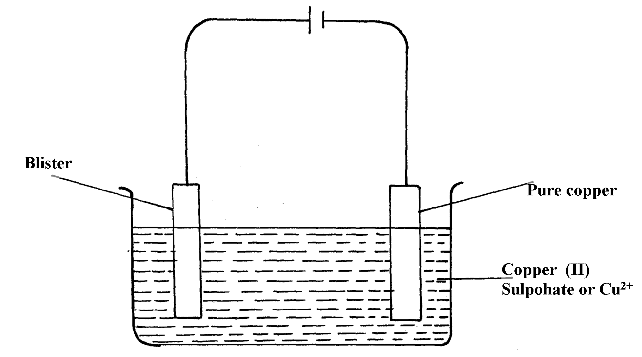
(e) Anode Cu_{(s)} Cu²_{+(aq)} + 2e⁻
Cathode Cu²⁺_{(aq)} + 2e- Cu_{(s)}

(g) – Add HNO₃ to the ore
- Filter and place small portion of the filtrate into a test tube
Add NH₄OH until in excess – deep blue solution confirms the presence of Cu²⁺ions
14. (a) (i) Gas Q- Carbon (II) Oxide
(ii) Liquid R- dilute sulphuric acid
(iii) Residue S – excess Zinc metal

(b) Zinc blende

(c) (i) To increase percentage of Zinc in the ore
(ii) The ore is crushed, mixed with water and oil and then air is blown into the mixture.

(d) (i) 2ZnS_{(s)} + 3O_{2(g)} ZnO_{(s)} + 2SO_{2(g)}
(ii) Zn_{(s)} + H₂SO_{4(aq)} ZnSO_{4(aq)} + H_{2(g)}

(e) (i) - Lead (II) sulphate //Pbs
- Silica //silicon (IV) oxide// SiO2
(ii) Lead (II) sulphide
2PbS_{(s)} + 3O_{2(g)} 2PbO_{(s)} + 2SO_{2(g)}

(f) (i) 45 x 250000
100
= 112,500g of ZnS

(ii) Rmm of ZnS = (65.4 + 32) – 97.4g
From the equation
The mole ration of Zn of ZnS: SO₂ = 1:1
97.4g of ZnS = 24dm³ of SO₂ at r.t.p
112,500g of ZnS = 112,500 x 24
97.4
= 27,720. 73920dm³ of SO₂

15. a) i) Zinc Blende (Penalize for formula only)
ii) Lead II Sulphide

b) It is concentrated by froth floatation where the ore is crushed or ground, a detergent
added and the mixture agitated. Zinc sulphide floats and is collected

c) 2ZnS_{(g)} + 3 O_{2(g)} __________ 2 ZnO_{(g)} + 2SO_{2(g)}

d) Zinc oxide is reduced by both carbon and carbon (ii) Oxide to zinc vapour. Lead (ii) Oxide is
also reduced by both carbon and carbon (ii) Oxide to lead liquid

Accept equations
ZnO_{(g)} + C_{(s)} ___________ Zn_{(g)} + CO _{(g)}

ZnO_{(g)} + CO_{(g)} __________ Zn_{(g)} + CO_{2(g)}

PbO_{(g)} + C_{(s)} ____________ Pb_{(L)} + CO_{(g)}

PbO_{(s)} + CO _____________ Pb_{(L)} + CO_{2(g)}

e) W = Sulphur (vi) Oxide // SO_{3(g)}
M= Conc. Sulphuric (Vi) acid // H₂SO_{4(L)}

f) H₂S₂O_{7(L)} + H2_{O(L)} ___________ 2H₂SO_{4(L)}
g) The process is highly exothermic and heat produced boils the acid leading to acid mist
which cannot be condensed easily because it is highly unstable
h) The sulphur (iv) Oxide dissolves in water to form acid rain which corrodes buildings and
affects aquatic life
16. (a) Purification and concentration.
(b) (i) Bauxite
(ii) Iron (III) Oxide /Silicon (IV) Oxide
(c) On diagram
(d) Lowers the melting point of the ore from 2015⁰c – 900⁰c.

17. ) Q = It = 3 x 10 x 60 = 1800
3F = 3x 96500c = 27g
∴1800c = 1800 x 27
3 x 96500
= 0.16788g

18. a) Zinc blende

b) i)
I- carbon IV oxide
II – Dil sulphuric acid
III – unreacted zinc

ii) To reduce zinc oxide to zinc metal

iii) Silica

iv)
I 2ZnS + 30 ________ 2ZnO(s) + 250 2(g)

II 2ZnO(q) + C(g) ________ 2Zn(q) + CO2(g)

v)Zn(g) + H2SO4(aq) ________ ZnSO4(aq) + H2(g)

vi) 45/100 x 250 = 112.5x1000 = 112500g
= 112.5 Kg

vii) – Used to make brass
- Used to make electrodes in dry cells
- Galvanize iron sheets

19. a) i) - Effervescence, a colorless gas is produced
- Grey solid dissolves, a colorless solution is formed
ii) Nitric acid is a strong oxidizing agent. It will oxidize the hydrogen gas formed to
form water instead

iii) I Zn_{(g)} + 2HCl_{(aq)} _________ ZnCl_{2(aq)} + H_{2(g)}
II Moles of Zn = 0.5g = 0.007692
65.0
Moles of HCL = 0.007692 X 2 = 0.015384
3 moles of HCl has 1000 cm³
0.015384 moles has 0.015384 X 1000cm³
3
= 5.182cm³
20. (a) P – Chlorine ( ½ )
Q – Sodium (½)
(b) Prevent reaction between sodium and chlorine
(c) Na⁺_{(l)} + e⁻ Na_{(l)}

21. (a)
B.E  ½
S.S  ½
(b) Pb^{2+ (l)} + 2e⁻ Pb_{(s)}
+
-
(c)
1

22. a) zinc blende√ ½
Calcium √ ½
b)2ZnS_{(s)} + SO_{2(g)} 2 ZnO _{(s)} + 2 SO₂ (g)√ 1 (penalize ½ if states are missing)

ZnCO₃ (s) ZnO _{(s)} + CO_{2(g)√}1 (penalize ½ if states are missing)

23. a) Iron III hydroxide
b) Concentrated sodium hydroxide is added at 4 atm pressure to the Bauxite at 160C
AL₂0₃ dissolves in the sodium hydroxide leaving the iron III oxide as a solid

24. a) i) The oxygen produced at the anode reacts with hot carbon to form carbon (iv) oxide hence
corrodes it therefore needs replacement
ii) Graphite is inert and a poor conductor of heat hence helps to conserve heat

b) Aluminum has more number of valency electrons which are delocalized

