NAME: …………………………………………. INDEX NO: ……………………………….

DATE : …………………………………..CANDIDATE’S SIGNATURE:…………………

MANGU HIGH SCHOOL TRIAL 4 MOCK 2025

121
MATHEMATICS
FORM 4 PAPER 2
TIME: 2 ½ HOURS
Kenya Certificate of Secondary Education 2025
INSTRUCTIONS TO CANDIDATES
- Write your name and admission number in the spaces provided at the top of this page.
- This paper consists of two sections: Section I and Section II.
- Answer all questions in section I and any five questions in Section II.
- Show all the steps in your calculations, giving your answers at each stage in the spaces below each question.
- Marks may be given for correct working even if the answer is wrong.
- KNEC Mathematical tables may be used.
For Examiner’s Use Only
1 | 2 | 3 | 4 | 5 | 6 | 7 | 8 | 9 | 10 | 11 | 12 | 13 | 14 | 15 | 16 | Total

17 | 18 | 19 | 20 | 21 | 22 | 23 | 24
Grand
Total

SECTION I (50 Marks)
Answer all questions in this section.
- Without using mathematical tables or a calculator, evaluate:
$2\log{5-\frac{1}{2}\log{16+2\log{40}}}$. (3 marks)

- a) Expand and simplify the binomial expression $({2+x)}^{5}$ upto the term in $x^{3}$. (2 marks)

b) Use your expression to estimate the value of $({1.97)}^{5}$ (2 marks)

- Find the interest on Ksh. 200,000 for 2 years at 14% per annum compounded semi-annually. (3 marks)

- At point A, Grace observed the top of a flag post at an angle of $30°$. After walking 25 m towards the foot of the flag post, she stopped at point B where she observed it again at angle of $60°$. Find the height of the flag post. (3 marks)

- Simplify $\frac{\sqrt{5}}{\sqrt{7-}\sqrt{2}}$ (2 marks)

- (a) Find the range of values of which satisfies the following inequalities simultaneously (3 marks)
$$4x-9≤x+6$$
$$4+x≥8-3x$$

(b) Represent the range of values of in (a) above on a number line. (1 mark)

- Make t the subject of the formula; $s=ut+\frac{1}{2}at^{2}$ (3 marks)

- A trader mixes 350 kg of beans type A costing Sh. 84 per Kg with 140 kg of beans type B costing Sh. 105 per Kg. Calculate the selling price per kg of the mixture if the trader makes a profit of 25% (3 marks)

- The figure below is a graph of $y={2x}^{2}$ for $-1.5≤x≤2.5$. 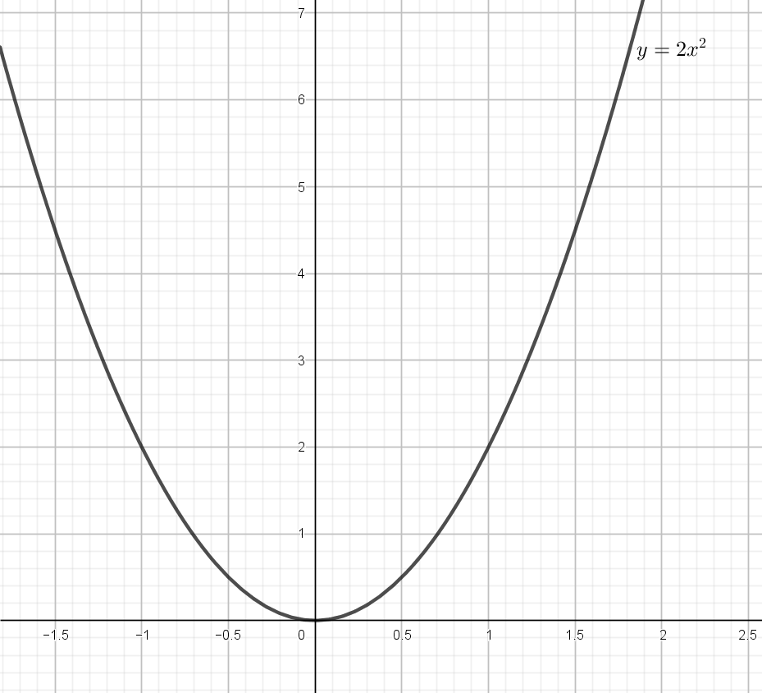
Use the graph to find the gradient at:
- $x=1.5$ (2 marks)

- $x=-0.8$ (2 marks)

- Given the function $y=2\cos\left(x+30°\right)$ for $0°≤x≤540°$, state:
- The period (1 mark)

- The phase angle (1 mark)

- Determine the interquartile range for the following set of numbers (2 marks)
$$10,15,14,17,12,13$$

- The diagram below represents a cuboid PQRSTUVW in which UV = 4.5cm, VW = 8cm and WR = 6cm

Calculate the size of the angle between the lines UR and UW (3 marks)

- Given that $r=i+2j-k, s=4i-j+2k, t=2i+3k$ and O is the origin, determine the coordinates of P if $OP=r-3s+t$. (3 marks)

- Bag contains 14 beads of which $x$ are red and the remainder blue .When 4 Red beads are removed ,the probability of selecting a red bead is $\frac{2}{5}$ .Find the value of $x$ (3 marks)

- Calculate the area of the unshaded region given that AC is an arc of a circle centre B. Given that AB = BC = 14cm, CD = 8cm and angle $ABD=75°$ (3 marks)
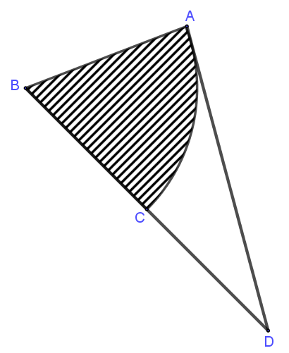

- If $A=2.3, B=8.7 and C=2.2$, find the percentage error in $\frac{A+B}{C}$ (4 marks)

SECTION B (50 Marks)
- The mass, m, grams of a cylinder varies jointly as the square of its radius, r, and its height, h.
- Find the percentage change in the mass if the radius is tripled and the height is halved. (3 marks)

- Given that $m = 990g$ when $r= 3cm$ and $h=7cm$;
- Find the equation connecting m, r and h. (3 marks)

- Calculate the value of m when r =3.5cm and h =5cm. (2 marks)

- Taking $π=\frac{22}{7}$ calculate the density of the cylinder (2 marks)

- The table below shows the distribution of marks scored by 60 students in a test.
Marks | 11-20 | 21-30 | 31-40 | 41-50 | 51-60 | 61-70 | 71-80 | 81-90
Frequency | 2 | 5 | 6 | 10 | 14 | 11 | 9 | 3
- On the grid provided draw a cumulative frequency curve of the data. (3 marks)
(Take 1cm to represent 5 students on the vertical scale and 1 cm to represent 10 marks on the horizontal scale).


- From the curve in (a) above
- Estimate the median mark (1 mark)

- Determine the quartile deviation. (2 marks)

- Determine the 10th and 90th percentile range. (2 marks)

- It is given that students who score over 45 marks pass the test. Use your graph in (a) above to estimate the percentage of students that pass. (2 marks)

- Seats in the theatre area arranged in rows. The number of seats in this theatre form the terms of an arithmetic series.
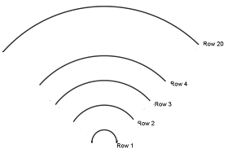
The sixth row has 23 seats and the fifteenth row has 50 seats. The theatre has 20 rows in total. Find:
- The number of seats in the first row. (4 marks)

- The number of seats in the eleventh row. (2 marks)

- The number of seats in this theatre. (4 marks)

- The figure below represent a model of a solid structure in the shape of a frustum of a cone with a hemispherical top. The diameter of the hemispherical part is 70cm and is equal to the diameter of the top of the frustum. The frustum has a base diameter of 30 cm and slant height of 60 cm (use $π$ = 3.142)
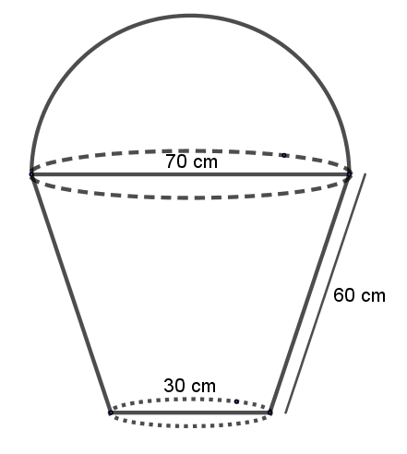
Calculate
- The area of the hemispherical surface. (2 marks)

- The slant height of cone from which the frustum was cut. (2 marks)

- The surface area of the frustum. (2 marks)

- The area of the base (2 marks)

- The total surface area of the model. (2 marks)

- The table below shows income tax rates in a certain year.
Taxable Income (Ksh per month) | Tax Rate (%)
$0 - 13 450$ | 10
$13 451 - 26 350$ | 15
$26 351 - 39 250$ | 20
$39 251 - 52 150$ | 25
$52 151 and above$ | 30
In that year, the monthly earnings for Amilo were as follows: basic salary Ksh 35 500, House allowance Ksh 12 600 and other allowances that amount to Ksh. 5 872 were exempted from taxation. Amilo contributes 12.5% of her basic salary to a pension scheme. She is entitled to a personal tax relief of Ksh 1 845 per month. Calculate:
  - Amilo’s taxable income in Ksh per month. (2 marks)

  - Amilo’s P.A.Y.E that month. (5 marks)

  - Amilo’s net pay that month, given that the following are deducted monthly from her salary; (3 marks)
NHIF – Ksh 1000,
Union dues – Kshs 455
BBF – Ksh 200.

- Machine K makes 45% of the biscuits. Machine J makes 30% of the biscuits. The rest of the biscuits are made by machine L. It is known that 2% of the biscuits made by machine J are broken, 3% of the biscuits made by machine K are broken and 5% of the biscuits made by machine L are broken. A biscuit is selected at random.
- Draw a tree diagram to illustrate all the possible outcomes and associated probabilities. (2 marks)

- Using the tree diagram, calculate the probability that the biscuit is:
- Made by machine J and is not broken. (3 marks)

- Broken. (3 marks)

- Broken but not made by machine K. (2 marks)

- The diagram below shows a circle center O. BF is a tangent to the circle at B. Angle ${DAC=20}^{0}$ and angle $FBD={50}^{0}$
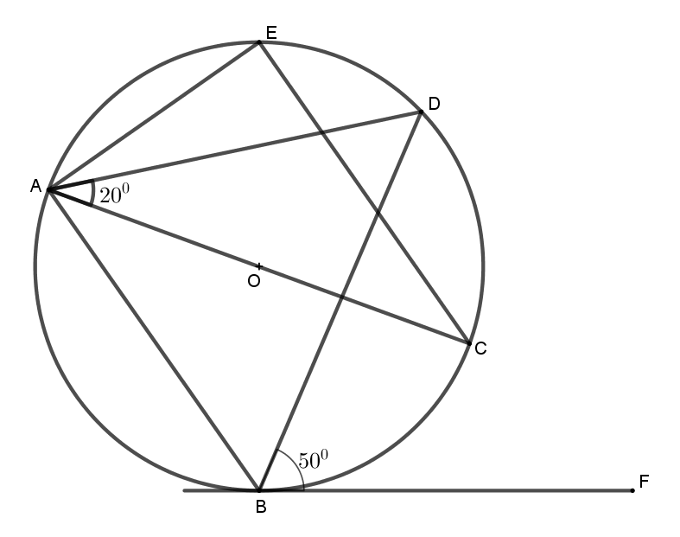

Giving reasons in each case, find;
- Angle AEC (2 marks)

- Angle CAB (2 marks)

- Angle ADB (2 marks)

- Angle BCD (2 marks)

- Angle AOB (reflex) (2 marks)

- The figure below shows two circles centres A and B and radii 6 cm and 8 cm respectively. The circles intersect at P and Q. Angle PAB = 42⁰ and angle ABQ = 30⁰.

42º
30º
B
8cm
6cm
Q
A
P

- Find the size of angle PAQ and angle PBQ. (2 marks)

- Calculate, to one decimal place the area of:
- Sector APQ and PBQ. (2 marks)

- Triangle APQ and PBQ. (2 marks)

- The shaded area (Take $π=\frac{22}{7}$) (4 marks)

