MATHEMATICS PAPER 1 FORM FOUR 2025
MARKING SCHEME
No | Working | Marks
1 | Let the amount withdrawn be $x$  Daughter’s fees = $\frac{3}{10}x$  Sons’ fees = $\left(\frac{3}{5}×\frac{7}{10}\right)x=\frac{21}{50}x$  Balance $=x-\left(\frac{3}{10}+\frac{21}{50}\right)x=\frac{7}{25}x$  Amount withdrawn = $10500×\frac{25}{7}=Ksh. 37 500$  Sons’ fees = $\frac{21}{50}×37 500=Ksh. 15 750$ | M1  M1  A1
2 | $$9^{(x+1)}+3^{(2x+1)}=108$$  $$3^{2x+2}+3^{2x+1}=108$$  Let $3^{2x}=k$  $$9k+3k=108$$  $$12k=108$$  $$k=9$$  $$3^{2x}=3^{2}$$  $$2x=2 ⟹x=1$$ | M1  M1  A1
3 | V.S.F = $\frac{4752}{1408}=\frac{27}{8}$  A.S.F = ${\left(\frac{27}{8}\right)}^{\frac{2}{3}}=\frac{9}{4}$  Surface area of the larger sphere = $\frac{9}{4}×352=792 cm^{2}$ | M1  M1  A1
4 | 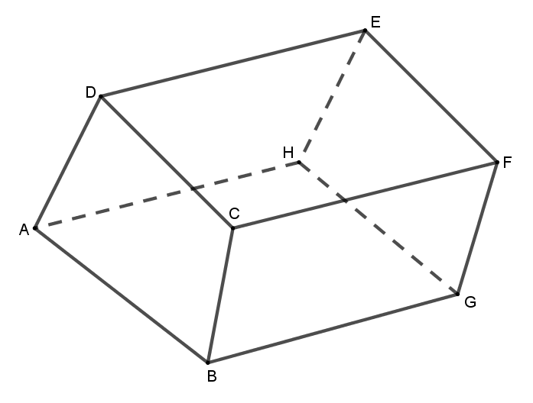 | B1 – complete solid  B1 – hidden lines  B1 – correct measurements
5 | LCM of 20, 24, 26 and 28  $=2^{3}×3×5×7×13=10 920$  Least length = $10 920+7=10 927 cm$ | B1  M1 M1  A1
  2 | 20 | 24 | 26 | 28
  2 | 10 | 12 | 13 | 14
  2 | 5 | 6 | 13 | 7
  3 | 5 | 3 | 13 | 7
  5 | 1 | 1 | 13 | 7
  7 | 1 | 1 | 13 | 7
  13 | 1 | 1 | 13 | 1
   | 1 | 1 | 1 | 1
6 | $$6x^{2}-13x+6=0$$  $$x^{2}-\frac{13}{6}x+ \frac{169}{144}=-1+\frac{169}{144}$$  $${\left(x-\frac{13}{12}\right)}^{2}=\frac{25}{144}$$  $$x=±\frac{5}{12}+\frac{13}{12}$$  $$x=\frac{3}{2} or\frac{2}{3}$$ | M1  M1  A1
7
8 | $$2\left(\begin{matrix}-3 \\ 4\end{matrix}\right)-\frac{3}{4}\left(\begin{matrix}16 \\ -4\end{matrix}\right)$$  $$\left(\begin{matrix}-6 \\ 8\end{matrix}\right)-\left(\begin{matrix}12 \\ -3\end{matrix}\right)=\left(\begin{matrix}-18 \\ 11\end{matrix}\right)$$ | M1  A1
9 | - Time difference = $1 hr 30 mins$  Distance between tem as at 10.30 a.m. = $40-\left(15×1.5\right)=17.5 km$  Time taken $=\frac{17.5}{40}=26 mins$  - $10.30 a.m. +26 mins 10.56 a.m.$ | M1  M1 A1  B1
10 | Area $=$ base $×perpendicular height$  $=12×\left(8×\sin{72}\right)$  $$=12×7.608=91.296 cm^{2}$$  $$≅91.3 cm^{2}$$ | M1  M1  A1
11 | $$N⟹\frac{1}{\sqrt{3}}×\frac{\sqrt{3}}{1}=1$$  $$D⟹\frac{\sqrt{3}}{2}×\frac{\sqrt{3}}{2}=\frac{3}{4}$$  $$\frac{N}{D}⟹1×\frac{4}{3}=1\frac{1}{3}$$ | M1  M1  A1
12 | Det M = $12-10=2$  $$M^{-1}=\frac{1}{2}\left(\begin{matrix}3 & -5 \\ -2 & 4\end{matrix}\right)=\left(\begin{matrix}\frac{3}{2} & -\frac{5}{2} \\ -1 & 2\end{matrix}\right)$$  $$M^{-1}N⟹\left(\begin{matrix}\frac{3}{2} & -\frac{5}{2} \\ -1 & 2\end{matrix}\right)\left(\begin{matrix}-2 & 3 \\ 1 & -1\end{matrix}\right)=\left(\begin{matrix}-5.5 & 7 \\ 4 & -5\end{matrix}\right)$$ | M1  M1A1
13 | $$N⟹m^{2}+10mn+25n^{2}+m^{2}-10mn+25n^{2}$$  $=2m^{2}+50n^{2}$  $$=2\left(m^{2}+25n^{2}\right)$$  $$D⟹3\left(m^{2}+25n^{2}\right)$$  $$\frac{N}{D}=\frac{2\left(m^{2}+25n^{2}\right)}{3\left(m^{2}+25n^{2}\right)}=\frac{2}{3}$$ | M1  M1  A1
14 |  | M1 –all logs  M1 – add & subtract  A1
  No | Std form | Log
  $$39.51$$  $$614$$ | $$3.951×10^{1}$$  $$6.14×{10}^{2}$$ | $$1.5967$$  $$2.7882+$$  $$4.3849$$
  $$0.758$$ | $$7.58×{10}^{-1}$$ | $$\overline{1}.8797-$$
  32 000 | $$3.2×{10}^{4}$$ | $$4.5052$$
15 | Cost price of car = 5000 dollars  Commission = $\frac{20}{100}×5000=1000 dollars$  Shipping fees = $\frac{80 325}{135}=595 dollars$  Total cost of the car = $5000+1000+595=6595 dollars$  Amount sent to agent = $6595×120=Ksh. 791 400$ | M1  M1  A1
16 | Area = $\frac{1}{2}bh$  $$17.5=\frac{1}{2}×\left(3x-2\right)×\left(x+2\right)$$  $$35=\left(3x-2\right)\left(x+2\right)$$  $$3x^{2}+4x-39=0$$  $$3x^{2}-9x+13x-39=0$$  $$3x\left(x-3\right)+13\left(x-3\right)=0$$  $$\left(3x+13\right)\left(x-3\right)=0$$  $$x=3 or x=\frac{-13}{3}$$  Length cannot be negative  Base = $3\left(3\right)-2=7 cm$  Height = $3+2=5 cm$ | M1  M1  A1 both values
17 | - $\frac{h}{h+30}=\frac{12}{15}$  $$h=120 cm$$  $$H=120+30=150 cm$$  Volume = $\left(\frac{1}{3}×3.142×{15}^{2}×150\right)-\left(\frac{1}{3}×3.142×{12}^{2}×120\right)$  $$=35347.5-18097.92$$  $$=17 249.58 cm^{3}$$  $$capacity= \frac{17 249.58}{1000}=17.25 litres$$  - (i) Volume $=3.142×{0.7}^{2}×1.2$  $$=1.847496 m^{3}$$  $$=1.847496×1000$$  $$=1847.496 litres$$  $\left(ii\right)$ No of buckets = $\frac{1847.496}{17.25}$  $$≅107 buckets$$ | M1  M1  M1  M1  A1  M1  M1  A1  M1  A1
18 | 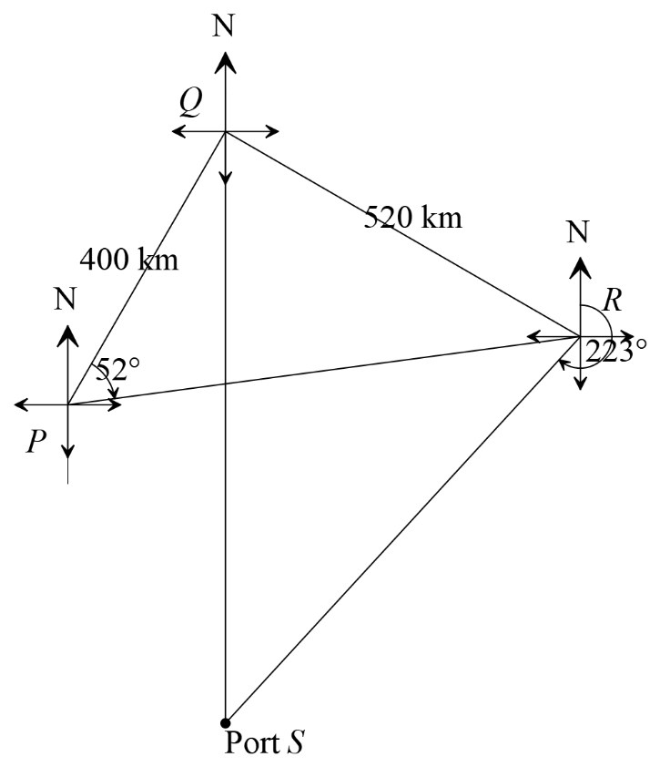  - (i) $30+52=82°$  (ii) $223°$  - $6.6×100=660 km$  - Position of W  Any 2 angle bisectors of triangle PSR | B1 – lines PQ,QR & QS  B1 – correct bearings  B1 – correct length  B1 – complete figure  B1  B1  M1 A1  B1  B1
19
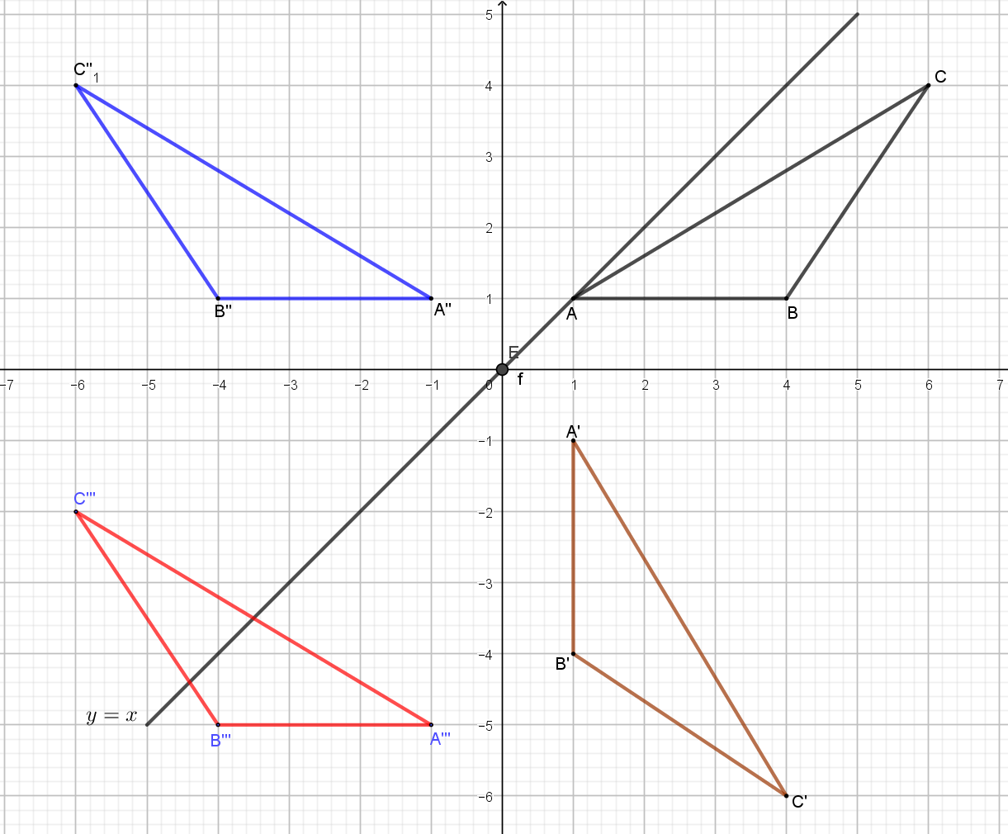
 | - (ii) Translation  Vector = $\left(\begin{matrix}0 \\ -6\end{matrix}\right)$  - (i) $∆A^{''}B^{''}C^{''}and ∆A^{'''}B^{'''}C^{'''}$  $$\left(ii\right) ∆ABC and ∆A''B''C''$$ | B1  B1  B1  B1
20 | - $s=\frac{1}{2}\left(13+8+10\right)=15.5$  Area = $\sqrt{15.5\left(15.8-8\right)\left(15.5-10\right)\left(15.5-13\right)}$  $=39.98 cm^{2}$  - Using cosine rule  ${10}^{2}=8^{2}+{13}^{2}-2×8×13×\cos{A}$  $$100=64+169-208\cos{A}$$  $$∠A=\cos^{-1}\left(0.639\right)=50.25°$$  - Using sine rule  $$\frac{10}{\sin{50.25}}=2R$$  $R=\frac{10}{2×0.7688}=6.504 cm$  - Area of circle = $\frac{22}{7}×{6.504}^{2}=132.95 cm^{2}$  Area of shaded region = $132.95-39.98$  $=92.97 cm^{2}$ | B1  M1  A1  M1  A1  M1  A1  M1  M1  A1
21 | - Table for the function $y=x^{3}-{5x}^{2}+2x+9$ | B2 – all correct values  B1 – less than 4 correct points
  $$x$$ | $$-2$$ | $$-1$$ | $$0$$ | $$1$$ | $$2$$ | $$3$$ | $$4$$ | $$5$$
  $$y$$ | $$-23$$ | $$1$$ | 9 | $$7$$ | $$1$$ | $$-3$$ | 1 | 19

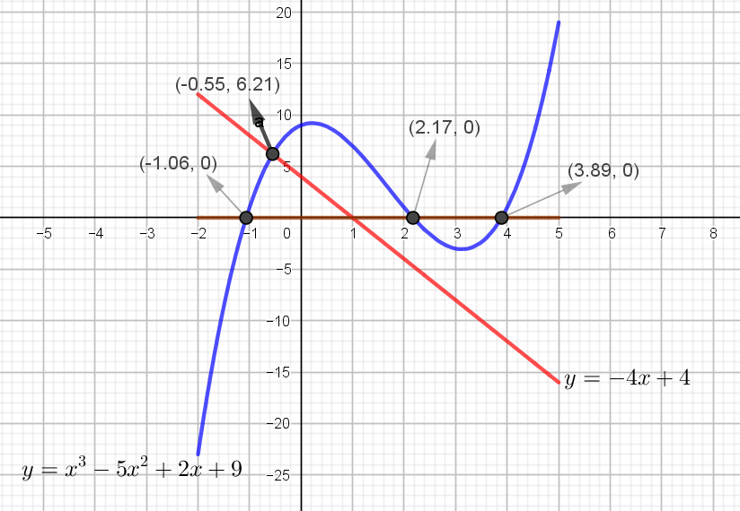
 | - (i) line $y=0$  $x=-1.1 or 2.2 or 3.9$  (ii) line $y=-4x+4$  $x=-0.6$ | B1  B1  B2  B1
22 | - (i) $C:S:B$  $1:2$ $×3$  $3:4$ $×2$  $$C:S:B=3:6:8$$  Cement : Ballast $= 3:8$  (ii) No of bags of ballast = $\frac{8}{17}×\frac{17}{6}×27$  $=36 bags$  - $\left(\frac{3}{17}×680\right)+\left(\frac{6}{17}×136\right)+\left(\frac{8}{17}×102\right)=Sh. 216$  - Number of trips = $\frac{30×1 000}{3600}=8\frac{1}{3}$  Total cost = $\frac{25}{3}×8 000=Sh. 66 666.67≅Sh.66 6677$ | M1  A1  M1  A1  M1 A1  M1 A1  M1 A1
23 | - $8c+12g=294 000$  $9c+15g=337 500$  - $\left(\begin{matrix}8 & 12 \\ 9 & 15\end{matrix}\right)\left(\begin{matrix}c \\ g\end{matrix}\right)=\left(\begin{matrix}294 000 \\ 337 500\end{matrix}\right)$  $\frac{1}{12}\left(\begin{matrix}15 & -12 \\ -9 & 8\end{matrix}\right)\left(\begin{matrix}8 & 12 \\ 9 & 15\end{matrix}\right)\left(\begin{matrix}c \\ g\end{matrix}\right)=\frac{1}{12}\left(\begin{matrix}15 & -12 \\ -9 & 8\end{matrix}\right)\left(\begin{matrix}294 000 \\ 337 500\end{matrix}\right)$  $$\left(\begin{matrix}1 & 0 \\ 0 & 1\end{matrix}\right)\left(\begin{matrix}c \\ g\end{matrix}\right)=\frac{1}{12}\left(\begin{matrix}294 000 \\ 337 500\end{matrix}\right)$$  $$\left(\begin{matrix}c \\ g\end{matrix}\right)=\left(\begin{matrix}30 000 \\ 4 500\end{matrix}\right)$$  Cow = Sh. 30 000 and Goat = Sh. 4 500  - SP of 8 cows = $\frac{140}{100}×30 000×8=Sh. 336 000$  SP of 12 goats = $\frac{145}{100}×4 500×12=Sh. 78 300$  Total sale = $336 000+78 300=Sh. 414 300$  - Profit = $414 300-294 000$  $=Sh. 120 300$ | B1  B1  M1  M1  M1  A1  M1  A1  M1  A1
24 | - (i) $\frac{y-3}{x+1}=-\frac{1}{2}$  $y-3=-0.5x-0.5$  $y=-0.5x+2.5$  (ii) At $y -$ intercept, $x=0$  $y=-0.5\left(0\right)+2.5⟹ y=2.5$  - (i) $m_{2}=\frac{5+3}{4-1}=\frac{8}{3}$  (ii) $\frac{y+3}{x-1}=\frac{8}{3}$  $8x-3y-17=0$  - $m_{3}=-\frac{3}{8}$  $$\frac{y-5}{x}=-\frac{3}{8}$$  $$3x+8y-40=0$$ | M1  A1  B1  B1  M1  A1  M1  A1

