NAME: …………………………………………. INDEX NO: ……………………………….

DATE : …………………………………..CANDIDATE’S SIGNATURE:…………………
MANGU HIGH SCHOOL TRIAL 4 MOCK 2025

121/1
MATHEMATICS
FORM 4
TIME: 2 ½ HOURS
Kenya Certificate of Secondary Education 2025
INSTRUCTIONS TO CANDIDATES
- Write your name and admission number in the spaces provided at the top of this page.
- This paper consists of two sections: Section I and Section II.
- Answer all questions in section I and ONLY five questions in Section II.
- Show all the steps in your calculations, giving your answers at each stage in the spaces below each question.
- Marks may be given for correct working even if the answer is wrong.
- KNEC Mathematical tables may be used.
For Examiner’s Use Only
1 | 2 | 3 | 4 | 5 | 6 | 7 | 8 | 9 | 10 | 11 | 12 | 13 | 14 | 15 | 16 | Total

17 | 18 | 19 | 20 | 21 | 22 | 23 | 24
Grand
Total

SECTION I (50 Marks)
Answer all the questions in this section
- A man withdrew some money from a bank. He spent $\frac{3}{10}$ of the money on his daughter’s school fees and $\frac{3}{5}$ of the remainder on his son’s school fees. If he remained with Ksh 10 500, calculate the amount of money he spent on son’s school fees. (3 marks)

- Solve for $x$ (3 marks)
$$9^{(x+1)}+3^{(2x+1)}=108$$

- The volume of two similar solid spheres are 4752 cm³ and 1408 cm³. If the surface area of the smaller sphere is 352 cm², find the surface area of the larger sphere. (3 marks)

- The figure below represents a sketch of the cross – section of a solid ABCDEFGH and its edge CF. Complete the sketch of the solid showing the hidden edges using dotted lines. (3 marks)

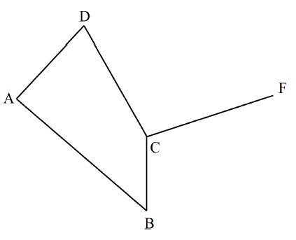

- When a given length of a piece of wire is divided into pieces measuring 20 cm or 24 cm or 26 cm or 28 cm, a piece of wire 7cm always remained. Find the length of wire. (4 marks)

- Solve the equation $6x^{2}-13x+6=0$ using the completing the square method. (3 marks)

- Using a ruler and a pair of compasses only, construct a trapezium ABCD in which $AB=5 cm$, $AD=6 cm,DC=10 cm, ∠BAD=105°$ and AB is parallel to DC. Draw a perpendicular from B to DC hence measure the height of the trapezium. (4 marks)

- Given that $\tilde{a}=2p - ¾ q$ where $p = \left(\begin{matrix}-3 \\ 4\end{matrix}\right)$ and $q =\left(\begin{matrix}16 \\ 4\end{matrix}\right)$ Find column vector $\tilde{a}$. (2 marks)

- Two friends Ojwang and David live 40 km apart. One day Ojwang left his house at 9.00 a.m. and cycled towards David’s house at an average speed of 15 km/h. David left his house at 10.30 a.m. on the same day and cycled towards Ojwang’s house at an average speed of 25 km/h. Determine;
- The time taken before the two friends met. (3 marks)

- The time they met. (1 mark)

- In the figure below, ABCD is a parallelogram in which AB = 12 cm, BC = 8 cm and angle ABC = $108°$.
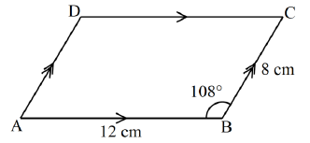
Calculate the area of the parallelogram correct to 3 significant figures. (3 marks)

- Without using mathematical tables or a calculator evaluate. (3 marks)
$$\frac{\tan{{30}^{o }}\tan{ {60}^{o}}}{\sin{{60}^{o}}\cos{30°}}$$

- Given that $M=\left(\begin{matrix}4 & 5 \\ 2 & 3\end{matrix}\right)$ and $N=\left(\begin{matrix}-2 & 3 \\ 1 & -1\end{matrix}\right)$, find $M^{-1}N$ (3 marks)

- Simplify completely; $\frac{{\left(m+5n\right)}^{2}+{\left(m-5n\right)}^{2}}{{3m}^{2}+75n^{2}}$ (3 marks)

- Use logarithms to evaluate. (3 marks)
$$\frac{39.51 × 614}{0.758}$$

- Dr. June needs to import a car from Japan that costs US dollars (USD) 5 000 outside Kenya. He intends to buy the car through an agent who deals in Japanese Yen (JPY). The agent charges a 20% commission on the price of the car and a further 80 325 JPY for shipping the car to Kenya. Find the amount in Kenya shillings that Dr. June will need to send to the agent to get the car given that 1 USD = Ksh. 120 and 1USD = 135 JPY (3 marks)

- In a right angled triangle, the two sides enclosing the right angle measure $\left(3x-2\right)$cm and $(x+2)$ cm. If the area of the triangle is $17.5 cm^{2}$, find the length of these two sides. (3 marks)

SECTION II (50 Marks)
Answer any Five questions only in this section
- The diagram below shows a frustum which represents a bucket with an open end diameter of 30 cm and bottom diameter 24 cm.
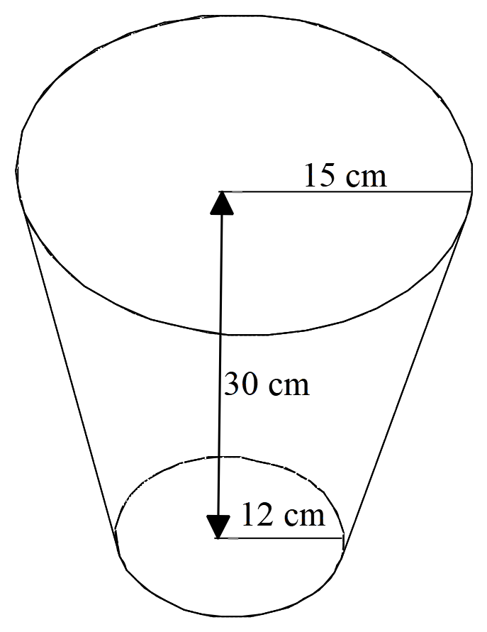
The bucket is 30cm deep. (Use $π$ = 3.142)
- Calculate the capacity of the tank in litres. (5 marks)

- The bucket is used to fill an empty cylindrical tank of diameter 1.4m and height 1.2m.
- Calculate the capacity of the tank in litres. (3 marks)

- Determine the number of buckets that must be drawn in order to fill the tank. (2 marks)

- Three islands P, Q, R and S are on an ocean such that island Q is 400Km on a bearing of $030°$ from island P. Island R is 520 km and a bearing of $120°$ from island Q. A port S is sighted 750 km due South of island Q.
- Taking a scale of 1cm to represent 100Km, give a scale drawing showing the relative positions of $P,Q,R and S$. (4 marks)

- Use the scale drawing to find the bearing of:
- Island R from island P (1 mark)

- Port S from island R (1 mark)

- Find the distance between island P and R (2 marks)

- A warship T is such that it is equidistant from the islands P, S and R. by construction locate the position of T. (2 marks)

- The vertices of a triangle ABC are A(1,1), B(4,1) and C(6,4)
- On the grid below, draw the triangles.

- ABC. (1 mark)
- $A'B'C'$, the image of triangle ABC under a negative quarter turn about the origin.
(2 marks)
- $A''B''C''$, the image of triangle $A'B'C'$, under reflection in the line $y=x$. (2 marks)

- Triangle $A'''B'''C'''$, with vertices $A^{'''}\left(-1, -5\right) B^{'''}\left(-4, -5\right)and C'''(-6, -2)$, is the image of , triangle $A''B''C''$, under a transformation T.

- Draw the triangle $A'''B'''C'''$, (1 mark)

- Describe fully the transformation T. (2 marks)

- State any pair of triangles which are:
  - Directly congruent. (1 mark)

  - Oppositely congruent. (1 mark)

- The figure below shows a triangle inside a circle. $AB=8 cm, BC=10 cm$ and $AC =13cm$
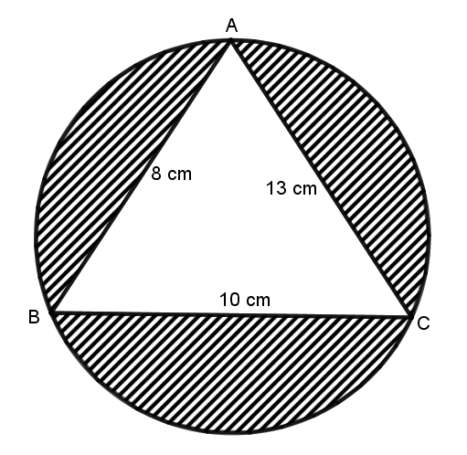
Calculate
- The area of triangle ABC. (3 marks)

- Angle BAC (2 marks)

- The radius of the circle. (2 marks)

- Area of the shaded region. (3 marks)

- (a) Complete the table below for the function $y=x^{3}-{5x}^{2}+2x+9$ for $-2≤x≤5$ (2 marks)
$$x$$ | $$-2$$ | $$-1$$ | $$0$$ | $$1$$ | $$2$$ | $$3$$ | $$4$$ | $$5$$
$$y$$ |  |  | 9

(b) On the grid provided, draw the graph of $y=x^{3}-{5x}^{2}+2x+9$ for $-2≤x≤5$ (3 marks)

(c) Use the graph in (b) above to find the roots of the following equations:
- $x^{3}-5x^{2}+2x+9=0$ (2 marks)

- $x^{3}-5x^{2}+6x=-5$ (3 marks)
- A construction company makes concrete by mixing cement, sand and ballast such that the ratio of cement to sand is 1:2 and that of sand to ballast is 3:4.
- Determine:
- The ratio of cement to ballast in the concrete. (2 marks)

- The number of bags of ballast required to make a concrete with 27 bags of sand. (2 marks)

- The cost of a bag of cement, sand and ballast is Ksh 680, Ksh 136 and Ksh 102 respectively. Calculate the cost of one bag of concrete. (2 marks)

- The construction company requires to transport 30 tonnes of sand to a site using a tractor. The tractor carries a maximum of 3 600 kg of sand and costs Ksh 8 000 per trip. Calculate the least amount of money required to transport the sand to the site. (4 marks)

- A trader bought 8 cows and 12 goats for a total of Ksh 294,000. If he had bought 1 more cow and 3 more goats he would have spent Ksh 337,500
- Form two equations to represent the above information. (2 marks)

- Use matrix method to determine the cost of a cow and that of a goat. (4 marks)

- The trader sold the animals he had bought making a profit of 40% per cow and 45% per goat. Calculate the total amount of money he received. (2 marks)

- Determine his profit in Kenya shillings. (2 marks)

- A straight line $l_{1}$ has a gradient 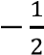 and passes through the point (−1, 3). Another line 𝑙₂ passes through the points 𝑄 (1, −3) and 𝑅 (4, 5) Find:
- (i) The equation of $l_{1}$ in the form $y = mx + c$, where m and c are constants. (2 marks)

(ii) Hence find the y intercept of line $l_{1}$ (1 mark)

- (i) The gradient of $l_{2}$ (1 mark)

(ii) The equation of $l_{2}$ in the form 𝑎𝑥 + 𝑏𝑦 = 𝑐, where 𝑎, 𝑏 and are integral values. (2 marks)

- The equation of a line passing through a point $\left(0, 5\right)$ and perpendicular to $l_{2}.$ (3 marks)

- Calculate the acute angle that $l_{3}$ makes with the $x$-axis. (1 mark)

