NAME: …………………………………………. INDEX NO: ……………………………….

DATE : …………………………………..CANDIDATE’S SIGNATURE:…………………

MANGU HIGH SCHOOL TRIAL 4 MOCK 2025

BIOLOGY
PAPER 1 (Theory)
TIME: 2 HOURS

FORM 4
JULY/AUGUST 2025

INSTRUCTIONS TO CANDIDATES
- Write your name and Adm. number in the spaces provided.
- Answer ALL the questions in the spaces provided

FOR EXAMINERS USE ONLY
Question | Maximum score | Candidates score
1-16 | 80

Candidates should check the question paper to ensure that all the pages are printed as indicated and no questions are missing.

SECTION A
- State the functions of each of the following organelles. (2 marks)
- Ribosomes

ii. Golgi apparatus:

- Give reasons for caring out the following procedures when preparing temporary wet mounts of a plant tissue

- why would carboxyhaemoglobin lead to death 2mks

- a)Name one salivary gland in humans 1mk

b) State two functions of saliva

2mks
- State three characteristics of the class crustacean 3mks

- State three characteristics that ensure cross-pollination takes place in flowering plants 3mks

- State the importance of negative phototaxis to termite 1mk-

- Name two tissues in plants that provide mechanical support 2mks

- State three structural differences between biceps and muscles of the gut 3mks
Biceps | Gut muscles

- The diagram below shows a specified plant cell……….

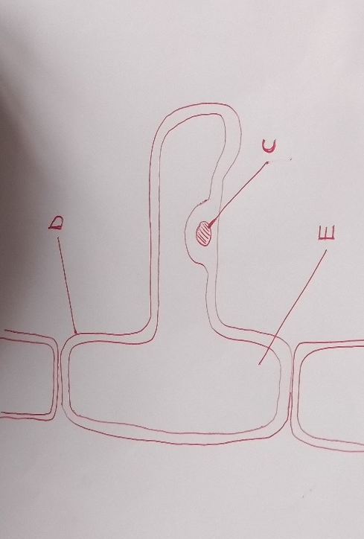

(a) (i) name the cell 1mk

(ii) Name the parts labeled Dand E 2MKS

(b) State the function of the part labeled C 1MK

11.(a) What is diffusion 2mks

(b) How do the following factors affect the rate of diffusion?
(i) Diffusion gradient

(ii) Surface area to volume ratio

(iii) Temperature

- (a) state the role of light in the process of photosynthesis 1mk

(b) Name one end product of dark reaction in photosynthesis 1mk

13. (a) The action of ptyalin stops at the stomach. Explain 1mk

(b) State a factor that denatures enzymes 1mk

(c) Name the feactures that increase the surface area of small intestines 1mk

14.The diagram below represents region of a root cap

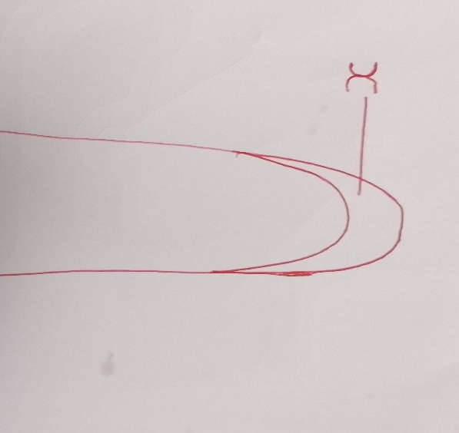

(a) Name two regions above X in ascending order 2mks

(b) State the function of the part labeled X 1MK

15. State three ways in which blood capillaries are structurally adapted to their functions 3mks

16. How are lenticels adapted for gaseous exchange 2mks

17.Apart from hearing state another function of the human ear 1mk

18.The diagram below illustrates a response by a certain plant ……………



(a) Name the type of response 1mk

(b) Explain how the response illustrated above occurs 3mks

19. Apart from the lungs name two gaseous exchange surfaces in a frog 2mks

20. State two functions of the muscles found in the alimentary canal of mammals 2mks

21..Name a disease caused by lack of each of the following in human diet (i)Vitamin D
(ii)Iodine
22.(a)State two factors that affect enzymatic activities 2mks

(b) Explain how one of the factors stated in (a) above affects enzymatic activities 1mk

23. State the importance of each of the following in living organisms
(a) nutrition 1mk

b) excretion 1mk

24. State two ways in which chloroplasts are adapted to their functions

25. State two disadvantages of self-pollination 2mks

26. (a) Name two types of muscles in mammals 2mks

(b) State the location of each of the following muscles in (a) above 2mks

27.state two advantages of internal fertilization 2mks

