QSN | RESPONSE
Parental genotype White and red patches White and red patches
Parental genotypes WR × WR
R
W
R
W
Gametes

F2 genotype WW WR WR RR
F2 phenotype White White and Red patches Red
- Blood group AB; Sickle cell trait; Reject sickle anaemia;
- Production of insulin; Production of human somatotropin hormone; Production of vaccine for hepatitis; Production of orally administered vaccines; Gene therapy;
- Carbonic anhydrase;
- Catalyzes reaction between water and carbon (IV) Oxide to form weak carbonic acid; and dissociation of weak carbonic acid into bicarbonate ions and hydrogen ions; (Tied to part (a))
- Carbon (IV) oxide is eliminated faster due to enzyme carbonic anhydrase; More carbon (IV) oxide is eliminated per unit time since some combine with haemoglobin to form carbaminohaemoglobin; Maintains pH of blood due to formation of bicarbonate ions;
- Activates thromboplastin/thrombokinase; which in turn neutralizes heparin; and activates prothrombin to thrombin;

- To investigate the effect of amylase concentration on digestion of starch;
- Test-tube A;
- The test-tube had the least amylase concentration; since it was diluted by the large volume of distilled water; this reduced the number of active sites available for binding with starch molecules;
- Amylase produced by salivary glands is denatured by hydrochloric acid in the stomach; thus, stopping its action;
- To prevent digesting the glands which produce them;
- K-Diplopoda; L-Chilopoda;
- K- Cylindrical body/Two pairs of legs per segment/A pair of short antennae;
L- Dorsa-ventrally body/A pair of legs per segment/A pair of long antennae/A pair of poison claws;
- K-Herbivorous/Detrivorous; L- Carnivorous;
- Feeds on small insects thus maintaining their population at carrying capacity;
- Lateral view;
- Presence of transverse process on either side;
- Neck;
- Presence of vertebraterial canal; Presence of wide neural canal;
- Large/Broad to provide large surface area for attachment of neck muscles;
- Long bones form site for synthesis of granulocytes; white destroy the pathogens; Skull protects brain, eye and ears form mechanical injury; Ribs protect lungs from mechanic injury; Sternum protect the heart from mechanical injury;

- Check the graph below;
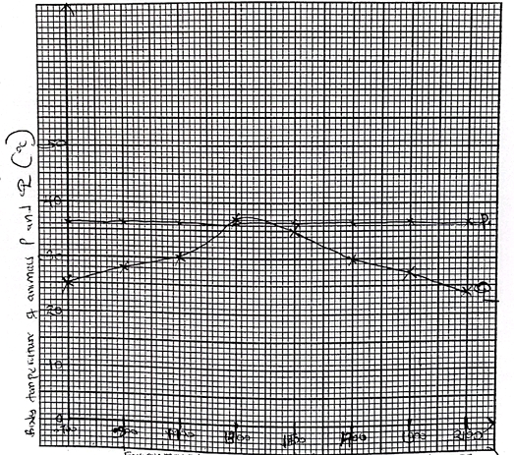
- P-Homoiotherm; - The body temperature is constant despite changes in environmental temperature;
Q-Poikilotherm; The body temperature fluctuates depending on environmental temperature;
- Can exploit a wide range of habitats; Remains active throughout;
- Cannot exploit a wide range of habitats;
- It is an endotherm, when the body temperature rises above optimum, the thermoreceptors in the hypothalamus detect and relay impulses to the liver to reduce exothermic reactions hence thermoregulation; when the body temperature falls below optimum, the thermoreceptors in the hypothalamus detect and relay impulses to the liver to increase exothermic reactions hence thermoregulation;
- Burrowing; Clustering; Basking; Coiling; Thermal gapping;

- A gill comprises of a gill bar/gill arch; gill rakers; and Gill filaments;
Gill bar is long and curved to provide large surface area; for attachment of gill filaments and gill rakers; It is also hard/bony to support the gill rakers and gill filaments;
Gill rakers are numerous and arranged in a saw-like manner facing the mouth to trap solid particles from water flowing from the mouth so as to prevent them from reaching the delicate gill filaments;
Gill filaments are long and numerous to provide large surface area; for gaseous exchange; Highly vascularised; for efficient transportation of respiratory gases; Have thin epithelial lining; to reduce distance for faster diffusion of respiratory gases; Have permeable epithelial lining; for diffusion of respiratory gases across them;

Support in herbaceous plants; Herbaceous plants lack support tissues; they have numerous parenchyma cells; which absorb water by osmosis; become turgid and offer mechanical support;
Absorption of water; The cell sap of root hair cell is hypertonic to the soil solution surrounding the root hair; this creates an osmotic pressure; which draws water molecules from the soil across the plasma membrane into the sap vacuole of the root hair cell by osmosis; the water drawn in dilutes the cell sap of root hair cell and piliferous cells making it hypotonic to that of adjacent cortical cells; the adjacent cortical cells therefore draw water from the piliferous cells by osmosis making their cell sap to become hypotonic to the cell sap of adjacent cortical cells on the inner side; water movement continues from successive cortical cells until water reaches the endodermis; water is actively pumped across the endodermis through the pericycle to the xylem;
Opening and closing of stomata; During daytime in the presence of light, chloroplasts in the guard cells carry out photosynthesis which yields glucose; glucose being osmotically active, raises osmotic pressure of guard cells; which absorb water from adjacent epidermal cells by osmosis; become turgid, bulge outwards; and open the stomata; At night, in the absence of light, the preformed glucose is converted to starch; starch being osmotically inactive, lowers the osmotic pressure of guard cells; which lose water to the surrounding epidermal cells by osmosis; become plasmolysed and close the stomata;
Feeding in insectivorous plants; The leaves of insectivorous plants have touch sensitive cells called pulvini; when insects land on them, midrib cells rapidly lose water by osmosis and consequently lose their turgor; making the leave to close with their spines interlocking hence trapping the insect; which they digest to obtain nutrients;
- The roles are described below;
Hormone | Secretory gland | Role
Follicle stimulating hormone; | Pituitary gland; | Stimulates synthesis; and Maturation of sperms;
Luteinizing hormone; | Pituitary gland | Stimulates interstitial cells to  secrete androgen such  as testosterone;
Testosterone; | Interstitial cells; | Stimulates development of male  secondary sexual  Characteristics; such as growth  of air in armpits and pubic  regions; enlargement of testis;  deepening of voice;

- Condensation of homologous chromosomes; Homologous chromosomes shorten; and thicken;
Synapsis; Homologous chromosomes lie side by side to form pairs called bivalents;
Chiasma formation; non-sister chromatids come into contact at points called chiasma;
Crossing over; There is an exchange of genetic material between non-sister chromatids at chiasmata;
The nucleolus disappears;
The nuclear membrane begins to disintegrate;
The spindle fibres begin to form from the centrioles;

