**NAME:………………………………………………………….INDEX NO.:……………………………… SCHOOL:…………………………………………..SIGNATURE………..……..…..DATE………..….…**

**443/1**

**AGRICULTURE PAPER 1**

**2 HOURS**

CATHOLIC DIOCESE OF KAKAMEGA EVALUATION TEST JULY/ AUGUST EXAM 2025

***KENYA CERTIFICATE OF SECONADRY EDUCATION (K.C.S.E)***

**INSTRUCTIONS TO CANDIDATES**

1. Write your name, admission number and class
2. This paper contains **three** sections **A, B and C.**
3. Answer all question in section **A** and **B**
4. In section **C** answer any two questions
5. Candidates should check the question paper to ascertain that all pages are printed as indicated and that no questions are missing
6. This paper has 8 printed pages
7. Candidates must answer all the questions in English

**For examiner’s use only**

|  |  |  |  |
| --- | --- | --- | --- |
| **Section** | **Questions** | **Maximum score** | **Candidate score** |
| **A** | **1 -16** | **30** |  |
| **B** | **17 -20** | **20** |  |
| **C** |  | **20** |  |
|  |  | **20** |  |
| **Total score** | | **90** |  |

**SECTION A 30 MARKS.ANSWER ALL QUESTION**

1. Differentiate between olericulture and pomoculture as used in crop production. (1mark)

…………………………………………………………………………………………………………………………………………………………

…………………………………………………………………………………………………………………………………………………………

…………………………………………………………………………………………………………………………………………………………

……………………………………………………………………

1. Give **two** methods of farming (1marks)

…………………………………………………………………………………………………………………………………………………………

…………………………………………………………………………………………………………………………………………………………

…………………………………………………………………………………………………………………………………………………………

…………………………………………………………………………………………………………………………………………………………

1. Give **two** examples for each of the following types of cost incurred in broiler production.
   1. Variable cost (1 mark)

…………………………………………………………………………………………………………………………………………………………

…………………………………………………………………………………………………………………………………………………………

* 1. fixed cost (1 mark)

…………………………………………………………………………………………………………………………………………………………

…………………………………………………………………………………………………………………………………………………………

1. Give **four** advantages of crop rotation. (2marks)

…………………………………………………………………………………………………………………………………………………………

…………………………………………………………………………………………………………………………………………………………

…………………………………………………………………………………………………………………………………………………………

………………………………………………………………………………………………………………………………………………………..

1. State **four** factors to consider when choosing seed rate. (2marks)

…………………………………………………………………………………………………………………………………………………………

…………………………………………………………………………………………………………………………………………………………

…………………………………………………………………………………………………………………………………………………………

…………………………………………………………………………………………………………………………………………………………

6(a) Give **four** reasons for using certified seeds for planting. (2marks)

…………………………………………………………………………………………………………………………………………………………

…………………………………………………………………………………………………………………………………………………………

…………………………………………………………………………………………………………………………………………………………

………………………………………………………………………………………………………………………………………………………..

(b).Give **four** disadvantages of using non capped multiple stem pruning in coffee (2marks)

…………………………………………………………………………………………………………………………………………………………

…………………………………………………………………………………………………………………………………………………………

…………………………………………………………………………………………………………………………………………………………

…………………………………………………………………………………………………………………………………………………………

1. State **two** reasons why cassava should be grown as the last crop in crop rotation programme. (1mark)

…………………………………………………………………………………………………………………………………………………………

…………………………………………………………………………………………………………………………………………………………

1. State **four** importance of farm records. (2marks)

…………………………………………………………………………………………………………………………………………………………

…………………………………………………………………………………………………………………………………………………………

…………………………………………………………………………………………………………………………………………………………

…………………………………………………………………………………………………………………………………………………………

1. Name **two** aspects of light that affect crop production. (1mark)

…………………………………………………………………………………………………………………………………………………………

…………………………………………………………………………………………………………………………………………………………

…………………………………………………………………………………………………………………………………………………………

…………………………………………………………………………………………………………………………………………………………

10.(a) Name any two high altitude legume pastures. (1mark)

…………………………………………………………………………………………………………………………………………………………

…………………………………………………………………………………………………………………………………………………………

…………………………………………………………………………………………………………………………………………………………

…………………………………………………………………………………………………………………………………………………………

(b) State two advantages of pure stand pastures. (1marks)

…………………………………………………………………………………………………………………………………………………………

…………………………………………………………………………………………………………………………………………………………

…………………………………………………………………………………………………………………………………………………………

………………………………………………………………………………………………………………………………………………………..

11.a) Apart from the identity of owner, title number and size of land, name other two essentials contained on a land title deed. (1 mark)

…………………………………………………………………………………………………………………………………………………………

…………………………………………………………………………………………………………………………………………………………

…………………………………………………………………………………………………………………………………………………………

…………………………………………………………………………………………………………………………………………………………

1. Give **four** importance of a land title deed. (2marks)

…………………………………………………………………………………………………………………………………………………………

…………………………………………………………………………………………………………………………………………………………

…………………………………………………………………………………………………………………………………………………………

…………………………………………………………………………………………………………………………………………………………

1. List **four** methods of fertilizer application. ( 2marks)

…………………………………………………………………………………………………………………………………………………………

…………………………………………………………………………………………………………………………………………………………

…………………………………………………………………………………………………………………………………………………………

…………………………………………………………………………………………………………………………………………………………

1. State **four** advantages of growing maize in rows instead of broadcasting. (2marks)

…………………………………………………………………………………………………………………………………………………………

…………………………………………………………………………………………………………………………………………………………

…………………………………………………………………………………………………………………………………………………………

…………………………………………………………………………………………………………………………………………………………

1. Name **four** factors that determine the choice of a nursery site. (2marks)

…………………………………………………………………………………………………………………………………………………………

…………………………………………………………………………………………………………………………………………………………

…………………………………………………………………………………………………………………………………………………………

…………………………………………………………………………………………………………………………………………………………

1. Name **two** post-harvest practices in beans. (1marks)

…………………………………………………………………………………………………………………………………………………………

…………………………………………………………………………………………………………………………………………………………

…………………………………………………………………………………………………………………………………………………………

…………………………………………………………………………………………………………………………………………………………

1. Give **four** reasons why burning is discouraged as a method of land clearing. (2marks)

…………………………………………………………………………………………………………………………………………………………

…………………………………………………………………………………………………………………………………………………………

…………………………………………………………………………………………………………………………………………………………

…………………………………………………………………………………………………………………………………………………………

**SECTION B 20 MARKS**

1. The table below shows output of maize in response to increase in D.A.P fertilizers on one hectare of land.

|  |  |  |  |  |
| --- | --- | --- | --- | --- |
| Fixed input land (in ha) | Variable input  D.A.P in 30kg-bag | Total product maize yield in 90-kg bag | Average product (AP) maize in 90kg bag | Marginal product (M.P) in 90kg bag |
| 1  1  1  1  1 | 0  1  2  3  4 | 2  5  14  21  26 | -  -  -  -  - | -  -  -  -  - |

* 1. Fill in the table for average product (A.P) and marginal products (M.P) (5marks)

1. The following is a list of plant nutrients; Copper, Calcium, Nitrogen, Molybdenum, Zinc, Phosphorus, Carbon, Sulphur, Iron and Magnesium.

Which of the above plant nutrients are:

1. Macro-nutrients (1mk)

………………………………………………………………………………………………………………

1. Micro-nutrients (1mk)

........................................................................................................................................................................

1. Fertilizer elements (1mk)

.......................................................................................................................................................................

1. Liming elements. (1mk)

.........................................................................................................................................................................

1. Mineral whose deficiency causes blossom end rot in tomatoes (1mk)

.........................................................................................................................................................................

1. The diagram below shows a structure used in crop production.

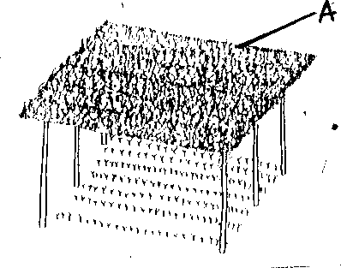

1. Identify the structure above. (1mark)

…………………………………………………………………………………………………………………………………………………..…

1. Give a reason for carrying out each of the following practices in the structure shown above

(i).Pricking out. (1mark)

…………………………………………………………………………………………………………………………………………………………

…………………………………………………………………………………………………………………………………………………………

(ii). Hardening off. (1mark)

…………………………………………………………………………………………………………………………………………………………

…………………………………………………………………………………………………………………………………………………………

(c).State **two** importance of the part labelled **A** in the above structure. (2marks)

…………………………………………………………………………………………………………………………………………………………

…………………………………………………………………………………………………………………………………………………………

1. Study the diagram below and answer the questions that follow.

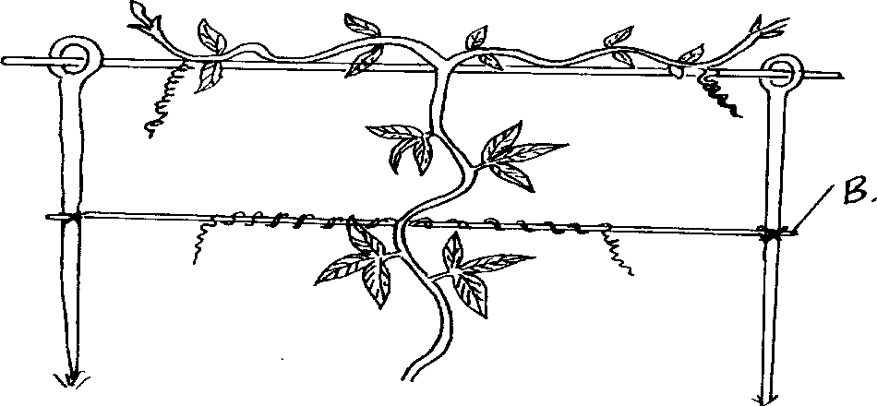

(a) Name the crop production practice illustrated above. (1mark)

…………………………………………………………………………………………………………………………………………………………

…………………………………………………………………………………………………………………………………………………………

1. Name a material that may be used as part B in the diagram (1mark)

…………………………………………………………………………………………………………………………………………………………

…………………………………………………………………………………………………………………………………………………………

1. State **three** reasons why the practice is done in crops. (3marks)

…………………………………………………………………………………………………………………………………………………………

…………………………………………………………………………………………………………………………………………………………

…………………………………………………………………………………………………………………………………………………………

**SECTION C 40 MARKS (ANSWER ONLY TWO QUESTIONS)**

**Answer any TWO questions from this section**

1. (a) Explain seven physical methods of pest control. (7mks) (b) Explain eight factors that contribute to the competitive ability of weeds. (8mks)

(c) Describe the harvesting of coffee. (5mks)

22 a) Explain the various farming practices carried out to control soil erosion. (8mks)

1. Describe the seven management practices that should be carried out on a vegetable

nursery after sowing seeds until the seedlings are ready for transplanting. (7mks)

1. Outline five ways in which high temperature affects agricultural production in Kenya. (5mks)

23. a) Outline the information contained in a purchase order. (5mks)

b) Explain five ways in which biotic factors influence crop production in agriculture. (5mks)

1. Describe the production of carrots under the following subheadings;
   1. land preparation. (3 mks)
   2. planting. (4 mks)
2. Explain three factors that may lead to an increase in demand of maize. (3 mks)

…………………………………………………………………………………………………………

…………………………………………………………………………………………………………

…………………………………………………………………………………………………………

…………………………………………………………………………………………………………

…………………………………………………………………………………………………………

…………………………………………………………………………………………………………

…………………………………………………………………………………………………………

…………………………………………………………………………………………………………

…………………………………………………………………………………………………………

…………………………………………………………………………………………………………

…………………………………………………………………………………………………………

…………………………………………………………………………………………………………

…………………………………………………………………………………………………………

…………………………………………………………………………………………………………

…………………………………………………………………………………………………………

…………………………………………………………………………………………………………

…………………………………………………………………………………………………………

…………………………………………………………………………………………………………

…………………………………………………………………………………………………………

…………………………………………………………………………………………………………

…………………………………………………………………………………………………………

…………………………………………………………………………………………………………

…………………………………………………………………………………………………………

…………………………………………………………………………………………………………

…………………………………………………………………………………………………………

…………………………………………………………………………………………………………

…………………………………………………………………………………………………………

…………………………………………………………………………………………………………

…………………………………………………………………………………………………………

…………………………………………………………………………………………………………

…………………………………………………………………………………………………………

…………………………………………………………………………………………………………

…………………………………………………………………………………………………………

…………………………………………………………………………………………………………

…………………………………………………………………………………………………………

…………………………………………………………………………………………………………

…………………………………………………………………………………………………………

…………………………………………………………………………………………………………

…………………………………………………………………………………………………………

…………………………………………………………………………………………………………

…………………………………………………………………………………………………………

…………………………………………………………………………………………………………

…………………………………………………………………………………………………………

…………………………………………………………………………………………………………

…………………………………………………………………………………………………………

…………………………………………………………………………………………………………

…………………………………………………………………………………………………………

…………………………………………………………………………………………………………

…………………………………………………………………………………………………………

…………………………………………………………………………………………………………

…………………………………………………………………………………………………………

…………………………………………………………………………………………………………

…………………………………………………………………………………………………………

…………………………………………………………………………………………………………

Page **8** of **8 AGRICULTURE PAPER 1**