Carbon and its compounds
1. (a) State one use of graphite
(b) Both graphite and diamond are allotropes of element Carbon. Graphite conducts electricity
whereas diamond does not. Explain

2. Below is a simplified scheme of solvay process. Study it and answer the questions that follow:
Brine
PROCESS
I
PROCESS
II
PROCESS
III
Ammonia
solution
Gas R
Sodium
Carbonate

a) Identify gas R.
b) Write an equation for the process III.
c) Give one use of sodium carbonate.

3. A burning magnesium continues to burn inside a gas jar full of carbon (IV) oxide. Explain.
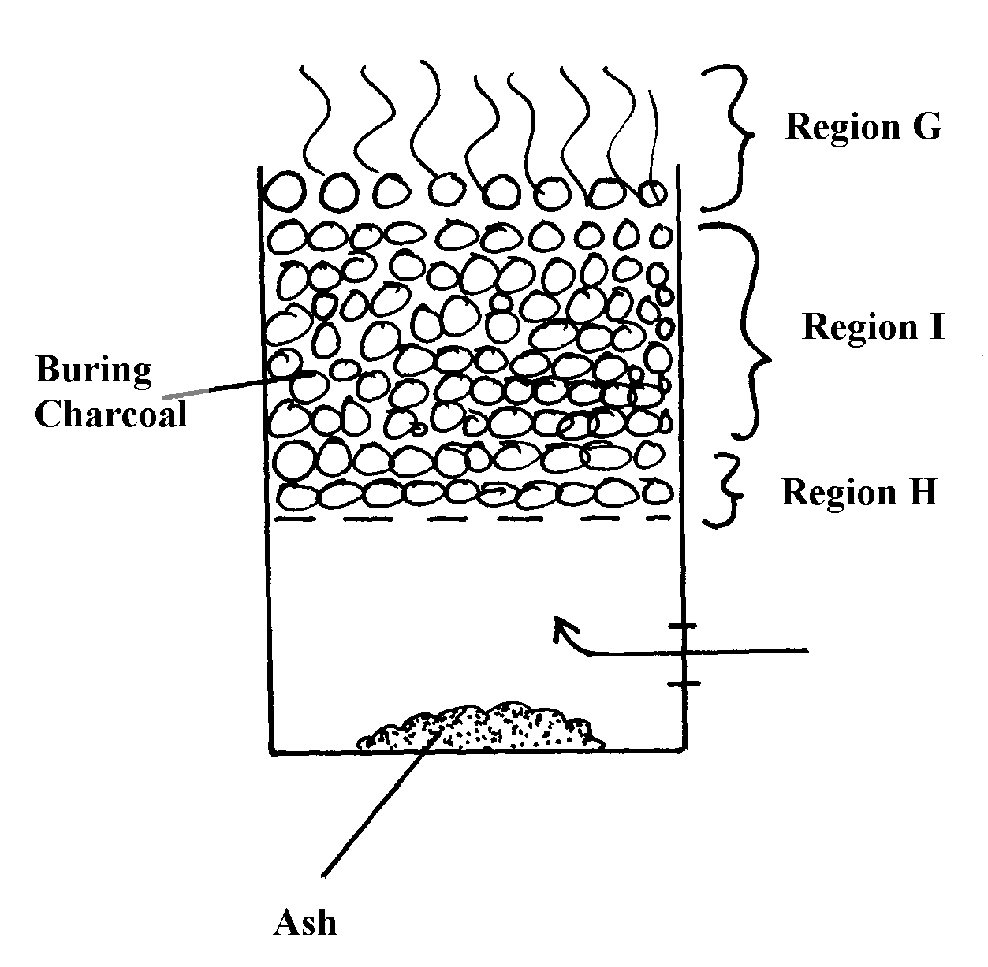
4. The diagram below shows a jiko when in use

(a) Identify the gas formed at region H
(b) State and explain the observation made at region G
5. Study the diagram below and use it to answer the questions that follow.

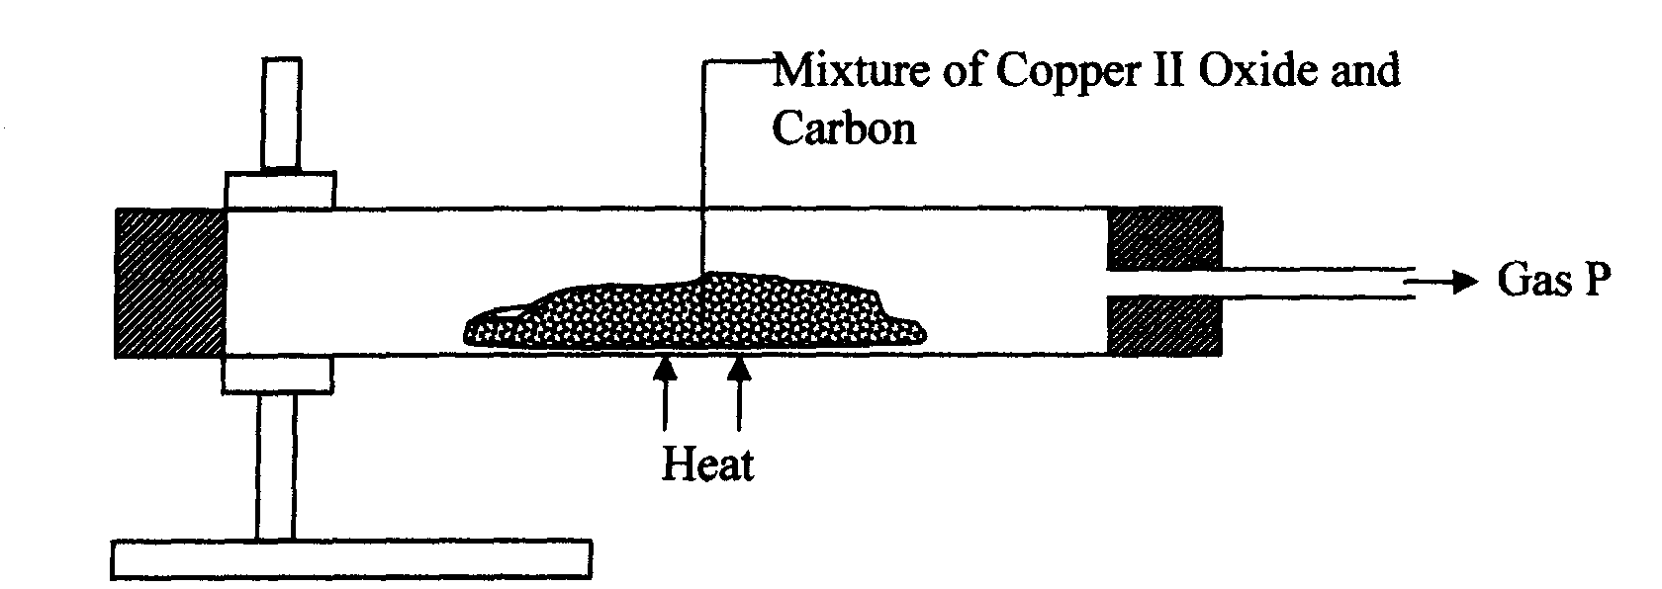

(a) State the observation made in the combustion tube.
(b) Write an equation for the reaction that took place in the combustion tube
(c) Give one use of P
6. (a) Identify two substance that are reacted to regenerate ammonia gas in the solvary process
(b) Write down a balanced chemical equation for the reaction above
7. When the oxide of element H was heated with powdered Carbon, the mixture glowed and
Carbon (IV) oxide was formed. When the experiment was repeated using the oxide of element J,
there was no apparent reaction
(a) Suggest one method that can be used to extract element J from its oxide
(b) Arrange the elements H, J and Carbon in order of their decreasing reactivity
8. (i) Diamond and silicon (IV) Oxide have a certain similarity in terms of structure and bonding.
State it
(ii) State one use of diamond
9. (a) What is allotropy?
(b) Diamond and graphite are allotropes of Carbon. In terms of structure and bonding
explain why graphite conducts electricity but not diamond
10. The diagram below shows a charcoal stove with different regions
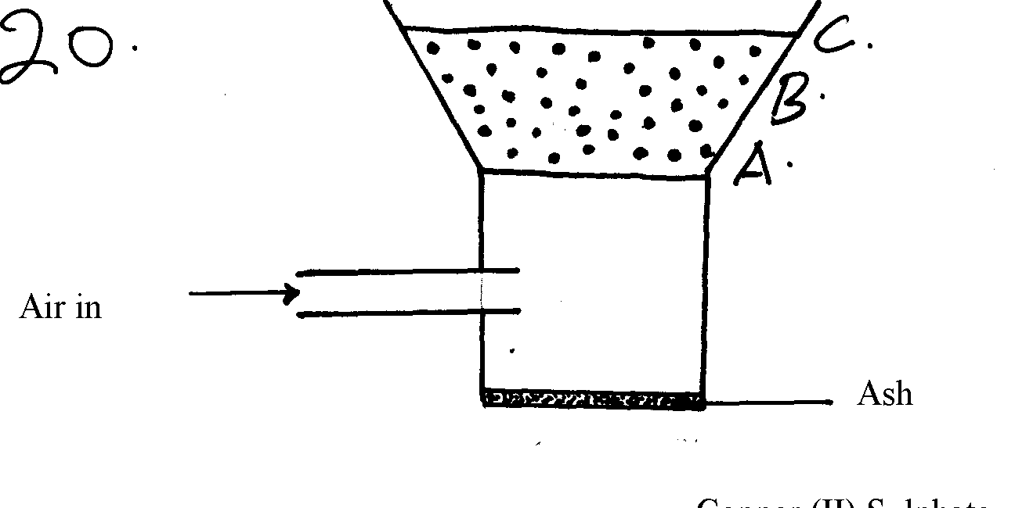

(a) Write an equation for the formation of the product in region B
(b) How would one avoid the production of the product at B? Give a reason for your answer

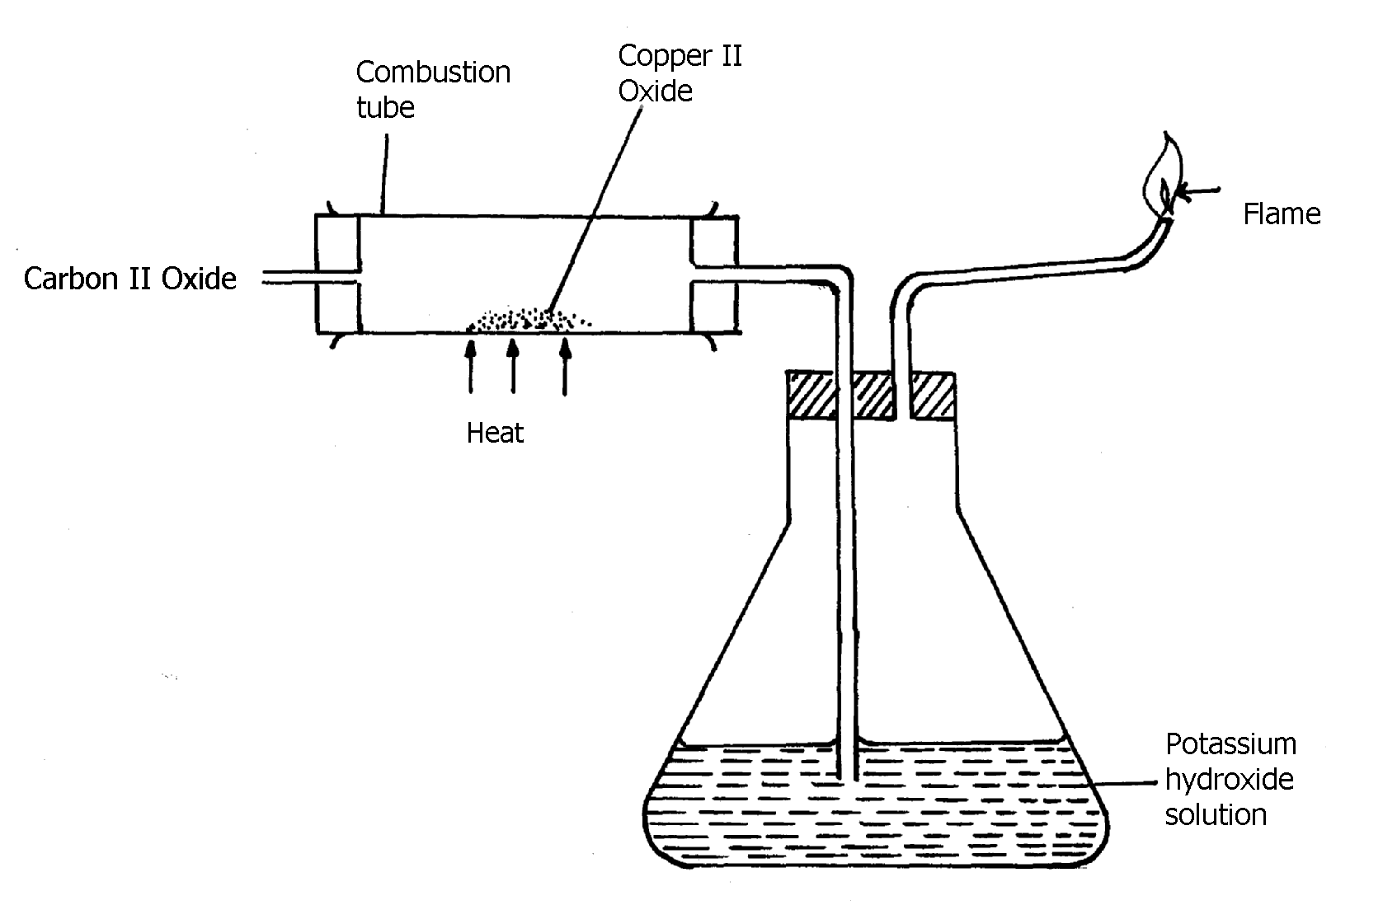
11. Study the diagram below and answer the questions that follow:

(a) Explain the observation made in the combustion tube during the experiment
(b) Write an equation for the reaction that takes place in the combustion tube
12. Diamond and graphite are allotropes of carbon:-
(a) What is meant by allotropes?
(b) How do they differ in their structure and bonding
13. Study the experimental set-up below:
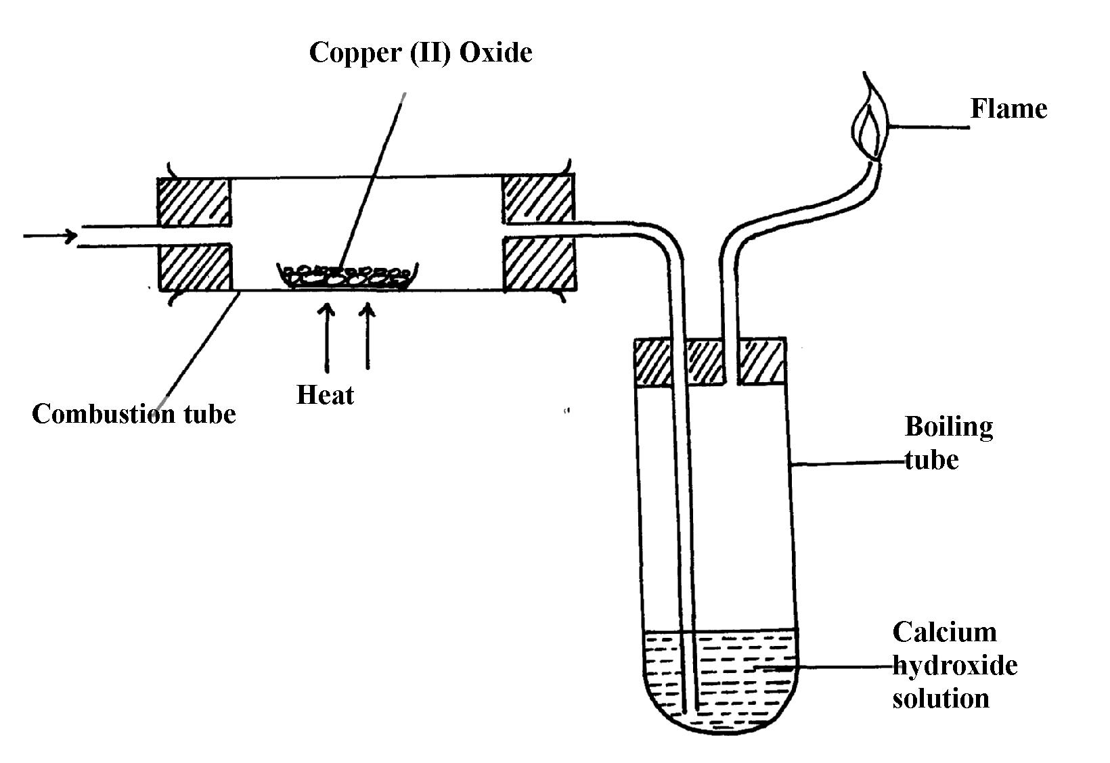
Carbon (II) Oxide

a) State two observations made in the set up as the experiment progressed
b) By use of a chemical equation, explain the changes that occurred in the boiling tube
c) Why was it necessary to burn the excess gas?
14. The diagram below shows the heating curve of a pure substance. Study it and answer the
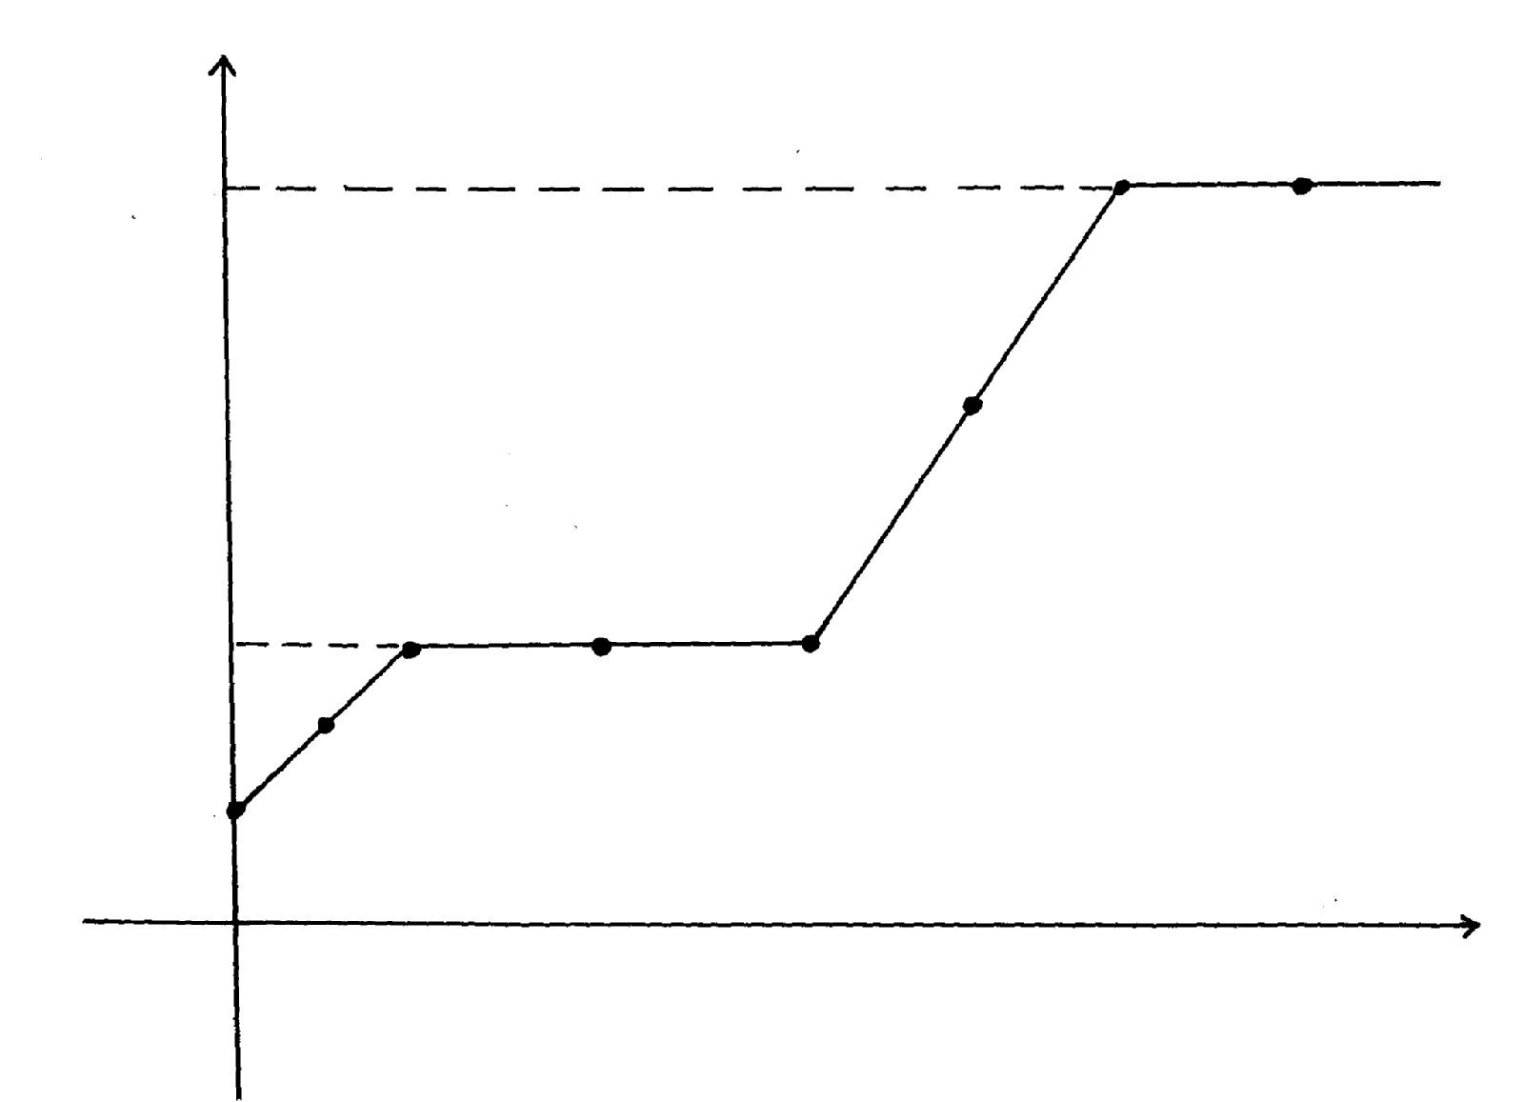
questions that follow:
Time
A
Y
444
D
W
K
C
B
H
115
Temperature

(a) What physical changes are taking place at H and W?
(b) What are the physical states of the substance at Y and K?
(c) Using the simple kinetic theory of matter, explain what happens to the substance between
points A and C
(d) The substance under test is definitely not water; Give a reason for this
(e) What would happen to the melting point of this substance if it were contaminated
with sodium chloride?
(f) What happens to the temperature between points B and C?
15. Study the set-up below and answer the questions that follow:
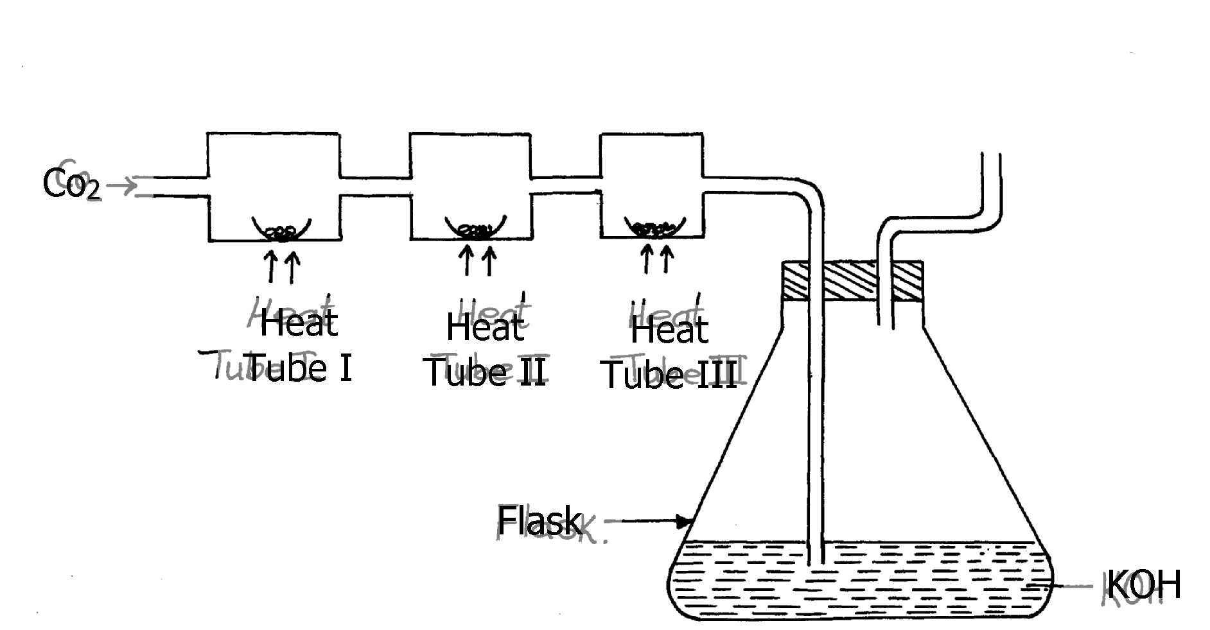

(a) (i) Name Gas X ………………………………………………………………
(ii) State the effect of releasing gas X to the environment
(b) Write down equations for the reactions taking place in;
(i) Tube I
(ii) Tube II
(iii) Flask
(c) State the observation made in tube III
(d) Write down an equation for the reaction which could be used to generate Carbon
(IV) Oxide for the above set up
(e) Name the reagents used to generate gas x in the laboratory
(f) Complete the diagram above to show how excess gas x can be collected

16. The figure below shows the stages in the manufacture of sodium carbonate. Study the diagram
below and use it to answer the questions that follow.
HEATING LIMESTONE
REACTION CHAMBER 2
REACTION CHAMBER 1
REACTION CHAMBER 3
Calcium chloride
Sodium carbonate
Solid V
Filtration
Liquid U
Carbon
(IV) Oxide
Ammonia
Brine

a) (i) Name three starting materials in the manufacturer of sodium carbonate.
(ii) Which substances are recycled in this process?
(iii) Identify the chambers in which the recycled substances are regenerated.
(iv) Name the substances U and V.
b) Give an equation for the reaction which occurs:
(i) In the reaction chamber 1
(ii) When solid V is heated.
(iii) In the reaction chamber 3.
c) State one commercial use for
(i) Sodium carbonate.
17. The set-up below was used to prepare dry carbon (II) Oxide gas. use it to answer the questions
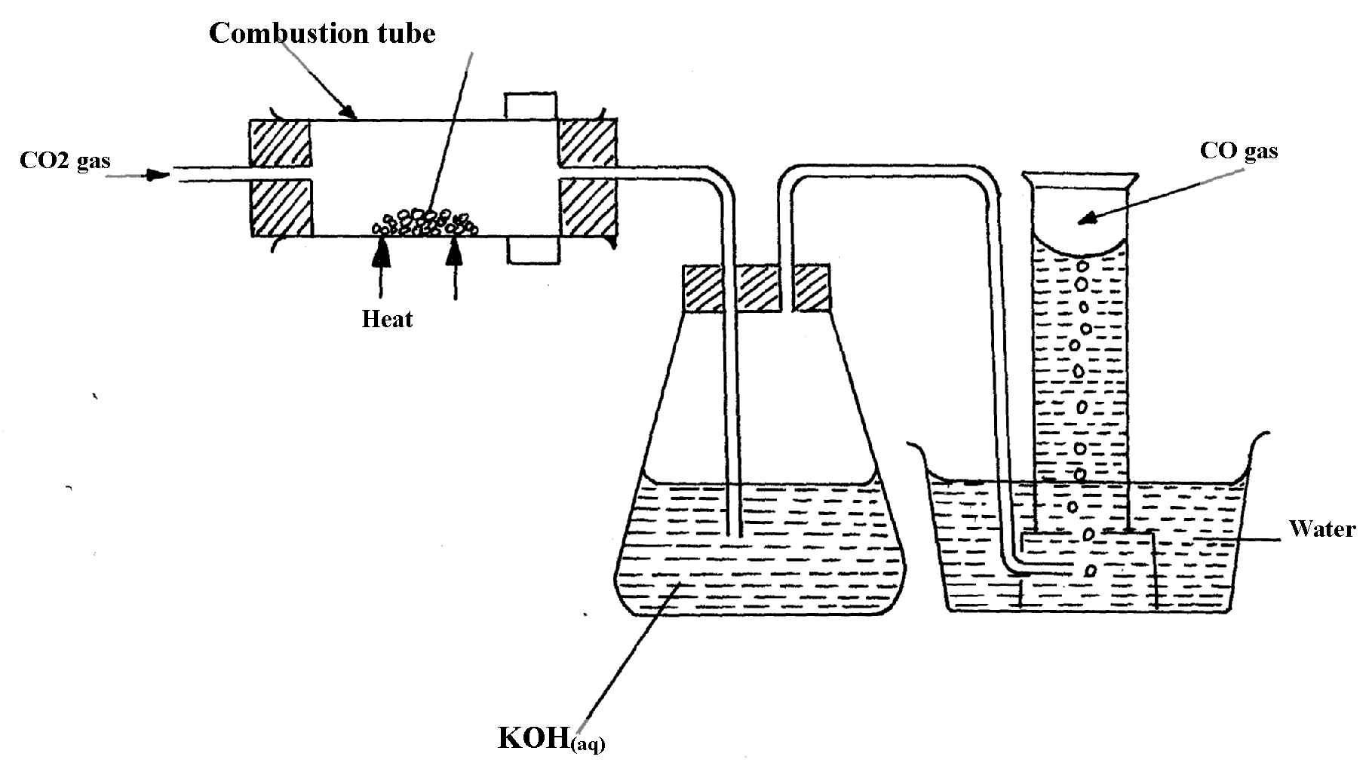
below it:
charcoal

(a) (i) State two mistakes committed in the set-up arrangement above

(ii) The student produced carbon (IV) oxide gas from the reaction between Lead (II) Carbonate
and dilute hydrochloric acid. The gas was produced for a short time and the reaction came
to a stop. Explain
(iii) Write the equation for the reactions taking place in the combustion tube and the conical
flask:
Combustion tube:…………………………………………………………………..
Conical flask ……………………………………………………………………..
(iv) State one use of carbon (IV) Oxide gas apart from fire extinguisher
(v) Give two properties that make carbon (IV) Oxide to be used as fire extinguisher
(b) PbO_{(s)} + CO_{(g)} Pb_{(s)} + CO_{2(g)}
Which property of carbon (II) Oxide is demonstrated by the above equation?
(c) Aluminium carbonate does not exist. Give a reason
(d) Ammonium carbonate decomposes when heated. Write a chemical equation to
represent this decomposition
18. State and explain the observation made when a piece of charcoal is dropped in a jar containing
concentrated nitric (V) acid

19. When Carbon (IV) oxide is passed through lime water, a white precipitate is formed but
when excess Carbon (IV) Oxide is passed, the white precipitate disappears;
(a) Explain why the white precipitate disappears
(b) Give an equation for the reaction that takes place in (a) above
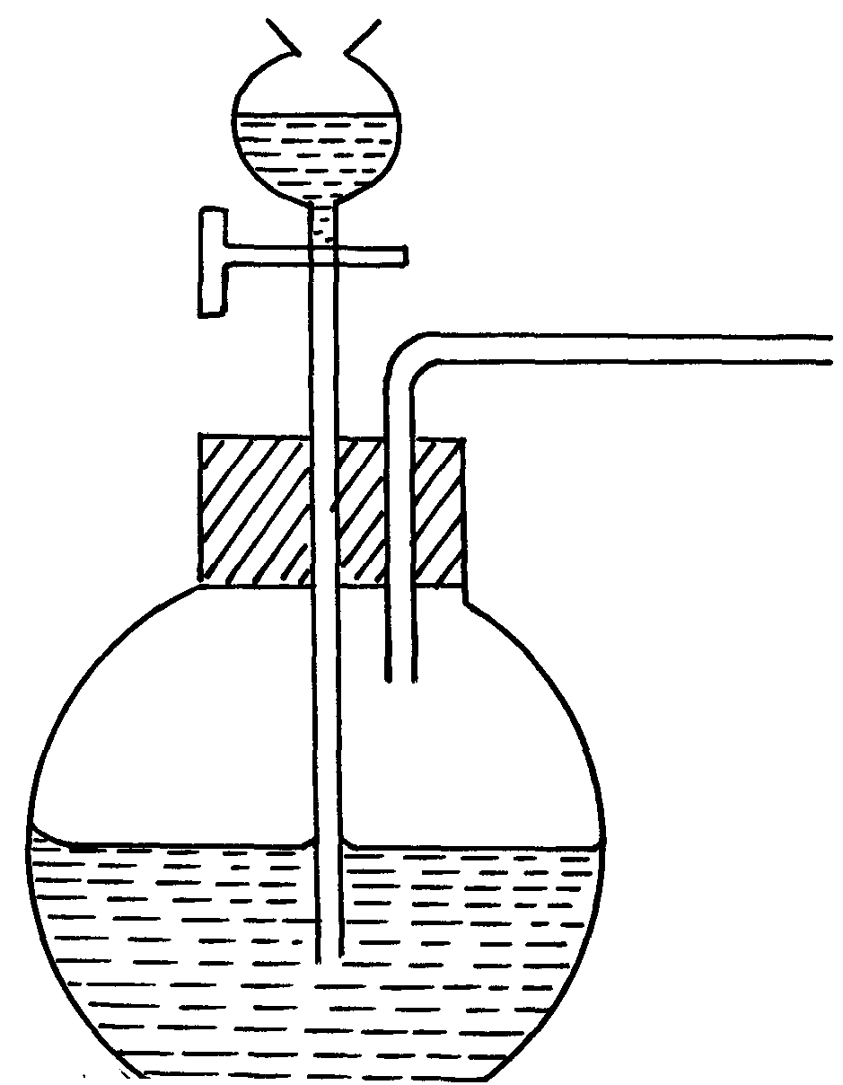
20. The set-up below was used to prepare a carbon (II) oxide gas.
A
Sodium methanoate solid

(a) Give the name of substance A ………………………………………………………….
(b) Complete the diagram to show how the gas can be collected
(c)Write the equation for the reaction

